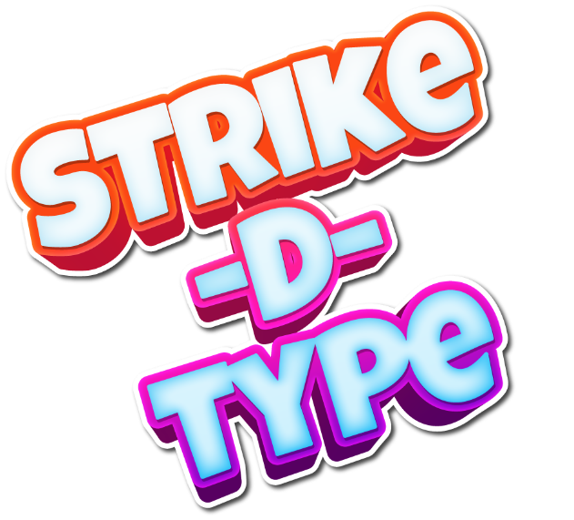

is an addictive card game for competitive players with a good peripheral vision.   
This tricky brain teaser will get you hooked, and you won't be able to stop playing!

The players get a deck of cards. There is only one symbol in common between the two cards. The objective of the game is to be the first player to announce the common symbol between two given cards.

Play Strike-D-Type with family and friends, develop your speed, concentration, and discernment skills, and let the adventure begin!

We built this app with Flutter - the newest open-source software development kit created by Google. We develop our application crossed platforms for Android, iOS, and Web.



[GitHub Link](https://github.com/Shirlosh/Strike-D-Type)

