Environment Setup
Python Installation
- Download and install the latest python version from this link: https://www.python.org/
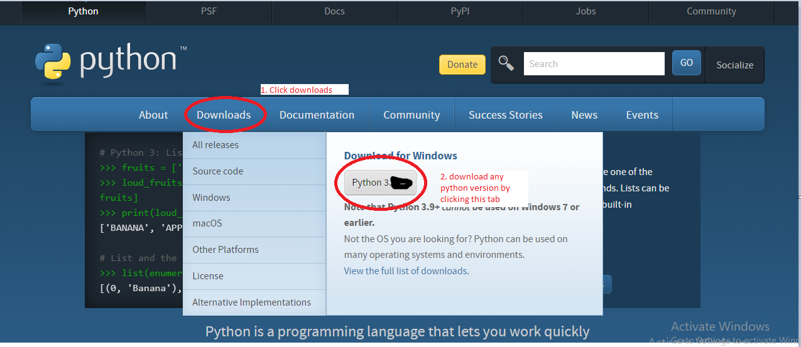
- Go to downloads folder and install the .exe file downloaded in previous step.
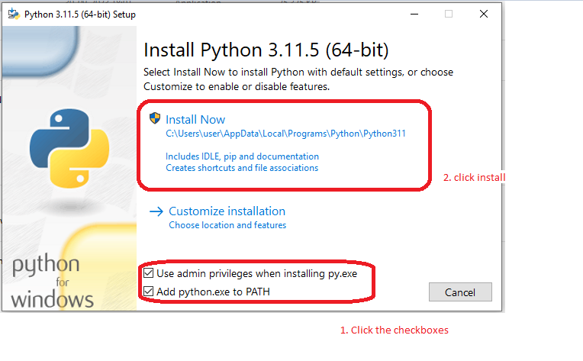
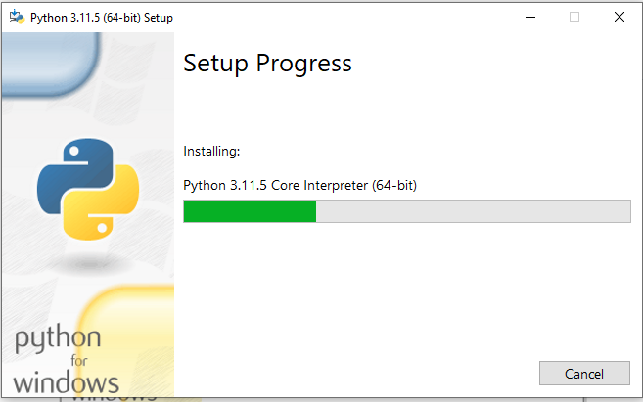
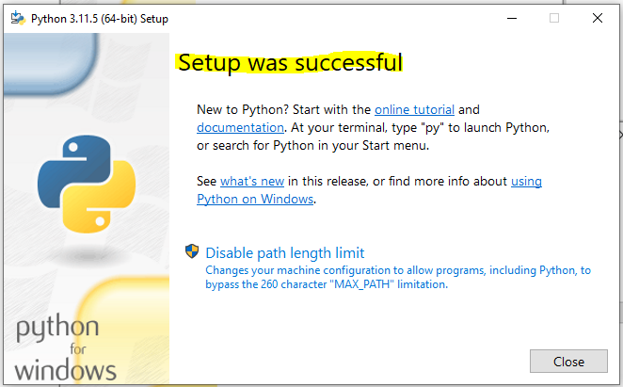
Close it
- To see python version
- Go to command prompt and type python as below.
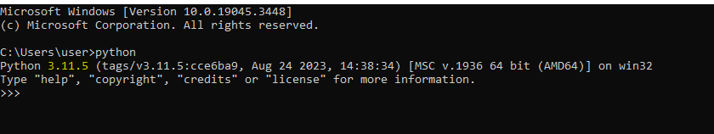

Pycharm Installation
- Download the pycharm community version in the below command.
https://www.jetbrains.com/pycharm/download/?section=windows

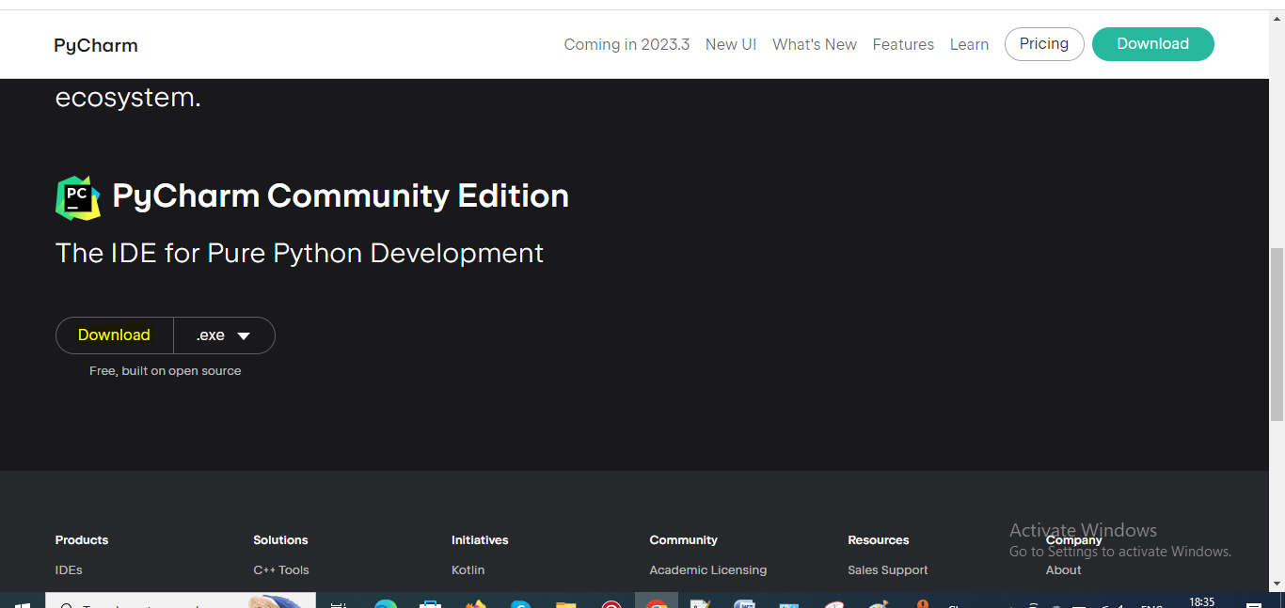
- Go to download folder and click .exe file.
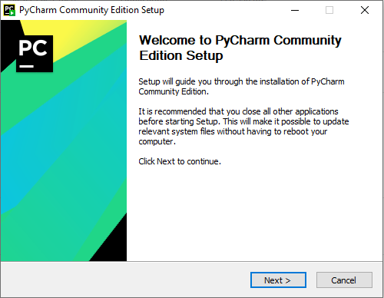
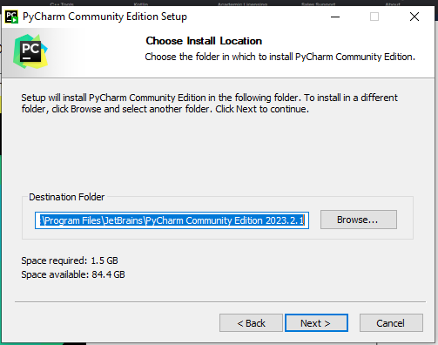
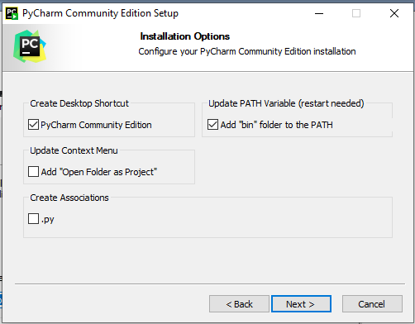
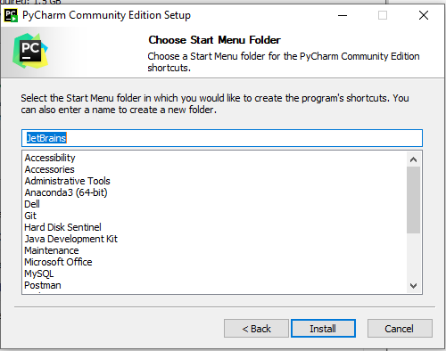
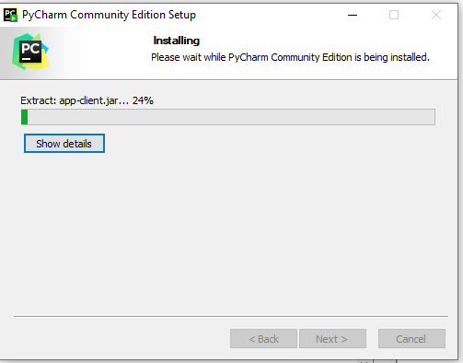
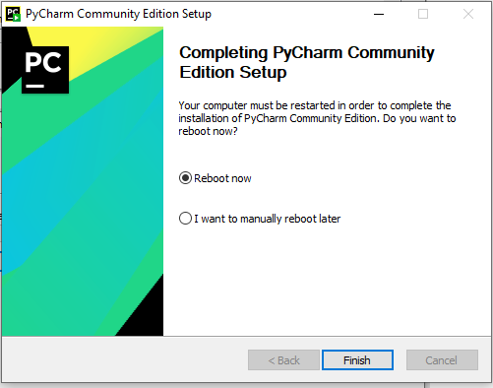
- Click finish system start to reboot If you want to reboot later click 2nd option.
- Open pycharm and setup your project folder.
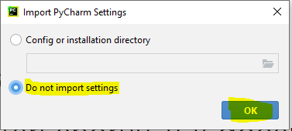

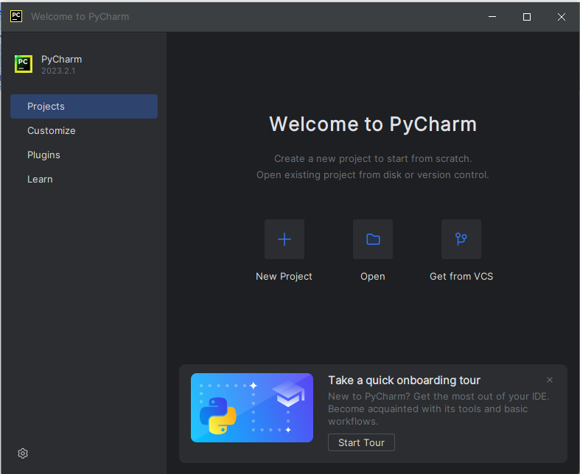
Click on new project
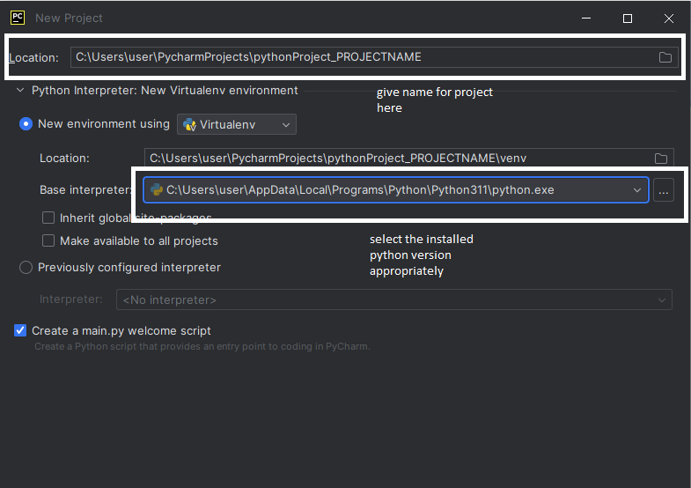
Click on create
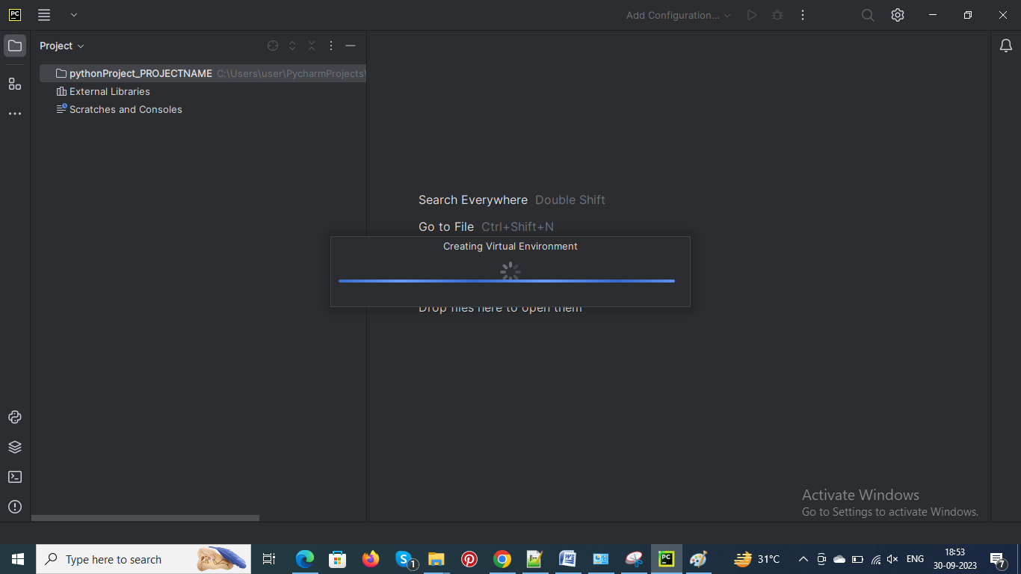
Once the virtual environment is created. Pycharm is ready for coding…

~ Happy Coding

