User Input
- Function used to get user input from console.
- Default data type of user input is string.
a=input()# 10
print(type(a))# <class 'str'> (default datatype)
print(a)# 10

a=input(“type any text”)# type any text10
print(type(a))# <class 'str'> (default datatype)
print(a)# 10

Note: if no message is passed in the input() function the console will not print any prompt
Get user input from user and add two numbers
num1=input("enter number1") # enter number110
num2=input("enter number2") # enter number220
print(type(num1)) # <class 'str'>
print(type(num2)) #<class 'str'>
print(num1+num2) # 1020- num1 and num2 are strings both will get concatenated
To add num1 and num2 convert the string type to integer type
# approach 1
num1=int(input("enter number1"))# enter number110
num2=int(input("enter number2"))# enter number220
print(num1+num2) # 30
# approach 2
num1=input("enter number1")# enter number110
num2=input("enter number2")# enter number220

print(int(num1)+int(num2)) # 30

Python Control statements
Normally programming statements are executed in line by line in python interpreter. To change flow of execution control statements are used.

- Conditional statements
  - Set of statements executed based on conditions
- Looping statements
  - Set of statements repeated based on conditions
- Jumping statements
  - Statement used to skip or exit from loops
- Note: indentation is used to define blocks of code. control statements are valid only with right indentation

Conditional statement
- if...
- if..else
- if..elif..else

if..
example1:
print("statement1")
print("statement2")
print("statement3")
print("statement4")
if False:
print("statement5")# these set of statements executed only
print("statement5")# when the condition is true
print("statement5") #
print("statement5")#
print("statement6")
print("statement7")
print("statement8")
print("statement9")
print("statement10")

example2:
n=2000
print(n%4==0)# True
if n%4==0:
print("leap year") # 2000 is leap year

if..else
example1:
n=2000
print(n%4==0)# True
if n%4==0:
print("leap year") # 2000 is leap year
else:
print("Not Leap year")

example2:
age=12
if age>=18:
print("eligible for Vote")
print("hello")
else:
print("not eligible for vote")# 12 is not eligible
print("hello")

example3: (single line approach)
age=25
print("eligible for Vote" if age>=18 else "not eligible for vote")
# if block contains more than one line of statements
{print("eligible for Vote"), print("hello")} if age>=18 else {print("not eligible for vote"), print("hello")}
if..elif..else(for multiple conditions)
n=7
if n==1:
print("Sunday")
elif n==2:
print("Monday")
elif n==3:
print("Tuesday")
elif n==4:
print("wednesday")
elif n==5:
print("thusday")
elif n==6:
print("Friday")
elif n==7:
print("Saturday")
else:
print("invalid input")

Looping statements
- while
- for loop

while loop
  - initialization
  - condition
  - increment
Print 1 to 10 numbers in ascending order
a=1 # init
while a<=10: # cond
print(a)
#a=a+1 # incre
#(or)
a+=1
Print 1 to 10 numbers in descending order
a=10 # init
while a>=1: # cond
print(a)
#a=a-1 # decr
#(or)
a-=1

range()[start:stop:step/increment/decrement]
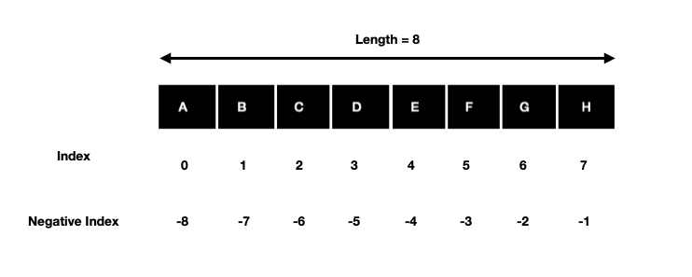

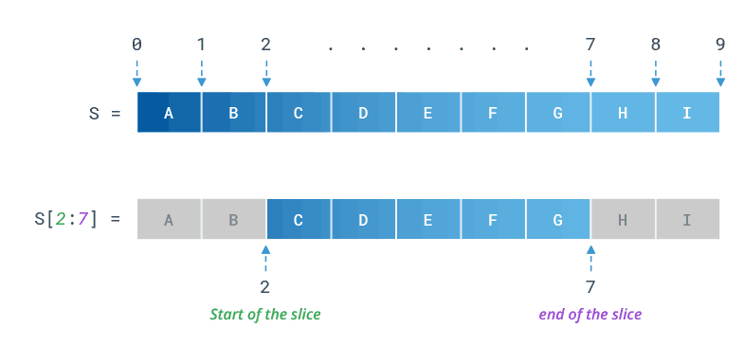 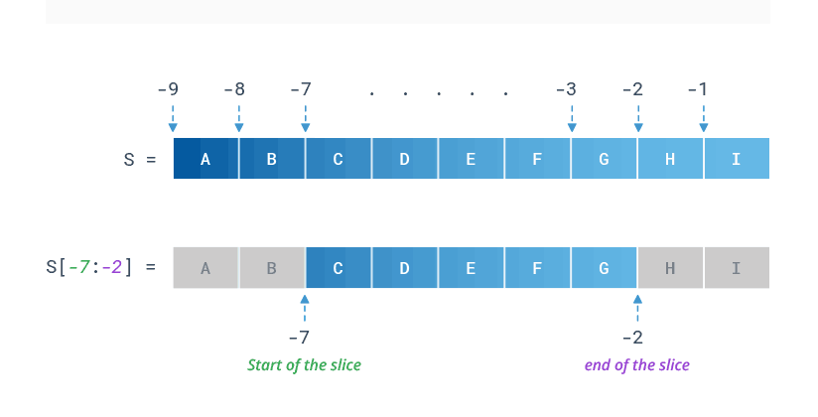 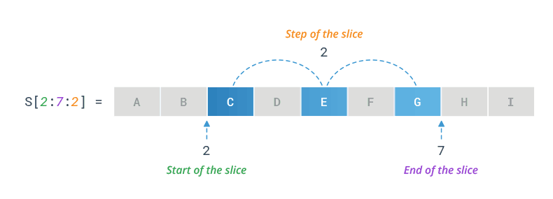
#print 1 to 10
#range(n) = range(start=0, ends=n-1, step/increment=1)
print(list(range(11))) # equal to range(0,11,1)# [0, 1, 2, 3, 4, 5, 6, 7, 8, 9, 10]
print(list(range(0,11,2)))# [0, 2, 4, 6, 8, 10]
print(list(range(2,11,2)))# [2, 4, 6, 8, 10]

For loop
Print 1 to 10 numbers in ascending order
for var in range(1,11):# 0,1,2,..9
print(var)
#
Print 1 to 10 numbers in descending order
for var in range(10,0,-1):# 10,9,8,..1
print(var)

Jumping statements
- continue – skip the loop
- break – exit the loop
Example1
a=1
while a<=10: # cond
print(a)
#a=a+1 # incre
if a==5:
break
a+=1
Example2
a=0
while a<=9: # cond
#a=a+1 # incre
a += 1
if a==5:
continue
print(a)
Example3
# skip number divisible by 3
for var in range(1,11):# 1,2,..10
if var%3==0:
continue
print(var)
Example4
#skip number divisible by 5
for var in range(1, 11): # 1,2,..10
print(var)
if var % 5 == 0:
break
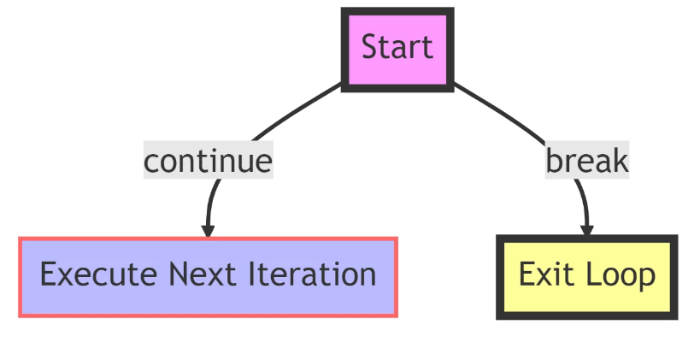

https://pynative.com/python-basic-exercise-for-beginners/
https://pynative.com/python-input-and-output-exercise/
https://pynative.com/python-if-else-and-for-loop-exercise-with-solutions/

