Python Exception handling
Error in Python can be of two types i.e. Syntax errors and Exceptions.

SyntaxError: This exception is raised when the interpreter encounters a syntax error in the code, such as a misspelled keyword, a missing colon, or an unbalanced parenthesis.
TypeError: This exception is raised when an operation or function is applied to an object of the wrong type, such as adding a string to an integer.
NameError: This exception is raised when a variable or function name is not found in the current scope.
IndexError: This exception is raised when an index is out of range for a list, tuple, or other sequence types.
KeyError: This exception is raised when a key is not found in a dictionary.
ValueError: This exception is raised when a function or method is called with an invalid argument or input, such as trying to convert a string to an integer when the string does not represent a valid integer.
AttributeError: This exception is raised when an attribute or method is not found on an object, such as trying to access a non-existent attribute of a class instance.
IOError: This exception is raised when an I/O operation, such as reading or writing a file, fails due to an input/output error.
ZeroDivisionError: This exception is raised when an attempt is made to divide a number by zero.
ImportError: This exception is raised when an import statement fails to find or load a module.

These are just a few examples of the many types of exceptions that can occur in Python. It’s important to handle exceptions properly in your code using try-except blocks or other error-handling techniques, in order to gracefully handle errors and prevent the program from crashing.

Difference between Syntax Error and Exceptions
Syntax Error: As the name suggests this error is caused by the wrong syntax in the code. It leads to the termination of the program.
Exceptions: Exceptions are raised when the program is syntactically correct, but the code results in an error. This error does not stop the execution of the program; however, it changes the normal flow of the program.

Try and Except Statement – Catching Exceptions

Try and except statements are used to catch and handle exceptions in Python.

a = [1, 2, 3]
try:
print ("Second element = %d" %(a[1]))

print ("Fourth element = %d" %(a[3]))

except:
print ("An error occurred")

Output:
Second element = 2
An error occurred

Catch exception with message

try:
print(1/0)
except Exception as var:
print("error captured")
print(var)

Output:
error captured
division by zero

capture specific exception
try:
#a=10
print(a) # NameError
#print("10" + 10) # TypeError
#print(1/0) # ZeroDivisionError
except ZeroDivisionError as var:
print("ZeroDivisionError handled")
print(var)
except TypeError as var:
print("TypeError handled")
print(var)
except NameError as var:
print("NameError handled")
print(var)

Optional blocks
- Else block
- Finally block

try:
#a=10
print(a)
except Exception as var:
print("Exception block", var)
else:# exception not occured
print("exception not happen proceeding further")
finally:
print("final block proceeding further")

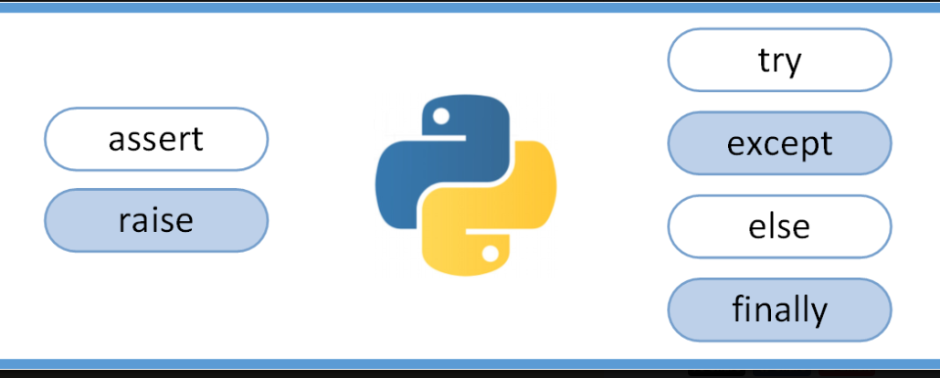

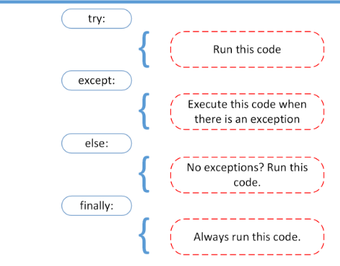

User induced exceptions
- Raise
- Assert
Raise- Always go with if condition
raise TypeError("error has been raised")
raise Exception("error has been raised")
raise AttributeError("error has been raised")

Assert – exception based in condition

assert n>0 and n<110#, ("invalid age")

