**Jenkins**

**2 ways to download**

<https://www.jenkins.io/download/>

Download exe for long time use --> click on windows--> .exe file is downloaded install that

Or

Download .war -->java -jar jenkins.war--> for temporary usgae (it need java installed in the system already)

For java installation steps refer <https://www.javatpoint.com/javafx-how-to-install-java>

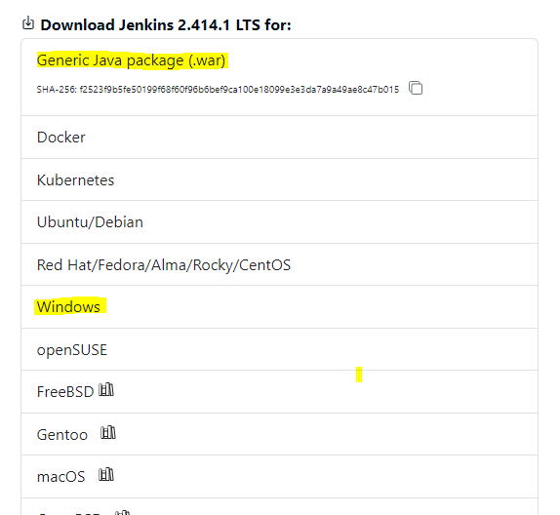

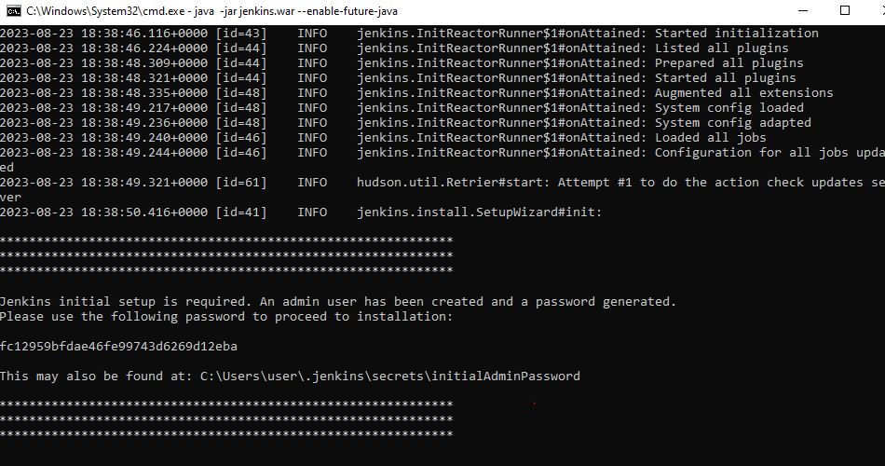

java -jar jenkins.war --enable-future-java

Or

java -jar jenkins.war

1. Open jenkins in browser using url <http://localhost:8080/login?from=%2F>

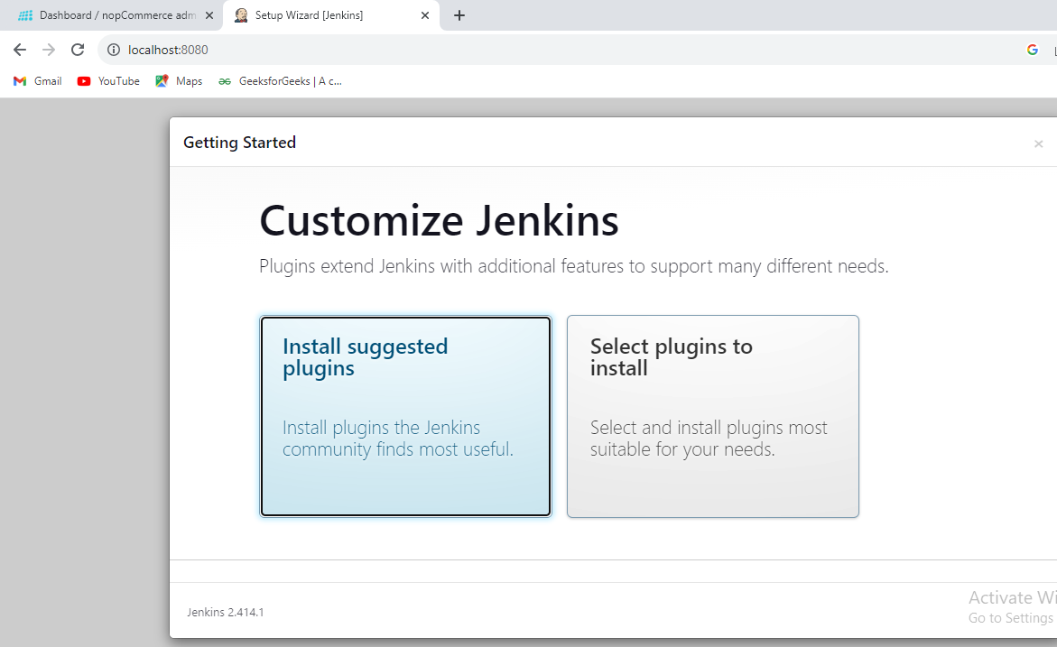

**Run test using Jenkins**

**To start Jenkins**

* Open command prompt
* Run below command

java -jar jenkins.war --enable-future-java

* Open jenkins in browser using url <http://localhost:8080/login?from=%2F>

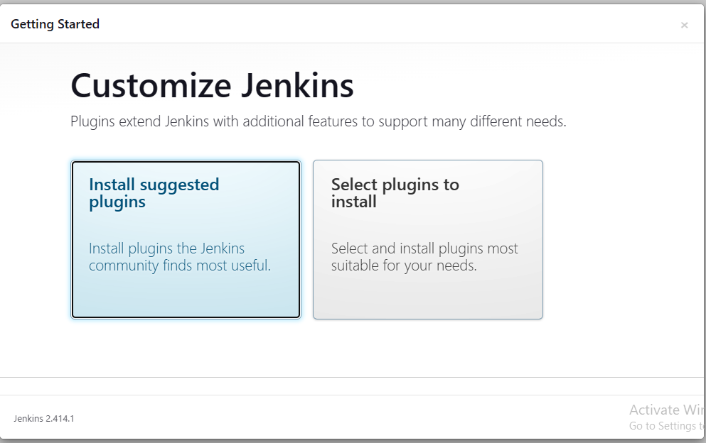

Select install suggested plugin

Create username and password

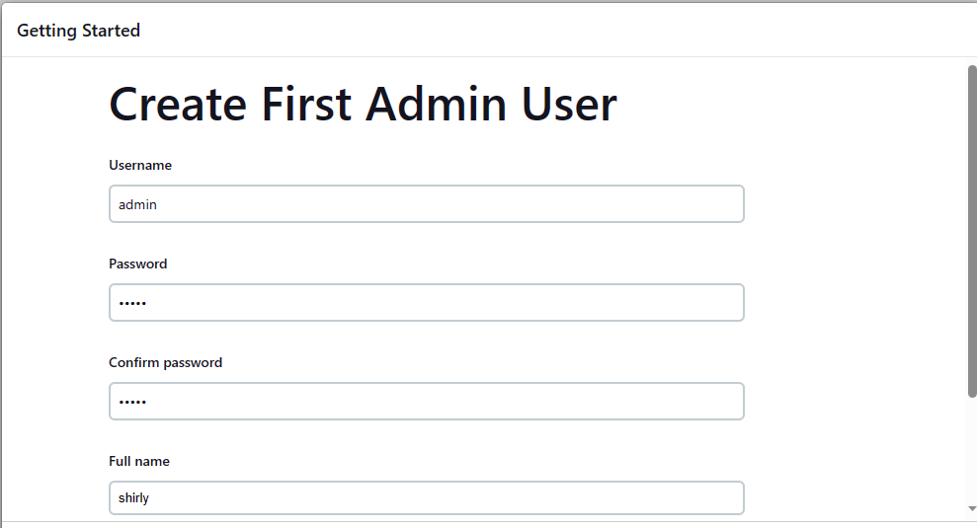 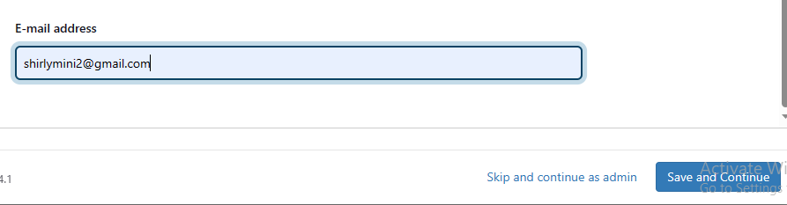

Select save and continue

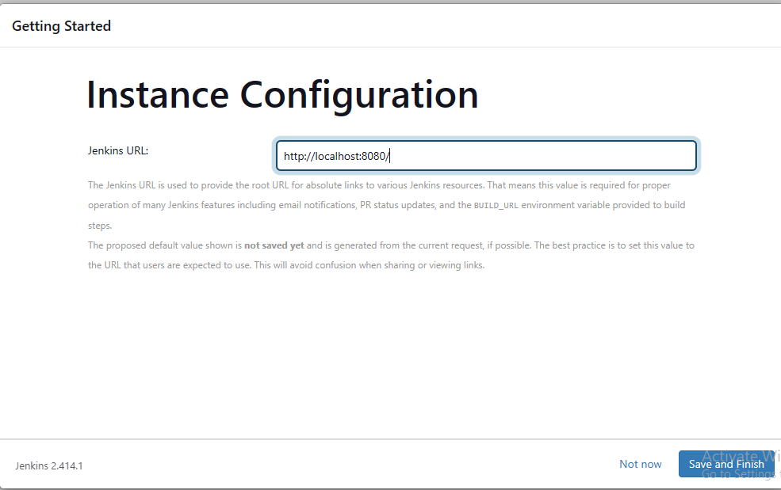

Click save and finish

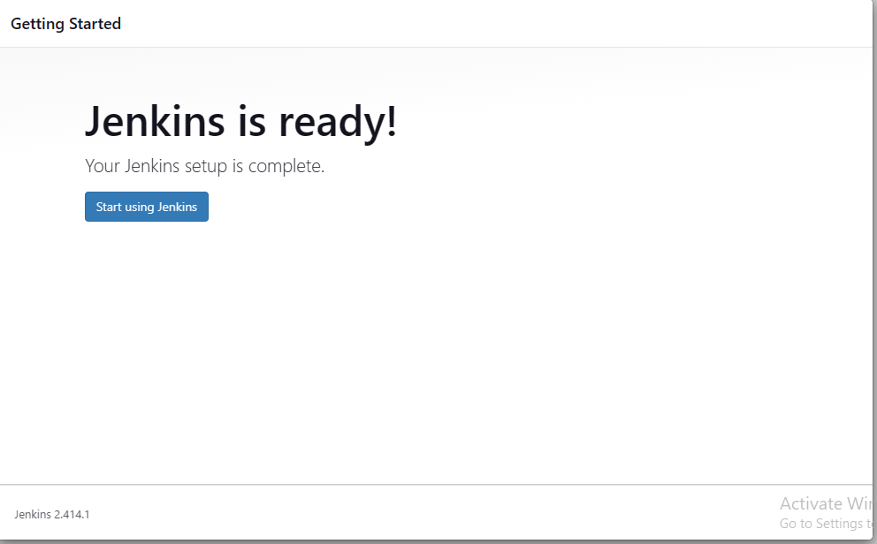

Click start using Jenkins button it will navigate to Jenkins dashboard

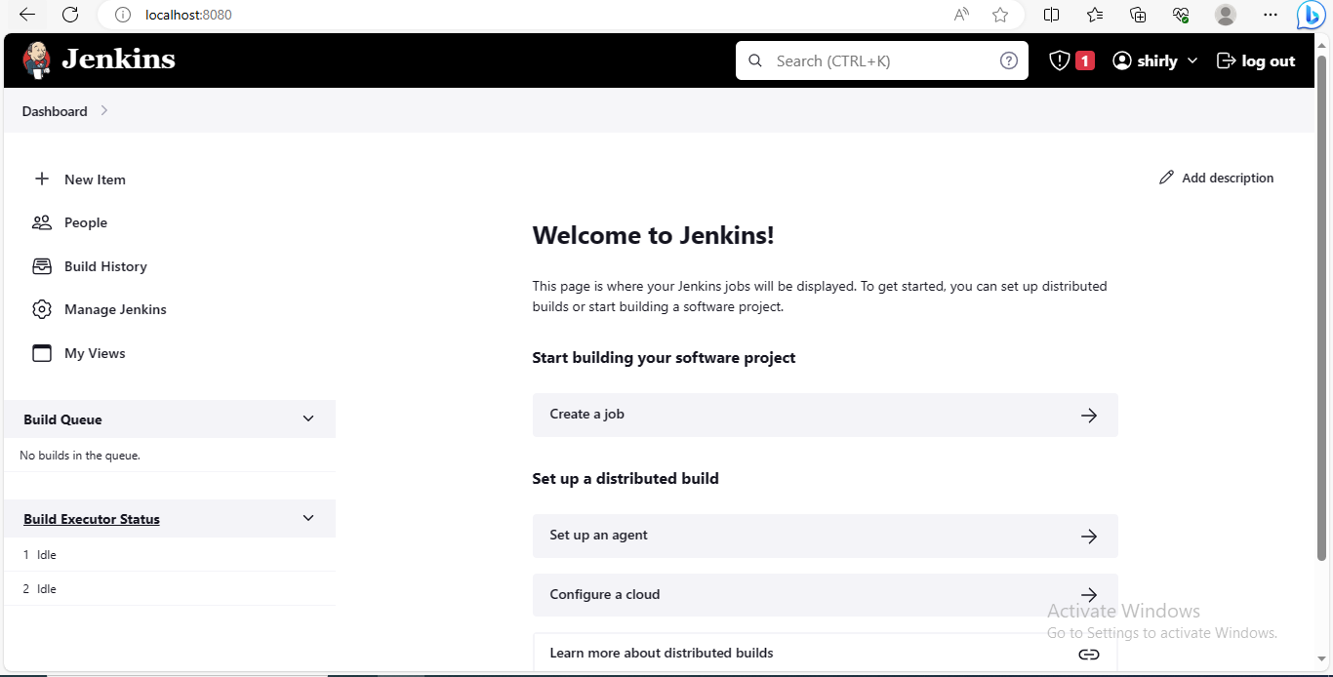

Successfully lauched the Jenkins dashboard

**Jenkins configurations**

1. **Make sure all the required packages are installed in your local machine**

Selenium

Pytest

Openpyxl

Etc…

1. **Jenkins-> manage Jenkins->go to tools->under git installations-> provide the git.exe path[full path]-> apply->save**

**Ex:** C:\Program Files\Git\bin\git.exe

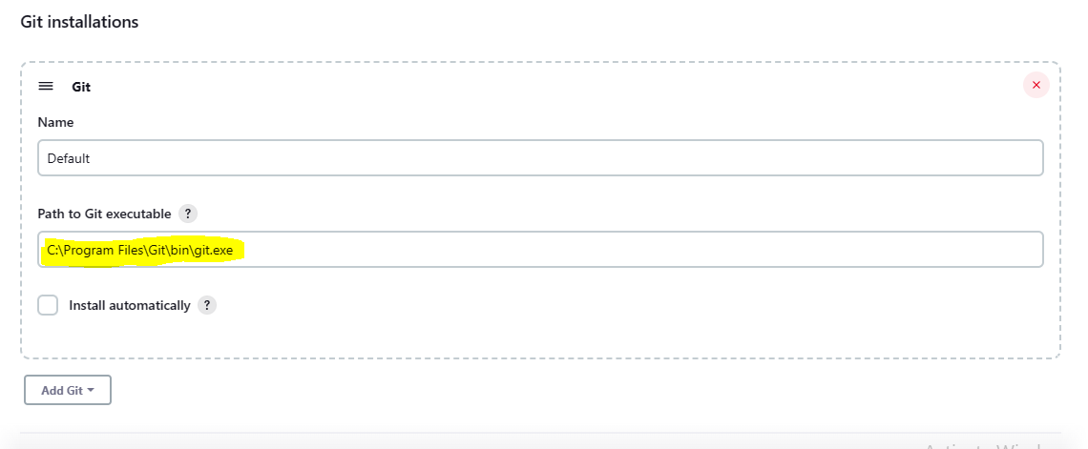

1. Go to Dashboard-> click “+ New Item”->enter the project name->select freestyle project->click ok

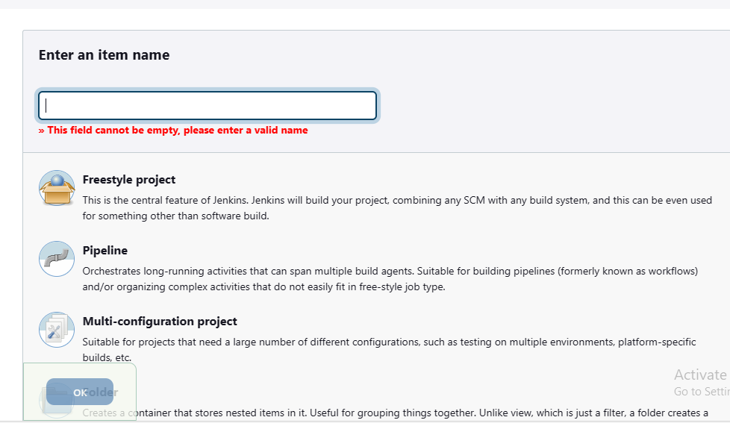

It will navigate to project configuration page

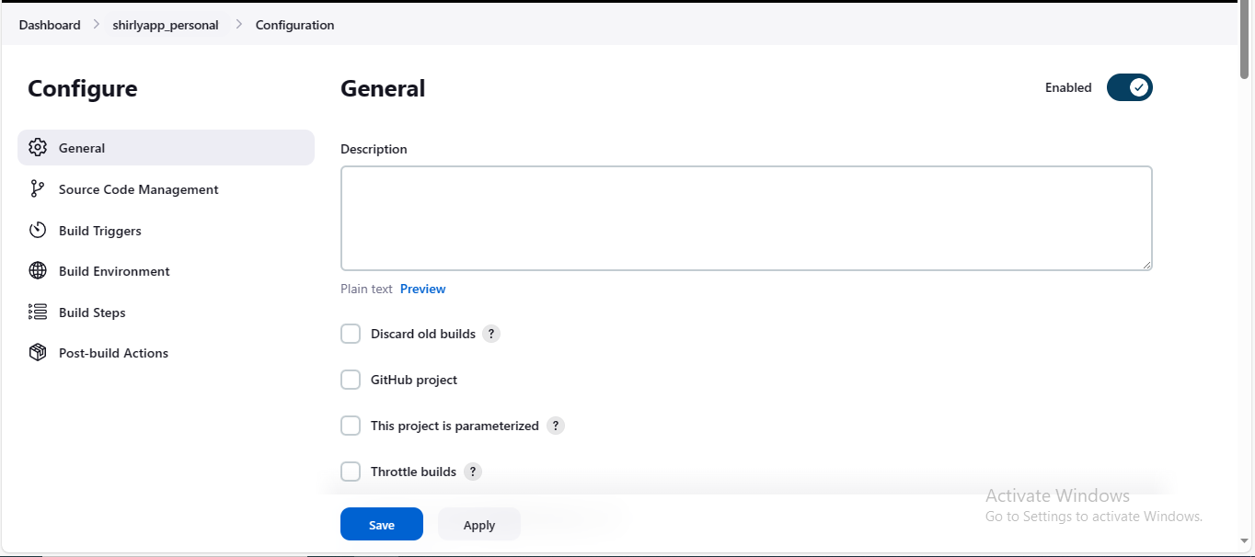

1. Go to source code management and select GIT. Give the repository URL

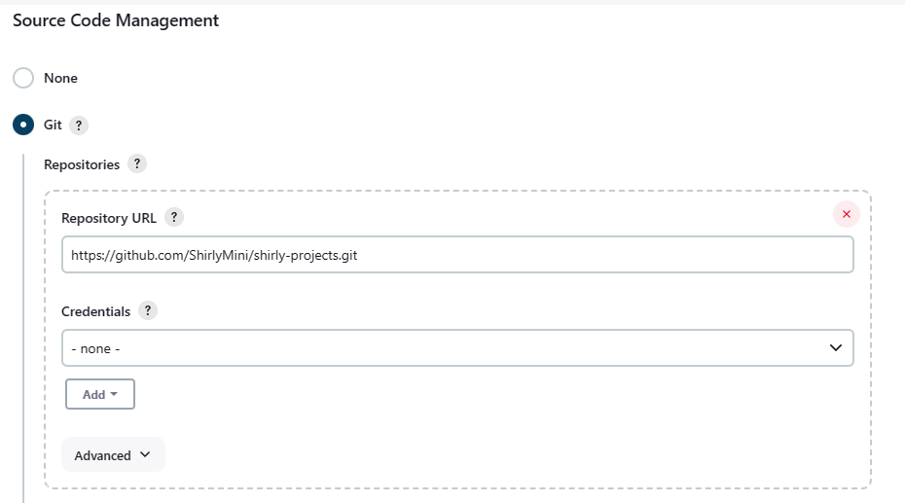

1. Go to build step-> select windows batch script-> give the commands in input tab

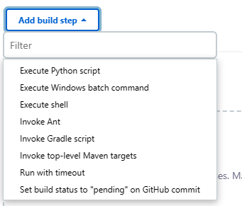

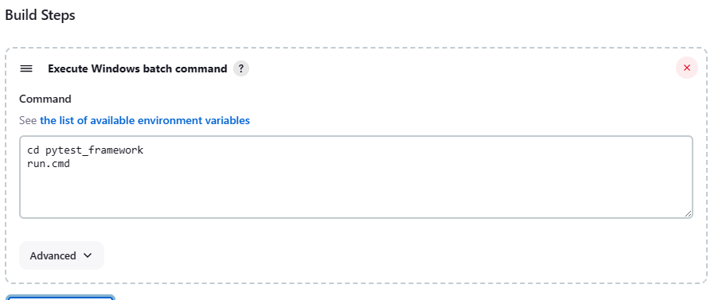

1. Click apply and save
2. Click build now option

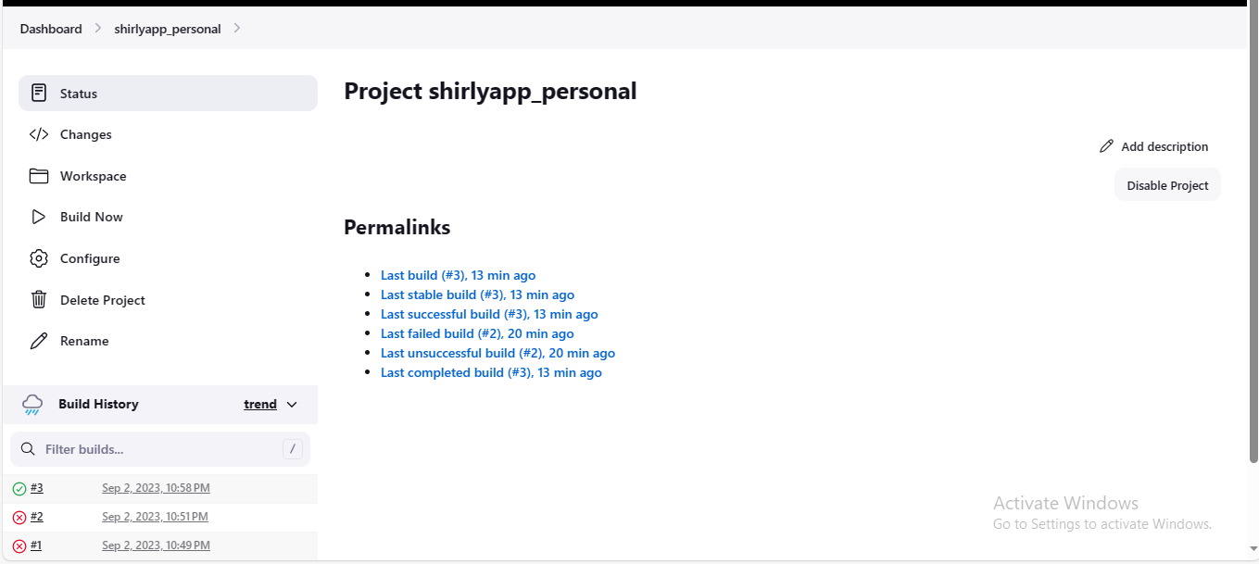

Build will start execution if the build is passed it will be indicated in green colour