**GITHUB - source management tool**

**Developer:**

Develops code for software ---> create webpage---> checkin to github

**Tester:**

Automation code----> framework--->checkin to github

**Devops:**

Get the build and automation code in jenkins and run the test cases

Git software(local repo) -> Github (global repo) -> Jenkins

**Git software(local repo) -> Github (global repo) -> Jenkins**

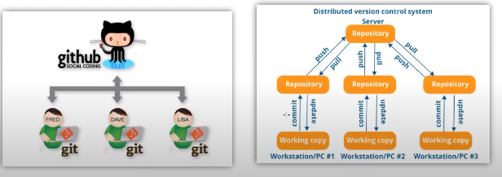

1. Github installation.

[Git - Downloading Package (git-scm.com)](https://git-scm.com/download/win)

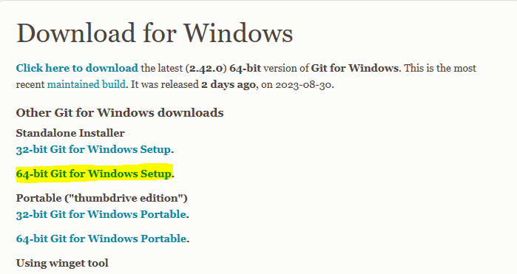

Download and run the exe file

Follow the below steps



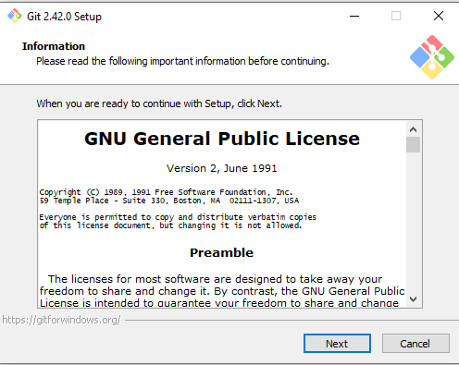

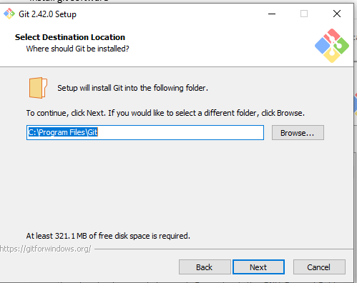

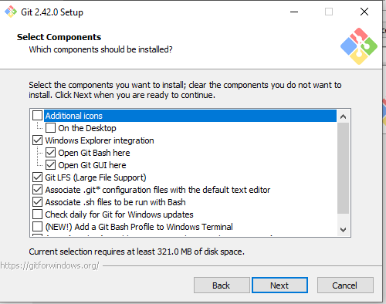

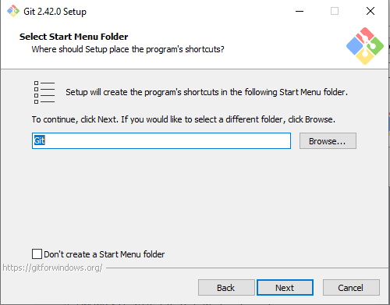

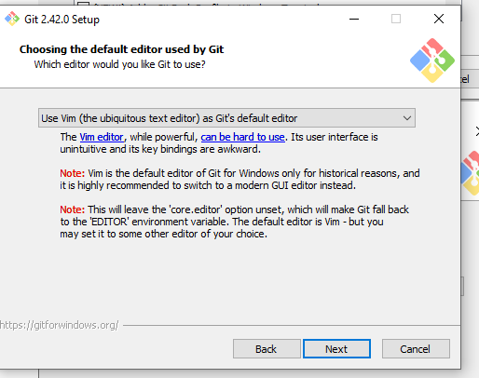 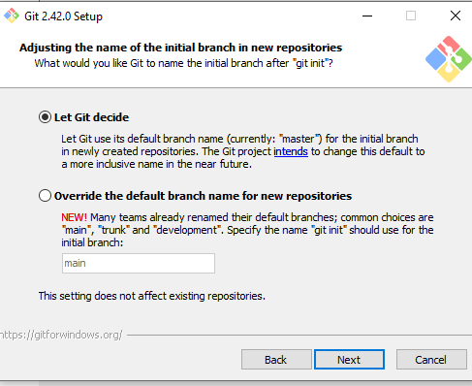 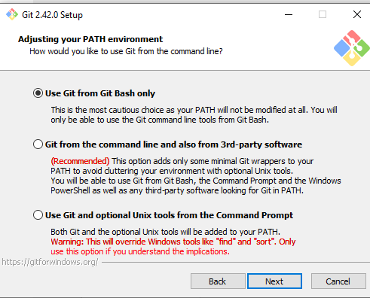 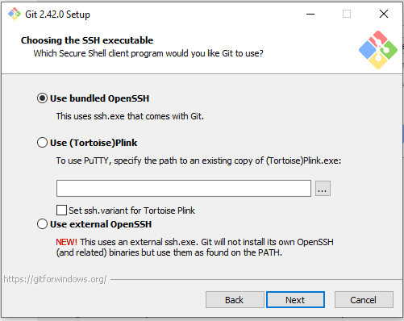 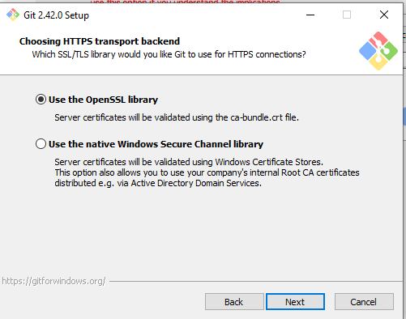 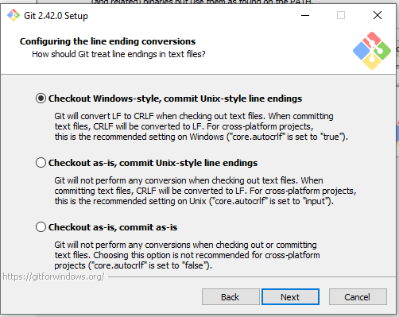 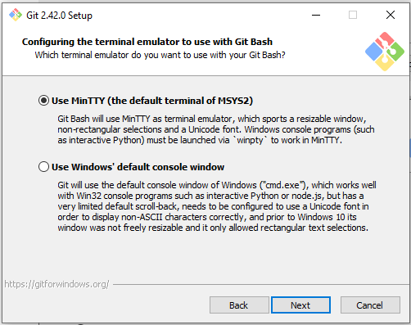 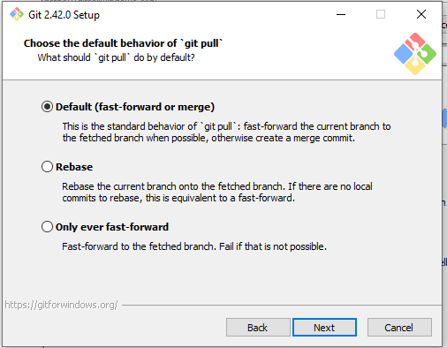 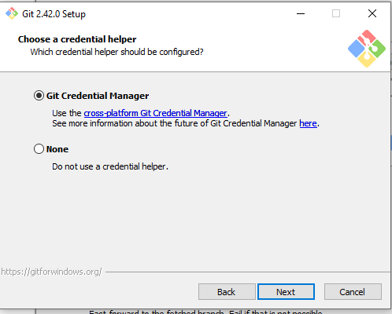 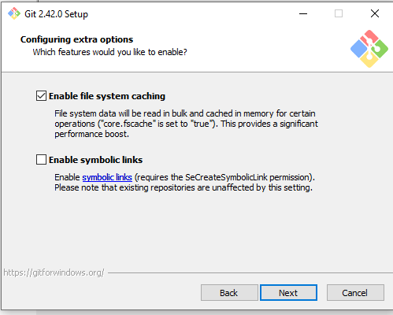 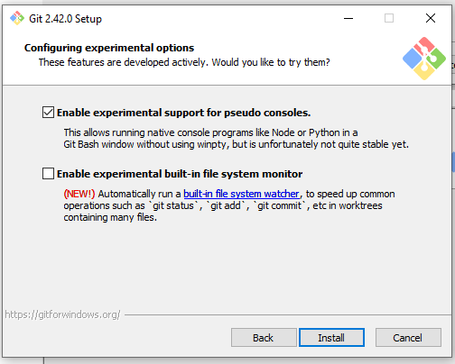 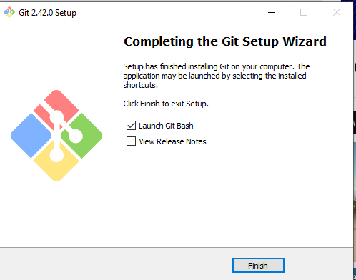

**Got to windows start search for git -> open Git bash command line**

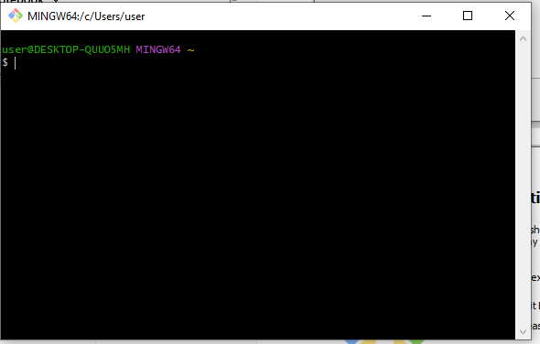

1. Go to github [GitHub](https://github.com/)

Create a free account create public account

<https://github.com/ShirlyMini/django.git>

**How to commit code in git repository**

**First time checkin**

1. Push code to git repositry. Create repo in local system
   * + Navigate to your project
     + Create local git repo by executing git init

user@DESKTOP-QUUO5MH MINGW64 ~

**$ cd "C:\Users\user\PycharmProjects\shirlyApp"**

user@DESKTOP-QUUO5MH MINGW64 ~/PycharmProjects/shirlyApp

**$ git init**

Initialized empty Git repository in C:/Users/user/PycharmProjects/shirlyApp/.git

1. Connect to github repository.
   * + Log in to github using your credentials
     + Create new repository by clicking option “public”
     + Note down the url of git repo created in git hub

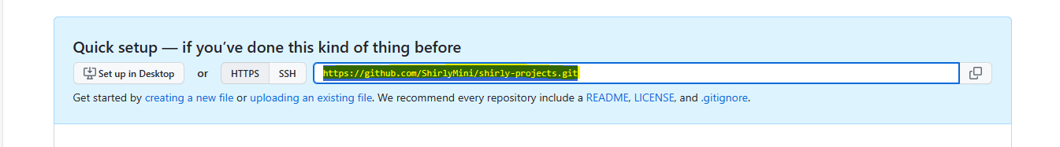

* + - Go to git bash and execute below

user@DESKTOP-QUUO5MH MINGW64 ~/PycharmProjects/shirlyApp (master)

$ **git remote add origin https://github.com/ShirlyMini/shirly-projects.git**

user@DESKTOP-QUUO5MH MINGW64 ~/PycharmProjects/shirlyApp (master)

* + - Now your local repo connected to github repo you created.

**Note**: Before doing commit first time below two commands are executed.

user@DESKTOP-QUUO5MH MINGW64 ~/PycharmProjects/shirlyApp (master)

$ git config --global user.name ShirlyMini

user@DESKTOP-QUUO5MH MINGW64 ~/PycharmProjects/shirlyApp (master)

$ git config --global user.email shirlymini2@gmail.com

* + - Local code -> staging(buffer area)-> git local commit

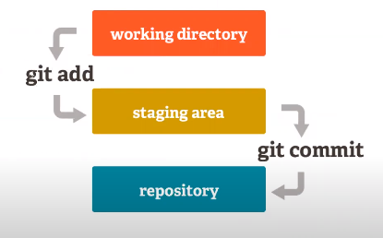

Local repo

* + - Verify status “git status”

$ git status

On branch master

No commits yet

Untracked files:

(use "git add <file>..." to include in what will be committed)

.idea/

behave_framework/

geckodriver.log

main.py

pytest_framework/

robot_framwork/

nothing added to commit but untracked files present (use "git add" to track)

* + - Git add –A will add files to staging area

$ git add -A

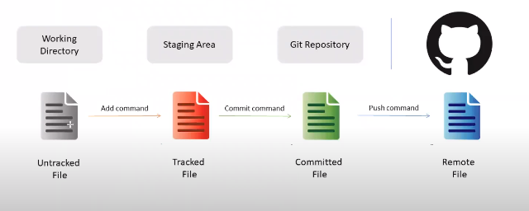

1. Commit code to git repository(local repo)

git commit -m "personal projects"

1. Push the files to github repository

Git push –u origin master

$ git push -u origin master

Enumerating objects: 89, done.

Counting objects: 100% (89/89), done.

Delta compression using up to 4 threads

Compressing objects: 100% (81/81), done.

Writing objects: 100% (89/89), 187.49 KiB | 2.88 MiB/s, done.

Total 89 (delta 12), reused 0 (delta 0), pack-reused 0

remote: Resolving deltas: 100% (12/12), done.

To https://github.com/ShirlyMini/shirly-projects.git

* [new branch] master -> master

branch 'master' set up to track 'origin/master'.

**Second time checkin**

* + - Git pull---if any changes happen in the github repo you can use git pull.

git pull

* + - Again repeat the step from git add -A you check-in your codes

git add –A

git commit –m “second time checkin”

git push –u origin master