Introduction of Django Framework
Installing django
Execute the below command in command prompt
- pip install django
- pip install --upgrade django==4.2 (For upgrading django)
Offical documentation
https://docs.djangoproject.com
setting up your first project
- create project folder – projectname execute below command.

- django-admin startproject myfirstproject
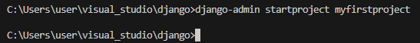
It will create all the basic project setup
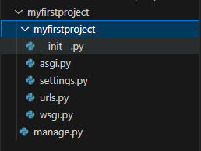
- manage.py
  - used for running server
  - running database
  - running applications

- init.py
  - it is blank python script
  - python will consider this particular folder as package
- settings.py
  - project settings and configurations, settings for installed applications, Database settings, Middleware configurations

- asgi.py
Asynchronus server gateway interface
Ex: to perform 3 different websites on single window

Cricket score2

Cricket score3

Cricket score1

- wsgi.py
  - web server gateway interface
  - this is used when deploying application in production env.
- urls.py
  - Helps in creating urls for different webpages
  - url patterns are stored in this file

***Django Project contains multiple applications

HDFC BANK [project] | Mutual funds[app]
HDFC BANK [project] | Banking [app]
HDFC BANK [project] | Insurance [app]
HDFC BANK [project] | Loan[App]

Project

App1
App3
App2
App4

Running server:
- Go to cmd prompt navigate to project folder
- Run python manage.py runserver
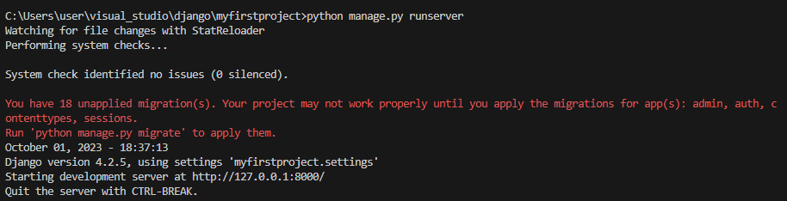
http://127.0.0.1:8000/ paste in browser and see the server page
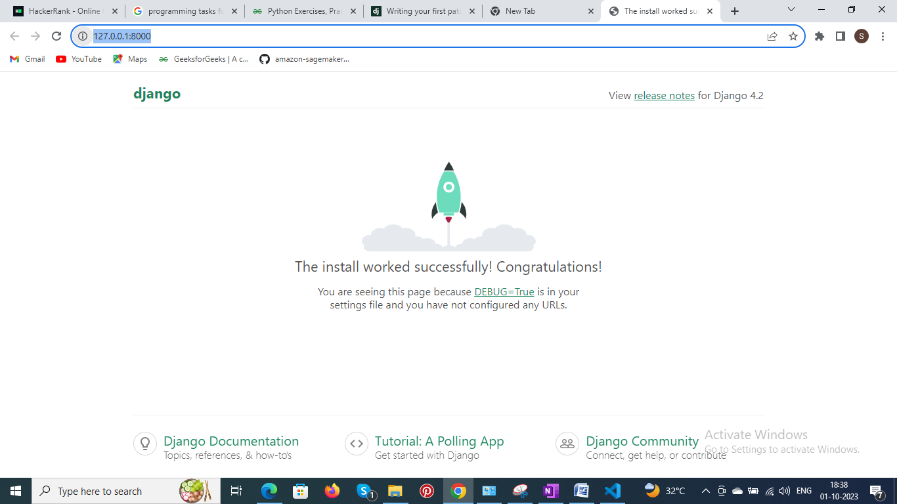
What server will do?
- Every website have its own ip address(static or dynamic).
- 127.0.0.1- localhost ip address
- 8000 port number

After running server db.sqlite file created in project folder
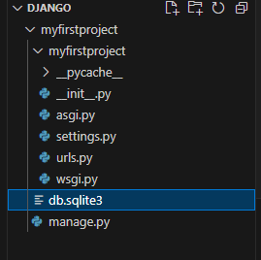
Web Server :
- Providing env to run web application.
- Server – http request – web components - http response.

First web application creation

- Execute as below
python manage.py startapp first_application
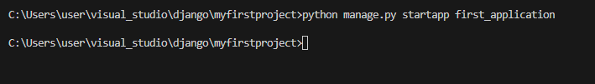
This will create application specific folder.
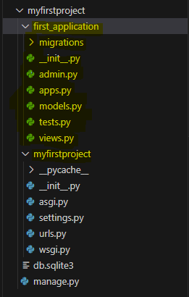
- Init.py
- admin.py
  - admin interface for django web application
- apps.py
- models.py
  - data models
- test.py
  - unit testing functions
- views.py
  - give views for all urls.
- migrations – DB specific information

go to settings.py change the below lines

INSTALLED_APPS = [
'django.contrib.admin',
'django.contrib.auth',
'django.contrib.contenttypes',
'django.contrib.sessions',
'django.contrib.messages',
'django.contrib.staticfiles',
'first_application'
]

In Views.py specify the url

- http://127.0.0.1:8000/page1 will render http response
- Give the below in views.py
from django.shortcuts import render
from django.http import HttpResponse

# Create your views here.

def page1(request):
msg="<h1>Welcome to page1</h1>"
return HttpResponse(msg)

Give the url in url.py
from django.contrib import admin
from django.urls import path
from first_application import views

urlpatterns = [
path('admin/', admin.site.urls),
path('page1/', views.page1),

]

- Request from browser
- Url.py -> views.py-> return response
Summary:
- Creation of project
- Django application
- Adding application to project - in settings
- Views.py – created httpresponse - business logic
- url.py- urlpattern
- run server

Many URLS

In Views.py create many functions
from django.shortcuts import render
from django.http import HttpResponse

# Create your views here.

def page1(request):
msg="<h1>Welcome to page1</h1>"
return HttpResponse(msg)

def page2(request):
msg="<h1>Welcome to page2</h1>"
return HttpResponse(msg)

def page3(request):
msg="<h1>Welcome to page3</h1>"
return HttpResponse(msg)

Give the url in url.py
from django.contrib import admin
from django.urls import path
from first_application import views

urlpatterns = [
path('admin/', admin.site.urls),
path('page1/', views.page1),
path('page2/', views.page2),
path('page3/', views.page3),

]
- will give you error
- change the code as below
from django.contrib import admin
from django.urls import path
from firstapp import views as v1
from secondapp import views as v2

urlpatterns = [
path('admin/', admin.site.urls),
path('page1/', v1.page1),
path('page2/', v1.page2),
path('page3/', v1.page3),
path('time/', v2.currenttime)

]

Many projects
Create second project in same application folder

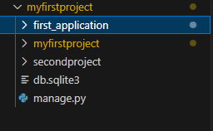

In Views.py
from django.shortcuts import render
from django.http import HttpResponse
import datetime
# Create your views here.
def currenttime(request):
msg="<h1> the time is " + str(datetime.datetime.now()) + " </h1>"
print(msg)
return HttpResponse(msg)

In settings.py
INSTALLED_APPS = [
'django.contrib.admin',
'django.contrib.auth',
'django.contrib.contenttypes',
'django.contrib.sessions',
'django.contrib.messages',
'django.contrib.staticfiles',
'firstapp',
'secondapp'
]

Give the url in url.py
from django.contrib import admin
from django.urls import path
from firstapp import views
from secondapp import views

urlpatterns = [
path('admin/', admin.site.urls),
path('page1/', views.page1),
path('page2/', views.page2),
path('page3/', views.page3),
path('time/', views.currenttime)

]
- will give you error
- change the code as below
from django.contrib import admin
from django.urls import path
from firstapp import views as v1
from secondapp import views as v2

urlpatterns = [
path('admin/', admin.site.urls),
path('page1/', v1.page1),
path('page2/', v1.page2),
path('page3/', v1.page3),
path('time/', v2.currenttime)

]

A good coding practice is to add urls.py file in every application and add the application specific url there

Add urls.py file in secondapp
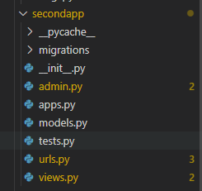

Add the app specific urls in url.py
from django.contrib import admin
from django.urls import path

urlpatterns = [
path('time/', v2.currenttime)

]

Add the following in project/urls.py
from django.contrib import admin
from django.urls import path, include
from firstapp import views as v1
# from secondapp import views as v2

urlpatterns = [
path('admin/', admin.site.urls),
path('page1/', v1.page1),
path('page2/', v1.page2),
path('page3/', v1.page3),
# path('time/', v2.currenttime)
path('secondapp/', include(“secondapp.urls”))

]

Templates and static files
It is not recommended to write html code in views.py. create template folder place all html files there.
Print(__file__) # prints the filename
Import os
Print(os.path.abspath(__file__))# absolute path of file
Print(os.path.dirname(os.path.abspath(__file__))) # gives dir name

Create template folder and create subfolder based on apps
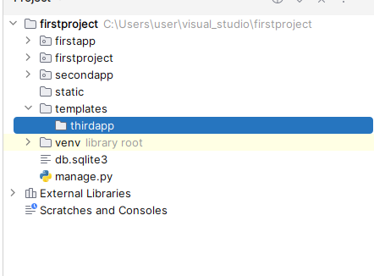
Go to settings and give the template dir[full path]
TEMPLATES = [
{
'BACKEND': 'django.template.backends.django.DjangoTemplates',
#'DIRS': ["{BASE_DIR2}/templates"],
'DIRS': [r"C:\Users\user\visual_studio\firstproject\templates"],
'APP_DIRS': True,
'OPTIONS': {
'context_processors': [
'django.template.context_processors.debug',
'django.template.context_processors.request',
'django.contrib.auth.context_processors.auth',
'django.contrib.messages.context_processors.messages',
],
},
},
]

Create a html file in template folder under application folder



<!DOCTYPE html>
<html lang="en">
<head>
<meta charset="UTF-8">
<title>page1</title>
</head>
<body style="background-color:black;">
<h1 style="color:white;">this is page1</h1>
</body>
</html>

Run the server and see the output

What is Template tags?

- Go to views and get the context from user and try to display it in html page
from datetime import datetime
from django.shortcuts import render
# Create your views here.
def display(request):
date=datetime.now()
dict1={"display_date":date, "name":"shirly"}
return render(request,"thirdapp/index1.html", context=dict1)

Note: it should be in key value pair

- In html page give the context like below
<!DOCTYPE html>
<html lang="en">
<head>
<meta charset="UTF-8">
<title>page1</title>
</head>
<body style="background-color:green;">
<h1 style="color:white;">this is page1</h1>
<h1 style="color:white;">{{display_date}} {{name}}</h1>
</body>
</html>

Static folders for CSS, images
- Create a static folder at project level
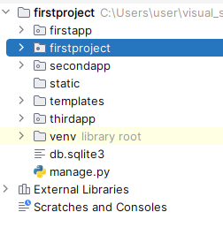
- Go to settings.py check static files path also refer the below path
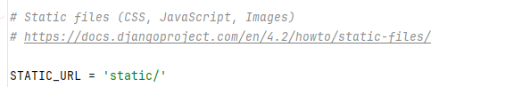
- Create STATICFILES_DIRS and give the static file path in settings.py

STATIC_URL = 'static/'
STATICFILES_DIRS = [r"C:\Users\user\visual_studio\firstproject\static"]

Check the image by giving http://127.0.0.1:8000/static/image1.jpg
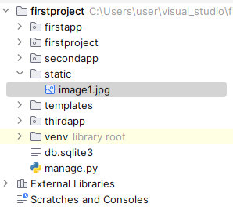
- Create static tag in html file
- {% load static %}
- <img src="{% static 'my_app/example.jpg' %}" alt="My image">

<!DOCTYPE html>
<html lang="en">
{% load static %}
<head>
<meta charset="UTF-8">
<title>page1</title>
</head>
<body style="background-color:green;">
<h1 style="color:white;">this is page1</h1>
<h1 style="color:white;">{{display_date}} {{name}}</h1>
<img src="{% static 'image1.jpg' %}" alt="My image">
</body>
</html>

Create CSS style sheet in static files

h1{
color: yellow;
}
img{
height:100px;
width:100px;
}

- change the html souce code. Add this css as style sheet
<!DOCTYPE html>
<html lang="en">
{% load static %}
<head>
<meta charset="UTF-8">
<title>page1</title>
<link rel="stylesheet" href="{% static 'thirdapp/sample.css' %}">
</head>
<body style="background-color:green;">
<h1>this is page1</h1>
<h1>{{display_date}} {{name}}</h1>
<img src="{% static 'thirdapp/image1.jpg' %}" alt="My image">
</body>
</html>

Models and data bases
- Go to settings make sure the below lines are present
DATABASES = {
'default': {
'ENGINE': 'django.db.backends.sqlite3',
'NAME': BASE_DIR / 'db.sqlite3',
}
}

Note: If you want to change the sql engine 'django.db.backends.sqlite3' to 'django.db.backends.mysql ' or 'django.db.backends.oracle’
DATABASES = {
"default": {
"ENGINE": "django.db.backends.mysql",
"NAME": "mydb1",
"USER": "root",
"PASSWORD": "root",
"HOST": "127.0.0.1",
"PORT": "5432",
}
}

- To connect sqlite db execute command Python manage.py shell
(venv) C:\Users\user\visual_studio\firstproject>python manage.py shell
Python 3.11.5 (tags/v3.11.5:cce6ba9, Aug 24 2023, 14:38:34) [MSC v.1936 64 bit (AMD64)] on win32
Type "help", "copyright", "credits" or "license" for more information.
(InteractiveConsole)
>>> from django.db import connection
>>> con = connection.cursor()
>>>

- Go models.py and create a class by importing models.Models
- Each model represent single DB table and
- Each model is a class which is a child of models.Models
- Each attribute represent DB field

Create a app and define the app in settings(here modelapp is application created)
- Give the below code in models.py
- from django.db import models
# Create your models here.
class Employee(models.Model):
empno=models.IntegerField()
empname=models.CharField(max_length=40)
empsalary=models.FloatField()
empaddress=models.CharField(max_length=300)

- go to command prompt and run the below command

python manage.py makemigration-- initialize the database connectivity

Note : this will create SQL query

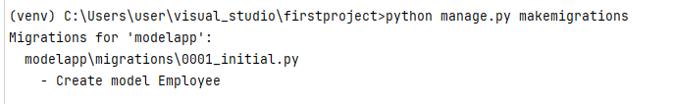
- again run the below to start the database
python manage.py migrate

Note : this will execute SQL query

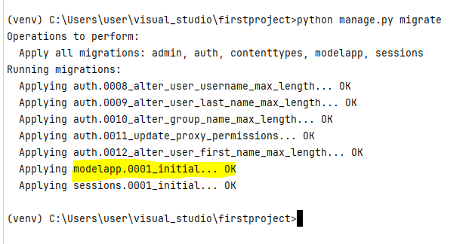
- step to check table creation
python manage.py sqlmigrate modelapp 0001
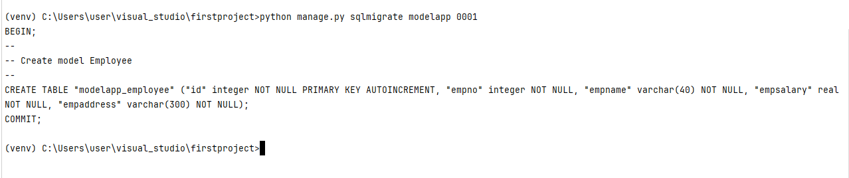

- add employee table in admin.py
from django.contrib import admin
from modelapp.models import Employee
# Register your models here.
admin.site.register(Employee)

- create admin user for your website
python manage.py createsuperuser

after creation use http://127.0.0.1:8000/admin/ to open page
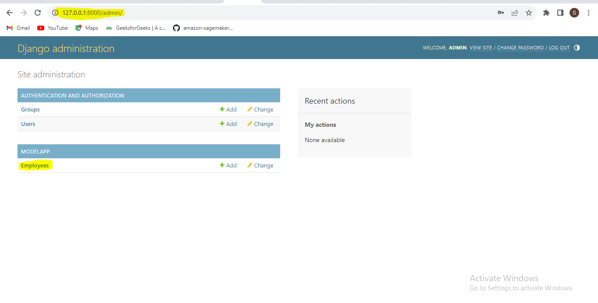

- add the return str in models.py
class Employee(models.Model):
empno=models.IntegerField()
empname=models.CharField(max_length=40)
empsalary=models.FloatField()
empaddress=models.CharField(max_length=300)
def __str__(self):
return f'Employee informations are added for {empname}'

- create a employee admin in admin.py file which will get all the emp info in list
from django.contrib import admin
from modelapp.models import Employee
# Register your models here.
class EmployeeAdmin(admin.ModelAdmin):
empinfo=["empno","empname","empsalary","empaddress"]
admin.site.register(Employee, EmployeeAdmin)

- design a html file in template folder and create views.py
- Views.py
from django.http import HttpResponse
from modelapp.models import Employee
# Create your views here.
def emp_info(request):
data=Employee.objects.all() # query set
emp_dict={'emp_list':data}
return render(request, "modelapp/index1.html", context=emp_dict)

- Html page
https://jinja.palletsprojects.com/en/3.1.x/

<!DOCTYPE html>
<html lang="en">
{% load static %}
<head>
<meta charset="UTF-8">
<title>Employee Database</title>
</head>
<body>
<table border="3">
{% if emp_list %}
{% for employee in emp_list %}
<tr>
<td>{{employee.empno}}</td>
<td>{{employee.empname}}</td>
<td>{{employee.empsalary}}</td>
<td>{{employee.empaddress}}</td>
</tr>
{% endfor %}
{% endif %}
</table>
</body>
</html>
- Add some data in database using super user

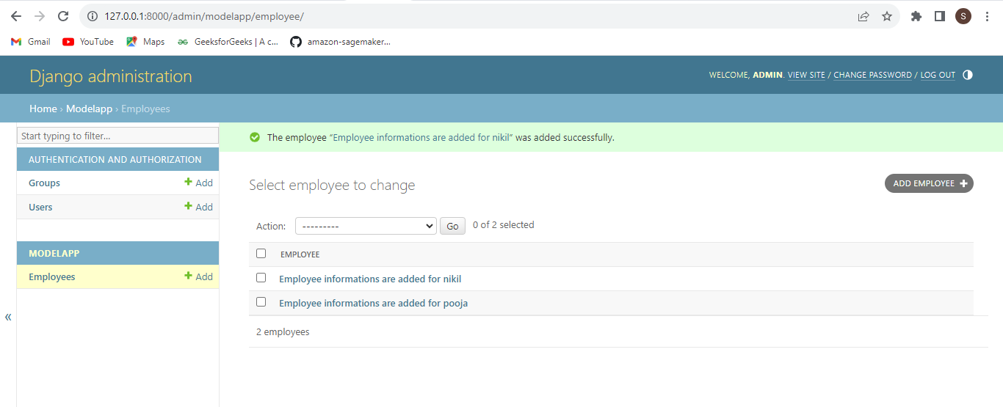

- Reload the html page to see the entries

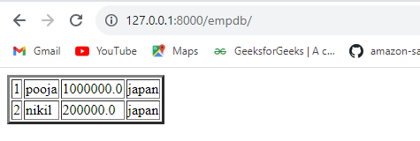

Django Forms
Create a forms.py file in application folder.
from django import forms
# Create your models here.
class EmployeeInfo(forms.Form):
name = forms.CharField()
id = forms.IntegerField()
age = forms.IntegerField()
sal = forms.FloatField()
tax = forms.BooleanField()

- Go to views.py and get the forms details
from django.shortcuts import render
from formsapp import forms
# Create your views here.
def emp_info(request):
emp_detials = forms.EmployeeInfo()
emp_dict = {'data': emp_detials}
return render(request, 'formsapp/index1.html', context=emp_dict)

- HTML file
<head>
<meta charset="UTF-8">
<title>Employee forms</title>
</head>
<body>
{{data.as_p}}
{{data.as_div}}
{{data.as_table}}
{{data.as_ul}}
</body>
</html>
What is CSRF token?
Cross site register forgery

<head>
<meta charset="UTF-8">
<title>Employee forms</title>
</head>
<body>
<form method="post">
{% csrf_token %}
{{data.as_p}}
<input type="submit" value="submit">
</form>
</body>
</html>

Django CRUD operations

- Create, Retrieve(retrive), Update and Delete
- Can be achieved with below types of views
  - Function based views
  - Class based views

To retrive the data in DB

- Create a Base HTML
<!DOCTYPE html>
<html lang="en">
<head>
<meta charset="UTF-8">
<title>base html</title>
</head>
<body>
{% block content %}
{% endblock%}
</body>
</html>
- Create index.html and extend the base html
<!DOCTYPE html>
<html lang="en">
{% extends 'modelapp/base.html' %}
<body>
{% block content %}
<table border="3">
{% if emp_list %}
{% for employee in emp_list %}
<tr>
<td>{{employee.empno}}</td>
<td>{{employee.empname}}</td>
<td>{{employee.empsalary}}</td>
<td>{{employee.empaddress}}</td>
</tr>
{% endfor %}
{% endif %}
</table>
{% endblock%}
</body>
</html>

To add the data in DB

- Step1: create employee form and give the fields
from django import forms
# Create your models here.
class EmployeeForm(forms.ModelForm):

- Give meta data-
from django import forms
from modelapp.models import Employee
# Create your models here.
class EmployeeForm(forms.ModelForm):
class Meta:
model = Employee
fields = '__all__'
#exclude = ['empno'] # to exclude any data field

- Create html file for forms

<!DOCTYPE html>
<html lang="en">
{% extends 'modelapp/base.html' %}
<body>
{% block content %}
<h1>Employee registration form</h1>
<form method="post">
{%csrf_token%}
{{form.as_p}}
<input type="submit" value="add">
</form>
{% endblock%}
</body>
</html>

- Give func in views.py
from django.shortcuts import render
from modelapp.models import Employee
from modelapp.forms import EmployeeForm
# Create your views here.
def emp_info(request):
data=Employee.objects.all() # query set
emp_dict={'emp_list':data}
return render(request, "modelapp/index.html", context=emp_dict)
def emp_reg(request):
form=EmployeeForm()
return render(request, 'modelapp/create.html', context={'form':form})

- add urls
- urlpatterns = [
path('admin/', admin.site.urls),
# path('page1/', v1.page1),
# path('page2/', v1.page2),
# path('page3/', v1.page3),
# path('time/', v2.currenttime)
path('emp_info/', views.emp_info),
path('emp_reg/', views.emp_reg)
]

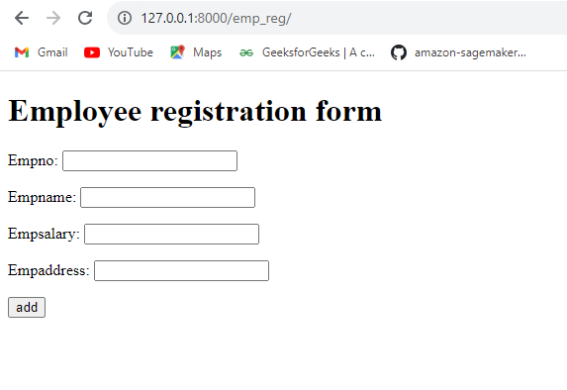

Now this add wont add the info in data base

- To add data in DB add below lines in Views.py
from django.shortcuts import render
from django.http import HttpResponse
from modelapp.models import Employee
from modelapp.forms import EmployeeForm
# Create your views here.
def emp_info(request):
data=Employee.objects.all() # query set
emp_dict={'emp_list':data}
return render(request, "modelapp/index.html", context=emp_dict)
def emp_reg(request):
form=EmployeeForm()
if request.method == 'POST':
form=EmployeeForm(request.POST)
if form.is_valid():
form.save()
return render(request, 'modelapp/create.html', context={'form':form})

- to connect between the pages add below lines

from django.shortcuts import render,redirect
from django.http import HttpResponseRedirect
from django.urls import reverse
from modelapp.models import Employee
from modelapp.forms import EmployeeForm
# Create your views here.
def emp_info(request):
data=Employee.objects.all() # query set
emp_dict={'emp_list':data}
return render(request, "modelapp/index.html", context=emp_dict)
def emp_reg(request):
form=EmployeeForm()
if request.method == 'POST':
form=EmployeeForm(request.POST)
if form.is_valid():
form.save()
return redirect('/emp_info')
return render(request, 'modelapp/create.html', context={'form':form})
#return HttpResponseRedirect(reverse('index'))

- in index page add a button which will redirect to registration form
- <!DOCTYPE html>
<html lang="en">
{% extends 'modelapp/base.html' %}
<body>
{% block content %}
<table border="3">
{% if emp_list %}
{% for employee in emp_list %}
<tr>
<td>{{employee.empno}}</td>
<td>{{employee.empname}}</td>
<td>{{employee.empsalary}}</td>
<td>{{employee.empaddress}}</td>
</tr>
{% endfor %}
{% endif %}
</table>
<a href="/emp_reg"><button type="submit">add employee</button></a>
{% endblock%}
</body>
</html>

Update and delete in html using django

- Index.html
<!DOCTYPE html>
<html lang="en">
{% extends 'modelapp/base.html' %}
<body>
{% block content %}
<table border="3">
{% if emp_list %}
{% for employee in emp_list %}
<tr>
<td>{{employee.empno}}</td>
<td>{{employee.empname}}</td>
<td>{{employee.empsalary}}</td>
<td>{{employee.empaddress}}</td>
<td><a href="#"><button type="button">Update</button></a></td>
<td><a href="#"><button type="button">Delete</button></a></td>
</tr>
{% endfor %}
{% endif %}
</table>
<a href="/emp_reg"><button type="submit">add employee</button></a>
{% endblock%}
</body>
</html>
- Views.py
- from django.shortcuts import render,redirect
from django.http import HttpResponseRedirect
from django.urls import reverse
from modelapp.models import Employee
from modelapp.forms import EmployeeForm
# Create your views here.
def emp_info(request):
data=Employee.objects.all() # query set
emp_dict={'emp_list':data}
return render(request, "modelapp/index.html", context=emp_dict)
def emp_reg(request):
form=EmployeeForm()
if request.method == 'POST':
form=EmployeeForm(request.POST)
if form.is_valid():
form.savea
return redirect('/emp_info')
return render(request, 'modelapp/create.html', context={'form':form})
#return HttpResponseRedirect(reverse('index'))
def emp_del(request, id): # primary key
data = Employee.objects.get(id=id)
data.delete()
return redirect('/emp_info')
- in Html
- <!DOCTYPE html>
<html lang="en">
{% extends 'modelapp/base.html' %}
<body>
{% block content %}
<table border="3">
{% if emp_list %}
{% for employee in emp_list %}
<tr>
<td>{{employee.empno}}</td>
<td>{{employee.empname}}</td>
<td>{{employee.empsalary}}</td>
<td>{{employee.empaddress}}</td>
<td><a href="#"><button type="button">Update</button></a></td>
<td><a href="/emp_del/{{employee.id}}"><button type="button">Delete</button></a></td>
</tr>
{% endfor %}
{% endif %}
</table>
<a href="/emp_reg"><button type="submit">add employee</button></a>
{% endblock%}
</body>
</html>

- In Urls.py

urlpatterns = [
path('admin/', admin.site.urls),
# path('page1/', v1.page1),
# path('page2/', v1.page2),
# path('page3/', v1.page3),
# path('time/', v2.currenttime)
path('emp_info/', views.emp_info),
path('emp_reg/', views.emp_reg),
path('emp_del/<id>', views.emp_del)
]

Update in django

- Create new html page
<!DOCTYPE html>
<html lang="en">
{% extends 'modelapp/base.html' %}
<body>
{% block content %}
<h1>Update Employee INFO</h1>
<form method="post">
Employee no:<input type="text" name="empno" value="{{employee.empno}}">
Employee name:<input type="text" name="empname" value="{{employee.empname}}">
Employee salary:<input type="text" name="empsalary" value="{{employee.empsalary}}">
Employee address:<input type="text" name="empaddress" value="{{employee.empaddress}}">
{%csrf_token%}
<input type="submit" value="update">
</form>
{% endblock%}
</body>
</html>

- Views.py - Id is needed for update
from django.shortcuts import render,redirect
from django.http import HttpResponseRedirect
from django.urls import reverse
from modelapp.models import Employee
from modelapp.forms import EmployeeForm
# Create your views here.
def emp_info(request):
data=Employee.objects.all() # query set
emp_dict={'emp_list':data}
return render(request, "modelapp/index.html", context=emp_dict)
def emp_reg(request):
form=EmployeeForm()
if request.method == 'POST':
form=EmployeeForm(request.POST)
if form.is_valid():
form.save()
return redirect('/emp_info')
return render(request, 'modelapp/create.html', context={'form':form})
#return HttpResponseRedirect(reverse('index'))
def emp_del(request, id): # primary key
data = Employee.objects.get(id=id)
data.delete()
return redirect('/emp_info')
def emp_update(request, id): # primary key
data = Employee.objects.get(id=id)
if request.method == 'POST':
form=EmployeeForm(request.POST, instance=data)
if form.is_valid():
form.save()
return redirect('/emp_info')
return render(request, 'modelapp/update.html', context={'employee': data})

- Index.html
<!DOCTYPE html>
<html lang="en">
{% extends 'modelapp/base.html' %}
<body>
{% block content %}
<table border="3">
{% if emp_list %}
{% for employee in emp_list %}
<tr>
<td>{{employee.empno}}</td>
<td>{{employee.empname}}</td>
<td>{{employee.empsalary}}</td>
<td>{{employee.empaddress}}</td>
<td><a href="/emp_update/{{employee.id}}"><button type="button">Update</button></a></td>
<td><a href="/emp_del/{{employee.id}}"><button type="button">Delete</button></a></td>
</tr>
{% endfor %}
{% endif %}
</table>
<a href="/emp_reg"><button type="submit">add employee</button></a>
{% endblock%}
</body>
</html>

- Url.py
urlpatterns = [
path('admin/', admin.site.urls),
# path('page1/', v1.page1),
# path('page2/', v1.page2),
# path('page3/', v1.page3),
# path('time/', v2.currenttime)
path('emp_info/', views.emp_info),
path('emp_reg/', views.emp_reg),
path('emp_del/<id>', views.emp_del),
path('emp_update/<id>', views.emp_update)
]

Class based views

Froms----- forms.Modelforms
Model---models.Model
Views----?
from django.shortcuts import render
from django.views.generic import View, TemplateView
from django.http import HttpResponse
# Create your views here.
# Froms-----◊ forms.Modelforms
# Model---◊models.Model
# Views----◊?
class Employee(View):
def get(self, request):
return HttpResponse('Hello Django')
class Employee2(TemplateView):
template_name = "classviewapp/base.html"
- urls.py
urlpatterns = [
path('admin/', admin.site.urls),
# path('page1/', v1.page1),
# path('page2/', v1.page2),
# path('page3/', v1.page3),
# path('time/', v2.currenttime)
# path('emp_info/', views.emp_info),
# path('emp_reg/', views.emp_reg),
# path('emp_del/<id>', views.emp_del),
# path('emp_update/<id>', views.emp_update)
path('check/', views.Employee.as_view()),
path('check2/', views.Employee2.as_view())
]
projects:
library
studentapp
todo

Summary:
templates - html
static folder - images, css style

1) create project - django-admin startproject <project_name>
2) create application - folder - python manage.py startapp <app_name>
3) settings.py - installed app - give application/app name
4) settings.py - templates_dir - template path and staticfiles_dir - static folder path
5)Model.py and forms.py - database - using class
6) models.py create database
7) forms.py update/add database
8) model.py--->
emp_id
emp_name
emp_sal
emp_add

BEGIN;
--
-- Create model Employee
--
CREATE TABLE "hrapp_employee" (
"id" integer NOT NULL PRIMARY KEY AUTOINCREMENT,
"emp_no" integer NOT NULL,
"emp_name" varchar(20) NOT NULL,
"emp_sal" real NOT NULL,
"emp_addr" varchar(200) NOT NULL);
COMMIT;

9) templates - base.html - index.html
create.html
home.html

{%block%} {% extend 'base.html'%}
{%endblock%}
10) crud operation
11) forms.py and post method

Django User Authentication
- Signin
- Signout
- Signup

- Create a authapp, add the app in settings, create urls in urls.py
- from django.contrib import admin
from django.urls import path
from authapp import views
urlpatterns = [
path('admin/', admin.site.urls),
path('home/', views.home),
path('login/', views.signin),
path('signup/', views.signup),
path('logout/', views.signout)
]

- in Views.py create a function

from django.shortcuts import render
from django.http import HttpResponse
# Create your views here.
def home(requests):
return render(requests, 'authapp/home.html')

- In Templates

Create a html gile for home page

<body>
<h1>Home page</h1>
<a href="/signup"><button type="submit">SignUp</button></a>
<a href="/signin"><button type="submit">SignIn</button></a>
<a href="/signout"><button type="submit">SignOut</button></a>
</body>

Create signup page
<body>
<form action="/signup/" method="post">
Username: <input type="text" name="username"><br>
First Name: <input type="text" name="firstname"><br>
Last Name: <input type="text" name="lastname"><br>
Email Address: <input type="email" name="emailaddress"><br>
Password: <input type="password" name="password"><br>
Confirm Password: <input type="password" name="con_password"><br>
{%csrf_token%}
<button type="submit">SignUp</button>
</form>
</body>

- In views.py
from django.shortcuts import render, redirect
from django.http import HttpResponse
from django.contrib.auth.models import User
from django.contrib import messages
# Create your views here.
def home(request):
return render(request, 'authapp/home.html')
def signin(request):
return HttpResponse("Hello Signin")
def signup(request):
print(request.method)
if request.method == "POST":
username=request.POST['username']
emailaddress=request.POST['emailaddress']
password=request.POST['password']
con_password=request.POST['con_password']
myuser=User.objects.create_user(username, emailaddress, con_password)
myuser.save()
messages.success(request, "User Added Successfully")
return redirect("/signin")
return render(request, 'authapp/signup.html')
def signout(request):
return HttpResponse("Hello Signout")

- check the browser once submitted page should get redirected to sign in page

- create signin.html
<body>
<form action="/signin/" method="post">
Username: <input type="text" name="username"><br>
Password: <input type="password" name="password"><br>
{%csrf_token%}
<button type="submit">SignIn</button>
</form>
</body>

- In views.py
from django.shortcuts import render, redirect
from django.http import HttpResponse
from django.contrib.auth.models import User
from django.contrib import messages
from django.contrib.auth import authenticate, login
# Create your views here.
def home(request):
return render(request, 'authapp/home.html')
def signin(request):
if request.method == "POST":
username=request.POST['username']
password=request.POST['password']
user = authenticate(username=username, password=password)
if user is not None:
login(request,user)
return render(request,'authapp/home.html', {'fname':username})
else:
messages.error(request,"Bad Credentials")
return redirect('/home')
return render(request, 'authapp/signin.html')
def signup(request):
if request.method == "POST":
username=request.POST['username']
emailaddress=request.POST['emailaddress']
password=request.POST['password']
con_password=request.POST['con_password']
myuser=User.objects.create_user(username, emailaddress, con_password)
myuser.save()
messages.success(request, "User Added Successfully")
return redirect("/signin")
return render(request, 'authapp/signup.html')
def signout(request):
return render(request, 'authapp/signout.html')

- signin.html

<body>
<h1>Home page</h1>
{% if user.is_authenticated %}
<h3> hello {{fname}}</h3>
{% endif %}

<a href="/signup"><button type="submit">SignUp</button></a>
<a href="/signin"><button type="submit">SignIn</button></a>
<a href="/signout"><button type="submit">SignOut</button></a>
</body>

- SignOut html page
<!DOCTYPE html>
<html lang="en">
<head>
<meta charset="UTF-8">
<title>signout</title>
</head>
<body>
<h1>Signed out Sucessfully</h1>
</body>
</html>

- In Views.py
def signout(request):
logout(request)
return redirect('/home')

