[DNA](https://en.wikipedia.org/wiki/DNA) is a nucleic acid present in the bodies of living things. Each piece of DNA contains a number of *genes*, some of which are beneficial and increase the DNA's *total health*. Each gene has a *health value*, and the *total health* of a DNA is the sum of the health values of all the beneficial genes that occur as a substring in the DNA. We represent genes and DNA as non-empty strings of lowercase English alphabetic letters, and the same gene may appear multiple times as a susbtring of a DNA.

Given the following:

* An array of beneficial gene strings, . Note that these gene sequences are ***not*** guaranteed to be distinct
* An array of gene health values, , where each is the health value for gene 
* A set of ***s*** DNA strands where the definition of each strand has three components, ***start*** , ***end***, and ***d***, where string ***d*** is a DNA for which genes  are healthy

Find and print the respective total healths of the ***unhealthiest*** (minimum total health) and ***healthiest*** (maximum total health) strands of DNA as two space-separated values on a single line.

**Input Format**

The first line contains an integer, ***n***, denoting the total number of genes.

The second line contains space-separated strings describing the respective values of  (i.e., the elements of ***genes***)  
The third line contains space-separated integers describing the respective values of  (i.e., the elements of ***health***)

The fourth line contains an integer, ***s***, denoting the number of strands of DNA to process

Each of the subsequent lines describes a DNA strand in the form ***start*** ***end*** ***d***, denoting that the healthy genes for DNA strand ***d*** are , and their respective correlated health values are 

**Constraints**

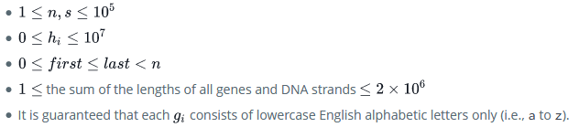

**Output Format**

Print two space-separated integers describing the respective total health of the *unhealthiest* and the *healthiest* strands of DNA.

**Sample Input 0**

6

a b c aa d b

1 2 3 4 5 6

3

1 5 caaab

0 4 xyz

2 4 bcdybc

**Sample Output 0**

0 19

**Explanation 0**

In the diagrams below, the ranges of beneficial genes for a specific DNA on the left are highlighed in *green* and individual instances of beneficial genes on the right are bolded.

The total healths of the  strands are:

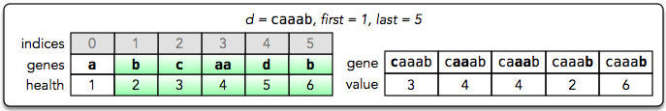

1. The total health of ‘**caaab**’ is 

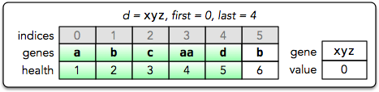

1. The total health of ‘**xyz**’ is ***0***, because it contains no beneficial genes.

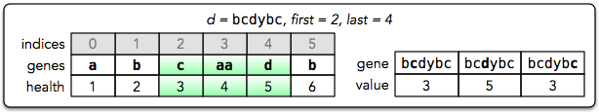

1. The total health of ‘**bcdybc**’ is 

The unhealthiest DNA strand is ‘**xyz**’ with a total health of ***0***, and the healthiest DNA strand is ‘**caaab**’ with a total health of ***19***. Thus, we print “**0 19**” as our answer.