Brief Description / Purpose
This flight booking and ticketing system is an example of a basic flight booking system. Users can reserve seats on the system for both the outbound and return flights. Every aircraft features a different configuration of seats, with sections allocated for business and economy classes. Users choose available seats for the flights they want to take to interact with the system. This code demonstrates how to reserve a seat, how to display seating maps graphically and print out the receipt. It can act as the basis for more intricate systems with more features, and capabilities for booking flights.
- Flight Initialization: The system allows for the initialization of flight data, including departure location, destination location, departure time, and seating layout. Each flight's seating layout can be customized to distinguish between business and economy class seats.
- Seat Reservation: Users interact with the system to select and book available seats for their desired flights. The system checks seat availability and updates the seating chart upon successful booking, ensuring that a seat can only be reserved once.
- Display Functions: The system includes functions to display the seating chart of each flight in a visually organized format, indicating available seats with '-', reserved seats with ‘x’, economy class seats with the color white, and business class seats with the color yellow.
Constants & Variables Constants:
Constant | Value | Data Type | Purpose
NUM_ROWS | 26 | int | Number of rows in  the flight
SEATS_PER_ROW | 6 | int | Number of seats per row in the flight
TOTAL_SEATS | 156 | int | Number of seats total in the flight
seats | int row = seat[0] - 'A'; int col = seat[1] - '1'; | vector<vector<char> > | Store and manages seat status
isValidDateFormat | true | bool | Validates the given date string conforms to be expected
isNumeric | true | bool | Determines the input contain only numeric
isValidCreditCardN umber | true | bool | Validates the input is valid 16-digit numeric
isValidSecurityCode | true | bool | Validates the input is valid 3-digit numeric
Variable:
Variable Name | Data Type | Purpose
callMainMenu | bool | Prompt Main Menu page
seatcount | int | Store how many seat user  selected
RnumTicket | int | Store total number of ticket shown on report
destination | string | Store the destination name
departure | string | Store the departure name
departDate | string | Store the departure date
returnDate | string | Store the return date
repeat | char | Repeat the program
now | auto | Store real-time
localTime | struct | Store local time
currentYear | int | Store current year
ticketprice | int | Store ticket price
User Interface & Input Handling Variable:
Variable Name | Data Type | Purpose
choicetrip | string | Allow user to choose Round Trip or One way Trip
menu | string | Allow user to choose  BookFlight or Login Admin
arrivedto | int | Store the code of the destination
departfrom | int | Store the code of the return point
cardNumber | string | Store the credit card number
expirationDate | string | Store the credit card expiration date
securityCode | string | Store the credit card security code
cardname | string | Store the credit card name
Pusername | string | Store the username of payment page
Ppassword | string | Store the password of payment page
paymentmethod | char | Store the payment method code
seatReservation | map<string,bool> | Store user selected seat
returnSeatReservation | map<string,bool> | Store user return flight reservation seat
Admin :
RTotalTicketPrice | float | Store total number of ticket price shown on report
RTotalPackagePrice | float | Store total number of package price shown on report
RTotalPrice | float | Store total price shown on report
username | string | Store admin username
password | string | Store admin password

Overall Program Design

Structure Chart
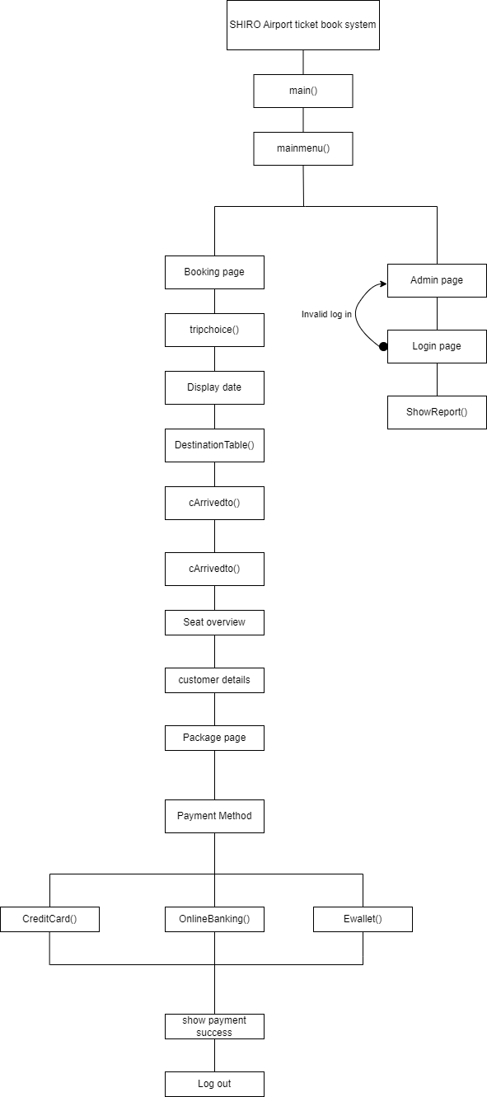
Flowchart
Main Menu:
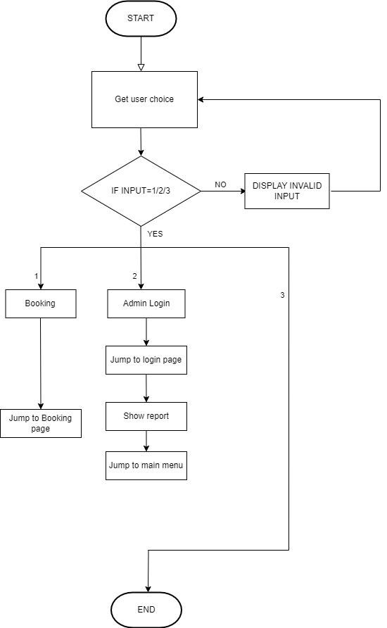
Ordering function
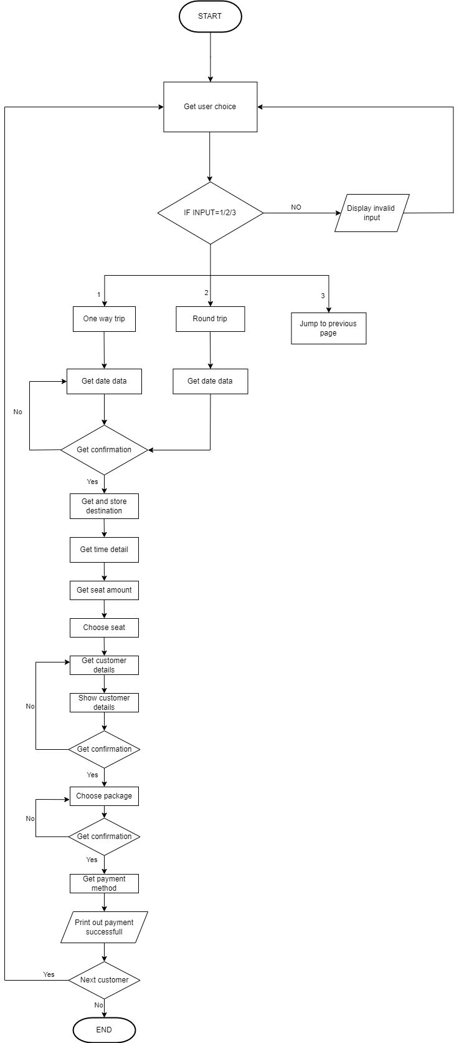
Additional functionalities
- Admin Operation :
  - Each admin provide different username and password.
  - Access admin to view for the sales report such as ticket sold,total sales,total package sales.
- Local time
  - Provide user to more intuitive to book flight when user want to select date,program will shown the local time and remind user only can brought ticket that between 1 year.
- Flight Package
  - User allow to choose any package that suitable for itself.
  - Each package provide different content and price.
- Dynamic seat layout with color
  - Seats are categorized to Business Class and Economy Class
  - When the seat is reserved,it will show ‘X’ and if it is available,it will show ‘-’.Economy class layout shown as white color and business class layout shown as yellow color.
Program Testing & Outputs
Main Menu Page
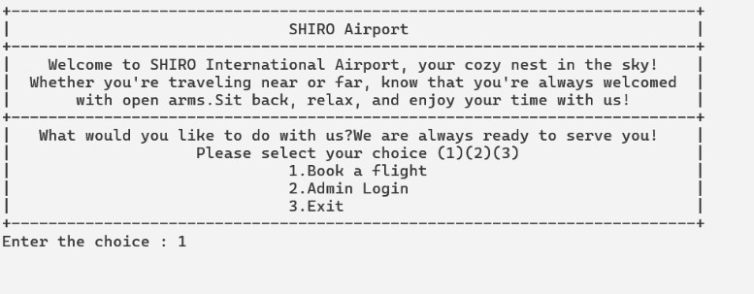
User able to insert ‘1’,‘2’ or ’3’ on this Main Menu page.
Enter 1 for Booking Flight Ticket
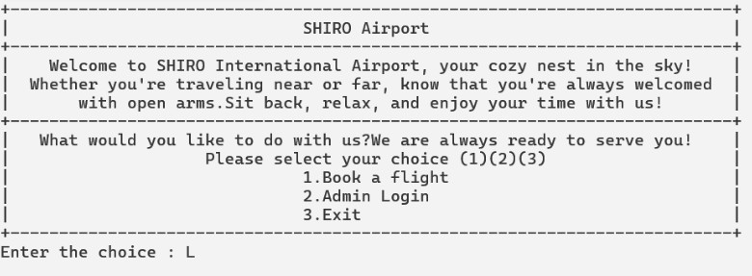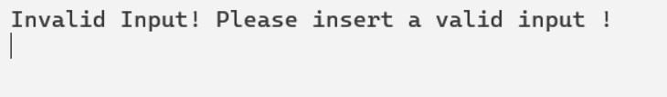
If enter invalid input,it will display error message and loop back to re-select the selection on Main Menu page.Screen would be clean and display the Main Menu page.
Choice Trip Page
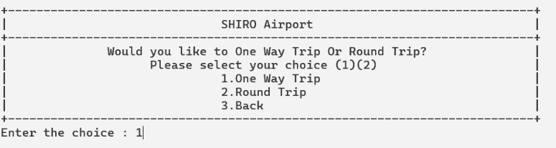
This page allows the user to select one way trip,round trip and back by input ‘1’,’2’ or ‘3’, and this is a page that let user to select the type of trip.
Enter 1 for choosing One Way Trip
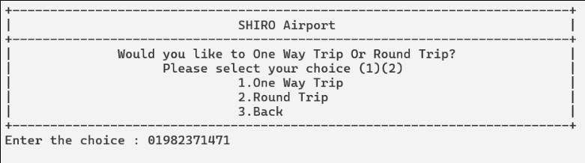
If enter invalid input,it will display error message and loop back to re-select the selection on Main Menu page.Screen would be clean and display the Main Menu page.
Departure Date Page
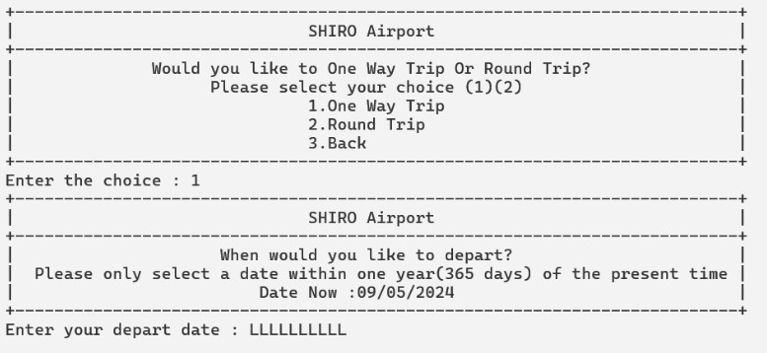
User allow to insert a date by follow the format ‘DD/MM/YYYY’ and user only able to select flight date within one year of the current date
Enter a invalid input
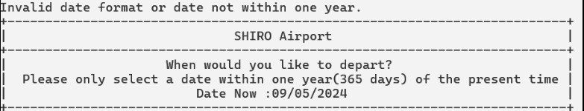
If enter invalid input,it will display error message and loop back to re-select the selection on Departure Date page.Screen would be clean and display the Departure Date page.
Date Confirm Page
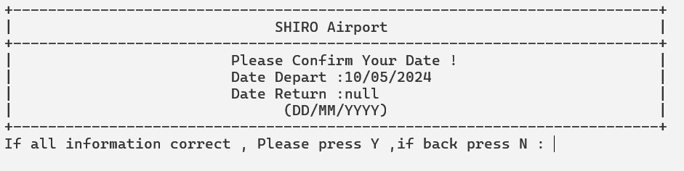
Enter ‘Y’ for proceed next page.Enter ‘N’ for re-select selection and looping back to the Departure Date Page.
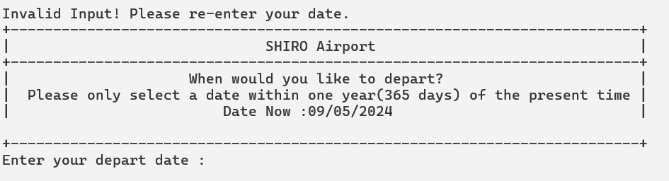
It will show error message if user enter invalid input.Program will loop back to the Depart Date Page to re-confirm the user input.
Destination Selected Page
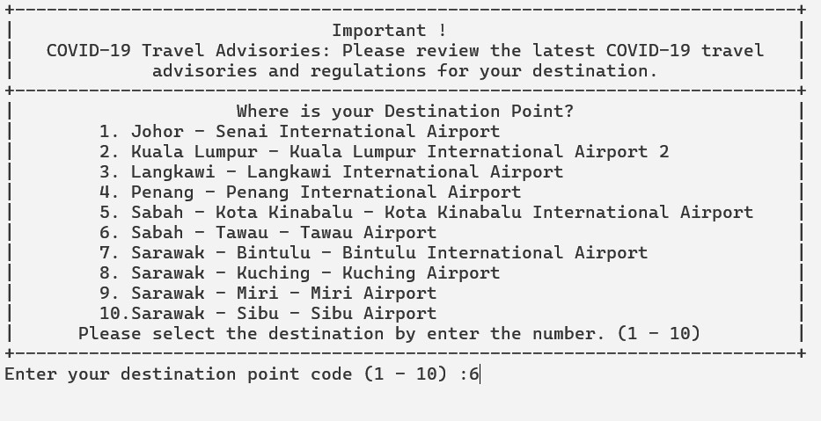
User able to choose destination with the code (1-10) .
Enter ‘6’ to select destination point as Sabah-Tawau-Tawau Airport
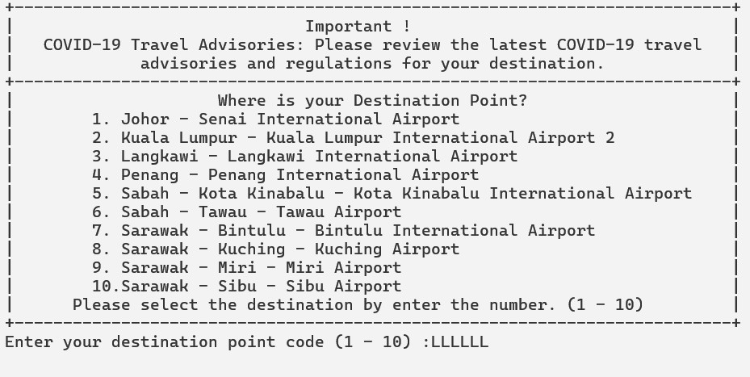
If enter invalid input,it will display error message and loop back to re-select the selection on Destination Selected Page.Screen would be clean and display the page.
Depart Time Page
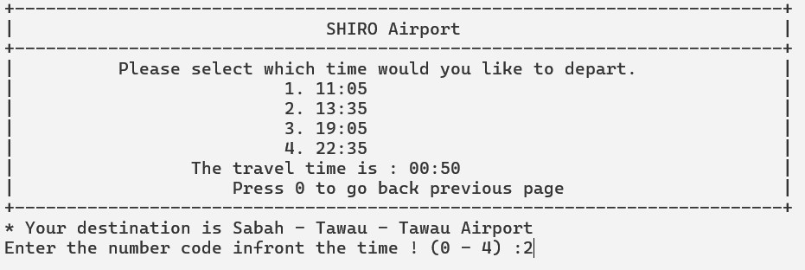
This page able user to choose on-board time.User can insert (1-4) to select time and insert 0 to loop back to choose the destination point.
Enter 2 to choose 13:35

If enter invalid input,it will display error message and loop back to re-select the selection on Destination Selected Page.Screen would be clean and display the page.
Select Seat Page
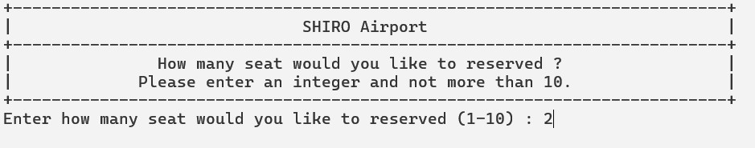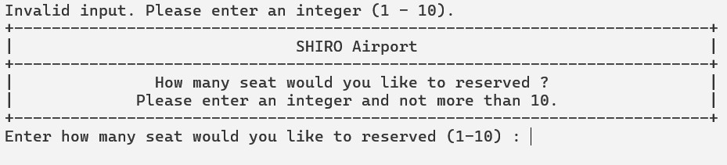
This page able user to choose how many seat would like to reserved.User are not able to enter more than 10 seat.It will show error message and loop back to the Select Seat Page.
Enter 2 for reserved 2 seat.
Seat Layout Page
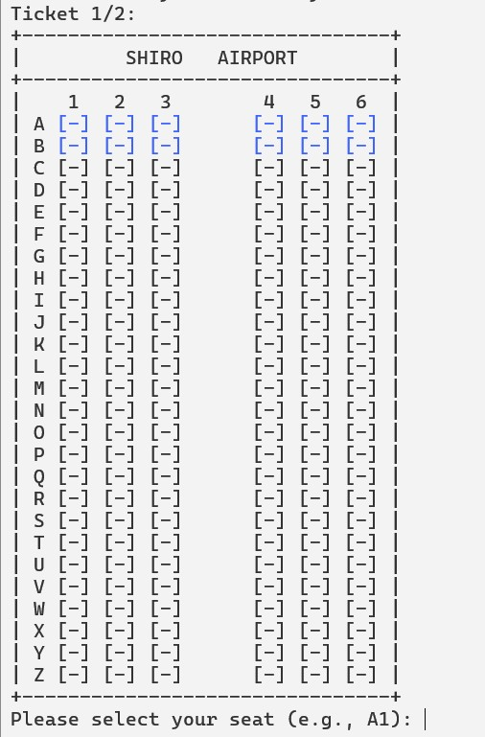
This layout able user to watch and describe which seat user wanted to reserved.On the top show number of ticket is current choosing.Blue color show that is business class and else is business class.
Enter A1 to reserved.
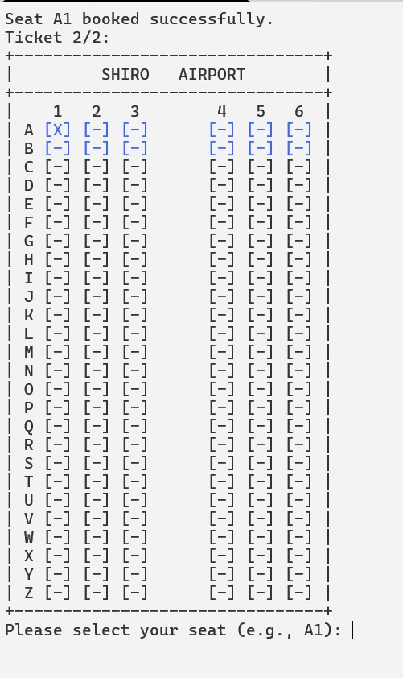
This layout show which seat is reserved and the top show 2/2 mean is the last ticket that user select to reserved.A1 is reserved via using a simbol ‘x’ as reserved.
Enter A2 to reserved seat.
If enter invalid input,it will display error message and loop back to re-select the selection on Seat Layout Page.Screen would be clean and display the page.
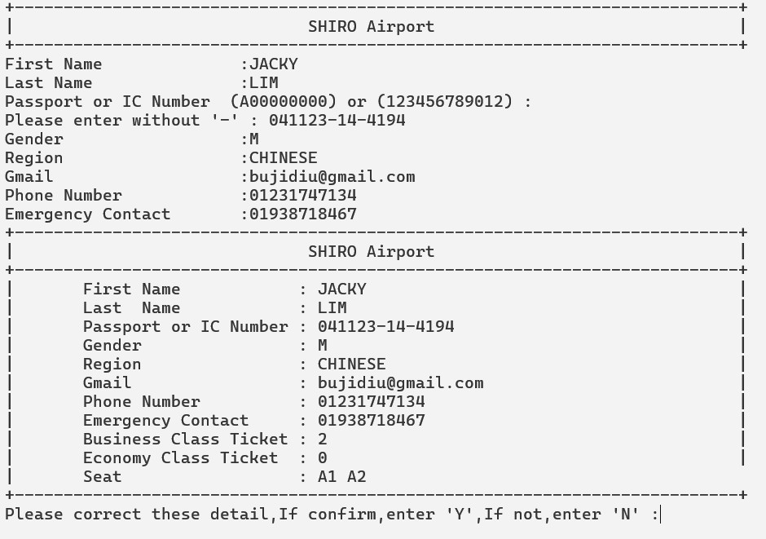
This page allow user to insert passenger detail and will print out the summary,seat and detail.
Enter Y to proceed.
Return Selected Page
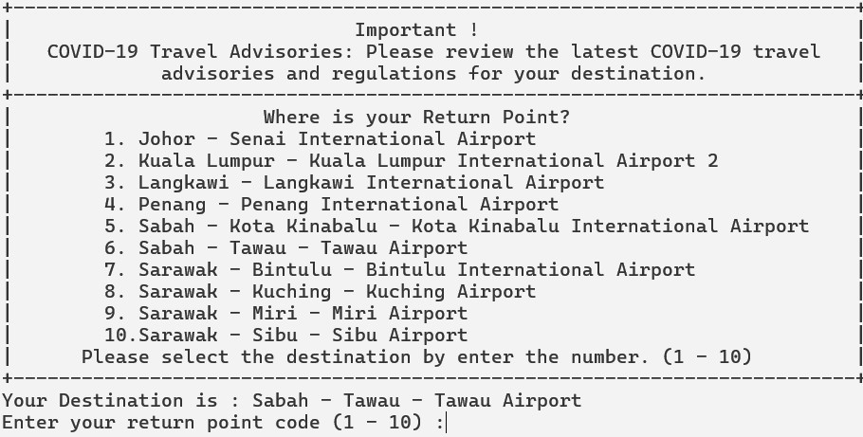
User able to choose destination with the code (1-10) .
Enter ‘2’ to select destination point as Kuala Lumpur - Kuala Lumpur International Airport 2

If enter invalid input,it will display error message and loop back to re-select the selection on Destination Selected Page.Screen would be clean and display the page.
This page will confirm the depart and return point as user selected.Press Y to proceed.
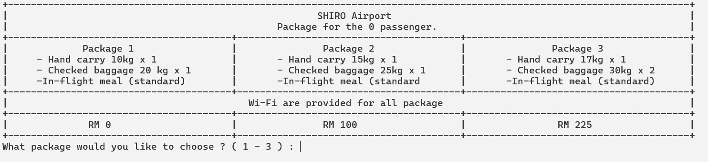
This page allow user to select which package passenger like.Insert (1 - 3).
Press 2 to select package 2.
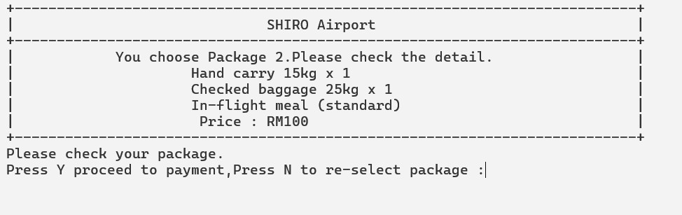
This page will re-confirm and show detail to user.
Press Y to proceed to payment and N to re-select package.
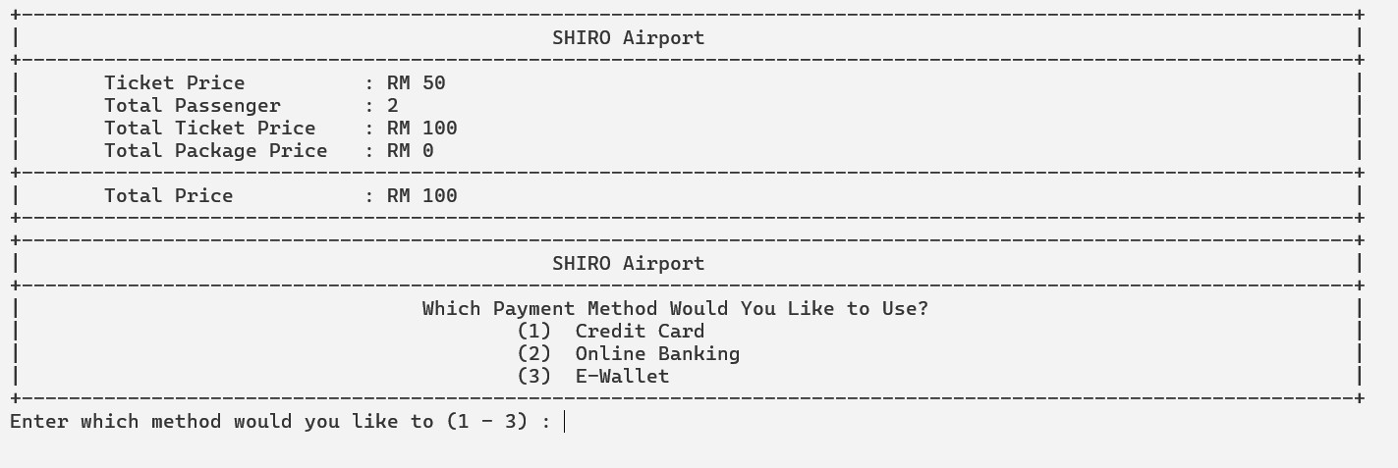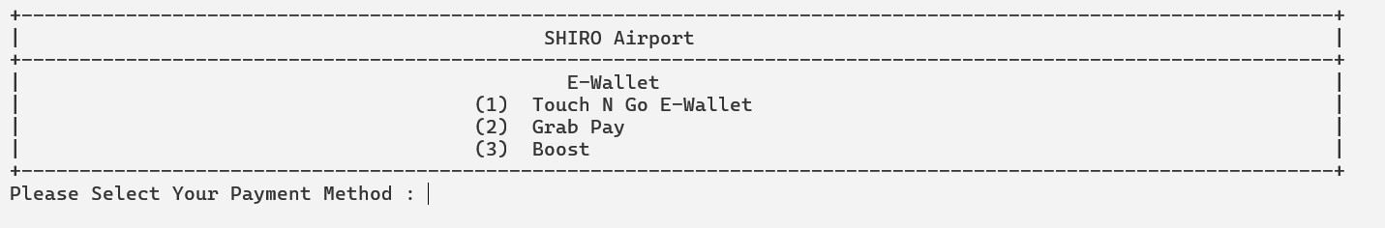
This page will print out the receipt and ask user to choose a method to pay.
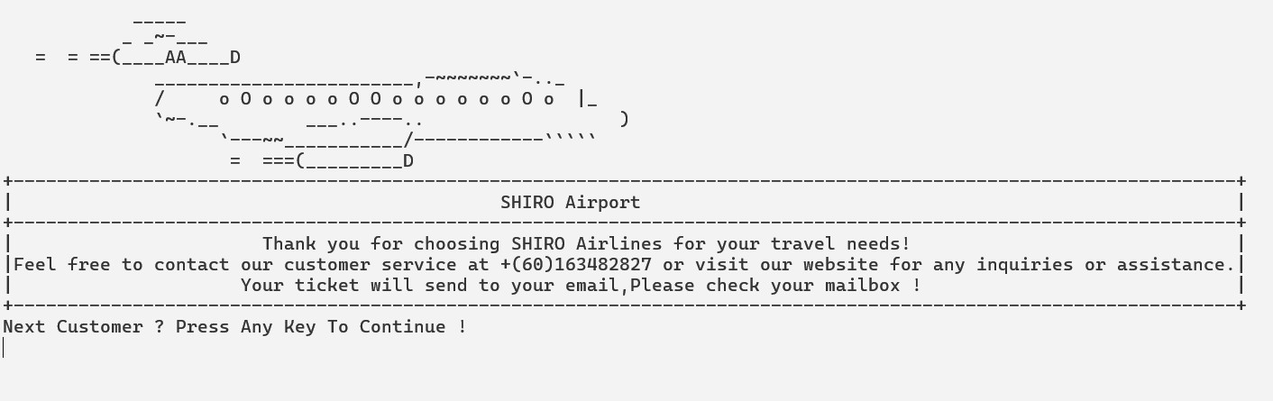
Payment successful ! Next customer?
Press Any key to proceed.
2.
Main Menu Page

User able to insert ‘1’,‘2’ or ’3’ on this Main Menu page.
Enter 1 for Booking Flight Ticket

If enter invalid input,it will display error message and loop back to re-select the selection on Main Menu page.Screen would be clean and display the Main Menu page.
Choice Trip Page
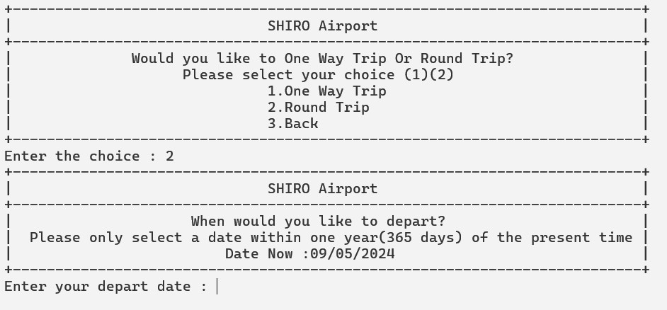
These page allows the user to select one way trip,round trip and back by input ‘1’,’2’ or ‘3’, and this is a page that let user to select the type of trip.
Enter 2 to choose round trip.
User allow to insert a date by follow the format ‘DD/MM/YYYY’ and user only able to select flight date within one year of the current date
Enter a invalid input

If enter invalid input,it will display error message and loop back to re-select the selection on Departure Date page.Screen would be clean and display the Departure Date page.
Date Confirm Page

Enter ‘Y’ for proceed next page.Enter ‘N’ for re-select selection and looping back to the Departure Date Page.

It will show error message if user enter invalid input.Program will loop back to the Depart Date Page to re-confirm the user input.
Destination Selected Page

User able to choose destination with the code (1-10) .
Enter ‘6’ to select destination point as Sabah-Tawau-Tawau Airport

If enter invalid input,it will display error message and loop back to re-select the selection on Destination Selected Page.Screen would be clean and display the page.
Depart Time Page

This page able user to choose on-board time.User can insert (1-4) to select time and insert 0 to loop back to choose the destination point.
Enter 2 to choose 13:35

If enter invalid input,it will display error message and loop back to re-select the selection on Destination Selected Page.Screen would be clean and display the page.
Select Seat Page

This page able user to choose how many seat would like to reserved.User are not able to enter more than 10 seat.It will show error message and loop back to the Select Seat Page.
Enter 2 for reserved 2 seat.
Seat Layout Page

This layout able user to watch and describe which seat user wanted to reserved.On the top show number of ticket is current choosing.Blue color show that is business class and else is business class.
Enter A1 to reserved.

This layout show which seat is reserved and the top show 2/2 mean is the last ticket that user select to reserved.A1 is reserved via using a simbol ‘x’ as reserved.
Enter A2 to reserved seat.
If enter invalid input,it will display error message and loop back to re-select the selection on Seat Layout Page.Screen would be clean and display the page.
Seat Layout Page

This layout able user to watch and describe which seat user wanted to reserved.On the top show number of ticket is current choosing.Blue color show that is business class and else is business class.
Enter A2 to reserved.

This layout show which seat is reserved and the top show 2/2 mean is the last ticket that user select to reserved.A1 is reserved via using a simbol ‘x’ as reserved.
Enter A2 to reserved seat.
If enter invalid input,it will display error message and loop back to re-select the selection on Seat Layout Page.Screen would be clean and display the page.
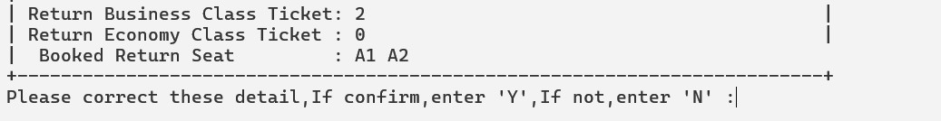
The confirm page show the return seat,class to the user.
Press Y to proceed.

This page allow user to select which package passenger like.Insert (1 - 3).
Press 2 to select package 2.

This page will re-confirm and show detail to user.
Press Y to proceed to payment and N to re-select package.


This page will print out the receipt and ask user to choose a method to pay.

Payment successful ! Next customer?
Press Any key to proceed.
3.Admin Login
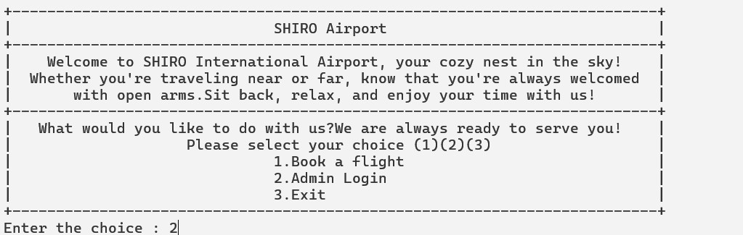
User able to insert ‘1’,‘2’ or ’3’ on this Main Menu page.
Enter 2 for Admin Login Page.
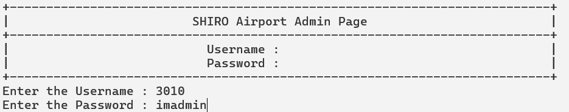
Enter admin username and password to show sales report on this page.
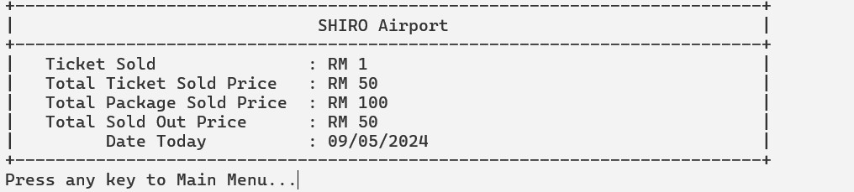
This page shown sales report include ticket sold,Total sold price,Package sold price and date today.
Program Listing
#include <iostream>
#include <string>
#include <sstream>
#include <iomanip>
#include <chrono>
#include <ctime>
#include <thread> #include <map> #include <vector>
using namespace std; using namespace std::chrono;
string choicetrip,menu; bool callMainMenu = true; int arrivedto,departfrom,seatcount,i, RnumTicket = 0; string destination, departure,departDate, returnDate; string cardNumber, expirationDate, securityCode,cardname,Pusername,Ppassword; char paymentmethod,repeat = 'Y'; float RTotalTicketPrice = 0.0, RTotalPackagePrice = 0.0, RTotalPrice = 0.0;
const int NUM_ROWS = 26, SEATS_PER_ROW = 6, TOTAL_SEATS = NUM_ROWS * SEATS_PER_ROW;
vector<vector<char>> seats(NUM_ROWS, vector<char>(SEATS_PER_ROW, '-')); //For Go vector<vector<char>> returnSeats(NUM_ROWS, vector<char>(SEATS_PER_ROW, '-')); //For Back
vector<vector<char>> seatsPPN(NUM_ROWS, vector<char>(SEATS_PER_ROW, '-')); //For Go PPN
vector<vector<char>> returnseatsLKW(NUM_ROWS, vector<char>(SEATS_PER_ROW, '-'));
//For Back LWK
map<string, bool> seatReservation; map<string, bool> returnSeatReservation; // To store seat reservation status map<string, bool> seatReservationPPN; map<string, bool> returnseatReservationLKW;
void displaySeatingChart() { cout << "+--------------------------------+" << endl; cout << "| SHIRO AIRPORT |" << endl;
cout << "+--------------------------------+" << endl;
cout << "| 1 2 3 4 5 6 |" << endl;
char row_label = 'A'; for (int i = 0; i < NUM_ROWS; ++i) {
cout << "| " << row_label++ << " "; for (int j = 0; j < SEATS_PER_ROW; ++j) {
if (j == 3) {
cout << " ";
} if ((i == 0 || i == 1) && (j >= 0 && j < SEATS_PER_ROW)) { cout << "\033[33m"; // Yellow color
} cout << "[" << seats[i][j] << "] "; cout << "\033[0m"; // Reset color
} cout << "|" << endl;
} cout << "+--------------------------------+" << endl;
} bool isSeatAvailable(const string& seat) {
int row = seat[0] - 'A'; int col = seat[1] - '1'; return seats[row][col] == '-' && !seatReservation[seat];
} void bookSeat(const string& seat) {
int row = seat[0] - 'A'; int col = seat[1] - '1'; seats[row][col] = 'X'; seatReservation[seat] = true;
}
void displayReturnSeatingChart() {
cout << "+--------------------------------+" << endl;
cout << "| SHIRO AIRPORT |" << endl;
cout << "+--------------------------------+" << endl;
cout << "| 1 2 3 4 5 6 |" << endl;
char row_label = 'A'; for (int i = 0; i < NUM_ROWS; ++i) { cout << "| " << row_label++ << " "; for (int j = 0; j < SEATS_PER_ROW; ++j) {
if (j == 3) {
cout << " ";
} if ((i == 0 || i == 1) && (j >= 0 && j < SEATS_PER_ROW)) { cout << "\033[33m"; // Yellow color
} cout << "[" << returnSeats[i][j] << "] "; cout << "\033[0m"; // Reset color
// cout << "[" << returnSeats[i][j] << "] ";
} cout << "|" << endl;
} cout << "+--------------------------------+" << endl;
} bool isReturnSeatAvailable(const string& seat) {
int row = seat[0] - 'A'; int col = seat[1] - '1'; return returnSeats[row][col] == '-' && !returnSeatReservation[seat];
} void bookReturnSeat(const string& seat) {
int row = seat[0] - 'A'; int col = seat[1] - '1'; returnSeats[row][col] = 'X'; returnSeatReservation[seat] = true;
}
void displaySeatingChartPPN() {
cout << "+--------------------------------+" << endl;
cout << "| SHIRO AIRPORT |" << endl;
cout << "+--------------------------------+" << endl;
cout << "| 1 2 3 4 5 6 |" << endl;
char row_label = 'A'; for (int i = 0; i < NUM_ROWS; ++i) {
cout << "| " << row_label++ << " "; for (int j = 0; j < SEATS_PER_ROW; ++j) {
if (j == 3) {
cout << " ";
} if ((i == 0 || i == 1) && (j >= 0 && j < SEATS_PER_ROW)) { cout << "\033[33m"; // Yellow color
} cout << "[" << seats[i][j] << "] "; cout << "\033[0m"; // Reset color
} cout << "|" << endl;
} cout << "+--------------------------------+" << endl;
} bool isSeatAvailablePPN(const string& seat) {
int row = seat[0] - 'A'; int col = seat[1] - '1'; return seats[row][col] == '-' && !seatReservationPPN[seat];
} void bookSeatPPN(const string& seat) {
int row = seat[0] - 'A'; int col = seat[1] - '1'; seatsPPN[row][col] = 'X'; seatReservationPPN[seat] = true;
}
void displayReturnSeatingChartLKW() {
cout << "+--------------------------------+" << endl;
cout << "| SHIRO AIRPORT |" << endl;
cout << "+--------------------------------+" << endl;
cout << "| 1 2 3 4 5 6 |" << endl;
char row_label = 'A'; for (int i = 0; i < NUM_ROWS; ++i) {
cout << "| " << row_label++ << " "; for (int j = 0; j < SEATS_PER_ROW; ++j) {
if (j == 3) {
cout << " ";
} if ((i == 0 || i == 1) && (j >= 0 && j < SEATS_PER_ROW)) { cout << "\033[33m"; // Yellow color
} cout << "[" << returnSeats[i][j] << "] "; cout << "\033[0m"; // Reset color
// cout << "[" << returnSeats[i][j] << "] ";
}
cout << "|" << endl;
} cout << "+--------------------------------+" << endl;
} // bool isReturnSeatAvailableLKW(const string& seat) {
int row = seat[0] - 'A'; int col = seat[1] - '1'; return returnSeats[row][col] == '-' && !returnseatReservationLKW[seat];
} void bookReturnSeatLKW(const string& seat) {
int row = seat[0] - 'A'; int col = seat[1] - '1'; returnseatsLKW[row][col] = 'X'; returnseatReservationLKW[seat] = true;
}
// 检查日期格式是否有效
bool isValidDateFormat(const string& date) {
if (date.length() != 10) return false; for (int i = 0; i < 10; ++i) {
if (i == 2 || i == 5) {
if (date[i] != '/') return false;
} else {
if (!isdigit(date[i])) return false;
} } return true;
}
// 检查日期是否在一年内
bool isWithinOneYear(const string& date) {
auto now = system_clock::now(); time_t nowTimeT = system_clock::to_time_t(now); struct tm localTime; localtime_s(&localTime, &nowTimeT); int currentYear = localTime.tm_year + 1900;
int day, month, year; sscanf_s(date.c_str(), "%d/%d/%d", &day, &month, &year); if (year < currentYear || year > currentYear + 1) return false;
if (year == currentYear && (month < localTime.tm_mon + 1 || (month == localTime.tm_mon
+ 1 && day < localTime.tm_mday))) return false; return true;
}
bool isNumeric(const string& str) {
for (char c : str) { if (!isdigit(c)) { return false;
} } return true;
}
// 检查信用卡号是否为16位数字
bool isValidCreditCardNumber(const string& cardNumber) {
return (cardNumber.length() == 16) && isNumeric(cardNumber);
}
// 检查过期日期是否有效
bool isValidExpirationDate(const string& expirationDate) {
int month, year; char slash; istringstream iss(expirationDate);
if (!(iss >> month >> slash >> year)) {
return false; // 格式不正确
}
// 检查月份和年份是否合理（简化版本，不考虑具体的月份和年份逻辑）
return (month >= 1 && month <= 12) && (year >= 0 && year <= 99);
}
// 检查安全码是否为3位数字
bool isValidSecurityCode(const string& securityCode) {
return (securityCode.length() == 3) && isNumeric(securityCode);
}
void mainmenu() {
cout << "+--------------------------------------------------------------------------+" << endl;
cout << "| SHIRO Airport |" << endl;
cout << "+--------------------------------------------------------------------------+" << endl;
cout << "| Welcome to SHIRO International Airport, your cozy nest in the sky! |" << endl;
cout << "| Whether you're traveling near or far, know that you're always welcomed |" << endl;
cout << "| with open arms.Sit back, relax, and enjoy your time with us! |" << endl;
cout << "+--------------------------------------------------------------------------+" << endl;
cout << "| What would you like to do with us?We are always ready to serve you! |" << endl; cout << "| Please select your choice (1)(2)(3) |" << endl;
cout << "| 1.Book a flight |" << endl; cout << "| 2.Admin Login |" << endl; cout << "| 3.Exit |" << endl;
cout << "+--------------------------------------------------------------------------+" << endl; cout << "Enter the choice : "; cin >> menu; if (menu == "1" || menu == "2") {
callMainMenu = false;
} else if (menu == "3") {
cout << "Thank You For Using Our Airline ! Have a good trip !"; repeat = 'N'; return ; }
else { system("cls"); cout << "Invalid Input! Please insert a valid input !" << endl; this_thread::sleep_for(chrono::seconds(2)); system("cls"); cin.clear(); cin.ignore(numeric_limits<streamsize>::max(), '\n'); } }
void tripchoice() { cout << "+--------------------------------------------------------------------------+" << endl;
cout << "| SHIRO Airport |" << endl;
cout << "+--------------------------------------------------------------------------+" << endl;
cout << "| | Would you like to One Way Trip Or Round Trip? |" << endl;
cout << "| | Please select your choice (1)(2) |" << endl;
cout << "| | 1.One Way Trip |" << endl;
cout << "| | 2.Round Trip |" << endl;
cout << "| | 3.Back |" << endl;
cout << "+--------------------------------------------------------------------------+" << endl; cout << "Enter the choice : "; cin >> choicetrip; if (choicetrip == "1" || choicetrip == "2") { return; }
else if (choicetrip == "3") { system("cls"); callMainMenu = true;
return; }
else { system("cls"); cout << "Invalid Input! Please re-enter a new input. (1) (2) or (3) !" << endl; this_thread::sleep_for(chrono::seconds(2)); system("cls"); cin.clear(); cin.ignore(numeric_limits<streamsize>::max(), '\n'); } }
void cArrivedto() { switch (arrivedto) { case 1: destination = "Johor - Senai International Airport"; break;
case 2: destination = "Kuala Lumpur - Kuala Lumpur International Airport 2"; break;
case 3: destination = "Langkawi - Langkawi International Airport"; break; case 4:
destination = "Penang - Penang International Airport"; break;
case 5: destination = "Sabah - Kota Kinabalu - Kota Kinabalu International Airport"; break;
case 6: destination = "Sabah - Tawau - Tawau Airport"; break;
case 7: destination = "Sarawak - Bintulu - Bintulu International Airport"; break;
case 8: destination = "Sarawak - Kuching - Kuching Airport"; break;
case 9: destination = "Sarawak - Miri - Miri Airport"; break;
case 10: destination = "Sarawak - Sibu - Sibu Airport"; break;
} }
void cDepartfrom() { switch (departfrom) { case 1: departure = "Johor - Senai International Airport"; break;
case 2: departure = "Kuala Lumpur - Kuala Lumpur International Airport 2"; break;
case 3: departure = "Langkawi - Langkawi International Airport"; break;
case 4: departure = "Penang - Penang International Airport"; break;
case 5:
departure = "Sabah - Kota Kinabalu - Kota Kinabalu International Airport";
break;
case 6: departure = "Sabah - Tawau - Tawau Airport"; break;
case 7: departure = "Sarawak - Bintulu - Bintulu International Airport"; break;
case 8: departure = "Sarawak - Kuching - Kuching Airport"; break;
case 9: departure = "Sarawak - Miri - Miri Airport"; break;
case 10: departure = "Sarawak - Sibu - Sibu Airport"; break;
} }
void PackageTable() {
cout <<
"+------------------------------------------------------------------------------------------------------------------
-----+" << endl;
cout << "| SHIRO Airport |"
<< endl;
cout << "| Package for the " << i << " passenger.
|" << endl;
cout <<
"+---------------------------------------+---------------------------------------+--------------------------------------+" << endl;
cout << "|  |" << endl; | Package 1 | | Package 2 | Package 3
cout << "| | - Hand carry 10kg x 1 | | - Hand carry 15kg x 1 | - Hand carry
17kg x 1 | |" << endl;
cout << "| | - Checked baggage 20 kg x 1 | | - Checked baggage 25kg x 1 | -
Checked baggage 30kg x 2 |" << endl; cout << "| -In-flight meal (standard) | -In-flight meal (standard | -In-flight meal (standard) |" << endl;

"+---------------------------------------+---------------------------------------+--------------------------------
-------+" << endl;
cout << "| Wi-Fi are provided for all package
|" << endl;
cout <<
"+---------------------------------------+---------------------------------------+--------------------------------
-------+" << endl;
cout << "| RM 0 | RM 100 | RM 225
|" << endl;
cout <<
"+---------------------------------------+---------------------------------------+--------------------------------
-------+" << endl; cout << "What package would you like to choose ? ( 1 - 3 ) : ";
}
void DestinationTable() { cout << "+--------------------------------------------------------------------------+" << endl;
cout << "| Important ! |" << endl;
cout << "| COVID-19 Travel Advisories: Please review the latest COVID-19 travel |" << endl;
cout << "| advisories and regulations for your destination. |" << endl; cout << "+--------------------------------------------------------------------------+" << endl;
cout << "| | Where is your Destination Point? |" << endl;
cout << "| | 1. Johor - Senai International Airport |" << endl;
cout << "| | 2. Kuala Lumpur - Kuala Lumpur International Airport 2 |" << endl;
cout << "| | 3. Langkawi - Langkawi International Airport |" << endl;
cout << "| | 4. Penang - Penang International Airport |" << endl;
cout << "| | 5. Sabah - Kota Kinabalu - Kota Kinabalu International Airport |" << endl;
cout << "| | 6. Sabah - Tawau - Tawau Airport |" << endl;
cout << "| | 7. Sarawak - Bintulu - Bintulu International Airport |" << endl;
cout << "| | 8. Sarawak - Kuching - Kuching Airport |" << endl;
cout << "| | 9. Sarawak - Miri - Miri Airport |" << endl;
cout << "| | 10.Sarawak - Sibu - Sibu Airport |" << endl;
cout << "| | Please select the destination by enter the number. (1 - 10) |" << endl;
cout << "+--------------------------------------------------------------------------+" << endl; cout << "Enter your destination point code (1 - 10) :";
} void CreditCard() { system("cls"); char paymentchoice;
cout <<
"+-----------------------------------------------------------------------------------------------------------------
+" << endl;
cout << "| SHIRO Airport |" << endl;
cout <<
"+-----------------------------------------------------------------------------------------------------------------
+" << endl;
cout << "|  endl; | Credit Card | |" <<
cout << "|  endl; | (1) Visa Card | |" <<
cout << "|  endl; | (2) Master Card | |" <<
cout << "| endl; | (3) American Express | |" <<
cout <<
"+-----------------------------------------------------------------------------------------------------------------
+" << endl; cout << "Please Select Your Payment Method : "; cin >> paymentchoice; system("cls");
cout <<
"+-----------------------------------------------------------------------------------------------------------------
+" << endl;
cout << "| SHIRO Airport |" << endl;
cout <<
"+-----------------------------------------------------------------------------------------------------------------
+" << endl;
cout << "| Card Number (16 digits) : ";
cin >> cardNumber;
cout << "| Name on Card : ";
cin >> cardname;
cout << "| Expire Date (MM/YY) : ";
cin >> expirationDate;
cout << "| Security Code (3 digits) : ";
cin >> securityCode;
}
void OnlineBanking() { system("cls"); char paymentchoice;
cout <<
"+-----------------------------------------------------------------------------------------------------------------
+" << endl;
cout << "| SHIRO Airport |" << endl;
cout <<
"+-----------------------------------------------------------------------------------------------------------------
+" << endl;
cout << "|  endl; | Online Banking | |" <<
cout << "|  endl; | (1) Maybank2U | |" <<
cout << "| | (2) PBe | |" << endl;
cout << "|  endl; | (3) CIMB Clicks | |" <<
cout << "|  endl; | (4) RHB Now | |" <<
cout << "|  << endl; | (5) BANK ISLAM | |"
cout << "|  endl; | (6) HSBC | |" <<
cout << "|  endl; | (7) AmBank | |" <<
cout <<
"+-----------------------------------------------------------------------------------------------------------------
+" << endl; cout << "Please Select Your Payment Method : "; cin >> paymentchoice; system("cls");

cout << "|  endl; | SHIRO Airport | |" <<
cout <<
"+-----------------------------------------------------------------------------------------------------------------
+" << endl;
cout << "| cin >> Pusername; | Username : ";
cout << "| cin >> Ppassword; | Password : ";
cout <<
"+-----------------------------------------------------------------------------------------------------------------
+" << endl; }
void Ewallet() { system("cls"); char paymentchoice;
cout <<
"+-----------------------------------------------------------------------------------------------------------------
+" << endl;
cout << "| SHIRO Airport |" << endl;
cout <<
"+-----------------------------------------------------------------------------------------------------------------
+" << endl;
cout << "| | E-Wallet | |" << endl;
cout << "|  << endl; | (1) Touch N Go E-Wallet | |"
cout << "|  endl; | (2) Grab Pay | |" <<
cout << "| | (3) Boost | |" << endl;
cout <<
"+-----------------------------------------------------------------------------------------------------------------
+" << endl; cout << "Please Select Your Payment Method : "; cin >> paymentchoice;
cout << "|  endl; | SHIRO Airport | |" <<
cout <<
"+-----------------------------------------------------------------------------------------------------------------
+" << endl;
cout << "| cin >> Pusername; | Username : ";
cout << "| cin >> Ppassword; | Password : ";
cout <<
"+-----------------------------------------------------------------------------------------------------------------
+" << endl; }
void ShowReport() {
cout << "+--------------------------------------------------------------------------+" << endl;
cout << "| SHIRO Airport |" << endl;
cout << "+--------------------------------------------------------------------------+" << endl;
cout << "| Ticket Sold : RM " << setw(40) << left << RnumTicket << "|" << endl;
cout << "|  << endl; | Total Ticket Sold Price : RM " << setw(40) << left << RTotalTicketPrice << "|"
cout << "|  "|" << endl; | Total Package Sold Price | : RM " << setw(40) << left << RTotalPackagePrice <<
cout << "|  << endl; } int main() { | Total Sold Out Price | : RM " << setw(40) << left << RTotalTicketPrice << "|"
auto now = system_clock::now(); time_t nowTimeT = system_clock::to_time_t(now); struct tm localTime; localtime_s(&localTime, &nowTimeT); char currentDate[11]; strftime(currentDate, sizeof(currentDate), "%d/%m/%Y", &localTime); string strCurrentDate(currentDate); while (repeat == 'Y') {
// Start
while (true) {
if (callMainMenu = true) {
mainmenu();
}
if (callMainMenu == false && menu == "1") { system("cls"); tripchoice(); if (choicetrip == "3") { continue;
menu = 3; } else if (choicetrip == "1" || choicetrip == "2") { break; } else {
callMainMenu = false;
} }
else if (menu == "2") {
string username; string password; cout << "+--------------------------------------------------------------------------+" << endl;
cout << "| SHIRO Airport Admin Page |" << endl;
cout << "+--------------------------------------------------------------------------+" << endl;
cout << "| Username : |" << endl; cout << "| Password : |" << endl;
cout << "+--------------------------------------------------------------------------+" << endl; cout << "Enter the Username : "; cin >> username; cout << "Enter the Password : "; cin >> password; if (username == "3010" && password == "imadmin" || username == "1130" &&
password == "imadmin" || username == "zhengyan" && password == "imadmin") {
ShowReport();
cout << "| Date Today : " << setw(43) << left << currentDate << "|" <<
endl; cout << "+--------------------------------------------------------------------------+" << endl;
"Press any key to Main Menu...";

cin.ignore(); cin.get(); system("cls");
} else { system("cls"); cout << "Error ! Please confirm your info again !" << endl; } } else if (menu == "3") { return 0;
} }
string departDate; string returnDate = "null "; char confirm = 'Y'; int ticketprice = 0; do {
if (choicetrip == "1" || choicetrip == "2") {
cout << "+--------------------------------------------------------------------------+" << endl;
cout << "| SHIRO Airport |" << endl;
cout << "+--------------------------------------------------------------------------+" << endl;
cout << "| When would you like to depart? |" << endl;
cout << "| Please only select a date within one year(365 days) of the present time |" <<
endl;
cout << "| Date Now :" << currentDate << " | " <<
endl; cout << "+--------------------------------------------------------------------------+" << endl; cout << "Enter your depart date : "; cin >> departDate; system("cls"); while (!isValidDateFormat(departDate) || !isWithinOneYear(departDate)) { //One way system("cls"); cout << "Invalid date format or date not within one year." << endl; this_thread::sleep_for(chrono::seconds(2)); cout << "+--------------------------------------------------------------------------+" << endl;
cout << "| SHIRO Airport |" << endl;
cout << "+--------------------------------------------------------------------------+" << endl;
"| When would you like to depart? |" << endl;
cout << "| Please only select a date within one year(365 days) of the present time |"
<< endl;
cout << "| Date Now :" << currentDate << " | " <<
endl;
cout << "+--------------------------------------------------------------------------+" << endl;
cout << " Please enter a valid departure date (DD/MM/YYYY) :"; cin >> departDate;
} if (choicetrip == "1") { //one way trip confirm page system("cls"); cout << "+--------------------------------------------------------------------------+" << endl;
cout << "| SHIRO Airport |" << endl;
cout << "+--------------------------------------------------------------------------+" << endl;
cout << "| | Please Confirm Your Date ! | |" << endl;
cout << "| endl; | Date Depart :" << departDate << " | | " <<
cout << "| endl; | Date Return :" << returnDate << " | | " <<
cout << "| | (DD/MM/YYYY) | |" << endl;
cout << "+--------------------------------------------------------------------------+" << endl; cout << "If all information correct , Please press Y ,if back press N : "; cin >> confirm; if (confirm == 'y' || confirm == 'Y') { // error input one way trip confirm page break; } else if (confirm == 'N' || confirm == 'n') { //empty } else { system("cls"); cout << "Invalid Input! Please re-enter your date." << endl; this_thread::sleep_for(chrono::seconds(2)); confirm = 'N';
} }
else if (choicetrip == "2") { //Two way system("cls");
"+--------------------------------------------------------------------------+" << endl;
cout << "| SHIRO Airport |" << endl;
cout << "+--------------------------------------------------------------------------+" << endl;
cout << "| When would you like to return? |" << endl;
cout << "| Please only select a date within 1 month(31 days) of the present time |"
<< endl;
cout << "| Date Depart :" << departDate << " | " <<
endl;
cout << "+--------------------------------------------------------------------------+" << endl;
cout << "Enter your return date (DD/MM/YYYY): "; cin >> returnDate;
while (!isValidDateFormat(returnDate) || !isWithinOneYear(returnDate) || returnDate
< departDate) { system("cls"); cout << "Invalid date format or date not within one month." << endl; this_thread::sleep_for(chrono::seconds(2)); cout << "+--------------------------------------------------------------------------+" <<
endl;
cout << "| SHIRO Airport |" << endl;
cout << "+--------------------------------------------------------------------------+" <<
endl;
cout << "| When would you like to return? |" << endl;
cout << "| Please only select a date within 1 month(31 days) of the present time
|" << endl;
cout << "| Date Now :" << departDate << " | " <<
endl; cout << "+--------------------------------------------------------------------------+" <<
endl; cout << " Please enter a valid return date (DD/MM/YYYY) :"; cin >> returnDate;
}
cout << "+--------------------------------------------------------------------------+" << endl;
cout << "| SHIRO Airport |" << endl;
cout << "+--------------------------------------------------------------------------+" << endl;
cout << "| | Please Confirm Your Date ! | |" << endl;
cout << "| endl; | Date Depart :" << departDate << " | | " <<
cout << "| endl; | Date Return :" << returnDate << " | | " <<
"| | (DD/MM/YYYY) | |" << endl;

cout << "+--------------------------------------------------------------------------+" << endl; cout << "If all information correct , Please press Y ,if back press N : "; cin >> confirm; if (confirm == 'y' || confirm == 'Y') { // error input one way trip confirm page
break; } else if (confirm == 'N' || confirm == 'n') { //empty } else { system("cls"); cout << "Invalid Input! Please re-enter your date." << endl; this_thread::sleep_for(chrono::seconds(2)); confirm = 'N';
}
}
}
} while (confirm == 'N' || confirm == 'n');
int numTickets = 0; int numBusinessClass = 0, numEconomyClass = 0;//numTickets string seat; vector<string> bookedSeats; do {
system("cls"); confirm = 'Y'; while (confirm == 'Y') {
DestinationTable(); //Destination Table if (!(cin >> arrivedto)) { system("cls");
cout << "Invalid input. Please enter an integer." << endl; cin.clear(); // 清除错误状态
cin.ignore(numeric_limits<streamsize>::max(), '\n'); // 忽略剩余输入
} else if (arrivedto < 1 || arrivedto > 10) { system("cls");
cout << "Invalid input. Please enter an integer." << endl; cin.clear(); // 清除错误状态 cin.ignore(numeric_limits<streamsize>::max(), '\n'); // 忽略剩余输入 } else { break;
} }
cArrivedto(); int departTime; string DepartTime1, DepartTime2, DepartTime3, DepartTime4, ArrivedTime1,
ArrivedTime2, ArrivedTime3, ArrivedTime4, TravelTime = "00:00";
if (arrivedto >= 1) {
if (arrivedto == 1) {
DepartTime1 = "6:15";
DepartTime2 = "11:30";
DepartTime3 = "16:10";
DepartTime4 = "20:00";
ArrivedTime1 = "9:10";
ArrivedTime2 = "14:25";
ArrivedTime3 = "19:05";
ArrivedTime4 = "22:55";
TravelTime = "02:55";
}
else if (arrivedto == 2) {
DepartTime1 = "10:10";
DepartTime2 = "15:25";
DepartTime3 = "20:05";
DepartTime4 = "23:55";
ArrivedTime1 = "13:05";
ArrivedTime2 = "18:20";
ArrivedTime3 = "23:00";
ArrivedTime4 = "02:50";
TravelTime = "02:55";
}
else if (arrivedto == 3) {
DepartTime1 = "07:30"; DepartTime2 = "11:15";
DepartTime3 = "15:35";
DepartTime4 = "19:45";
ArrivedTime1 = "08:35";
ArrivedTime2 = "12:20";
ArrivedTime3 = "16:40";
ArrivedTime4 = "20:50";
TravelTime = "01:05"; } else if (arrivedto == 4) {
DepartTime1 = "09:05";
DepartTime2 = "12:50";
DepartTime3 = "15:35";
DepartTime4 = "19:45";
ArrivedTime1 = "10:10";
ArrivedTime2 = "13:55";
ArrivedTime3 = "18:30";
ArrivedTime4 = "22:25";
TravelTime = "01:05"; } else if (arrivedto == 5) {
DepartTime1 = "09:30";
DepartTime2 = "12:00";
DepartTime3 = "17:30";
DepartTime4 = "21:00";
ArrivedTime1 = "10:20";
ArrivedTime2 = "12:50";
ArrivedTime3 = "18:20";
ArrivedTime4 = "21:50";
TravelTime = "00:50"; } else if (arrivedto == 6) {
DepartTime1 = "11:05";
DepartTime2 = "13:35";
DepartTime3 = "19:05";
DepartTime4 = "22:35";
ArrivedTime1 = "11:55";
ArrivedTime2 = "14:25";
ArrivedTime3 = "19:55";
ArrivedTime4 = "23:25";
TravelTime = "00:50"; } else if (arrivedto == 7) {
DepartTime1 = "07:10"; DepartTime2 = "10:30";
DepartTime3 = "13:00";
DepartTime4 = "18:30";
ArrivedTime1 = "08:10"; ArrivedTime2 = "11:30";
ArrivedTime3 = "14:00";
ArrivedTime4 = "19:30";
TravelTime = "01:00"; } else if (arrivedto == 8) {
DepartTime1 = "08:55";
DepartTime2 = "12:15";
DepartTime3 = "14:45";
DepartTime4 = "20:15";
ArrivedTime1 = "09:55";
ArrivedTime2 = "13:15";
ArrivedTime3 = "15:45";
ArrivedTime4 = "21:15";
TravelTime = "01:00"; } else if (arrivedto == 9) {
DepartTime1 = "08:00";
DepartTime2 = "12:15";
DepartTime3 = "16:00";
DepartTime4 = "20:00";
ArrivedTime1 = "10:15";
ArrivedTime2 = "14:30";
ArrivedTime3 = "18:15";
ArrivedTime4 = "22:15";
TravelTime = "02:15"; } else if (arrivedto == 10) {
DepartTime1 = "11:15";
DepartTime2 = "15:30";
DepartTime3 = "19:15";
DepartTime4 = "23:15";
ArrivedTime1 = "13:30";
ArrivedTime2 = "17:45";
ArrivedTime3 = "21:30";
ArrivedTime4 = "01:30"; TravelTime = "02:15";
}
else if (arrivedto == 11) {
DepartTime1 = "07:40"; DepartTime2 = "11:30";
DepartTime3 = "14:00";
DepartTime4 = "19:00";
ArrivedTime1 = "09:40";
ArrivedTime2 = "13:30";
ArrivedTime3 = "16:00";
ArrivedTime4 = "21:00";
TravelTime = "02:00";
}
else if (arrivedto == 12) {
DepartTime1 = "10:40";
DepartTime2 = "14:30";
DepartTime3 = "17:00";
DepartTime4 = "22:00";
ArrivedTime1 = "12:40";
ArrivedTime2 = "16:30";
ArrivedTime3 = "19:00";
ArrivedTime4 = "00:00";
TravelTime = "02:00";
}
}
cout << "+--------------------------------------------------------------------------+" << endl;
//Depart Time Page
cout << "| SHIRO Airport |" << endl;
cout << "+--------------------------------------------------------------------------+" << endl;
cout << "| Please select which time would you like to depart. |" << endl;
cout << "| 1. " << DepartTime1 << " |" << endl; cout << "| 2. " << DepartTime2 << " |" << endl; cout << "| 3. " << DepartTime3 << " |" << endl; cout << "| 4. " << DepartTime4 << " |" << endl;
cout << "| The travel time is : " << TravelTime << " |" <<
endl;
cout << "| Press 0 to go back previous page |" << endl;
cout << "+--------------------------------------------------------------------------+" << endl;
cout << "* Your destination is " << destination << endl; cout << "Enter the number code infront the time ! (0 - 4) :"; cin >> departTime; if (departTime >= 1 && departTime <= 4) {
while (true) {
cout << "+--------------------------------------------------------------------------+" << endl;
cout << "| SHIRO Airport |" << endl;
cout << "+--------------------------------------------------------------------------+" << endl;
cout << "| How many seat would you like to reserved ? |" <<
endl;
cout << "| Please enter an integer and not more than 10. |" << endl; cout << "+--------------------------------------------------------------------------+" << endl;
cout << "Enter how many seat would you like to reserved (1-10) : "; if (!(cin >> numTickets)) { system("cls");
cout << "Invalid input. Please enter an integer (1 - 10)." << endl; cin.clear(); // 清除错误状态
cin.ignore(numeric_limits<streamsize>::max(), '\n'); // 忽略剩余输入
} else if (numTickets > 10) { system("cls");
cout << "Invalid input. Please enter an integer (1 - 10)." << endl; cin.clear(); // 清除错误状态
cin.ignore(numeric_limits<streamsize>::max(), '\n'); // 忽略剩余输入
} else { break;
}
}//GO PPN 4, BACK LWK 3
for (int ticket = 1; ticket <= numTickets; ++ticket) {
cout << "Ticket " << ticket << "/" << numTickets << ":" << endl;
if (arrivedto != '4') {
while (true) { displaySeatingChart();
cout << "Please select your seat (e.g., A1): "; cin >> seat; system("cls");
if (seat.length() != 2 || seat[0] < 'A' || seat[0] > char('A' + NUM_ROWS - 1) ||
seat[1] < '1' || seat[1] > char('1' + SEATS_PER_ROW - 1) || !isSeatAvailable(seat)) {
system("cls"); cout << "Invalid seat. Please try again." << endl; continue; } bookSeat(seat);
if (seat[0] >= 'A' && seat[0] <= 'B') {
++numBusinessClass; ticketprice += 250;
} else {
++numEconomyClass; ticketprice += 134;
} bookedSeats.push_back(seat); cout << "Seat " << seat << " booked successfully." << endl;
break; // Break the loop after booking a seat } } else if (arrivedto == '4') {
while (true) { displaySeatingChartPPN();
cout << "Please select your seat (e.g., A1): "; cin >> seat; system("cls");
if (seat.length() != 2 || seat[0] < 'A' || seat[0] > char('A' + NUM_ROWS - 1) ||
seat[1] < '1' || seat[1] > char('1' + SEATS_PER_ROW - 1) || !isSeatAvailablePPN(seat)) {
system("cls"); cout << "Invalid seat. Please try again." << endl; continue;
}
bookSeatPPN(seat);
if (seat[0] >= 'A' && seat[0] <= 'B') {
++numBusinessClass; ticketprice += 250;
} else {
++numEconomyClass; ticketprice += 134;
} bookedSeats.push_back(seat); cout << "Seat " << seat << " booked successfully." << endl;
break; // Break the loop after booking a seat
}
}
} }
else {
confirm = 'N';
}
} while (confirm == 'N' || confirm == 'n');
string Fname, Lname, IdentityNo, region, gmail, phoneNo, emergencyCon; char gender;
cout << "+--------------------------------------------------------------------------+" << endl;
cout << "| SHIRO Airport |" << endl;
cout << "+--------------------------------------------------------------------------+" << endl;
cout << "| Important !!! |" << endl;
cout << "| Please double confirm your detail before pressing enter !!! |" << endl;
cout << "+--------------------------------------------------------------------------+" << endl; this_thread::sleep_for(chrono::seconds(3)); system("cls");
do {
cout << "Please Enter the detail for " << numTickets << " passenger." << endl;
cout << "+--------------------------------------------------------------------------+" << endl;
cout << "| SHIRO Airport |" << endl;
cout << "+--------------------------------------------------------------------------+" << endl;
cout << "First Name :";
cin.get(); getline(cin, Fname);
cout << "Last Name :";
getline(cin, Lname); cout << "Passport or IC Number (A00000000) or (123456789012) :" << endl; cout << "Please enter without '-' : "; getline(cin, IdentityNo);
cout << "Gender :";
cin >> gender;
cout << "Region :";
cin >> region;
cout << "Gmail :";
cin >> gmail;
cout << "Phone Number :"; cin >> phoneNo; cout << "Emergency Contact :"; cin >> emergencyCon;
char ticketconfirm; cout << "+--------------------------------------------------------------------------+" << endl;
cout << "| SHIRO Airport |" << endl;
cout << "+--------------------------------------------------------------------------+" << endl;
cout << "| First Name : " << setw(43) << left << Fname << "|" << endl; cout << "| Last Name : " << setw(43) << left << Lname << "|" << endl;
cout << "| Passport or IC Number : " << setw(43) << left << IdentityNo << "|" << endl;
cout << "| | Gender : " << setw(43) << left << gender << "|" << endl;
cout << "| | Region : " << setw(43) << left << region << "|" << endl;
cout << "| | Gmail : " << setw(43) << left << gmail << "|" << endl;
cout << "| | Phone Number : " << setw(43) << left << phoneNo << "|" << endl;
cout << "| endl; | Emergency Contact : " << setw(43) << left << emergencyCon << "|" <<
cout << "|  << endl; | Business Class Ticket : " << setw(43) << left << numBusinessClass << "|"
cout << "| Economy Class Ticket : " << setw(43) << left << numEconomyClass <<
"|" << endl;
cout << "| Seat : ";
for (const auto& seat : bookedSeats) {
cout << seat << " ";
}
cout << "\n+--------------------------------------------------------------------------+" << endl; cout << "Please correct these detail,If confirm,enter 'Y',If not,enter 'N' :"; cin.ignore(numeric_limits<streamsize>::max(), '\n'); cin >> ticketconfirm; if (ticketconfirm == 'Y' || ticketconfirm == 'y') { continue; system("cls");
} else if (ticketconfirm == 'N' || ticketconfirm == 'n') { system("cls"); confirm = 'N';
} else {
confirm = 'N'; system("cls"); cout << "Invalid Input ! Please only enter [Y]es or [N]o :"; }
} while (confirm == 'N' || confirm == 'n'); do {
cout << "+--------------------------------------------------------------------------+" << endl;
cout << "| Important ! |" << endl;
cout << "| COVID-19 Travel Advisories: Please review the latest COVID-19 travel |"
<< endl; cout << "| advisories and regulations for your destination. |" << endl; cout << "+--------------------------------------------------------------------------+" << endl;
cout << "| | Where is your Return Point? |" << endl;
cout << "| | 1. Johor - Senai International Airport |" << endl;
cout << "| endl; | 2. Kuala Lumpur - Kuala Lumpur International Airport 2 |" <<
cout << "| | 3. Langkawi - Langkawi International Airport |" << endl;
cout << "| | 4. Penang - Penang International Airport |" << endl;
cout << "| 5. Sabah - Kota Kinabalu - Kota Kinabalu International Airport |" << endl;
cout << "| | 6. Sabah - Tawau - Tawau Airport |" << endl;
cout << "| | 7. Sarawak - Bintulu - Bintulu International Airport |" << endl;
cout << "| | 8. Sarawak - Kuching - Kuching Airport |" << endl;
cout << "| | 9. Sarawak - Miri - Miri Airport |" << endl;
cout << "| | 10.Sarawak - Sibu - Sibu Airport |" << endl;
cout << "| | Please select the destination by enter the number. (1 - 10) |" << endl;
cout << "+--------------------------------------------------------------------------+" << endl; cout << "Your Destination is : " << destination << endl; cout << "Enter your return point code (1 - 10) :"; cin >> departfrom; while (departfrom < 1 || departfrom > 10) { system("cls"); cout << "Error Input ! Please Re-enter the return point code !" << endl; this_thread::sleep_for(chrono::seconds(1)); cout << "+--------------------------------------------------------------------------+" << endl;
cout << "| Important ! |" << endl;
cout << "| COVID-19 Travel Advisories: Please review the latest COVID-19 travel
|" << endl; cout << "| advisories and regulations for your destination. |" << endl; cout << "+--------------------------------------------------------------------------+" << endl;
cout << "| Where is your Return Point? |" << endl;
cout << "| 1. Johor - Senai International Airport |" << endl;
cout << "| 2. Kuala Lumpur - Kuala Lumpur International Airport 2 |" <<
endl;
cout << "| | 3. Langkawi - Langkawi International Airport |" << endl;
cout << "| | 4. Penang - Penang International Airport |" << endl;
cout << "| endl; | 5. Sabah - Kota Kinabalu - Kota Kinabalu International Airport |" <<
cout << "| | 6. Sabah - Tawau - Tawau Airport |" << endl;
cout << "| | 7. Sarawak - Bintulu - Bintulu International Airport |" << endl;
cout << "| | 8. Sarawak - Kuching - Kuching Airport |" << endl;
cout << "| | 9. Sarawak - Miri - Miri Airport |" << endl;
cout << "| | 10.Sarawak - Sibu - Sibu Airport |" << endl;
cout << "| | Please select the destination by enter the number. (1 - 10) |" << endl;
cout << "+--------------------------------------------------------------------------+" << endl; cout << "Your Destination is : " << destination << endl; cout << "Enter your return point code (1 - 10) :"; cin >> departfrom;
confirm = 'Y';
} cDepartfrom(); if (departfrom == arrivedto) { system("cls");
cout << "Your Destination Point can't same with the Return Point,Please Re-enter." <<
endl;
this_thread::sleep_for(chrono::seconds(2)); confirm = 'N'; cDepartfrom();
} else { system("cls");
cout << "* Your destination is " << destination << ",and you return from " <<
departure << endl; cout << "Press [Y] for Next Step and [N] For Re-select return point ： "; cin >> confirm; if (confirm == 'Y' || confirm == 'y') { break; } else if (confirm == 'N' || confirm == 'n') { continue;
}
else { //Can only show 1 time system("cls"); cout << "Invalid Input ! Please Enter [Y]es or [N]o." << endl; cout << "* Your destination is " << destination << ",and you return from " <<
departure << endl; cout << "Press [Y] for Next Step and [N] For Re-select return point ： "; cin >> confirm;
}
}
} while (confirm == 'N' || confirm == 'n');
int numReturnBusinessClass = 0; int numReturnEconomyClass = 0; vector<string> bookedReturnSeats;
do {
if (choicetrip == "2") {
for (int ticket = 1; ticket <= numTickets; ++ticket) {
cout << "Return Ticket " << ticket << "/" << numTickets << ":" << endl;
if (departfrom != '3') {
while (true) { displayReturnSeatingChart();
string returnSeats; cout << "Please select your return seat (e.g., A1): "; cin >> returnSeats; system("cls");
if (returnSeats.length() != 2 || returnSeats[0] < 'A' || returnSeats[0] > char('A' + NUM_ROWS - 1) || returnSeats[1] < '1' || returnSeats[1] > char('1' + SEATS_PER_ROW - 1) ||
!isReturnSeatAvailable(returnSeats)) { cout << "Invalid seat. Please try again." << endl; continue; } bookReturnSeat(returnSeats);
if (returnSeats[0] >= 'A' && returnSeats[0] <= 'B') {
++numReturnBusinessClass; ticketprice += 250;
} else {
++numReturnEconomyClass; ticketprice += 134;
} bookedReturnSeats.push_back(returnSeats); cout << "Return Seat " << returnSeats << " booked successfully." << endl;
break; // Break the loop after booking a seat } } else if (departfrom == '3') {
while (true) {
displayReturnSeatingChartLKW();
string returnSeats; cout << "Please select your return seat (e.g., A1): "; cin >> returnSeats; system("cls");
if (returnSeats.length() != 2 || returnSeats[0] < 'A' || returnSeats[0] > char('A' + NUM_ROWS - 1) || returnSeats[1] < '1' || returnSeats[1] > char('1' + SEATS_PER_ROW - 1) ||
!isReturnSeatAvailableLKW(returnSeats)) { cout << "Invalid seat. Please try again." << endl; continue; } bookReturnSeatLKW(returnSeats);
if (returnSeats[0] >= 'A' && returnSeats[0] <= 'B') {
++numReturnBusinessClass; ticketprice += 250;
} else {
++numReturnEconomyClass; ticketprice += 134;
} bookedReturnSeats.push_back(returnSeats); cout << "Return Seat " << returnSeats << " booked successfully." << endl;
break; // Break the loop after booking a seat }
} }
char ticketconfirm; //Comfirm Page
cout << "+--------------------------------------------------------------------------+" << endl;
cout << "| SHIRO Airport |" << endl;
cout << "+--------------------------------------------------------------------------+" << endl;
cout << "| First Name : " << setw(43) << left << Fname << "|" << endl; cout << "| Last Name : " << setw(43) << left << Lname << "|" << endl;
cout << "| endl; | Passport or IC Number : " << setw(43) << left << IdentityNo << "|" <<
cout << "| | Gender : " << setw(43) << left << gender << "|" << endl;
cout << "| | Region : " << setw(43) << left << region << "|" << endl;
cout << "| | Gmail : " << setw(43) << left << gmail << "|" << endl;
cout << "| | Phone Number : " << setw(43) << left << phoneNo << "|" << endl;
cout << "|  << endl; | Emergency Contact : " << setw(43) << left << emergencyCon << "|"
cout << "|  "|" << endl; | Business Class Ticket : " << setw(43) << left << numBusinessClass <<
cout << "|  << "|" << endl; | Economy Class Ticket : " << setw(43) << left << numEconomyClass
cout << "| | Booked Seat : ";
for (const auto& seat : bookedSeats) {
cout << seat << " ";
} cout << "\n| Return Business Class Ticket: " << setw(43) << left <<
numReturnBusinessClass << "|" << endl; cout << "| Return Economy Class Ticket : " << setw(43) << left <<
numReturnEconomyClass << "|" << endl; cout << "| Booked Return Seat : ";
for (const auto& returnSeats : bookedReturnSeats) {
cout << returnSeats << " ";
} cout << endl;
cout << "+--------------------------------------------------------------------------+" << endl;
cout << "Please correct these detail,If confirm,enter 'Y',If not,enter 'N' :"; cin >> ticketconfirm; if (ticketconfirm == 'Y') { continue; system("cls");
} else if (ticketconfirm == 'N') { system("cls"); cout << "+--------------------------------------------------------------------------+" << endl;
cout << "| SHIRO Airport |" << endl;
cout << "+--------------------------------------------------------------------------+" << endl;
cout << "First Name :";
cin.get();
getline(cin, Fname);
cout << "Last Name :";
getline(cin, Lname); cout << "Passport or IC Number (A00000000) or (123456789012) :" << endl; cout << "Please enter without '-' : "; getline(cin, IdentityNo);
cout << "Gender :";
cin >> gender;
cout << "Region :";
cin >> region;
cout << "Gmail :";
cin >> gmail;
cout << "Phone Number :"; cin >> phoneNo; cout << "Emergency Contact :"; cin >> emergencyCon; confirm = 'N';
}
}
} while (confirm == 'N' || confirm == 'n');
char package; int packageprice = 0, TotalPackagePrice = 0; string d1, d2, d3; map<int, pair<string, int>> passengerPackages; for (int i = 1; i <= numTickets; ++i) {
do {
PackageTable(); cin >> package; system("cls"); if (package == '1') {
packageprice = 0; d1 = "Hand carry 10kg x 1"; d2 = "Checked baggage 20kg x 1"; d3 = "In-flight meal (standard)";
} else if (package == '2') { packageprice = 100;
d1 = "Hand carry 15kg x 1"; d2 = "Checked baggage 25kg x 1"; d3 = "In-flight meal (standard)";
} else if (package == '3') {
packageprice = 225; d1 = "Hand carry 17kg x 1"; d2 = "Checked baggage 30kg x 2"; d3 = "In-flight meal (standard)";
} else { system("cls"); cout << "Invalid Input! Please Re-enter (1 to 3)" << endl; this_thread::sleep_for(chrono::seconds(2)); continue;
}
cout << "+--------------------------------------------------------------------------+" << endl;
//Package Confirm page
cout << "| SHIRO Airport |" << endl;
cout << "+--------------------------------------------------------------------------+" << endl;
cout << "| You choose Package " << package << setw(42) << left << ".Please
check the detail." << "|" << endl;
cout << "| " << setw(53) << left << d1 << "|" << endl; cout << "| " << setw(53) << left << d2 << "|" << endl; cout << "| " << setw(53) << left << d3 << "|" << endl;
cout << "| Price : RM" << packageprice << " | |" <<
endl;
cout << "+--------------------------------------------------------------------------+" << endl;
cout << "Please check your package.\nPress Y proceed to payment,Press N to re-select package :"; cin >> confirm; if (confirm == 'Y') {
passengerPackages[i] = make_pair(d1 + ", " + d2 + ", " + d3, packageprice); }
} while (confirm == 'N');
}
int perticket = 0, TotalTicketPrice = numTickets * perticket, TotalPrice = 0; for (auto& passenger : passengerPackages) {
TotalPackagePrice += passenger.second.second;
}
if (choicetrip == "1") { //one way trip
perticket = 50;
TotalTicketPrice = perticket * numTickets; TotalPrice = TotalTicketPrice + TotalPackagePrice; system("cls");
cout <<
"+-----------------------------------------------------------------------------------------------------------------
+" << endl;
cout << "| SHIRO Airport |"
<< endl;
cout <<
"+-----------------------------------------------------------------------------------------------------------------
+" << endl;
cout << "| Ticket Price : RM 50
|" << endl;
cout << "| | Total Passenger | : " << setw(82) << left << numTickets << "|" << endl;
cout << "|  << endl; | Total Ticket Price | : RM " << setw(79) << left << TotalTicketPrice << "|"
for (auto& passenger : passengerPackages) {
cout << "| Passenger " << passenger.first << " : Package " <<
passenger.second.first << " |" << endl;
cout << "| Price : RM " << setw(79) << left << passenger.second.second << "|" << endl;
}
cout << "| Total Package Price : RM " << setw(79) << left << TotalPackagePrice << "|" << endl;
cout <<
"+-----------------------------------------------------------------------------------------------------------------
+" << endl; cout << "| Total Price : RM " << setw(79) << left << TotalPrice << "|" << endl; cout <<
"+-----------------------------------------------------------------------------------------------------------------
+" << endl; } else { //round trip
perticket = 100;
TotalTicketPrice = perticket * numTickets;
TotalPrice = TotalTicketPrice + TotalPackagePrice; system("cls");
cout <<
"+-----------------------------------------------------------------------------------------------------------------
+" << endl;
cout << "| SHIRO Airport |"
<< endl;
cout <<
"+-----------------------------------------------------------------------------------------------------------------
+" << endl;
cout << "| Ticket Price : RM 100
|" << endl;
cout << "| | Total Passenger | : " << setw(82) << left << numTickets << "|" << endl;
cout << "|  << endl; | Total Ticket Price | : RM " << setw(79) << left << TotalTicketPrice << "|"
for (auto& passenger : passengerPackages) {
cout << "| Passenger " << passenger.first << " : Package " <<
passenger.second.first << " |" << endl;
cout << "| Price : RM " << setw(79) << left << passenger.second.second << "|" << endl;
}
cout << "| Total Package Price : RM " << setw(79) << left << TotalPackagePrice << "|" << endl;
cout <<
"+-----------------------------------------------------------------------------------------------------------------
+" << endl; cout << "| Total Price : RM " << setw(79) << left << TotalPrice << "|" << endl; cout <<
"+-----------------------------------------------------------------------------------------------------------------
+" << endl; } while (choicetrip == "1" || choicetrip == "2") {
char paymentmethod;
cout <<
"+-----------------------------------------------------------------------------------------------------------------
+" << endl;
cout << "| SHIRO Airport |"
<< endl;
cout <<
"+-----------------------------------------------------------------------------------------------------------------
+" << endl;
cout << "| Which Payment Method Would You Like to Use?
|" << endl;
cout << "| (1) Credit Card |"
<< endl;
cout << "| (2) Online Banking
|" << endl;
cout << "| (3) E-Wallet |"
<< endl;
cout <<
"+-----------------------------------------------------------------------------------------------------------------
+" << endl; cout << "Enter which method would you like to (1 - 3) : "; cin >> paymentmethod; while (true) { switch (paymentmethod) { case '1': {
bool isValidCardNumber = false, isValidExpDate = false, isValidSecCode = false; while (!isValidCardNumber || !isValidExpDate || !isValidSecCode) { CreditCard(); isValidCardNumber = isValidCreditCardNumber(cardNumber); isValidExpDate = isValidExpirationDate(expirationDate);
isValidSecCode = isValidSecurityCode(securityCode);
// 显示验证结果
if (isValidCardNumber && isValidExpDate && isValidSecCode) {
cout << "Payment Successful ! " << endl; break; } else {
cout << "Invalid credit card information. Please check and try again." << endl;
}
break;
}
}
case '2':
OnlineBanking();
cout << "Login Succesful! Please Approve the payment on your phone." << endl; this_thread::sleep_for(chrono::seconds(2)); cout << "Payment Successful ! " << endl;
break;
case '3': Ewallet(); cout << "Login Succesful! Please Approve the payment on your phone." << endl; this_thread::sleep_for(chrono::seconds(2)); cout << "Payment Successful ! " << endl;
break;
default:
cout << "Please re-enter a valid input ! (1 - 3)" << endl;
} break; } break; }
char repeat,printticket;
RnumTicket = RnumTicket += numTickets;
RTotalTicketPrice = RTotalTicketPrice += TotalTicketPrice, RTotalPackagePrice =
RTotalPackagePrice += TotalPackagePrice, RTotalPrice = RTotalPrice += TotalPrice; this_thread::sleep_for(chrono::seconds(2)); system("cls");
cout << " | _____ " << endl;
cout << " | _\ _~-\___" << endl;
cout << " | = = ==(____AA____D" << endl;
cout << " | \_____\___________________,-~~~~~~~`-.._" << endl;
cout << " | / o O o o o o O O o o o o o o O o |\_" << endl;
cout << " | `~-.__ ___..----.. )" << endl;
cout << " | `---~~\___________/------------`````" << endl;
cout << " | = ===(_________D" << endl;
cout <<
"+-----------------------------------------------------------------------------------------------------------------
+" << endl;
cout << "| SHIRO Airport |"
<< endl;
cout <<
"+-----------------------------------------------------------------------------------------------------------------
+" << endl; cout << "| Thank you for choosing SHIRO Airlines for your travel needs!
|" << endl; cout << "|Feel free to contact our customer service at +(60)163482827 or visit our website
for any inquiries or assistance.|" << endl; cout << "| Your ticket will send to your email,Please check your mailbox !
|" << endl;
cout <<
"+-----------------------------------------------------------------------------------------------------------------
+" << endl;
this_thread::sleep_for(chrono::seconds(2));
cout << "Next Customer ? Press Any Key To Continue !" << endl; cin.ignore(); cin.get(); repeat = 'Y';
} return 0;
}

