Name: TEK Chansetha
ID: e20220186
Group: I5-GIC-C

Deploy Juice Shop
Setting up Juice Shop, which I pulled from github and ran using command `npm start`
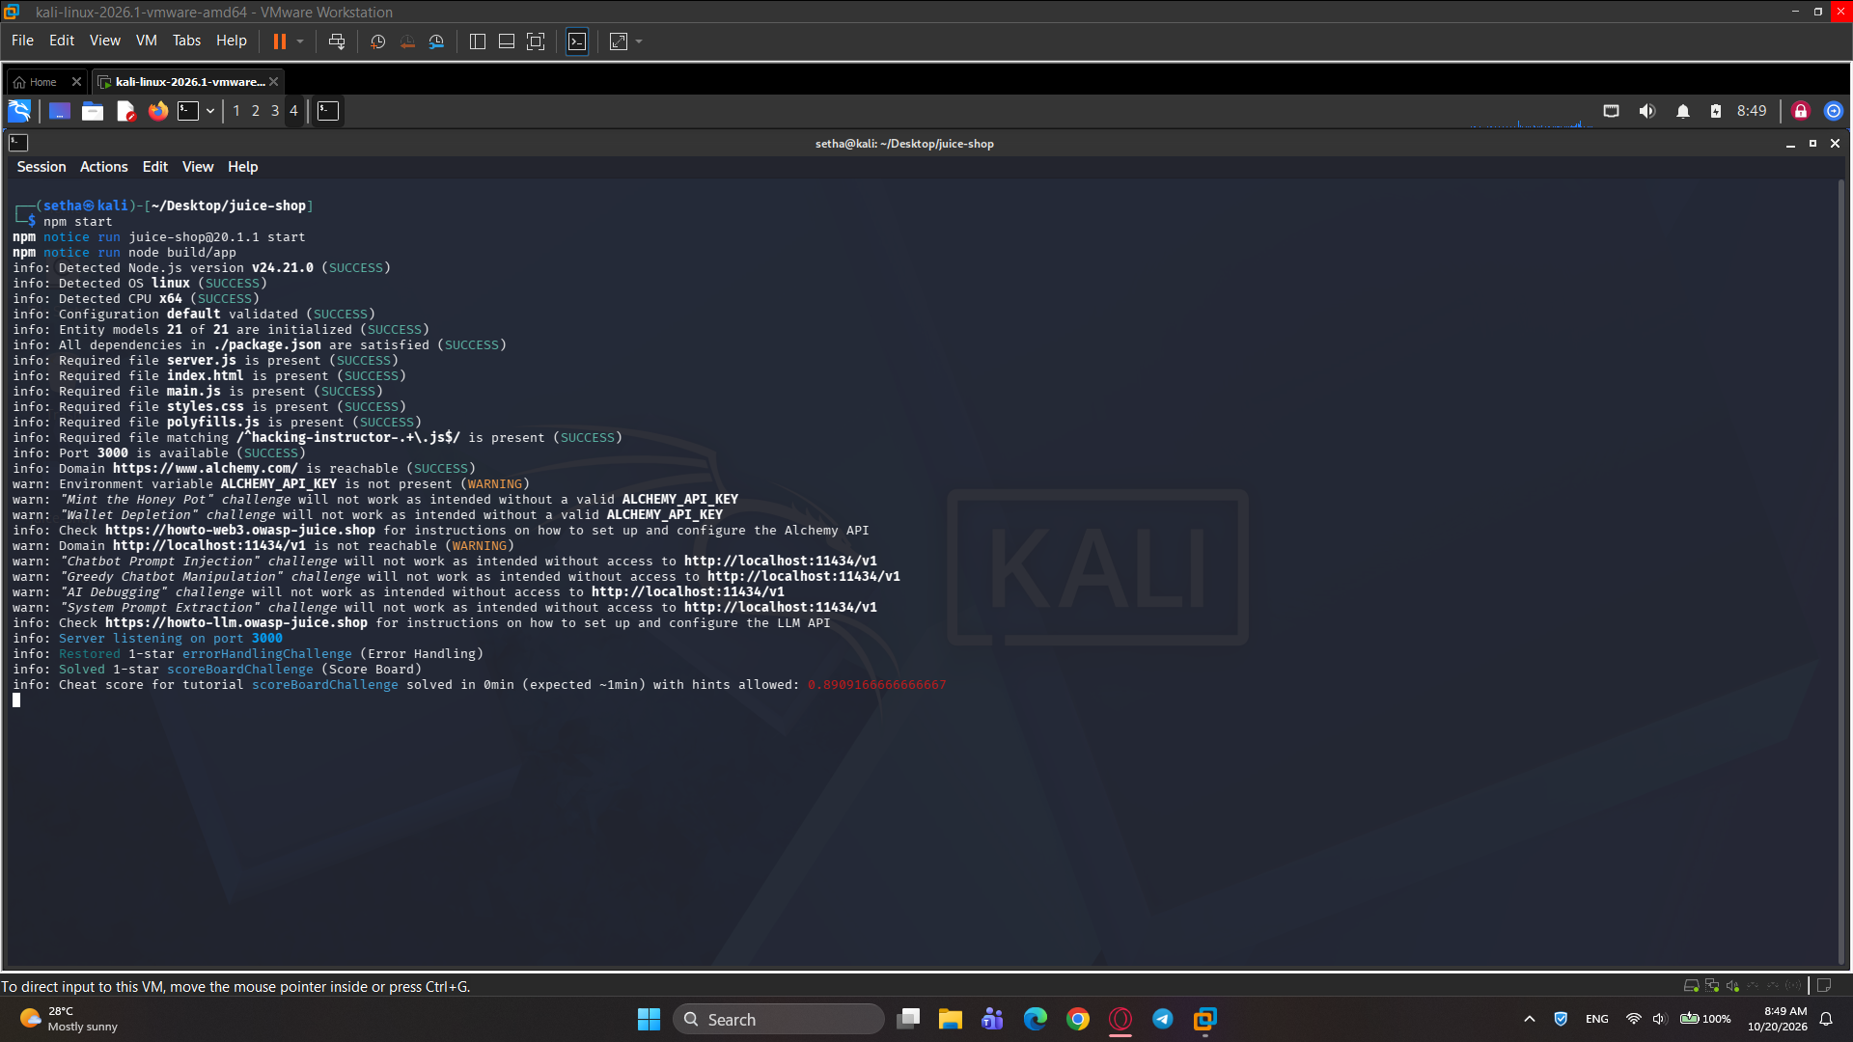
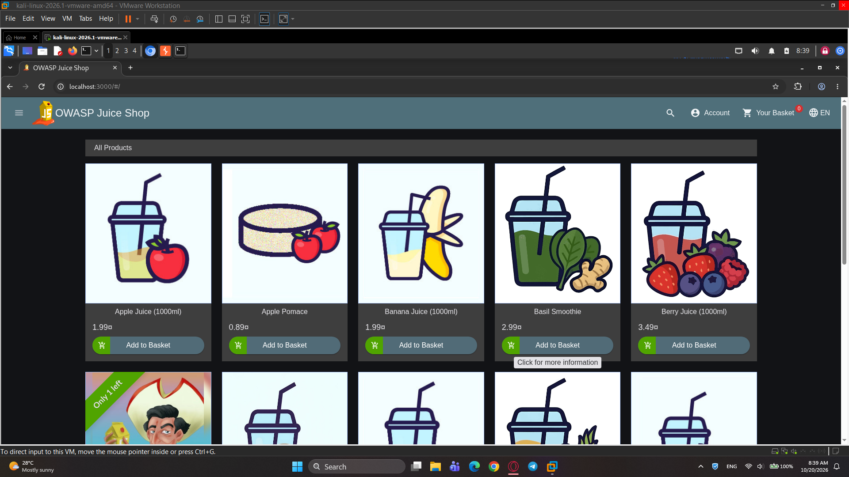

Find the Admin Username (investigation)
I can find the admin account by looking and browsing through the comment section of the products. One of the product reviews was posted by the administrator account, which revealed the admin email “admin@juice-sh.op”.
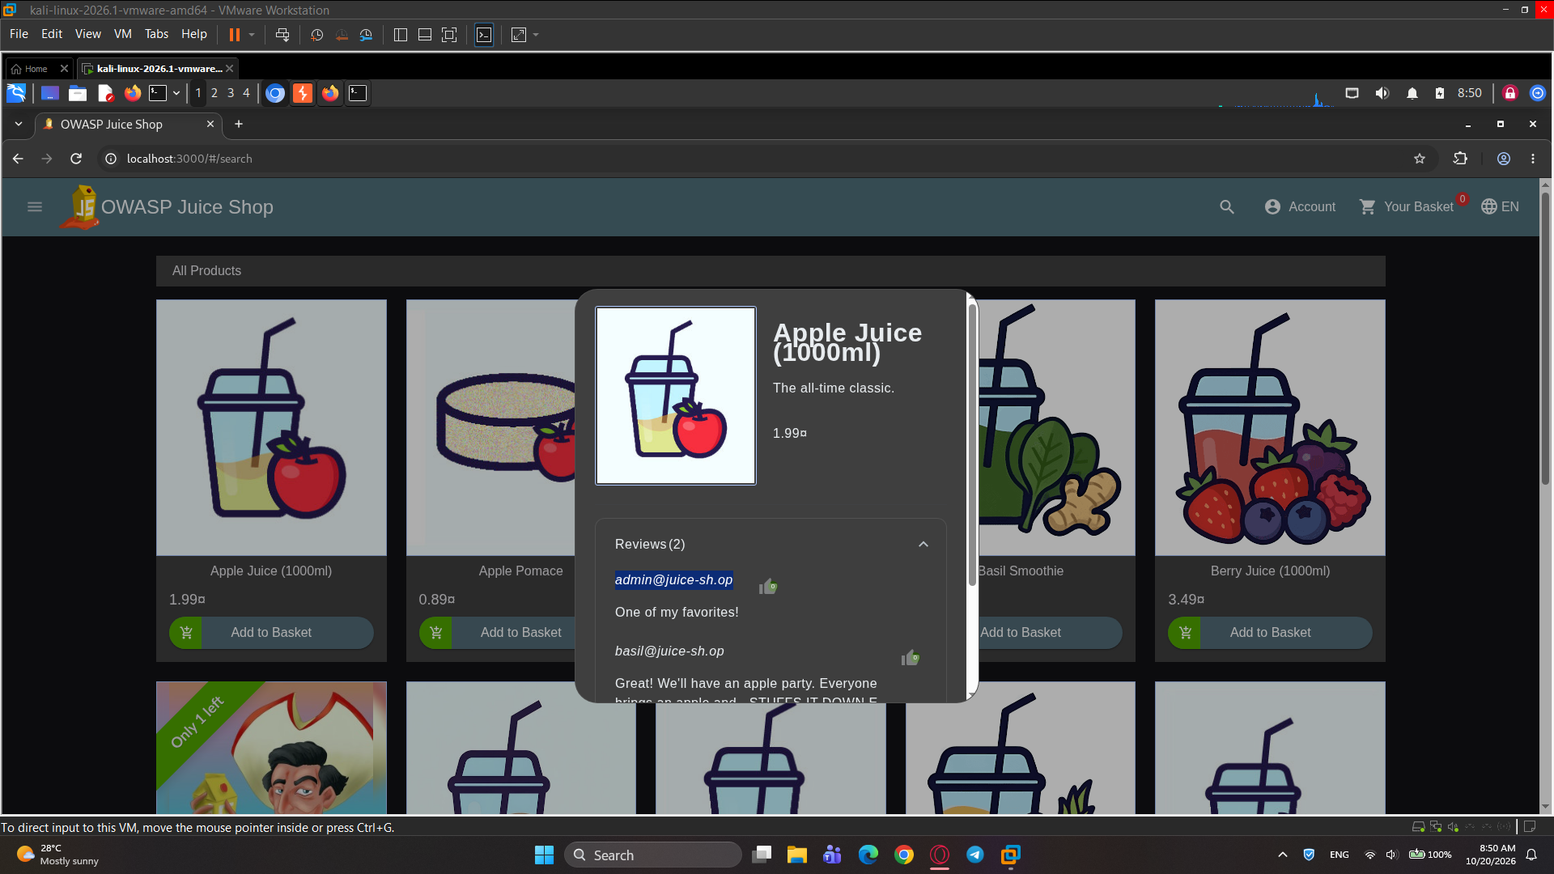

Explore SQL Injection Vectors (guided)

Before testing for SQL injection, I performed a normal login attempt to observe the application's normal behavior.
I entered test@example.com as the email address and a normal password. Since these credentials do not belong to a valid account, Juice Shop rejected the login attempt and displayed the message "Invalid email or password."
This result is used as the baseline response for comparison with later input tests.
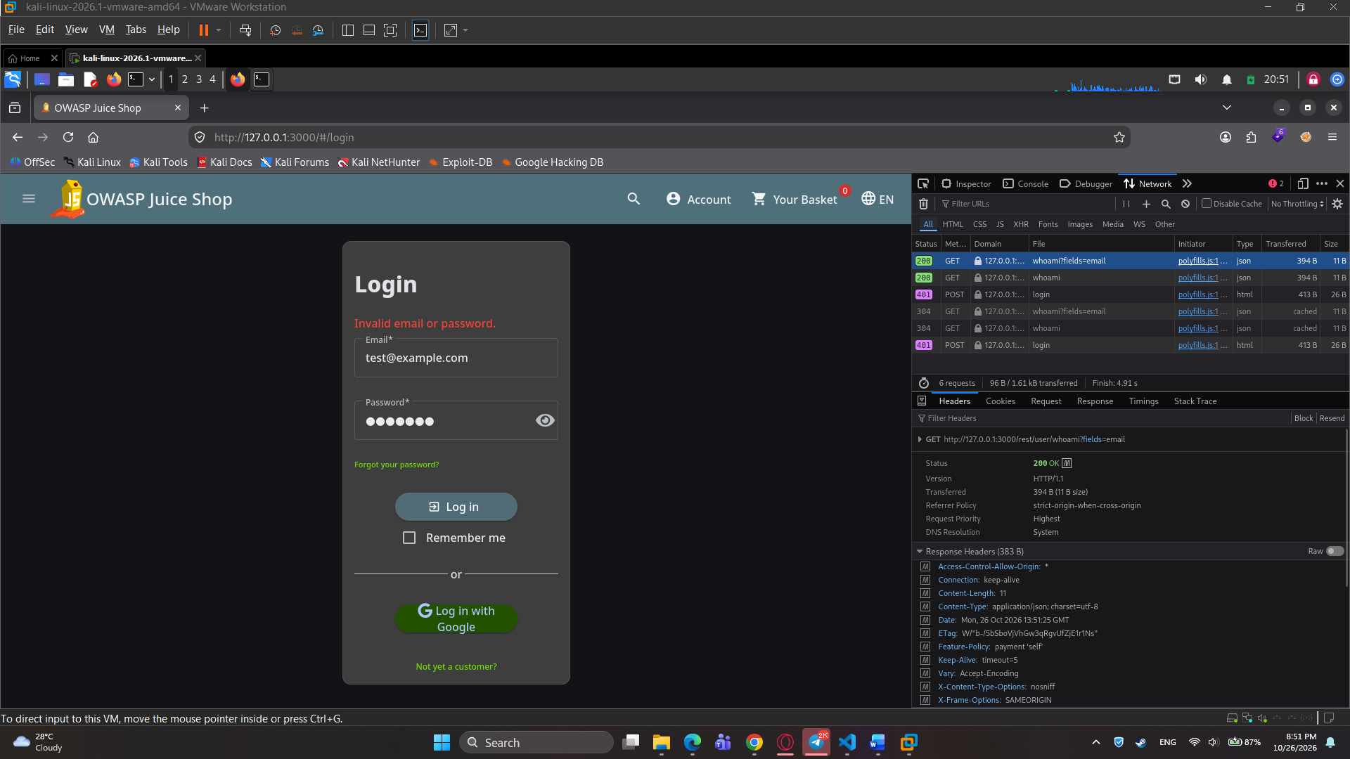

After that I tried to SQL inject the admin account through the password, by trying to comment it.
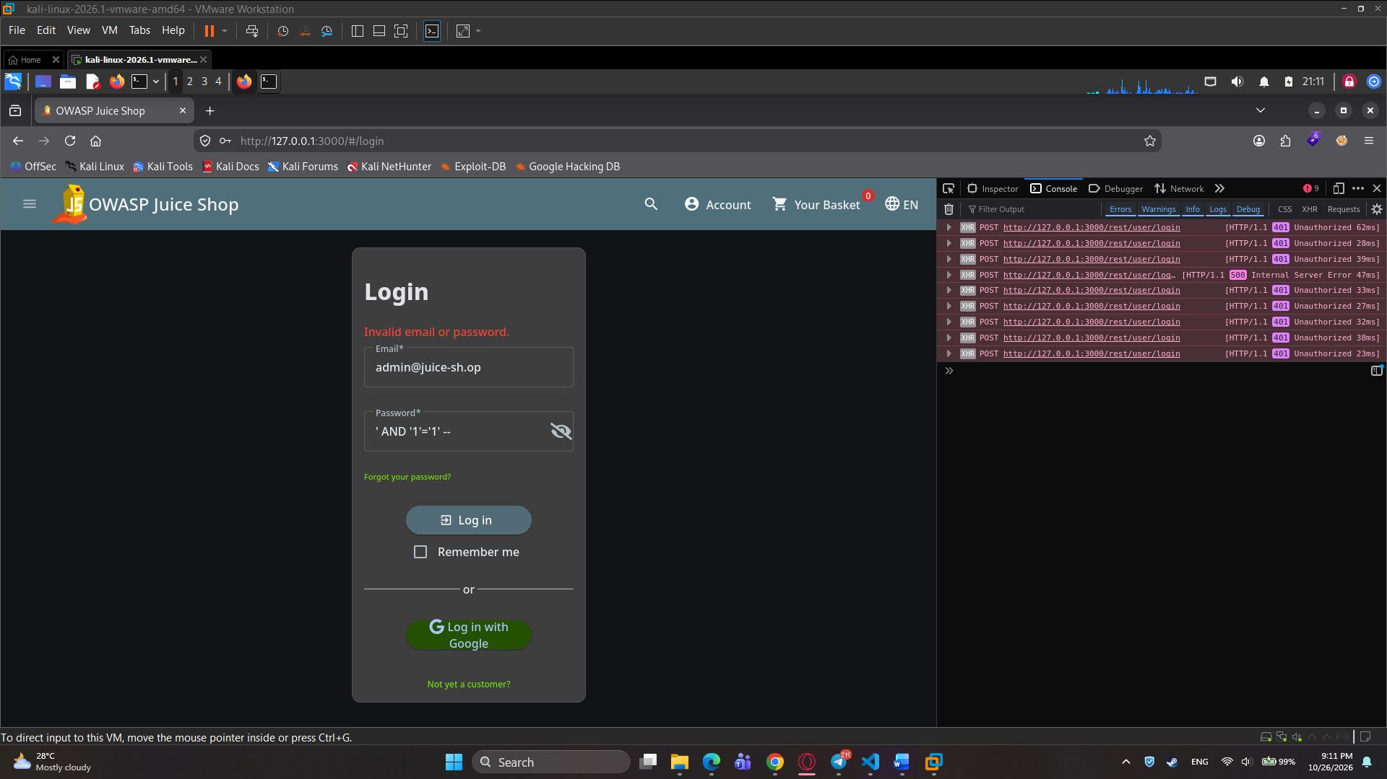
Then I tried to inject through the email input field instead with the same SQL injection string but with ‘OR’ and see if I can comment the password.
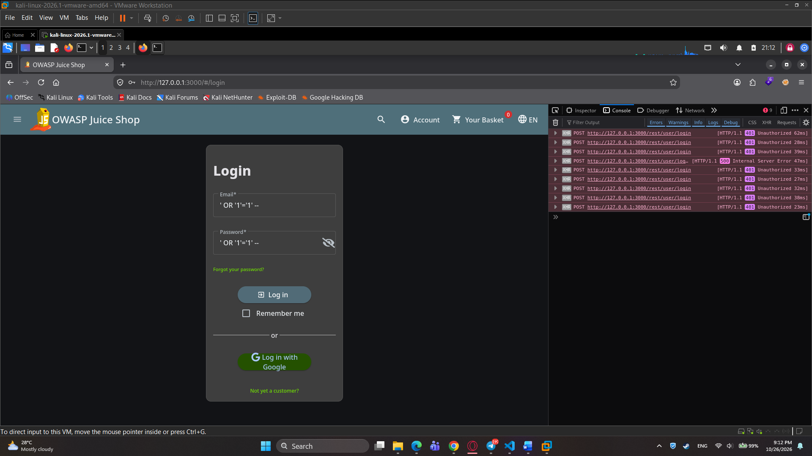

The result is a success and I am able to login into the admin account.


