What role do bank branches play today, and how should that role evolve based on customer behavior and operational realities?

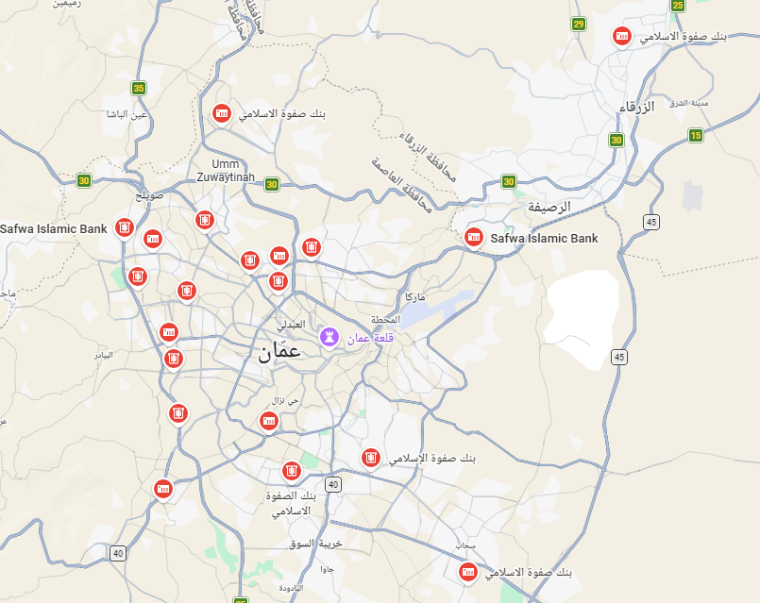

📄 Executive Summary — Branch Visit Analysis (2020–2025)

Purpose of the Study
This analysis evaluates why customers visit branches, how visit patterns have changed from 2020–2025, and where the bank can migrate traffic to digital, improve branch efficiency, and optimize staffing & service design.
The goal is to clarify the core role of branches in the customer journey today and in the future.

How the Analysis Was Done
- Analysed 7.6+ million branch arrivals and 6.1+ million served transactions across 2020–2025.
- Normalized 30+ service types into a unified taxonomy: Cash, Accounts, Cards, Lending, Payments/Transfers, Digital Support, Customer Support & Complaints, Other.
- Calculated:
  - Served volumes,
  - Share of reasons,
  - Trend lines (2020–2025),
  - Heatmaps,
  - Declining vs. rising categories.
- Visualizations generated:
  - Reason share by year
  - Trend by category (2020–2025)
  - Heatmap (Category × Year)

Key Insights

1) Branches are still dominated by Cash — but the share is decreasing
- Cash = ~76.4% of all served interactions (≈ 4.65M served).
- Cash share dropped from 81.3% → 71.5% (2020–2025).
- This is the strongest indicator that cash can continue shifting to ATMs/ITMs, smart recyclers, and digital.

2) Customer Support & Problem Resolution is rising sharply
- Increased from 8.5% → 13.9% of all visits.
- Customers increasingly rely on branches for guidance, troubleshooting, and exceptions, not transactions.

3) Lending interactions are growing
- Lending share increased from 3.8% → 5.6%.
- Indicates branches remain the preferred channel for advice-driven, high-trust services (credit cards, loans, inquiries).

4) Digital Support demand is accelerating
- 0.56% → 2.81% — 5× growth.
- Customers need assisted digital onboarding, meaning branches should include digital ambassadors and self-service zones.

5) Top service drivers (2020–2025 total)
- Withdrawal/Deposit: ~68% of all served
- Other Services: ~9.1%
- Cheques: ~6.6%
- Financing/Credit Cards: ~5.0%
- Account Opening: ~4.0%

What This Means for the Bank — Strategic Interpretation

Branches are transitioning from “transaction centers” to:
- Service & problem-resolution hubs
- Sales & advisory hubs (lending, onboarding)
- Digital enablement centers for customers who need help going digital

This evolution is happening naturally — supported by the declining share of Cash and the rising share of Support, Digital Support, and Lending.

Recommended Next Moves (Prioritized)

1) Accelerate Digital Migration for Low-Complexity Processes
Target immediate quick wins:
→ Reduces queue pressure and boosts service availability.
The answer is withdraw/deposit

Section 2 — Scope & Methodology

Scope
- Period covered: From January 2020 to December 2025
- Focus of analysis: All customer transactions carried out inside bank branches, analyzed by service type (for example: withdrawals and deposits, cheques, account opening, and financing services).
- How activity is measured: The analysis is based on the number of transactions successfully completed at the branch counters.
- Additional context used: Customer arrivals and waiting/service time indicators were reviewed to help explain branch pressure and customer experience, but they were not used as the main sizing measure.
- Level of coverage: Results are presented at the bank-wide level for each year. More detailed branch and regional analysis will be added once transaction-level data by branch and region becomes available.

Data Sources Used in This Study
The analysis is based on the following official data extracts:
- Statistical Summary (Per Year: 2020–2025)
Used to analyze year-by-year changes in service demand, completion rates, workload, and waiting times.
- Statistical Summary (Multi-Year Aggregate: 2020–2025)
Used to understand overall service mix, workload concentration, and long-term structural patterns.
- General Regional Statistics (Single-Year and Multi-Year)
Used to support regional comparisons and identify variations in volume, workload, and service pressure across the network.
:

Contents
Executive Summary – Key Points 2
Section 2 — Scope & Methodology 3
Scope 3
Data Sources Used in This Study 3
Quick intro (2020–2025 snapshot) 4
1) Why do customers still visit branches? 4
2) What services dominate branch activity? 7
Key Observations 8
🧠 Stronger Insights (From the Improved Charts) 8
🔥 True Bottleneck =2 High Arrival + High Service Time 8
⚠️ Hidden Bottlenecks = Medium Arrival + Very Long Service Time 9
⚡ Fast Services = Best Flow 9
5) Served vs Not Served (Volumes) — Stacked 10
📊 1) Served vs Not Served (Stacked Bar) – 2020→2025 10
🔍 Quick insights: 11
📈 2) % Served Trend (Year-over-Year) 11
🔍 Insight: 12
📈 3) Arrived vs Served vs Not Served (Line Trend) 12
🔍 Key patterns: 12
4) Not Served Rate by Service (Sorted) 12
🚦 Trend Direction 2020 → 2025 (change in avg wait) 14
3) Are branches under operational pressure? 15
A) Where is the load (volume)? 15
B) Who waits the longest? 17
C) Where are customers abandoning (non-served)? 17
📊 Workload (Hours) — Cleaned (CS removed) 19
🔴 Top 5 Highest Workload (Worst Pressure) 19
Metric ④ — % Served (Throughput Effectiveness) 19
🔴 Bottom 5 “Worst” Regions (Lowest % Served) 19
🟢 Bottom 5 Lowest Workload (Best / Lightest Pressure) 21
Top 5 (% Served Best — highest completion success) 21
Early, data-backed insights (smooth narrative for management) 22
Section 3 — Why Customers Visit Branches 24
Core role of branches 24
2) Trend of each reason (served volumes, 2020–2025) 25
3) Heatmap — share by category × year 26
A) Top 3 Reasons Customers Still Visit Branches (Overall 2020–2025) 26
B) Cash Share Decline (2020 → 2025) 27
B.2) Growth in Non-Cash Categories (Digital Support, Customer Support, Lending) 28
Growth (2020 → 2025): 28
C) Evolution of Top 3 Branch Visit Reasons (2020–2025) 29
A) Arrivals per service per year (Top 10) 31
C) Momentum heatmap – YoY % change in arrivals (Top 10) 32
E) Directional trends (↑ ↓ →) — arrivals 2020 → 2025 33
**F) What changed (behavioral storyline) 34
G) Manual vs Digital — where to move next 35
Immediate Digital (end-to-end potential) 35
Hybrid (digital intake + branch finalize) 35
Cash migration (reduce teller load) 35
Teller triage → digital 35

Quick intro (2020–2025 snapshot)

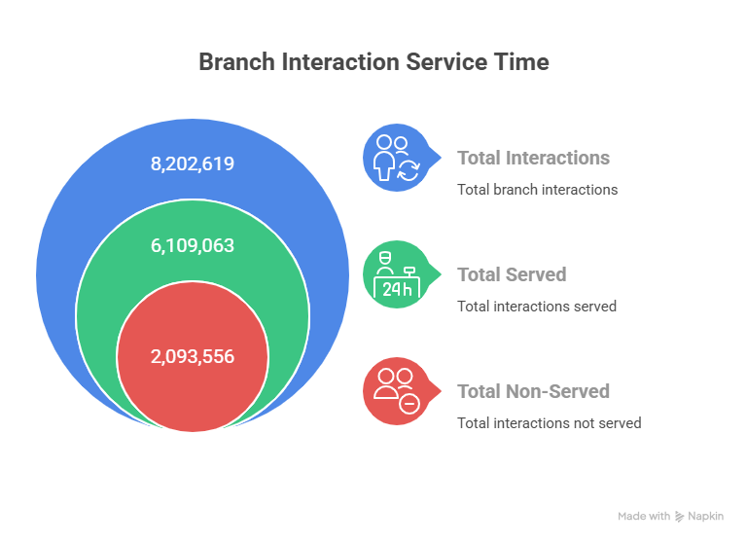

1) Why do customers still visit branches?
Answer (bank-wide service mix):
Because branches remain essential for cash, trust-based, and complex services that digital channels cannot fully replace.

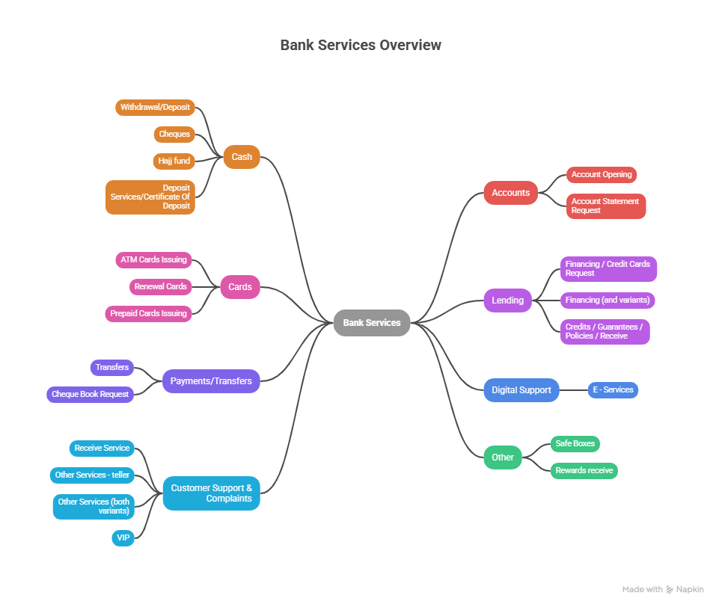
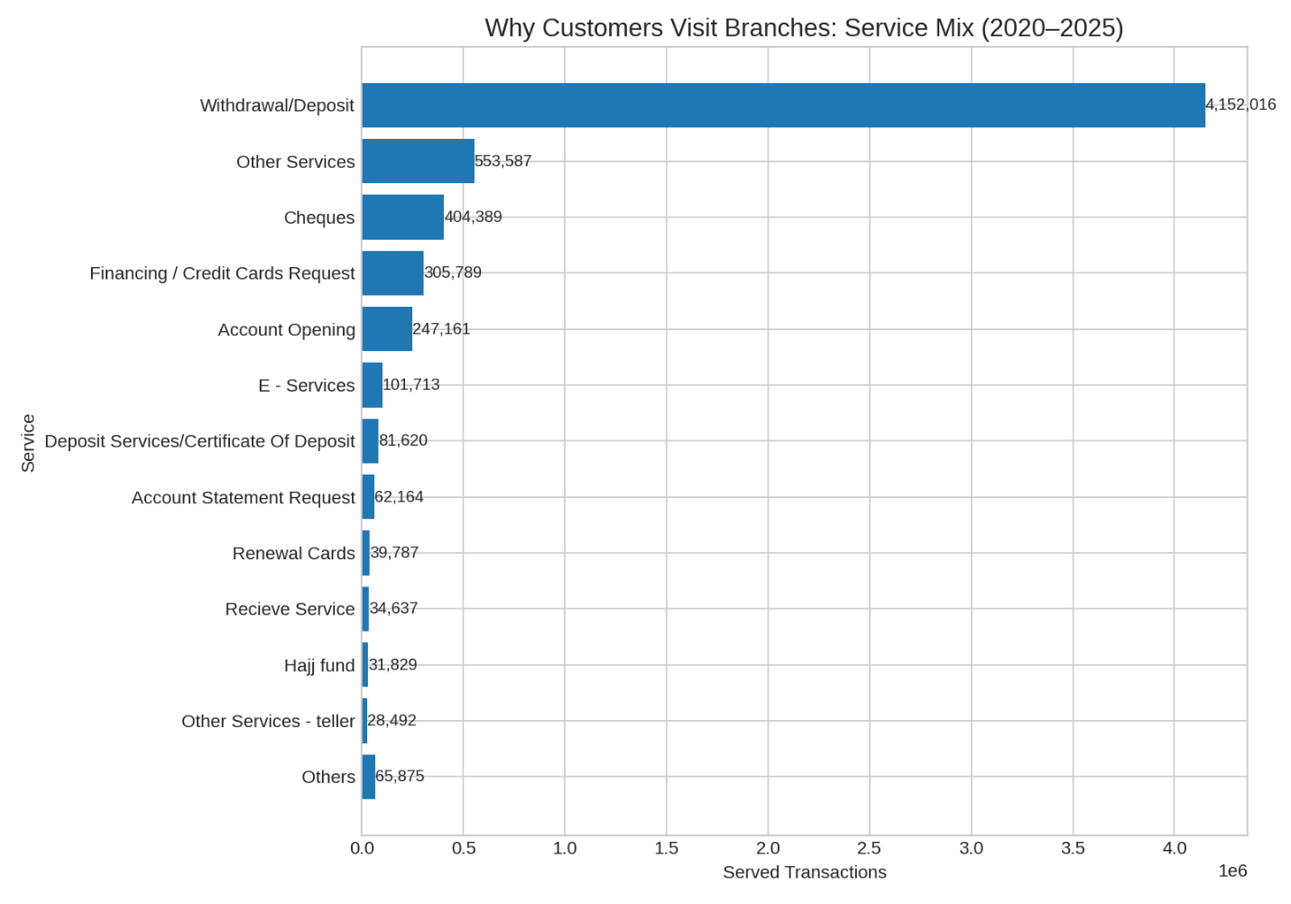
What stands out
- Withdrawal/Deposit = 4,152,016 served (~68.0%) → the core reason customers still show up in person.
- Next 4 services: Other Services (9.1%), Cheques (6.6%), Financing/Credit Cards (5.0%), Account Opening (4.0%).
- Top 5 services together ≈ 92.7% of all served transactions → branch activity is highly concentrated in a few service families.
Implication:
Optimizing cash handling, teller workflow, and pushing digital alternatives for routine services (where policy allows) would relieve the lobby the fastest.

2) What services dominate branch activity?
Same chart answers this—plus an operational angle:
- Dominant mix: Cash (W/D) leads by a wide margin; Cheques are still material; Lending/Card requests and Account Opening represent non-cash reasons that are “advisory/complex” and keep branches relevant.
- Operational load by service time (weighted average across branches):
- 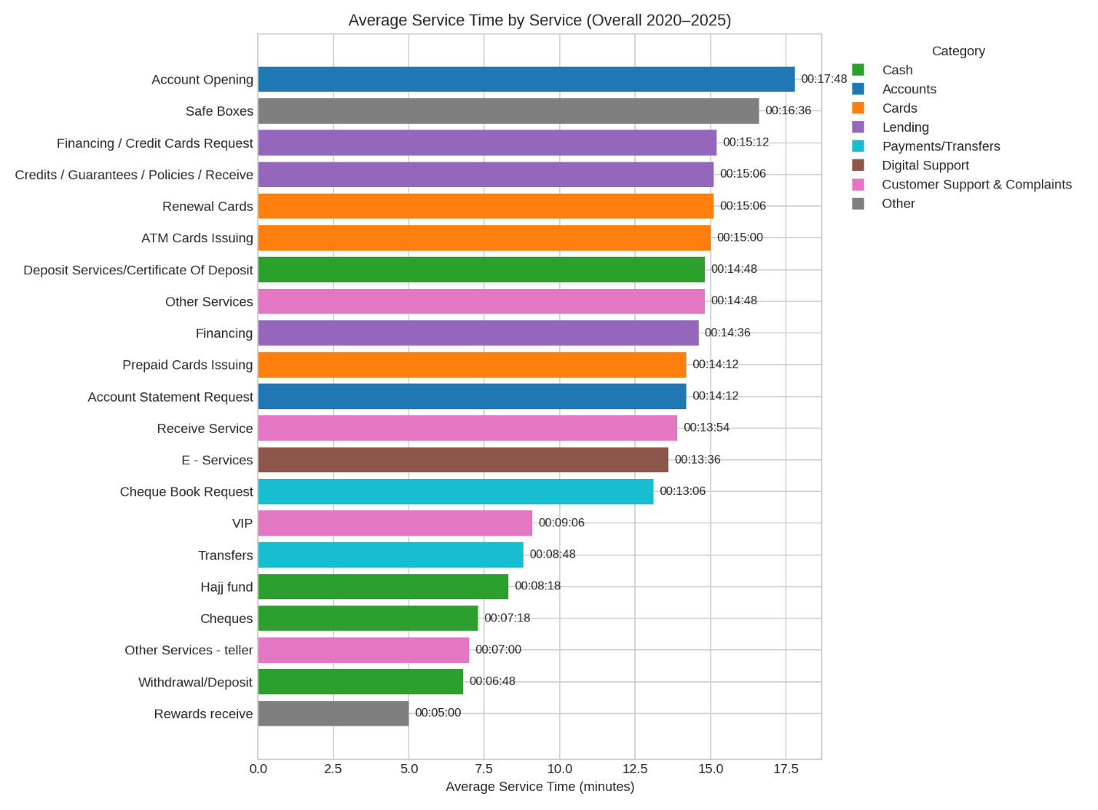

Key Observations
- Account Opening has the longest service time → a core operational bottleneck.
- Financing / Credit Cards, Deposit Services, and E-Services are slow services.
- Cheques and Withdrawal/Deposit remain the fastest.

🧠 Stronger Insights (From the Improved Charts)

🔥 True Bottleneck =2 High Arrival + High Service Time
- Withdrawal/Deposit
- Other Services
- Financing/Credit Cards
These three must be top priority for:
- Staffing allocation
- Queue system tuning
- Workflow redesign

⚠️ Hidden Bottlenecks = Medium Arrival + Very Long Service Time
- Account Opening
- Deposit Services
- E-Services
- Renewal Cards
These choke the branch even at moderate demand levels.

⚡ Fast Services = Best Flow
- Cheques
- Teller Other Services
- Hajj Fund

5) Served vs Not Served (Volumes) — Stacked
Focus: the absolute served vs not-served volumes by service.
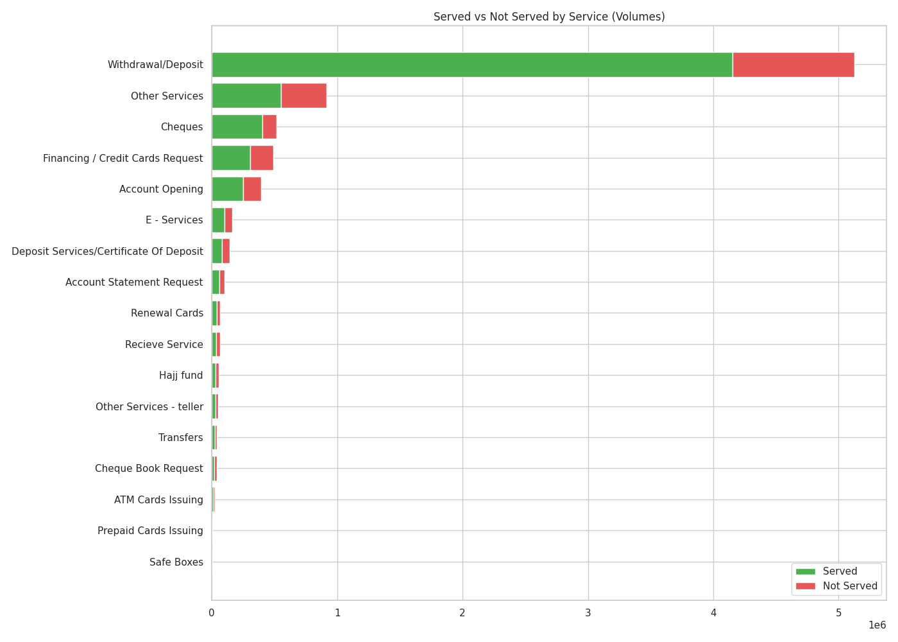
What it reveals:
- Even a modest % not served can translate to a large absolute volume when demand is high (e.g., Other Services, Withdrawal/Deposit).
- This highlights where lost demand is material and justifies intervention.

📊 1) Served vs Not Served (Stacked Bar) – 2020→2025
This chart shows actual customer throughput vs. abandonment, with total arrivals visualized as combined bar height.
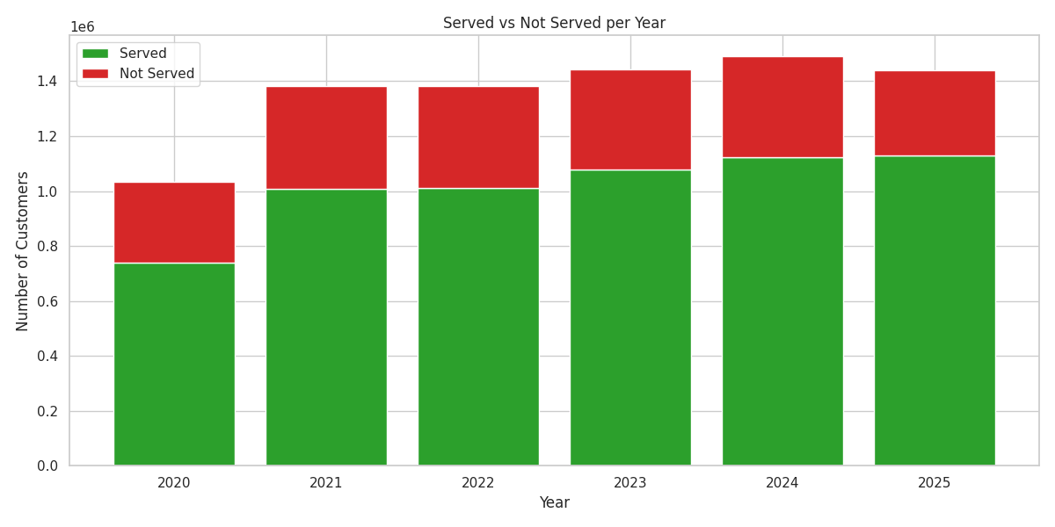

🔍 Quick insights:
- Total demand increased from 2020 → 2025 (except a dip in 2025).
- Not-served volume is shrinking, even as demand grows.
- Big improvement in 2024 & 2025—served volume reaches its peak.

📈 2) % Served Trend (Year-over-Year)
This shows the service effectiveness ratio (served ÷ arrived × 100).
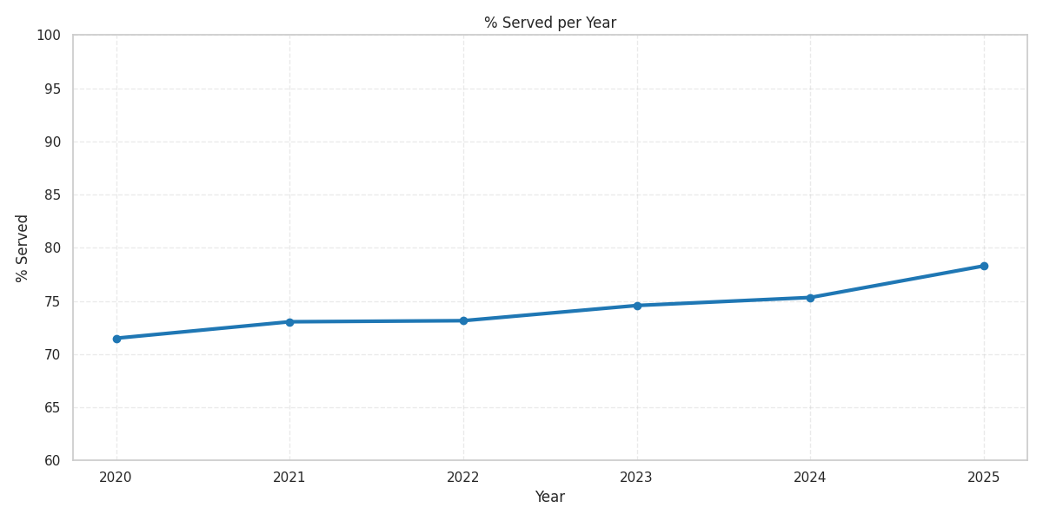

🔍 Insight:
- % Served improved from ~71% (2020) → ~78% (2025).
- 2024 and 2025 show the strongest service performance despite high arrival volumes.
- This confirms operational efficiency improvements and queue enhancements.

📈 3) Arrived vs Served vs Not Served (Line Trend)
This chart tracks demand, throughput, and abandonment on a single timeline.
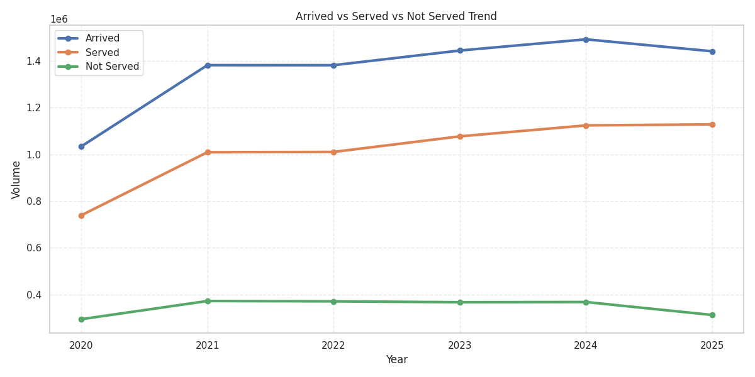

🔍 Key patterns:
- Arrivals peaked in 2024 (~1.49M).
- Served volume rises steadily each year.
- Not-served volume dropped sharply from ~300K+ (2020–2022) down to ~310K (2025).
- The gap between arrival and served lines is narrowing, reflecting better customer handling.

4) Not Served Rate by Service (Sorted)
Focus: where customers are most likely to abandon or not be served.
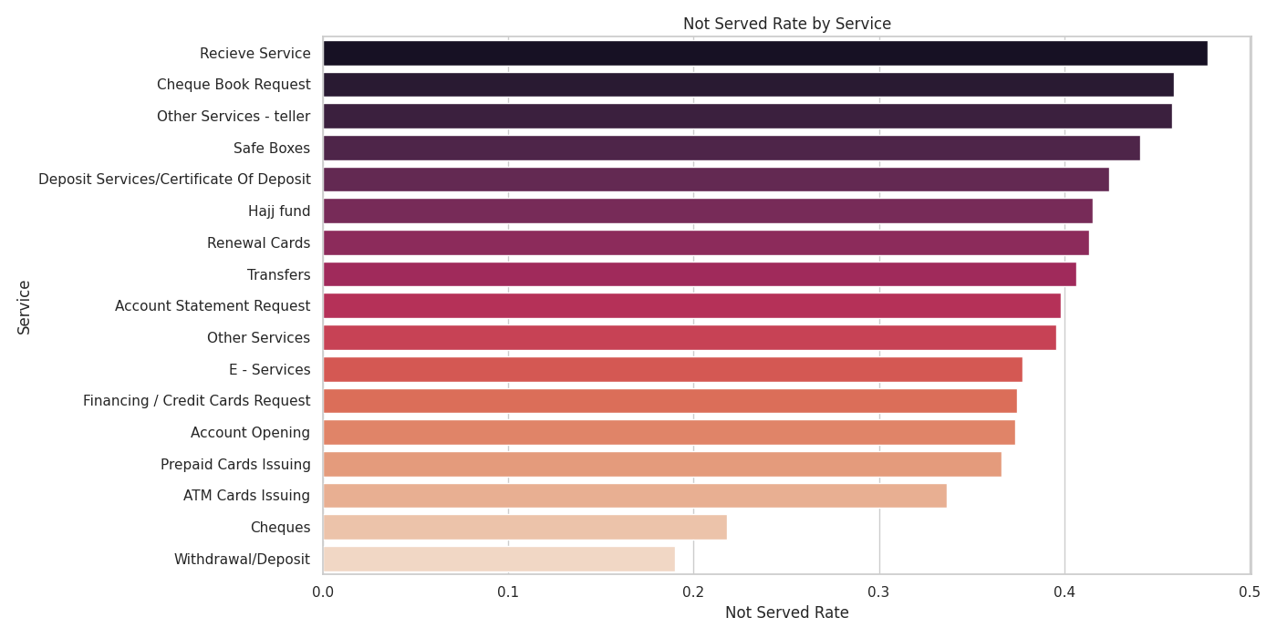
What it reveals:
- Account Opening, Financing/Credit Cards, Renewal Cards, E-Services, and Deposit Services have elevated not-served%, aligning with long service & wait times.
- Prioritize capacity smoothing (e.g., booking, pre-verification, document checks online) for these services.

🚦 Trend Direction 2020 → 2025 (change in avg wait)
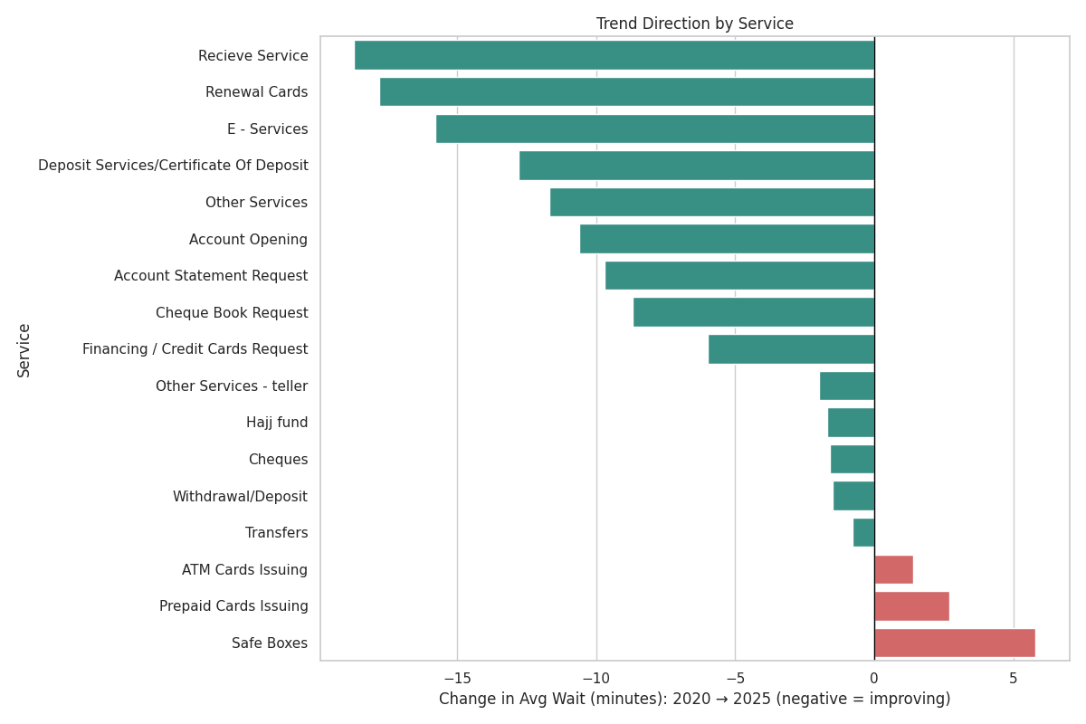
Improving (biggest drops in avg wait):
- Other Services: ↓ ~11.7 minutes
- Account Opening: ↓ ~10.6 minutes
- Deposit Services/Certificates: ↓ ~12.8 minutes
- E-Services: ↓ ~15.8 minutes
- Recieve Service: ↓ ~18.7 minutes (from ~28.9 to ~10.2)
- Renewal Cards: ↓ ~17.8 minutes
- Withdrawal/Deposit: ↓ ~1.5 minutes
- Cheques: ↓ ~1.6 minutes
Worsening:
- Safe Boxes: ↑ ~5.8 minutes (since 2022)
- A few low-volume services (e.g., some card/issuing categories) show minor residual long tails, but overall improved vs 2020.

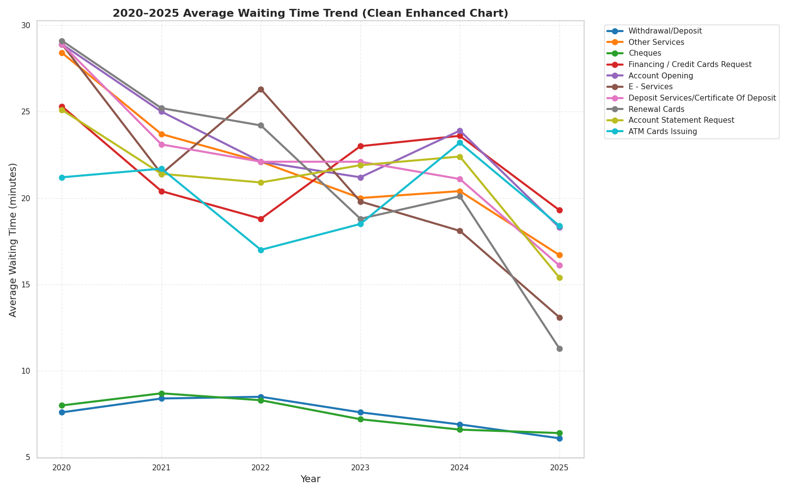

3) Are branches under operational pressure?
I looked at pressure from three angles: volume, waiting time, and non-served rate.

A) Where is the load (volume)?
Top 15 branches by served transactions:
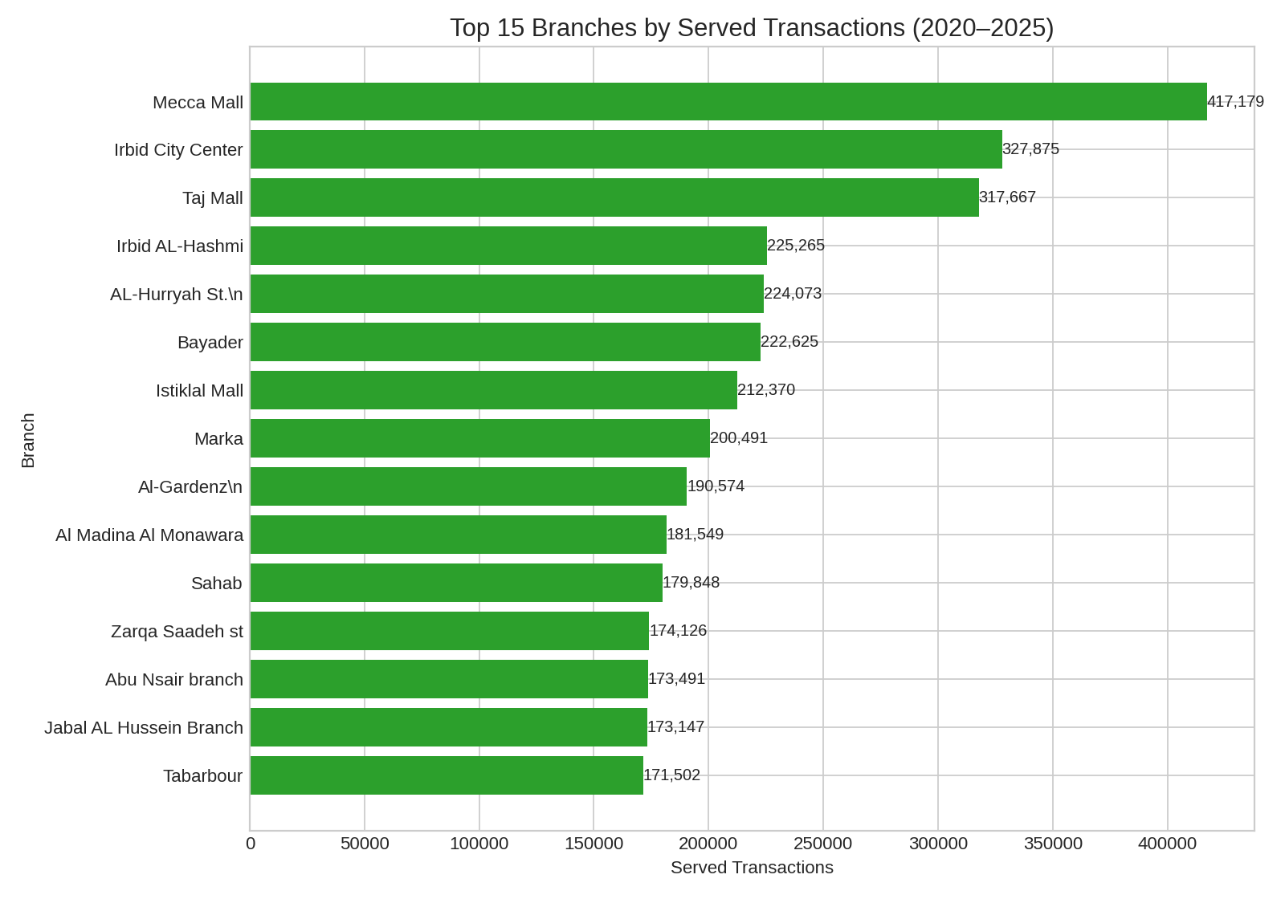
• Mecca Mall (417k), Irbid City Center (328k), Taj Mall (318k) lead the network by volume.
• These should be priority sites for staffing, counters, and self-service footprint.

B) Where are customers abandoning (non-served)?
Branches with the highest non-served rate (only where total ≥ 20k interactions):
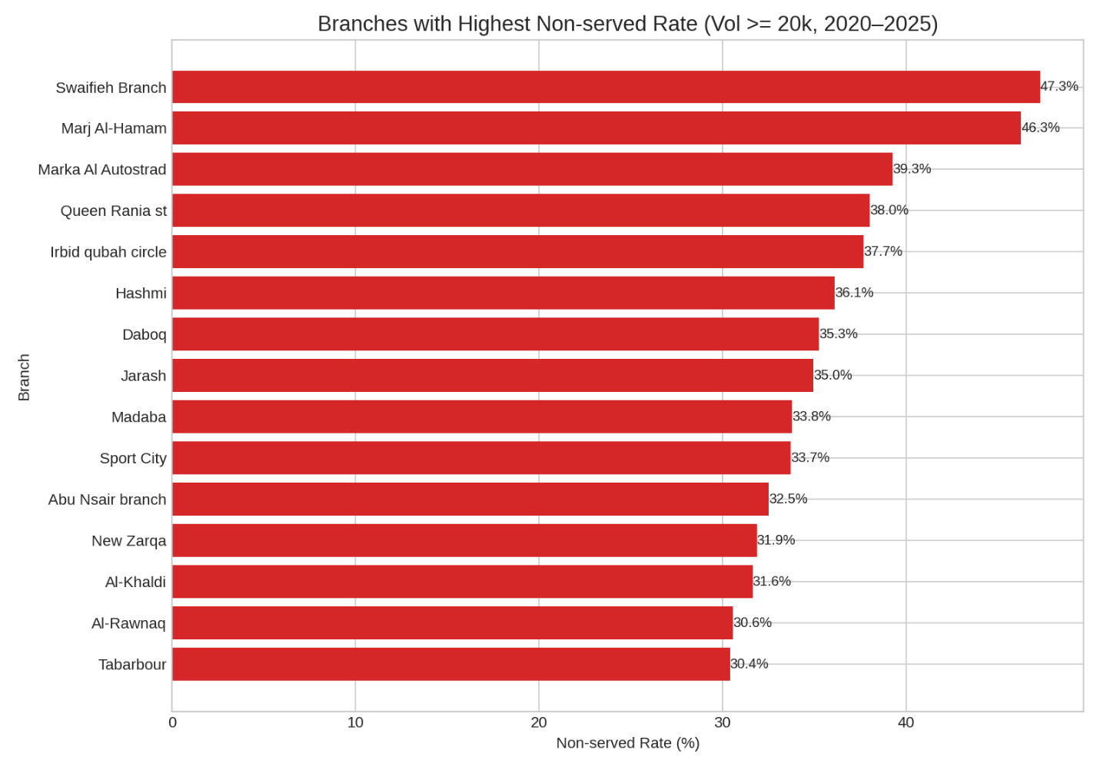
- Swaifieh Branch ~47.3%, Marj Al-Hamam ~46.3%, Marka Autostrad ~39.3%,
Queen Rania St ~38.0%, Irbid Qubah Circle ~37.7%, Hashmi ~36.1%, Daboq ~35.3%…
Interpretation
- Long waits correlate with higher non-served (expected).
- Some sites (e.g., Marj Al-Hamam, Irbid Qubah Circle) appear in both the long-wait and high non-served lists → strong candidates for intervention (queue design, capacity, appointment models, or digital migration for specific services).

📊 Workload (Hours) —

🔴 Top 5 Highest Workload (Worst Pressure)
These branches consume the most staff hours — heavy operational strain.
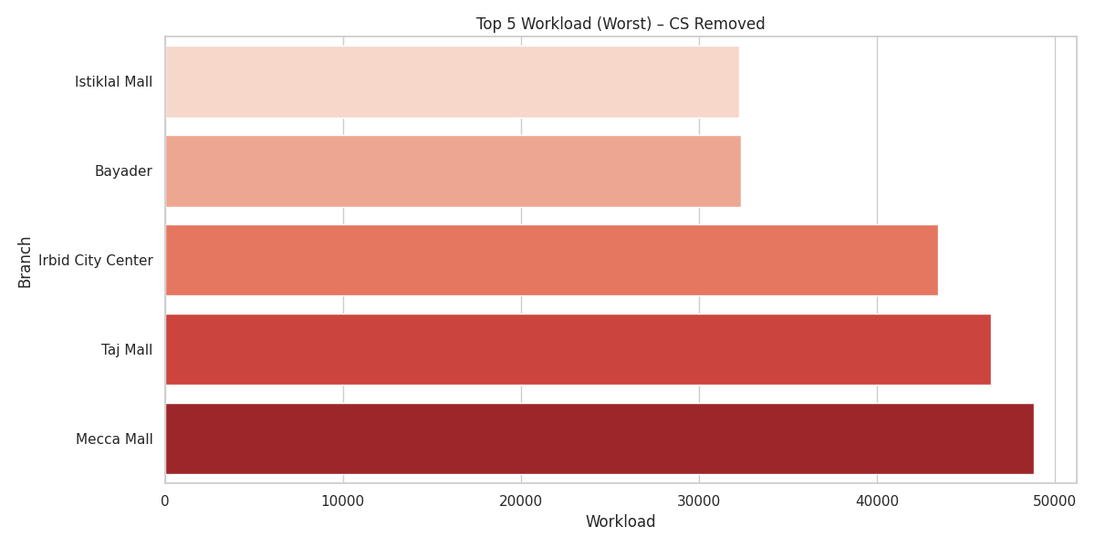

🔴 Bottom 5 “Worst” Regions (Lowest % Served)
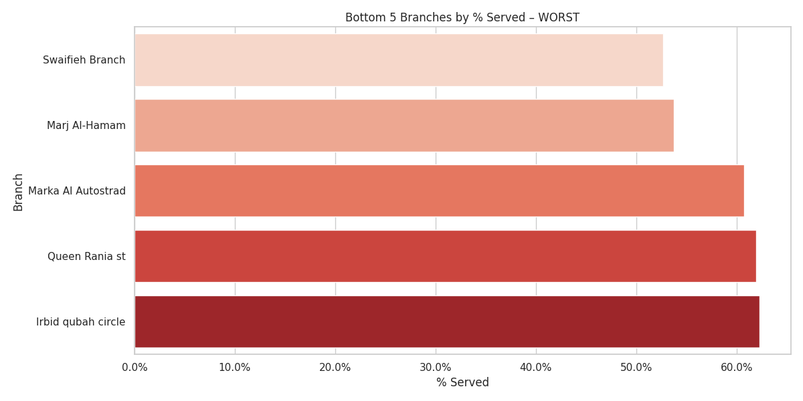
What this means: These branches see the highest drop-off / not-served rates—indicative of queues that are too long, insufficient capacity, or process friction.

🟢 Bottom 5 Lowest Workload (Best / Lightest Pressure)
Branches with lighter service-load burden.

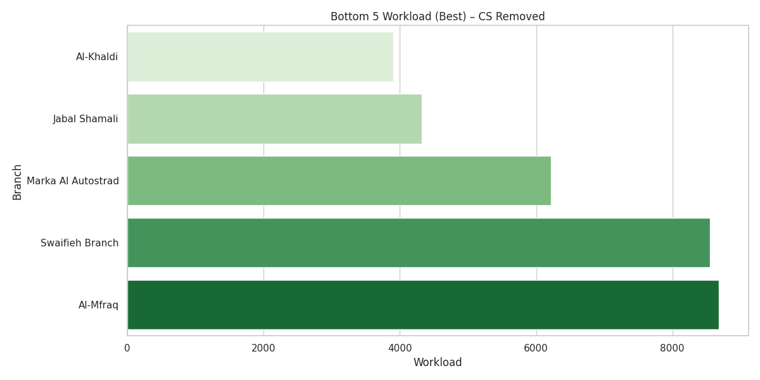

Top 5 (% Served Best — highest completion success)
These regions complete most of their service interactions successfully.
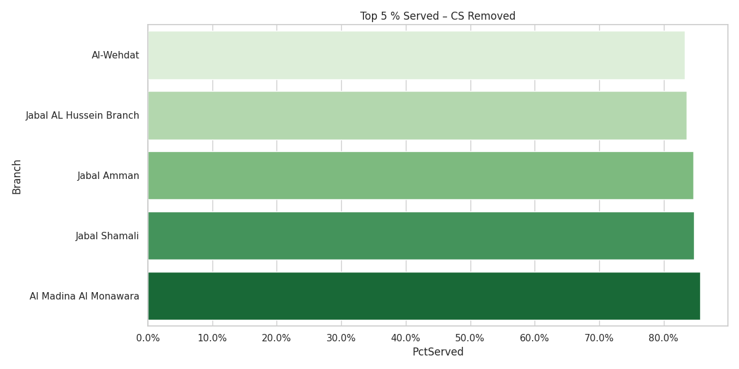

Metric ④ — % Served (Throughput Effectiveness)
How I computed it:
% Served = Served / (Served + Non-served) at the branch.

Early, data-backed insights (smooth narrative for management)
- What branches do (at scale): Nearly 7 in 10 visits are cash (Withdrawal/Deposit). The rest is split among Other Services, Cheques, and Sales/Advisory activities (new accounts, lending/cards).
- Why it matters:
  - If we lift cash efficiency (teller allocation, cash devices, self-service, queue logic), we improve customer experience for the majority of visits.
  - If we digitize routine requests inside “Other Services” (e.g., statement/KYC certs where policy allows), we shift meaningful traffic out of queues.
  - If we protect advisory time (account opening, lending/cards) with appointments or specialist desks, we raise conversion and NPS.
- Where pressure exists: A cluster of branches (e.g., Zarqa Mall, Irbid Qubah Circle, Jarash, Queen Rania, Abu Nsair, Istiklal Mall) carry both volume and delay.
- Non-served hotspots: A few branches exceed 35–47% non-served—that’s a red flag for queue design and/or mismatch between demand and capacity (days/hours/staffing or number of open counters).



Section 3 — Why Customers Visit Branches

Core role of branches
Branches are predominantly teller-driven with a growing role in problem resolution & guided support, plus steady sales & servicing of products:
- Cash handling dominates: withdrawals, deposits, cheques, CDs, and Hajj fund.
- Problem resolution & general servicing is becoming more prominent (Customer Support & Complaints cluster).
- Sales/onboarding (Accounts + Lending) remains material and slightly growing.
- Digital hand-holding (E-Services) is rising, showing customers still need in-person help to adopt digital.
- 1) Share of reasons (stacked by year)

- 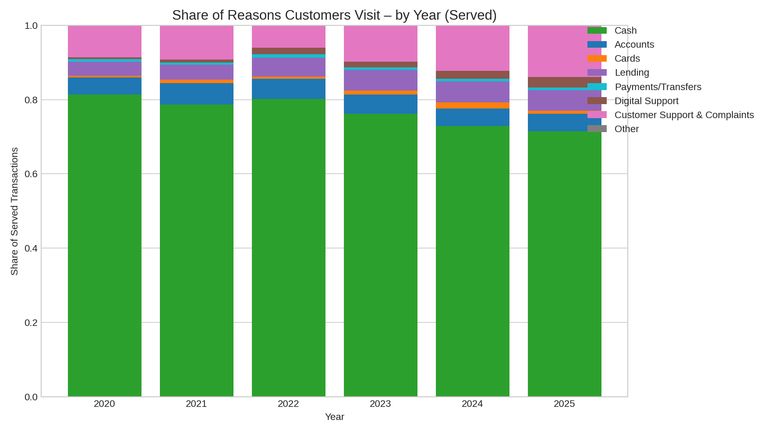

How to read: Each bar totals 100% of served interactions for that year. Colors show the share of each reason category.

2) Trend of each reason (served volumes, 2020–2025)
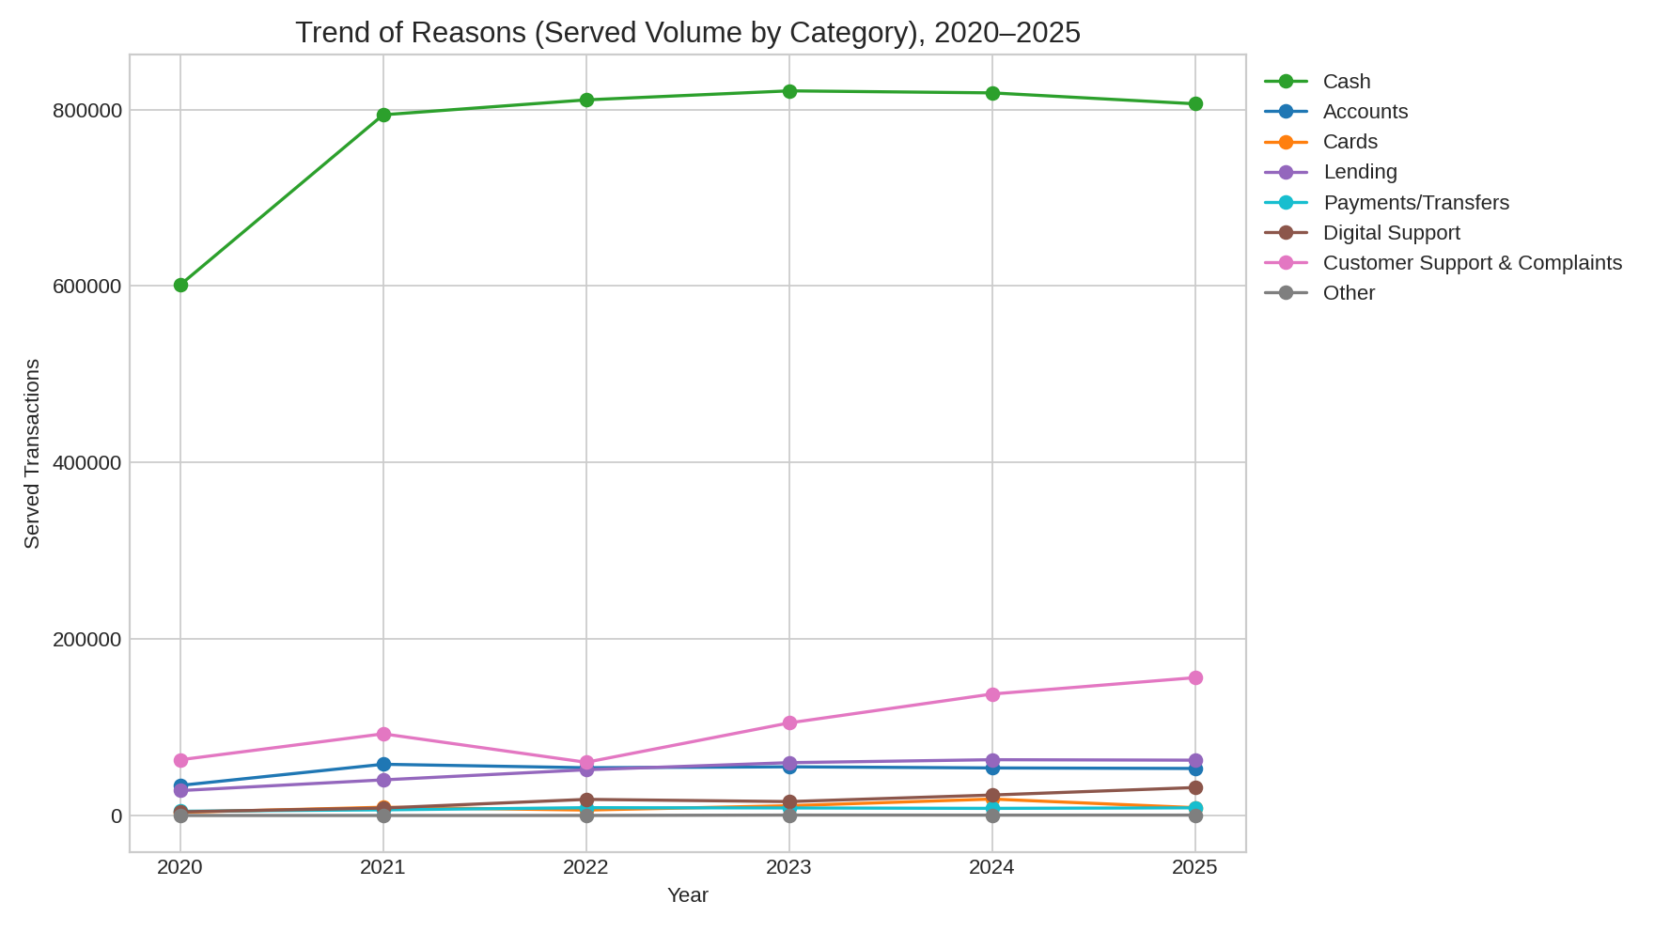
How to read: Lines show served volumes by category over time—useful for spotting growth/decline beyond proportional share.

3) Heatmap — share by category × year
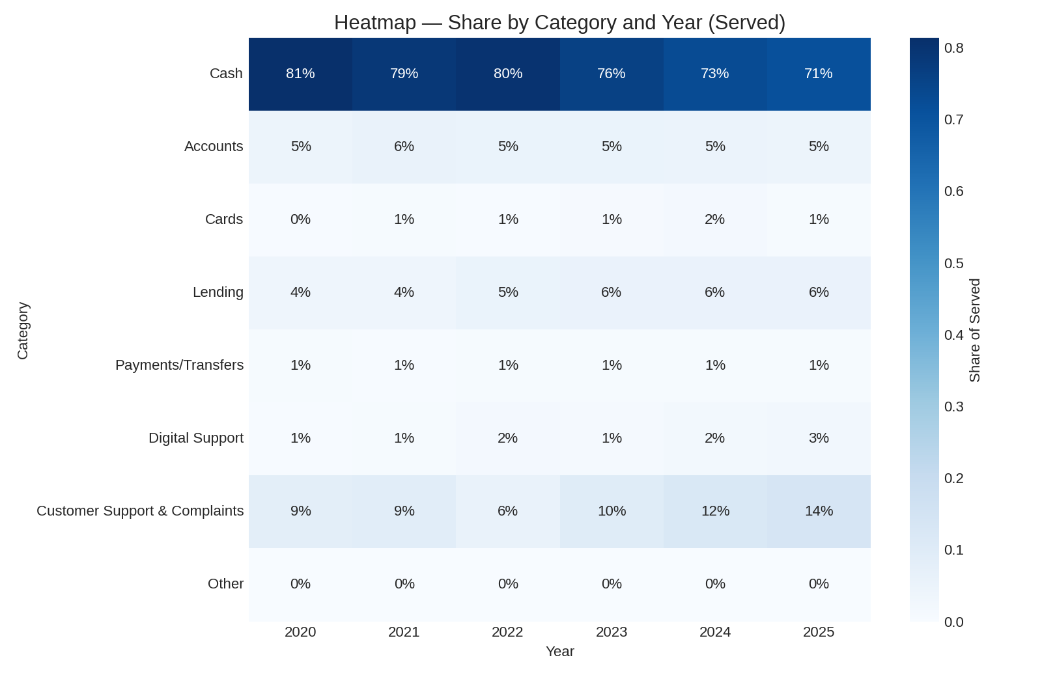

How to read: Darker cells indicate larger share of total served in that year.

A) Top 3 Reasons Customers Still Visit Branches (Overall 2020–2025)
This chart visualizes the overall breakdown of branch-visit drivers.
Cash remains the dominant reason (~76.4%), followed by:
- Customer Support & Complaints (~10.1%)
- Accounts (~5.1%)
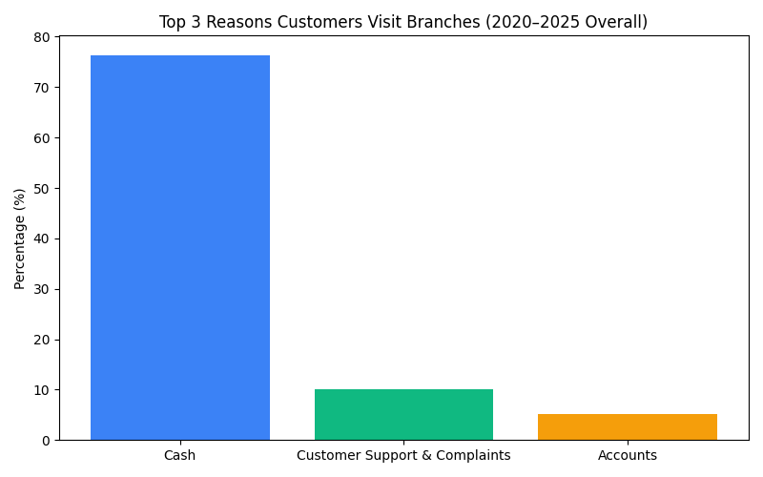

B1) Growth in Non-Cash Categories (Digital Support, Customer Support, Lending)
These categories are strongly increasing, indicating a shift toward advisory/support and digital-related needs.

Growth (2020 → 2025):
- Digital Support: 0.56% → 2.81%
- Customer Support & Complaints: 8.54% → 13.85%
- Lending: 3.82% → 5.55%
- 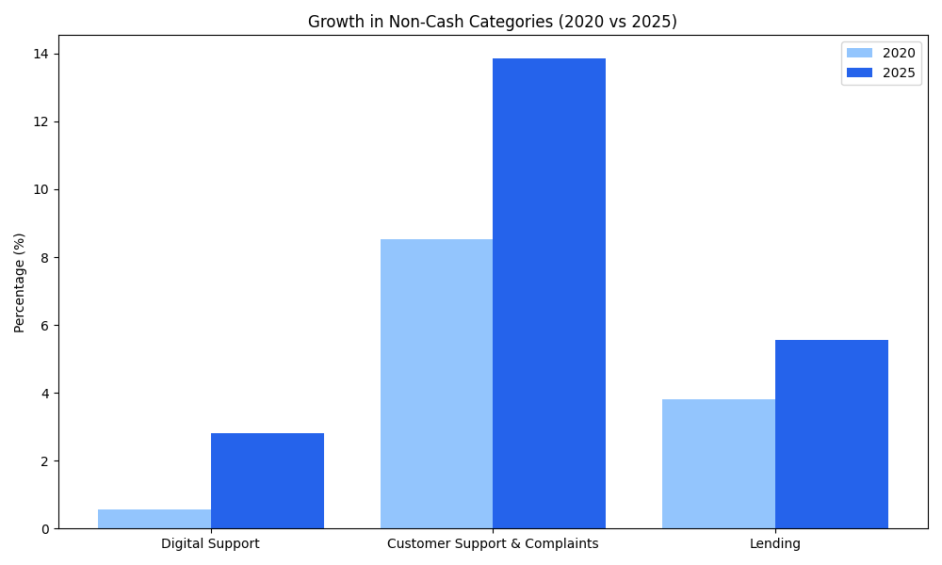

A) Arrivals per service per year (Top 10)
This shows the demand evolution for the largest services.
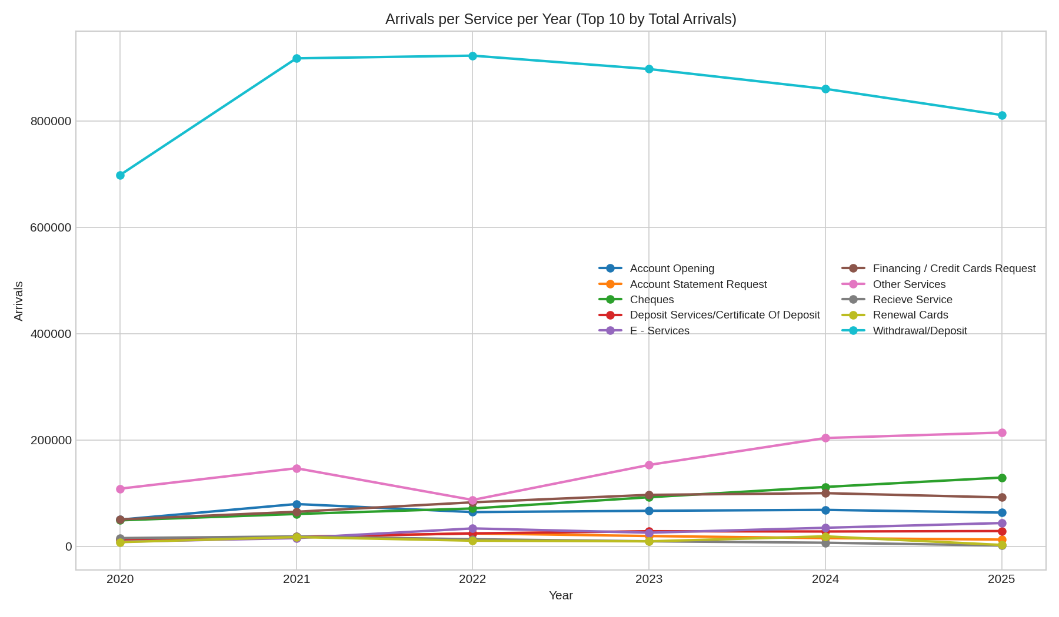

C) Momentum heatmap – YoY % change in arrivals (Top 10)
Where growth hits (greens) and slowdowns (reds).
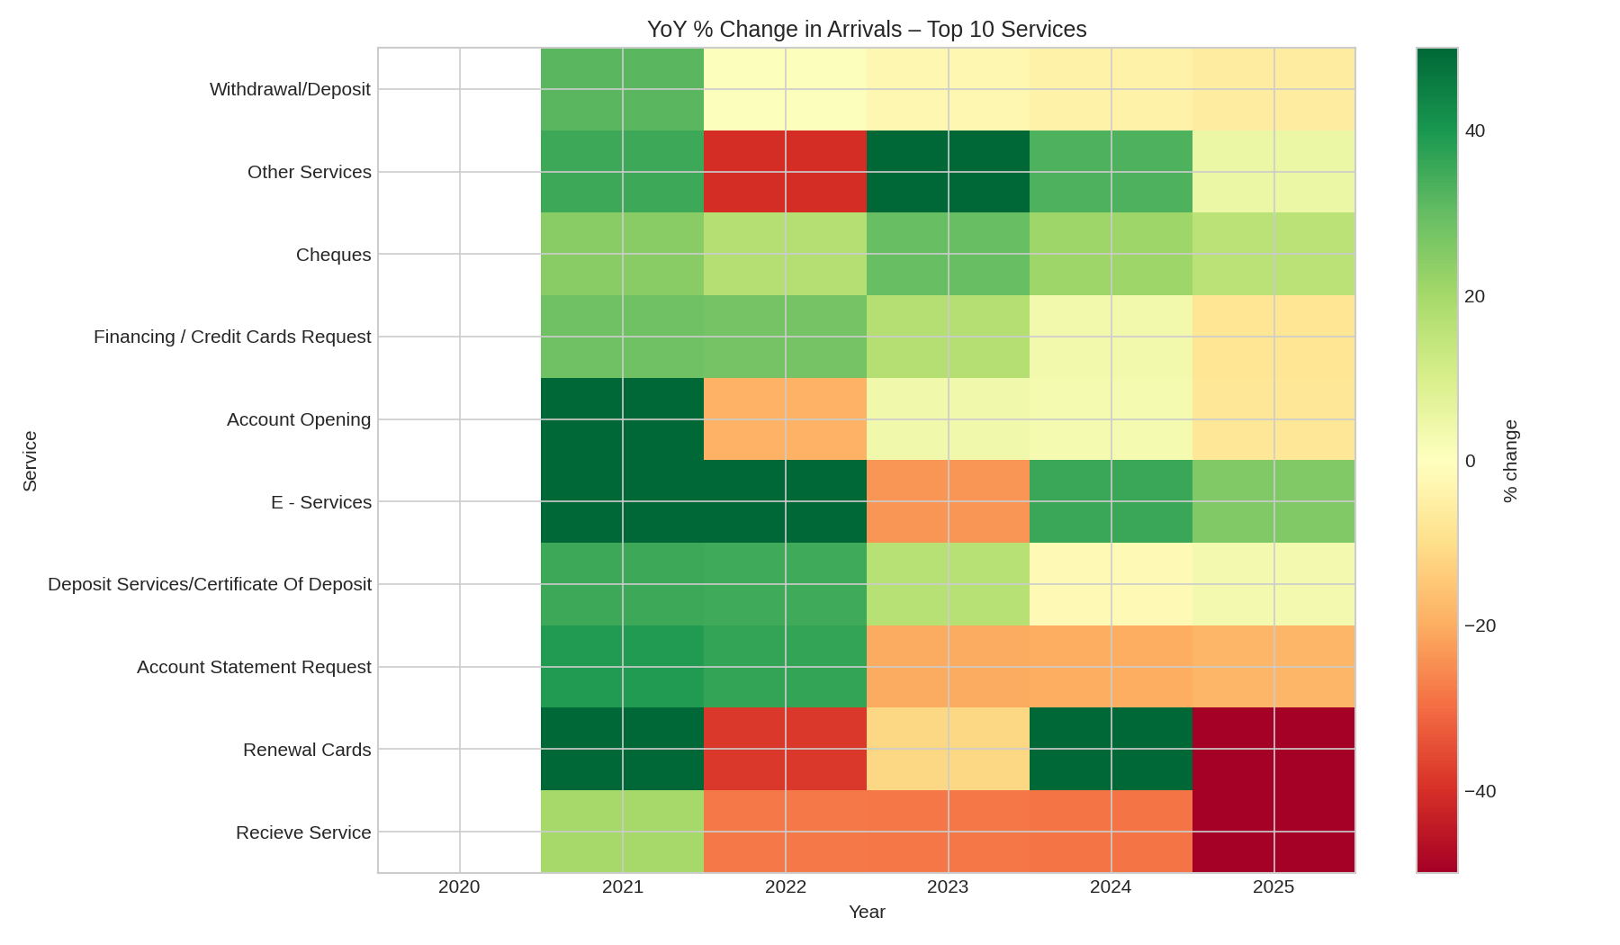

E) Directional trends (↑ ↓ →) — arrivals 2020 → 2025

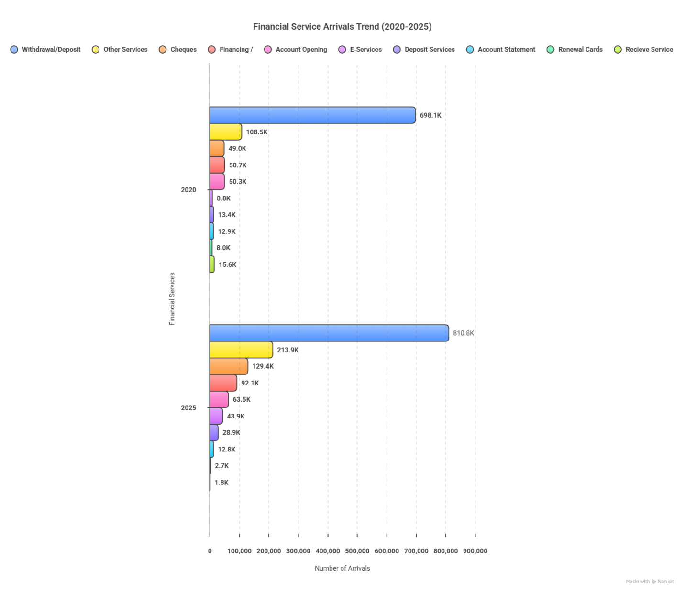

**F) What changed (behavioral storyline)
1) Cash remains dominant—but evolving
- Withdrawal/Deposit volumes rose modestly (+16%).
- Cheques grew strongly (+164%)—suggests heavier reliance by certain customer segments (e.g., SMEs/corporate deposits), or programs that drive cheque usage.
2) Service desk/advisory grew
- “Other Services” nearly doubled (+97%). This bucket often captures teller/desk requests that are partially digitizable (profile updates, fee disputes, information requests).
- E-Services support at branches is up nearly 5×. Customers are coming for “how-to digital” help—prime for guided self-service and digital ambassadors.
3) Sales/servicing is gaining share
- Financing / Credit Cards Request (+82%) and Account Opening (+26%) point to more sales-like or higher-touch interactions at branches—good for hybrid journeys (pre-fill digital → branch finalize).
4) Legacy requests are flattening or falling
- Account Statement Request is flat (≈–1%): this should be near-100% digital.
- Renewal Cards (–66%) and Recieve Service (–88%) are already migrating out of the branch—momentum to finish the job digitally (auto-issuance/courier, appointment pickup, digital document intake).
⚠️ Some services (e.g., ATM Cards Issuing) were not reported in 2020 and appear as ↑ by definition; treat those as newly tracked rather than true growth from zero.

G) Manual vs Digital — where to move next

Immediate Digital (end-to-end potential)
- Account Statement Request → online statements, historical downloads, certified PDFs.
- Cheque Book Request → digital request + courier or secure pickup by appointment.
- Transfers → already standard digital; keep nudging (promotions, in-app banners, fee incentives).
- Renewal Cards → auto-issuance, in-app tracking, courier/pickup lockers.
- E-Services support → funnel to chat/IVR/WhatsApp plus in-app “how-to” videos; only complex cases escalate.

Hybrid (digital intake + branch finalize)
- Account Opening → eKYC, OCR of IDs, selfie-match, digital form pre-fill; book branch slot for wet-signature or card/pin pickup if regulation requires.
- Financing / Credit Cards Request → digital pre-assessment, doc upload, e-signature where allowed; branch for advisory and closing.

Cash migration (reduce teller load)
- Withdrawal/Deposit, Hajj fund, Cheques
  - Expand CDMs/ITMs (cash recyclers), evening hours in high-traffic sites, “deposit-only” fast lanes, and smart envelopes.
  - Onboard heavy users at the lobby (digital ambassadors).
  - For Cheques: promote drop-box / scheduled cutoff, corporate deposit windows, and—if permissible—remote cheque deposit pilots for SMEs.

Teller triage → digital
- Other Services / Other Services – teller → build a triage catalog inside mobile/web: disputes, fee reversals, address/phone updates, stop payments, standing orders, balance/limit adjustments. Route to self-service or assisted chat first.

