Lam Le

CSC 375

Professor Bailey

Feb 2nd 2021

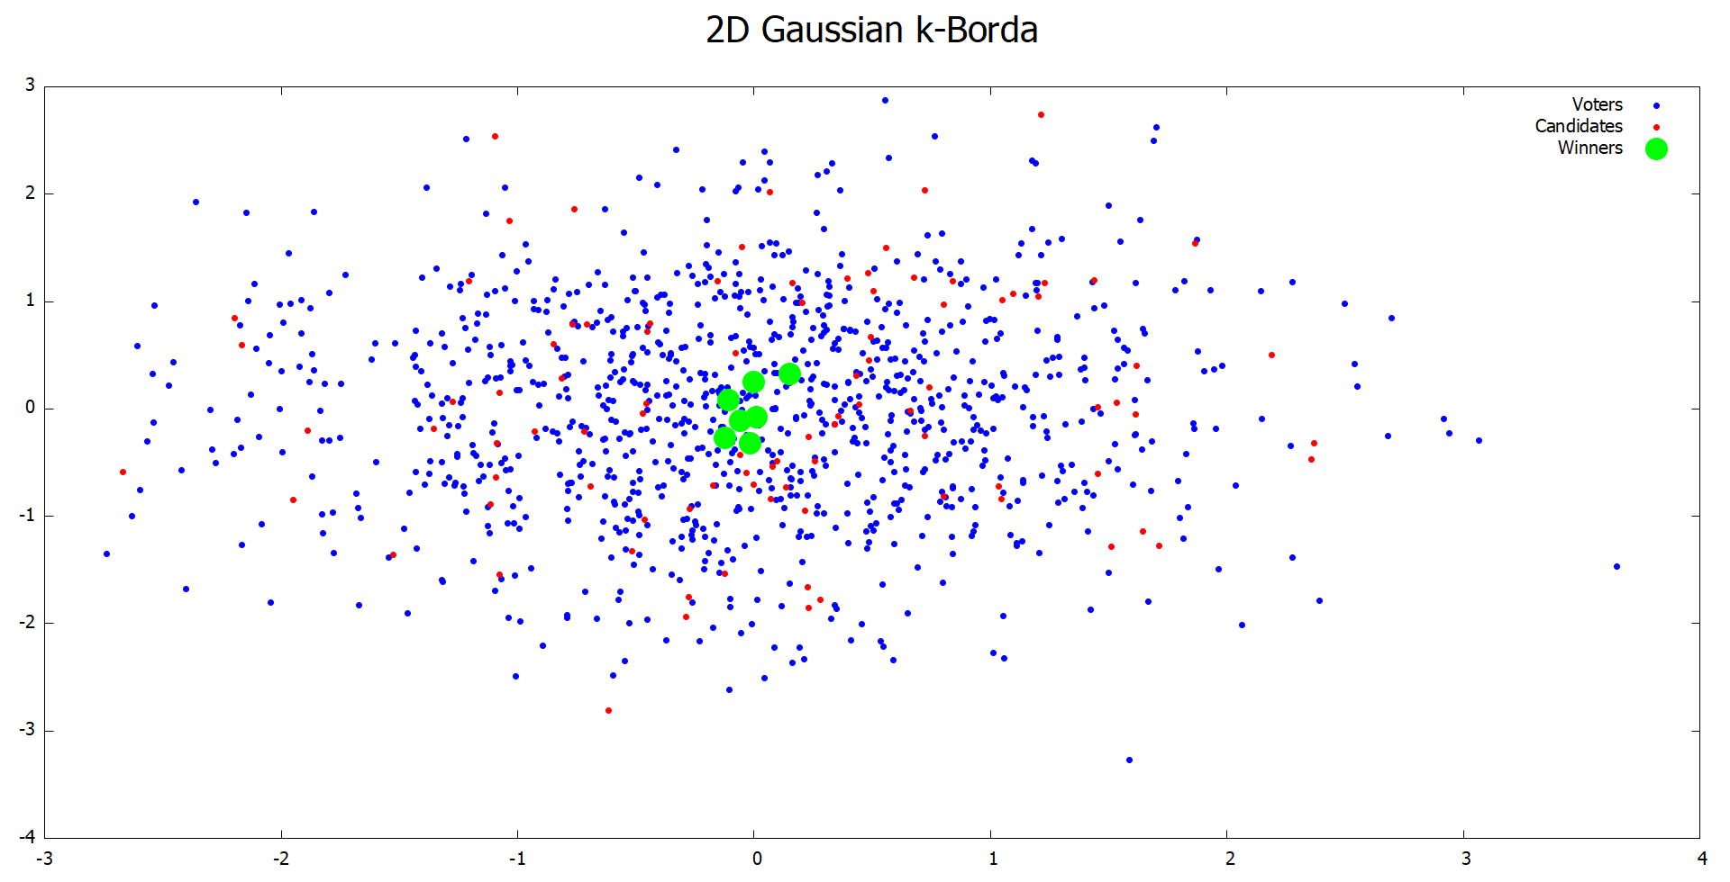

Figure 1: Scatter plot showing result of k-Borda rule in 2D Gaussian space. Blues represent Voters, Reds represent Candidates, Greens represent Committee Members.

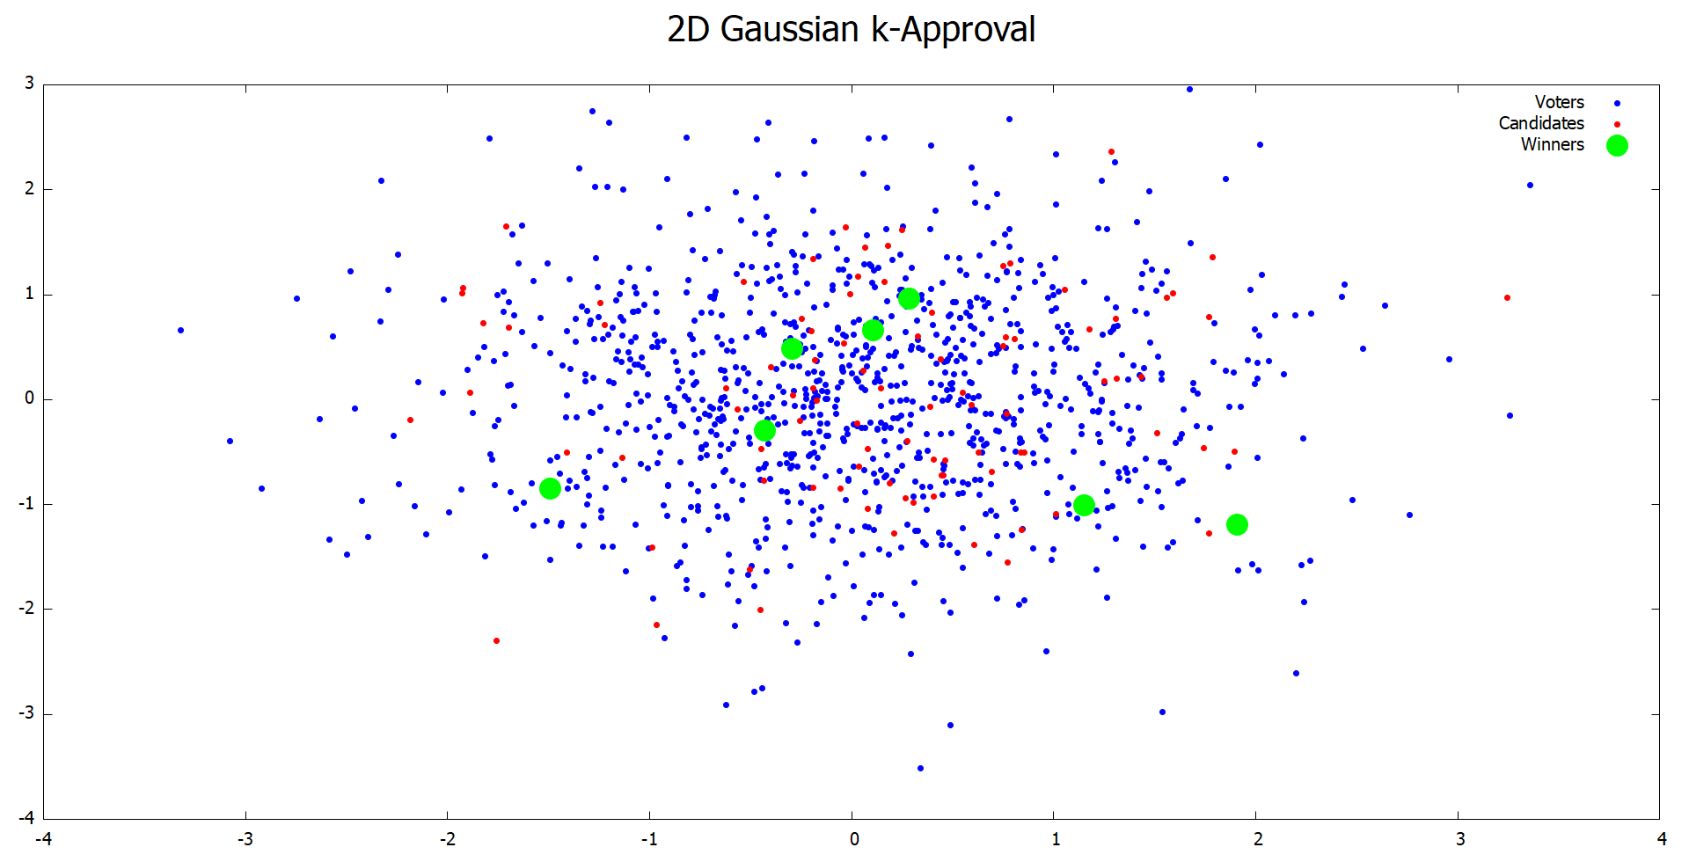

Figure 2: Scatter plot showing result of k-Approval rule in 2D Gaussian space. Blues represent Voters, Reds represent Candidates, Greens represent Committee Members.

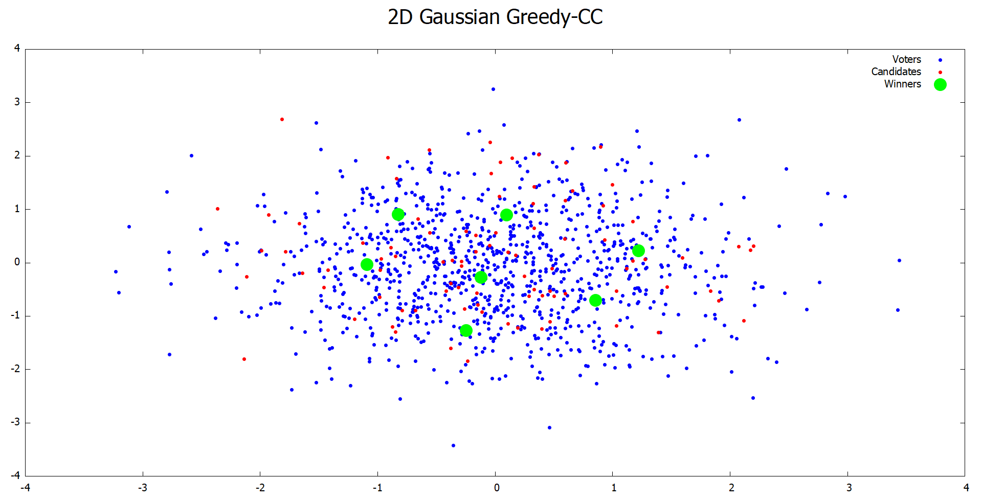

Figure 3: Scatter plot showing result of Greedy-Chamberlin Courant rule in 2D Gaussian space. Blues represent Voters, Reds represent Candidates, Greens represents Committee Members.

In the 3 rules, k-Borda’s plot appears to be the most excellence-based with committee members focused around (0, 0) and are close together. This is because candidates that have closest distance to every voters should be around the origin due to normal distribution, and k-Borda chose the best candidates. k-Approval’s committee members are the most spread out, showing more diversity-focused. No committee member is very close to (0, 0), but still in the first standard variation distance from the origin. It also appears to be proportional, as there are 4 committee members around the center where most of the voters are, and 3 committee members spread around the outer space because k-Approval assigns the same score to every approved committee member. Greedy-CC is in the middle of the spectrum, with the most preference member is the one with highest Borda score and is near (0, 0) and other members spread out but still stay close to where most voters are, because staying near most voters will brings them more marginal score. Greedy-CC shows both excellence-based and diversity-focused.