SUN PHARMA / ORGANON
Taro cash is part of the funding stack - not the strategic rationale
The accounts support a nuanced conclusion: Sun can and probably will use Taro-linked liquidity, but the size, legal structure and operating evidence do not support the view that Organon is primarily a cash-extraction transaction.
US$673m  Taro-linked liquid assets | US$556m  held in Sun Pharma Canada | ~US$540m  deployable after reserve/tax case | 4.6%  of Organon enterprise value
Our conclusion  Investor concern is directionally correct on one point: after Sun acquired the remaining Taro minorities in June 2024, the historic minority-governance constraint largely disappeared. There is no blanket legal clause that makes Taro cash unusable. The remaining constraints are ordinary corporate solvency, operating liquidity, tax leakage, transfer-pricing and cross-border financing rules.  The Organon merger agreement goes further: Sun Pharma Canada and Sun Pharma Netherlands are primary guarantors of the payment obligations, while the Indian parent is required to fund US$1.0bn. This explicitly puts overseas subsidiaries - including the entity holding most former Taro liquidity - inside the acquisition financing architecture.  However, Taro cash is economically too small to be the deal rationale. Headline liquidity is only 5.7% of Organon's US$11.75bn enterprise value. After a 60-day operating reserve and a conservative 5% Canada-to-Israel dividend withholding case, deployable cash is ~US$540m, or 4.6% of EV. | 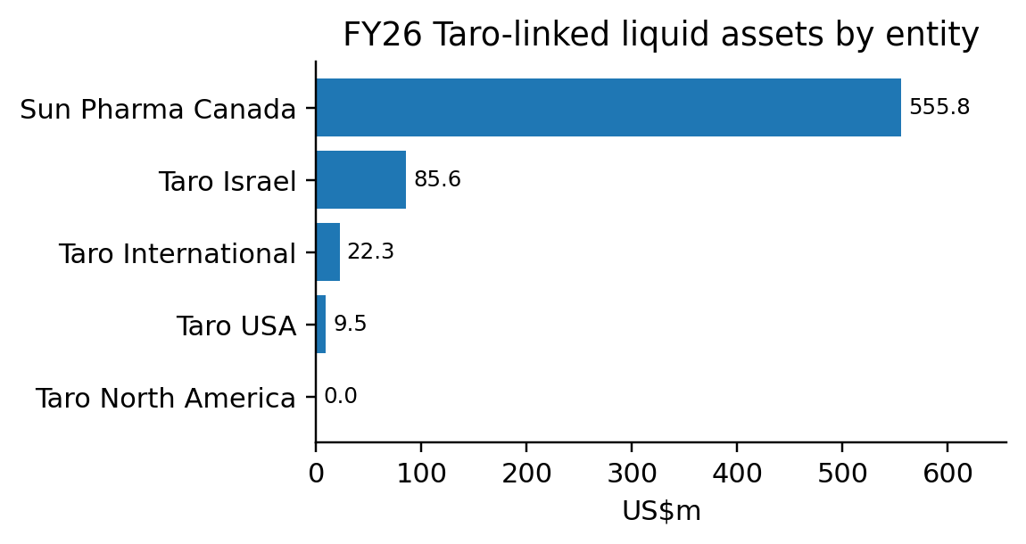  Canada holds 83% of the pool; cash is not evenly distributed.
FY26 legal-entity map: four operating entities, two effectively dormant shells
Entity | Primary role | Liquid  assets | Trade  AR | Inventory | Trade  AP | Analytical read-through
Sun Pharma Canada | Operating company; treasury and receivables purchaser | 555.8 | 177.6 | 114.7 | 21.7 | Core liquidity hub; still has real sales, inventory and rebate/accrual obligations.
Taro Israel | Manufacturing, R&D, IP and Taro parent | 85.6 | 58.0 | 65.8 | 16.6 | US$138m of FY26 sales were to connected entities; economically integrated supply node.
Taro International | Small Israel/overseas marketer | 22.3 | 11.7 | 7.6 | 4.1 | Modest operating subsidiary; some affiliate receivables.
Taro USA | Legacy US distributor; LRD moved to Sun US | 9.5 | (6.6) | ~0 | 16.6 | Sales fell to US$62m and inventory to near-zero; balance sheet is dominated by intercompany balances.
Taro North America | Non-operating holding/goodwill shell | ~0 | - | - | - | No sales; US$373m asset base is almost entirely goodwill.
Taro Pharma Corp. | Dormant shell | ~0 | - | - | - | US$1 total assets; no operating relevance.
Gross total* |  | 673.3 | 240.7 | 188.2 | 59.0 | Before consolidation eliminations; Taro USA trade AR is a credit balance.
*US$m. Liquid assets include cash, short-term deposits and marketable securities; Taro USA includes US$6.5m of long-term marketable securities. Standalone accounts use different accounting bases and include intercompany items, so totals are directional and not a substitute for consolidated cash.
Cash by instrument and what is actually fungible
Instrument | US$m | % of pool | Accessibility / constraint
Cash and cash equivalents | 407.6 | 60.5% | Most fungible, but remains subject to operating liquidity and local solvency tests.
Short-term bank deposits | 90.0 | 13.4% | Near-cash; maturity timing is the principal practical constraint.
Current marketable securities | 169.2 | 25.1% | Generally monetisable, subject to market value, settlement and tax effects.
Long-term marketable securities | 6.5 | 1.0% | Smaller and less immediate; concentrated in Taro USA.
Total | 673.3 | 100.0% | Headline pool before operating reserves, tax leakage and consolidation eliminations.
Why the question existed  Before the June 2024 take-private, Taro had public minorities and an independent-board/fiduciary framework. Sun could not simply upstream cash for its sole benefit without minority-protection scrutiny. Full ownership largely removes that governance conflict. | What remains today  There is no disclosed blanket cash-trapping clause. The merger documents name Sun Pharma Canada and Sun Pharma Netherlands as primary payment guarantors, while the Indian parent is required to provide US$1.0bn. Remaining frictions are solvency, withholding tax, transfer pricing and foreign-investment rules.
Analyst interpretation. The 2024 privatisation removes the former minority-shareholder conflict; it does not eliminate ordinary legal-entity and tax constraints.

THE MECHANISM AND THE INVESTMENT DEBATE
The cash can move - but the accounts show an operating treasury architecture, not a one-off sweep
How funds can be deployed  • Direct foreign funding/guarantee: Sun Pharma Canada is a named primary obligor in the merger agreement, allowing foreign liquidity to support the US acquisition without first being repatriated to India.  • Dividend upstream: legally possible after board approval and solvency tests, but a Canada-to-Israel dividend may attract 5% withholding under the treaty where the 25% ownership test and beneficial-ownership conditions are met.  • Intercompany loan or capital contribution: feasible subject to local corporate, tax, transfer-pricing and financing rules. This route can avoid treating the full movement as a dividend.  • Working-capital financing: already occurring. Sun Canada purchased US$1.197bn of Sun Inc. receivables in FY26; US$489m remained outstanding at year-end.  • Cash sweep is not costless: Canada still carries US$378m sales, US$178m trade AR, US$115m inventory and US$109m current liabilities, so part of the pool is operating capital. | 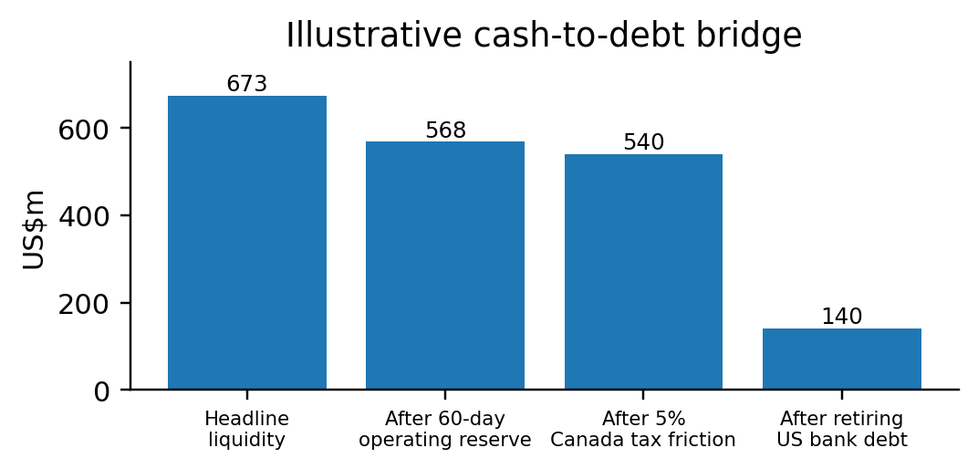  Illustrative, not company guidance. The 5% tax friction applies only to a dividend route; direct financing may differ.
AR/AP and export-revenue lens
Metric | US$m | % of Sun FY26 ex-India  formulation sales | What it means
Sun Pharma Canada sales | 377.7 | 9.1% | Cleanest lower-bound proxy for the Taro franchise: ~9% of ex-India formulation revenue.
Taro Israel connected-party supply | 138.3 | 3.3% | Shows manufacturing/export flow into Sun, Canada and legacy Taro USA; not additive to Canada sales.
Gross trade receivables** | 247.3 | 6.0% | Only ~22 days of ex-India sales; does not support a large operating-cash lock-up.
Gross inventory | 188.2 | 4.5% | Equivalent to ~17 days of ex-India sales; concentrated in Canada and Israel.
Gross trade payables | 59.0 | 1.4% | Small relative to revenue; net trade working capital remains asset-heavy.
Net trade working capital | 376.5 | 9.1% | US$376m, or ~9% of ex-India sales, before intercompany eliminations.
**Excludes Taro USA's US$6.6m credit balance in trade receivables. Sun FY26 ex-India formulation sales = US$4.138bn (US US$1.904bn, Emerging Markets US$1.265bn, Rest of World US$0.969bn). Legal-entity sales and working-capital items are not fully additive due to intercompany trade.
Why the Organon rationale extends beyond access to Taro liquidity
1. The size test rejects a cash-driven explanation. The ~US$540m deployable case is 4.6% of Organon EV and 22-27% of Sun's planned US$2.0-2.5bn cash contribution. It improves funding efficiency, but it cannot justify a US$11.75bn transaction.  2. The operating reorganisation predates the deal. Taro USA's sales fell from US$326m to US$62m and inventory went to near-zero as the limited-risk distribution business moved into Sun US. This is a commercial integration and working-capital simplification, not merely a balance-sheet extraction. | 3. The strategic assets are identifiable: Organon adds women's health, a global established-brand platform, biosimilars, China scale and 150-market reach. Management expects innovative medicines to rise from 20% to 27% of combined sales and targets US$350m of cost synergies.  4. The real investor question is return on capital, not cash provenance. Sun expects 2.3x net debt/EBITDA at closing and US$2.0-2.5bn annual combined free cash flow. Execution should be judged on deleveraging, preservation of R&D investment and growth of women's health/biosimilars.
INVESTOR TAKEAWAY: Taro liquidity is available and embedded in the financing architecture, so investors should expect part of it to fund Organon. But the evidence supports 'financing optimisation around a strategic acquisition', not 'an acquisition undertaken to unlock Taro cash'. The latter thesis fails the size test and ignores the operating integration already visible in receivables, inventory and distribution flows.
What investors should monitor through closing and deleveraging
Monitor | Base-case expectation | Red flag | Read-through
Funding mix | Taro/Canada liquidity contributes to the US$2.0-2.5bn cash component; the balance is bank debt. | A large pre-close cash extraction with limited disclosure on tax or working-capital needs. | Confirms whether cash is funding optimisation or the central transaction objective.
Debt paydown | US$2.0-2.5bn annual combined FCF drives rapid deleveraging from ~2.3x net debt/EBITDA. | Cash remains offshore while acquisition debt persists or refinancing costs rise. | Most important near-term determinant of EPS and equity value.
Innovation investment | R&D remains protected while Organon adds women's health, biosimilars and global commercial reach. | Material R&D cuts are required to meet synergy or leverage targets. | Would weaken management's innovation-led strategic argument.
Working capital | Receivables factoring and LRD integration continue to simplify US operations. | Taro/Canada AR or inventory rises without matching sales growth. | Tests whether the treasury architecture remains operationally grounded.
Sources: FY26 standalone financial statements of Taro Pharmaceutical Industries, Sun Pharma Canada, Taro USA, Taro International, Taro North America and Taro Pharma Corp.; Sun Pharmaceutical Holdings USA FY26 special-purpose consolidated statements; Sun Pharma FY26 Annual Report; Organon merger agreement dated 26 April 2026; Sun Pharma-Organon investor call transcript; Canada-Israel Income Tax Convention. Estimates and bridge scenarios are analyst calculations.

