Shaily Engineering
Shaily has a confirmed pen customer in Canada and a probable route into Brazil through Adalvo. Canada also has a specific quality event: one Apotex starter-pen lot may display and deliver the full 2 mg contents in a single injection. We think Axiom Max is the leading candidate for Shaily's planned innovator partnership, while Mira still requires a drug development partner. [3–10, 14]

Brazil
There are three supply groups to track beyond Novo Nordisk. EMS launched Ozivy from its Hortolândia operation, which it says integrates peptide and pen production. Sun supplies semaglutide for its own Brazilian labels and Hypera's Semavy; those registrations belong to the same supply arrangement. Adalvo developed Owozy, which Sandoz will supply and Biolab will promote when it reaches pharmacies. [1–3, 18]
Our best estimate for Shaily is Adalvo. Shaily names Adalvo as a customer, a Shaily executive linked their pen partnership to Adalvo's Brazilian approval, and Shaily reported Brazil orders following partner approvals. Adalvo also says it dual-sources pens, so Shaily's share of Owozy cannot be inferred. Sun is another possible route: press reporting names it as a Shaily customer. EMS describes local pen production and does not identify an external mechanism maker. [2, 4–7, 19]

Canada
Apotex's Apo-Semaglutide uses Shaily's Neo pen through Orbicular. The starter pen contains 2 mg in total and is meant to select either 0.25 mg or 0.5 mg per injection. On 27 August, Health Canada recalled lot 7000599A, DIN 02568020, because it may show and deliver 2 mg instead. That is eight times a 0.25 mg starting dose or four times a 0.5 mg dose. Apotex's instructions say the starter pen should stop at 0.5 mg. Affected-unit count, patient outcome, root cause and corrective action have not been published. [8–10]
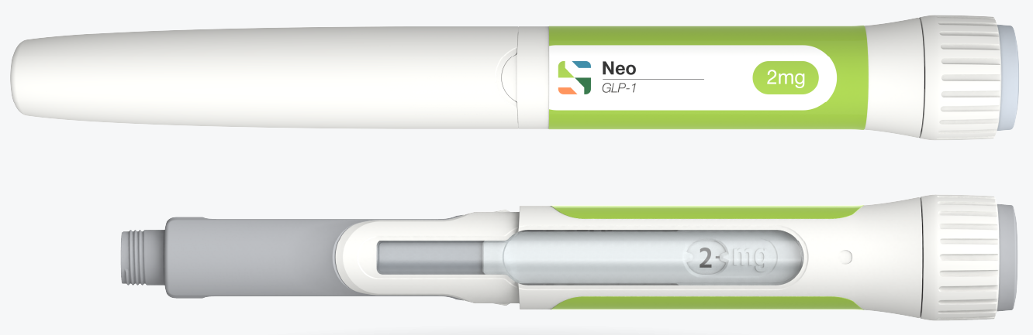
Shaily’s Neo platform, shown in its product material. The 2 mg marking describes the pen presentation; this is not an image of Apotex lot 7000599A or the reported dose error. Source: Shaily. [20]
The earlier complaint log of Shaily does not explain this recall. On 20 May, Shaily reported one user error and one issue with printed dose numbers when asked about India and Canada together; it did not identify their countries. On 10 August it described few performance issues and stable batch tests. The recall came later and describes possible delivery of 2 mg, so the link to the earlier print issue is unproven. A mix-up with Apotex's other approved pen is not an adequate explanation by itself: the 4 mg presentation also limits injections to 1 mg. [7, 9–11]
Canadian patient posts raise a separate usability question. One person changing from Ozempic to Apotex reported slower delivery and a drop on the skin; another mentioned pain, while a third had no problem. Users also discuss carrying click-count habits across brands. Apotex says to hold the needle in place for a slow count of six after the window reaches zero and prohibits selecting a dose by counting clicks. None of those posts gives a lot number or a measured delivered dose, so they cannot establish the cause or frequency of the recall issue. [10, 12, 13]

Innovator partnership
Axiom Max is our leading platform estimate. Shaily said in November 2025 that it designed this fixed-dose pen with next-generation GLP-1 innovators in mind and had held 18 meetings for it at three exhibitions. Neo was also being discussed with innovators, making it the second candidate. It had previously said that a selected Axiom Max programme would normally take three to four years to reach market, so an announcement would most likely mark a development award rather than commercial shipments. [7, 14]

Mira and Sarclisa
Mira can accommodate the 10 mL volume of Sarclisa Escena on paper. Sanofi's approved product uses Enable Injections' CirCLIQ and reported a median on-body delivery time of 13 minutes in its pivotal study. Shaily lists Mira at up to 20 mL, but described it in August as a prototype awaiting a partner; 3–15 mL appeared feasible and 23 mL uncertain. For now, Enable is the device supplier to the approved product. [7, 15–17]

Sources
[1] Anvisa, Brazilian semaglutide approvals, July 2026
[2] EMS, Ozivy production and pen capacity
[3] Biolab and Sandoz, Owozy supply and launch
[4] Adalvo, semaglutide pen double sourcing
[5] Shaily FY26 annual report, named customers
[6] Shaily executive, Adalvo Brazil relationship
[7] Shaily Q1FY27 call, Brazil and innovator comments
[8] Shaily and Orbicular, Apotex Neo pen
[9] Health Canada, Apotex dose display recall, 27 August
[10] Apotex, Canadian monograph, pages 48–52
[11] Shaily Q4FY26 call, May customer complaints
[12] Canadian user discussion, Apo pen experience
[13] BC Diabetes, device click differences
[14] Shaily Q2FY26 call, Axiom Max and Neo innovator focus
[15] Shaily, Mira platform specification
[16] FDA, Sarclisa Escena prescribing information
[17] Sanofi, Sarclisa Escena and Enable CirCLIQ
[18] Sun, Brazil approval and Hypera arrangement
[19] NDTV Profit, Shaily general customer reporting
[20] Shaily, official Neo platform product image

