VAT GROUP AG (SIX: VACN) | RECORD BACKLOG, CAPACITY CATCH-UP, EARNINGS UPGRADES
RECOMMENDATION  BUY | PRICE  CHF 602 | TARGET PRICE  CHF 785 | UPSIDE  +30% | MARKET CAP  CHF 18.1bn | HORIZON  12 months | PRIMARY CATALYST  Q3 update, 15 Oct  2026
1. INVESTMENT THESIS
Buy VAT. H1 2026 order intake of CHF 856m and backlog of CHF 648m give unusually high visibility into a 2027 revenue step-up, while quarterly factory capacity is moving from c.CHF 320m at June-end to >CHF 450m by year-end. Public consensus still models CHF 1.64bn revenue and CHF 589m EBITDA in 2027; we forecast CHF 1.90bn and CHF 703m as backlog converts and temporary ramp costs unwind. At 33.5x our 2027E EBITDA, the shares are worth CHF 785, implying 30% upside from CHF 602. VAT's >70% market share, exposure to vacuum-heavy deposition and etch, and high-margin service base support the premium.
2. VARIANT PERCEPTION
PREVAILING VIEW | Record orders are an AI-cycle pull-forward. Hiring, supplier bottlenecks and foreign exchange will delay margin recovery, while VAT's premium valuation already discounts the 2027 wafer-fab-equipment upcycle.
OUR VIEW | Orders are leading revenue by 6-12 months. The constraint is output, not demand. Management is lifting factory run-rate by >40% from the June exit level to >CHF 450m per quarter by year-end - an annualized revenue base above CHF 1.8bn before further 2027 productivity.
WHY DIFFERENT | Consensus extrapolates H1's 29% margin and underestimates conversion. Q2 orders were CHF 500m, backlog reached CHF 648m, Q3 sales guidance is CHF 355-385m, and Global Service grew 16.5% at a 47.2% margin. Our 2027 revenue/EBITDA are 16%/19% above consensus.
3. MARKET SENTIMENT AND SETUP
Price / setup. The shares fell 8% on 22 July and now sit c.17% below the July high despite record orders. Investors are focused on H1 sales -8%, a 29% margin and CHF 42m free cash flow; these are lagging indicators during a capacity catch-up.  Valuation. Spot is c.32.7x 2027 consensus EBITDA and 45x P/E - expensive versus peers, but only c.25.6x/36x on our estimates. The target assumes 33.5x EBITDA: upside is primarily earnings revisions, not a heroic rerating. | Consensus. Public estimates are CHF 1.29bn/CHF 430m revenue/EBITDA in 2026 and CHF 1.64bn/CHF 589m in 2027. Our 2027 estimates are CHF 1.90bn/CHF 703m.  Sentiment / timing. The post-results de-rating reset the entry point before backlog conversion becomes visible. The next formal proof point is the Q3 trading update on 15 October.
BUSINESS / VALUE CHAIN / MOAT IN 90 SECONDS
What it makes: precision valves and modules that control pressure, isolate process chambers and move wafers inside semiconductor tools. Why vacuum matters: deposition and etch require stable pressure, controlled gases and near-zero particles; a valve failure can destroy yield. Where VAT sits: TSMC/Samsung/Micron/SK Hynix buy tools from ASML/Applied/Lam/TEL/KLA; VAT is the qualified subsystem supplier inside those tools. Moat: c.71% semiconductor-related share, >90% in selected leading-edge applications, multi-year qualification and an installed base that drives service. Growth algorithm: WFE x vacuum intensity x VAT content/share + aftermarket revenue. Advanced logic, gate-all-around, high-bandwidth memory and advanced packaging raise chamber and valve content.
Sources: VAT FY2025 results and Annual Report; VAT H1 2026 report and presentation; uploaded stock-pitch deck; MarketScreener consensus and peer valuation snapshots; SIX/LSEG price in uploaded deck; analyst estimates. [R] reported, [G] guidance, [C] consensus, [A] analyst estimate, [I] inference.

VAT GROUP AG - CATALYSTS, RISKS AND EVENT PATH | BUY / CHF 785 TP
4. CATALYSTS
DATE / EVENT | WHAT CHANGES | BULLISH READ-THROUGH | BEARISH READ-THROUGH
15 Oct 2026  Q3 update | Sales vs CHF 355-385m guide; orders, book-to-bill, backlog, margin and working capital. | Sales above CHF 385m, orders above CHF 400m, book-to-bill >1.0x and margin >33% force FY26/27 upgrades. | Sales below CHF 355m, book-to-bill <1.0x or margin below 30% questions backlog conversion.
Oct-Nov  OEM / fab Q3 | TSMC, Samsung, Micron and SK Hynix capex; ASML, AMAT, Lam, TEL and KLA 2027 outlooks. | 2027 WFE holds near USD 180bn; leading-edge logic and HBM budgets rise; OEM capacity plans move up. | AI capacity digestion, fab delays or export restrictions reduce tool demand visibility.
4Q26  Capacity milestone | Quarterly factory run-rate versus management's >CHF 450m exit target. | Target reached without expedite costs, supplier shortages or quality issues; annualized output exceeds CHF 1.8bn. | Temporary-labour ramp creates yield, delivery or cost slippage; output remains below CHF 400m.
2 Mar 2027  FY26 results | Formal 2027 guidance, backlog quality, margin bridge, free cash flow and Atonarp integration. | 2027 sales guide >CHF 1.8bn and EBITDA margin >35%; strong order coverage supports our estimates. | Guide below CHF 1.7bn, backlog cancellations or a slower margin recovery break the thesis.
5. RISKS
1. WFE / AI-capex rollover  The base case assumes 2027 WFE remains near USD 170-180bn. A hyperscaler or memory-capex reset would hit orders and the multiple together. | 2. Double ordering / cancellations  CHF 648m backlog is valuable only if clean. Long lead times or customer capacity reservations could create duplicate orders that disappear as supply improves.
3. Capacity-ramp execution  VAT added more than 700 employees in H1. Supplier qualification, training, yield or quality failures would delay shipments and dilute operating leverage. | 4. China / export controls  Direct China exposure remains material. Restrictions can change tool mix, strand inventory or accelerate local sourcing at mature nodes.
5. Customer concentration / second source  A small number of equipment OEMs drive demand. A second-source qualification or customer insourcing would pressure share and pricing. | 6. Valuation / FX / Atonarp  VAT remains a high-multiple stock. A stronger CHF, slower estimate revisions or losses at the CHF 110m Atonarp acquisition could compress the premium.
6. RISK / REWARD
CASE | 2027 REV.  CHF m | EBITDA  MARGIN | EBITDA  CHF m | EV/EBITDA | TP  CHF | RETURN | PROB.
Bear | 1,550 | 31.0% | 481 | 26x | 420 | -30% | 15%
Base | 1,900 | 37.0% | 703 | 33.5x | 785 | +30% | 55%
Bull | 2,100 | 38.5% | 809 | 36x | 970 | +61% | 30%
Probability-weighted value: CHF 786, rounded to CHF 785 (+30%). The base case combines a 19% EBITDA estimate gap versus consensus with a target multiple only 0.8x above the current consensus multiple. The bull case requires quarterly output above CHF 500m and continued vacuum-intensity gains.
7. EVENT PATH
EVENT / DATE | MONITOR | CONFIRMS THESIS | DISPROVES THESIS
Aug-Sep | Hiring, supplier lead times, inventory and shipment commentary | Output rises without another working-capital spike | Inventory or supplier constraints continue to delay revenue
15 Oct | Q3 sales, orders, margin, book-to-bill and backlog | Guide beat plus >1.0x book-to-bill and sequential margin improvement | Guide miss, orders below revenue or another margin setback
Oct-Nov | Leading-edge logic, HBM and memory capex | Customer and OEM 2027 budgets rise; WFE holds near USD 180bn | Project delays, China mix deterioration or memory cuts
Dec-Mar | YE26 factory run-rate and formal 2027 guidance | >CHF 450m quarterly output; 2027 revenue guide >CHF 1.8bn | Output below CHF 400m; 2027 guide below CHF 1.7bn
THREE ASSUMPTIONS THAT DECIDE THE PITCH  1) 2027 WFE remains at least USD 170-180bn and the mix stays deposition/etch-heavy. 2) VAT exits 2026 above CHF 450m quarterly factory output. 3) EBITDA margin recovers to c.37% as temporary labour and expedite costs normalize. | REMAINING INFORMATION GAPS  Exact backlog cancellability; customer-level order concentration; logic/memory/China split within semiconductor orders; net pricing versus mix; and the near-term earnings profile of Atonarp. These are not assumed away.
Sources: VAT H1 2026 report and presentation; VAT FY2025 Annual Report and results; VAT event calendar; public WFE assumptions cited by VAT; MarketScreener consensus; analyst estimates. Scenario prices use 30.0m shares and approximately zero 2027 net debt.

PAGE 3 - KEY FINANCIALS AND KPIs | CHF m unless stated
METRIC | FY2023A | FY2024A | FY2025A | FY2026E [A] | FY2027E [A]
Orders | 692 | 1,033 | 1,033 | 1,750 | 1,950
Book-to-bill | 0.78x | 1.10x | 0.96x | 1.32x | 1.03x
Backlog | 292 | 370 | 304 | 729 | 779
Revenue | 885 | 942 | 1,074 | 1,325 | 1,900
Revenue growth | -22.7% | 6.4% | 13.9% | 23.4% | 43.4%
Semiconductor sales | 518 | 632 | 725 | 965 | 1,450
Semiconductor growth | -34.9% | 22.0% | 14.6% | 33.1% | 50.3%
Global Service sales | 173 | 168 | 199 | 240 | 290
Global Service growth | 1.8% | -3.1% | 18.7% | 20.6% | 20.8%
EBITDA | 271 | 294 | 322 | 440 | 703
EBITDA margin | 30.6% | 31.2% | 30.0% | 33.2% | 37.0%
EBIT | 229 | 250 | 273 | 390 | 635
EPS (CHF) | 6.33 | 7.06 | 7.15 | 10.6 | 16.7
Operating cash flow | 256 | 241 | 299 | 315 | 570
Free cash flow | 189 | 183 | 230 | 225 | 470
Capex | 69.2 | 55.7 | 68.3 | 90 | 100
Net debt / (cash) | 63.2 | 83.7 | 107 | 210 | (50)
ROIC | 33.4% | 35.6% | 35.2% | 38.0% | 52.0%
EV / sales | - | - | - | 13.8x | 9.5x
EV / EBITDA | - | - | - | 41.5x | 25.6x
P / E | - | - | - | 56.8x | 36.0x
FCF yield | - | - | - | 1.2% | 2.6%
H1 2026 operating snapshot
ORDERS  CHF 856m | BACKLOG  CHF 648m | SALES  CHF 512m | FACTORY RUN-RATE  c.CHF 320m/qtr | GLOBAL SERVICE  +16.5% YoY
+75% YoY | +121% YoY | -8% YoY | >CHF 450m YE26 target | 47.2% EBITDA margin
Estimate bridge. Our 2027 revenue/EBITDA are 16%/19% above public consensus. The model does not require market-share gains: it assumes Q4 2026 sales of c.CHF 440m, average quarterly sales of c.CHF 475m in 2027, and EBITDA margin recovery to 37% as temporary labour and supply-chain costs normalize.
Sources: FY2023A-FY2025A: VAT annual reports. H1 2026: VAT H1 report. FY2026E-FY2027E: analyst estimates [A]. Public consensus: MarketScreener. Spot valuation uses CHF 602, 30.0m shares and analyst net-debt estimates; FCF yield uses equity market capitalization.

PAGE 4 - VALUATION AND INVESTMENT EVIDENCE | Earnings upgrades, not multiple expansion, drive 30% upside
1 COMPARABLE-COMPANY VALUATION  COMPANY 2027 P/E 2027 EV/EBITDA  VAT (spot / consensus) 45.2x 32.7x  VAT (spot / our est.) 36.0x 25.6x  ASML 27.6x 21.5x  Applied Materials 32.7x 28.5x  Lam Research 31.3x 25.8x  KLA 39.4x 31.7x  MKS Instruments 25.6x 14.9x  Tokyo Electron 32.6x 22.1x  Read-through: VAT looks expensive on consensus, but trades below KLA and close to Lam/AMAT on our 2027 estimates. The thesis does not require a rerating; it requires consensus to catch up. | 2 HISTORICAL RANGE / TARGET METHOD  PERIOD / CASE P/E EV/EBITDA  FY2021 62.8x 44.5x  FY2022 trough 24.7x 19.0x  FY2023 66.5x 46.9x  FY2024 48.6x 35.3x  FY2025 54.0x 36.3x  Current / consensus 45.2x 32.7x  Base target [A] 47.0x 33.5x  Target: CHF 703m 2027E EBITDA x 33.5x = CHF 23.55bn enterprise value; approximately zero net debt and 30.0m shares = CHF 785. The target multiple is only 0.8x above spot consensus; c.90% of upside comes from our earnings estimate gap.
3 BULL / BASE / BEAR AND EXPECTED VALUE
BEAR - 15%  CHF 420 | BASE - 55%  CHF 785 | BULL - 30%  CHF 970 | EXPECTED VALUE  CHF 786
1.55bn revenue | 31% margin | 26x | 1.90bn revenue | 37% margin | 33.5x | 2.10bn revenue | 38.5% margin | 36x | Rounded target: CHF 785 | +30%
4 OPERATING EVIDENCE
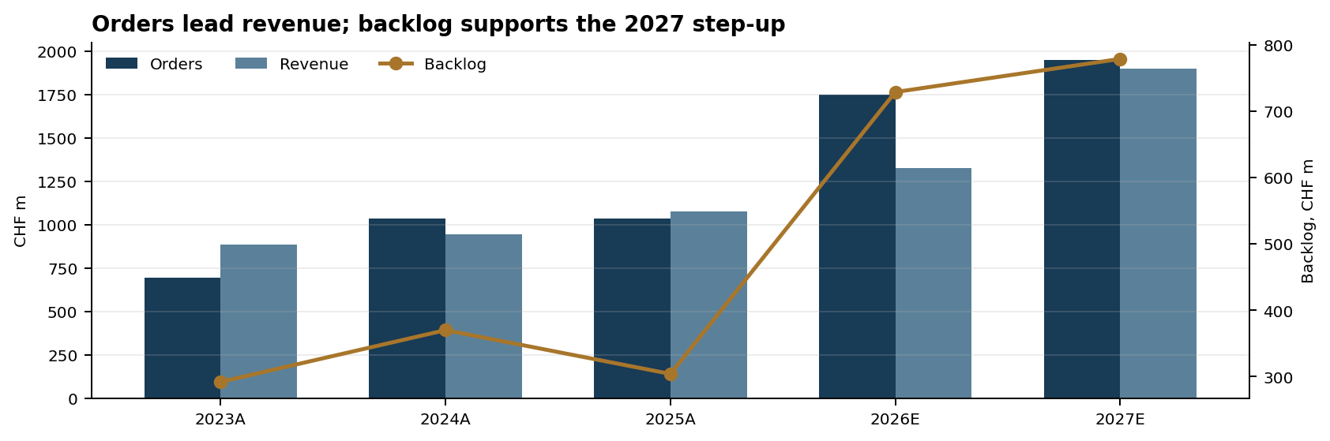
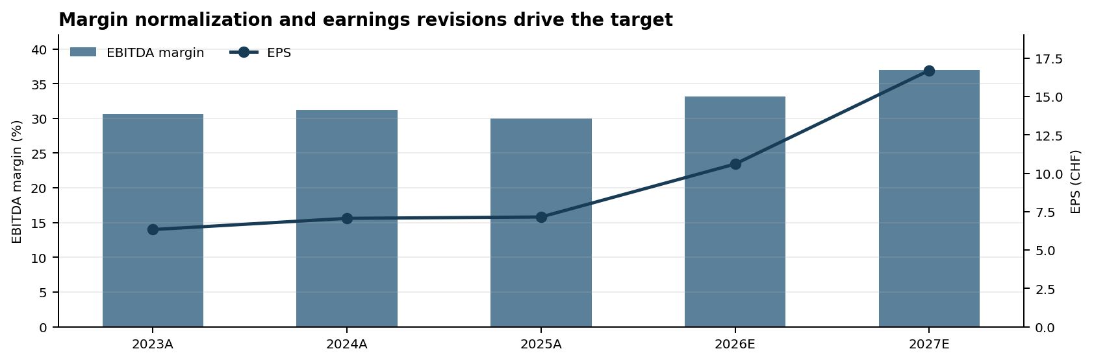
Sources: VAT historical and H1 2026 data from company reports; consensus and peer valuation snapshots from MarketScreener (late July/early August 2026; fiscal year-ends differ); share price CHF 602 from uploaded deck dated 31 July 2026; analyst estimates and calculations. Peer multiples should be refreshed immediately before presentation.

