INDUSTRY NOTE | INDIA HEALTHCARE
India GLP-1: Large market, fragmented profits; delivery and the next molecule decide the winners
Semaglutide expands access, but price, format and pipeline limit the company-level prize.

HIGHLIGHTS
India’s semaglutide patent expiry has created supply much faster than it has established durable demand. The principal Indian compound patent expired on 20 March 2026, and the market moved from an innovator-only structure in February to 20 branded-generic launches, 55 packs and 11 companies in March. April added three brands and 22 packs. Monthly market value increased from INR 610 million in February to INR 700 million in March and INR 950 million in April, while branded generics reached 36% of value and 31% of volume. The June-quarter data shows the category at INR 2.81 billion, with branded generics contributing INR 1.07 billion. This is a meaningful start, but not evidence of a concentrated blockbuster. Generic volume is growing faster than value because treatment prices have fallen sharply, and early sales include stocking, sampling and first prescriptions before refill behaviour is visible. The same price reduction that expands access also disperses revenue across companies, strengths and formats. Our INR 138 billion FY31 category estimate therefore remains intact, but the company-level conclusion is more restrained. INR 3-4 billion of annual revenue for a leading Indian participant requires only 2.2-2.9% share of the category, yet even that modest share must be sustained through repeated price cuts, new molecules and 15-20 competitors. India is building a large GLP-1 market, but the first quarter supports a conjoint market rather than one domestic blockbuster.
The early market is already being decided by format, specialist confidence and persistence rather than by molecule availability alone. Novo Nordisk retained 62% of semaglutide value in the June quarter, including 82% of oral value and 53% of pen value in the supplied IQVIA data. Pens contributed more than half of incremental generic value, while lower-priced oral products and vials generated more volume than their value share suggests. This split matters because the same active ingredient can produce different commercial outcomes when device reliability, dose accuracy, titration breadth, patient training, supply and doctor familiarity differ. Torrent has the clearest early branded-generic execution across formats, while Lupin and Zydus have a more differentiated cartridge and reusable-device proposition. Eris has built visible pen and vial positions, but repeat demand remains untested. The market is also moving beyond semaglutide before genericisation has matured. Mounjaro generated INR 4.30 billion in the June quarter, 17% above the March quarter and larger than the entire semaglutide category in the supplied dataset. In the direct SURMOUNT-5 comparison, maximum tolerated tirzepatide produced 20.2% average weight loss versus 13.7% for semaglutide at 72 weeks in adults with obesity without diabetes. This does not make tirzepatide superior for every patient, but it sets a higher efficacy benchmark. Semaglutide can continue expanding in India while losing clinical and economic share to dual agonists, higher-dose products, amylin combinations and scalable oral small molecules.
The investor implication is that market growth will not translate evenly into Indian pharma earnings. Our model indicates that GLP-1 can reach INR 138 billion by FY31, add roughly 3% to the future Indian Pharmaceutical Market and increase its share of the anti-diabetic value pool from 6% in FY26 to 36% in FY31. Insulin’s modeled share declines from 22% to 13%, a nine-percentage-point or roughly 41% relative reduction, rather than the 50% implied by the original exhibit title. This is a material therapeutic shift, but the profit pool should sit above undifferentiated peptide supply. Drug substance and basic formulation will face rising capacity and price competition. Device integration, reliable fill-finish, titration breadth, specialist access, distribution and patient support should retain more value. Torrent deserves credit for early commercial execution, Lupin and Zydus for device and manufacturing optionality, Sun Pharma for specialist reach and utreglutide, and Dr. Reddy’s for export and API potential. Eris can benefit if its specialist franchise converts initial share into refills. We would give limited valuation credit to companies offering one copied presentation through a general field force. The key evidence over the next four quarters is not launch count. It is value per unit after price normalisation, refill persistence, pen and cartridge mix, innovator erosion, Mounjaro growth and whether early leaders sustain share after channel inventory normalises.

SUPPLY ARRIVED FASTER THAN DEMAND
The patent event opened semaglutide competition, but it did not commoditise every layer of the product. Indian patent IN262697, which covered acylated GLP-1 analogues and included semaglutide, completed its 20-year term on 20 March 2026. The expiry removed the principal compound-patent barrier to domestic commercialisation. It did not automatically remove process, formulation, absorption-enhancer, cartridge or injector rights. The commercial market therefore opened at the active-ingredient level while product design, delivery and manufacturing quality remained differentiators. This distinction matters because investors initially treated the expiry as a conventional generic event. The early market looks closer to specialty pharma, where the product is a combination of peptide, dose, device, training and chronic commercial support. ^{[1]}
IQVIA data shows how quickly companies responded. February was effectively an innovator market. March brought 20 brands, 55 packs and 11 companies, and April brought three additional brands and 22 packs. Value rose by INR 90 million in March and a further INR 250 million in April. Most of the April increase came from branded generics, which added roughly INR 240 million of value and 0.43 million units, while innovators added limited value and lost some volume. By April, branded generics held 36% of value and 31% of volume. The category therefore expanded rather than simply transferring from innovator to generic products.
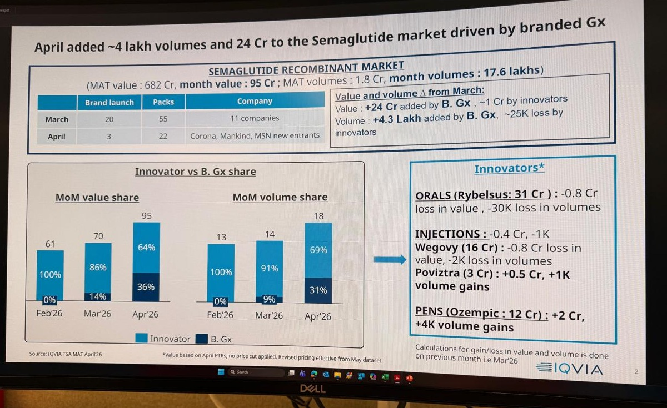
Exhibit 1. Generic entry expanded April value and volume, but price diluted revenue concentration
Source: IQVIA TSA MAT April 2026; Bernstein analysis
The more important point is that volume has moved faster than value. Lower-priced generic packs broaden the treated population, but they also reduce the revenue generated by each prescription. This effect is amplified by the number of brands, strengths and presentations. A company can report strong unit growth while gaining little economic share if its mix is concentrated in low-priced oral tablets or vials. Conversely, a smaller-volume pen business can generate more value because the device and fill-finish content is higher. The first quarter should therefore be read through value per unit and format mix, not through volume alone.
The June-quarter data reinforces this conclusion. Semaglutide generated INR 2.81 billion of value, split between INR 1.74 billion for innovators and INR 1.07 billion for branded generics. Innovators still held 62% of value after a quarter of generic entry. The incremental value was concentrated in pens, while oral generic growth was partly offset by innovator pressure. This is not the normal pattern of an immediate small-molecule patent cliff. The molecule has opened, but the innovator retains value through evidence, brand, device, dose confidence and established specialist use.
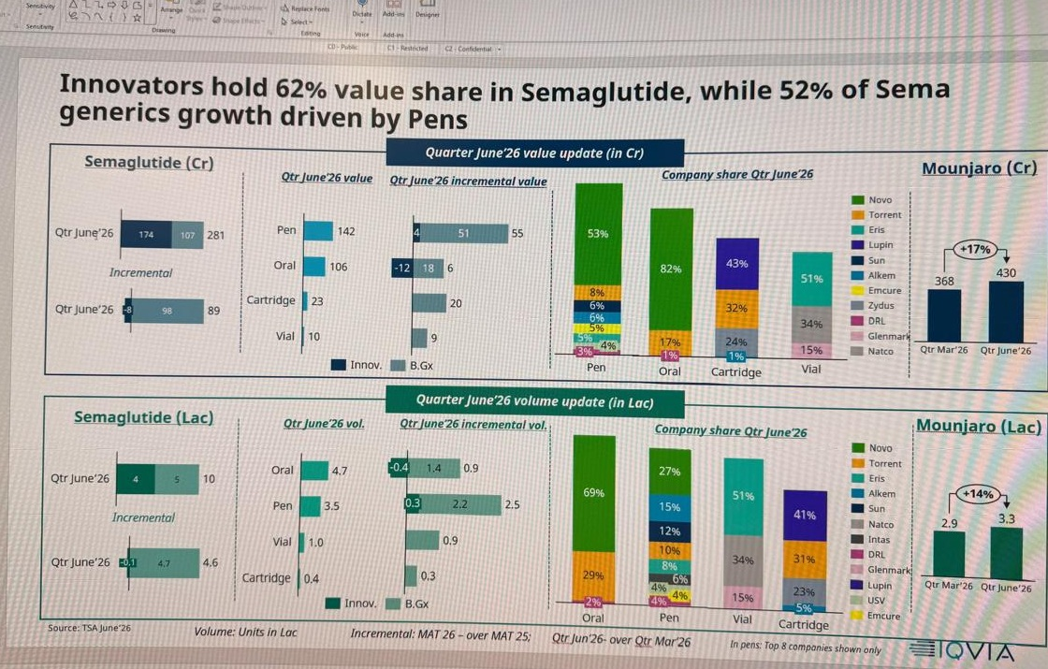
Exhibit 2. Innovators retained 62% of semaglutide value; pens drove most incremental generic value
Source: IQVIA TSA June 2026; Bernstein analysis
Three months is also too early to equate dispatches with treated patients. Launch inventory, distributor placement, doctor samples and initial titration packs all appear in market data before stable refill demand is visible. GLP-1 treatment starts at low doses and moves upward to manage gastrointestinal tolerability. A first pack may represent trial rather than a durable monthly revenue stream. The mature market will be determined by how many patients remain on therapy after three, six and twelve months, what dose they reach and whether they migrate between brands or formats. None of these variables can be inferred from launch-quarter volume.
India should also have a flatter adoption curve than the US. Clinical need is large, but most patients pay out of pocket. INR 3,000-5,000 per month is materially more affordable than pre-expiry innovator pricing, yet it remains a recurring expense rather than a one-time purchase. Insurance coverage for obesity treatment is limited, specialist density is concentrated in cities and many patients will stop once the initial weight-loss objective is met or adverse effects become difficult to manage. Price can accelerate initiation, but persistence determines the revenue pool. We therefore retain our view that India reaches a later peak, with lower value per treated patient and shorter average treatment duration than the US.
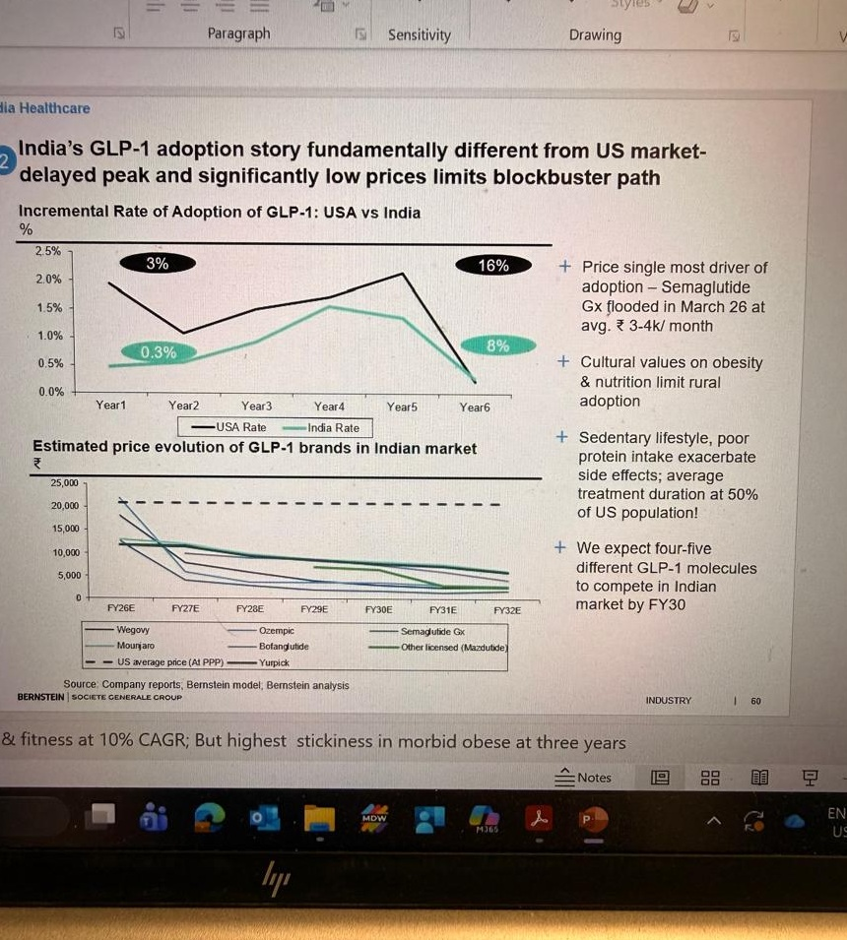 | 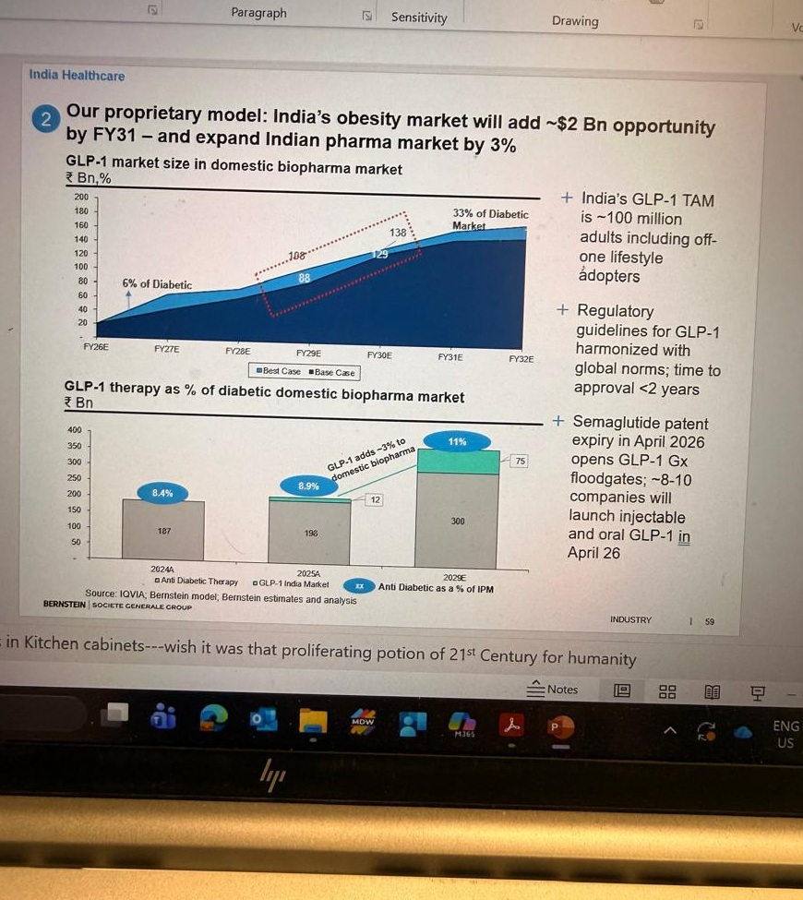
Exhibits 3-4. India should reach a later adoption peak, while the category can still reach INR 138 billion by FY31
Source: IQVIA, company reports, Bernstein estimates and analysis
Our FY31 market estimate remains INR 138 billion, but this is a category forecast rather than a semaglutide forecast. It includes the progressive contribution of semaglutide, tirzepatide and subsequent GLP-1-related molecules. The market can be large because the addressable population is large and treatment prices are falling. It can remain unattractive for individual generic companies because revenue is split across molecules, formats and brands. A 1% share of our FY31 market equals INR 1.38 billion of annual value, 2% equals INR 2.76 billion and 3% equals INR 4.14 billion. The INR 3-4 billion revenue outcome in our house view therefore requires roughly 2-3% share. That is plausible for a leader, but not exceptional enough to justify broad sector re-rating.
Exhibit 5. Market size does not equal company-level value
FY31 category share | Illustrative annual value
1% | INR 1.38 billion
2% | INR 2.76 billion
3% | INR 4.14 billion
5% | INR 6.90 billion
10% | INR 13.80 billion
Source: Bernstein estimates and analysis
The initial evidence is consistent with this framework. Supply has formed immediately, prices have expanded access and value has increased. At the same time, generic share is dispersed, innovators remain economically relevant and the data does not yet demonstrate persistence. The principal risk to our view is not that the category remains small. It is that investors capitalise a large market estimate into every participating company before durable company-level share is visible.
THE MOLECULE IS GENERIC; COMMERCIAL OUTCOMES ARE NOT
The early rankings show that companies are competing through format architecture rather than a single common launch. Torrent leads across several visible branded-generic presentations, with Semalix and Sembolic appearing among the leading oral, pen and injection brands in the supplied data. Lupin’s Semanext has gained across oral and injectable formats. Eris has early positions in pens and vials, while Sun, Alkem, Zydus, Dr. Reddy’s, USV, Glenmark and Natco occupy narrower format positions. This breadth creates an important difference between launch participation and competitive relevance. A company with one low-priced strength may appear in the market without building a defensible franchise.
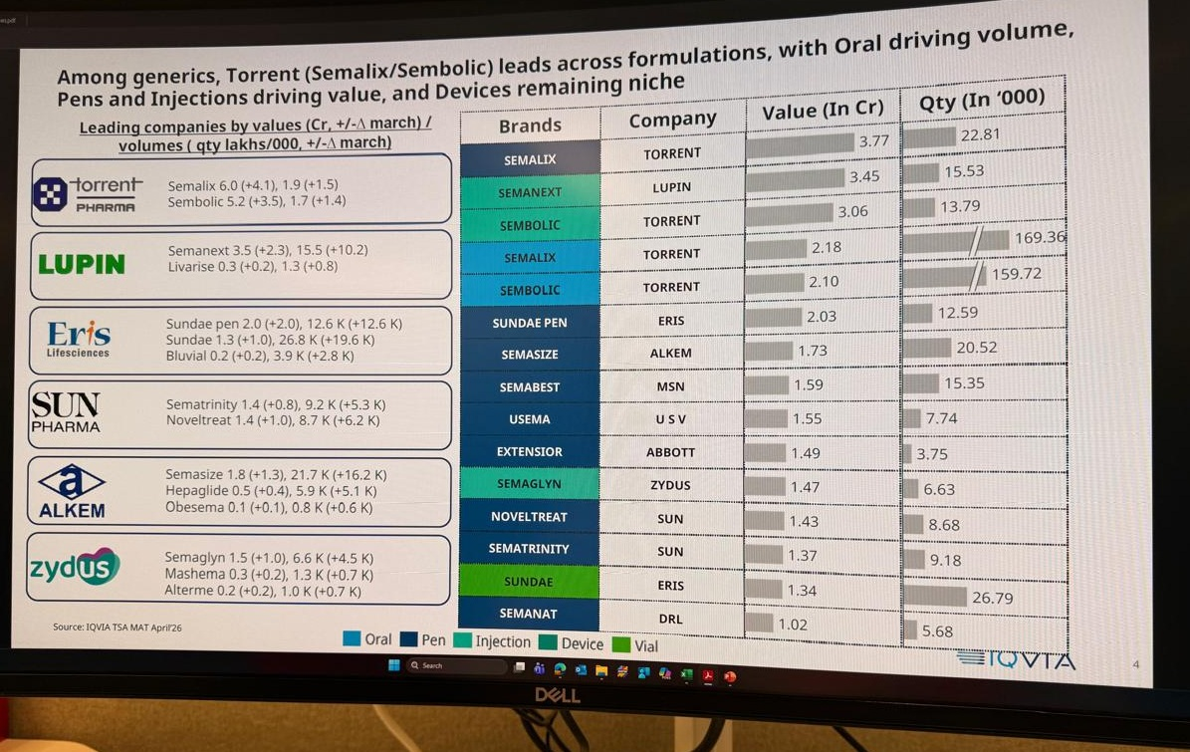 | 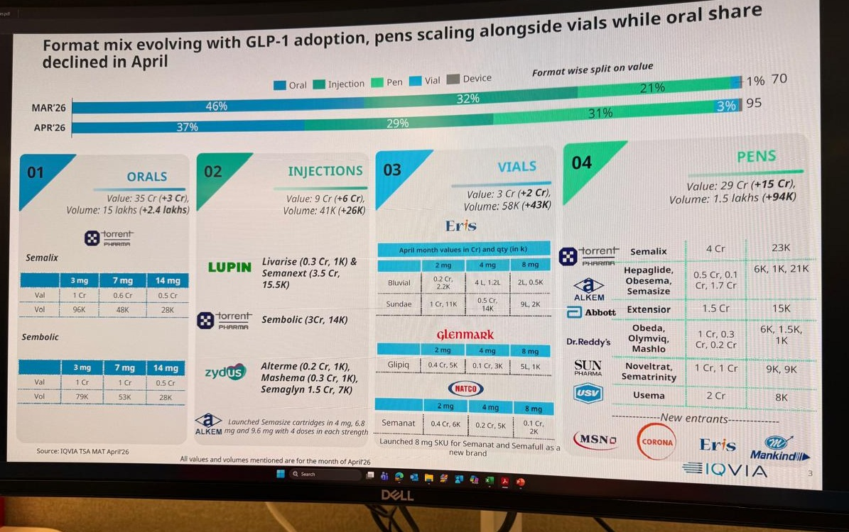
Exhibits 6-7. Leadership differs by brand and format; oral drives volume while pens drive value
Source: IQVIA TSA April 2026; Bernstein analysis
Torrent has the clearest early commercial lead, but the quality of that lead remains unproven. The company entered early, used several presentations and appears to have converted established chronic-sales reach into initial prescriptions. Its oral brands generate volume, while pens and injections contribute higher value. This is the right architecture for launch because it serves both price-sensitive patients and specialists who prefer controlled delivery. The risk is that first-mover inventory is mistaken for repeat demand. Torrent deserves near-term share credit, but the investment case requires the lead to persist after other companies broaden their strengths and prices normalise.
Lupin and Zydus are more interesting strategically because their proposition extends beyond the first brand. Their reusable-cartridge model can lower the recurring device cost once the pen is placed with the patient. It can also create a modest installed-base advantage if cartridges are reliable, available and easy to use. The moat should not be overstated. We have not identified sufficient evidence that the entire device system is proprietary, and device sourcing, compatibility and patient training remain execution risks. Even so, the model is more defensible than competing through vial price alone and has better export optionality if manufacturing and regulatory quality are established.
Eris has a smaller distribution base but a specialist-heavy diabetes franchise. Its early pen and vial share is therefore more relevant than a generalist launch of similar size. The company can create value if endocrinologist access converts into repeat prescriptions and cross-selling across its metabolic portfolio. The limitation is scale and device differentiation. Sun Pharma is not the clear early semaglutide leader, but its larger specialist network and internal obesity pipeline create a different form of optionality. Dr. Reddy’s combines a domestic prefilled product with API, formulation and export capabilities. Alkem, USV, Glenmark, Natco, MSN, Corona and Mankind can all participate, but participation alone does not establish pricing power.
Novo Nordisk’s retained share is the clearest evidence that branded generics are not interchangeable commercially. Novo held 82% of oral semaglutide value and 53% of pen value in the June-quarter data. Its advantage is not simply a higher price or the original molecule. It combines trial evidence, physician familiarity, device quality, consistent dosing, supply systems and outcomes data. Higher-income patients and specialists can rationally continue using the innovator even when lower-priced alternatives exist. Generic erosion should therefore be gradual and format-specific rather than uniform.
The format economics explain why. Oral tablets remove the needle and can reach a broader primary-care population, but peptide absorption is low and administration discipline is strict. They are likely to generate high volume and intense price competition. Vials have the lowest packaging cost and can expand access, but they create more handling, dosing and training risk. Cartridges used with reusable pens reduce recurring device waste and can support chronic use, but they require compatible hardware and reliable cartridge supply. Disposable prefilled pens provide the simplest patient experience and strongest dose confidence, but they carry higher device, fill-finish and capital costs. The same semaglutide molecule can therefore sit in very different gross-margin and persistence pools.
Exhibit 8. The same molecule sits in different commercial and margin pools
Format | Commercial role | Main constraint | Economic moat
Oral tablet | High-volume access | Daily administration and price competition | Formulation, brand, distribution
Vial | Lowest-cost injectable access | Handling, dosing and training risk | Limited without channel scale
Cartridge / reusable pen | Chronic use at lower recurring device cost | Compatibility and device availability | Installed base and refill ecosystem
Disposable prefilled pen | Highest convenience and dose confidence | Device and fill-finish cost | Reliability, device integration, brand
Standard injection | Middle-price injectable segment | More handling than a pen | Manufacturing and strength breadth
Source: Company disclosures; Bernstein estimates and analysis
Price is already being shaped by strength and presentation. The supplied pricing ladder shows oral and vial products at materially lower median price per dose than several pen products. Companies are also choosing different strength ladders. Lupin and Zydus have focused on reusable-pen and cartridge structures, while Alkem launched higher-strength presentations and several companies concentrated on lower-dose prefilled pens. This is rational segmentation rather than one national clearing price. Low-dose orals and vials can win access. Pens can win value. A broad strength ladder can keep patients within the same brand as they titrate upward.
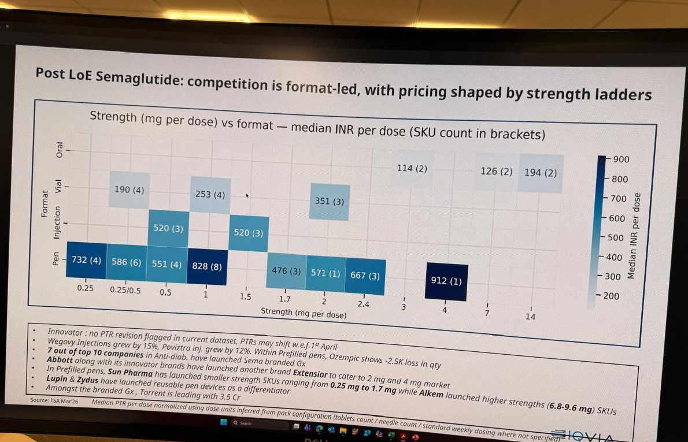 | 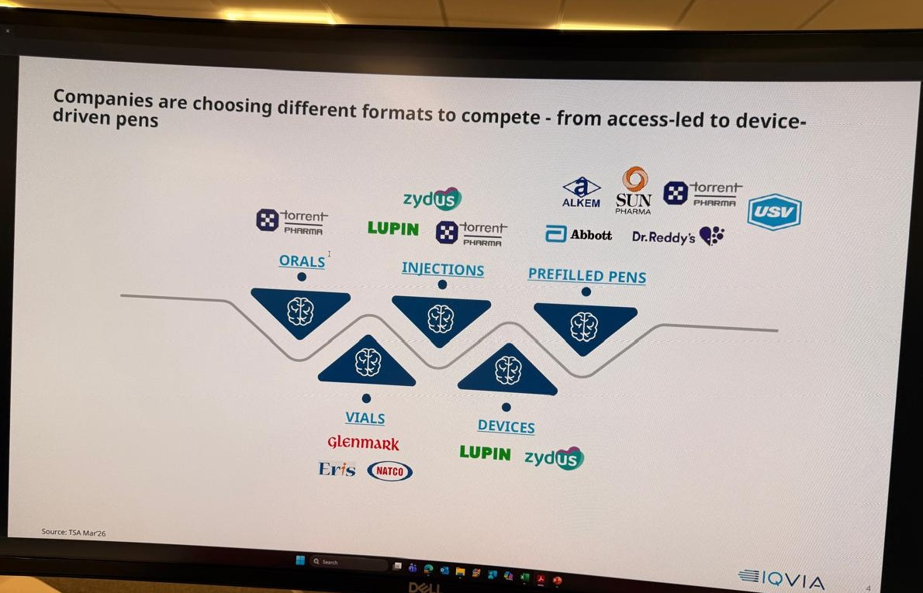
Exhibits 9-10. Competition is format-led, with price determined by strength ladders and delivery choice
Source: IQVIA TSA March 2026; Bernstein analysis
This matters because dose progression is a commercial retention mechanism. A company offering only an initiation dose can create the first prescription and lose the patient when the doctor escalates treatment. A company with multiple strengths, reliable supply and a familiar device can retain the patient across titration. The economic moat therefore sits partly in portfolio completeness. Brand, device and channel relationships become more valuable over time than the first price point.
Our value-pool framework consequently places less emphasis on peptide synthesis than the market narrative does. Peptide and API capacity are necessary and can support export revenue, but capacity additions should increase commoditisation. Basic formulation also faces competition. The higher-barrier layers are sterile fill-finish, reliable devices, human-factor design, specialist marketing, distribution continuity and patient support. These are the areas where quality failures are visible to doctors and patients and where switching costs can emerge. Post-patent GLP-1 economics should therefore resemble specialty pharma more than conventional oral generics.
The company implication is selective. We would reward evidence of sustained share, full titration breadth, device control, fill-finish quality and specialist conversion. We would not reward launch count. Torrent currently has the best branded execution evidence. Lupin and Zydus have the most credible device-led differentiation. Sun has the strongest Indian innovation optionality. Dr. Reddy’s has a broader manufacturing and export option. Eris has specialist-channel leverage. The remainder need to demonstrate that their product is more than a lower-priced pack in a crowded market.
SEMAGLUTIDE EXPANDS ACCESS; THE CLINICAL FRONTIER MOVES ON
Generic semaglutide expands access, but tirzepatide already sets a higher efficacy and commercial benchmark. Mounjaro generated INR 4.30 billion of value in the June quarter, up 17% from the March quarter and larger than the INR 2.81 billion semaglutide category in the supplied IQVIA data. The two markets should not be combined because the molecules, brands and mechanisms differ. The comparison is still important because doctors and self-paying patients choose between treatment options rather than between patent categories.
SURMOUNT-5 provides a direct clinical comparison. In adults with obesity without diabetes, maximum tolerated tirzepatide produced 20.2% average weight loss versus 13.7% for maximum tolerated semaglutide at 72 weeks under the treatment-regimen estimand. Tirzepatide also produced greater waist reduction in the published study. This is stronger evidence than a cross-trial comparison because population, duration and comparator were controlled directly. It does not establish superiority on affordability, supply, long-term adherence or every safety endpoint. In India, a cheaper semaglutide product can remain commercially relevant even when tirzepatide offers greater average weight loss. ^{[3]}
Exhibit 11. Tirzepatide sets the efficacy benchmark; semaglutide sets the access benchmark
Dimension | Semaglutide | Tirzepatide | Investor read-through
Mechanism | GLP-1 receptor agonist | Dual GIP/GLP-1 agonist | Different clinical value propositions
Direct obesity comparison | 13.7% average weight loss | 20.2% average weight loss | SURMOUNT-5, 72 weeks, obesity without diabetes
India market role | Lower-price access anchor | Higher-efficacy premium benchmark | Price and persistence determine realised share
Main constraint | Generic price erosion and GI tolerability | Affordability, supply and GI tolerability | Clinical leadership does not guarantee broad access
Source: SURMOUNT-5; IQVIA; Bernstein analysis
The mechanistic difference explains part of the efficacy gap. Semaglutide activates the GLP-1 receptor, reducing appetite, slowing gastric emptying and improving glucose-dependent insulin secretion. Tirzepatide activates both GIP and GLP-1 receptors. The additional GIP pathway may improve metabolic and appetite effects, although the precise human contribution remains under study. The commercial consequence is simple. Semaglutide no longer competes only against cheaper semaglutide. It competes against molecules offering a different efficacy, tolerability or convenience profile.
The next pipeline wave makes this pressure structural. Higher-dose semaglutide can extend the familiar molecule toward greater efficacy, but may also increase gastrointestinal burden. CagriSema combines GLP-1 with amylin to add a second satiety pathway. Retatrutide adds glucagon to GIP and GLP-1, seeking both appetite suppression and higher energy expenditure. Roche’s enicepatide and Kailera’s ribupatide compete in the dual-agonist class. Survodutide adds glucagon with a particular liver-fat and MASH rationale. MariTide uses GLP-1 agonism with GIP receptor antagonism and aims for monthly or less frequent dosing. Oral small molecules such as orforglipron and CT-996 offer chemical manufacturing and simpler administration rather than maximum injectable efficacy.
Investors should not rank these assets on headline weight loss alone. Trial populations, doses, durations and estimands differ. A molecule with slightly lower peak efficacy may create a larger market if it is oral, easier to manufacture, cheaper, better tolerated or dosed less frequently. Conversely, a high-efficacy injectable can remain a premium specialist product. The next market should segment by patient need: maximum weight loss, diabetes control, liver disease, low gastrointestinal burden, muscle preservation, maintenance after initial loss and oral convenience.
This segmentation shortens semaglutide’s period of strategic dominance even if semaglutide sales continue rising. The molecule is likely to be the access anchor for India because manufacturing is established and prices are falling. It is less likely to remain the clinical frontier through FY31. The relevant company question is therefore not only who sells semaglutide in 2026. It is who can move to the next format or molecule without rebuilding the commercial platform.
The anti-diabetic market model captures the size of the therapeutic shift. We estimate the total market increasing from roughly INR 225 billion in FY26 to INR 446 billion in FY31. GLP-1 share rises from 6% to 36%, while insulin falls from 22% to 13%, DPP-4 and several classic therapies lose relative share and SGLT2 remains more resilient. The insulin change is a relative-share shift, not elimination. Insulin remains essential in type 1 diabetes, advanced beta-cell failure, severe hyperglycaemia, acute care and several special clinical settings. GLP-1 adoption can delay insulin initiation and reduce its share of value without replacing basal and prandial insulin one for one.
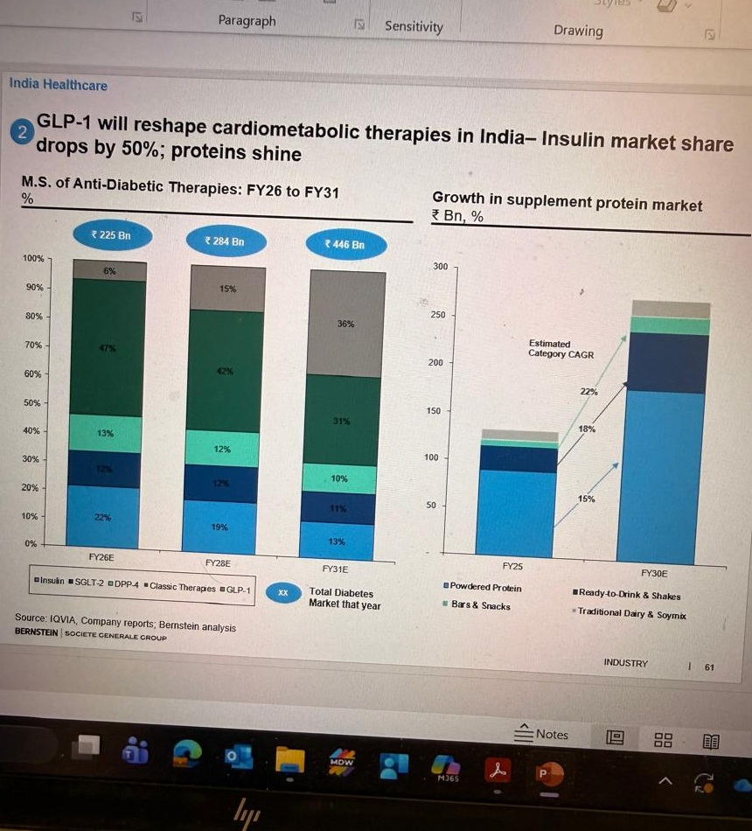
Exhibit 12. GLP-1 expands the anti-diabetic value pool and reduces insulin share; nutrition is a secondary adjacency
Source: IQVIA, company reports, Bernstein estimates and analysis
The protein and nutrition adjacency is plausible but should remain outside the core pharmaceutical valuation. Lower appetite and rapid weight loss can increase concern about inadequate protein intake and lean-mass loss. Obesity programmes may therefore promote powdered protein, ready-to-drink products, bars and clinical nutrition. Our supplied model indicates meaningful category growth. Direct causality is not yet established, and the exhibit inputs are not fully consistent enough to support a precise 50% claim. We treat nutrition as a secondary consumer-health opportunity rather than a direct read-through from every GLP-1 prescription.
RNA interference represents a later, more speculative wave. WVE-007 and ARO-INHBE target the INHBE or Activin E pathway, seeking to reduce visceral and total fat while preserving lean mass. Early company-reported data show body-composition effects with modest monotherapy scale-weight loss. ARO-ALK7 targets adipose biology more directly. These programmes may be most useful as combination or maintenance therapies after initial incretin-driven loss. Their potential advantages are infrequent dosing, muscle preservation and reduced weight regain. Their risks are equally important: tissue delivery, long duration of adverse effects, immune reactions, cost, manufacturing complexity and limited current evidence of stand-alone obesity-level weight loss.
The pipeline therefore changes the commercial question. The next obesity winners may not be the assets with the highest single weight-loss number. They may be the products that combine sufficient efficacy with tolerability, muscle preservation, convenient dosing, scalable manufacturing and durable use. For Indian companies, this favors platforms that can commercialise multiple metabolic products rather than one molecule-specific launch.
INDIA PHARMA IMPLICATIONS: PREMIUM VALUE SITS ABOVE THE PEPTIDE
The India opportunity is large enough to matter, but not large enough to rescue weak company economics. At INR 138 billion in FY31, a 1% market share produces INR 1.38 billion of annual value, 3% produces INR 4.14 billion and 5% produces INR 6.90 billion. At an illustrative 20% EBITDA margin, those outcomes translate into INR 0.28 billion, INR 0.83 billion and INR 1.38 billion of EBITDA. A 34% margin, which resembles a differentiated export or specialty model, raises the contribution materially. The range shows why capability matters. A low-price domestic product can win volume and still create modest profit. A device-led or export-oriented product can create more EBITDA from the same market share.
Exhibit 13. Capability, not market share alone, determines the EBITDA outcome
Share | Revenue | EBITDA at 20% | EBITDA at 34%
1% | INR 1.38bn | INR 0.28bn | INR 0.47bn
2% | INR 2.76bn | INR 0.55bn | INR 0.94bn
3% | INR 4.14bn | INR 0.83bn | INR 1.41bn
5% | INR 6.90bn | INR 1.38bn | INR 2.35bn
10% | INR 13.80bn | INR 2.76bn | INR 4.69bn
Source: Bernstein estimates and analysis
The highest-quality Indian exposure is therefore not the company with the largest launch press release. It is the company that controls several parts of the value chain and can retain patients. Torrent currently scores highest on branded execution. Its risk is that the early lead is inventory-led and that it lacks a verified proprietary device moat. Lupin and Zydus score higher on reusable-format and manufacturing differentiation, but execution and device ownership need continued verification. Sun has the best specialist network and the only meaningful internally owned Indian obesity-pipeline option in utreglutide, but its generic semaglutide position is not dominant. Dr. Reddy’s has the broadest combined API, formulation and export optionality. Eris is a specialist-channel option with smaller scale. Other participants remain broadly distribution-led until refill and share data establish more.
Exhibit 14. India company implications
Company | Current evidence | What can create value | Principal risk
Torrent | Early multi-format leadership | Brand execution and full dose ladder | Launch stocking mistaken for durable share
Lupin / Zydus | Reusable cartridge and device model | Device ecosystem, manufacturing and export | Device ownership and execution
Sun Pharma | Specialist reach; utreglutide optionality | Pipeline migration and premium channel | Generic share is not yet leading
Dr. Reddy's | Prefilled product plus API/formulation | Export and manufacturing integration | Domestic share remains modest
Eris | Visible pen and vial share | Specialist conversion and metabolic cross-sell | Smaller scale and untested refills
Other entrants | Launch participation | Distribution reach | Low differentiation and price competition
Source: IQVIA, company disclosures, Bernstein analysis
This framework also separates domestic and export economics. India pricing will remain constrained by self-pay affordability and intense branded competition. Export markets offer higher nominal prices and reward regulatory quality, sterile fill-finish, peptide manufacturing and device integration. They also require more capital, clinical bridging, regulatory filings and partner execution. Export optionality deserves value only where a company has disclosed assets, capacity and market access. Generic participation in India is not evidence of a global obesity franchise.
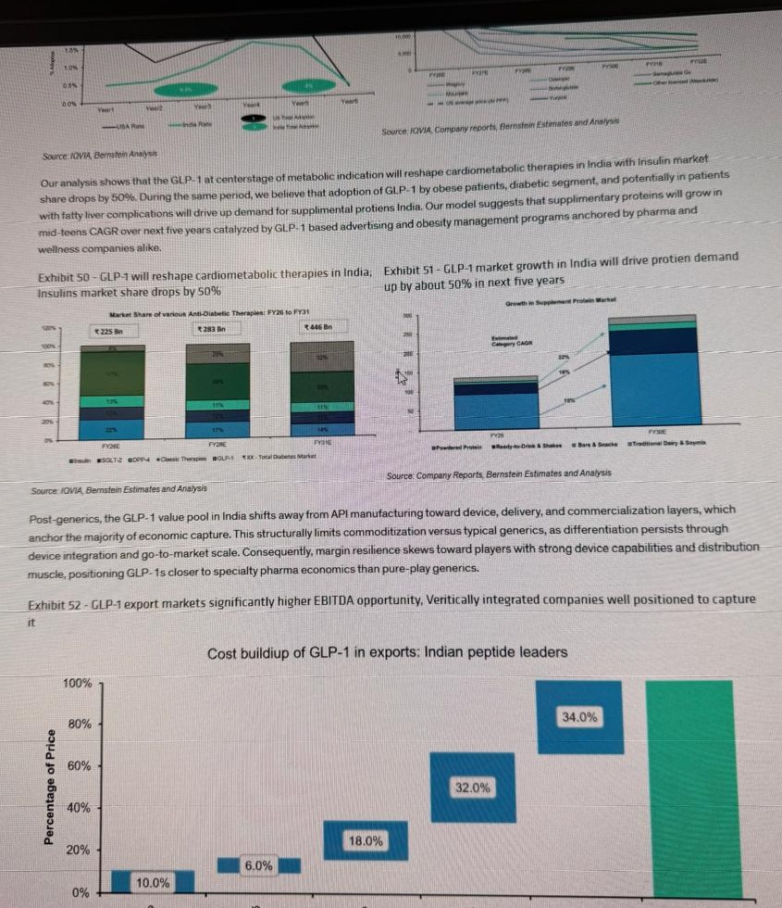
Exhibit 15. Post-generic economics shift from peptide supply toward device, fill-finish and commercialisation
Source: Company reports, Bernstein estimates and analysis
Our initiation thesis is broadly intact, but the evidence is uneven. Price-led market expansion is confirmed. High fragmentation is confirmed. Innovator share retention and the importance of pens are confirmed. Slower persistence and a later adoption peak remain untested because refill cohorts are unavailable. Limited individual-company revenue is partly confirmed by dispersed early share, but market leadership is too young to call. GLP-1’s effect on insulin and nutrition remains a forecast rather than observed commercial evidence. The assumption most at risk is that generic semaglutide would remain the centre of the market long enough to support a stable company ranking. Tirzepatide is already larger by value in the supplied quarter, and the global pipeline is moving faster than the genericisation cycle.
Exhibit 16. What has changed since initiation
Initiation thesis | Current assessment | What the data says
Price expands access | Confirmed | Generic volume has grown faster than value
Market remains fragmented | Confirmed | Many companies, brands, strengths and formats entered immediately
Innovators retain value | Confirmed | Novo retained 62% of June-quarter semaglutide value
Devices matter | Confirmed | Pens drove most incremental generic value
Persistence is lower than the US | Too early | No refill cohort is available
Individual company revenue remains limited | Partly confirmed | Early share is dispersed; leadership is not mature
Semaglutide remains the central molecule | Challenged | Mounjaro is already larger by value in the supplied quarter
Source: IQVIA, company reports, Bernstein analysis
The monitoring framework should therefore be narrow. First, track monthly value per unit to distinguish patient growth from price erosion. Second, track three- and six-month refills rather than new prescriptions. Third, track pen and cartridge value share because format determines both margin and retention. Fourth, track Novo’s value share by format to measure how quickly clinical trust and device quality erode. Fifth, track Mounjaro and later-molecule growth because semaglutide share can fall even while the category expands. Sixth, track whether early leaders broaden their dose ladders and maintain supply. These indicators will determine whether the market becomes a durable specialty category or a large low-return generic pool.
INVESTMENT CONCLUSION
India’s GLP-1 market is moving in the direction we expected, but the route to company earnings is narrower than the size of the category suggests. Generic semaglutide has reduced price, expanded volume and created a meaningful new market. It has also created immediate fragmentation. Novo retains substantial value, pens capture more economics than low-cost formats and tirzepatide is already larger than semaglutide in the supplied quarterly dataset. The next phase will be decided by persistence, full titration breadth, device reliability, specialist access and the ability to migrate from semaglutide to the next molecule.
We would pay for evidence of durable share and differentiated capability, not for launch participation. Torrent has the best early branded execution. Lupin and Zydus have the most credible device-led differentiation. Sun and Dr. Reddy’s have broader innovation or export optionality. Eris can create value through specialist conversion. Undifferentiated vial and oral entrants should receive limited credit. The market can reach INR 138 billion by FY31 while no Indian company builds an individual blockbuster. Large category growth and fragmented company economics are not contradictory. They are the central investment conclusion.

APPENDIX A: GLOBAL OBESITY PIPELINE
Cross-trial efficacy is not directly comparable because populations, duration, dose, comparator and estimand differ.
Asset | Code | Sponsor / partner | Mechanism | Route / frequency | Phase or status | Latest material evidence | Next catalyst / plausible timing | India relevance | Main advantage | Main risk
Semaglutide 7.2mg | NN9536 | Novo Nordisk | GLP-1 agonist | Weekly injection | Approved/submitted in major markets | 20.7% mean loss under full-adherence estimand | Further launches from 2026 | Premium innovator segment | Familiar molecule, higher efficacy | GI tolerability, generic 2.4mg price
Oral semaglutide 25mg | NN9932 | Novo Nordisk | GLP-1 agonist | Daily oral peptide | Approved US obesity | 16.6% full-adherence weight loss | International filings | Oral premium segment | Established outcomes platform | Administration restrictions, peptide cost
CagriSema | NN9388/NN9838 | Novo Nordisk | GLP-1 plus amylin | Weekly injection | Submitted / phase 3 | REDEFINE 1: 22.7% vs 2.3% at 68 weeks, hypothetical estimand | Regulatory decisions 2026–27 | Later premium India market | Complementary satiety pathway | Failed REDEFINE 4 non-inferiority vs tirzepatide
Cagrilintide | NN9833 | Novo Nordisk | Amylin agonist | Weekly injection | Phase 3 | 11.8% vs 2.3% at 68 weeks in analysis | RENEW programme | Alternative for GLP-1 intolerance | Potential tolerability differentiation | Lower efficacy as monotherapy
Zenagamtide | NN9487/NN9490 | Novo Nordisk | Unimolecular GLP-1/amylin | Oral and injection | Phase 3 obesity initiated | Phase 2 T2D weight loss up to 14.6% at 36 weeks at highest reported injection dose | Phase 3 readouts later decade | Potential multi-format premium product | Single-molecule dual biology | Development complexity
IcoSema | NN1535 | Novo Nordisk | Weekly insulin icodec plus semaglutide | Weekly injection | Approved EU diabetes | Glycaemic and weight combination evidence | Geographic launches | Relevant to insulin displacement | Simplified insulin/GLP-1 regimen | Hypoglycaemia and titration complexity
Tirzepatide | LY3298176 | Eli Lilly | GIP/GLP-1 dual agonist | Weekly injection | Marketed | SURMOUNT-5: 20.2% vs semaglutide 13.7% at 72 weeks | Lifecycle and outcomes expansion | Already major India product | Direct efficacy benchmark | Price and GI tolerability
Orforglipron | LY3502970 | Eli Lilly | Non-peptide GLP-1 agonist | Daily oral | FDA-approved April 2026 | ATTAIN phase 3 supports low-double-digit weight loss | Global filings and launches | Potentially high due scalable oral route | No food/water restriction; chemical manufacturing | Lower efficacy than leading injections
Retatrutide | LY3437943 | Eli Lilly | GIP/GLP-1/glucagon triple agonist | Weekly injection | Phase 3 | TRIUMPH-1 topline: 28.3% at 80 weeks, 12mg | Regulatory submissions after full phase 3 | Future high-efficacy segment | Potential bariatric-range efficacy | GI effects, heart rate, full dataset pending
Enicepatide | CT-388 | Roche/Carmot | GIP/GLP-1 dual agonist | Weekly injection | Moving to phase 3 | Phase 2: 22.5% placebo-adjusted at 48 weeks, efficacy estimand | Phase 3 initiation | Longer-term premium market | High reported efficacy | Competitive late entry
CT-996 | CT-996 | Roche/Carmot | Oral small-molecule GLP-1 agonist | Daily oral | Early clinical | Limited mature efficacy data disclosed | Phase 2 development | Potential mass-market relevance | Scalable oral chemistry | Liver safety and efficacy
Petrelintide | ZP8396 | Roche/Zealand | Long-acting amylin agonist | Weekly injection | Moving to phase 3 | ZUPREME-1: up to 10.7% at 42 weeks vs 1.7% placebo | Phase 3 and CT-388 combinations | Potential tolerability-led niche | Appetite effect with potentially lower GI burden | Lower monotherapy efficacy
Ribupatide | KAI-9531 | Kailera/Hengrui | GIP/GLP-1 dual agonist | Weekly injection | Phase 3 | Global phase 3 KaiNETIC underway | Phase 3 data later decade | Potential licensed India product | Competitive dual efficacy | Crowded class
Oral ribupatide | KAI-9531-T | Kailera/Hengrui | Oral peptide dual agonist | Daily oral | Phase 2 | Company-reported up to 12.1% at 26 weeks | Phase 3 possible 1H27 | Oral alternative | Dual biology in oral form | Absorption and scale
KAI-7535 | KAI-7535 | Kailera/Hengrui | Oral small-molecule GLP-1 | Daily oral | Phase 2 | Limited public efficacy data | Phase 2 readout | Potential price-relevant asset | Manufacturing scalability | Competitive differentiation
KAI-4729 | KAI-4729 | Kailera/Hengrui | Triple incretin agonist | Injectable | Preclinical/phase 1 planning | No clinical efficacy data | First-in-human planned | Long-dated | Multi-receptor potential | Early-stage risk
Survodutide | BI 456906 | Boehringer/Zealand | GLP-1/glucagon dual agonist | Weekly injection | Phase 3 | Phase 2 established weight and liver-fat effects | SYNCHRONIZE and MASH readouts | Relevant to India’s metabolic-liver burden | Liver and energy-expenditure profile | Glucagon balance and GI tolerability
MariTide | AMG 133 | Amgen | GLP-1 agonist/GIPR antagonist | Monthly or less frequent injection | Phase 3 | Phase 2: up to 19.9% efficacy-estimand loss at 52 weeks | MARITIME phase 3 | Premium maintenance segment | Infrequent dosing | Antibody complexity and initial GI effects
Mazdutide | IBI362/OXM3 | Innovent; licensed from Lilly for China | GLP-1/glucagon dual agonist | Weekly injection | Approved in China at some doses; 9mg under review | GLORY-2: 18.55% at 60 weeks vs 3.02% placebo | 9mg decision in China | Asian evidence relevant; no Indian license verified | Weight and liver-fat effect | Geographic rights and glucagon tolerability
Utreglutide | GL0034 | Sun Pharma | Potent GLP-1 agonist | Weekly injection | Phase 2 | Early phase 1b/2a weight and metabolic activity | Phase 2 data | Direct Indian pipeline optionality | Domestic ownership and specialist reach | Early stage, crowded class
WVE-007 | WVE-007 | Wave Life Sciences | INHBE/Activin E siRNA | Subcutaneous, potentially 1–2 times yearly | Phase 1/2a | Early data: visceral fat reduction with lean-mass preservation; low scale-weight effect | Phase 2a and combination studies | Long-dated maintenance potential | Body-composition differentiation | Limited monotherapy weight reduction
ARO-INHBE | ARO-INHBE | Arrowhead | INHBE siRNA | Infrequent subcutaneous | Phase 1/2a | Combination with tirzepatide: 9.4% weight loss at week 16 vs 4.8% control cohort | Larger controlled studies | Combination/maintenance potential | Visceral and liver-fat effects | Small early cohorts
ARO-ALK7 | ARO-ALK7 | Arrowhead | Adipocyte ALK7 RNAi | Infrequent subcutaneous | Phase 1 | Early human target knockdown and visceral-fat activity | Dose escalation and efficacy | Potential direct adipose targeting | Novel tissue delivery | Safety and durability unproven

APPENDIX B: NOMENCLATURE AUDIT
Dictated or uncertain name | Verified conclusion | Confidence
Semaglutide attributed to Lilly | Incorrect. Semaglutide belongs to Novo Nordisk. | High
Tirzepatide | Correct. Eli Lilly dual GIP/GLP-1 agonist, marketed as Mounjaro for diabetes and Zepbound for obesity in relevant markets. | High
Enzepatide | Most likely enicepatide, CT-388, Roche/Carmot dual GIP/GLP-1 agonist. | High
Calera Therapeutics | Most likely Kailera Therapeutics. | High
Manidate by Amgen | MariTide, generic name maridebart cafraglutide, formerly AMG 133. | High
Masurutide | Mazdutide, IBI362/OXM3. | High
WaveLife Science P11 | Wave Life Sciences WVE-007, INHBE/Activin E siRNA. | High
Oltregutide | Most likely utreglutide, GL0034, developed by Sun Pharma. | High
Ciranbio P1 | No sufficiently credible match identified. Excluded from published narrative. | Low
Extreme Deep | No verified obesity company or asset identified. Excluded. | Low
Bohanglutide | No high-confidence asset identification. Excluded. | Low
Lupin or Zydus relationship with mazdutide | No verified development, licensing or manufacturing relationship identified. | High
Ribupatide | Correct name for KAI-9531, Kailera/Hengrui dual agonist. | High
Amycretin | Previous name for Novo Nordisk’s zenagamtide. | High
Source: Bernstein research and verification

APPENDIX C: INTERNAL FACT-CHECK TABLE
Claim | Value / period | Unit | Source | Classification | Qualification | Confidence
Principal patent expiry | 20 Mar 2026 | Date | Court/patent records | Regulatory/legal fact | Process and device rights may remain | High
March launches | 20 brands, 55 packs, 11 companies | Count | Supplied IQVIA | IQVIA data | Launches may include initial stocking | High
April additions | 3 brands, 22 packs | Count | Supplied IQVIA | IQVIA data | Pack definition per IQVIA | High
February market value | 610 | INR million | Supplied IQVIA | IQVIA data | Innovator-only displayed market | High
March market value | 700 | INR million | Supplied IQVIA | IQVIA data | Rounded chart value | High
April market value | 950 | INR million | Supplied IQVIA | IQVIA data | April values based on PTR in exhibit | High
April generic value share | 36% | % | Supplied IQVIA | IQVIA data | Innovator price revision effective later | High
April generic volume share | 31% | % | Supplied IQVIA | IQVIA data | Units do not equal patients | High
June-quarter sema value | 2.81 | INR billion | Supplied IQVIA | IQVIA data | Sum of 1.74 innovator and 1.07 generic | High
June-quarter innovator share | 62% | % | Supplied IQVIA | IQVIA data | Value share, not volume share | High
June-quarter Mounjaro value | 4.30 | INR billion | Supplied IQVIA | IQVIA data | Quarter-ending June 2026 | High
Mounjaro value growth | 17% | % QoQ | Supplied IQVIA | IQVIA data | Versus March quarter | High
June-quarter sema volumes | Displayed totals | Units | Supplied IQVIA | IQVIA data | Do not reconcile with April monthly panel; use directionally | Medium
FY31 India GLP-1 market | 138 | INR billion | Bernstein model | Bernstein estimate | Includes category, not one molecule | Medium
IPM contribution | ~3% | % | Bernstein model | Bernstein estimate | Forecast-period contribution | Medium
Leading company revenue | 3–4 | INR billion | Bernstein model | Bernstein estimate | Implies 2.2–2.9% category share | Medium
Anti-diabetic FY31 market | 446 | INR billion | Bernstein model | Bernstein estimate | Based on supplied exhibit | Medium
GLP-1 share FY26/FY31 | 6% / 36% | % | Bernstein model | Bernstein estimate | Value share | Medium
Insulin share FY26/FY31 | 22% / 13% | % | Bernstein model | Bernstein estimate | Nine-point, 41% relative decline, not 50% | High
Torrent early leadership | Multiple leading displayed brands | Directional | Supplied IQVIA | IQVIA data | Does not prove sustainable share | High
Lupin/Zydus reusable format | 15mg/3mL cartridge arrangement | Product | Company disclosure | Company-reported | Proprietary ownership not established | High
SURMOUNT-5 result | 20.2% vs 13.7% | Weight loss | NEJM/Lilly | Peer-reviewed clinical evidence | 72 weeks, obesity without diabetes, treatment-regimen estimand | High
CagriSema REDEFINE 1 | 22.7% vs 2.3% | Weight loss | Novo | Company-reported/phase 3 | Hypothetical adherence estimand | High
Retatrutide TRIUMPH-1 | 28.3% at 80 weeks | Weight loss | Lilly | Company-reported phase 3 | Topline; full peer review pending | Medium-high
Enicepatide phase 2 | 22.5% placebo-adjusted | Weight loss | Roche | Company-reported phase 2 | 48 weeks, 24mg, efficacy estimand | High
MariTide phase 2 | Up to 19.9% | Weight loss | Amgen/NEJM | Clinical evidence | 52 weeks, efficacy estimand; treatment-policy lower | High
Mazdutide GLORY-2 | 18.55% vs 3.02% | Weight loss | JAMA/Innovent | Peer-reviewed clinical evidence | 60 weeks, Chinese adults, 9mg | High
WVE-007 body composition | -14% visceral fat, -5% total fat, +2% lean mass | % | Wave | Company-reported early clinical | Small early cohort, six months | Medium
ARO-INHBE combination | -9.4% vs -4.8% | Weight | Arrowhead | Company-reported early clinical | Small cohort, low-dose tirzepatide, week 16 | Medium
Protein market growth | Roughly doubles | Directional | Bernstein exhibit | Bernstein estimate | Exhibit title and bars are inconsistent; avoid precise 50% claim | Low-medium

APPENDIX D: SOURCE APPENDIX
1. Delhi High Court and related patent reporting on IN262697 and semaglutide manufacturing and export litigation, 2025-2026.
2. Novo Nordisk, Annual Report 2025: Innovation and Therapeutic Focus, published 2026.
3. Eli Lilly, complete SURMOUNT-5 results, 11 May 2025, and associated peer-reviewed publication.
4. American Diabetes Association, Standards of Care in Diabetes 2026, published December 2025.
5. Wilding et al., STEP 1 extension, Diabetes, Obesity and Metabolism, published May 2022.
6. Eli Lilly, orforglipron regulatory and launch disclosures, April 2026.
7. Eli Lilly, TRIUMPH-1 retatrutide topline disclosures, May-June 2026.
8. Roche, CT-388 phase 2 results, January 2026, and 2026 ADA obesity-pipeline update.
9. Amgen, phase 2 MariTide results and FY2025 pipeline update.
10. Innovent, GLORY-2 mazdutide results and peer-reviewed publication, June 2026.
11. Zealand Pharma and Boehringer Ingelheim, survodutide development disclosures, accessed 23 July 2026.
12. Wave Life Sciences, INLIGHT phase 2a initiation and ClinicalTrials.gov NCT06842186, June 2026.
13. Arrowhead Pharmaceuticals, ARO-INHBE and ARO-ALK7 interim clinical disclosures, January-May 2026.
14. Sun Pharma, semaglutide approvals, launches and GL0034 or utreglutide development disclosures, 2024-2026.
15. Lupin and Zydus, semaglutide co-marketing and reusable-cartridge disclosures, March 2026.
16. Supplied IQVIA semaglutide market exhibits, data through the June 2026 quarter.
17. Supplied Bernstein India GLP-1, anti-diabetic market, protein-market and economic-pool models.
18. Company annual reports, presentations and regulatory disclosures referenced in the pipeline and company analysis.

