AUROBINDO PHARMA

The earnings stack is starting to convert
Upgrade to OUTPERFORM from Market-Perform
Rating | Price | Target | Upside | FY29E EPS | FY29E P/E
OUTPERFORM | ₹1,686 | ₹2,100 | 24.6% | ₹100.6 | 16.8x

We upgrade Aurobindo to Outperform with a ₹2,100 target. The thesis has changed for operational reasons. Five assets that were previously capital-consuming, delayed or too early to value are moving into the earnings base: Lannett, US inhalation, Pen-G, biosimilars and Acrotech dermatology. The FY27 estimate does not carry the upgrade. Our FY27 EPS is ₹70.9, below the old ₹73.9. The call rests on FY29–31 conversion, where EPS reaches ₹100.6 in FY29 and ₹132.9 in FY31.
The other change is the shape of regulatory risk. Raleigh has a closed VAI classification, Seymour's four observations were described as procedural, and several API inspections ended with zero to three observations. Eugia remains under OAI across three units and still constrains injectable approvals. We therefore reduce the probability of a group-wide disruption while retaining a site-specific sterile drag.
Our DCF yields ₹2,091 per share before rounding, using a 10.5% WACC and 4.5% terminal growth. At ₹1,686, the stock trades at 16.8x FY29E EPS. The ₹2,100 target implies 20.9x FY29E and 17.8x FY30E, supported by EBITDA margin expansion from 20.4% in FY26 to 23.0% in FY30.
Analytical stance: facts, company guidance and analyst estimates are separated throughout. Product names, transfer routes and timing are not filled where public evidence is absent.

Investment conclusion

The old bear case is weakening faster than the new earnings are arriving
The initiation note was right to resist an upgrade when the assets were mostly promises. Lannett was a low-utilization acquisition, Pen-G needed policy support and yield stabilization, biosimilars were late, Raleigh was blocked, and Eugia's observations made every US launch assumption less reliable. The market could see the assets, but it could not underwrite their timing.
That timing risk has narrowed. Lannett now has a disclosed base of at least US$60m quarterly sales and around 40% utilization. Advair is launched; QVAR is approved; Raleigh's inspection is closed. Pen-G is running at 800–900 tonnes per month, supplies third parties, converts into 6-APA and has started export activity. Four biosimilars are commercial in Europe and the UK. ADQUEY launched on 30 September. These are operating facts, not terminal-value stories. [S3–S4, S9, S13–S15, S20]
The upgrade is still contingent. We require Lannett to pass 50% utilization in FY29, Pen-G to earn a double-digit EBITDA return excluding PLI by FY30, respiratory EBITDA to cover the Eugia approval drag in FY29, and biosimilars to move above break-even by FY28/29. The workbook makes each of those tests visible and editable.
Exhibit 1: Catalyst EBITDA
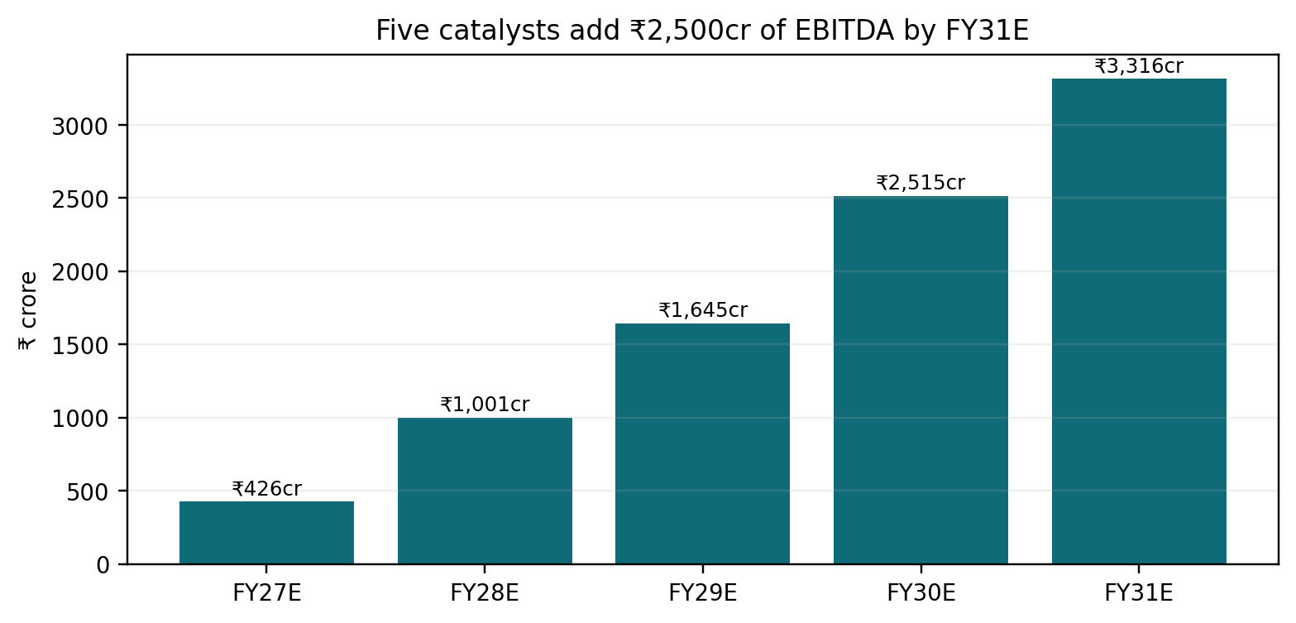
Source: company disclosures and analyst estimates. Includes Lannett, respiratory, Pen-G, biosimilars and US dermatology.

What changed versus the Market-Perform initiation
Debate | Old thesis | New evidence | Model consequence
Lannett | 5–6pp dilutive; ~₹12/share PV | Closed, operating and at ~40% utilization | ₹559cr FY29E EBITDA
Quality | Fifth year of broad FDA concern | Raleigh closed VAI; oral/API outcomes better | Risk narrows to Eugia
Respiratory | Pipeline with uncertain timing | Advair launched; QVAR approved | ₹233cr FY29E EBITDA
Pen-G | Benefit seen as priced in | MIP, volume ramp, external sales and exports | ₹522cr FY29E EBITDA
Biosimilars | Late, single-digit return | Four products selling; trials largely complete | 18% FY29E margin
Dermatology | Outside core case | ADQUEY launched; platform built | FY29E break-even

Forecasts: FY27 is not the upgrade year
Year | Revenue | EBITDA | Margin | EPS | Vs old EPS
FY26A | ₹33,653cr | ₹6,856cr | 20.4% | ₹60.3 | 0.6%
FY27E | ₹38,127cr | ₹8,015cr | 21.0% | ₹70.9 | -4.1%
FY28E | ₹42,502cr | ₹9,151cr | 21.5% | ₹85.0 | 6.8%
FY29E | ₹46,995cr | ₹10,381cr | 22.1% | ₹100.6 | 17.1%
FY30E | ₹51,426cr | ₹11,807cr | 23.0% | ₹117.7 | 26.9%
FY31E | ₹55,418cr | ₹13,073cr | 23.6% | ₹132.9 | 32.7%
Exhibit 2: EPS revision
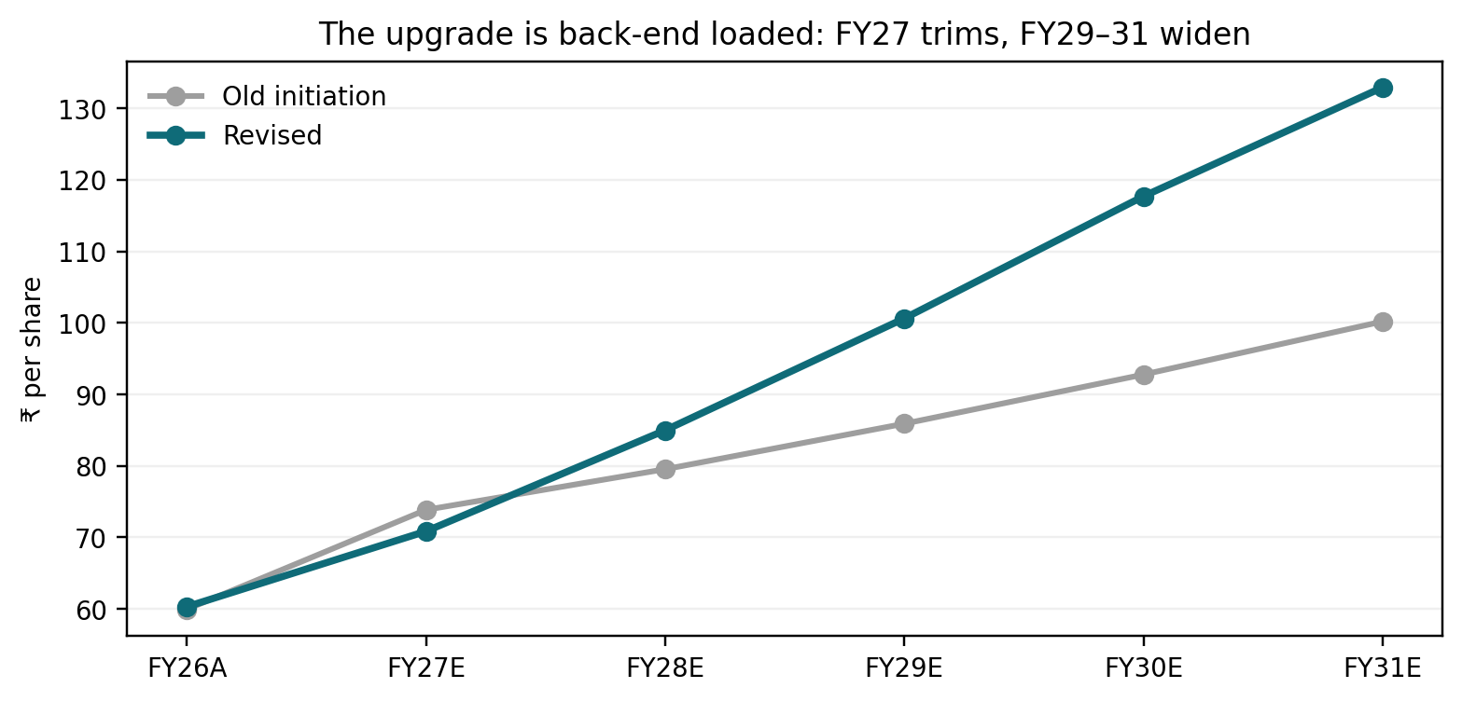
Source: uploaded initiation estimates, company results and analyst estimates. FY29–31 old estimates are extrapolated at 8% from the old FY28 base and are labelled as analyst extrapolations in the workbook.

1. Lannett will turn around in 12–18 months

At 40% utilization, the plant is an absorption problem before it is a growth problem
Lannett acquired a 3.6bn-dose plant producing about 1.4bn units, or roughly 39% of demonstrated capacity. The Seymour footprint includes about 425,000 square feet, including a 116,000 square foot leased distribution facility, more than 500 employees and roughly 70 active products. FY25 sales were US$306m, while management's post-close base objective is at least US$60m a quarter before new launches. The mismatch explains the initial dilution: the asset carries US labor, compliance and plant overhead without enough units moving through it. [S4–S6]
The first-principles lever is throughput. At the disclosed FY25 revenue/output relationship, each 10 percentage points of utilization represents roughly US$76m of annual revenue capacity. At a 30% incremental contribution margin, that is about US$23m of incremental EBITDA before corporate allocation. The exact number will vary by product mix, but it shows why utilization matters more than headline acquisition multiples.
Our base case raises utilization from 40% in FY27 to 47% in FY28 and 56% in FY29. Revenue reaches US$265m in FY28 and US$305m in FY29, close to Lannett's FY25 sales despite the four FTC divestitures. EBITDA margin rises from 12% in FY27 to 16% in FY28 and 19% in FY29. The 12–18 month turnaround therefore means a return to a mid-teens margin first; it does not assume Aurobindo USA's 23–24% margin immediately.
Exhibit 3: Lannett utilization and margin
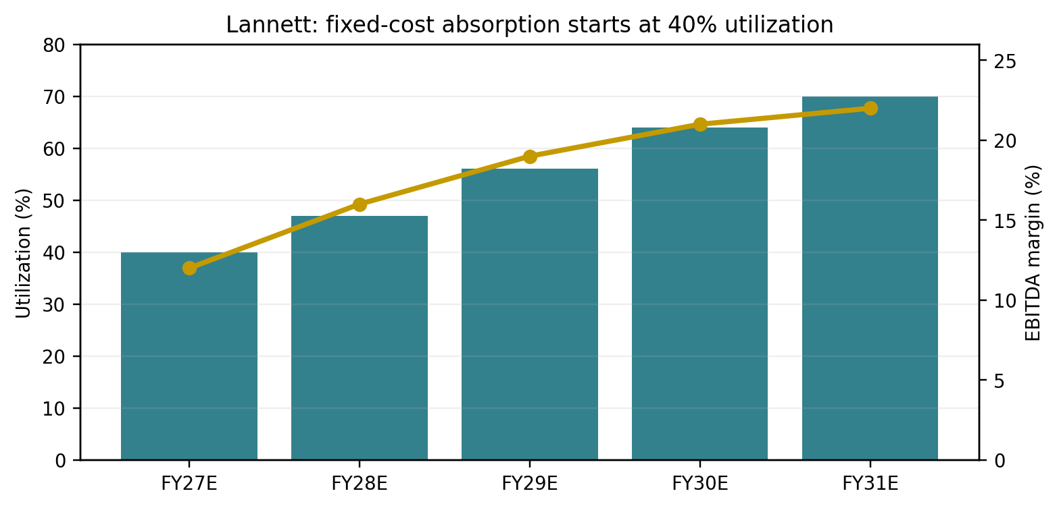
Source: Lannett transaction disclosure, Q1FY27 call and analyst estimates.

ADHD adds value, but quota release is excluded
The controlled-substance portfolio is strategically useful because it diversifies Aurobindo's US mix and requires domestic quota access. It is also the easiest part of the case to overstate. The transaction deck showed FY25 composition of 6% controlled products, 47% non-controlled products and 47% CMO. Management said controlled volumes cannot jump unless DEA quotas rise or a competitor fails. We therefore hold ADHD/controlled products at 8–10% of modelled Lannett revenue and apply 5% annual growth. The margin recovery comes from non-ADHD site transfers, CDMO work and fixed-cost absorption. [S4–S5]

CBE-30 transfers arrive before PAS transfers
A manufacturing-site change can follow a Changes Being Effected in 30 Days route or require a Prior Approval Supplement. Product-specific routes have not been disclosed. The model uses eight internal transfer programs, assigns five to CBE-30 with six-to-nine month lags and three to PAS with 15-to-18 month lags, then applies 65–85% probabilities. This produces US$25m of risk-adjusted transfer sales in FY28 and US$60m in FY29. The route matrix is an analyst scenario rather than a company transfer list.
The FTC required Aurobindo to divest mycophenolate suspension, niacin ER, pilocarpine and rabeprazole. Those products are excluded from the transfer opportunity. [S7]

The Seymour inspection does not remove risk, but it protects the timetable
FDA inspected Seymour in August 2026 and issued four observations described by the company as procedural. A final classification remains a gating item. The base case assumes remediation inside the transfer timetable; an OAI would invalidate the FY28–29 ramp. [S8]

Lannett valuation and failure test
At ₹559cr FY29 EBITDA, the business earns a mid-teens pre-tax return on the approximate ₹2,100–2,300cr acquisition cost before central synergies. The call fails if utilization remains below 50% through FY29, if PAS transfers slip into FY30, or if DEA constraints coincide with weaker CDMO demand.

2. FDA headwinds are less bumpy; respiratory offsets Eugia

The quality signal has split into two different businesses
The FDA read-through is no longer one company-wide score. Raleigh received a VAI classification and an EIR; the inspection is closed and pending inhaler, dermatology and transdermal applications can progress. Seymour's four observations were procedural. Recent peptide and API inspections ended with zero to three observations. By contrast, Eugia Units I, II and III are OAI, Unit I has a Warning Letter, and 52 ANDAs sit under review across those three units. [S8–S12]
This is why we use the phrase less bumpy. The probability of a broad non-sterile approval stop has fallen. The sterile launch pipeline remains constrained, and existing supply is not the same as new approvals. Unit I contributes around 2% of group revenue and current supply continues, which limits the immediate P&L shock; Unit III's 40 pending ANDAs create the larger opportunity cost. [S3, S10–S11]
Site | Status | Role | Model read-through
Raleigh | VAI / EIR closed | Inhalers, derma, transdermal | Applications can progress
Seymour | 4 procedural observations | Oral solids / controlled | Classification pending
API / peptide sites | 0–3 recent observations | Inputs and peptides | Lower broad risk
Eugia I | OAI + Warning Letter | Sterile | Existing supply unchanged; ~2% group sales
Eugia II | OAI | Sterile | New approvals constrained
Eugia III | OAI | Sterile | 40 pending ANDAs affected

Advair monetizes first; QVAR proves the MDI platform
Lannett launched generic Advair Diskus in 100/50 and 250/50 strengths on 31 August. The disclosed reference market was US$908m. We model US$10m sales in FY27 and US$30m in FY28, below a 5% value share after adjusting for only two strengths, market erosion and multiple competitors. [S14]
Aurobindo then received final approval for beclomethasone HFA 40mcg and 80mcg, its first US metered-dose inhaler. The product will be made at Raleigh, and the disclosed market for the approved product plus newer QVAR versions was US$301m. QVAR RediHaler is a different breath-actuated presentation, so the full US$301m is not directly substitutable. We apply a 35% accessible-market factor and model US$12m sales in FY28. [S13]
Cipla's model-informed, in-silico filing work is relevant to the regulatory route for complex inhalers, but it does not establish substitutability across devices or Aurobindo's timing for a new RLD case. Manager input indicates outsourced device components with fill-finish and assembly at Raleigh. Public disclosure verifies Raleigh manufacturing; the make-versus-buy split remains an operating assumption and receives no separate valuation credit.
Spiriva and Flovent remain development programs. We give Spiriva US$16m in FY29 and Flovent no sales until FY30. No other respiratory product contributes before FY31.
Exhibit 4: Respiratory vs Eugia
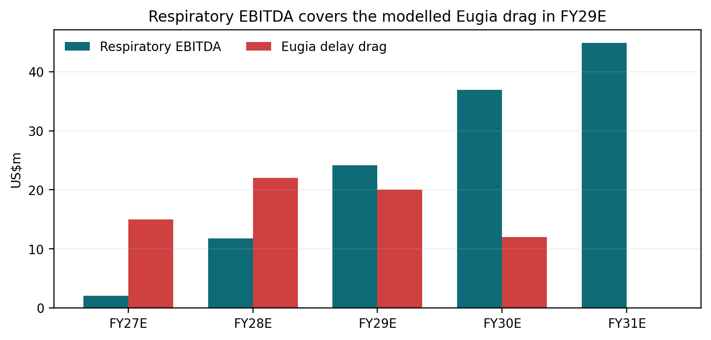
Source: company disclosures and analyst estimates. Eugia drag is the EBITDA difference versus an unconstrained approval case.

The offset point is FY29, not FY27
Respiratory EBITDA is only US$2m in FY27 against a modelled US$15m Eugia delay drag. It reaches US$24m in FY29 against a US$20m drag. The portfolio therefore offsets the sterile approval block in FY29 even without a full Eugia remediation. If Eugia recovers earlier, the upside comes through approvals rather than the respiratory case.

3. Pen-G breakout: external sales, captive savings and PLI

A 15,000MT plant has three profit pools, and only one is subsidy
Lyfius has installed 15,000MT of Penicillin G capacity at Kakinada after ₹2,270cr of investment. Government data show more than 90% domestic value addition and ₹1,191cr of cumulative production. Management reported an 800–900 tonne monthly run-rate in Q1, supplies to large Indian customers, conversion into 6-APA and amoxicillin, and export activity. [S4, S15]
The model separates three pools. External domestic/export volume creates reported revenue. Captive volume does not create consolidated revenue; it reduces the cost and volatility of 6-APA, amoxicillin and finished-dose production. PLI is shown as other operating benefit and expires from the terminal case. This separation avoids the common error of counting captive transfer value as both sales and savings.
Year | Production MT | Utilization | External sales | EBITDA ex-PLI | PLI | Total EBITDA
FY27E | 10,000 | 66.7% | ₹832cr | ₹222cr | ₹240cr | ₹462cr
FY28E | 12,000 | 80.0% | ₹1,242cr | ₹332cr | ₹216cr | ₹548cr
FY29E | 13,500 | 90.0% | ₹1,522cr | ₹441cr | ₹81cr | ₹522cr
FY30E | 14,500 | 96.7% | ₹1,635cr | ₹523cr | ₹0cr | ₹523cr
FY31E | 15,000 | 100.0% | ₹1,757cr | ₹574cr | ₹0cr | ₹574cr
Exhibit 5: Pen-G EBITDA stack
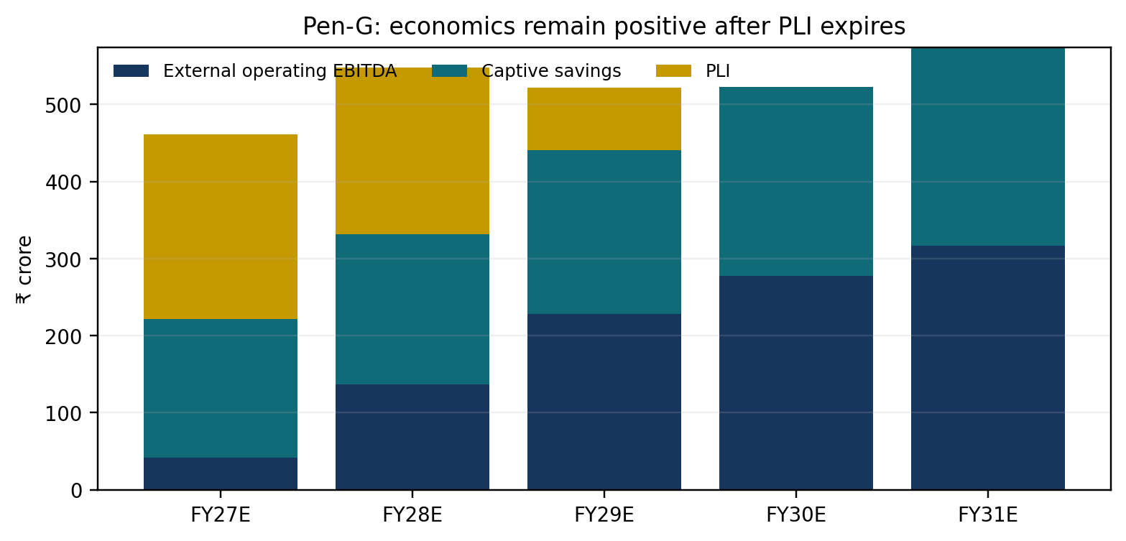
Source: Government of India, company commentary and analyst estimates.

MIP supports domestic pricing; exports test the real cost curve
DGFT set one-year minimum import prices of ₹2,216/kg for Pen-G, ₹3,405/kg for 6-APA and ₹2,733/kg for amoxicillin trihydrate. The policy makes Chinese import undercutting harder in the domestic tariff area. It does not protect export realizations or exempt supply channels. Our external export price is ₹1,850/kg, 17% below the domestic Pen-G floor. [S16]
Production reaches 12,000MT in FY28 and 15,000MT in FY31. We do not include the 15–16k MT debottleneck in the base case. At FY30, after PLI has expired, external operating EBITDA plus captive savings reach about ₹523cr, or a 23% EBITDA return on the ₹2,270cr plant investment. This is the durable part of the thesis.

PLI accelerates payback but does not support terminal value
Management quantified PLI at ₹240cr per 10,000MT, proportionate to production. We reproduce that result in FY27, step the rate to 15% in FY28 and 5% in FY29, then set it to zero. [S17] The base case still produces ₹523cr EBITDA in FY30 without PLI.

Failure test
The Pen-G case fails if export prices fall below ₹1,650/kg while captive savings remain below ₹325/kg, or if utilization stalls below 70% after FY28. The workbook contains a two-way sensitivity for those variables.

4. Biosimilars: second wave, sufficiently margin accretive

Late entry limits share; returns depend on fixed-cost absorption
Aurobindo will not be early in denosumab, omalizumab, bevacizumab or several follow-on molecules. FDA's list already contains multiple denosumab approvals. Price and tender share must therefore be conservative. [S18] The economic question is whether incremental products can absorb an existing biologics platform and use Aurobindo's European tender, regulatory and distribution infrastructure.
Four products are already live across the UK, selected European countries and Mexico: Bevqolva, Zefylti, Dyrupeg and Dazublys. The route to market includes Aurobindo's own network, Orion and STADA. Management expects tender conversion to lag launch by two to three quarters. The model starts at US$35m FY27 sales and US$80m FY28, then adds denosumab, omalizumab, tocilizumab and ranibizumab. [S3–S4]
Program | Molecule | Current stage | Model timing
Bevqolva | Bevacizumab | Launched | UK/EU/Mexico
Zefylti | Filgrastim | Launched | UK/EU/Mexico
Dyrupeg | Pegfilgrastim | Launched | UK/EU/Mexico
Dazublys | Trastuzumab | Launched | UK/EU
Denosumab pair | Denosumab | Filed EMA | FY28/29 base launch
Omazijev | Omalizumab | Phase 3 successful | FY29 base launch
BP08 | Tocilizumab | Pivotal complete | FY29/30
BP05 | Ranibizumab | Phase 3 near complete | FY30

Margin expands as trials finish and the product base broadens
R&D was guided at ₹1,450–1,500cr in FY27, with roughly 35–36% directed to biosimilars. Most large Phase 3 programs are complete, so clinical spend should decline before the pipeline stops expanding. We model biosimilar EBITDA at -20% in FY27, +5% in FY28, 18% in FY29 and 26% in FY30. The FY30 margin exceeds the current group margin because tender/partner fees and fixed R&D are spread over US$260m of sales.
The model does not value the long list of early programs individually. Next-wave assets add US$48m only in FY31. The upgrade receives credit for filed or advanced assets, not for every originator market printed in the pipeline slide.

Return test
The biosimilar thesis passes if the segment is above break-even by FY28/29 and reaches at least 20% EBITDA margin by FY30. It fails if European tender conversion stays below US$80m in FY28, the denosumab/omalizumab filings slip more than 12 months, or partner fees prevent margin from reaching the high teens.

5. US dermatology: the second product makes the platform profitable

ADQUEY is verified; the second asset is not publicly named
Acrotech launched ADQUEY, difamilast 1% ointment, on 30 September for mild-to-moderate atopic dermatitis in adults and children aged two years and older. The company created a dedicated dermatology unit and disclosed a US$1.3bn market. Acrotech's public dermatology page lists ADQUEY only. [S19–S20]
Manager input identifies one launched product and one pipeline product. We could not verify the name of the second product in public company material as of 6 October. The workbook therefore calls it Pipeline Product 2 and values it through a break-even hurdle. This protects the model from a false product attribution.

The fixed field platform requires roughly US$66m of revenue
We use a 58% contribution margin after product cost, royalties and gross-to-net deductions. Fixed commercial and medical cost rises from US$25m in FY27 to US$38m in FY29. FY29 break-even revenue is therefore US$65.5m. ADQUEY contributes US$60m in that year, leaving only US$5.5m of required sales from Product 2. Our base case assigns US$15m and produces US$5.5m EBITDA.
If Product 2 does not launch, FY29 segment EBITDA is -US$3.2m. The earnings shortfall is contained if ADQUEY reaches US$60m. The larger risk is ADQUEY access: a US$45m outcome with no second product would leave the platform about US$12m below break-even.
Year | ADQUEY | Product 2 | Fixed cost | EBITDA
FY27E | US$8m | US$0m | US$25m | US$-20.4m
FY28E | US$35m | US$0m | US$31m | US$-10.7m
FY29E | US$60m | US$15m | US$38m | US$5.5m
FY30E | US$85m | US$40m | US$42m | US$30.5m
FY31E | US$105m | US$65m | US$46m | US$52.6m

Consolidated earnings and valuation

Revenue broadens; EBITDA grows faster than sales
Revenue rises from ₹33,653cr in FY26 to ₹55,418cr in FY31, a 10.5% CAGR. EBITDA rises from ₹6,856cr to ₹13,073cr, a 13.8% CAGR. Margin reaches 23.6%. Lannett, respiratory, Pen-G, biosimilars and dermatology account for roughly ₹2,500cr of FY31 EBITDA.
FY27 captures nine months of Lannett and the first Pen-G/PLI benefit, but it also absorbs dermatology launch cost and a biosimilar loss. EPS is ₹70.9, 4% below the old ₹73.9. FY28 EPS is ₹85.0, 7% above the old estimate, and FY29 reaches ₹100.6. The earnings slope is the reason for the rating change.

DCF supports a ₹2,100 target
We forecast explicit FCFF through FY36, use 28% cash tax, 4.5% of incremental sales for working capital, a 10.5% WACC and 4.5% terminal growth. Enterprise value is ₹121,073cr. Adding ₹397cr net cash and dividing by 58.08cr shares yields ₹2,091 per share. We round to ₹2,100.
The terminal-growth assumption is 50bp below the original initiation's 5.0%, while WACC is unchanged. The valuation still carries duration risk: a 11.5% WACC and 3.5% terminal growth would move fair value below the current price. The workbook contains the full sensitivity grid.
Metric | Value | Basis
Current price | ₹1,686 | 6 Oct 2026
Target price | ₹2,100 | DCF rounded
Upside | 24.6% | Ex-dividend
FY29E EPS | ₹100.6 | Model
Current / FY29E P/E | 16.8x | Market price / EPS
Target / FY29E P/E | 20.9x | Target / EPS
Target / FY30E P/E | 17.8x | Target / EPS

What would make us wrong
- Lannett utilization remains below 50% through FY29 or Seymour receives OAI, delaying site transfers.
- Raleigh regresses or another major oral/API facility receives OAI, reversing the narrower quality-risk thesis.
- Eugia remediation lasts beyond FY30 and existing supply becomes constrained, turning an approval delay into a revenue loss.
- Pen-G export realizations fall below ₹1,650/kg, captive savings stay below ₹325/kg, or the plant cannot sustain 80% utilization.
- Biosimilar tender conversion is slower than two to three quarters and the segment remains loss-making after FY29.
- ADQUEY misses US$60m in FY29 and Product 2 is delayed; the dermatology fixed platform would stay under-absorbed.
- US generic price erosion, tariffs or a sharper lenalidomide decline reduce core US margin below 23%.

Monitoring dashboard
Workstream | Evidence needed | Cadence
Lannett | Quarterly sales ≥US$60m; utilization >45% by FY28 | Every quarter
Seymour / Raleigh | Final inspection status and ANDA progression | On disclosure
Respiratory | Advair share; QVAR launch quarter | Quarterly
Eugia | OAI remediation and Unit III approvals | On FDA/company update
Pen-G | Monthly tonnes, external/export mix, ex-PLI EBITDA | Quarterly
Biosimilars | Tender wins, EMA/US filings, segment break-even | Quarterly
Dermatology | ADQUEY net sales and identity/timing of Product 2 | Quarterly

Appendix: source map and modelling conventions
All financial forecasts are analyst estimates unless explicitly described as reported or guided. ₹ crore figures may not add because of rounding. Market sizes are company-disclosed IQVIA figures where identified. Spiriva and Flovent TAMs, site-transfer routes, product-level launch shares, Pen-G export prices and the second dermatology asset are analyst inputs.
ID | Source | Used for | Date
S1 | Uploaded sector initiation note | Original Market-Perform rating, ₹1,498 target, old forecasts and objections | 30 Aug 2026
S2 | Aurobindo Q4/FY26 press release | FY26 revenue, EBITDA, PAT and geography/API revenue | 21 May 2026
S3 | Aurobindo Q1FY27 earnings presentation | Q1 financials, filings, biosimilar pipeline and country launches | 5 Aug 2026
S4 | Aurobindo Q1FY27 earnings call transcript | Lannett run-rate/utilization/synergies; Pen-G run-rate and demand; biosimilar filings; Eugia guidance | Aug 2026
S5 | Lannett transaction summary | $250m price, $306m FY25 sales, 3.6bn dose capacity, 1.4bn output and FY25 business mix | 30 Jul 2025
S6 | Lannett FTC approval press release | Acquisition terms, approximately 4bn dose capacity and strategic rationale | 22 Jun 2026
S7 | FTC Aurobindo-Lannett case | Four product divestitures and divested product identities | 18 Jun 2026
S8 | Lannett Seymour FDA inspection disclosure | Four procedural observations in August 2026 inspection | 24 Aug 2026
S9 | Raleigh VAI/EIR disclosure | VAI classification, inspection closed; pending inhaler/derma applications can progress | 17 Aug 2026
S10 | Eugia Unit I warning letter disclosure | OAI/Warning Letter; current supply unchanged; approximately 2% of group revenue | 14 Aug 2026
S11 | Eugia Unit III OAI disclosure | 11 observations and OAI classification | 12 Jun 2026
S12 | Eugia Unit II OAI disclosure | Nine observations and OAI classification | 17 Mar 2026
S13 | QVAR generic approval press release | First Aurobindo MDI; Raleigh manufacturing; $301m reference/new-version market | 15 Sep 2026
S14 | Aurobindo press release index: Advair launch | Generic Advair launch in 100/50 and 250/50 strengths; disclosed market $908m | 31 Aug 2026
S15 | Government of India PIB: bulk-drug PLI | ₹2,270.05cr Pen-G plant investment, 15,000MT capacity, ₹1,191cr cumulative production and >90% domestic value add | 25 Sep 2026
S16 | DGFT minimum import price notification 56/2025-26 | Pen-G ₹2,216/kg, 6-APA ₹3,405/kg and amoxicillin trihydrate ₹2,733/kg | 29 Jan 2026
S17 | Aurobindo Q3FY26 earnings call transcript | Management stated PLI of ₹240cr per 10,000MT, proportionate to production | 10 Feb 2026
S18 | FDA biosimilar product information | Competitive approval density, including multiple denosumab biosimilars | accessed 6 Oct 2026
S19 | Acrotech dermatology product page | ADQUEY is the only publicly listed dermatology product | accessed 6 Oct 2026
S20 | ADQUEY launch announcement | US launch, dedicated dermatology unit and $1.3bn atopic dermatitis market | 30 Sep 2026
S21 | Google Finance: AUROPHARMA | 6 October 2026 closing price ₹1,686 | 6 Oct 2026
S22 | Google Finance peer pages | 6 October 2026 market prices and TTM P/E for Indian pharma peer context | 6 Oct 2026

Key source URLs
S1 Uploaded sector initiation note: Local upload: India Healthcare_ Innovation Power Decade...pdf
S2 Aurobindo Q4/FY26 press release: https://www.aurobindo.com/api/uploads/resultsannouncement/APL_PressRelease_Q4FY26.pdf
S3 Aurobindo Q1FY27 earnings presentation: https://www.aurobindo.com/api/uploads/resultsannouncement/APL_EarningsPresentation_Q1FY27.pdf
S4 Aurobindo Q1FY27 earnings call transcript: https://www.aurobindo.com/api/uploads/conferencecalltranscripts/APL_ECT_Q1FY27_Final.pdf
S5 Lannett transaction summary: https://www.aurobindo.com/api/uploads/disclosureofeventsinformation/LtrToSEsLannett30072025.pdf
S6 Lannett FTC approval press release: https://www.aurobindo.com/api/uploads/corporateannouncements/LtrToSEsLnnettPR22062026.pdf
S7 FTC Aurobindo-Lannett case: https://www.ftc.gov/legal-library/browse/cases-proceedings/251-0096-aurobindo-lannett-matter
S8 Lannett Seymour FDA inspection disclosure: https://www.aurobindo.com/api/uploads/disclosureofeventsinformation/LtrToSEsLannettUSFDA24082026.pdf
S9 Raleigh VAI/EIR disclosure: https://www.aurobindo.com/api/uploads/disclosureofeventsinformation/LtrToSEsAurolifeNCVAI17082026.pdf
S10 Eugia Unit I warning letter disclosure: https://www.aurobindo.com/api/uploads/disclosureofeventsinformation/LtrToSEsEugiaUnitIWarningLetter14082026.pdf
S11 Eugia Unit III OAI disclosure: https://www.aurobindo.com/api/uploads/disclosureofeventsinformation/LtrToSEsEuigaUnit3USFDAinspection12062026.pdf
S12 Eugia Unit II OAI disclosure: https://www.aurobindo.com/api/uploads/disclosureofeventsinformation/LtrToSEsEugiaUSFDA17032026.pdf
S13 QVAR generic approval press release: https://www.aurobindo.com/api/uploads/corporateannouncements/LtrToSEsPressReleaseUSFDAapproval15092026.pdf
S14 Aurobindo press release index: Advair launch: https://www.aurobindo.com/media/press-releases
S15 Government of India PIB: bulk-drug PLI: https://www.pib.gov.in/PressReleseDetailm.aspx?PRID=2314891&lang=1&reg=3
S16 DGFT minimum import price notification 56/2025-26: https://content.dgft.gov.in/Website/dgftprod/85a8d911-e529-43c0-a691-7056dd6fff45/Notification%20English.pdf
S17 Aurobindo Q3FY26 earnings call transcript: https://www.aurobindo.com/api/uploads/conferencecalltranscripts/Transcript_Q3FY26_Final.pdf
S18 FDA biosimilar product information: https://www.fda.gov/drugs/biosimilars/biosimilar-product-information
S19 Acrotech dermatology product page: https://acrotechbiopharma.com/our-dermatology-products/
S20 ADQUEY launch announcement: https://acrotechbiopharma.com/
S21 Google Finance: AUROPHARMA: https://www.google.com/finance/quote/AUROPHARMA:NSE
S22 Google Finance peer pages: https://www.google.com/finance/quote/AUROPHARMA:NSE

Disclosure note
This document is an internal analytical working draft prepared from public sources, an uploaded initiation note and management workplan headings. It is not a company document. Forecasts and valuation are estimates and should be reviewed against house compliance, distribution and certification requirements before external use.

