US GENERICS | PARA IV | FIRST GENERIC

Zydus First Generic Adempas Opens a US$20 to 25mn Para IV Opportunity
  - The launch validates the partner-led complex generics leg of our initiation thesis
US$20–25mn  FY27E sales estimate | c.10%  assumed US share | ₹0.4–0.6  estimated EPS addition

HIGHLIGHTS
1 Zydus and MSN have launched the first generic Adempas across all five strengths
Zydus will commercialize the product in the US and MSN will supply it. We estimate US$20–25mn of FY27E sales if Zydus reaches a c.10% share during the October-to-March launch period. That equals INR 1.9–2.4bn at INR 96.4 per US dollar, or 0.6–0.7% of our FY27E revenue estimate. A 30–35% contribution margin and normal tax rate produce INR 0.4–0.6 of EPS, equal to c.0.7–1.0% of FY27E EPS. Partnership economics are not public. Our estimate assumes Zydus records product sales and pays MSN through product cost or profit share. The exact accounting can change reported revenue and leave the profit pool broadly intact.
2 Adempas converts a small rare-disease patient pool into a high-value chronic market
Pulmonary hypertension raises pressure in the lung circulation and increases the load on the right side of the heart. Riociguat stimulates soluble guanylate cyclase, restores cyclic GMP signalling and relaxes pulmonary blood vessels. It is approved for pulmonary arterial hypertension and for chronic thromboembolic pulmonary hypertension that cannot be corrected by surgery or persists after surgery. The second indication carries distinct value because riociguat is the only US-approved drug for this setting. Treatment is chronic, dosed three times daily and titrated through five strengths. A REMS programme manages embryo-fetal risk. These features concentrate prescribing in specialist centres and make conversion operationally slower than a standard tablet generic. Bayer reported EUR 745mn of global Adempas sales in 2025. US Medicare Part D gross spending alone was c.US$0.8bn.
3 This is a settlement-enabled Para IV entry and a proof point for the initiation thesis
MSN filed ANDA 211135 in October 2017 with Paragraph IV certifications. Bayer and MSN settled the core Delaware patent cases in 2020. Public documents do not disclose the entry terms. The launch roughly two months before the listed compound patent expires indicates that the settlement created an early-entry path. We describe this as settlement-enabled entry. The public record does not show a court judgment invalidating the patents. FDA’s 2022 approval letter called MSN one of the first applicants and said it may be eligible for shared 180-day exclusivity. FDA had not made a final exclusivity determination. We do not underwrite a protected six-month window. Additional competition after December 2026 is the main risk to price and share. The launch still validates Zydus’s ability to pair its US commercial platform with partner-owned development assets. It is one more monetisation event from the Para IV pipeline highlighted in our initiation work.

ZYDUS LIFESCIENCES | QUICK TAKE DRAFT | 7 OCTOBER 2026

ADEMPAS IS A HIGH VALUE CHRONIC THERAPY FOR TWO RARE FORMS OF PULMONARY HYPERTENSION
Start with the disease. The right ventricle pumps blood through the lungs. Resistance in the pulmonary arteries forces it to work harder. Persistent resistance causes breathlessness, loss of exercise capacity and progressive right-heart failure. Pulmonary arterial hypertension, or PAH, is driven by narrowing and remodelling of small pulmonary arteries. Chronic thromboembolic pulmonary hypertension, or CTEPH, is driven by organised clots that remain in the pulmonary vessels. Surgery is the preferred treatment for operable CTEPH. Drug therapy is required when surgery is not possible or pressure remains after surgery.
Riociguat repairs a signalling deficit that sits upstream of vasodilation. Nitric oxide normally activates soluble guanylate cyclase, or sGC, which raises cyclic GMP and relaxes vascular smooth muscle. Riociguat sensitises sGC to endogenous nitric oxide and also stimulates the enzyme directly. The result is lower pulmonary vascular resistance. In pivotal trials, Adempas improved six-minute walk distance by 46 metres versus placebo in CTEPH and by 36 metres in PAH. The clinical value is functional improvement and delayed worsening.
The product architecture explains the commercial stickiness. Treatment starts at 1mg three times daily and rises in 0.5mg steps every two weeks to a maximum of 2.5mg three times daily, subject to blood pressure. The five strengths support this titration. Pregnancy is contraindicated and dispensing runs through a REMS programme. Nitrates and PDE5 inhibitors are also contraindicated. A generic must therefore win formulary access, specialist confidence, pharmacy readiness and patient conversion. Price alone does not move the whole market on day one.

THE US POOL IS SMALL IN PATIENTS AND LARGE IN DOLLARS
The market has rare-disease economics. Public Medicare Part D data show c.US$791mn of gross Adempas spending in 2025 across roughly 5,300 beneficiaries. Gross spend includes plan and patient payments and excludes rebates. It is not Bayer net sales. It still establishes the order of magnitude of US drug expenditure. Bayer reported EUR 745mn of global Adempas sales in 2025, up 3% as reported, with US volume the main growth driver. Quarterly sales remained near EUR 180–190mn through the first half of 2026.
EXHIBIT 1 Adempas quarterly sales have held near EUR 180–190mn
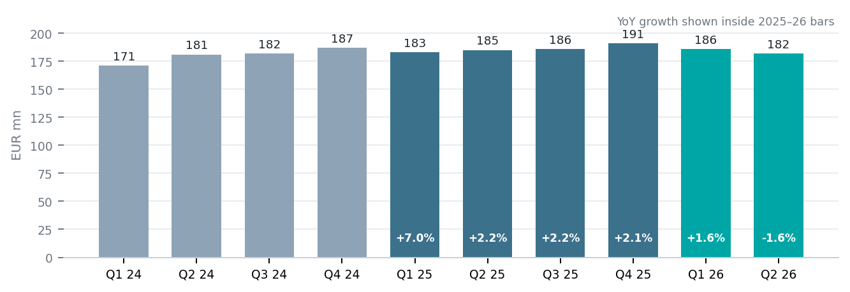
Source: Bayer quarterly and annual reports. Sales include Bayer's proportionate recognition under the sGC collaboration. YoY growth calculated by Bernstein.
Our bridge starts with the c.US$0.8bn Part D gross pool. We apply 50–60% generic price realisation after rebates and channel deductions, a 10% Zydus share and six months of FY27 contribution. This produces US$20–25mn of FY27E sales. The share assumption is achievable for a first generic with national commercial coverage. The conversion curve will be paced by specialist prescribing, REMS processes and existing patient stability.

THE PARA IV ROUTE ENDED IN A SETTLEMENT LED EARLY ENTRY
MSN challenged the listed patent estate early. The company submitted ANDA 211135 on 10 October 2017 and certified that the listed patents were invalid, unenforceable or not infringed. The filing triggered litigation in Delaware. Bayer and MSN settled the core cases in December 2020. The terms are confidential. FDA granted final approval on 1 September 2022. The approval letter listed a compound patent expiring on 4 December 2026 and two later patents expiring in 2034. The September 2026 commercial start confirms that MSN secured a route to enter ahead of the compound-patent date.
The legal description matters. This was a negotiated entry, not a public merits judgment. FDA identified MSN as one of the first applicants and stated that it may be eligible for shared 180-day exclusivity. The agency also noted a potential forfeiture issue because tentative approval came after the statutory 30-month period. FDA had not resolved the question in the approval letter. Our estimates assume no protected exclusivity. Teva has a tentative approval and other filers have appeared in later litigation. The December 2026 compound-patent expiry can accelerate competition.

ZYDUS LIFESCIENCES | QUICK TAKE DRAFT | 7 OCTOBER 2026

ADEMPAS VALIDATES ZYDUS'S PARTNER LED PARA IV MODEL
The operating model divides risk and capability cleanly. MSN owns product development and manufacturing. Zydus contributes its US regulatory and commercial infrastructure. This structure reduces the development burden on Zydus and gives MSN access to a scaled front end. It also introduces an undisclosed transfer-price or profit-share. We therefore model the opportunity from the market pool and show the revenue and EPS sensitivities explicitly.
EXHIBIT 2 A 10% share supports US$20–25mn of FY27E sales
FY27E bridge | 5% share | 10% share | 15% share
US Part D brand gross pool | US$0.79bn | US$0.79bn | US$0.79bn
Generic price realisation | 50–60% | 50–60% | 50–60%
Six-month Zydus sales | US$10–12mn | US$20–25mn | US$30–36mn
INR revenue at 96.4/USD | INR 1.0–1.2bn | INR 1.9–2.4bn | INR 2.9–3.5bn
EPS at 30–35% margin | INR 0.2–0.3 | INR 0.4–0.6 | INR 0.7–0.9
Source: CMS Medicare Part D public-use data, company reports and Bernstein estimates. Price realisation, share, margin and EPS are estimates. Partnership economics are undisclosed.
The base case adds INR 1.9–2.4bn of revenue and INR 0.4–0.6 of EPS. That is 0.6–0.7% of our FY27E revenue estimate and c.0.7–1.0% of FY27E EPS. The direct earnings contribution is contained. The strategic read-through is broader. Zydus has converted a partner-sourced Paragraph IV asset into a first-generic launch in a specialist market. This is the operating proof point we looked for in the US pipeline leg of our initiation thesis.
The US business provides useful scale. Zydus reported US$327mn of North America sales in Q1 FY27. Our Adempas base case equals c.3–4% of an unchanged six-month regional run-rate. The contribution is visible within North America and small at the group level. It can absorb part of routine price erosion in the existing oral-solids portfolio.
The 10% share case is built from a short set of operating steps. Zydus must secure formulary access, connect specialty pharmacies to the REMS process and convert roughly one in ten prescription-value dollars. The case does not require full-market patient switching. Existing patients can remain stable while new starts and payer-led conversions build share through the fiscal second half.
Three variables determine the outcome. The first is the speed of specialist and specialty-pharmacy conversion. The second is the number and timing of follow-on generics after December 2026. The third is the Zydus-MSN economic split. Each moves reported revenue and margin in a straight line. We would treat US$10–12mn as the downside case at 5% share and US$30–36mn as the upside case at 15% share.
Primary references: FDA ANDA 211135 approval correspondence; US prescribing information for riociguat; Bayer annual and quarterly reports; CMS Medicare Part D public-use data; Zydus and MSN launch announcement. Financial estimates are Bernstein estimates.

