Eda.py:
(venv) C:\Users\91986\OneDrive\Desktop\ICS_LAB\ics mini proj>py eda.py

Train Shape: (175341, 45)
Test Shape: (82332, 45)

Columns:
Index(['id', 'dur', 'proto', 'service', 'state', 'spkts', 'dpkts', 'sbytes',
'dbytes', 'rate', 'sttl', 'dttl', 'sload', 'dload', 'sloss', 'dloss',
'sinpkt', 'dinpkt', 'sjit', 'djit', 'swin', 'stcpb', 'dtcpb', 'dwin',
'tcprtt', 'synack', 'ackdat', 'smean', 'dmean', 'trans_depth',
'response_body_len', 'ct_srv_src', 'ct_state_ttl', 'ct_dst_ltm',
'ct_src_dport_ltm', 'ct_dst_sport_ltm', 'ct_dst_src_ltm',
'is_ftp_login', 'ct_ftp_cmd', 'ct_flw_http_mthd', 'ct_src_ltm',
'ct_srv_dst', 'is_sm_ips_ports', 'attack_cat', 'label'],
dtype='str')

First 5 rows:
id dur proto service state spkts ... ct_flw_http_mthd ct_src_ltm ct_srv_dst is_sm_ips_ports attack_cat label
0 1 0.121478 tcp - FIN 6 ... 0 1 1 0 Normal 0
1 2 0.649902 tcp - FIN 14 ... 0 1 6 0 Normal 0
2 3 1.623129 tcp - FIN 8 ... 0 2 6 0 Normal 0
3 4 1.681642 tcp ftp FIN 12 ... 0 2 1 0 Normal 0
4 5 0.449454 tcp - FIN 10 ... 0 2 39 0 Normal 0

[5 rows x 45 columns]

Data Types:
id int64
dur float64
proto str
service str
state str
spkts int64
dpkts int64
sbytes int64
dbytes int64
rate float64
sttl int64
dttl int64
sload float64
dload float64
sloss int64
dloss int64
sinpkt float64
dinpkt float64
sjit float64
djit float64
swin int64
stcpb int64
dtcpb int64
dwin int64
tcprtt float64
synack float64
ackdat float64
smean int64
dmean int64
trans_depth int64
response_body_len int64
ct_srv_src int64
ct_state_ttl int64
ct_dst_ltm int64
ct_src_dport_ltm int64
ct_dst_sport_ltm int64
ct_dst_src_ltm int64
is_ftp_login int64
ct_ftp_cmd int64
ct_flw_http_mthd int64
ct_src_ltm int64
ct_srv_dst int64
is_sm_ips_ports int64
attack_cat str
label int64
dtype: object

Missing Values:
id 0
dur 0
proto 0
service 0
state 0
spkts 0
dpkts 0
sbytes 0
dbytes 0
rate 0
sttl 0
dttl 0
sload 0
dload 0
sloss 0
dloss 0
sinpkt 0
dinpkt 0
sjit 0
djit 0
swin 0
stcpb 0
dtcpb 0
dwin 0
tcprtt 0
synack 0
ackdat 0
smean 0
dmean 0
trans_depth 0
response_body_len 0
ct_srv_src 0
ct_state_ttl 0
ct_dst_ltm 0
ct_src_dport_ltm 0
ct_dst_sport_ltm 0
ct_dst_src_ltm 0
is_ftp_login 0
ct_ftp_cmd 0
ct_flw_http_mthd 0
ct_src_ltm 0
ct_srv_dst 0
is_sm_ips_ports 0
attack_cat 0
label 0
dtype: int64

Label Distribution:
label
1 119341
0 56000
Name: count, dtype: int64

Attack Categories:
attack_cat
Normal 56000
Generic 40000
Exploits 33393
Fuzzers 18184
DoS 12264
Reconnaissance 10491
Analysis 2000
Backdoor 1746
Shellcode 1133
Worms 130
Name: count, dtype: int64

Statistical Summary:
id dur spkts ... ct_srv_dst is_sm_ips_ports label
count 175341.000000 175341.000000 175341.000000 ... 175341.000000 175341.000000 175341.000000
mean 87671.000000 1.359389 20.298664 ... 9.100758 0.015752 0.680622
std 50616.731112 6.480249 136.887597 ... 10.756952 0.124516 0.466237
min 1.000000 0.000000 1.000000 ... 1.000000 0.000000 0.000000
25% 43836.000000 0.000008 2.000000 ... 2.000000 0.000000 0.000000
50% 87671.000000 0.001582 2.000000 ... 4.000000 0.000000 1.000000
75% 131506.000000 0.668069 12.000000 ... 12.000000 0.000000 1.000000
max 175341.000000 59.999989 9616.000000 ... 62.000000 1.000000 1.000000

[8 rows x 41 columns]
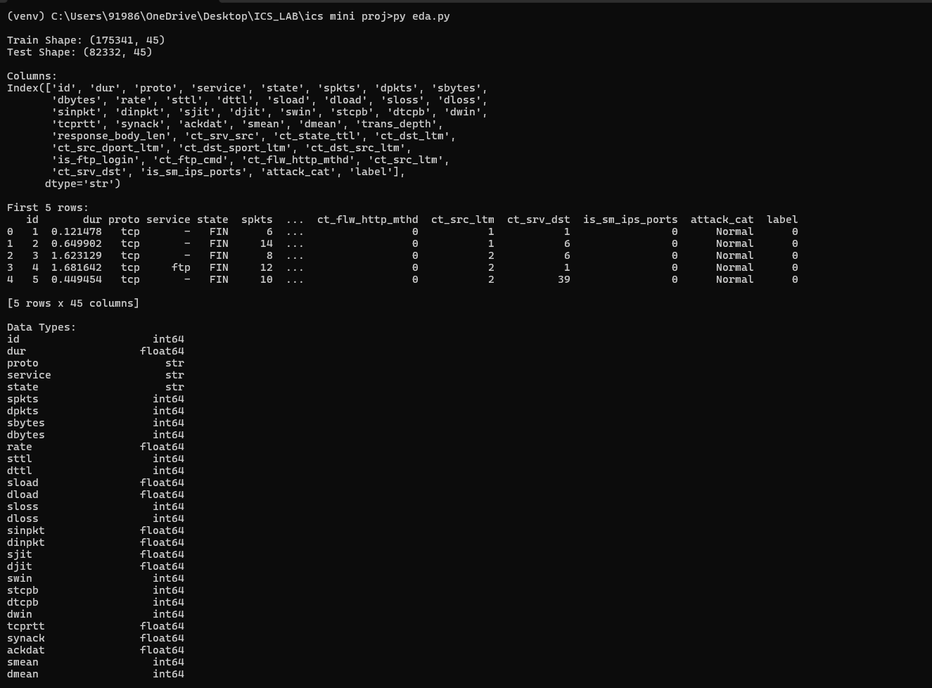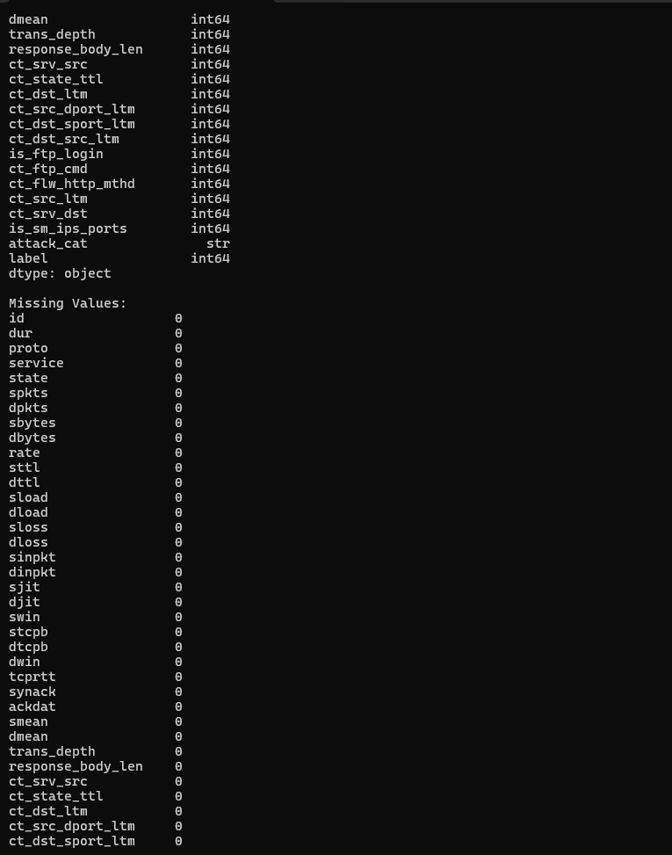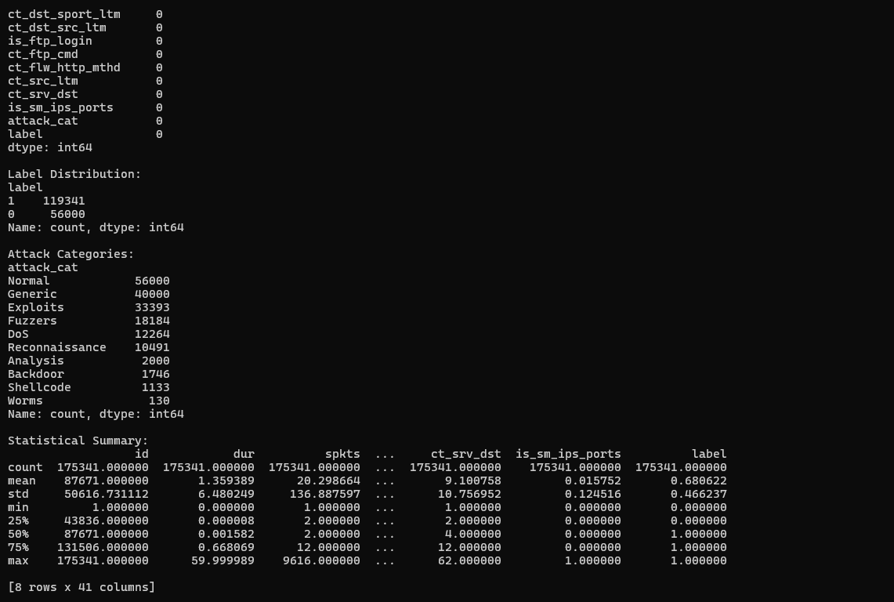
Preprocessing:
(venv) C:\Users\91986\OneDrive\Desktop\ICS_LAB\ics mini proj>py preprocessing.py
Train shape: (175341, 45)
Test shape: (82332, 45)

Categorical encoding completed.
proto service state
0 113 0 4
1 113 0 4
2 113 0 4
3 113 3 4
4 113 0 4
Processed Training Shape: (175341, 42)
Processed Testing Shape: (82332, 42)
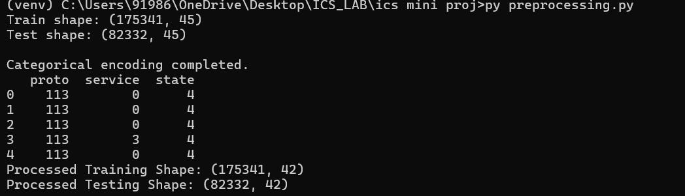

Model Training:
(venv) C:\Users\91986\OneDrive\Desktop\ICS_LAB\ics mini proj>py train_model.py
Train shape: (175341, 45)
Test shape: (82332, 45)

Categorical encoding completed.

Training Random Forest model...

Model Accuracy: 0.8726861973473254

Classification Report:
precision recall f1-score support

0 0.98 0.73 0.84 37000
1 0.82 0.99 0.89 45332

accuracy 0.87 82332
macro avg 0.90 0.86 0.87 82332
weighted avg 0.89 0.87 0.87 82332

Model saved successfully.
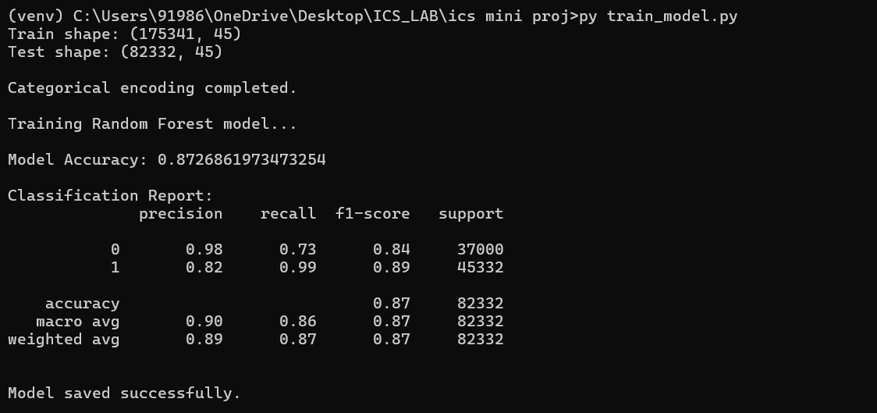

XAI Analysis:

(venv) C:\Users\91986\OneDrive\Desktop\ICS_LAB\ics mini proj>py xai_analysis.py
Train shape: (175341, 45)
Test shape: (82332, 45)

Categorical encoding completed.
Model loaded successfully.
Sample size for SHAP: (1000, 42)
SHAP values generated.
LIME explainer initialized.
C:\Users\91986\OneDrive\Desktop\ICS_LAB\ics mini proj\venv\Lib\site-packages\sklearn\utils\validation.py:2691: UserWarning: X does not have valid feature names, but RandomForestClassifier was fitted with feature names
warnings.warn(

LIME Explanation:
[('sttl <= 62.00', -0.1810167451201756), ('ct_state_ttl <= 1.00', -0.08567794594051292), ('is_sm_ips_ports <= 0.00', 0.05432487722759883), ('0.00 < swin <= 255.00', -0.04552293449505195), ('sloss > 3.00', -0.033732320827206695), ('0.00 < dttl <= 29.00', -0.03222953723653151), ('state <= 4.00', -0.02924379213707308), ('ct_srv_dst <= 2.00', 0.021867834702902315), ('ct_srv_src <= 2.00', 0.017852840005305248), ('service > 2.00', 0.015818616644864867)]
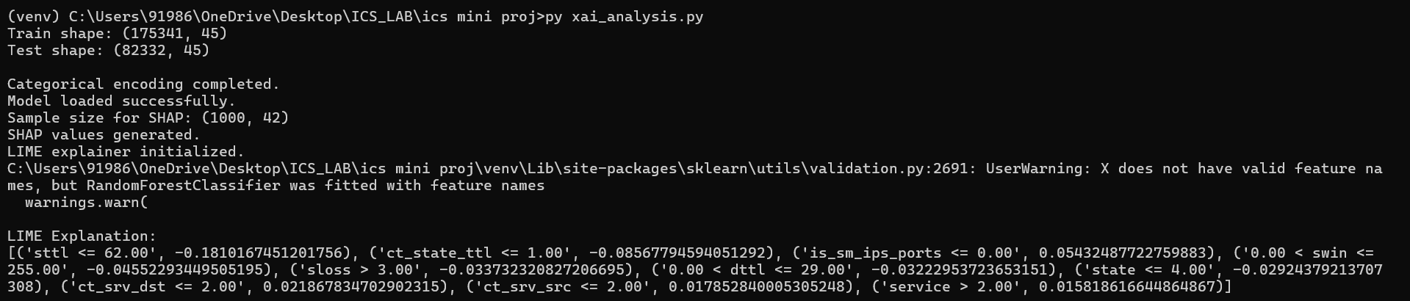

Stability Testing:

(venv) C:\Users\91986\OneDrive\Desktop\ICS_LAB\ics mini proj>py stability_analysis.py
Train shape: (175341, 45)
Test shape: (82332, 45)

Categorical encoding completed.
Model loaded.
LIME explainer ready.
Samples selected: (200, 42)

Average SHAP Stability: 0.9621852319072255

Average LIME Stability: 0.6495549071541773
