1. A simple embedded system

Microwave

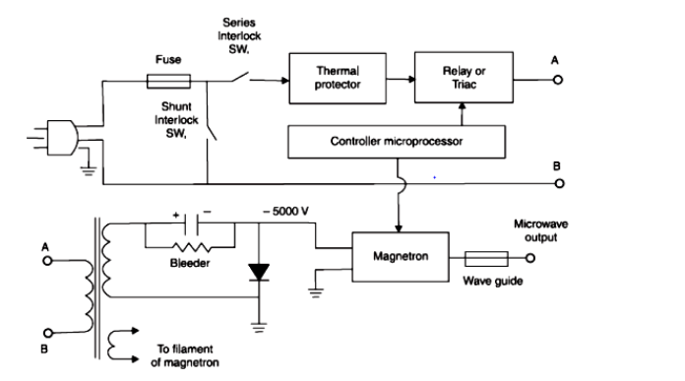

A microwave oven heats food by passing microwave radiation through it. Microwaves are a form of non-ionizing electromagnetic radiation with a frequency higher than ordinary radio waves but lower than infrared light. Microwave ovens use frequencies in one of the 15M industrial, scientific, medical) bands, which are reserved for this use, so they don't interfere with other vital radio services

The mains plug and socket are three-pin earthing type. The fast blow ceramic fuse is of 15 A 250 V Interlock switches linked with the oven door Power will be applied to the mains transformer only when the oven door is closed. At least one interlock switch is in series with the transformer primary, hence even a spot of dirt in the relay or trial, cannot turn the oven on when the door is open

Consumer ovens usually use 2.45 GHz, a wavelength of 122 cm (4 80 in) while large industrial/commercial ovens often use 915 MHz 32 8 cm (12.9 in) Water, fat, and other substances in the food absorb energy from the microwaves in a process called dielectric heating Many molecules (such as those of water) are electric dipoles meaning that they have a partial positive charge at one end and a partial negative charge at the other, and therefore rotate as they try to align themselves with the alternating electric field of the microwaves Rotating molecules hit other molecules and put them into motion, thus dispersing energy This energy, when dispersed as molecular vibration in solids and liquids Microwave ovens heat foods quickly and efficiently because excitation is fairly uniform in the outer 25-38 mm (1-15 inches) of a homogenous thigh water contents food item, food is more evenly heated throughout (except in heterogeneous, dense objects) than generally occurs in other cooking techniques.

2. A mid level to complex embedded system

Real time system for Autonomous Flight Control

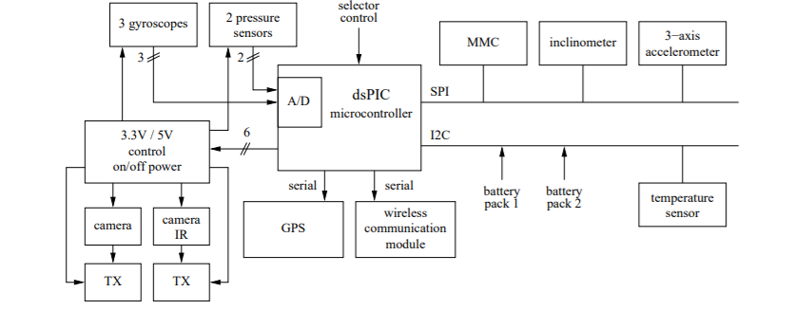

SYSTEM DESCRIPTION

The onboard system architecture is illustrated in Figure 1. It performs sensory acquisition and uses such data to trigger the motors for speed and direction control during autonomous flight, control the power consumption of the external devices, and send the relevant sensor information to the ground station.

A. Onboard controller

The onboard processing unit is a Microchip's dsPIC 30F6014 microcontroller [16], which integrates the control features of a Micro-Controller Unit (MCU) with the processing and throughput capabilities of a Digital Signal Processor (DSP). It is a 16-bit microcontroller with a maximum processing power of 30 MIPS. The model selected for proto typing includes a program memory space of 144 KBytes, a data memory …

[2:33 am, 18/02/2022] Shirsha: Data Converter Interface (DCI), which supports common audio Codec protocols such as I2S and AC'97.

The MCU power management system allows two reduced power modes, idle and sleep. The idle mode disables the CPU, but keeps the system clock source operative. Therefore, the peripherals continue to operate, even though they can optionally be disabled. In the sleep mode, both the CPU and the system clock source are disabled, as well as every peripherals that need the system clock to work. The sleep mode consumes less power than the idle mode, but, while the former has a latency of 10-130 us to resume the system, the latter has no wake-up delay. The microcontroller supports a method to disable a peripheral device which consists in stopping all the clock sources supplied to that module. When this method is adopted, the device has a minimum power consumption. This method requires 1 instruction cycle delay for both disabling and enabling the peripheral device.

B. The real-time kernel

The control application is developed on top of the ERIKA (Embedded Real time Kernel Architecture) Enterprise real time kernel . The kernel is organized in a modular fashion and it is fully configurable both in terms of services and kernel objects (tasks, resources, and events). It allows the user to include only those services strictly required by the application, thus achieving a minimal memory footprint of 2 Kbytes, up to more complete configurations. It is available for a wide variety of and 32 bit CPUs and supports advanced scheduling mechanisms, such as Rate Monotonic. Earliest Deadline First and resource reservations]. The kernel modular design allows reusing the software modules ng in different applications, speeding up the development of new d. projects or the upgrade of existing projects to more powerful architectures, and simplifying the maintenance.

C. Sensors and actuators

The microcontroller is connected to several sensors and actuators to perform autonomous flight and environment monitoring. Figure I shows the sensors and actuators managed by the microcontroller. The onboard configuration includes:

3 gyroscopes, one for each axis;

2 pressure sensors, which are needed to evaluate the pressure at the ground level and the flight speed through the difference between the pressures detected at aircraft head and tail;

one inclinometer;

. an MMC (MultiMedia Card) memory module, used to store the data logging during the flight; a digital 3-axis accelerometer,

a temperature sensor:

. a GPS module, to determine the absolute aircraft position;

• a wireless communication module, to exchange informa

tion with the ground station;

. a video camera, for monitoring the environment and facilitating the manual control when the aircraft is not visible;

• an infrared camera, for increasing sensitivity in fire detection.