**Stepper Motor Control Using Arduino**

**-SHIRSHA GHOSH**

**99007864**

**Abstract:**

A Stepper Motor is a type of DC Motor that rotates in discrete steps. Due to their unique design, stepper motors can be controlled for precise positioning without any feedback.

A typical stepper motor has multiple coils that are divided into phases. When each phase is energised in sequence, the rotor of the stepper motor rotates in steps. Stepper Motor Control utilizing Arduino is a basic task where a Bipolar Stepper Motor is controlled utilizing Arduino UNO. Stepper Motor is a kind of brushless DC Motor that changes over electrical pulses into unmistakable mechanical developments for example the shaft of a stepper engine pivots in discrete advances. At the point when a PC controls these means, we can get exact position and speed control.

Due to this discrete nature of step - revolution of a stepper engine, they are regularly utilized in modern computerization, CNC frameworks, and so forth where accuracy movement is required. This involves Arduino UNO as the super controlling piece of the venture to control the means of the stepper engine.

Basically, stepper motors are like the DC motors that rotate in discrete steps. They have multiple arranged coils and they are usually known as phases. Motor will rotate one step at a time if we energize each phase sequence. High levels of precision can be achieved by controlling the stepper motor with computer. Steppers motors are available in the market in many different sizes. The speed of the stepper motor is controlled by frequency of pulses generated.

**Block diagram:**

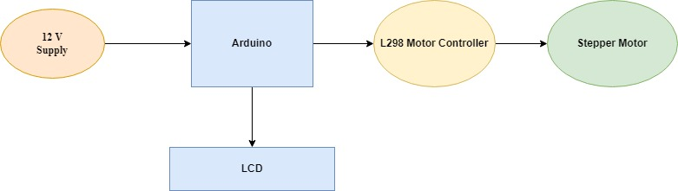

**Components Required:**

* Arduino UNO
* L298D Motor Driver IC ]
* Bipolar Stepper Motor
* Power Supply (suitable for the stepper motor)
* Connecting Wires
* LCD

**Requirements:**

* High Level Requirements:

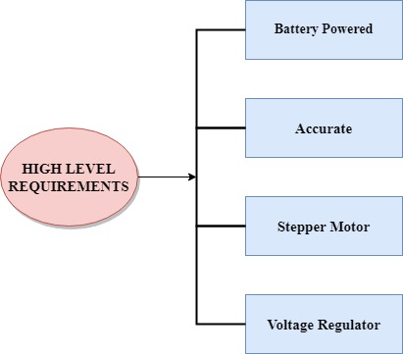

* Low Level Requirements:

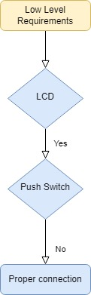

**Future and Applications:**

The stepper motor is used for precise positioning with a motor, such as hard disk drives, robotics, antennas, telescopes, and some toys. Stepper motors cannot run at high speeds, but have a high holding torque.

This project can be used as a proto type further development and growth and can provide impetus to the cutting edge technology. This device can be integrated with robotics, drones, cameras, house doors, lockers, smart systems and buildings. It lays emphasis on eliminating the need and use of multiple remotes for each individual object using with Bluetooth or wireless communication. Using pulse width modulation output of an Arduino microcontroller controls the speed of dc motor that simulates a treadmill machine.