**INDIAN INSTITUTE OF SCIENCE EDUCATION AND RESEARCH**

**BHOPAL**

****

**SUMMER INTERNSHIP REPORT**

**“Design and Analysis of a 2.4 GHz Bluetooth Microstrip Patch Antenna on Polyamide”**

**SHIRSHAKK PURKAYASTHA**

***Department of Electrical Engineering and Computer Sciences,***

***Indian Institute of Science Education and Research, Bhopal***

**July, 2021**

\_\_\_\_\_\_\_\_\_\_\_\_\_\_\_\_\_\_\_\_\_\_\_\_\_\_\_\_\_\_\_\_\_\_\_\_\_\_\_\_\_\_\_\_\_\_\_\_\_\_\_\_\_\_\_\_\_\_\_\_\_\_\_\_\_\_\_\_\_\_\_\_\_\_\_\_\_\_\_\_\_\_\_\_\_

**Abstract:**

Microstrip Antenna has many advantages and can easily be installed in the system. Dual band or Multi-band antenna has the main role for Wireless communication systems. Wireless Local Area Network (WLAN) and Worldwide Interoperability for Microwave Access (WiMAX) have been used for mobile devices and smartphones. Both are cost effective, reliable, flexible and high speed data connectivity.

This report analyses the patch antenna for Bluetooth application with a resonant frequency of 2.4 GHz. The antenna parameters are calculated and simulated by using COMSOL (v 5.6) simulation software. The parameters considered for the antenna are : S11 parameter, electric field, 3D radiation pattern, far-field norm, polar plots (E-plane, H-plane, Far-field gain) and electric-field norm.

**Project located at:** <https://github.com/Shirshakk-P/Summer_Intern-IISER-B>

**COMSOL File hosted at:** [**https://mega.nz/file/VJowHAhB#90\_Ag\_LuCPCOL4w1GrnhA4gAHDVnzqdWiKljQ0dBBEo**](https://mega.nz/file/VJowHAhB#90_Ag_LuCPCOL4w1GrnhA4gAHDVnzqdWiKljQ0dBBEo)

**Introduction:**

Antenna is an electrical device which converts electrical power into electromagnetic waves and vice versa. It is used with a radio transmitter or radio receiver. In transmission section, a transmitter supplies an electric current to the antenna's terminals, and the antenna radiates the energy electromagnetic waves. In the receiver section, an antenna intercepts some of the power of an electromagnetic wave in order to produce a tiny voltage at its terminals, which is applied to a receiver section to be amplified. Wireless

communication systems are attracted toward multi-functionality. Also it provides users with options of

connecting to different kinds of wireless services for different purposes at different times.

To exchange the data over a short distance communication a wireless technology called Bluetooth is

used within the frequency range 2400-2485 MHz. So the antenna is an essential device to transmit the data through unguided media. In wireless communication applications the major constraints are size, weight and ease of installation of antennas. These constraints are overcome by using a low or flat profile Microstrip Antenna (MSA). MSA is a simple configuration of radiating patches of different shapes on one side of dielectric material whose dielectric constant lies in 4< εr <12 and the ground plane on the other side. It is a narrow band wide beam antenna.

Patch antenna is a type of radio antenna; which can be mounted on a flat surface (usually a rectangular surface is used). The rectangular sheet is generally made up of metals, but our design considers Polyamide material . To mount this rectangular sheet, a large ground surface is required which is called ground plane. The combination is usually placed inside a plastic housing, which protects the antenna from certain damages. Major advantages of patch antennas are its ease in modification, customization and fabrication. In this paper the Bluetooth application has been chosen for the analysis of its various parameters which includes the reflectivity (S11) parameter, electric field, 3D radiation pattern, far-field norm, polar plots (E-plane, H-plane, Far-field gain) and electric-field norm.

A Microstrip patch antenna consists of a radiating patch on one side of and ground plane on the other

side. The patch is made of conducting material and can take any possible shape such a rectangular,

circular, square, hexagonal, triangular etc. The radiating patch and the feed lines are usually photo etched

on the dielectric substrate. Low dielectric constant substrates are preferred for maximum radiation. The dielectric substrate used here is Polyamide.

Microstrip patch antenna consists of a radiating patch and one side of dielectric substrate which has a ground plane on the other side. The patch is generally made of conducting materials such as copper/gold and be of any possible shape. The radiating patch and feed lines are etched on the dielectric substrate.

Due to advantages provided by microstrip patch antennas such as light weight, low volume, low cost,

compatibility with integrated circuits and easy to install on rigid surfaces. However microstrip patch antennas have narrow bandwidth, thus bandwidth enhancement is necessary for practical applications, so for bandwidth enhancement different approaches have been utilized.

**Design Parameters used in COMSOL Simulation:**

* Design frequency: 2.4 GHz
* Minimum frequency: 2 GHz
* Maximum frequency: 5 GHz
* Dielectric constant of polyamide: 2.8
* Loss tangent of polyamide: 0.012
* Thickness of substrate: 32 mm
* Thickness of metal: 35 μm
* Patch width: 2 cm
* Patch length: 1.5 cm
* Width of feed line: 1.75 mm
* Length of feed line: 15 mm
* Matching distance: 5 mm
* Gap: 0.5 mm

**Literature Survey:**

A microstrip Bluetooth Patch antenna for Wireless Communication application is to be designed and analysed for wireless communications. The aim is to design and analyse the results of the radiation

characteristics, far-field gain, electric field characteristics and radiation pattern for the antenna at a

proposed operating frequency of 2.4 GHz.

The aim is to design and analyse the 2.4 GHz operating frequency characteristics for the microstrip patch

antenna on Polyamide dielectric patching material.

A compact rectangular patch antenna has been designed and analysed for Wireless Communication applications. This antenna has a compact, cost effective, simple structure and is suitable for the 2.4 GHz frequency band for Wireless Communication applications.

**Terminology:**

* **Radiation Pattern:** A radiation pattern of an antenna defines the variation of the power radiated by an antenna as a function of the direction away from the antenna.
* **Directivity:** It is a measure of how directional an antenna's radiation pattern is. The directivity of an antenna increases as its beam width is made smaller.
* **Antenna Efficiency:** An efficiency of an antenna is a measure of how much power is radiated by the antenna relative to the antenna input power.
* **Antenna Gain:** Gain of antenna describes how much power is transmitted in the direction of peak radiation to that of an isotropic source.
* **Effective Aperture:** Effective aperture is a measure of the power captured by an antenna from a plane wave.

**Design of the Antenna:**

The microstrip Patch antenna consists of a conductive ground plane, dielectric substrate and the conductive patch on the substrate.

The construction details of the antenna is given via:

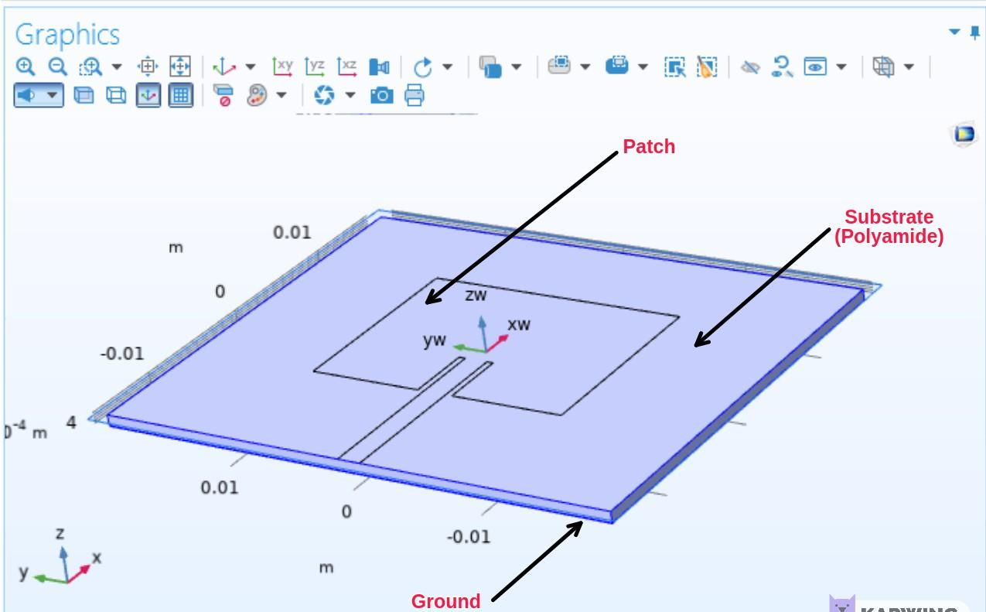

**Equations:**

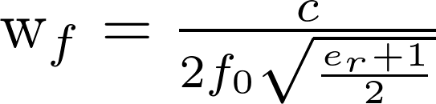

**Width of the patch:**

11§display§L = \frac{\lambda_0}{2 \sqrt{\epsilon_eff}} - 2 \Delta L§svg§600§FALSE§

**Length of the patch:**

11§display§\epsilon_eff = \frac{\epsilon_r + 1}{2} + \frac{\epsilon_r - 1}{2 \sqrt{1 + \frac{12 h}{W}}}§svg§600§FALSE§

**Effective Dielectric constant of the antenna:**

11§latex§\Delta L = 0.4h \frac{(\epsilon_eff+0.3)(\frac{W}{h}+0.27)}{(\epsilon_eff- 0.26)(\frac{W}{h}+0.8)}§svg§600§FALSE§

**Mesh Structure of the Antenna:**

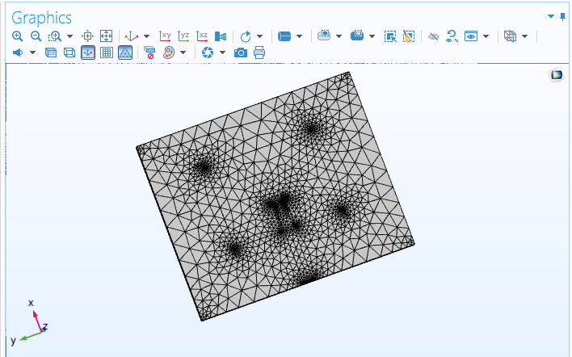

**Mesh Structure of the Far-Field Region:**

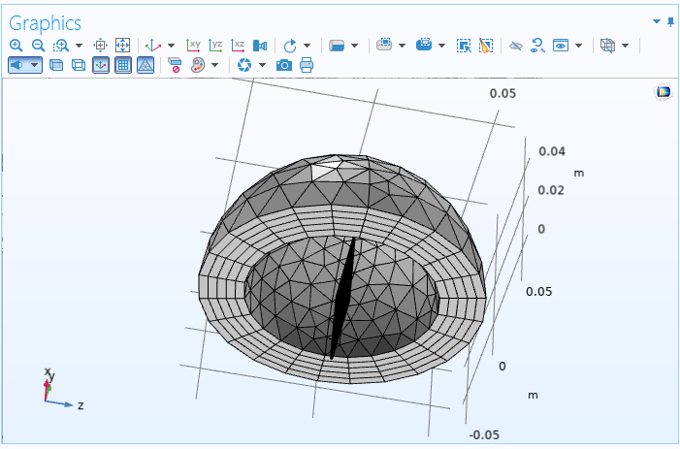

**Simulation Results:**

**Reflection Parameter (S11 parameter) Plot:**

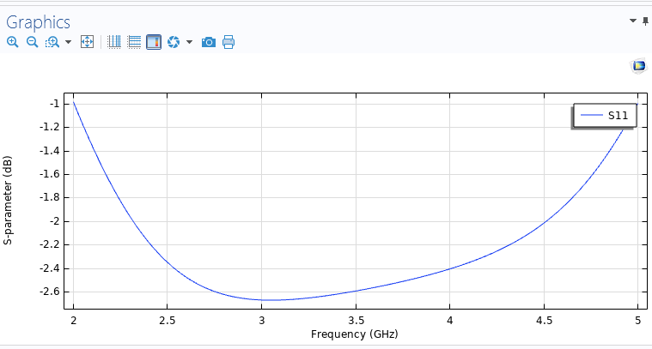

**Electric Field Plot:**

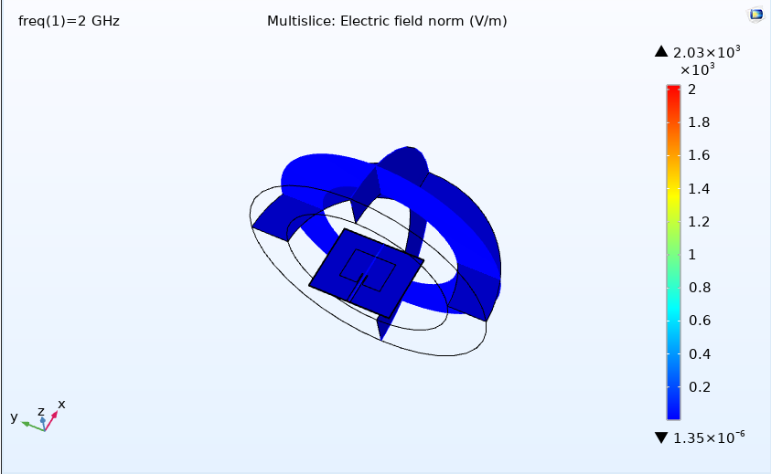

**3D Radiation Pattern Plot:**

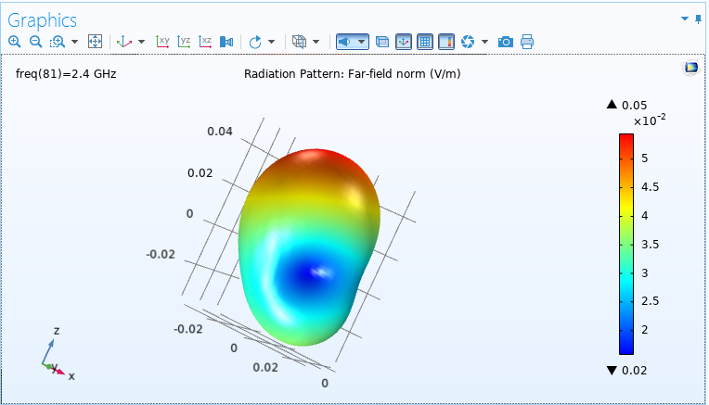

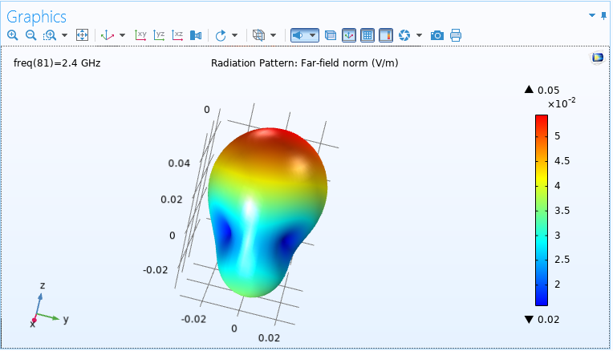

**Radiation Pattern Plot: Far-Field Norm**

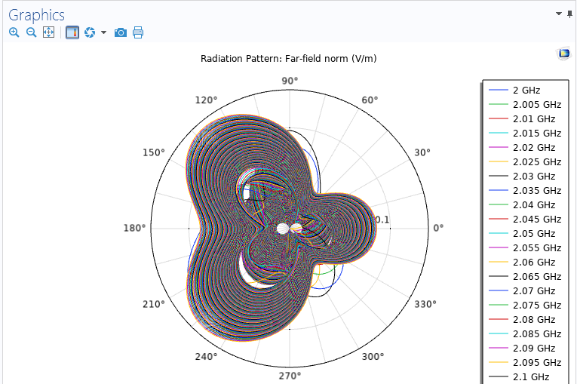

**Radiation Pattern Plot: Far-Field Gain (dB)**

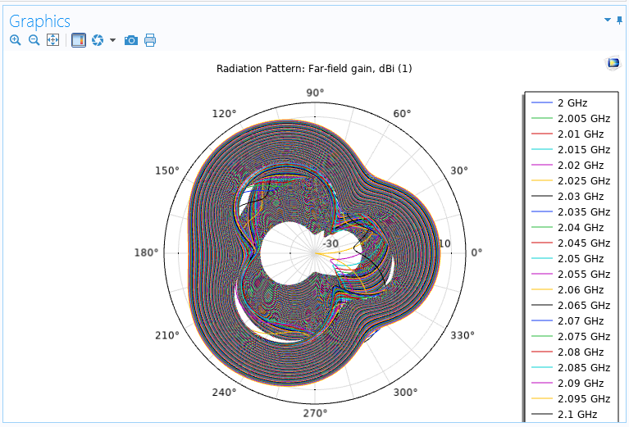

**Visualization Plane Plot:**

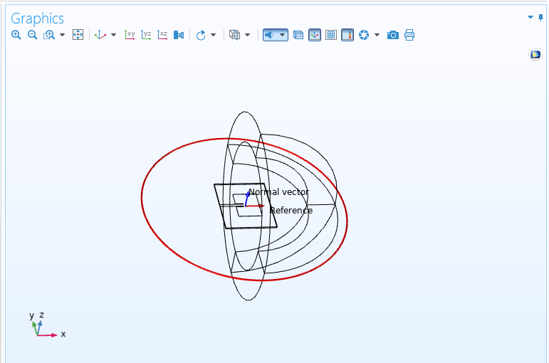

**Polar Plot: Far-Field Gain (dB)**

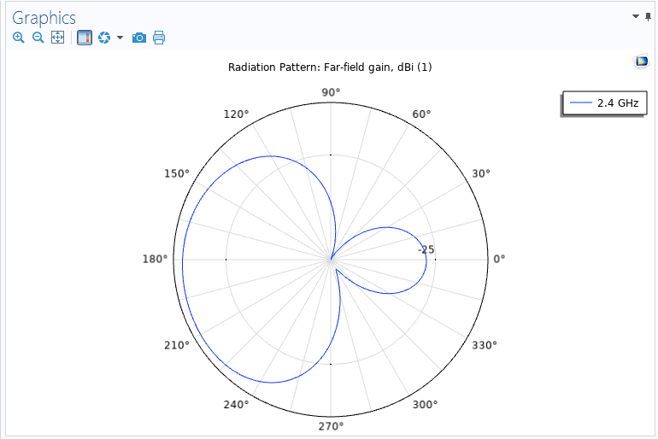

**Radiation Pattern: E-Plane**

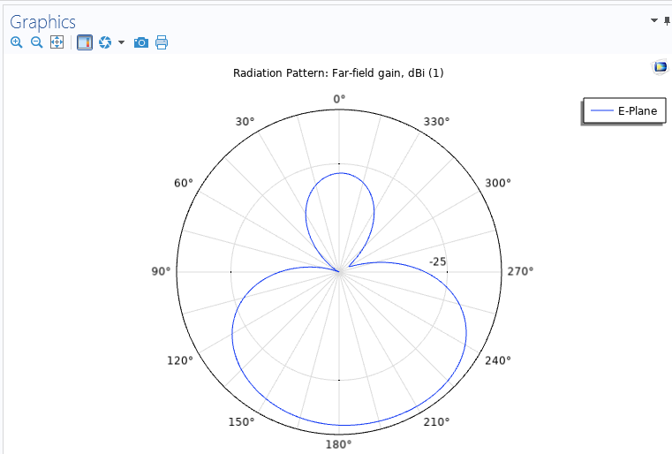

**Radiation Pattern: H-Plane**

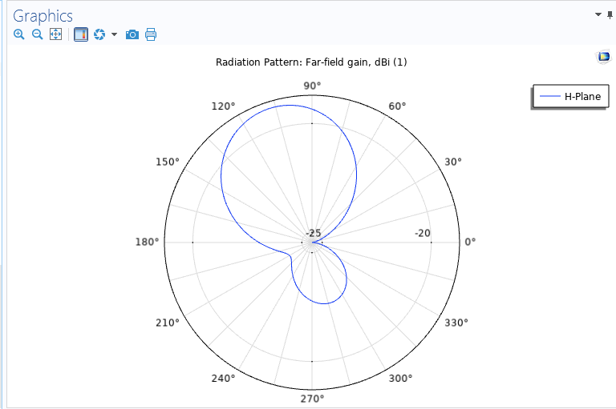

**Maximum Gain Plot:**

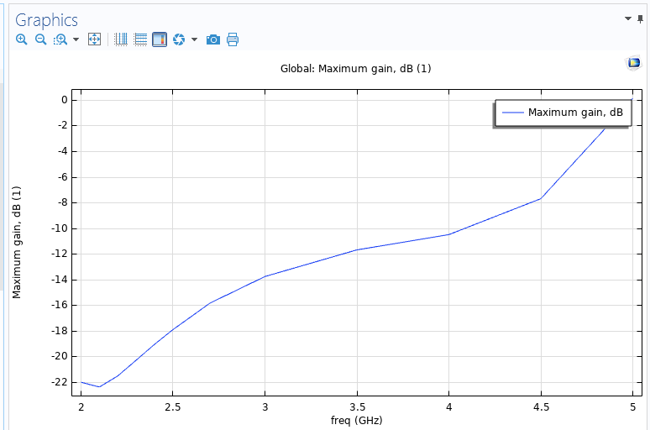

**Electric Field Norm: 2 GHz**

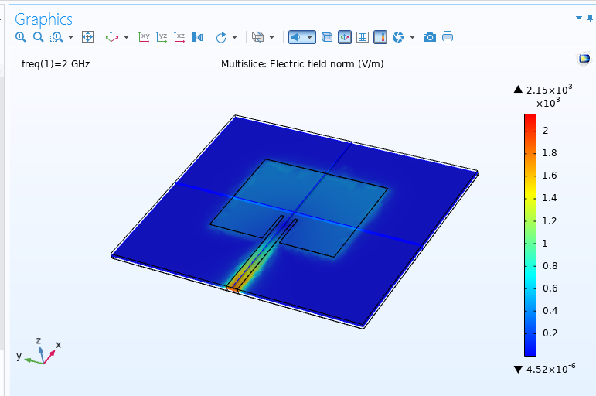

**Electric Field Norm: 2.4 GHz**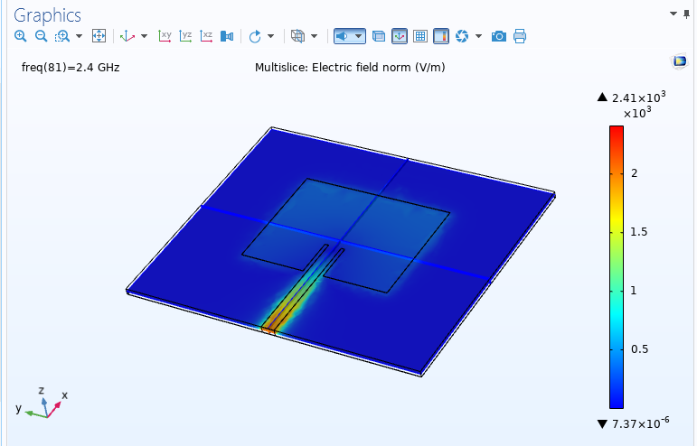

**Electric Field Norm: 3 GHz**

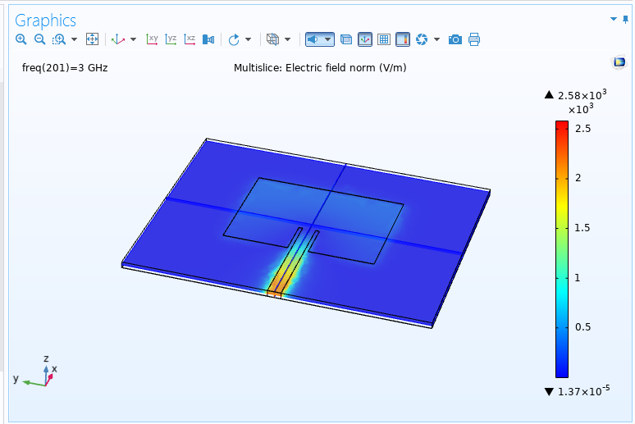

**Conclusion:**

This report presents the design and analysis of a microstrip rectangular patch antenna at 2.4 GHz for

Bluetooth application. Major analysis parameters such as reflection (S11) parameters, gain and radiation patterns have been analysed and plotted. This antenna is used for Bluetooth application with a resonant frequency of 2.4 GHz with patch material being Polyamide. The resultant dielectric constant of the antenna is found out to be 2.057.

**References:**

1. **Microstrip Patch Antenna with DGS for Bluetooth Application** *[Monika Sontakke,Vrushali Savairam, Shraddha Masram, P.P. Gundewar].*
2. **Design and Analysis of a Patch Antenna for Bluetooth Application** *[Ankit Dixit, O.P. Singh, G.R. Mishra].*
3. **Application Report for AN-1811 Bluetooth Antenna Design** *[Texas Instruments].*
4. **Design and Simulation of Microstrip Rectangular Patch Antenna for Bluetooth Application** *[Tejal B. Tandel , Nikunj Shingala].*
5. **Comsol Tutorial on simulation of Bluetooth Patch antenna by EM Spectrum Lab** *[YouTube].*

**\*\*\*\*\***