Delimiter->**something such as a**[**mark**](https://dictionary.cambridge.org/dictionary/english/mark)**or**[**symbol**](https://dictionary.cambridge.org/dictionary/english/symbol)**used to show the**[**beginning**](https://dictionary.cambridge.org/dictionary/english/beginning)**or end of**[**separate**](https://dictionary.cambridge.org/dictionary/english/separate)[**elements**](https://dictionary.cambridge.org/dictionary/english/elements)**in a**[**text**](https://dictionary.cambridge.org/dictionary/english/text)**,**[**computer**](https://dictionary.cambridge.org/dictionary/english/computer)[**program**](https://dictionary.cambridge.org/dictionary/english/program) .

In computer programming, a delimiter is a [character](https://www.techtarget.com/whatis/definition/character) that identifies the beginning or the end of a character string.

Token->A token is the smallest element of a program that is meaningful to the compiler.

Tokens can be classified as follows:

1. Keywords
2. Identifiers
3. Constants
4. Strings
5. Special Symbols
6. Operators

**Phases of a Compiler**

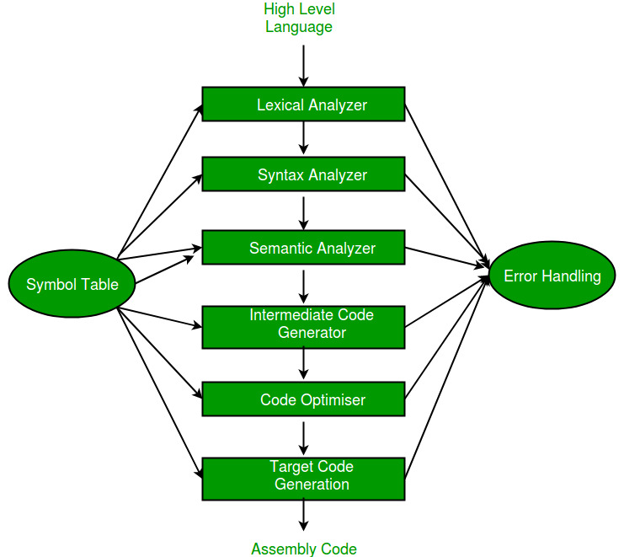

<https://www.geeksforgeeks.org/phases-of-a-compiler/>

Front End-> Depends on Source Code

Back End -> Depends on Intermediate Code

3 address code->(<https://www.geeksforgeeks.org/three-address-code-compiler/>)

**Three address code** is a type of intermediate code which is easy to generate and can be easily converted to machine code.

Example:-

a = b op c