A project Report
On
Project II: PRJ 151
EstateLink
Submitted by:
Sampada Dhakal Exam roll no: 23530087
Tulasi Rana Magar Exam roll no: 23530100
Shisam Khadka Exam roll no: 23530090
Under the Guidance of
Of
Mr.Dipendra Silwal
Submitted to the faculty of science and technology
OCEM
in partial fulfillment of the requirements for
Fourth semester Bachelor of Computer Application(BCA)
Year: 2025


ACKNOWLEDGEMENT

The success and the final outcome of this project required a lot of guidance and assistance from many people and we’re extremely fortunate to have got this all along the completion of our project work. We have completed this project only because of such guidance and assistance of such amazing people.
This project would not have taken this shape without the meaningful contributions and unwavering support from several individuals. Firstly, we owe immense gratitude to Mr. Dipendra Silwal, whose insightful guidance and constructive critiques consistently challenged us to push our boundaries of knowledge.
We would like to acknowledge the resources provided by our college that greatly assisted in the search and development phases. The hands-on experience we gained through this project has been extremely enriching, and we appreciate the time and effort our mentor has invested on it.
We would like to thank this college for creating a conducive environment for innovation and learning. The access to technical resources and the collaborative spirit in this space inspired much of the project’s direction and success.
We would also like to extend heartfelt appreciation to our family, whose unwavering encouragement and patience gave me the strength to persevere during moments of uncertainty and long coding sessions. We’re thankful to get constant encouragement, support and guidance from all teaching staff of the computer science department.

ABSTRACT

The real estate sector often struggles with outdated and manual property listing processes, unverified and unstructured information, limited dynamic search capabilities, and inconvenient administrative control. These issues create inefficiencies for both property seekers and administrators. EstateLink is developed to address these challenges by providing a modern, scalable, and user-friendly property listing and management system.
The project is implemented using the Python Flask framework to ensure a reliable and extensible backend. It offers a responsive interface across devices, enabling users to browse structured property listings containing details such as title, price, location, and description. Enhanced search and filter features allow users to quickly refine listings by location and price, improving accessibility and decision-making. Furthermore, a secure authentication system with an integrated admin dashboard equips administrators with the necessary tools to efficiently manage listings, ensuring accuracy, consistency, and convenience.
By integrating these features, EstateLink aims to streamline property discovery and management, replacing traditional inefficiencies with a dynamic and interactive digital solution. The system not only improves user experience but also provides scalability for future enhancements, positioning it as a sustainable and practical platform for real estate management.

CERTIFICATE OF AUTHENTICATION WORK

This is to certify that the project report entitled Prison management system submitted to Department of Bachelor of computer Application, Oxford College of Engineering and Management in partial fulfillment of second semester is an original

Sampada Dhakal Exam roll no: 23530087
Tulasi Rana Magar Exam roll no: 23530100
Shisam Khadka Exam roll no: 23530090

Under our guidance and supervision. The matter embodied in this project is authentic and genuine work done by the group and has not been submitted in other college/ institution/ University for the fulfillment of the requirement of any course of study.

………………. …. .……………… ……………………
Dipendra Silwal External Examiner Susant Tiwari
Project Guide HoD, BCA

Tables of Figures

Figure 1 :Data flow diagram 14
Figure 2 :System Design 15
Figure 3 :System Database Diagram 16
Figure 4 :Interface Design 17

List of Tables

Table 1 :Sample Schedule 11

Tables of Contents
ACKNOWLEDGEMENT
ABSTRACT
CERTIFICATE OF AUTHENTICATION WORK
Tables of Figures
List of Tables
Tables of Contents
CHAPTER 1: INRODUCTION 1
1.1 Background 1
1.2 Objectives 1
1.3 Purpose, scope, and applicability 2
1.3.1 Purpose 2
1.3.2 scope and limitation 2
1.3.3 Applicability 4
1.4 Achievements 5
1.5 Organization of report 5
CHAPTER 2: SURVEY OF TECHNOLOGIES 6
CHAPTER 3: REQUIREMENTS AND ANALYSIS 8
3.1 Problem definition 8
3.2 Requirements specifications 9
3.3 Planning and scheduling 10
3.4 System requirements 11
3.5 Preliminary product Description 12
CHAPTER 4: DESIGN 13
4.1 Introduction 13
4.2 System Design 14
4.3 Database design 15
4.4 Interface design 16
CHAPTER 5: Implementation and Testing 18
5.1 Implementation Approaches 18
5.2 Coding Designs and Code Efficiency 18
5.2.1 Code Efficiency 18
5.3 Testing Approach 18
5.3.1 Unit Testing 19
5.3.2 Integrated Testing 19
5.3.3 Beta Testing 19
5.4 Modifications and Improvements 19
5.5 Test Cases 19
CHAPTER 6: Results and Discussion 21
6.1 Test Reports 21
6.2 User Documentation 21
CHAPTER 7: CONCLUSIONS 22
7.1 Conclusion 22
7.1.1 Significance of the system 23
Recommendation 23
REFERENCES 24

CHAPTER 1: INRODUCTION

1.1 Background
Traditional property listings are manual, unstructured, and inefficient, making it hard for users to find verified details and for admins to manage data. With growing digital needs, a centralized and responsive system like EstateLink ensures structured listings, real-time search, and easy admin control for better property management.

1.2 Objectives
- Develop a Centralized Platform
Create a unified system where property information is collected, stored, and displayed in a structured manner. This eliminates scattered listings and provides users with a single trusted source for property details.
- Enable Real-Time Search and Filtering
Implement dynamic search features that allow users to instantly filter properties by price, location, and preferences. This ensures faster decision-making and improves overall user satisfaction.
- Ensure Admin Authentication
Integrate secure login functionality for administrators, protecting the platform from unauthorized access while safeguarding sensitive property information.
- Provide an Admin Dashboard
Design a user-friendly dashboard where administrators can add new listings, update existing ones, or remove outdated entries. This ensures accurate and up-to-date property data.
- Implement Responsive Design
Develop the platform with built-in responsiveness so it adapts seamlessly to both desktop and mobile devices, enhancing accessibility for all users.
- Enhance User Experience
Focus on simplicity, clarity, and ease of navigation to provide a smooth browsing experience, making property discovery efficient and reliable for end-users.

1.3 Purpose, scope, and applicability

1.3.1 Purpose
The purpose of this project is to create a digital platform that makes property listing, searching, and management easier and more reliable. It aims to replace manual methods with a structured system where users can quickly find properties and administrators can manage listings efficiently. At the same time, it provides practical exposure to modern web development using Flask, databases, and responsive design.
- Modernize Property Listings
Replace outdated and manual processes with a digital and automated system.
- Centralize Property Information
Provide a single, structured platform for verified property details.
- Improve Search Efficiency
Enable users to find properties quickly using real-time search and filtering.
- Simplify Admin Management
Offer an admin dashboard for easy addition, editing, and deletion of listings.
- Ensure Accessibility
Design a responsive system that works seamlessly on both mobile and desktop devices.

1.3.2 scope and limitation
Scope of the Project
The scope of the system includes developing a web application with user-friendly property browsing, search and filter functions, and an admin dashboard for managing listings. It focuses on providing core features like CRUD operations, authentication, and responsive design while leaving room for future upgrades such as online payments, property verification, or AI-based recommendations.
- Centralized Property Listings
Provides a single platform for all property listings, ensuring easy access and management.
- User-Friendly Interface
Enables users to browse, search, and filter properties efficiently on both desktop and mobile devices.
- Admin Dashboard
Allows administrators to securely add, edit, or delete listings and manage content effectively.
- Real-Time Search and Filtering
Facilitates quick property discovery based on user preferences like price and location.
- Responsive Design
Ensures the platform adapts seamlessly to different screen sizes and devices.
Limitations of the Project
The current system is limited to basic features like listing, searching, and admin management. It does not yet support advanced tools such as live chat, geo-mapping, or automated property verification. Also, it depends on manual updates from administrators and may face challenges in handling very large-scale data without further optimization.
- Dependent on Internet Connectivity
Users require an active internet connection to access the platform.
- Limited to Admin-Managed Listings
Only properties added and verified by admins will appear; user-generated listings are not included.
- Scalability Constraints
Performance may reduce if the number of listings grows significantly without proper server optimization.
- No Offline Access
The platform cannot be used offline; all interactions require online access.
- Feature Restrictions
Advanced features like payment integration, virtual tours, or AI-based recommendations are not included in this version.

1.3.3 Applicability
This project can be applied in real estate agencies, broker services, or independent sellers who want a professional and accessible way to display properties. Users can benefit from structured listings and filters, while administrators can easily maintain data. Beyond real estate, the system’s design can also be adapted to similar domains like hotel booking, vehicle listings, or rental services.
- Administrative Use – Enables administrators to manage property listings efficiently through a secure dashboard.
- Desktop Users – Provides a responsive platform accessible on desktop devices for easy property browsing.
- Mobile Users – Ensures smooth access and navigation on mobile devices with built-in responsiveness.
- Property Buyers – Helps users find verified properties quickly using search and filter options.
- Property Sellers – Allows sellers to list properties through admin facilitation, ensuring structured and visible listings.
- Real Estate Agencies – Supports agencies in centralizing property information and improving service delivery.
- Search & Filter Operations – Facilitates targeted property discovery based on location, price, and other preferences.

1.4 Achievements
- Centralized Property Management – Created a single platform for storing and accessing all property listings efficiently.
- Enhanced User Experience – Developed an intuitive, responsive interface for seamless browsing on both mobile and desktop.
- Efficient Search & Filter – Enabled real-time property search and filtering based on price, location, and user preferences.
- Improved Admin Control – Implemented a secure dashboard allowing admins to add, edit, or delete property listings easily.
- Structured Property Information – Ensured verified and organized property details for better reliability and trust.
- Responsive Design Implementation – Built the system to adapt smoothly to various devices, enhancing accessibility.

1.5 Organization of report
The report is structured to provide a systematic overview of the Estate-link project:
- Background – Explains the context, need, and importance of the project.
- Purpose – Describes the objectives and goals the project aims to achieve.
- Problem Definition – Defines the key problems with traditional property listing systems.
- Problem Statement – Highlights the specific issues the project seeks to resolve.
- Objectives – Lists the main aims of the project with detailed descriptions.
- Scope and Limitations – Defines what the project covers and its constraints.
- Requirement Analysis – Details the functional and non-functional requirements of the system.
- Preliminary Investigation – Explains the initial study, feasibility analysis, and research conducted before development.
- System Design – Describes the architecture, data flow, and design of the application including UI/UX design.
- Key Features – Details the main functionalities of the system.
- System Solution – Explains how the project addresses the identified problems.
- Testing – Covers the methods, types, and outcomes of testing to ensure system reliability.
- Achievements – Summarizes the successes and outcomes of the project.
- Applicability – Shows where and how the project can be used.
- Technology Stack – Lists the tools, languages, and frameworks used.
- Project Schedule – Provides a timeline for development and implementation.
- Conclusion and Future Scope – Presents the final summary, benefits, and potential future enhancements.

CHAPTER 2: SURVEY OF TECHNOLOGIES

- Real Estate Management Systems (REMS)
Overview: REMS are software applications designed to assist property managers and real estate agents in managing properties, tenants, and listings. These systems typically include features such as property listing management, tenant management, accounting and finance, and maintenance tracking.
Key Features:
- Property Listing Management: Allows real estate agents to create and update property listings with detailed descriptions, images, and pricing information.
- Tenant Management: Enables tracking of tenant information, lease agreements, and payment histories.
- Accounting and Finance: Facilitates financial tracking, including rent payments, expenses, and budgeting.
- Maintenance Tracking: Helps schedule and monitor property maintenance tasks and requests.
- Web-Based Real Estate Property Management Systems
- Study: A study introduced a web-based real estate property management system aimed at addressing challenges in managing real estate properties efficiently. Traditional methods often relied on manual processes, leading to inefficiencies, errors, and delays. The proposed system aimed to streamline operations and improve overall efficiency.
- Challenges: Real estate professionals faced difficulties in managing property information, tenant communication, maintenance scheduling, and financial tracking.
- Solutions: The proposed web-based system addressed these challenges by automating tasks, improving data accuracy, and enhancing communication channels.
- Digital Transformation in Property Management
Research: A systematic literature review evaluated the integration and utilization of significant digital transformation technologies within the real estate industry. The study aimed to understand the adoption of digital tools and their impact on property management practices.
Technologies: The adoption of technologies such as cloud computing, data analytics, and mobile applications has transformed property management operations.
Benefits: Digital transformation has led to improved efficiency, reduced costs, and enhanced decision-making processes in property management.

CHAPTER 3: REQUIREMENTS AND ANALYSIS

3.1 Problem definition
In the real estate sector, traditional methods of property listing and management remain highly inefficient, relying heavily on manual processes, paper records, or basic offline listings. These methods often result in incomplete, unverified, and unstructured property information, which makes it difficult for users to trust the data and make informed decisions. Existing platforms also provide limited search and filter options, forcing users to spend more time browsing irrelevant listings. On the administrative side, managing property data is inconvenient, as most systems lack tools for quick updates, verification, and removal of outdated entries. As a result, both buyers and sellers face delays, confusion, and reduced transparency in property transactions. Therefore, there is a strong need for a centralized, digital, and responsive web application that ensures accurate property information, provides advanced search and filter options, and offers efficient administrative control through secure and scalable technologies.
- Manual and Outdated Listings – Traditional property listing methods rely on paper, offline advertisements, or unstructured online posts, causing delays and inefficiency.
- Unverified Information – Users often encounter inaccurate or incomplete property details, leading to confusion and poor decision-making.
- Limited Search and Filtering – Existing systems rarely offer dynamic search or filter options, making it difficult for users to quickly find properties based on preferences like location or price.
- Cumbersome Admin Management – Administrators face difficulties in adding, updating, or deleting listings manually, resulting in errors and inconsistency.
- Accessibility Issues – Lack of mobile-friendly or responsive interfaces limits access for users who rely on smartphones or tablets.
- Lack of Centralization – Property information is scattered across multiple platforms, reducing reliability and making it hard to track updates.
- Delayed Updates – Changes in property availability or details are often not reflected in real-time, affecting user trust and satisfaction.
- Low User Engagement – Poor interface design and limited functionality reduce user interaction and the overall effectiveness of property search.

3.2 Requirements specifications
The real estate web application requires both functional and non-functional elements to operate effectively. Functionally, the system must allow users to view property listings with details such as title, price, location, and description, as well as perform searches and apply filters to quickly find suitable properties. It should also include an admin panel with secure authentication, enabling administrators to add, edit, and delete property listings while ensuring that the data remains structured and up to date. Non-functional requirements include ensuring the platform is responsive across devices, providing a simple and intuitive user interface, and maintaining data integrity with reliable database support. Additionally, the system should be scalable to accommodate future upgrades such as payment integration, AI-based recommendations, or property verification modules. Security, performance, and usability will be prioritized to make the application practical for both real-world users and academic demonstration purposes.
Functional Requirements
- User Registration and Login – Secure authentication for users and admins, ensuring controlled access to the system.
- Property Listings – Display property title, price, location, and description clearly for users.
- Search and Filter – Enable dynamic filtering by location, price, and user preferences for efficient property discovery.
- Admin Dashboard – Allow admins to add, edit, and delete property listings with ease.
- Responsive Interface – Ensure seamless usage on mobile devices and desktops.
Non-Functional Requirements
- Performance – System should provide fast loading times and real-time search results.
- Security – Protect user and admin data from unauthorized access and ensure secure login processes.
- Reliability – Maintain consistent system performance with accurate property listings.
- Scalability – Handle growing number of users and listings without performance degradation.
- Usability – Provide a simple, intuitive interface for smooth user and admin experience.

3.3 Planning and scheduling
The development of the real estate web application is planned in phases to ensure systematic progress and timely completion. The project begins with the requirement analysis phase, where the problems, objectives, and features are clearly defined. This is followed by the system design phase, involving the creation of DFDs, database schema, and interface layouts. Next comes the development phase, where the frontend is designed for user interaction, and the backend is implemented using Python Flask to manage data and business logic. After development, the testing phase ensures that all features, including search, filter, CRUD operations, and authentication, function correctly without errors. Finally, the deployment and documentation phase prepares the system for demonstration, with proper reporting of features, limitations, and applicability. The entire project is scheduled over a limited academic timeline, with tasks distributed among team members to balance workload and ensure completion before the presentation deadline.
- Requirement Analysis – Understand project needs and define functional and non-functional requirements.
- Design Phase – Develop system architecture, database schema, and UI/UX layouts.
- Development Phase – Implement backend and frontend modules using Python and web technologies.
- Testing Phase – Perform unit, integration, and system testing to ensure quality and reliability.
- Deployment Phase – Launch the system for real users and provide access through web or mobile platforms.
- Maintenance Phase – Monitor system performance, fix bugs, and update features as needed.

Sample Schedule:
Phase | Duration | Deliverables
RequirementAnalysis | 1 week | SRS Document
Design | 1 week | System Architecture & UI Design
Development | 3 weeks | Functional Modules
Testing | 1 week | Test Reports
Deployment | 1 week | Live System

Table 1:Sample Schedule

3.4 System requirements
Hardware Requirements
- Processor – Intel i3 or higher to run development and testing environments efficiently.
- RAM – Minimum 4GB for smooth application performance.
- Storage – Minimum 100GB HDD/SSD to store databases and project files.
- Display – Standard monitor for desktops; responsive design for mobile screens.
Software Requirements
- Operating System – Windows 10 or Linux for backend and frontend development.
- Python – Version 3.9+ to execute back-end logic and integrate with frameworks.
- Database – MySQL or SQLite for structured storage of property and user data.
- Web Framework – Flask or Django for backend development, routing, and rendering dynamic pages.
- Front-end Technologies – HTML, CSS, Bootstrap for responsive, interactive user interface design.
- Browser Compatibility – Chrome, Firefox, Edge to ensure consistent performance.
- Development Tools – IDEs like PyCharm or Visual Studio Code for efficient coding and debugging.

3.5 Preliminary product Description
The proposed system is a web-based real estate application developed using Python Flask that enables users to browse, search, and filter property listings while providing administrators with tools to manage property data effectively. The product will feature a responsive user interface that displays property details such as title, price, location, and description in a structured and organized format. Users will benefit from dynamic search and filtering options to quickly find properties that match their requirements, while administrators will have access to a secure dashboard with authentication to add, edit, or delete property listings. The backend will be supported by a database that stores all property information in a consistent manner, ensuring accuracy and reliability. The system is lightweight yet scalable, designed to meet current academic requirements and capable of future expansion into advanced features like payment integration, AI-based property recommendations, or map-based search. Overall, the product aims to deliver a modern, user-friendly, and efficient solution for property listing and management.
- Centralized Platform – Estate-link consolidates all property listings in one structured, accessible system.
- User-Friendly Interface – Simple navigation and clear menus ensure users and admins can operate the system effortlessly.
- Dynamic Search & Filter – Real-time search and filter options by price, location, and property type reduce search time.
- Admin Dashboard – Secure access for administrators to manage listings, view analytics, and monitor updates.
- Mobile and Desktop Accessibility – Fully responsive design supports various devices without losing functionality.
- Real-Time Updates – Any changes by admins are reflected instantly across the system.
- Data Security and Reliability – Safeguards user and property information while ensuring consistent system performance.
- Scalability – Designed to accommodate a growing number of listings and users in the future.
- Enhanced User Engagement – Interactive interface and efficient search encourage repeated use and better decision-making.

CHAPTER 4: DESIGN

4.1 Introduction
- Purpose of System Design –The purpose of this project is to create a digital platform that makes property listing, searching, and management easier and more reliable. It aims to replace manual methods with a structured system where users can quickly find properties and administrators can manage listings efficiently. At the same time, it provides practical exposure to modern web development using Flask, databases, and responsive design. Define how EstateLink will solve property management issues efficiently and provide a structured, user-friendly platform.
- Scope – The scope of the system includes developing a web application with user-friendly property browsing, search and filter functions, and an admin dashboard for managing listings. It focuses on providing core features like CRUD operations, authentication, and responsive design while leaving room for future upgrades such as online payments, property verification, or AI-based recommendations.Covers backend architecture, database management, frontend interface, and system responsiveness for both desktop and mobile users.
- Objectives – Ensure seamless property listing, real-time search, secure admin control, and dynamic data handling.
- Design Approach – Follows modular, scalable, and secure design principles to allow future expansion and maintainability

4.2 System Design
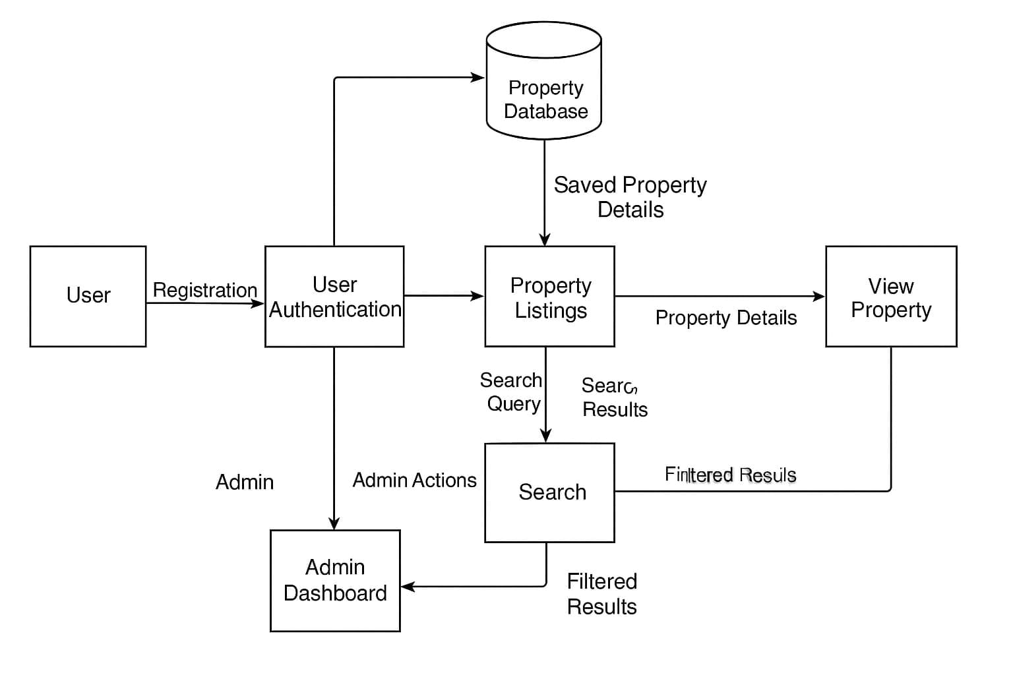
Figure 1:Data flow diagram

- Architecture – Uses a client-server model where the front-end interacts with the back-end via HTTP requests; back-end handles business logic and database operations.
- Modules – Key modules include User Management, Property Listing, Search & Filter, Admin Dashboard, and Responsive Interface.
- Data Flow – User inputs and searches are processed by back-end modules, validated, and responses returned in real time
- Security Design – Admin and user authentication implemented with hashed passwords and role-based access controls.
- Scalability Consideration – Modular design allows addition of features like virtual tours or payment integration in future.
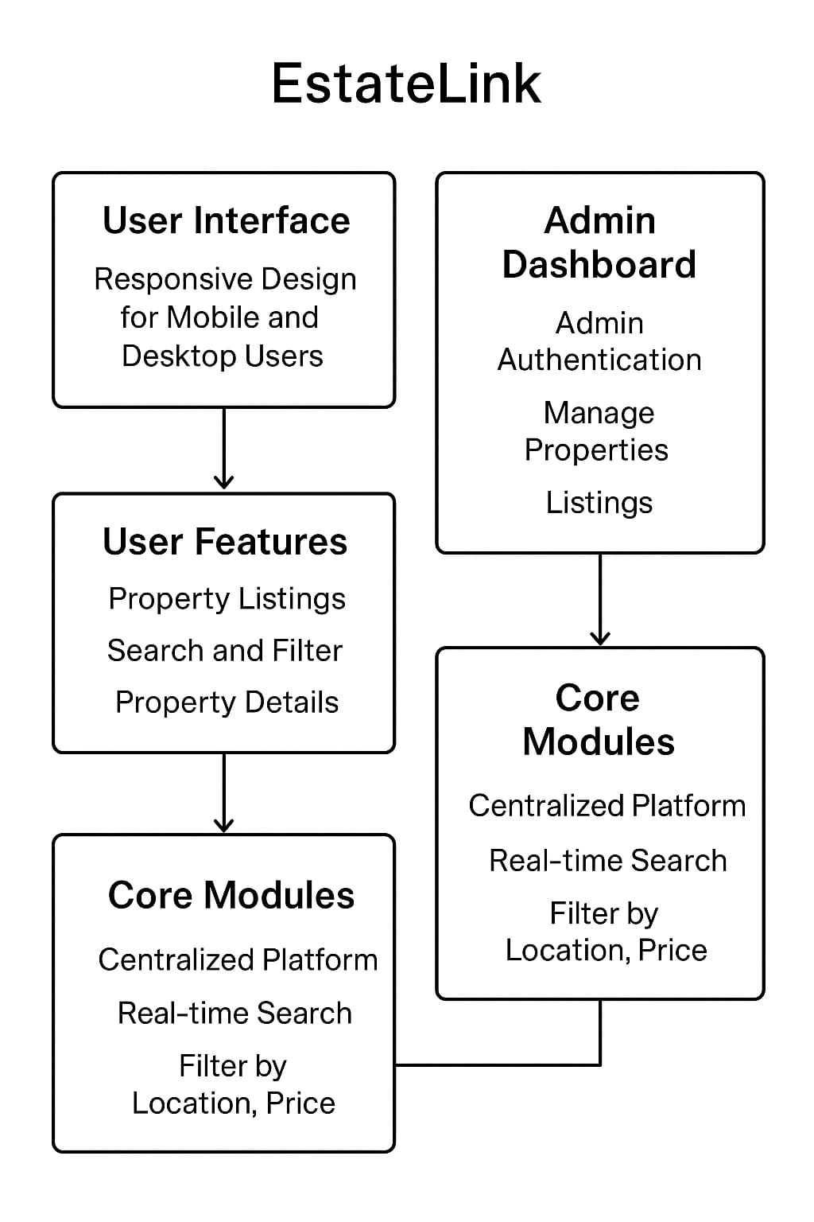
Figure 2:System Design

4.3 Database design
- Database Type – Relational database (MySQL/SQLite) for structured and secure storage of property and user data.
- Tables – Includes tables for Users, Admins, Properties, Property Types, and Search History.
- Relationships –
- One-to-many: Admins can manage multiple properties.
- One-to-one: Each property has a unique listing ID.
- Attributes – Property table includes ID, Title, Location, Price, Description, Images, and Status. User table includes ID, Name, Email, Password, and Role.
- Constraints – Primary keys for uniqueness, foreign keys for relational integrity, and validation for mandatory fields.
- Data Security – Sensitive data like passwords encrypted; database access restricted to authorized modules.

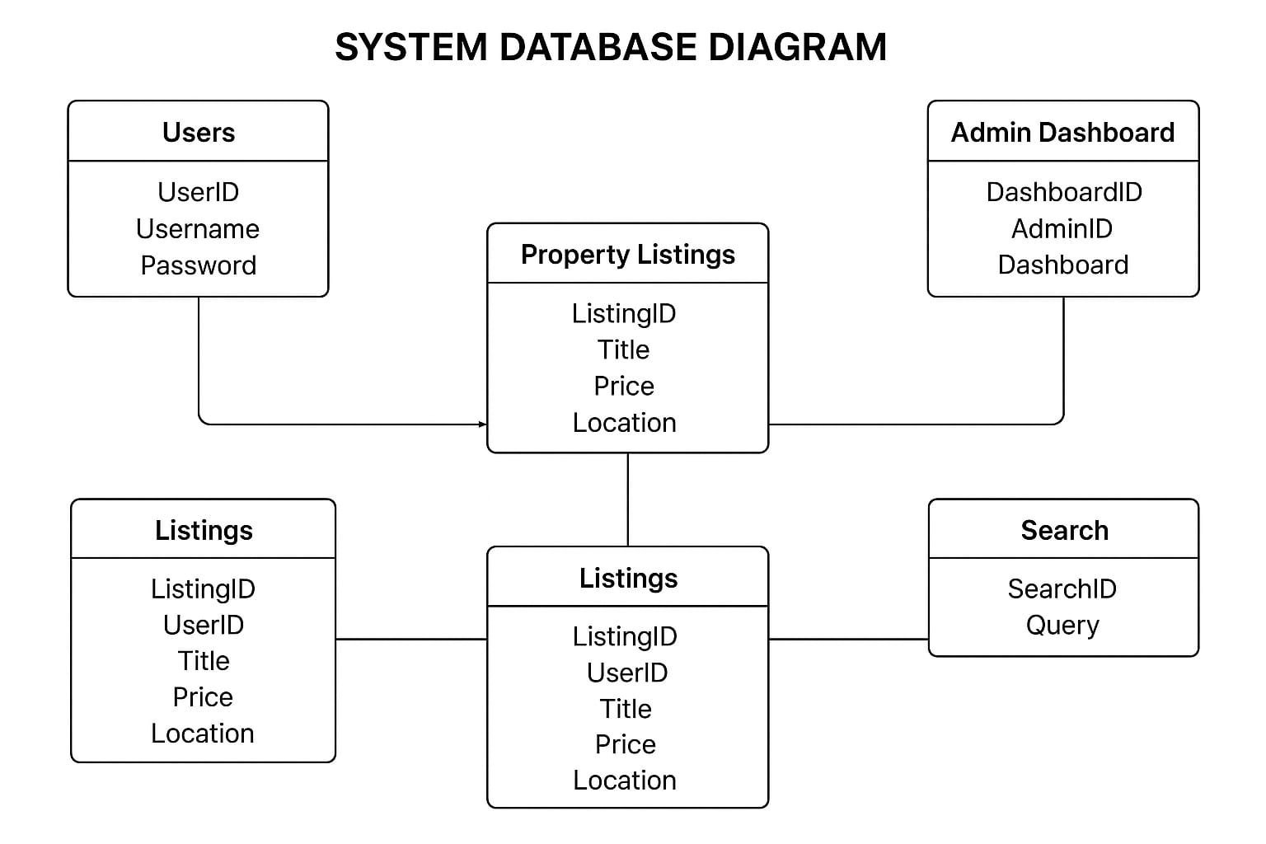
Figure 3:System Database Diagram

4.4 Interface design
- User Interface – Intuitive layout with clear navigation menus, property cards, search bar, and filter options.
- Admin Interface – Dashboard with quick access to add, edit, delete properties, view analytic, and manage users.
- Responsive Design – Adaptive layout for mobile and desktop users, ensuring consistent functionality across devices.
- Visual Design – Clean, modern interface using Bootstrap, CSS styling, and appropriate color schemes to enhance usability.
- Interaction Design – Smooth transitions, real-time updates, and instant feedback for user actions like search and filtering.
- Accessibility – Designed for easy use with standard screen sizes and touch interfaces for mobile devices.
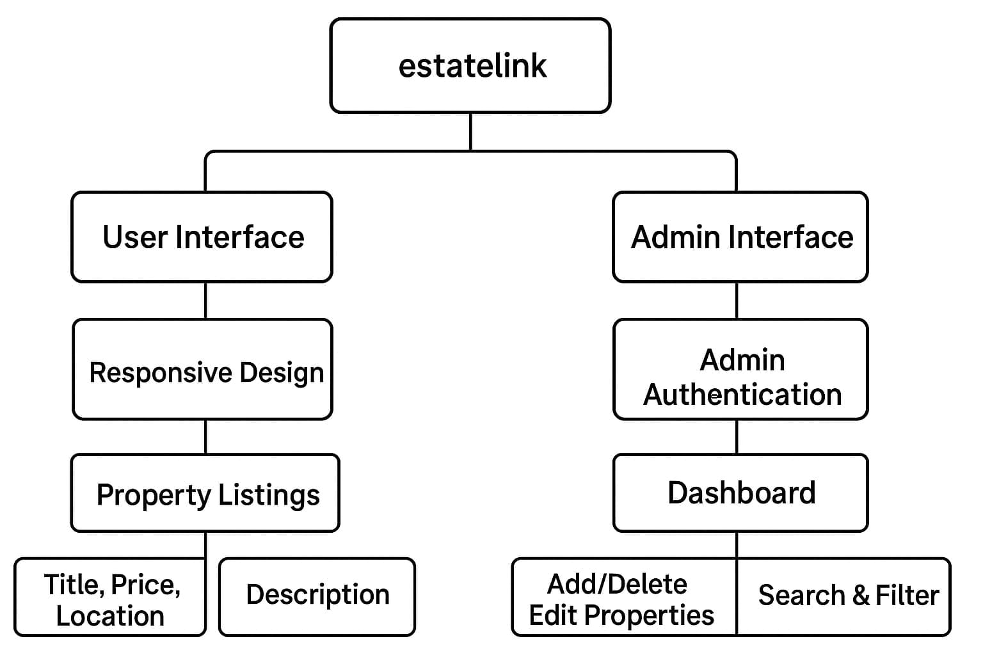
Figure 4:Interface Design

CHAPTER 5: Implementation and Testing

5.1 Implementation Approaches
The implementation of EstateLink follows a structured approach using modular and iterative development. Python is used for backend logic, Flask/Django frameworks for web services, and HTML, CSS, Bootstrap for frontend design. Each module is implemented separately—User Management, Property Listing, Search & Filter, and Admin Dashboard—ensuring maintainability. Real-time updates, secure authentication, and responsive design are integral throughout the implementation.

5.2 Coding Designs and Code Efficiency
The coding design of EstateLink is modular, maintainable, and optimized for performance. Backend functions are clearly defined, following PEP8 coding standards, and database queries are optimized for fast retrieval. Frontend components use reusable Bootstrap elements to ensure consistency, responsiveness, and fast loading times.

5.2.1 Code Efficiency
- Optimized Queries – Database queries are indexed and minimized for faster property retrieval.
- Reusable Functions – Functions for search filters, login validation, and data display are reusable to reduce redundancy.
- Modular Design – Backend and frontend modules are independent, simplifying debugging and future upgrades.
- Lightweight Front-end – Optimized CSS and JavaScript reduce page load time and enhance performance.

5.3 Testing Approach
Estate-link follows a multi-level testing strategy, including unit testing, integration testing, and beta testing, to ensure reliability, accuracy, and usability. Testing is conducted throughout development and before deployment.

5.3.1 Unit Testing
- Definition – Testing individual functions or modules in isolation.
- Purpose – Verify that each component works as intended.
- Example – Ensuring property search returns accurate results based on location or price.

5.3.2 Integrated Testing
- Definition – Testing how multiple modules work together.
- Purpose – Ensure data flow between frontend, backend, and database is correct.
- Example – Verifying that properties added through the admin dashboard appear immediately for users.

5.3.3 Beta Testing
- Definition – Testing the system with real users before final deployment.
- Purpose – Identify usability issues, bugs, and performance bottlenecks.
- Example – Users testing mobile responsiveness, search filters, and dashboard operations.

5.4 Modifications and Improvements
- Bug Fixes – Resolve errors found during testing phases.
- UI/UX Enhancements – Improve interface design, navigation, and responsiveness.
- Performance Optimization – Refine backend queries, caching, and frontend code for faster response.
- Feature Upgrades – Add new functionalities such as advanced filters or analytics based on feedback.

5.5 Test Cases
- User Login – Validate correct credentials allow login; incorrect credentials show proper error.
- Property Listing – Verify new property entries are correctly stored and displayed with title, price, location, and description.
- Search & Filter – Test search results match criteria like location, price, and property type.
- Admin Dashboard Actions – Ensure add, edit, delete operations update listings in real time.
- Responsiveness – Check layouts adapt correctly across desktop, tablet, and mobile devices.
- Data Security – Confirm unauthorized users cannot access admin functionalities or modify data.

CHAPTER 6: Results and Discussion

6.1 Test Reports
- Unit Test Report – Each module, such as user login, property listing, and search filters, was tested individually to ensure functionality. All modules returned expected results.
- Integration Test Report – Combined modules were tested for seamless interaction. Admin actions like adding a property were immediately reflected in user listings, and data flowed correctly between frontend, backend, and database.
- Beta Test Report – A selected group of end-users tested the system. Feedback indicated high usability, fast search responses, accurate property listings, and proper dashboard functionality.
- Performance Test Report – Tested loading time, database queries, and responsiveness across devices. The system performed efficiently, with no major delays or errors detected.
- Security Test Report – Verified user and admin authentication, data encryption, and role-based access controls. Unauthorized access attempts were blocked successfully.

6.2 User Documentation
- Login and Registration – Users and admins can securely register and log in. Admins require additional verification to access the dashboard.
- Property Listing Access – Users can browse listings with details such as title, price, location, and description.
- Search and Filter Functions – Users can filter properties by location, price range, or type, with results displayed in real time.
- Admin Dashboard Operations – Admins can add, edit, delete, and manage properties efficiently. Reports and analytics can also be accessed.
- Mobile and Desktop Usage – The interface is fully responsive, providing consistent functionality across devices.
- System Navigation – Clear menus, buttons, and search bars allow users and admins to navigate the system easily.
- Troubleshooting Guide – Common issues such as login failures, slow loading, or search errors are addressed with step-by-step solutions.
- Safety and Security Instructions – Users are instructed on safe password practices, secure logout, and avoiding unauthorized acces.

CHAPTER 7: CONCLUSIONS

7.1 Conclusion
The real estate web application developed using Python Flask marks an important step toward modernizing the property listing and management process. It successfully addresses the major challenges of traditional systems by offering verified and structured property details, advanced search and filter functionalities, and a secure administrative dashboard for managing listings. With its responsive design, the system ensures accessibility across multiple devices, making it convenient for both users and administrators. The lightweight yet scalable backend allows for future integration of advanced features such as online payments, property verification, and AI-driven recommendations, making the platform adaptable to evolving needs. Beyond providing a technical solution, the project has also served as an enriching academic experience, strengthening knowledge of system design, backend development, frontend responsiveness, and collaborative teamwork. In essence, the project not only fulfills its intended objectives but also lays the foundation for further innovation, proving its potential as both a practical industry tool and an educational achievement.
- Summary of the System – EstateLink provides a centralized, user-friendly, and responsive platform for property management. It addresses inefficiencies in traditional property listing methods, ensures verified information, and allows dynamic search and filtering.
- System Performance – The system performs efficiently across devices, supports real-time updates, and provides secure admin control. Testing reports confirm reliability, accuracy, and high usability.
- User Experience – Both users and administrators benefit from intuitive navigation, responsive design, and streamlined property management operations.

7.1.1 Significance of the system
- Efficiency – Reduces manual effort and time in managing and searching property listings
- Accuracy and Reliability – Ensures verified and structured property information, enhancing user trust.
- Accessibility – Fully responsive design allows access from desktops, tablets, and mobile devices.
- Admin Control – Simplifies property management with a secure, easy-to-use dashboard.
- Future Scalability – Modular design allows for future enhancements like advanced filters, analytics, or payment integration.

Recommendation
- Regular System Updates – Keep software and database updated to maintain security and performance.
- User Training – Provide tutorials or guides for new users and administrators to maximize system efficiency.
- Feature Expansion – Introduce additional functionalities such as virtual property tours, notifications, and advanced analytics.
- Feedback Mechanism – Implement a feedback system to gather user suggestions and improve usability.
- Continuous Testing – Perform regular testing to identify and fix potential bugs or performance issues.

REFERENCES

Book References
- Bhandari, Hari Prasad, Programing and Logic Techniques, Gaindakot, Oxford College of engineering and management(OCEM), Quality Press
- Scar-gall and McDermott (2020) Programming persistent memory. Apress.
Web References
- Morris, J. and Morris (2010) Deititan’s Guide to Assessment and Documentation, Jones & Bartlett Publishers.

