

1. **MINI PROJECT REPORT**

**ON**



**Fantasy League**



*Submitted in partial fulfillment for the award of the degree of Bachelor of Engineering*



*In*



**COMPUTER SCIENCE AND ENGINEERING**



***Submitted by***



**Vishnu Vardhan V**



**1NH17CS143**



**5B**



***Reviewed by***



**Ms.Priti B Badar**



**Assistant Professor**





***Certificate***



This is to certify that the mini project work titled



**Fantasy League**

*Submitted in partial fulfillment for the*

*award of the degree of Bachelor of Engineering*





**Vishnu Vardhan V**



**1NH17CS143**



**During the academic year**



***2019-2020***



**Signature of Reviewer** **Signature of HOD**



**Semester End Examination**



*Name of the Examiner*



*Signature with date*



***1. .…………………………….***



***……………………………***



***2. ..……………………………***

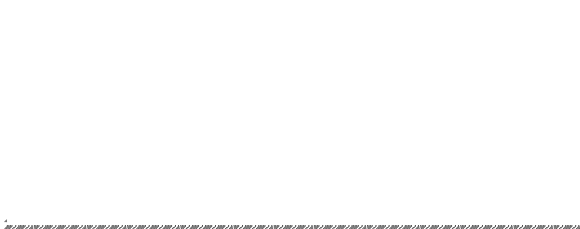

***……………………………***

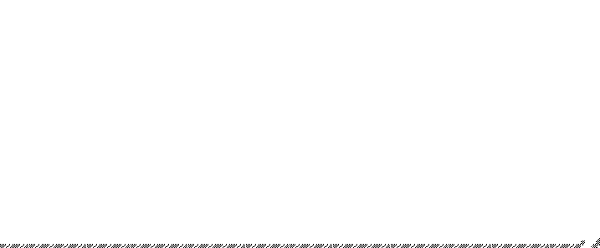



**ACKNOWLEDGEMENT**



The satisfaction and euphoria that accompany the successful completion of any task would be, but impossible without the mention of the people who made it possible, whose constant guidance and encouragement crowned my efforts with success.



I thank the management, **Dr. Mohan Manghnani**, Chairman of NEW HORIZON EDUCATIONAL INSTITUTIONS for providing necessary infrastructure and creating good environment.



I also record here the constant encouragement and facilities extended to me by **Dr. Manjunatha**, Principal, NHCE, **Dr. Prashanth. C. S. R,** Dean Academics,



**Dr. B. Rajalakshmi**, Head of the Department of Computer Science and Engineering. Iextend my sincere gratitude to them.



I express my gratitude to **Ms Priti B Badar** Senior Asst. Professor my project reviewer for constantly monitoring the development of the project and setting up precise deadlines. Her valuable suggestions were the motivating factors in completing the work.



Finally a note of thanks to all the teaching and non-teaching staff of Computer Science and Engineering Department for their cooperation extended to me and my friends, who helped me directly or indirectly in the course of the project work.



**Vishnu Vardhan V**



**1NH17CS143**



iii



**ABSTRACT**



Fantasy league is a GUI project based on allowing users to choose players from a football team to make a user defined team that earns the user points based on the user’s foresight to see which player is valuable and choose that player to make a team.

A predefined football team database along with its players is present which helps users pick their teams and also always for calculation of user score based on the football player’s stats.

iv





**TABLE OF CONTENTS**



|  |  |  |
| --- | --- | --- |
|  | **CHAPTERS** |  |
| **CHAPTER NO** | **TITLE** | **PAGE NO** |
|  | **Acknowledgement** | iii |
|  | **Abstract** | iv |
|  | **List of Figures** | vii |
| 1 | **Introduction** | 1 |
| 1.1 | **Course Objectives** | 2 |
| 1.2 | **Problem Definition** | 2 |
| 1.3 | **Outcomes of Project Work** | 2 |
| 2 | **Requirements and Design** | 3 |
| 2.1 | **Hardware Requirements** | 3 |
| 2.2 | **Software Requirements** | 3 |
| 3 | **Data Models and ER Model** | 4 |
| 3.1 | **Entity and attributes** | 5 |
| 3.2 | **Keys** | 6 |
| 3.3 | **Relationship and participation** | 7 |
| 3.4 | **Problem Statement** | 9 |
|  | **(assumptions)** |  |





|  |  |  |
| --- | --- | --- |
| 4 | **Relational Model concepts and** | 10 |
|  | **Schema** |  |
| 5 | **SQL** | 11 |
| 6 | **Python Features** | 13 |
| 6.1 | **Easy to code and read** | 13 |
| 6.2 | **Expressive** | 13 |
| 6.3 | **Portable** | 13 |
| 6.4 | **High-Level** | 14 |
| 6.5 | **Large Standard Library** | 14 |
| 7 | **Tkinter Widgets** | 15 |
| 7.1 | **Button Widget** | 15 |
| 7.2 | **Label Widget** | 15 |
| 7.3 | **Entry Widget** | 16 |
| 7.4 | **MessageBox Widget** | 16 |
| 7.5 | **Frame Widget** | 17 |
| 8 | **Implementation** | 17 |
| 9 | **Output Snapshots** | 22 |
| 10 | **Conclusion** | 26 |
| 11 | **Bibliography** | 27 |





**LIST OF FIGURES**



**Figure No** **Figure Name** **Page No**





|  |  |  |
| --- | --- | --- |
| 2.3a | Flow Diagram | 4 |
| 3.1a | Entity | 5 |
| 3.1b | Single Valued Attribute | 5 |
| 3.1c | Multi Valued Attribute | 5 |
| 3.1d | Composite Attribute | 6 |
| 3.1e | Key Attribute | 6 |
| 3.1f | Derived Attribute | 6 |
| 3.3a | 1:1 Relationship | 7 |
| 3.3b | 1:N Relationship | 8 |
| 3.3c | N:N Relationship | 8 |
| 3.3d | Participation Constraints | 8 |
| 3.4a | ER Diagram | 9 |
| 4 | Relational Schema | 10 |
| 7.1a | Button Widget | 15 |
| 7.2a | Label Widget | 16 |
| 7.3a | Entry Widget | 16 |
| 7.4a | MessageBox Widget | 17 |
| 7.5a | Frame Widget | 17 |
| 9.0a | Signup Page | 22 |
| 9.0b | Login Page | 23 |
| 9.0c | Home page | 24 |
| 9.0d | Rankings page | 25 |

vii