5.1. Technology Stack Overview
For this coursework, PySpark was selected as the main distributed processing engine, running in local mode with 3 cores and 2GB of driver/executor memory. The full stack used is summarised below:
- PySpark 4.1.1 was used for the distributed DataFrame API and Spark SQL for transformations and aggregations.
- Spark MLlib was used for all the machine learning tasks (regression, K-Means clustering and FP-Growth).
- Pandas, Matplotlib and Seaborn were used only after aggregation, for plotting the collected results.
- HuggingFace Transformers was used along with a pre-trained multilingual BERT model for sentiment inference, which runs on the driver and not on the Spark cluster.
- Jupyter Notebook was used for interactive development and reporting purposes.

5.2. Data Loading and Schema
The cleaned dataset is stored as partitioned CSV directories under /cleaned_dataset. Spark reads all part files in one call by giving the directory path to spark.read.csv. The tables loaded are as follows:
- orders: 400,000 rows × 9 cols (one row per order, with order_date, status, shipping city, payment method etc.)
- order_items: 919,204 rows × 6 cols (line-level details: product_id, quantity, unit_price_at_sale, discount_pct, line_total)
- products: 5,000 rows × 8 cols (product_name, category, subcategory, price, supplier)
- customers: 121,200 rows × 9 cols (city, age_group, customer_segment)
- reviews: product reviews with review_text and review_score (1 to 5 stars)
- date_dim: 2,557 rows, calender helper table

[Insert screenshot: dataset row-count / schema output]

5.3. Transformations Applied
Several PySpark transformations were applied before the analysis stage could begin:
- Joins: the order_items table was inner-joined to orders and products in order to build a wide fact table containing all the columns needed for analysis.
- Derived columns: revenue (= line_total), profit (calculated as line_total × (1 − discount_pct) × 0.30, assuming a 30% gross margin), and order_year and order_month extracted from order_date.
- Filtering: only the rows where order_status == 'Delivered' are counted towards confirmed revenue and profit KPIs, since pending or cancelled orders should not be treated as realised income.
- Sentiment label: review_score was mapped into 3 classes, where 1 to 2 stars = bad (0), 3 = neutral (1) and 4 to 5 = good (2).
- Null handling: rows with missing review_text were dropped before the model training step.
- Feature engineering for forecasting: monthly revenue was aggregated by year-month, and then lag features (lag_1, lag_2, lag_3) were created together with a time index t.
- RFM features: per-customer aggregation was done to compute Recency (days since last order), Frequency (number of orders) and Monetary (total revenue spent).
- Text pipeline: tokenizer, then stop-word remover, then HashingTF, then IDF, and finally Logistic Regression for the Spark MLlib sentiment model.

5.4. Analysis Output and Results

Sales Performance Analysis
- KPI dashboard: Total Revenue is approximately NPR 12.41 B, Profit around NPR 3.28 B, with 240,352 delivered orders and an average order value of roughly NPR 22,458.
- Sales by category: Electronics clearly dominates with around 62% of total revenue, followed by Home & Garden and Sports & Outdoors.
- Sales by region: the top 15 cities contributes the majority of orders, with Kathmandu, Pokhara and Lalitpur leading the list.
- Seasonality: the monthly trend and yearly trend both shows mid-year and year-end peaks.
- Top / low products: a clear Pareto pattern is visible, where a small set of SKUs drives most of the revenue.
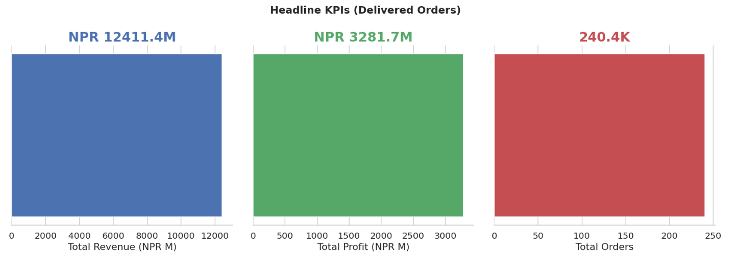

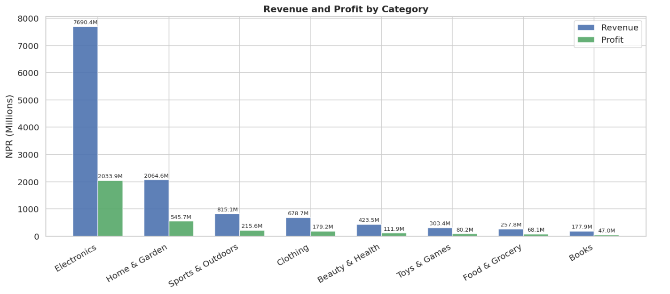

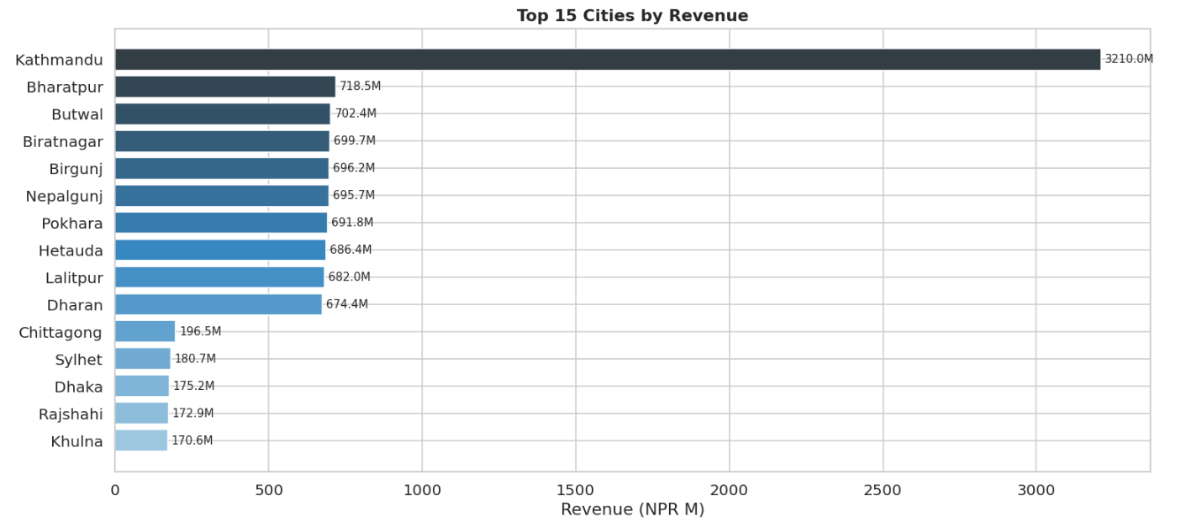
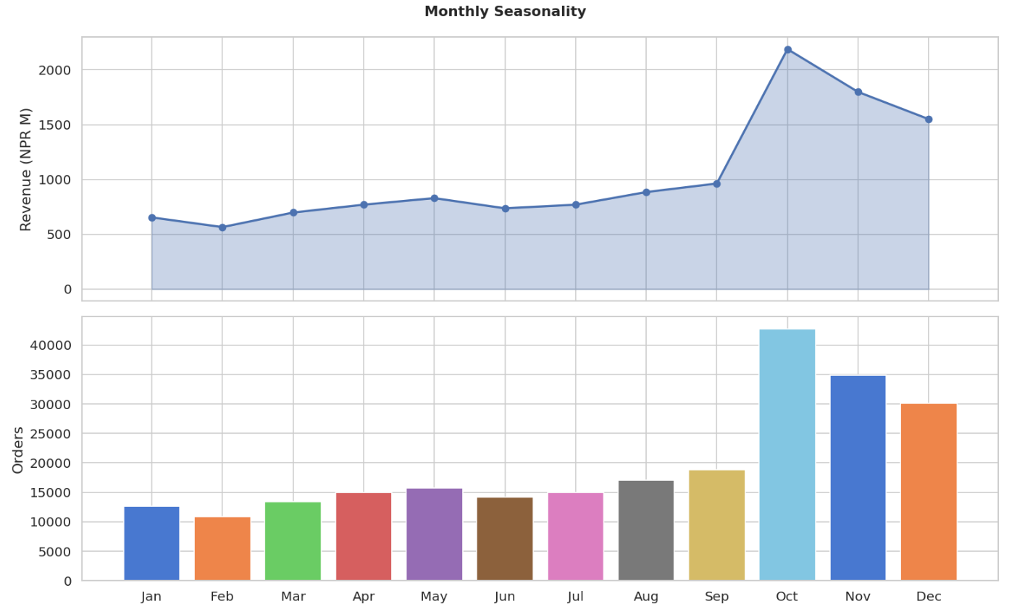

Customer Segmentation (K-Means clustering)
- The RFM features were scaled before clustering was performed.
- Values of K from 2 to 7 were tried, and the best K was picked using the elbow method (WSSSE) and silhouette score together.
- The resulting clusters were then profiled to give them business meaning, namely VIP, regular, dormant and new customers.
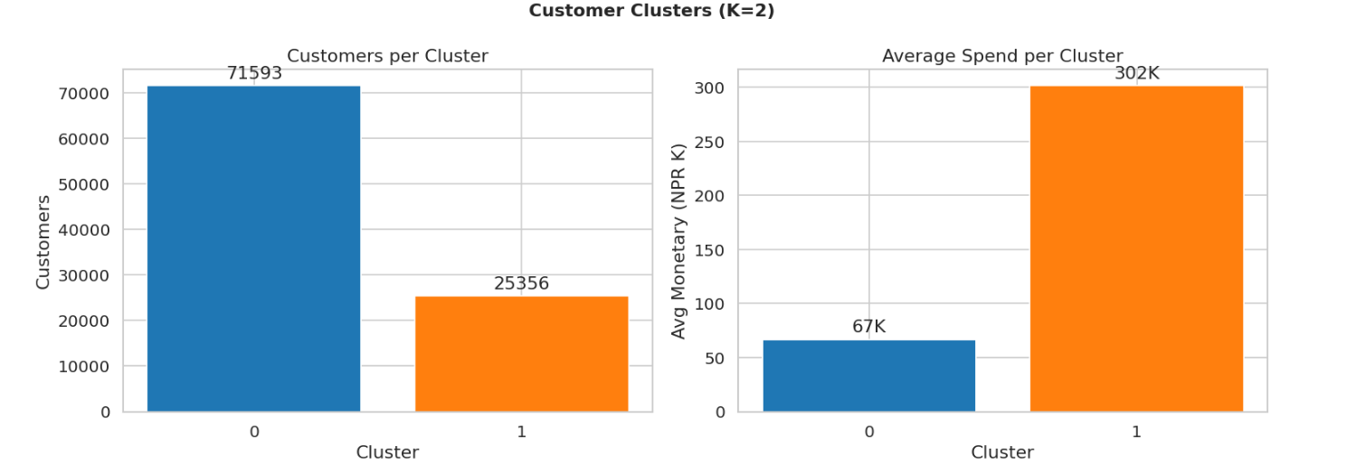

Market Basket Analysis (FP-Growth)
- Baskets were built at the order level using the product category list for each order.
- Association rules were extracted along with their support, confidence and lift metrics.
- Rules with lift > 1 were shortlisted for cross-sell recommendation purposes.

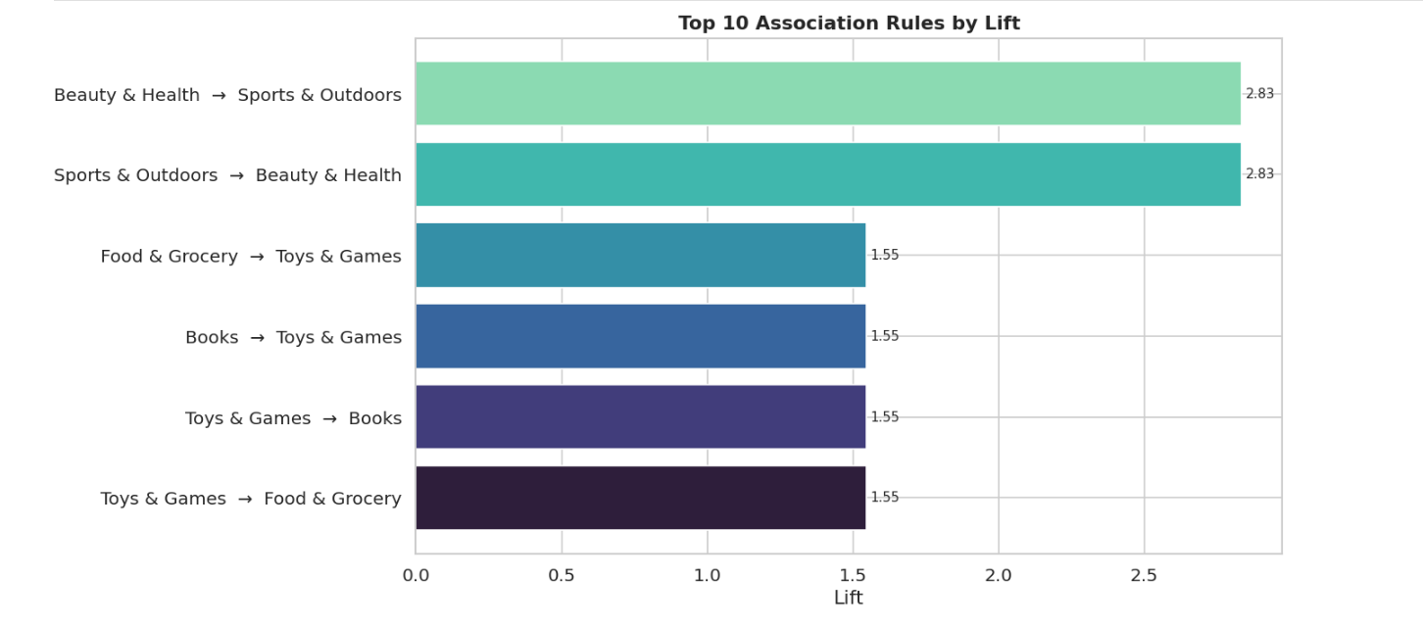

Sentiment Analysis
- Reviews were labelled into 3 sentiment classes (good / neutral / bad) based on the review_score column.
- A Logistic Regression model (Spark MLlib, with TF-IDF features) was trained on the full dataset and produced solid accuracy and F1 scores.
- A BERT model (the multilingual nlptown model) was also ran on a 2000-review sample for comparision purposes. It gave higher accuracy but was much slower.
- Additional breakdowns were also produced: sentiment by category, by price range, by customer type (frequent vs rare), by age group, and by payment method.
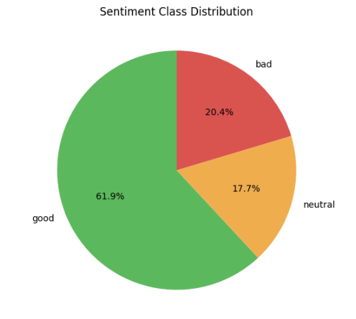
Linear Regression Scores:
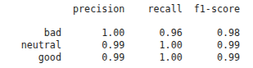

BERT scores:
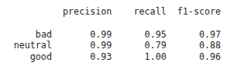

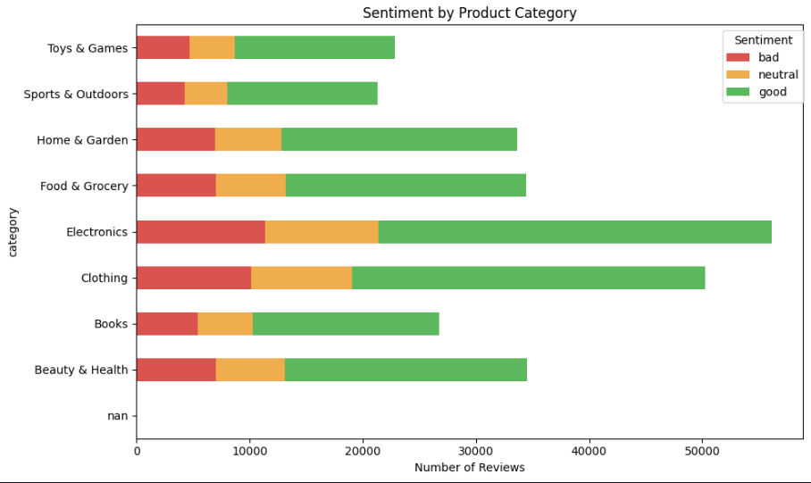

5.5. Business Interpretation
The combined analysis leads to a number of business takeaways:
- Electronics is clearly the main revenue engine, so any stock-out in this category directly hurts the top line. Inventory planning should therefore prioritise this category above the others.
- Revenue is concentrated in a handful of cities. Setting up regional fulfilment hubs in the top three cities would most likely reduce both shipping cost and delivery time.
- A clear seasonality pattern exists in the data, which means that promotional campaigns and stock build-up should ideally start 4 to 6 weeks before the peak months arrive.
- Forecasting with Random Forest on lagged revenue gives usable monthly revenue predictions that can be used for next-month budgeting purposes.
- The K-Means customer segments allows for differentiated marketing strategies, such as loyalty perks for VIP customers, reactivation offers for dormant ones, and welcome offers targetted at new customers.
- The market-basket rules can directly feed into the "Frequently bought together" widget and the bundle offer pages, which would help boosting cross-sell revenue.
- Sentiment analysis shows that the majority of reviews are positive in nature, however the neutral and negative clusters tends to be concentrated in specific categories and price bands. These are the areas where product quality or customer expectation management needs more attention.
- Overall, the business should lean into their winning categories and cities, while at the same time using the predictive and segmentation outputs to improve targeting and operational decisions.

