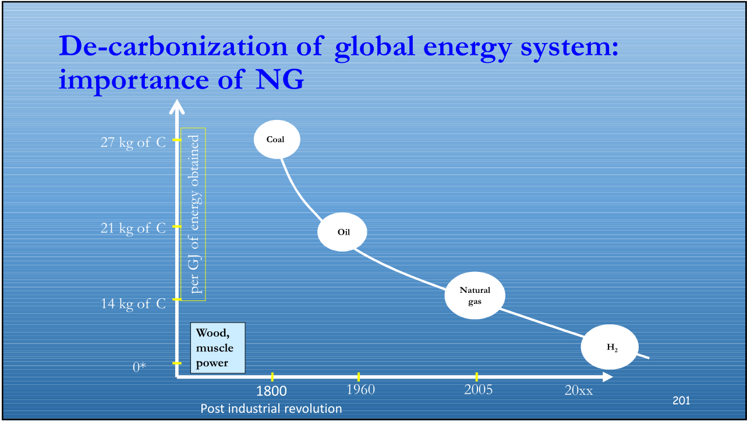
Notes_9
Carbon footprint per unit of energy: The y-axis shows the amount of carbon released per unit of energy obtained (grams of carbon per gigajoule of energy).
Fossil fuels: The diagram compares the carbon footprint of coal, oil, and natural gas. As you can see, natural gas has the lowest carbon footprint of the three fossil fuels listed (14 kg of carbon per GJ).
Other energy sources: Wood, muscle power (presumably referring to human and animal labor), and hydrogen are also listed on the diagram.
The inclusion of natural gas is likely to spark debate in the context of unconventional oil and gas reserves. Natural gas is a fossil fuel, and its combustion does release greenhouse gasses. However, it is often seen as a “bridge fuel” during the transition to renewable energy sources because it burns cleaner than coal or oil.

Here are some of the arguments for and against natural gas as a bridge fuel:

Natural gas burns cleaner than coal or oil: As the diagram shows, natural gas produces less carbon dioxide per unit of energy than coal or oil. This means that switching from coal or oil to natural gas can help to reduce greenhouse gas emissions in the short term.
Natural gas is abundant: There are large reserves of natural gas around the world, which means that it could be a reliable source of energy for many years to come.
Natural gas can be used to generate electricity quickly: Natural gas power plants can be ramped up and down quickly to meet changes in demand for electricity. This can be helpful for balancing the electrical grid, which is increasingly reliant on variable renewable energy sources like solar and wind power.
However, there are also some drawbacks to using natural gas as a bridge fuel:

Natural gas is still a fossil fuel: Even though it burns cleaner than coal or oil, natural gas still produces greenhouse gas emissions. These emissions contribute to climate change.
There are methane emissions associated with natural gas production and transportation: Methane is a potent greenhouse gas, and there are leaks of methane throughout the natural gas supply chain. These leaks can offset some of the climate benefits of switching from coal to natural gas.
Investing in natural gas infrastructure locks us into fossil fuels: The development of new natural gas infrastructure can make it more difficult to transition to renewable energy sources in the long term.
The role of natural gas in the transition to a low-carbon economy is a complex issue. There are both advantages and disadvantages to using natural gas as a bridge fuel. The decision of whether or not to use natural gas will likely depend on a variety of factors, including the specific circumstances of each country or region.
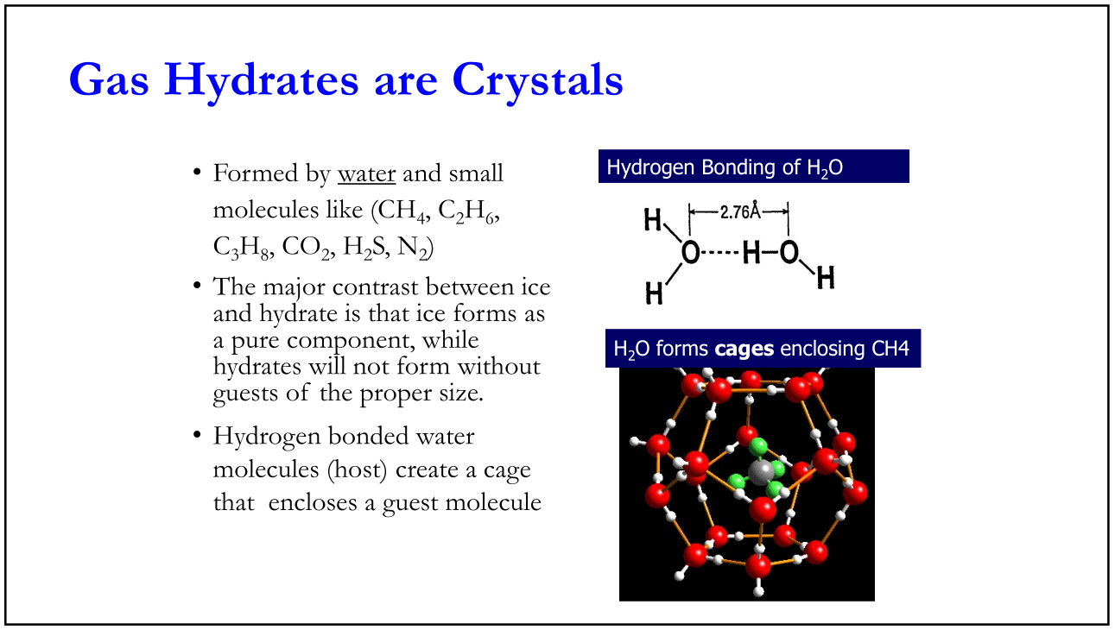
The image you sent is about gas hydrates, which are ice-like crystals formed by water molecules and small molecules [1]. The small molecules that can form gas hydrates are methane (CH4), ethane (C2H6), propane (C3H8), carbon dioxide (CO2), hydrogen sulfide (H2S), and nitrogen (N2) [1].

Here’s a more detailed explanation of the image:

* **Formation of gas hydrates:** The upper left corner of the image shows the formation of gas hydrates. Here, water molecules form hydrogen-bonded cages that trap a guest molecule of methane (CH4) inside [1].
* **Hydrogen bonding:** The image highlights the role of hydrogen bonding in gas hydrate formation. Hydrogen bonds are the attractive forces between the hydrogen atom in one water molecule and the oxygen atom in another water molecule [1]. These hydrogen bonds cause the water molecules to form cages with specific shapes and sizes.
* **Comparison with ice:** The lower left corner of the image shows the key difference between ice and gas hydrates. Ice forms from a single component (water molecules), whereas gas hydrates require the presence of guest molecules of the right size to form cages [1].
* **Structure:** The right side of the image shows the 3D cage-like structure of gas hydrates. These cages are formed by hydrogen-bonded water molecules [1].

Gas hydrates are naturally occurring and are found in permafrost regions, deep ocean sediments and underneath the sea floor [2]. They are a potential energy source, as the trapped gas molecules can be extracted and burned as fuel [2]. However, extracting gas from gas hydrates is challenging because they are stable at low temperatures and high pressures [2].

I hope this explanation is helpful! Let me know if you have any other questions about gas hydrates or unconventional oil and gas reserves.
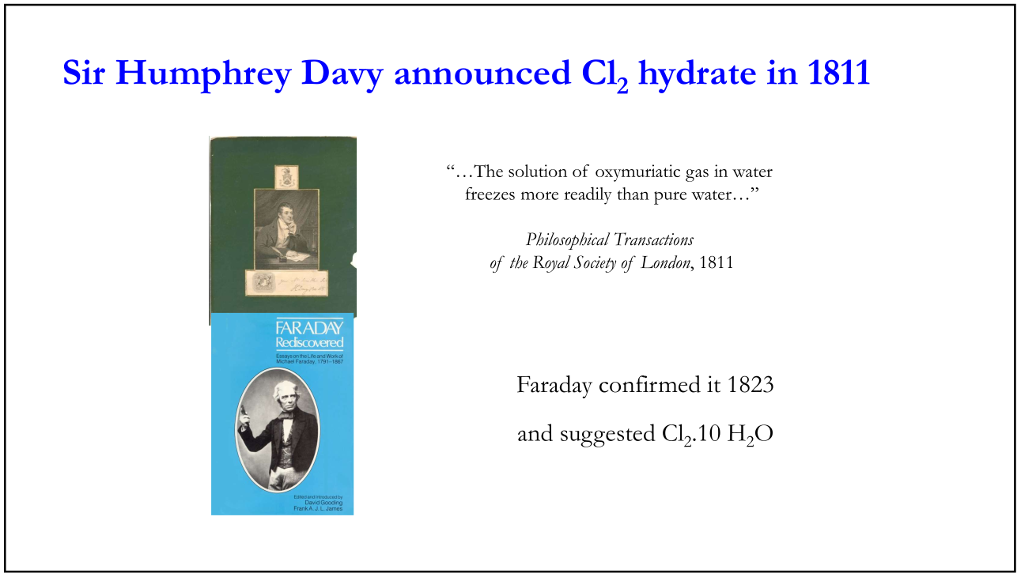
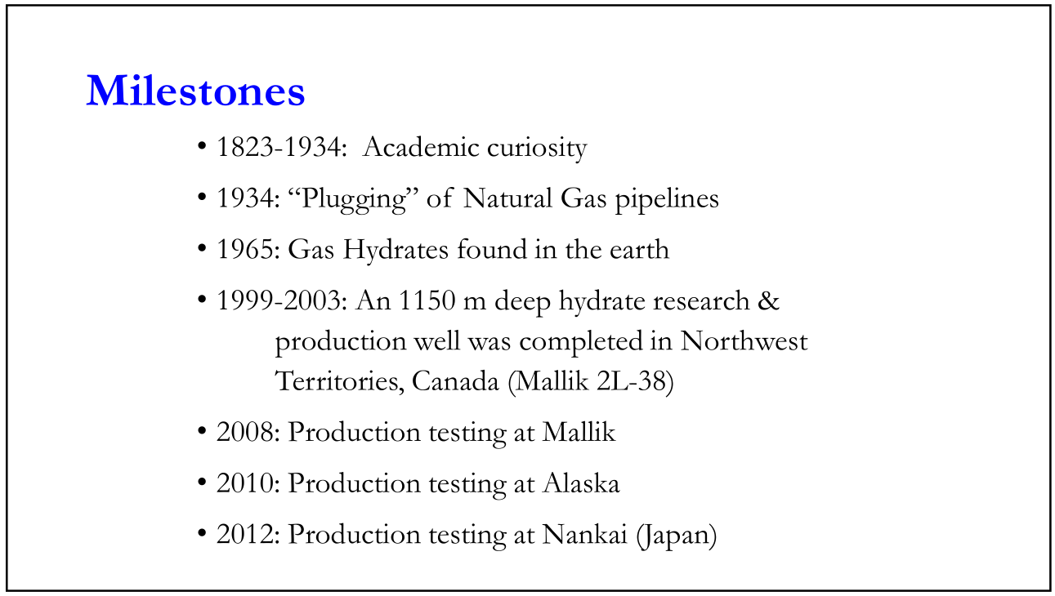
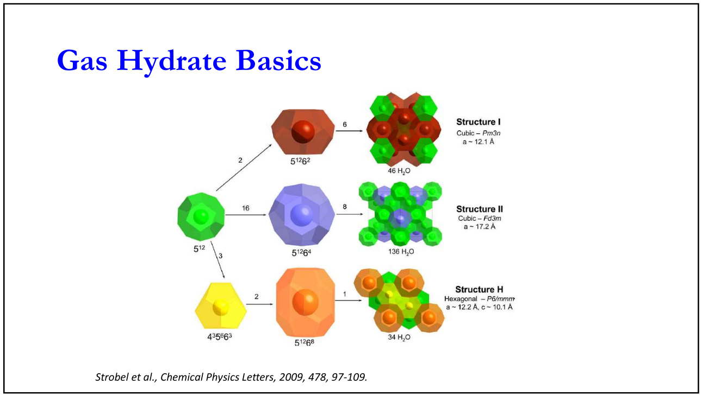
Structure I - This structure is identified as cubic with a space group Pm3n [1]. The lattice parameter, a, is specified as 12.1 angstroms (Å) [1]. This parameter signifies the basic unit cell dimension within the crystal structure [2]. Additionally, the formula unit, 51262, indicates the number of water molecules (H₂O) per unit cell in this structure [1]. It also shows 16 guest molecules trapped within the cages formed by the water molecules [1].
Structure II - This structure is identified as cubic with a space group Fd3m [1]. The lattice parameter, a, is specified as 17.3 Å [1]. The formula unit, 51264, signifies the number of water molecules (H₂O) per unit cell in this structure [1]. It also shows 136 guest molecules trapped within the cages formed by the water molecules [1].
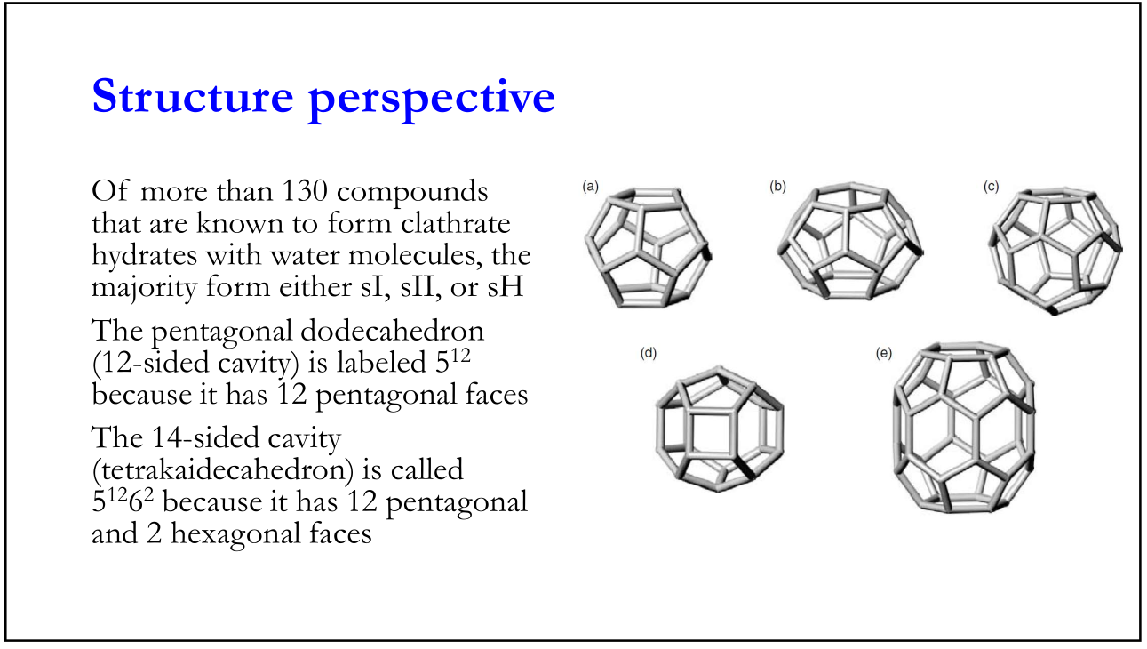
Structure H - This structure is identified as hexagonal with a space group P6/mmm [1]. The lattice parameters, a and c, are specified as 12.2 Å and 10.1 Å, respectively [1]. The formula unit, 51268, signifies the number of water molecules (H₂O) per unit cell in this structure [1]. It also shows 34 guest molecules trapped within the cages formed by the water molecules [1].

- Types of cavities: The image showcases two different types of cavities formed by the water molecules:
  - Pentagonal dodecahedron: This 12-sided cavity is labeled as 512 because it has 12 pentagonal faces [1].
  - Tetradecahedron: This 14-sided cavity is called 51262 because it has 12 pentagonal faces and 2 hexagonal faces [1].
- Number of compounds: The text states that over 130 compounds are known to form clathrate hydrates with water molecules [1].
- Types of clathrate hydrates: The text mentions three main hydrate structures: sI, sII and sH [1]. These labels likely refer to different crystallographic structures that the escan form, although the specific details are not provided in the image itself [1]
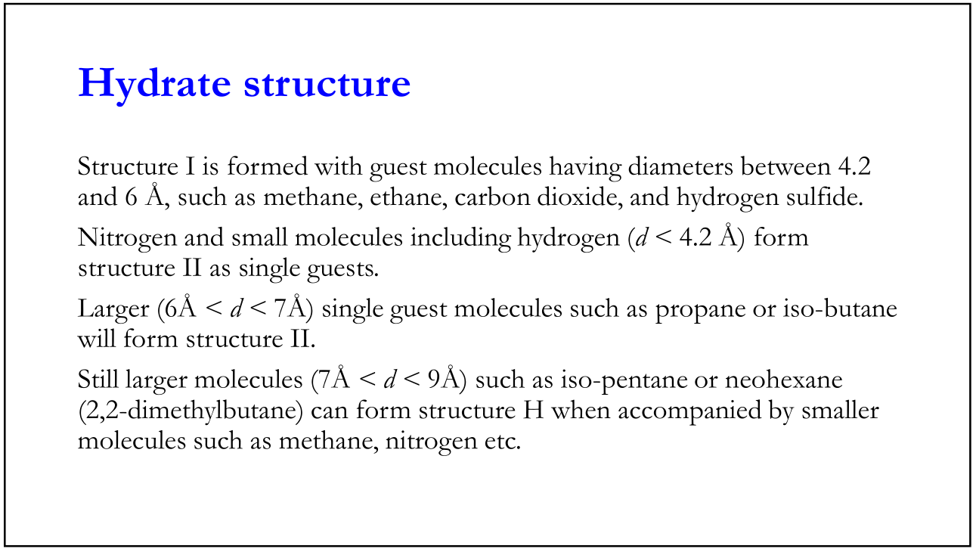
Gas hydrates are crystalline solids that form when water molecules combine with small gas molecules under low temperature and high pressure conditions [1, 4]. These hydrates can be found in permafrost regions, deep ocean sediments and underneath the sea floor where the conditions of low temperature and high pressure are met [2, 4]. Because they contain trapped natural gas molecules, gas hydrates are considered a potential source of unconventional natural gas [4]. However, extracting methane gas from hydrates is challenging due to the technical difficulties of working in these extreme environments, and the challenges of dissociating the gas from the water molecules at a commercially viable scale [4].
The image you sent shows three main types of gas hydrate structures, designated as Structure I, Structure II, and Structure H [1]. The ability to form a specific hydrate structure depends on the size and shape of the small gas molecule trapped within the cages formed by the water molecules [1].
Here’s how the structural information in the image relates to unconventional gas reserves:
- Size of guest molecules: The size of the gas molecules found in unconventional reservoirs can influence the type of gas hydrate structure that forms [1]. For instance, methane molecules (CH₄), a primary component of natural gas, are small enough to fit within the cages of Structure I and Structure II [1].
- Impact on stability: The type of gas hydrate structure can affect the stability of the gas hydrate under different pressure and temperature conditions [5]. This stability is important when considering the technical challenges of extracting methane gas from hydrates found in unconventional reservoirs.
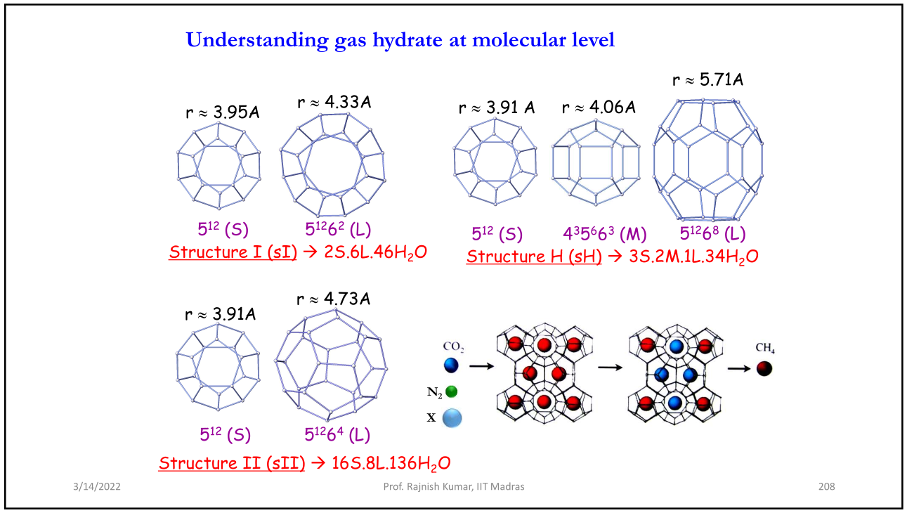
Formation of gas hydrates: The upper left corner of the image shows the formation of gas hydrates. Here, water molecules form hydrogen-bonded cages that trap a guest molecule of methane (CH4) inside [1].
Hydrogen bonding: The image highlights the role of hydrogen bonding in gas hydrate formation. Hydrogen bonds are the attractive forces between the hydrogen atom in one water molecule and the oxygen atom in another water molecule [1]. These hydrogen bonds cause the water molecules to form cages with specific shapes and sizes.
Comparison with ice: The lower left corner of the image shows the key difference between ice and gas hydrates. Ice forms from a single component (water molecules), whereas gas hydrates require the presence of guest molecules of the right size to form cages [1].
Structure: The right side of the image shows the 3D cage-like structure of gas hydrates. These cages are formed by hydrogen-bonded water molecules [1].

The table compares the properties of different types of cages found in hydrate crystals:
- Cavity: This refers to the specific type of cage structure. The table identifies four different cavity types: small, large, medium, and another small cage denoted by a lowercase b [3].
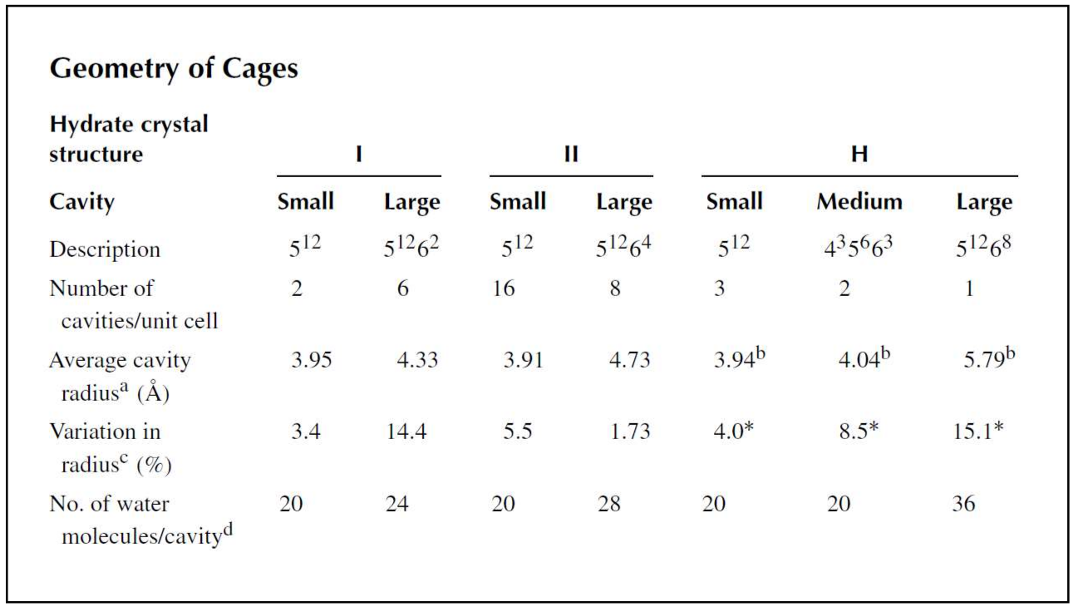
- Description: This column describes the geometry of each cage using a notation system. Unfortunately, I can’t find a definitive explanation for this notation system used to describe the specific cage geometries [3].
- Number of cavities/unit cell: This column shows how many of each cavity type are found within a unit cell of the crystal structure. A unit cell is the basic repeating unit of a crystal structure [2].
- Average cavity radius (Å): This column shows the average radius of each cavity type in Angstroms (Å). An Angstrom is a unit of length equal to 10^-10 meters [2].
- Variation in radius (%): This column shows the variation in the radius for each cavity type as a percentage.

The image focuses on the change in hydrate structure for hydrogen (H₂) gas [1]. Here’s a breakdown of the information presented in the image:
Normal pressure: At normal pressures, hydrogen gas forms a hydrate structure called sI [1].
High pressure: When pressure is applied, the hydrate structure changes from sI to sII at around 0.3 Gigapascals (GPa) [1]. One Gigapascal is a unit of pressure equal to one billion Pascals (Pa) [2].
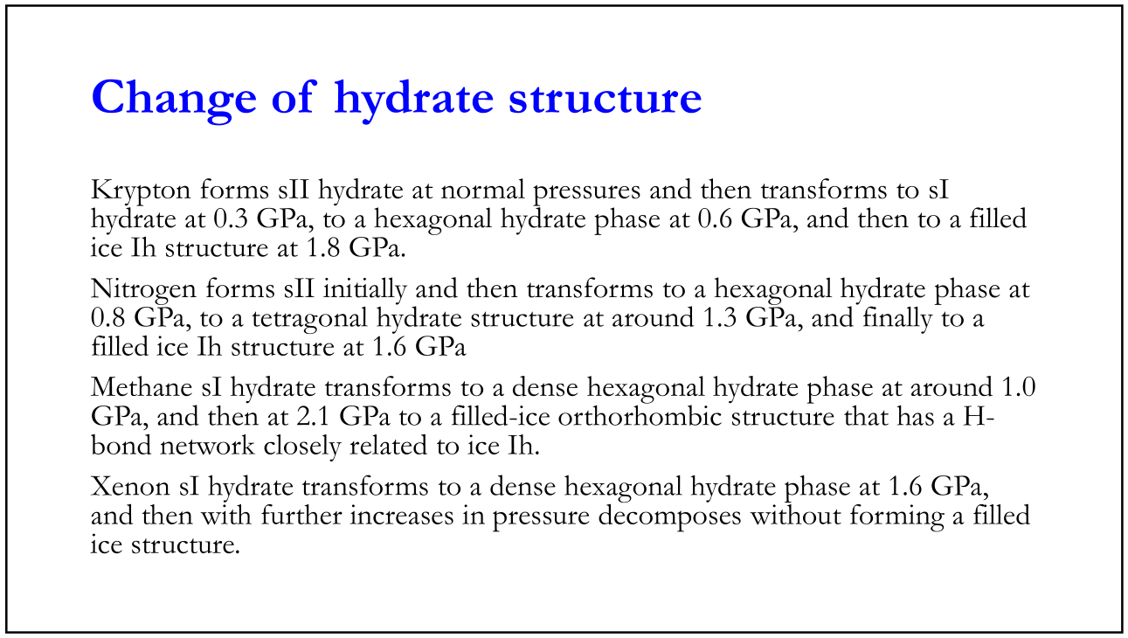
The text mentions that other gases, such as krypton (Kr), nitrogen (N₂), and methane (CH₄), also exhibit a change in hydrate structure when subjected to high pressure conditions [1].
Here are some additional details to consider:
- Impact of pressure on cage structure: The pressure changes can cause the cages formed by the water molecules to rearrange into different configurations [1]. This change in cage structure can influence the size and shape of the cavities available to trap the gas molecules.
- Size of gas molecules: The size of the gas molecule plays a role in determining which hydrate structure is formed [1]. For instance, small molecules like hydrogen (H₂) can fit within the cages of both sI and sII hydrate structures, whereas larger molecules may only fit within the cages of a specific hydrate structure.
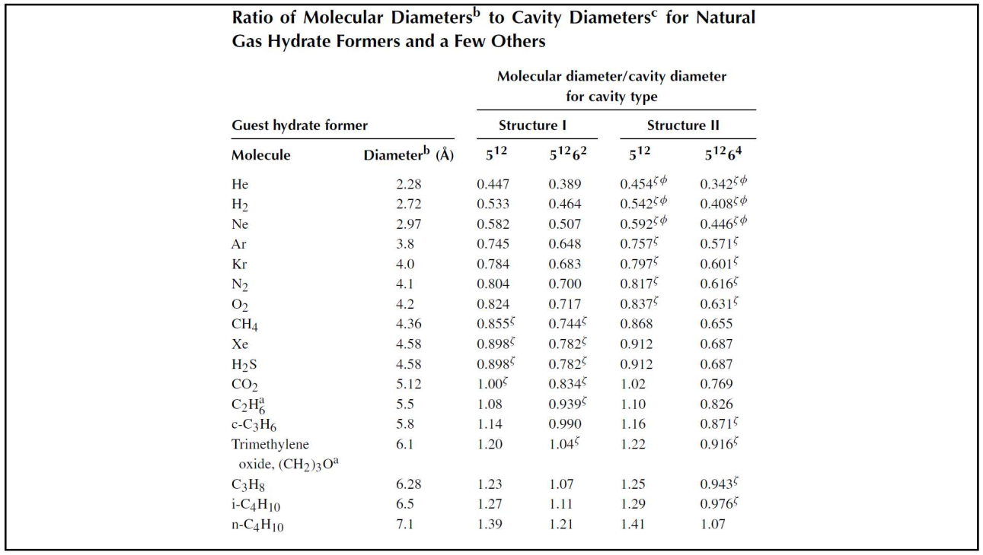
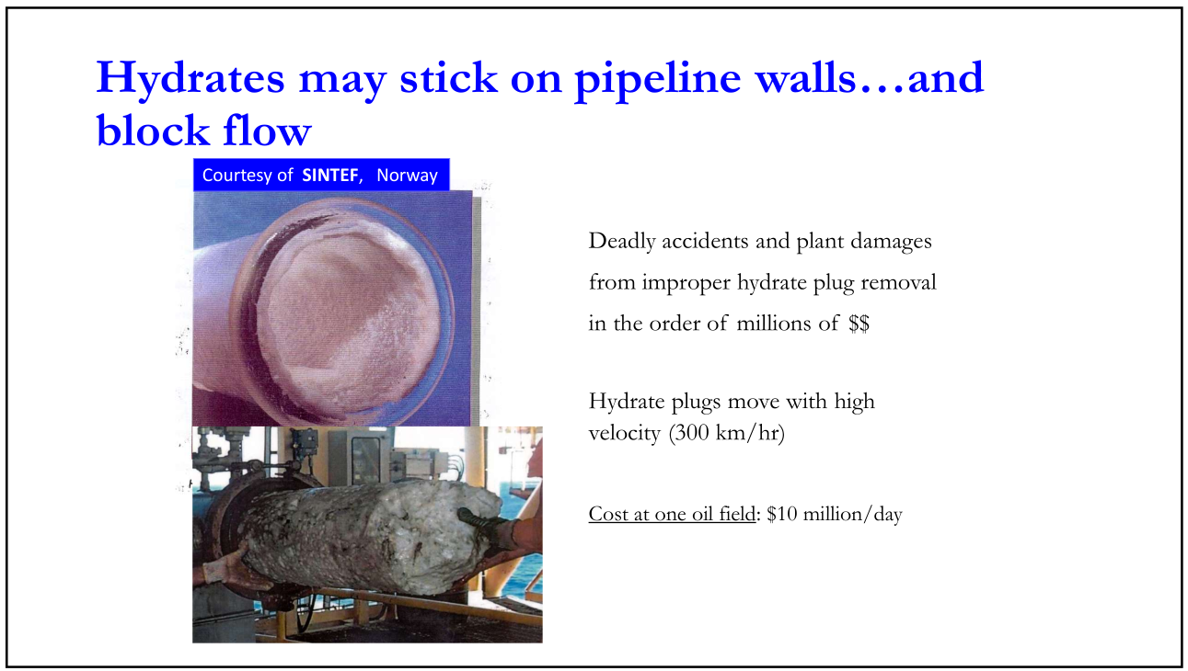
The diagram shows the following stages of hydrate formation and pipeline plugging:
- Formation of Hydrate Particles: Small gas molecules (represented by blue circles) combine with water molecules (represented by white circles) to form hydrates (light blue circles) in the bulk gas stream [1].
- Hydrate Particles Adhere to Pipe Wall: The hydrate particles then adhere to the inner wall of the pipeline [1]. This adhesion can be caused by several factors, including the presence of ice or certain hydrocarbons on the pipe wall [2].
- Hydrate Particles Grow and Block Pipeline: As more hydrates accumulate on the pipe wall, they continue to grow and eventually restrict or completely block the flow of gas through the pipeline [1].
The text labels in the image also highlight the following points:
- Kinetic Hydrate Inhibitors (KHI): These are chemicals that can be added to the gas stream to prevent the formation and accumulation of hydrates [1].
- Thermal Insulation: Maintaining the pipeline at a temperature above the hydrate formation temperature can prevent hydrate formation [1].
Hydrate formation is a major concern in the oil and gas industry because it can lead to pipeline blockages, production shutdowns, and economic losses [2]. The methods mentioned in the diagram, such as using kinetic hydrate inhibitors (KHIs) and thermal insulation, are commonly employed to mitigate hydrate formation in pipelines that transport natural gas.

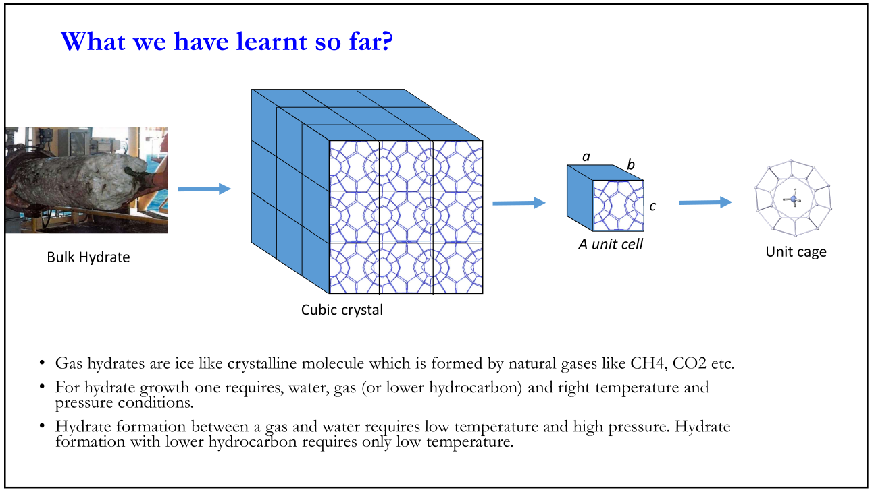

- Upper left corner: This section shows the formation of gas hydrates. Here, water molecules (red spheres connected by white sticks) form cages with specific shapes and sizes around a small guest molecule of methane (blue sphere) trapped inside [1]. The hydrogen bonds between water molecules (white sticks) are responsible for the cage formation [1].
- Lower left corner: This section highlights the difference between ice and gas hydrates. Regular ice forms from a single component, water molecules (red spheres connected by white sticks), arranged in a repeating crystalline structure [1]. In contrast, gas hydrates require the presence of small guest molecules (blue sphere) like methane to fill the cavities within the cages formed by hydrogen-bonded water molecules [1].
- Right side: This section depicts the 3D cage-like structures of gas hydrates. These cages are formed by hydrogen-bonded water molecules (red spheres connected by white sticks). The cages have cavities that can trap small guest molecules (blue spheres) of methane gas in this example [1].
The text labels within the image identify different structural forms of gas hydrates: Structure I (SI), Structure II (SII), and Structure H (SH) [1]. These structures are classified based on the arrangement of the cages formed by the water molecules that entrap the small gas molecules within the hydrate lattice [1].
Here’s a breakdown of the structural features for each hydrate structure:
- Structure I (SI): This structure is cubic with a space group Pm3n [1]. The cages are primarily composed of 12 pentagonal faces (dodecahedron) [1].
- Structure II (SII): This structure is also cubic with a space group Fd3m [1]. The cages are a combination of 12 pentagonal faces and 2 hexagonal faces (tetradecahedron) [1].
- Structure H (SH): This structure is hexagonal with a space group P6/mmm [1]. The specific cage geometries are not labelled in the image, but they differ from those in SI and SII hydrates [1].
The size and shape of the cages in these different hydrate structures influence the size of the gas molecules that can be trapped within them [4]. For instance, small molecules like methane (CH₄) can fit within the cages of all three hydrate structures (SI, SII, and SH) shown in the image [1]. However, larger gas molecules may only be able to fit within the cages of specific hydrate structures.

Notes 10
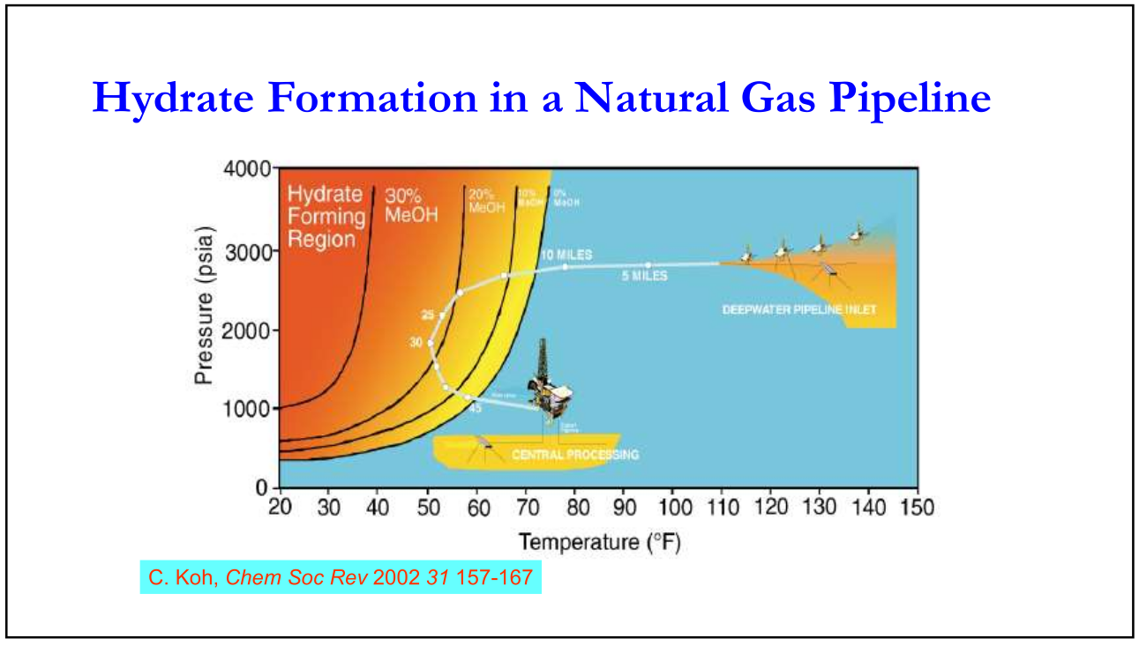
Here’s a breakdown of the key features in the image:
- T (°F): The vertical axis represents temperature in degrees Fahrenheit (°F) [1].
- Pressure (psia): The horizontal axis represents pressure in pounds per square inch absolute (psia) [1].
- Hydrate forming region: The shaded area on the left side of the diagram is the hydrate formation region. Any combination of temperature and pressure within this region will form gas hydrates [1].
- Gas and water: The region on the right side of the diagram represents conditions where natural gas exists as a vapor and water as a liquid [1].
- Ice formation: The bottom portion of the diagram shows the ice formation region. Here, water will be present as ice [1].
The hydrate equilibrium curve is called the diagonal line within the hydrate formation region [1]. This curve separates the conditions where hydrates will form (below the curve) from the situations where they will not (above the curve) [1].
Here are some additional points to consider:
- Impact of pressure and temperature on hydrate formation: As pressure increases or temperature decreases, the conditions move towards the hydrate formation region, making hydrate formation more likely [1].
- Composition of natural gas: The specific composition of the natural gas mixture will affect the exact location of the hydrate equilibrium curve in the phase diagram [3]. Different gas components have varying abilities to form hydrates under various pressure and temperature conditions.
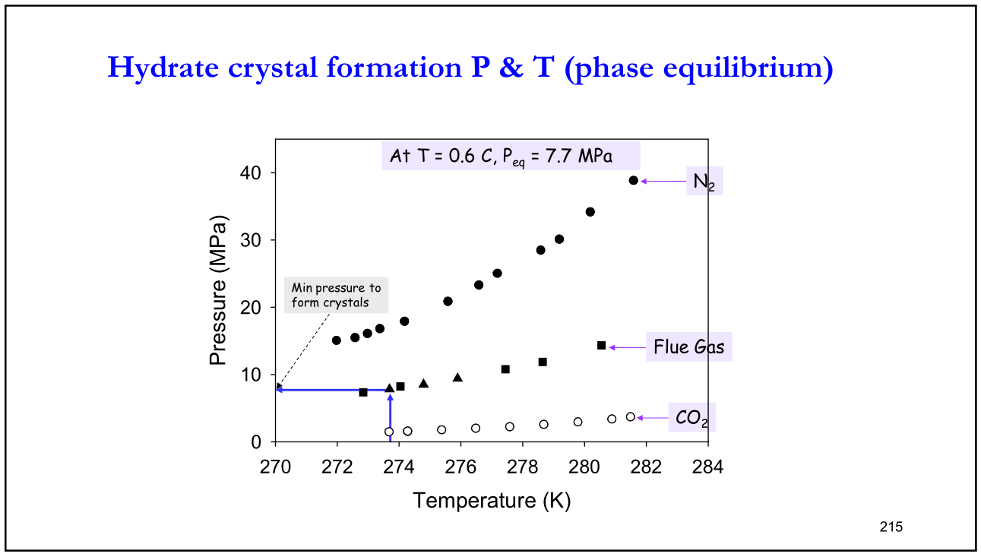
The text within the image identifies the following key features:
- T (°C): The y-axis represents temperature in degrees Celsius (°C) [1].
- Pressure (MPa): The x-axis represents pressure in MegaPascals (MPa) [1].
The diagram also shows three distinct regions:
- Gas + Water: The upper right region labelled “Gas + Water” represents conditions where methane gas exists as a vapor and water exists as a liquid [1].
- Ice: The lower left region labelled “Ice” represents conditions where water is present as ice [1].
- Hydrate: The shaded area in the middle of the diagram is the hydrate formation region. Any combination of temperature and pressure within this region will result in the formation of gas hydrates, which trap methane molecules within cages of hydrogen-bonded water molecules [1].
The curved line separating the hydrate and gas + water regions is the hydrate equilibrium curve [1]. This important curve represents the conditions at which hydrates will begin to form (below the curve) and dissociate (decompose) into gas and water (above the curve) [1].
Here are some additional points to consider:
- Impact of pressure and temperature on hydrate formation: As pressure increases or temperature decreases, the conditions move towards the hydrate formation region, making hydrate formation more likely [1].
- Minimum pressure for hydrate formation: The point where the hydrate equilibrium curve intersects the pressure axis at lower temperatures is called the minimum pressure for hydrate formation [4]. Below this pressure, hydrates cannot form regardless of the temperature [4].

