
Tribhuvan University
Faculty of Humanities and Social Sciences
CAFEOS: AN INTELLIGENT INVENTORY MANAGEMENT SYSTEM FOR CAFES
A PROJECT REPORT
Submitted to
Department of Computer Application
D.A.V. College
In partial fulfillment of the requirements for the Bachelors in Computer Application
Submitted by
Rabindra Prasad Sah
[TU Reg No: ____________]
July, 2026
Under the Supervision of
[Supervisor Name]

ACKNOWLEDGEMENT
I would like to express my sincere gratitude to the Department of Computer Application, D.A.V. College, for providing me the opportunity to undertake this project as part of Project III. I am thankful to my supervisor, [Supervisor Name], for the continuous guidance, technical feedback, and patience extended throughout every stage of this work.
I am grateful to the faculty members of the department, whose teaching in database management, software engineering, and data analysis formed the foundation on which this project was built.
I would also like to thank the cafe owners and staff in Kathmandu who gave their time to explain how they currently manage stock, place supplier orders, and cope with items running out during service. Their descriptions of daily practice shaped the problem statement far more than any textbook could.
Finally, I thank my friends and family for their encouragement and support during the development and documentation of this project.
ABSTRACT
Small and medium cafes in Kathmandu manage their stock almost entirely from memory. Orders are placed when a staff member notices a container looking empty, which means fast-moving and perishable goods are discovered missing only when a customer has already ordered the item. The consequences are twofold: lost sales when an item must be withdrawn mid-service, and spoilage when a manager over-corrects and buys more perishable stock than the cafe can use.
CafeOS is an existing web-based cafe management platform providing point-of-sale, kitchen display, menu management, expense tracking, and an inventory module. Its inventory module, however, is purely descriptive: it records what is in stock and raises an alert only after stock has already fallen below a fixed threshold. It cannot say what will be needed tomorrow.
This project extends CafeOS with a predictive layer built on two supervised machine learning models:
- A Demand Forecaster — a Random Forest Regressor that predicts the number of units of
each menu item that will sell on the following day, using lagged sales, weekday rhythm, the Nepali festival calendar, seasonality, and active promotions.
- A Stockout Risk Classifier — a Random Forest Classifier that assigns every ingredient
a seven-day risk class of SAFE, WATCH, or URGENT, learned from observed historical stockout events rather than from a threshold rule.
The two models are combined with a deterministic rule layer that converts forecast demand into ingredient requirements via the recipe book, and applies non-negotiable safety guardrails for supplier lead time, pack sizes, and perishable shelf life.
Evaluated on a chronologically held-out test window, the Demand Forecaster achieved an R² of 0.8955 and a Mean Absolute Error of 8.13 units, improving on a seasonal-naive baseline by 16.4%. The Stockout Risk Classifier achieved 77.79% accuracy and a macro F1-score of 0.7497. Most importantly, it recalled 82.21% of genuinely imminent stockouts, against 44.84% for the static threshold rule the system previously used — the machine learning model catches nearly twice as many real stockouts.
Of nine pre-declared acceptance criteria, seven passed and two failed. The classifier did not meet its 80% accuracy or 0.75 macro F1 targets. These failures are reported rather than adjusted away, and Chapter 4 analyses their cause: the WATCH class is intrinsically ambiguous, occupying a narrow band between "fine" and "urgent" that the available features do not cleanly separate.
All training and evaluation data is synthetic, generated by a simulator documented in Section 3.4. This limitation, and its implications for interpreting every figure in this report, is stated explicitly in Sections 1.4, 3.4.1, and 4.4.8.
Keywords: Inventory Management, Demand Forecasting, Random Forest, Stockout Prediction, Machine Learning, Cafe Management System, Nepal
TABLE OF CONTENTS
Section | Page
ACKNOWLEDGEMENT | ii
ABSTRACT | iii
LIST OF ABBREVIATIONS | vi
LIST OF FIGURES | vii
LIST OF TABLES | viii
CHAPTER 1: INTRODUCTION | 1
1.1 Introduction | 1
1.2 Problem Statement | 2
1.3 Objectives | 3
1.4 Scope and Limitation | 3
1.5 Development Methodology | 5
1.6 Report Organization | 6
CHAPTER 2: BACKGROUND STUDY AND LITERATURE REVIEW | 7
2.1 Background Study | 7
2.2 Literature Review | 9
2.3 Research Gap | 13
CHAPTER 3: SYSTEM ANALYSIS AND DESIGN | 14
3.1 System Analysis | 14
3.2 System Design | 22
3.3 Algorithm Details | 28
3.4 Dataset Construction | 33
CHAPTER 4: IMPLEMENTATION AND TESTING | 37
4.1 Implementation | 37
4.2 Testing | 46
4.3 Acceptance Testing | 50
4.4 Result Analysis | 52
CHAPTER 5: CONCLUSION AND FUTURE WORK | 62
REFERENCES | 65
APPENDICES | 67

LIST OF ABBREVIATIONS
Abbreviation | Expansion
API | Application Programming Interface
BCA | Bachelor of Computer Application
CSV | Comma-Separated Values
FIFO | First In, First Out
HTTP | HyperText Transfer Protocol
JSON | JavaScript Object Notation
JWT | JSON Web Token
KDS | Kitchen Display System
MAE | Mean Absolute Error
ML | Machine Learning
MOQ | Minimum Order Quantity
POS | Point of Sale
R² | Coefficient of Determination
RBAC | Role-Based Access Control
REST | Representational State Transfer
RF | Random Forest
RLS | Row Level Security
RMSE | Root Mean Squared Error
SKU | Stock Keeping Unit
SQL | Structured Query Language
SRS | Software Requirements Specification
UI | User Interface
UML | Unified Modeling Language

LIST OF FIGURES
Figure | Title | Page
Figure 1.1 | Incremental Development Model of CafeOS | 5
Figure 3.1 | Use Case Diagram of the Intelligent Inventory Module | 16
Figure 3.2 | Gantt Chart of the Project Schedule | 20
Figure 3.3 | Entity Relationship Diagram | 22
Figure 3.4 | Class Diagram of the Prediction Subsystem | 23
Figure 3.5 | Sequence Diagram — Generating a Reorder Plan | 24
Figure 3.6 | Activity Diagram — Daily Inventory Decision Flow | 25
Figure 3.7 | State Diagram — Ingredient Risk Lifecycle | 26
Figure 3.8 | Component Diagram of CafeOS with the ML Service | 27
Figure 3.9 | Deployment Diagram | 28
Figure 3.10 | Machine Learning Pipeline | 32
Figure 4.1 | Demand Forecaster — Actual vs Predicted | 53
Figure 4.2 | Demand Forecaster — Residual Plot | 54
Figure 4.3 | Demand Forecaster — Forecast Timeline | 55
Figure 4.4 | Demand Forecaster — Feature Importance | 56
Figure 4.5 | Stockout Risk — Confusion Matrix (Model) | 57
Figure 4.6 | Stockout Risk — Confusion Matrix (Static Rule Baseline) | 58
Figure 4.7 | Stockout Risk — Feature Importance | 59

LIST OF TABLES
Table | Title | Page
Table 3.1 | Functional Requirements Summary | 15
Table 3.2 | Simulated Effects in the Dataset Generator | 34
Table 3.3 | Feature Set — Demand Forecaster | 35
Table 3.4 | Feature Set — Stockout Risk Classifier | 36
Table 4.1 | Tools and Technologies Used | 38
Table 4.2 | REST API Endpoints of the ML Service | 44
Table 4.3 | Unit Test Cases of Model Components | 47
Table 4.4 | Validation-Based Model Selection — Demand Forecaster | 49
Table 4.5 | Validation-Based Model Selection — Risk Classifier | 49
Table 4.6 | Model Acceptance Test Results | 51
Table 4.7 | Demand Forecaster — Test Set Evaluation | 52
Table 4.8 | Stockout Risk Classifier — Per-Class Evaluation | 57
Table 4.9 | Model versus Static Rule — Operational Comparison | 60
Table 4.10 | Final Acceptance Summary | 61

CHAPTER 1: INTRODUCTION
1.1 Introduction
The cafe sector in Kathmandu has expanded rapidly over the past decade. A typical independent cafe operates on thin margins, serves between one and three hundred customers a day, and carries twenty to forty distinct raw ingredients — milk, tea leaves, coffee beans, vegetables, meat, bread, and packaged goods. Many of these ingredients are highly perishable. Milk and minced meat are usable for three to four days; bread and prepared cakes for a similar period.
Despite this operational complexity, stock control in most such cafes is informal. Purchasing decisions are made by a manager who inspects the storeroom, forms an impression of what is running low, and telephones a supplier. This approach fails in two directions at once.
When the manager under-orders, the cafe runs out of an ingredient during service. A cafe that cannot serve milk tea on a Saturday afternoon — its single highest-volume item — loses not only that sale but the accompanying food orders and, over time, the customer's habit of visiting.
When the manager over-corrects and buys generously, perishable stock expires before it can be sold. The cash is already spent, and the loss is silent: no alert fires when milk is poured away, so the cafe never learns the true cost of its buffer.
CafeOS is a web-based cafe management platform developed for the Nepali market. It provides a counter point-of-sale system, a kitchen display system, menu and category management, order tracking, daily expense and profit calculation (Hisab Kitab), shift reconciliation (Din Ko Hisab), customer recognition, and an inventory module (Saman Hisab) that tracks ingredients, links them to menu items through a recipe book, and computes food cost per dish.
The existing inventory module is, however, descriptive rather than predictive. It records current stock levels and raises an alert when a quantity falls below a manually configured minimum. This is a restatement of the manager's own eyeball method in software: it reports a problem that has already occurred and offers no view of what tomorrow requires.
This project addresses that gap by adding a predictive layer to CafeOS. Two supervised machine learning models are trained, deployed as a dedicated service, and integrated into the existing inventory screen:
- A Demand Forecaster answers "how much will we sell tomorrow?"
- A Stockout Risk Classifier answers "what am I about to run out of?"
A deterministic rule layer then converts the answers into a purchase list, applying safety constraints that a statistical model must never be permitted to override.
1.2 Problem Statement
The inventory module currently shipped with CafeOS suffers from four specific deficiencies.
First, alerts are reactive. The system compares current stock against a fixed minimum level. By the time the alert fires, the shortage already exists. Given that most Kathmandu suppliers require one to five days of lead time, an alert raised on the day stock runs low is too late to prevent the stockout.
Second, the threshold ignores consumption rate. Two ingredients each showing "5 kg remaining" are treated identically, even when one is consumed at 0.5 kg per day (ten days of cover) and the other at 4 kg per day (just over one day of cover). The static threshold has no concept of how fast stock is moving.
Third, the threshold ignores variability and seasonality. Cafe demand in Kathmandu is strongly patterned. Saturday, Nepal's weekly holiday, is the busiest trading day. The monsoon months suppress walk-in footfall. During Dashain and Tihar, residents leave the valley for their ancestral homes and cafe trade collapses — but the four days immediately preceding those festivals see a shopping-driven surge. A fixed threshold set for an average week is simultaneously too high during Dashain and dangerously too low in the week before it.
Fourth, there is no link between forecast sales and purchasing. CafeOS already stores a recipe book mapping each menu item to its ingredient quantities. This is used to calculate food cost, but never to project forward. The information required to compute "if we sell 155 milk teas tomorrow, we need 23 litres of milk" is present in the database and simply not used.
The consequence is that a system already holding the sales history, the recipe book, and the stock ledger cannot answer the one question that determines whether the cafe trades profitably tomorrow: what should I buy today, and how much?
1.3 Objectives
The objectives of this project are:
- To develop a demand forecasting model that predicts the number of units of each menu
item that will be sold on the following day, using historical sales patterns, weekday rhythm, the Nepali festival calendar, seasonal effects, and promotional activity.
- To develop a stockout risk classification model that identifies, in advance, which
ingredients are at risk of running out within a seven-day horizon, learning from observed historical stockout events rather than from a fixed threshold rule.
- To integrate both models into the existing CafeOS platform through a dedicated
prediction service, combining their output with deterministic purchasing guardrails to produce an actionable reorder plan on the cafe's inventory screen.
1.4 Scope and Limitation
1.4.1 Scope
- The system forecasts next-day sales volume for every active menu item in the cafe's catalogue.
- The system classifies every active ingredient into a seven-day stockout risk category of
SAFE, WATCH, or URGENT, with an associated confidence value.
- Forecast demand is converted into ingredient requirements using the recipe book already
present in CafeOS.
- A deterministic rule layer applies purchasing guardrails covering supplier lead time,
supplier minimum order quantity, pack-size rounding, and perishable shelf life.
- The resulting reorder plan is presented on the existing Saman Hisab inventory screen,
showing what to buy, how much, the estimated cost, and the date by which the order must be placed.
- Predictions are served over an authenticated REST API, scoped to the logged-in cafe.
- The system degrades gracefully: if the prediction service is unavailable, the inventory
screen falls back to the previous static rule and states plainly that it has done so.
- Model performance is evaluated against pre-declared acceptance criteria and against both a
seasonal-naive baseline and the static rule the system previously used.
1.4.2 Limitations
- The training data is synthetic. This is the single most important limitation of this
project. The live CafeOS database contains approximately seventeen genuine point-of-sale orders, far below the volume any supervised model requires. All training and evaluation therefore uses data produced by the simulator described in Section 3.4. Every accuracy figure in Chapter 4 measures the models' ability to recover structure that the simulator placed in the data; none of them is evidence of real-world forecasting accuracy. Validation against genuine trading data is the first item of future work.
- Forecast horizon is limited to one day ahead for demand and seven days ahead for stockout
risk. Longer horizons were not evaluated.
- The models do not incorporate weather data, local events, road closures, or competitor
activity, all of which measurably affect footfall in Kathmandu.
- The festival calendar is hard-coded from the Gregorian equivalents of the Bikram Sambat
calendar for the simulated period. A production deployment would require a maintained Nepali calendar service.
- Supplier lead times and shelf lives are configured as constants per ingredient rather than
learned from delivery history.
- The system assumes recipes are accurate and kept current. An unrecorded recipe change will
silently degrade the ingredient requirement calculation.
- The prediction service must be running for full functionality; without it the system reverts
to the previous, weaker heuristic.
- The models are retrained offline by running a training script. Automatic scheduled
retraining is not implemented.
1.5 Development Methodology
This project follows the Incremental Development Model. The system was built and delivered as a sequence of working increments, each adding functionality to a system that remained operational throughout.
This model was chosen in preference to the Waterfall or Iterative Waterfall approach for a specific reason: CafeOS was already a working, deployed application before this project began. There was no greenfield requirements phase to conduct and no possibility of a "big bang" delivery, because the existing point-of-sale, kitchen, and inventory features had to keep working at every stage. The task was to add a capability to a live system, which is precisely the situation incremental development addresses.
A second factor supported the choice. Machine learning development is empirical: feature sets, model families, and target definitions cannot be specified correctly in advance and must be revised in response to measured results. During this project the dataset generator required substantial revision when the first version produced a class distribution of 98.4% SAFE, leaving nothing meaningful to classify. Modelling perishable spoilage and unreliable suppliers corrected this. A methodology that treated the design phase as closed would have made this correction awkward; incremental development treats it as normal.
The increments delivered were:
Increment | Deliverable
1 | Requirement analysis; audit of the existing CafeOS inventory module and database schema
2 | Dataset simulator; feature engineering; exploratory analysis
3 | Demand Forecaster — training, candidate comparison, evaluation
4 | Stockout Risk Classifier — training, candidate comparison, evaluation
5 | Prediction service (REST API) and deterministic rule layer
6 | Integration with the CafeOS web application; degraded-mode fallback
7 | Acceptance testing, result analysis, documentation

Figure 1.1: Incremental Development Model of CafeOS
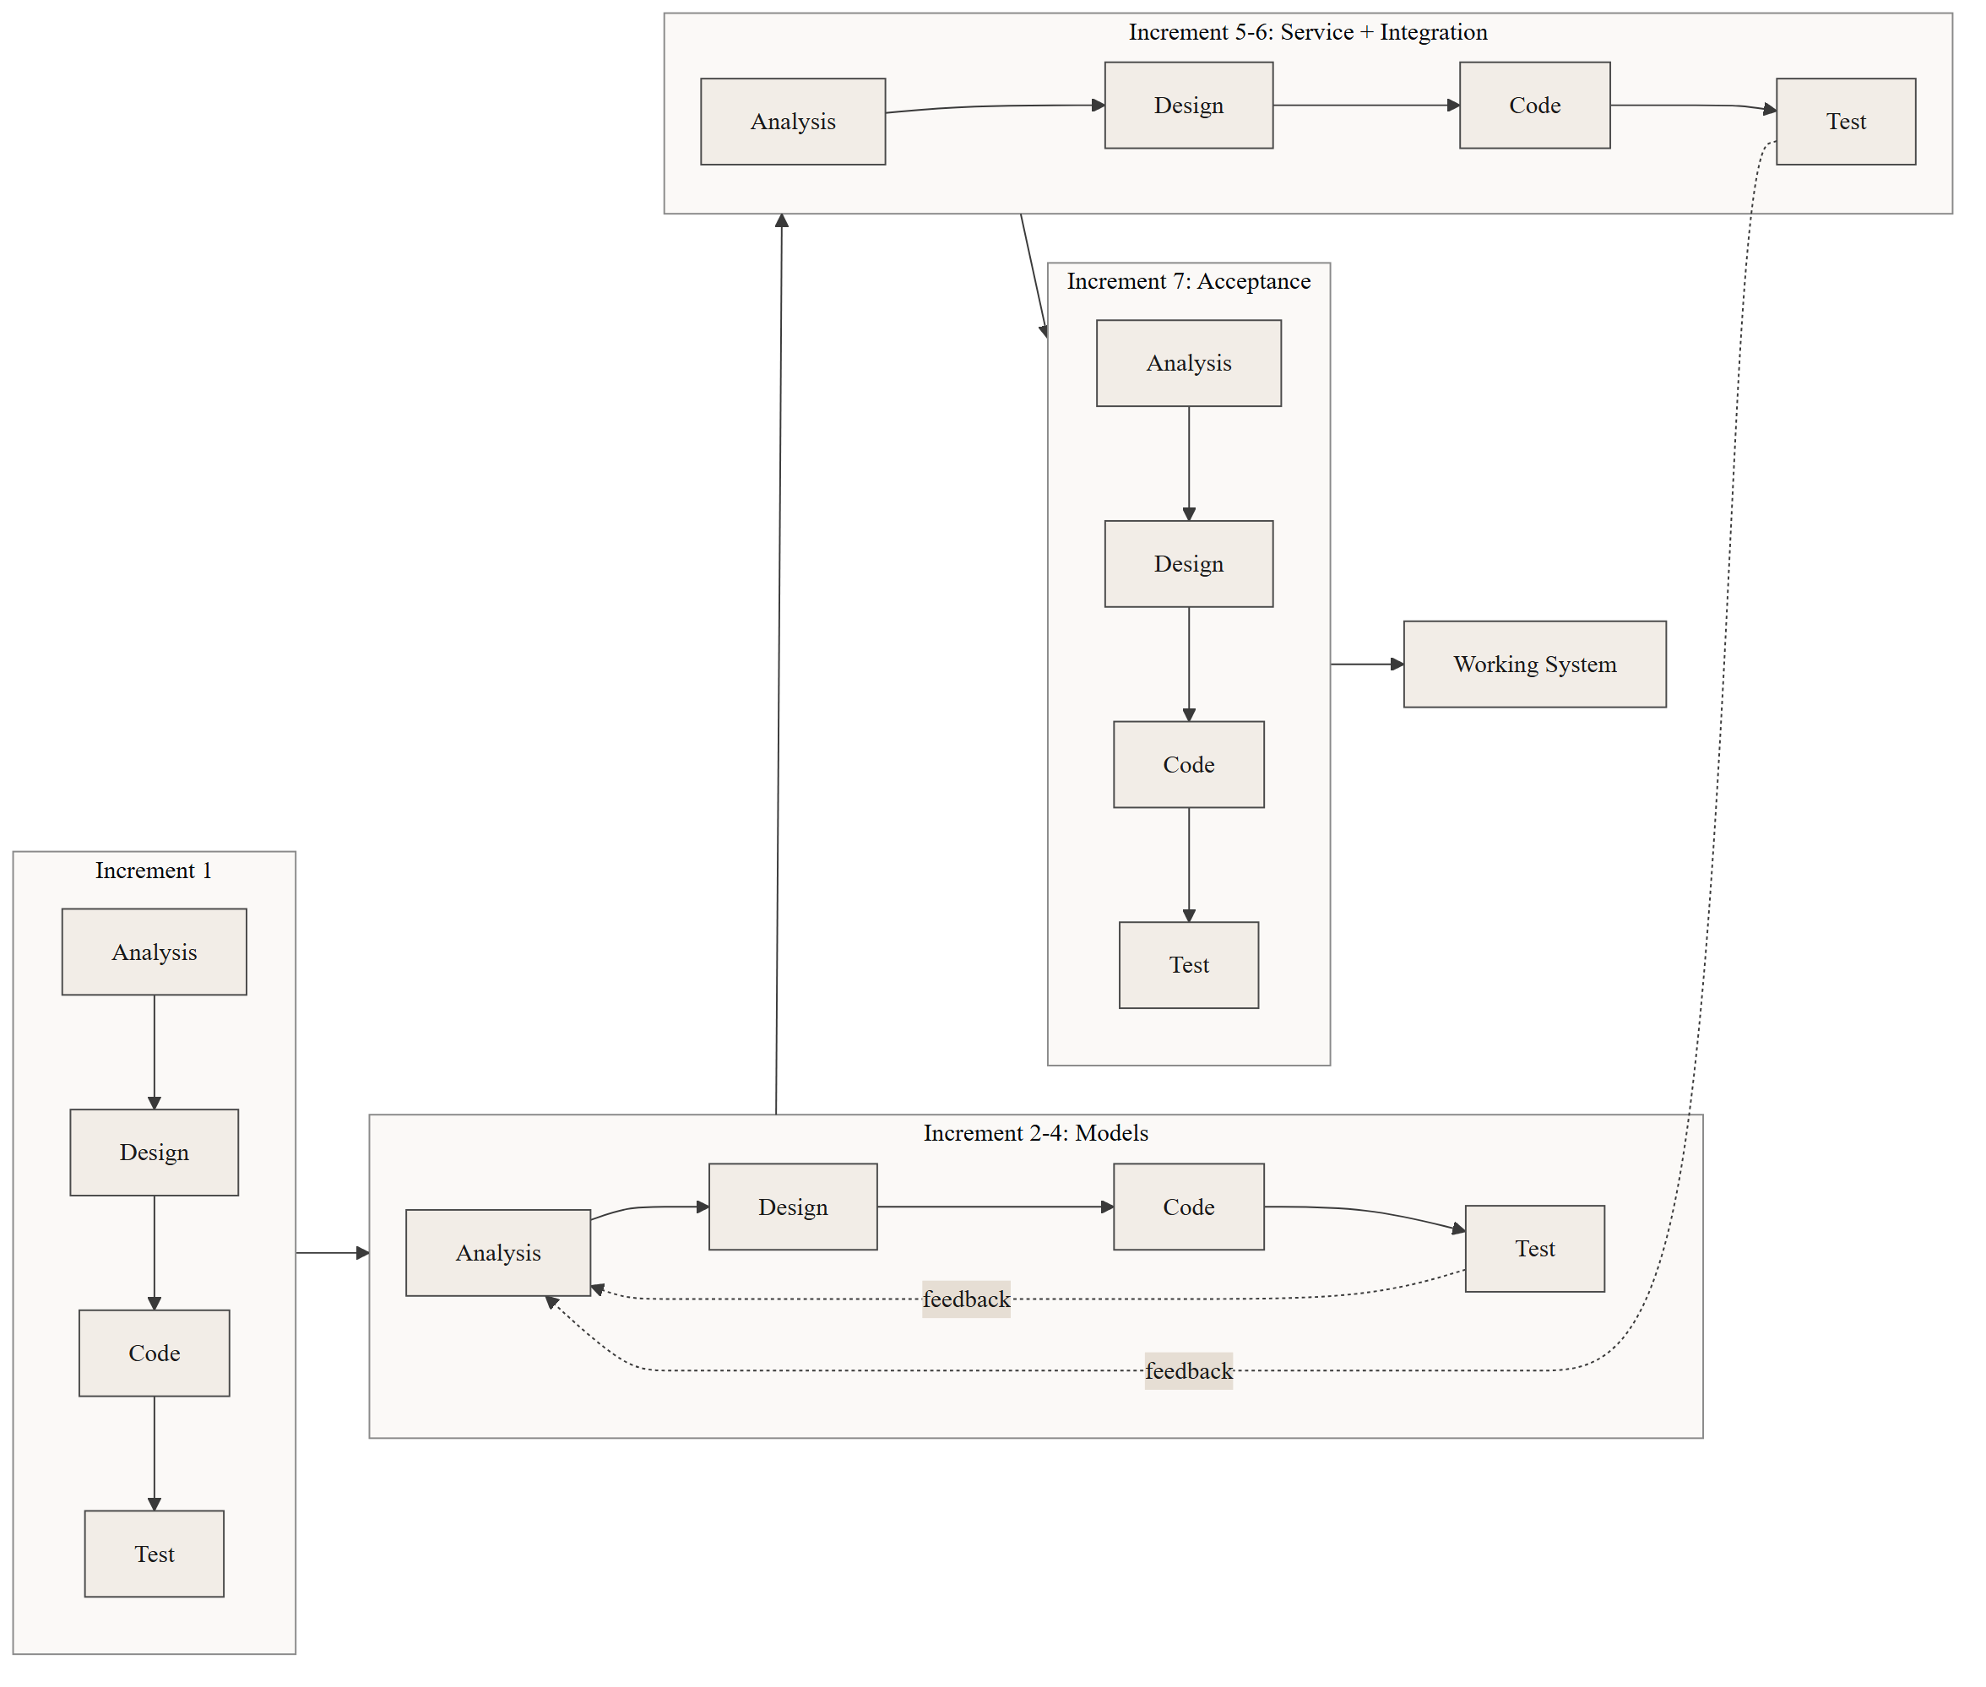
1.6 Report Organization
Chapter 1: Introduction presents the project background, the problem statement, the objectives, the scope and limitations, and the development methodology adopted.
Chapter 2: Background Study and Literature Review reviews inventory management theory relevant to perishable goods, examines existing commercial cafe and restaurant management systems, surveys academic work on demand forecasting and stockout prediction, and identifies the research gap this project addresses.
Chapter 3: System Analysis and Design presents the functional and non-functional requirements, the feasibility analysis, the system models expressed in UML, the database design, the algorithms employed, and the construction of the dataset.
Chapter 4: Implementation and Testing describes the tools used, the implementation of each module, the testing performed at unit and acceptance level, and a detailed analysis of the results including the criteria that were not met.
Chapter 5: Conclusion and Future Work summarises what was achieved, states plainly what was not, and sets out the work required before the system could be relied upon commercially.

CHAPTER 2: BACKGROUND STUDY AND LITERATURE REVIEW
2.1 Background Study
2.1.1 Inventory Management in Food Service
Inventory management in food service differs from general retail in three respects that together make it unusually difficult.
Perishability. A significant share of cafe stock has a shelf life measured in days. Classical inventory models such as the Economic Order Quantity assume stock can be held indefinitely at a constant carrying cost. For milk with a four-day life, this assumption fails outright: the carrying cost becomes total loss at a fixed date. Ordering policy for perishables must therefore balance stockout risk against spoilage risk, and the optimum is not simply "order more".
Derived demand. A cafe does not sell ingredients; it sells prepared items. Demand for milk is not observed directly but derives from demand for milk tea, cappuccino, latte, hot chocolate and cold coffee, each consuming a different quantity. Forecasting ingredient requirement therefore requires forecasting item demand and then transforming it through a recipe book — a two-stage problem sometimes described as bill-of-materials explosion in manufacturing.
Substitution and lost sales. When a retail item is out of stock, the sale is often merely delayed. In a cafe, a customer who cannot obtain their intended order will frequently either choose a lower-margin substitute or leave. The lost sale is rarely recorded anywhere, so stockout cost is systematically invisible in the accounts.
2.1.2 Classification of Inventory Control Policies
Inventory control policies are conventionally grouped as follows.
Continuous review (s, Q) policies place an order of fixed quantity Q whenever stock falls to reorder point s. Periodic review (R, S) policies inspect stock every R days and order up to a target level S. Min-max policies, of which the current CafeOS implementation is an instance, order when stock falls below a minimum and top up to a maximum.
All of these are static: the parameters are fixed and do not adapt to changing demand rate, demand variability, or known future events. A reorder point calculated for an average week is wrong in every week that is not average — which, in a market with a strong festival calendar and a pronounced monsoon, is most weeks.
The alternative is a predictive policy, in which the reorder decision is driven by a forecast of future consumption rather than by a threshold on present stock. This is the approach taken in this project.
2.1.3 The Existing CafeOS Platform
CafeOS is implemented as a Next.js web application backed by a PostgreSQL database hosted on Supabase. Its inventory module maintains three principal tables: cafe_ingredients recording each raw material with its unit, current stock, minimum stock level, and purchase price; cafe_recipes linking a menu item to a set of ingredient requirements; and cafe_recipe_ingredients holding the quantity and waste factor of each component.
The module supports adding and editing ingredients, defining recipes, calculating food cost and gross margin per menu item, and displaying a low-stock alert list. The alert logic is a direct comparison of current_stock against min_stock_level.
This project does not replace that module. It adds a predictive layer above it, consuming the same tables and presenting its output on the same screen.
2.2 Literature Review
2.2.1 Existing Commercial Systems
Petpooja, widely deployed across South Asia including Nepal, offers restaurant billing, kitchen display, and inventory management with recipe-based stock deduction and low-stock alerts. Its inventory intelligence is threshold-driven; published documentation describes consumption reporting and variance analysis but not forward demand prediction at the item level.
Square for Restaurants provides point-of-sale, inventory tracking, and sales reporting, including historical trend charts. Its stock alerts are again threshold-based. Square publishes sales trend visualisations that assist a human in forecasting, but the ordering decision itself remains manual.
MarketMan and Craftable are specialised restaurant inventory and procurement platforms offering supplier integration, invoice reconciliation, theoretical-versus-actual usage variance, and par-level management. Par levels are typically set manually or computed from historical averages. These systems represent the current commercial state of the art in restaurant inventory, and their sophistication lies principally in procurement workflow and cost control rather than in statistical forecasting.
The common characteristic across these platforms is that inventory intelligence is retrospective. They analyse what was consumed with considerable rigour, and alert when stock is presently low, but they do not predict item-level demand and propagate it through the recipe book to derive future ingredient requirements.
2.2.2 Demand Forecasting in Food Retail
Demand forecasting is a mature field, and the applicability of machine learning to it is well established.
Classical time-series approaches — exponential smoothing and the ARIMA family — model a single series through its own autocorrelation structure. They perform well on long, stable, regular series. Their weakness in the present context is that they accommodate exogenous variables awkwardly and require a separate model per series; a cafe with twenty-one menu items would require twenty-one fitted models, each with too little data.
Tree-based ensemble methods have become the practical default for retail demand forecasting. Random Forests, introduced by Breiman, construct many decision trees on bootstrap samples with randomised feature subsets and average their predictions, which reduces the variance that makes a single deep tree unreliable. Gradient boosting methods fit trees sequentially to the residuals of their predecessors.
The decisive advantage of these methods for retail demand is that they accept heterogeneous features naturally. Calendar effects, promotional flags, price, weather, and lagged sales can all be presented as columns of a single table, and a single model can be fitted across all items with the item identity itself as a feature. This allows items with sparse history to borrow strength from the overall pattern — an important property for a cafe menu in which the top item may sell a hundred times more than the least popular.
The prominence of gradient-boosted trees in retail forecasting competitions, notably the M5 competition on Walmart hierarchical sales data, reflects this practical strength. Recurrent and transformer-based neural architectures have demonstrated superior accuracy on very large retail datasets, but require training data volumes far beyond what a single independent cafe generates.
2.2.3 Stockout Prediction
Stockout prediction has received less academic attention than demand forecasting, and is usually treated as a downstream consequence of it: forecast demand, compare with stock, declare a stockout when the former exceeds the latter.
This arithmetic approach has a recognised weakness. It propagates all the error of the demand forecast into the stockout decision and, critically, it treats the forecast as certain. It has no way to express that an ingredient with highly variable consumption is riskier than one with the same average consumption but stable demand, even though both show identical days of cover.
Treating stockout prediction as a classification problem in its own right, with the label drawn from observed historical stockout events, avoids this. The classifier can learn directly that volatility, supplier lead time, shelf life, and time since last delivery carry information about stockout risk beyond what days-of-cover expresses. This is the formulation adopted in this project, and Section 4.4.5 provides empirical support for it: consumption volatility and time since last purchase rank among the model's most important features, and the model substantially outperforms the days-of-cover rule.
2.2.4 Perishable Inventory Theory
The foundational treatment of ordering under uncertainty for perishable goods is the newsvendor model, in which a single order is placed before demand is observed, unsold stock is lost, and the optimal order quantity balances the cost of over-ordering against the cost of under-ordering. The optimal quantity is the demand quantile determined by the ratio of these two costs.
The practical implication for this project is that the correct order quantity is not the expected demand. Where spoilage cost is low relative to lost margin, the optimum exceeds expected demand; where spoilage cost is high, it falls below it. The rule layer implemented in this project reflects this asymmetry in a simplified, deterministic form: it will top up an ingredient classified URGENT even when the arithmetic does not demand it, while capping any perishable order at the quantity consumable within its shelf life.
2.3 Research Gap
The review above identifies a consistent gap.
Commercial cafe and restaurant platforms — including CafeOS itself — maintain the recipe book and the sales history required for predictive inventory control, but use them only retrospectively, for costing and for threshold alerts.
The academic literature demonstrates that tree-based ensembles forecast retail demand effectively, but published work concentrates on large chains with substantial data, and treats stockout as an arithmetic consequence of the forecast rather than as a learned classification task.
Neither body of work addresses the specific setting of an independent cafe in Nepal, where the festival calendar produces demand swings of ±45%, the monsoon suppresses footfall for three months, and perishable shelf lives of three to four days make over-ordering as costly as under-ordering.
This project addresses that gap by combining three elements within a single working system:
- Item-level demand forecasting that explicitly encodes Nepali weekday rhythm, festival
effects, and monsoon seasonality;
- Stockout risk treated as a supervised classification problem learned from observed stockout
events, benchmarked against the arithmetic rule it replaces; and
- A deterministic guardrail layer that prevents either model from producing an order that
violates perishability or supplier constraints.

CHAPTER 3: SYSTEM ANALYSIS AND DESIGN
3.1 System Analysis
3.1.1 Requirement Analysis
i. Functional Requirements
FR-1: Demand Forecasting
- The system shall predict next-day unit sales for each active menu item.
- The prediction shall incorporate lagged sales, day of week, month, festival effect, monsoon
status, price, and promotion status.
- The system shall return predictions for multiple items in a single request.
FR-2: Stockout Risk Classification
- The system shall classify every active ingredient as SAFE, WATCH, or URGENT over a
seven-day horizon.
- Each classification shall carry a confidence value and a full probability distribution over
the three classes.
- The system shall report days of cover alongside the classification.
FR-3: Ingredient Requirement Calculation
- The system shall convert forecast item demand into ingredient requirements using the recipe
book.
- The calculation shall apply the waste factor recorded against each recipe component.
- Where no recipe exists for an ingredient, the system shall fall back to that ingredient's own
recent consumption rate.
FR-4: Reorder Plan Generation
- The system shall produce a purchase list stating, per ingredient, the quantity to order, the
number of supplier packs, the estimated cost, and the date by which the order must be placed.
- The order-by date shall account for supplier lead time and risk class.
- The plan shall be sortable by urgency.
FR-5: Purchasing Guardrails
- The system shall never recommend a perishable quantity exceeding what can be consumed within
its shelf life, after pack-size rounding and after any supplier minimum order quantity.
- The system shall round order quantities up to whole supplier packs, subject to the above.
- Guardrails shall be deterministic and shall override model output.
FR-6: Presentation
- The reorder plan shall be displayed on the existing inventory screen.
- The horizon shall be user-selectable between three, seven, and fourteen days.
- Ingredients requiring no action shall be collapsed by default.
FR-7: Graceful Degradation
- If the prediction service is unreachable, the system shall fall back to the static coverage
rule and display a clear notice that predictions are unavailable.
- Failure of the prediction service shall never prevent the inventory screen from rendering.
FR-8: Data Quality Reporting
- The system shall report how many days of sales history were available.
- Where history is insufficient, the interface shall state so rather than presenting a
confident-looking but unsupported prediction.
Table 3.1: Functional Requirements Summary
ID | Requirement | Priority | Verified By
FR-1 | Demand forecasting | High | MAT-01, MAT-02, MAT-03
FR-2 | Stockout risk classification | High | MAT-04, MAT-05, MAT-06
FR-3 | Ingredient requirement calculation | High | Unit test MUT-08
FR-4 | Reorder plan generation | High | Unit test MUT-11
FR-5 | Purchasing guardrails | Critical | MAT-08
FR-6 | Presentation on inventory screen | Medium | Manual test
FR-7 | Graceful degradation | High | Manual test MT-01
FR-8 | Data quality reporting | Medium | Manual test

ii. Non-Functional Requirements
Performance. A reorder plan covering forty ingredients shall be produced within two seconds under normal conditions. The prediction service shall time out after eight seconds, after which the fallback path is taken.
Reliability. The web application shall remain fully functional when the prediction service is unavailable. No single point of failure introduced by this project may take down the existing inventory module.
Security. All prediction endpoints exposed to the browser shall require an authenticated session. A cafe shall be able to obtain predictions only for its own ingredients, enforced through the existing Row Level Security policies. The prediction service shall bind to the loopback interface and shall not be exposed publicly.
Usability. The reorder plan shall be comprehensible to a cafe manager with no statistical training. Risk shall be conveyed through colour and plain language rather than probability values alone. Every recommendation shall carry a one-line explanation of why it was made.
Maintainability. Model training shall be reproducible from a fixed random seed. The prediction service shall be independently deployable and testable.
Portability. The prediction service shall run on standard consumer hardware without a GPU.
3.1.2 Feasibility Analysis
Technical Feasibility. The project uses established, well-documented technologies. The existing application is Next.js with TypeScript on Supabase PostgreSQL. The prediction service uses Python with scikit-learn and FastAPI, all mature open-source libraries with extensive documentation. Model training completes in under two minutes on a standard laptop with no specialised hardware. The project is technically feasible.
Operational Feasibility. The predictive layer appears within a screen cafe staff already use, requires no new login or workflow, and presents its output as a shopping list rather than as statistics. The manager retains full decision authority; the system advises and does not order automatically. Adoption risk is therefore low.
Economic Feasibility. All components are open-source and free of licensing cost. The prediction service runs on the same machine as the web application in development. The dominant cost is developer time. Against this, a single avoided stockout of a high-volume item, or a single avoided spoilage of a bulk perishable purchase, recovers a meaningful fraction of the cafe's daily margin. The project is economically feasible.
Schedule Feasibility. The work was scheduled across the increments listed in Section 1.5. Because the project extends an existing, working application rather than building one from scratch, the schedule risk concentrated in the modelling increments, where results cannot be guaranteed in advance. This risk materialised once — the first dataset generator produced an unusable class distribution — and was absorbed within the increment.
Figure 3.2: Gantt Chart of the Project Schedule
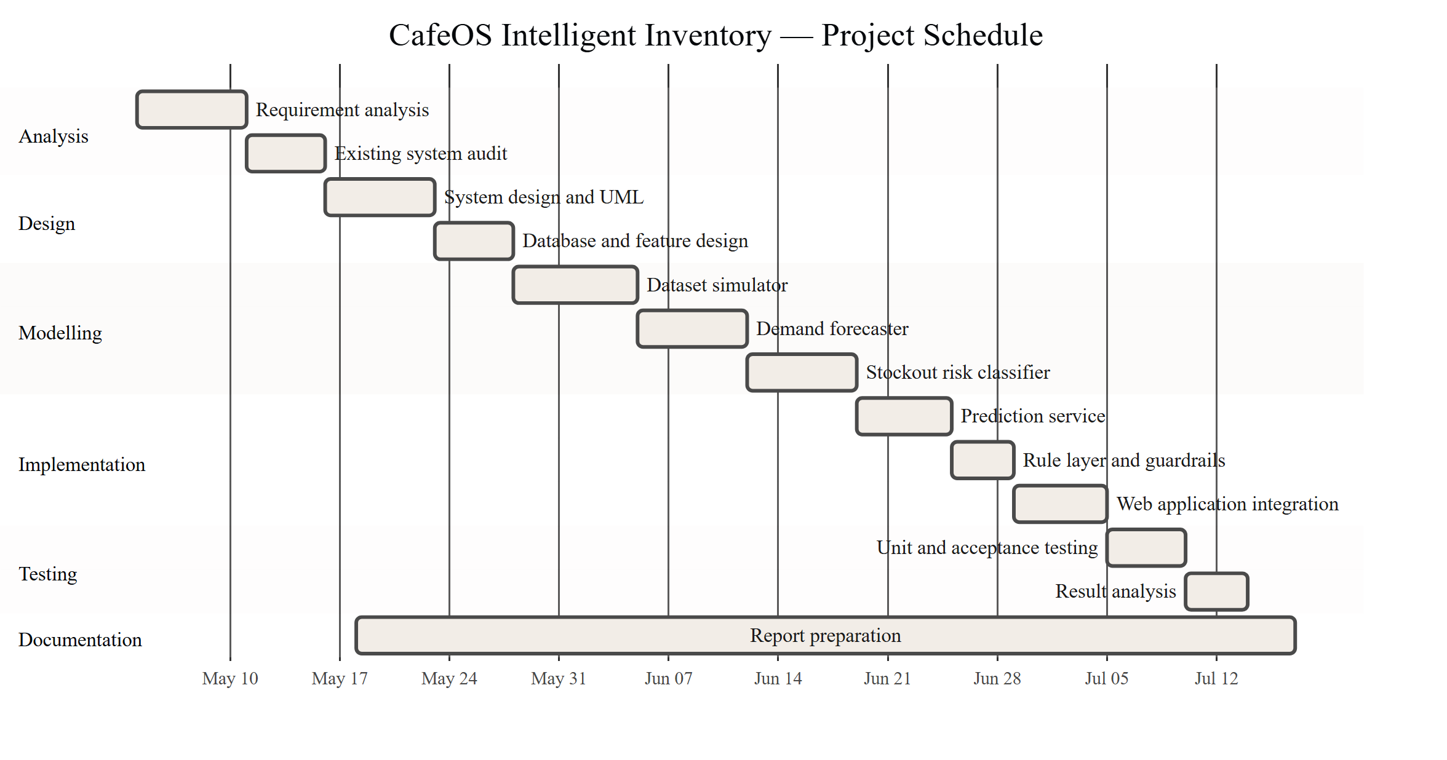
3.1.3 Use Case Analysis
Figure 3.1: Use Case Diagram of the Intelligent Inventory Module
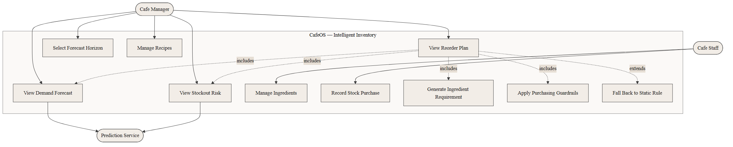
Use Case: View Reorder Plan
Field | Description
Actor | Cafe Manager
Precondition | Manager is authenticated; the cafe has at least one active ingredient
Main Flow | 1. Manager opens the Saman Hisab inventory screen. 2. System reads active ingredients and the recipe book. 3. System reconstructs recent daily consumption from order history. 4. System requests a demand forecast and risk classification. 5. System converts forecast demand into ingredient requirement. 6. System applies purchasing guardrails. 7. System displays the ranked reorder plan.
Alternate Flow A | At step 4, the prediction service is unreachable. System applies the static coverage rule, marks the response as degraded, and displays a notice.
Alternate Flow B | At step 3, fewer than seven days of history exist. System proceeds but flags the data quality as insufficient.
Postcondition | Manager can see which ingredients to order, in what quantity, and by when

3.2 System Design
3.2.1 Database Design
The predictive layer reads from the existing CafeOS schema and introduces no new tables. The entities relevant to this project are shown below.
Figure 3.3: Entity Relationship Diagram
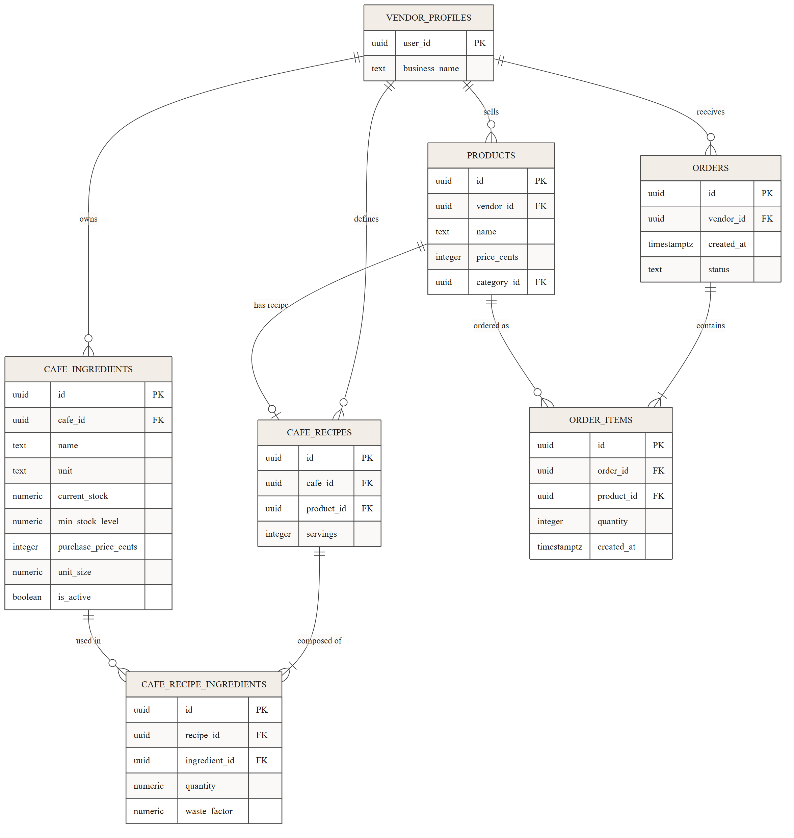
3.2.2 Class Design
Figure 3.4: Class Diagram of the Prediction Subsystem
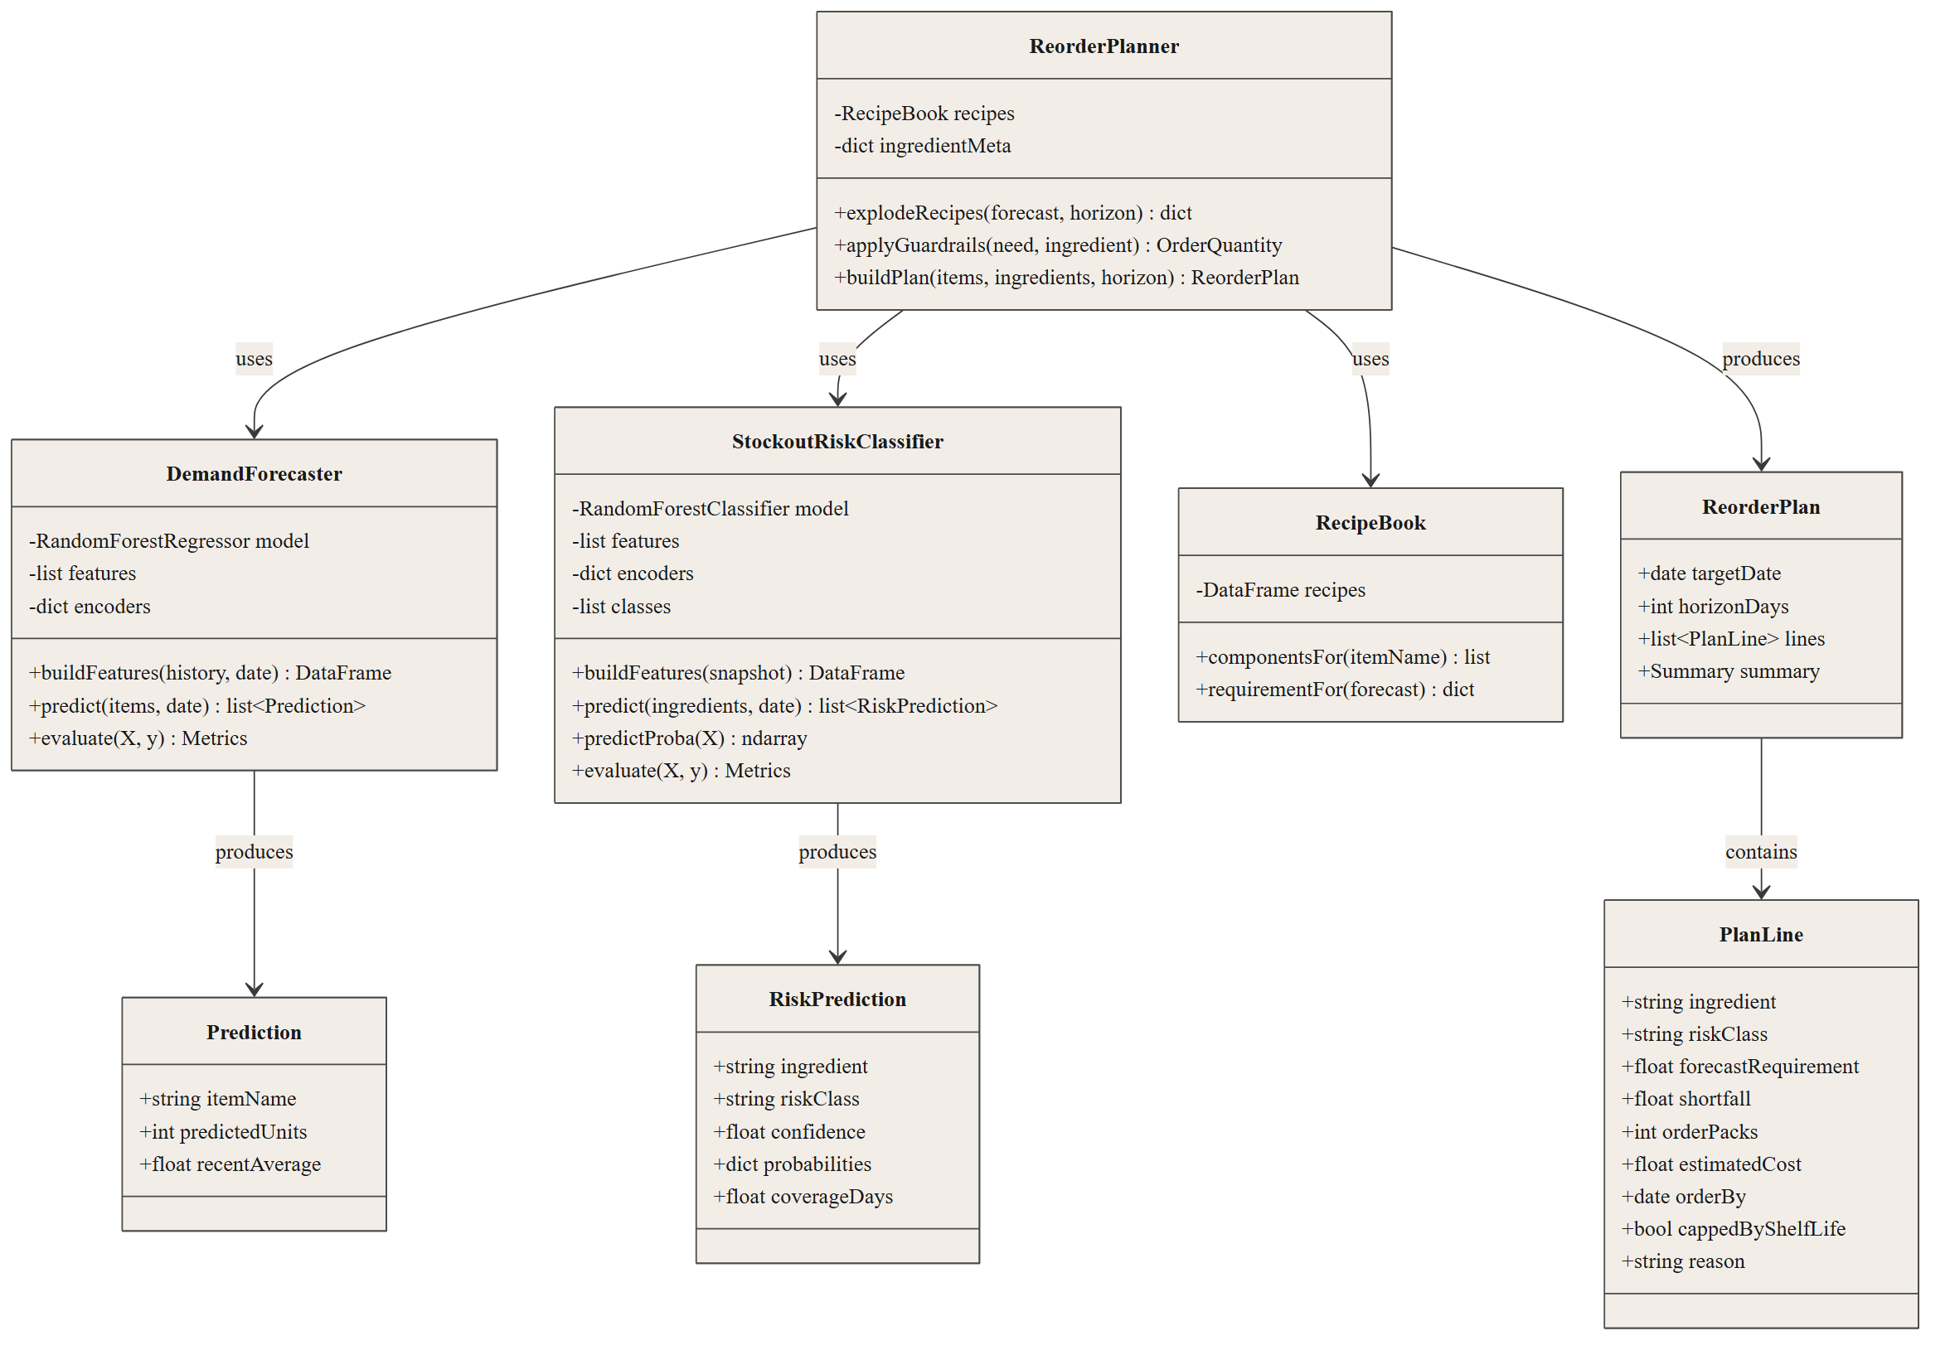
3.2.3 Dynamic Modelling
Figure 3.5: Sequence Diagram — Generating a Reorder Plan
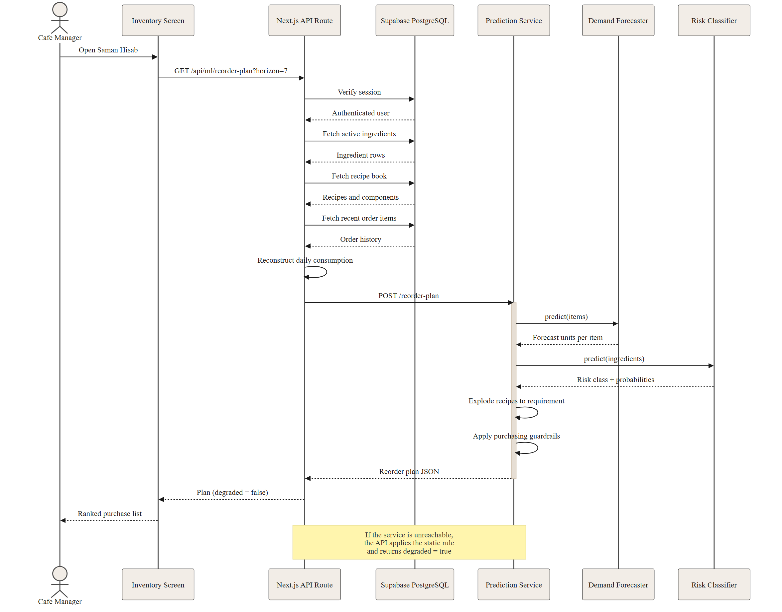
Figure 3.6: Activity Diagram — Daily Inventory Decision Flow
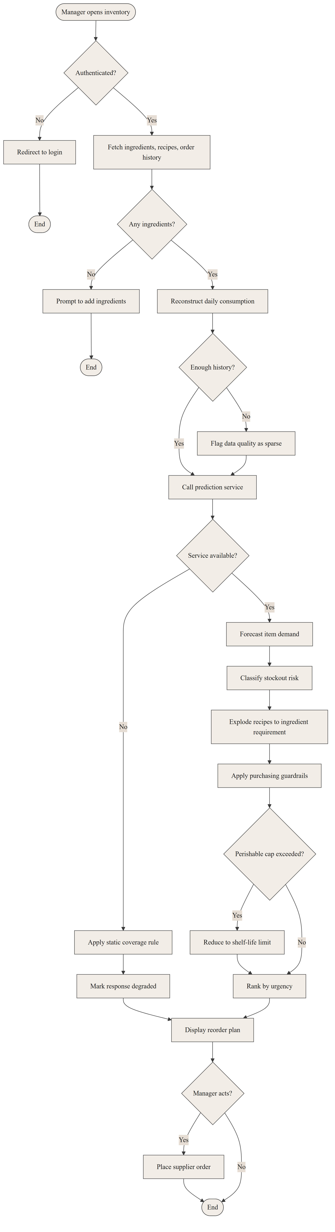
Figure 3.7: State Diagram — Ingredient Risk Lifecycle
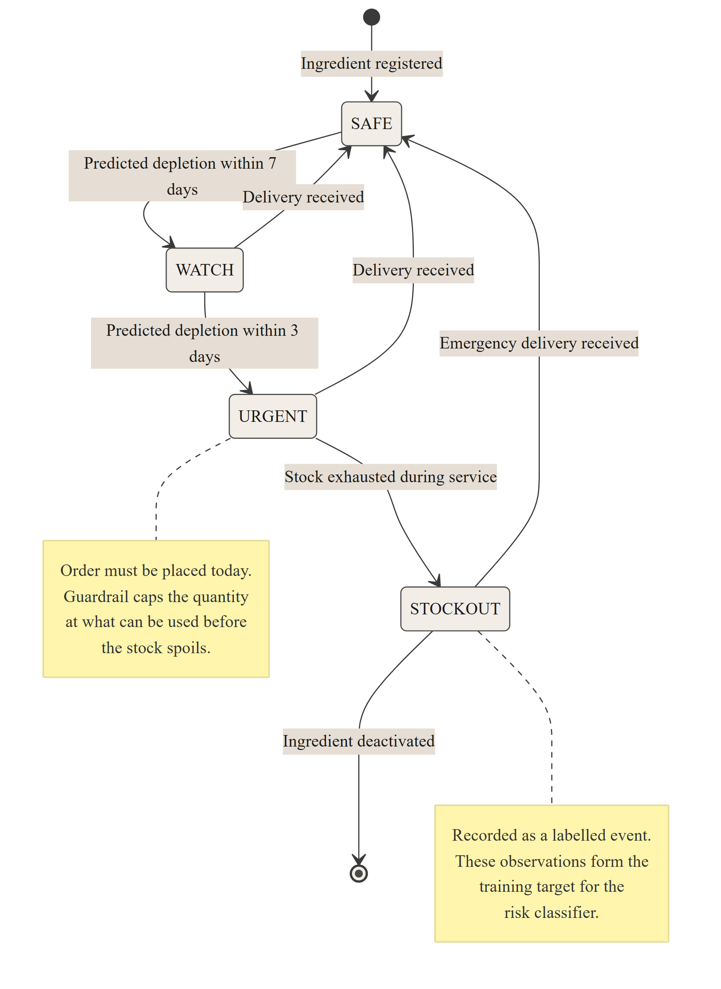
3.2.4 Architectural Design
Figure 3.8: Component Diagram of CafeOS with the ML Service
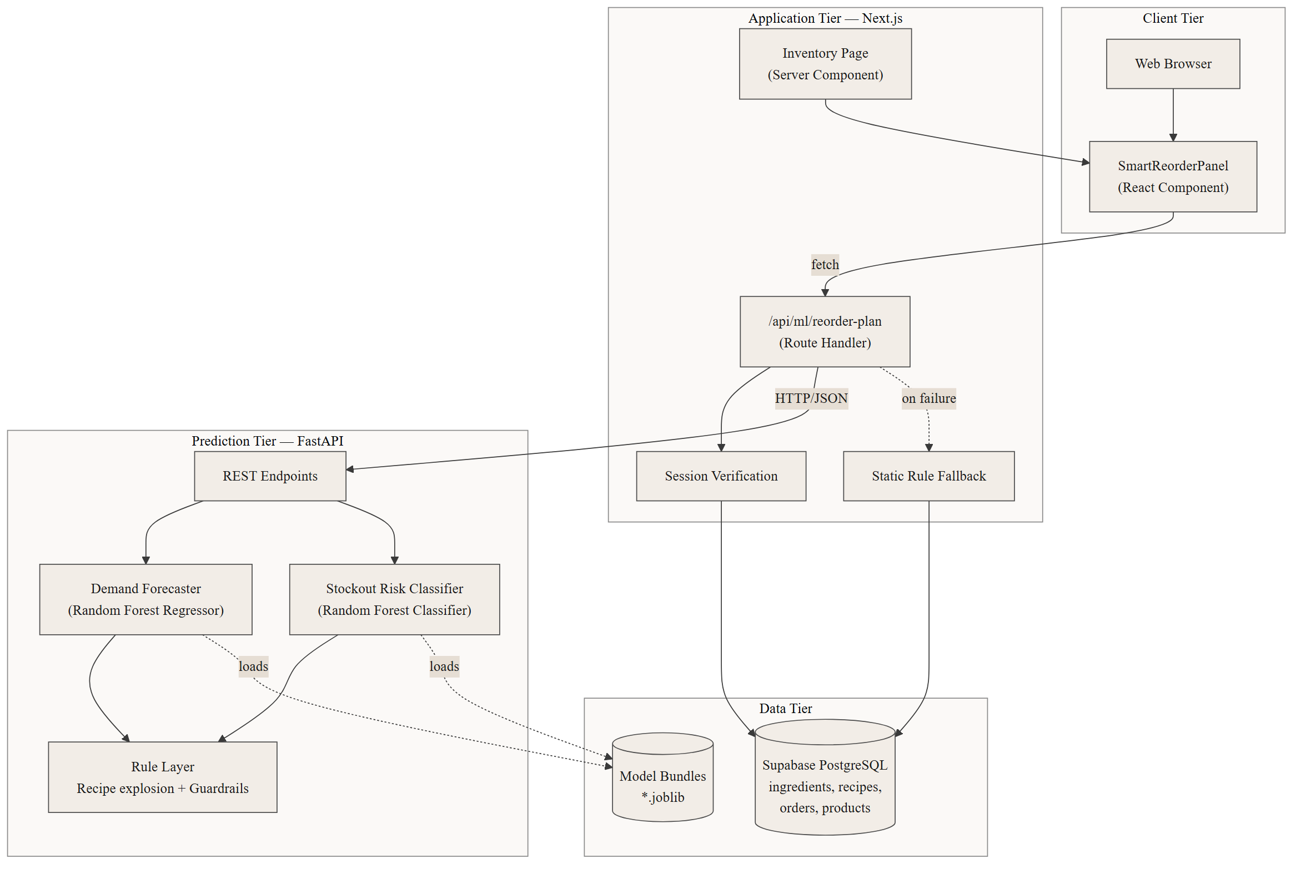
Figure 3.9: Deployment Diagram
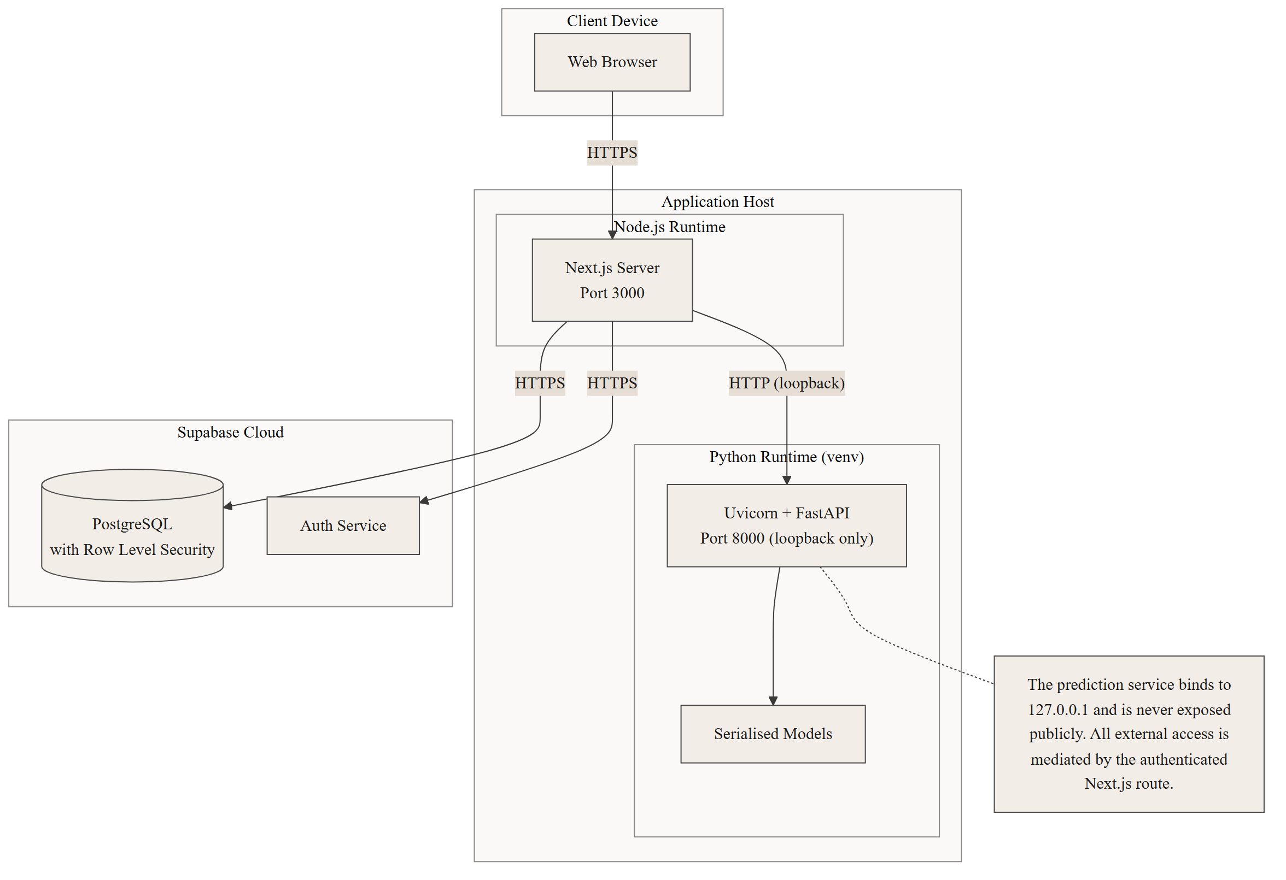
3.3 Algorithm Details
3.3.1 Algorithm 1: Random Forest Regressor — Demand Forecasting
A Random Forest is an ensemble of decision trees. Each tree is trained on a bootstrap sample of the training data, and at each split only a random subset of features is considered. For regression, the ensemble prediction is the mean of the individual tree predictions. Averaging reduces the variance that makes a single deep decision tree unstable, while randomised feature selection decorrelates the trees so that averaging is effective.
Purpose in this project: predict the number of units of a menu item that will be sold on the following day.
Input features:
Group | Features
Lagged sales | lag_1, lag_7, lag_14
Rolling statistics | roll_mean_7, roll_mean_28, roll_std_7
Weekday signature | dow_ratio (same weekday last week ÷ weekly mean)
Calendar | day_of_week, month, day_of_month, is_saturday
Nepali context | festival_effect, is_monsoon, thermal_index
Commercial | price_rs, promo_active
Item identity | item_name, category
Maturity | days_since_open

Output: predicted units sold (continuous, floored at zero and rounded for display).
Steps:
- Assemble the daily sales history for every menu item.
- For each item, compute lagged and rolling features using only days strictly earlier than the
day being predicted.
- Encode categorical features (item_name, category, festival_effect) as integers.
- Split the data chronologically into training, validation, and test windows.
- Train candidate regressors on the training window.
- Score each candidate on the validation window; select the lowest Mean Absolute Error.
- Score the selected model once on the untouched test window.
- Serialise the model together with its feature list and encoders.
Pseudocode:
ALGORITHM DemandForecast
INPUT sales_history H, target_date d, item i
OUTPUT predicted units u

BEGIN
S <- filter(H, item = i AND date < d)
IF |S| < 28 THEN
S <- left_pad(S, mean(S)) // new items borrow their own mean
END IF

f.lag_1 <- S[d - 1]
f.lag_7 <- S[d - 7]
f.lag_14 <- S[d - 14]
f.roll_mean_7 <- mean(S[d-7 .. d-1])
f.roll_mean_28<- mean(S[d-28 .. d-1])
f.roll_std_7 <- stddev(S[d-7 .. d-1])
f.dow_ratio <- f.lag_7 / f.roll_mean_7

f.day_of_week <- weekday(d)
f.is_saturday <- (weekday(d) = SATURDAY)
f.month <- month(d)
f.festival <- festival_effect(d) // spike | exodus | pre_festival | holiday | none
f.is_monsoon <- month(d) IN {6,7,8}
f.thermal <- cos(2*PI*(dayofyear(d) - 15) / 365.25)

FOR EACH tree t IN forest DO
p[t] <- t.predict(f)
END FOR

u <- max(0, mean(p))
RETURN u
END

3.3.2 Algorithm 2: Random Forest Classifier — Stockout Risk
The same ensemble principle is applied to classification, with each tree casting a vote and the class probability given by the proportion of trees voting for it. Class weights are balanced so that the minority WATCH and URGENT classes are not overwhelmed by the majority SAFE class.
Purpose in this project: classify each ingredient's risk of running out within seven days.
Target definition. This is the key design decision of the project, and it distinguishes the approach from the arithmetic method described in Section 2.2.3. The label is not derived from a threshold on days of cover. It is derived from observed future outcomes in the history: for each daily snapshot of an ingredient, the number of days until that ingredient actually ran out during service is counted forward, and the class assigned accordingly.
Days until the ingredient actually ran out | Class
3 or fewer | URGENT
4 to 7 | WATCH
More than 7 (or never) | SAFE

Because the label records what really happened rather than what a rule predicted, the model is free to discover that factors beyond days of cover — consumption volatility, supplier lead time, shelf life, time since last delivery — carry genuine information. Section 4.4.5 confirms that it does.
Input features:
Group | Features
Stock position | opening_stock, coverage_days, incoming_qty_7d
Consumption rate | consumption_mean_7d, consumption_mean_14d, consumption_mean_28d
Consumption stability | consumption_std_7d, volatility_ratio, consumption_trend
Supply chain | supplier_lead_time_days, days_since_purchase, pack_price_rs
Product nature | shelf_life_days, unit, ingredient
Calendar | day_of_week, month, festival_effect, is_monsoon

Output: class in {SAFE, WATCH, URGENT} with a probability distribution.
Steps:
- Replay the sales history through the recipe book to derive daily ingredient consumption.
- Simulate the stock ledger with FIFO batch expiry, supplier lead times, and delivery delays,
recording every day on which an ingredient was exhausted during service.
- For each daily snapshot, compute the stock, consumption, supply-chain, and calendar features
using information available on that day only.
- Assign the label by counting forward to the next observed stockout.
- Split chronologically; train candidates; select on validation macro F1.
- Score the selected model once on the test window, and score the static coverage rule on the
same window for comparison.
Pseudocode:
ALGORITHM StockoutRisk
INPUT ingredient g, snapshot date d, consumption history C, stock position P
OUTPUT risk class r, confidence c

BEGIN
f.opening_stock <- P.on_hand(g, d)
f.mean_7 <- mean(C[g][d-7 .. d-1])
f.mean_28 <- mean(C[g][d-28 .. d-1])
f.std_7 <- stddev(C[g][d-7 .. d-1])
f.volatility_ratio <- f.std_7 / f.mean_7
f.trend <- f.mean_7 / f.mean_28
f.coverage_days <- f.opening_stock / f.mean_7
f.lead_time <- g.supplier_lead_time
f.shelf_life <- g.shelf_life
f.days_since_buy <- d - P.last_delivery(g)
f.incoming_7d <- sum(P.pending(g, d+1 .. d+7))
f.festival <- festival_effect(d)

votes <- empty map
FOR EACH tree t IN forest DO
votes[t.predict(f)] <- votes[t.predict(f)] + 1
END FOR

r <- argmax(votes)
c <- votes[r] / |forest|
RETURN (r, c)
END

3.3.3 Algorithm 3: Deterministic Rule Layer
Machine learning output is advisory. The rule layer converts it into a purchase decision and enforces constraints that must hold regardless of what either model predicts.
Rationale. A model may be wrong about quantity; it must never be permitted to recommend buying a week's supply of a three-day perishable. Encoding these constraints as learned behaviour would make them probabilistic. Encoding them as deterministic rules makes them guarantees.
Rules implemented:
Rule | Statement
R1 — Recipe explosion | Ingredient requirement = Σ (forecast units × quantity per serving × waste factor) over all menu items using that ingredient
R2 — Fallback requirement | Where no recipe exists, requirement = mean recent daily consumption × horizon
R3 — Shortfall | Shortfall = requirement − current stock − incoming deliveries
R4 — Urgent top-up | If class is URGENT, order at least half the horizon requirement even when the shortfall calculation says otherwise
R5 — Pack rounding | Round the order up to whole supplier packs
R6 — Minimum order quantity | Respect the supplier's minimum order quantity
R7 — Shelf-life cap | After R5 and R6, cap the quantity at what can be consumed within the shelf life. One pack is always permitted, since a part pack cannot be bought. R7 overrides R4, R5 and R6.
R8 — Order-by date | URGENT → order today; WATCH → order within (3 − lead time) days; SAFE → within (7 − lead time) days

Rule R7 is the most important, and its ordering relative to R5 and R6 was corrected during testing. The initial implementation applied the shelf-life cap before pack rounding, with the result that rounding up to the nearest whole pack pushed the final quantity marginally past the cap. Acceptance test MAT-08 detected this (81 litres of milk ordered against a 3-day shelf life, equal to 3.01 days of supply). The rule was reordered so that the cap is applied after rounding, and the test now passes at 2.98 days of supply. This is documented in Section 4.3.
Figure 3.10: Machine Learning Pipeline
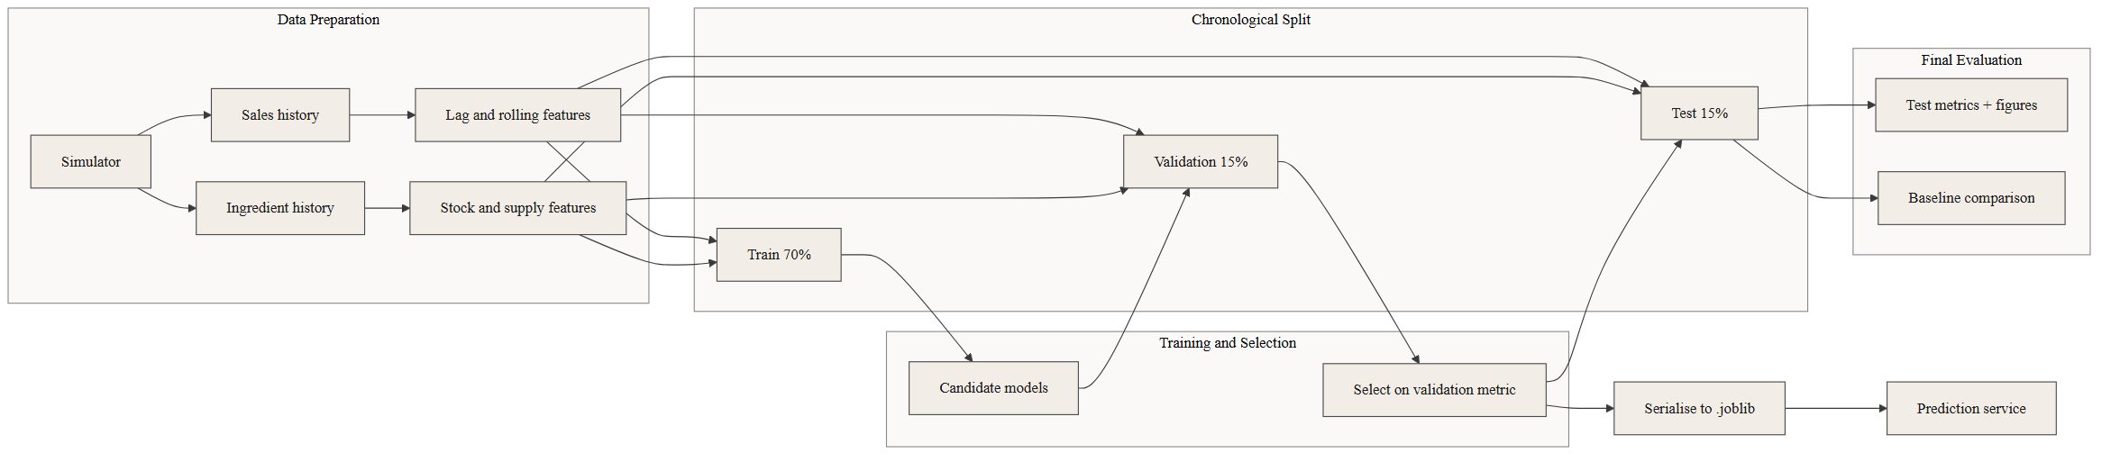
3.4 Dataset Construction
3.4.1 The Data Problem and Its Disclosure
Supervised learning requires labelled historical data. The live CafeOS database contains approximately seventeen genuine point-of-sale orders; the remaining fifteen hundred rows in the orders table were inserted directly during development to exercise the user interface and do not represent real trading. There is no genuine stock movement history at all, because the inventory module records current levels rather than a movement ledger.
Training a model on seventeen orders is not possible. Two options were available: postpone the project until real trading data accumulated, or construct a simulator that generates data with realistic structure and be explicit that the resulting figures measure recovery of simulated structure rather than real-world accuracy.
The second option was taken, and the disclosure is repeated wherever results are presented. The evaluation in Chapter 4 answers the question "can these models learn the patterns that exist in cafe demand?" It does not answer "how accurate will these models be at a real cafe?" Answering the second question requires real trading data and is the first item of future work in Chapter 5.
3.4.2 The Simulator
The simulator constructs eighteen months of operating history, from 1 February 2025 to 31 July 2026, for a cafe with 21 menu items and 28 ingredients. It is driven by a fixed random seed so that every figure in this report is reproducible.
Table 3.2: Simulated Effects in the Dataset Generator
Effect | Modelling | Justification
Weekday rhythm | Saturday ×1.32, Friday ×1.14, Sunday ×0.90, Monday ×0.92 | Saturday is Nepal's weekly holiday; Sunday is a working day
Festival spike | Holi, Nepali New Year, Teej, Christmas, Valentine's ×1.45 | Celebratory footfall
Festival exodus | Dashain and Tihar ×0.58 | Kathmandu residents travel to ancestral homes
Pre-festival rush | Four days before an exodus festival ×1.28 | Shopping and social activity before departure
Monsoon | June ×0.88, July ×0.82, August ×0.86 | Rain suppresses walk-in footfall
Thermal elasticity | Hot items ×(1 + 0.42·cos θ); cold items inverted | Hot drinks rise in winter, cold in summer
Growth | Linear +38% across the window | Organic growth of the customer base
Promotions | Nine campaigns, 7–21 days, ×1.22 on affected items | Happy-hour and discount activity
Daily shock | Gaussian, σ = 0.085 | Weather, local events, road closures
Item noise | Poisson around the resulting mean | Count data are Poisson-distributed

Ingredient consumption is derived by replaying each day's item sales through the recipe book with a random kitchen waste factor of 4–9%. The stock ledger is then simulated with:
- FIFO batch expiry. Stock is held as dated batches. Perishables are discarded when they
pass their shelf life. Without this, simulated milk accumulated indefinitely and the cafe never ran out of anything.
- Unreliable suppliers. Approximately one delivery in eight arrives one to three days late.
- Imperfect review cadence. The simulated manager inspects stock every third day against a
flat four-day rule of thumb — deliberately modelling the heuristic CafeOS ships today.
The first version of the simulator omitted spoilage and used a more diligent ordering policy. It produced a class distribution of 98.4% SAFE, 0.9% WATCH, 0.7% URGENT — a target with nothing to learn. Adding the three friction sources above produced the distribution actually used: 54.46% SAFE, 18.43% WATCH, 27.11% URGENT.
3.4.3 Resulting Datasets
Dataset | Rows | Shape
sales_history.csv | 11,466 | 546 days × 21 menu items
ingredient_history.csv | 14,448 | 516 days × 28 ingredients (30-day warm-up excluded)
menu_items.csv | 21 | Menu definition
ingredients.csv | 28 | Ingredient definition with shelf life and lead time
recipes.csv | 67 | Item-to-ingredient components

Table 3.3: Feature Set — Demand Forecaster (19 features)
Feature | Type | Description
lag_1, lag_7, lag_14 | Numeric | Units sold 1, 7, 14 days ago
roll_mean_7, roll_mean_28 | Numeric | Mean units over the trailing 7 and 28 days
roll_std_7 | Numeric | Standard deviation over the trailing 7 days
dow_ratio | Numeric | lag_7 ÷ roll_mean_7
price_rs | Numeric | Menu price
thermal_index | Numeric | Seasonal temperature proxy, −1 to +1
day_of_week, month, day_of_month | Numeric | Calendar position
is_saturday, is_monsoon, promo_active | Binary | Indicator flags
days_since_open | Numeric | Days since the start of the history
item_name, category, festival_effect | Encoded | Label-encoded categoricals

Table 3.4: Feature Set — Stockout Risk Classifier (19 features)
Feature | Type | Description
opening_stock | Numeric | Stock on hand at the start of the day
coverage_days | Numeric | opening_stock ÷ 7-day mean consumption
consumption_mean_7d, _14d, _28d | Numeric | Mean daily consumption over each window
consumption_std_7d | Numeric | Consumption standard deviation, 7 days
volatility_ratio | Numeric | std_7d ÷ mean_7d
consumption_trend | Numeric | mean_7d ÷ mean_28d
days_since_purchase | Numeric | Days since the last delivery
incoming_qty_7d | Numeric | Quantity already ordered and arriving within 7 days
shelf_life_days | Numeric | Product shelf life
supplier_lead_time_days | Numeric | Supplier lead time
pack_price_rs | Numeric | Cost per supplier pack
day_of_week, month, is_monsoon | Numeric / Binary | Calendar position
ingredient, unit, festival_effect | Encoded | Label-encoded categoricals

3.4.4 Preventing Data Leakage
Two precautions were taken against leakage, since either would inflate every figure in Chapter 4.
Chronological splitting. The data is split by date, not at random. The earliest 70% of days train, the next 15% validate, and the final 15% test. A random split would place days from after the test period into the training set, allowing the model to learn seasonal patterns it would not have access to in reality. Acceptance test MAT-09 verifies that the training window ends before the test window begins.
Causal feature construction. Every lag and rolling feature is computed using days strictly earlier than the day being predicted. For the risk classifier, each daily snapshot is taken before that day's service is simulated, so no feature can contain information about the outcome being labelled.

CHAPTER 4: IMPLEMENTATION AND TESTING
4.1 Implementation
4.1.1 Tools Used
Table 4.1: Tools and Technologies Used
Category | Tool | Purpose
CASE tools | Mermaid / draw.io | UML and ER diagrams
 | Git | Version control
 | Visual Studio Code | Source code editor
Existing application | Next.js 16 | React framework, server components, route handlers
 | TypeScript 5 | Type-safe application code
 | React 19 | User interface
 | Tailwind CSS 4 | Styling
Prediction service | Python 3.12 | Machine learning implementation
 | scikit-learn 1.6.1 | Random Forest models, metrics, preprocessing
 | pandas 2.2.3 | Data manipulation
 | NumPy 2.2.6 | Numerical computation
 | FastAPI 0.115.9 | REST API framework
 | Uvicorn 0.34.0 | ASGI server
 | Pydantic 2.11.7 | Request and response validation
 | joblib 1.4.2 | Model serialisation
 | Matplotlib 3.10.1 | Evaluation figures
Database | Supabase (PostgreSQL) | Data storage, authentication, Row Level Security
Testing | Custom acceptance suite | Pre-declared criteria verification
 | tsc --noEmit | TypeScript type checking

4.1.2 Implementation Details of Modules
Module 1: Dataset Simulator (generate_dataset.py)
Implements the simulation described in Section 3.4. Principal procedures:
- festival_context(date) — returns the festival name, effect category, and demand multiplier
for a given date, including the pre-festival shopping window.
- thermal_index(date) — returns a value in [−1, +1] representing seasonal temperature,
computed from the day of year with the minimum at mid-January.
- build_sales_history() — generates the daily unit sales for every menu item by composing the
weekday, festival, monsoon, thermal, growth, promotion, and shock multipliers, then drawing from a Poisson distribution.
- build_ingredient_history() — replays sales through the recipe book, simulates the stock
ledger with FIFO batch expiry and unreliable deliveries, records stockout events, and assigns the risk label by counting forward to the next observed stockout.
Module 2: Model Training (train_models.py)
- chronological_split(df) — performs the 70/15/15 split on the date axis.
- build_demand_features(sales) — constructs lag and rolling features per item.
- train_demand_model() — trains and compares the demand regressor candidates, selects on
validation MAE, scores once on the test window, generates figures, and serialises the bundle.
- train_risk_model() — the equivalent for the risk classifier, selecting on validation macro
F1 and additionally scoring the static rule baseline on the same test window.
- rule_baseline(df) — implements the static coverage threshold for comparison.
Each serialised bundle contains the fitted model, the ordered feature list, the label encoders, the selected model name, and the recorded metrics, so that the service can reconstruct feature vectors identically to training.
Module 3: Prediction Service (app/main.py)
A FastAPI application exposing five endpoints.
Table 4.2: REST API Endpoints of the ML Service
Method | Path | Purpose
GET | /health | Liveness probe; returns the loaded model names
GET | /metrics | Returns the evaluation figures reported in this chapter
POST | /predict/demand | Model 1 — next-day units for one or more menu items
POST | /predict/stockout | Model 2 — risk class per ingredient
POST | /reorder-plan | Combined pipeline producing the purchase list

Design decisions of note:
- Unseen category handling. safe_encode() maps any category value not present during
training onto class zero rather than raising. A cafe can add a menu item at any time; the service must degrade rather than fail.
- Short history padding. _pad() left-pads a history shorter than 28 days with its own
mean, so newly added items still receive a prediction.
- Loopback binding. The service listens on 127.0.0.1 only and is never exposed publicly.
All browser access is mediated by the authenticated Next.js route.
Module 4: Rule Layer (reorder_plan in app/main.py)
Implements rules R1–R8 from Section 3.3.3. It calls both models, explodes the recipe book, computes shortfalls, applies the guardrails in the correct order, assigns order-by dates, and ranks the output by urgency. The response flags capped_by_shelf_life where rule R7 reduced the quantity, and the reason string explains this to the user.
Module 5: Web Application Integration (/api/ml/reorder-plan/route.ts)
A Next.js route handler that:
- Verifies the Supabase session and resolves the cafe identity.
- Loads active ingredients and the recipe book.
- Reconstructs recent daily consumption by joining order items to recipe components. Because a
development database may hold no orders in the last 28 calendar days, the route takes the most recent 28 days that contain data and reports the coverage found rather than silently returning zeros.
- Calls the prediction service with an eight-second timeout.
- On any failure, falls back to the static coverage rule and returns degraded: true.
The fallback is the significant engineering decision in this module. An inventory screen that renders nothing because a Python process has stopped is worse for the cafe than one showing a weaker prediction with an honest notice.
Module 6: User Interface (SmartReorderPanel.tsx)
A React client component rendered above the existing ingredient list. It presents a summary strip (urgent count, watch count, items to order, estimated cost), a ranked list of recommendations with plain-language reasons, a horizon selector, and banners for degraded mode and insufficient history. Ingredients requiring no action are collapsed by default.
Risk is communicated through colour and words — "Urgent", "Watch", "Safe" — rather than through probability values, in line with the usability requirement that a manager without statistical training can act on the output.
4.2 Testing
Testing concentrated on the machine learning components and the rule layer, which are the contribution of this project. The pre-existing point-of-sale, kitchen, and authentication features of CafeOS were not re-tested.
4.2.1 Unit Testing of Model Components
Sixteen unit tests were implemented in test_units.py and are reproducible by running that script. The table below is the script's actual output, not a summary of it.
Table 4.3: Unit Test Cases of Model Components
Test ID | Component | Test Input | Expected Result | Actual Result | Status
MUT-01 | festival_context | 2025-10-01 (Dashain) | effect exodus, mult 0.58 | effect exodus, mult 0.58 | Pass
MUT-02 | festival_context | 2025-09-19 (3 days pre-Dashain) | effect pre_festival, mult 1.28 | effect pre_festival, mult 1.28 | Pass
MUT-03 | festival_context | 2026-03-03 (Holi) | effect spike, mult 1.45 | effect spike, mult 1.45 | Pass
MUT-04 | thermal_index | 15 January | approx +1.0 | 1.000 | Pass
MUT-05 | thermal_index | 16 July | approx −1.0 | −1.000 | Pass
MUT-06 | FIFO batch expiry | 1 expired batch (10), 1 fresh (5) | expired discarded, 5 retained | wasted 10.0, on hand 5.0 | Pass
MUT-07 | Stockout detection | demand 50, stock 30 | stockout flagged, 30 consumed | flag True, consumed 30.0 | Pass
MUT-08 | Recipe explosion | 155 milk teas × 0.15 L | 23.25 L raw, ≈24.6 L with waste | 23.25 L raw, 24.64 L with waste | Pass
MUT-09 | safe_encode | unseen ingredient name | returns 0, no exception | returned 0 | Pass
MUT-10 | _pad | 10-day history, 28 required | padded to length 28 | length 28, mean 5.0 | Pass
MUT-11 | Risk prediction (stable, high cover) | Sugar, ~11 days cover | class SAFE | SAFE, confidence 0.8115 | Pass
MUT-12 | Risk prediction (perishable, low cover) | Buff Mince, ~0.25 days cover | class URGENT | URGENT, confidence 0.7709 | Pass
MUT-13 | Probability distribution | risk prediction output | 3 classes summing to 1.0 | 3 classes, sum 1.0000 | Pass
MUT-14 | Model bundle loading | both .joblib bundles | models + feature lists load | RF Regressor (19 features); RF Classifier (19 features) | Pass
MUT-15 | Health endpoint | GET /health | status ok with model names | ok: both model names | Pass
MUT-16 | Causal feature construction | lag_7 alignment check | lag_7 at row i equals units at row i−7 | aligned True | Pass

Passed: 16 / 16
MUT-16 deserves particular note. It verifies the leakage precaution described in Section 3.4.4 by directly asserting that the lag feature at any row equals the observed value seven rows earlier. A misaligned shift would silently give the model access to the value it is meant to predict, and would inflate every result in this chapter while producing no visible error.
The demand and risk prediction endpoints were additionally exercised end-to-end with hand-constructed payloads representing a Saturday in monsoon season. The service returned 155 units for milk tea against a recent seven-day average of 168.7 — a reduction consistent with the monsoon suppression the simulator encodes — and classified milk (0.39 days of cover) and buffalo mince (0.25 days) as URGENT while classifying sugar (10.95 days) as SAFE.
4.2.2 Validation-Based Model Selection
Candidate models were compared on the validation window only. The test window was scored once, with the already-selected model.
Table 4.4: Validation-Based Model Selection — Demand Forecaster
Candidate | Validation MAE | Validation R² | Selected
Random Forest Regressor | 8.489 | 0.9029 | Yes
Ridge Regression | 9.377 | 0.8885 | No
Baseline: same weekday last week | 10.742 | 0.8457 | —

Table 4.5: Validation-Based Model Selection — Risk Classifier
Candidate | Validation Accuracy | Validation Macro F1 | Selected
Gradient Boosting Classifier | 81.59% | 0.7872 | No
Random Forest Classifier | 81.22% | 0.7900 | Yes
Decision Tree Classifier | 80.47% | 0.7775 | No
Baseline: static coverage rule | 48.52% | 0.4636 | —
Baseline: majority class | 53.11% | 0.2312 | —

The Random Forest Classifier was selected over Gradient Boosting despite marginally lower accuracy, because selection was made on macro F1, which weights the minority WATCH and URGENT classes equally with the majority SAFE class. Accuracy alone would favour a model that performs well on SAFE — which is precisely the class whose correct prediction has the least operational value. Failing to warn about an ingredient that is about to run out costs the cafe a sale; correctly confirming that sugar is fine costs nothing to get wrong.
4.3 Acceptance Testing
Nine acceptance criteria were declared before the test window was scored, and are reported below exactly as measured. Two were not met. They have not been adjusted to match the results.
Table 4.6: Model Acceptance Test Results
Test ID | Acceptance Criterion | Required | Actual | Status
MAT-01 | Demand forecast R² | ≥ 0.85 | 0.8955 | Pass
MAT-02 | Demand forecast MAE | ≤ 12 units | 8.13 units | Pass
MAT-03 | Improvement over lag-7 baseline | ≥ 10% | 16.4% | Pass
MAT-04 | Risk classifier accuracy | ≥ 80% | 77.79% | Fail
MAT-05 | Risk classifier macro F1 | ≥ 0.75 | 0.7497 | Fail
MAT-06 | URGENT-class recall (safety-critical) | ≥ 0.75 | 0.8221 | Pass
MAT-07 | Beats the static coverage rule on macro F1 | > baseline | 0.7497 vs 0.4727 | Pass
MAT-08 | Perishable order never exceeds shelf life | ≤ 3 days of supply | 2.98 days | Pass
MAT-09 | Chronological split — no future data in training | train < test | train ends 2026-02-17, test starts 2026-05-11 | Pass

Passed: 7 Failed: 2 Acceptance pass rate: 77.78%
4.3.1 A Defect Found by Acceptance Testing
MAT-08 initially failed. The reorder planner recommended 81 litres of milk against a three-day shelf life, equal to 3.01 days of supply — a marginal but genuine breach of the guardrail that rule R7 exists to guarantee.
The cause was rule ordering. The shelf-life cap was applied to the target quantity before the quantity was rounded up to whole supplier packs, so the rounding step pushed the final figure past the cap. Since R7 is a safety guarantee rather than a preference, it must be the last rule applied.
The implementation was corrected so that the cap is enforced after pack rounding and after the supplier minimum order quantity, with one pack always permitted because a part pack cannot be purchased. The test now passes at 2.98 days of supply.
This is recorded here because it illustrates the value of expressing guardrails as executable tests rather than as prose. The breach was 0.01 days — invisible to inspection, and certain to have been missed by a manual review of the code.
4.3.2 Manual Test: Graceful Degradation
Requirement FR-7 concerns behaviour spanning the browser, the Next.js route handler, and the authenticated Supabase session. It cannot be exercised by the automated suite, which runs against the prediction service alone. It is therefore specified as a manual test procedure.
MT-01 — Graceful degradation when the prediction service is unavailable
Field | Description
Precondition | Both the Next.js application and the prediction service are running; the manager is logged in
Steps | 1. Open the Saman Hisab inventory screen and confirm the reorder plan renders normally. 2. Stop the prediction service (close its terminal window). 3. Reload the inventory screen.
Expected result | The screen renders in full. An amber banner reads "Prediction service offline — showing the basic stock rule instead." The plan is populated using the static coverage rule. No error page and no blank screen appears. The response carries degraded: true.
Verifies | FR-7

The fallback path is implemented in the route handler's catch block, which applies staticRuleFallback() on any fetch failure or non-200 response, including the eight-second timeout. The TypeScript for both the route and the panel compiles without error.
4.4 Result Analysis
Data disclosure. Every figure in this section is computed on synthetic data produced by the simulator described in Section 3.4. These results demonstrate that the models recover the structure present in the simulation. They are not evidence of real-world forecasting accuracy at a working cafe.
4.4.1 Demand Forecaster — Test Set Results
Table 4.7: Demand Forecaster — Test Set Evaluation
Metric | Value | Acceptance Target | Status
Mean Absolute Error | 8.131 units | ≤ 12 units | Pass
Root Mean Squared Error | 10.924 units | Not mandatory | —
R² (coefficient of determination) | 0.8955 | ≥ 0.85 | Pass
Baseline MAE (same weekday last week) | 9.726 units | — | —
Improvement over baseline | 16.4% | ≥ 10% | Pass

The model explains 89.55% of the variance in next-day unit sales on the held-out test window. The mean absolute error of 8.13 units should be read against the scale of the data: the busiest item averages 158.8 units per day, so the typical error on that item is approximately 5% of volume. For low-volume items selling around 12 units per day, the same absolute error is proportionally much larger — a limitation discussed in Section 4.4.3.
The 16.4% improvement over the seasonal-naive baseline is the more meaningful figure. Predicting "tomorrow will be like the same weekday last week" is what an experienced manager does implicitly, and it is a strong baseline precisely because cafe demand is weekly-periodic. The model's advantage comes from the effects that break the weekly pattern: festivals, the monsoon, promotions, and trend.
Figure 4.1: Demand Forecaster — Actual vs Predicted
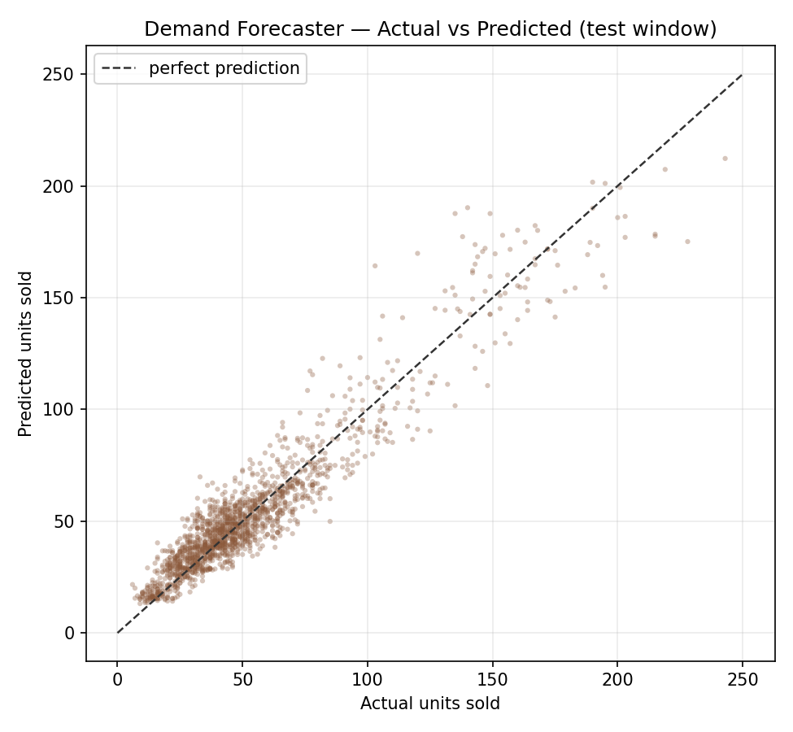
Points cluster along the diagonal across the range. Dispersion widens at higher volumes, which is expected for count data where variance scales with the mean.
Figure 4.2: Demand Forecaster — Residual Plot
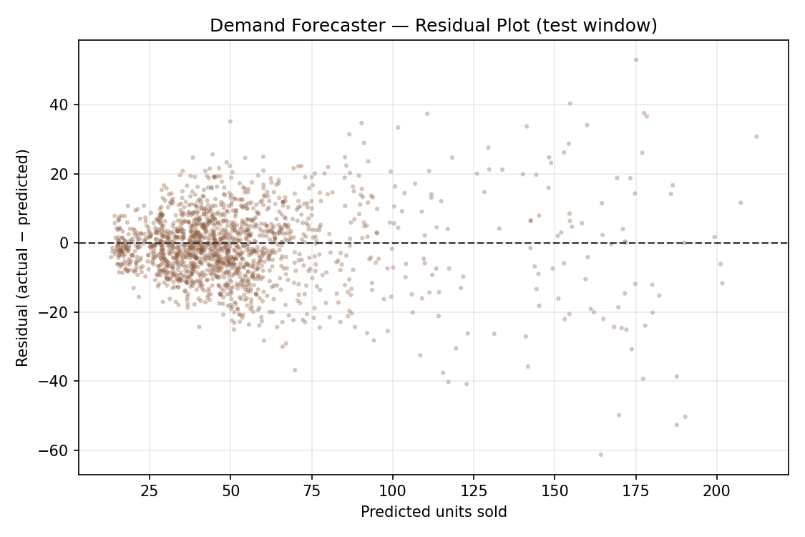
Residuals are centred on zero with no systematic directional bias, indicating the model is not consistently over- or under-forecasting. The spread widens as predicted volume increases — heteroscedasticity, again expected for Poisson-distributed counts.
Figure 4.3: Demand Forecaster — Forecast Timeline
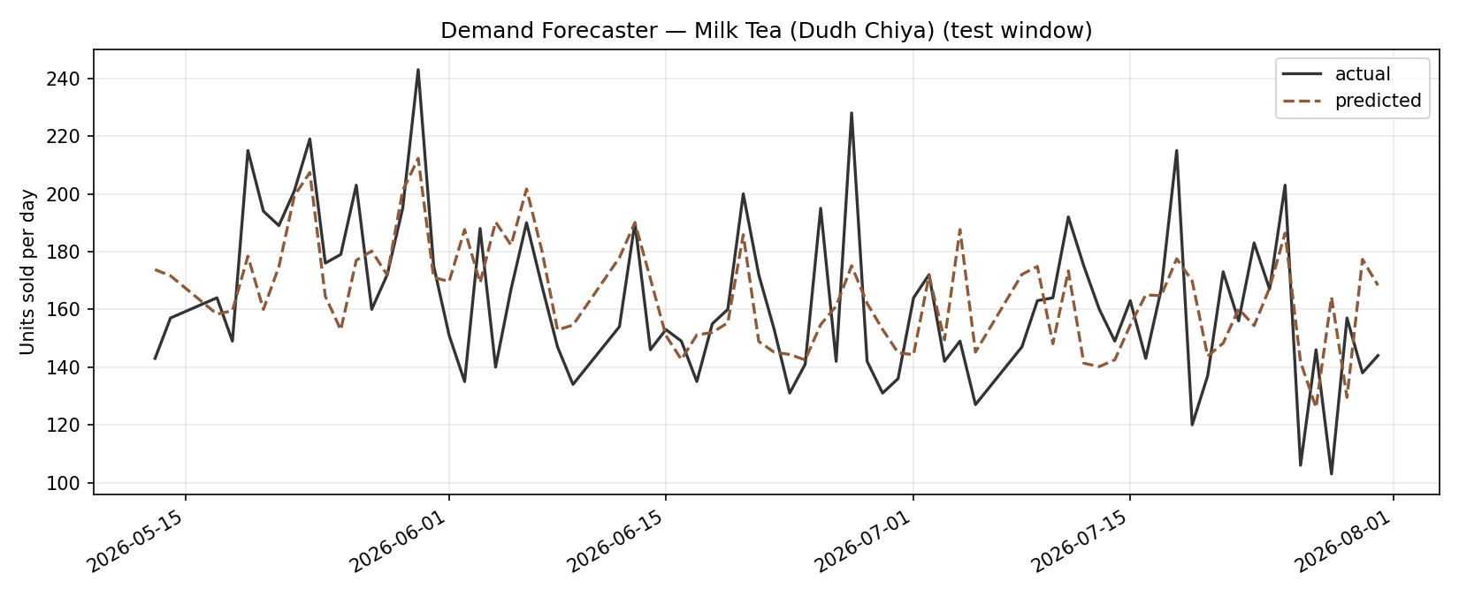
Actual and predicted series for the highest-volume item track closely across the test window, including the weekly Saturday peaks.
4.4.2 Demand Forecaster — Feature Importance
Figure 4.4: Demand Forecaster — Feature Importance
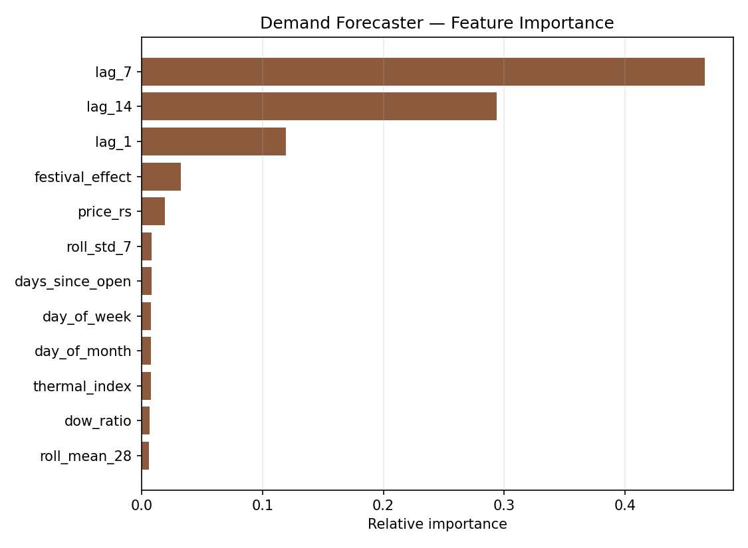
Rank | Feature | Importance
1 | lag_7 | 0.4660
2 | lag_14 | 0.2937
3 | lag_1 | 0.1195
4 | festival_effect | 0.0324
5 | price_rs | 0.0192
6 | roll_std_7 | 0.0084

The dominance of lag_7 and lag_14 confirms that cafe demand is strongly weekly-periodic: the single best predictor of tomorrow is the same weekday one and two weeks ago. That lag_7 outranks lag_1 by a factor of nearly four is a direct measurement of how much stronger the weekday signature is than day-to-day momentum.
festival_effect is the fourth most important feature. Although it carries far less weight than the lag features, this is expected: festivals affect a small minority of days. On those days its influence is decisive, which is precisely where the model gains its advantage over the seasonal-naive baseline.
4.4.3 Demand Forecaster — Limitations Observed
Two weaknesses are visible in the results.
Proportional error on low-volume items. The model is trained on all items jointly and optimises absolute error, so it is dominated by high-volume items. An absolute error of 8 units is 5% for milk tea but exceeds 60% for a croissant averaging 12 units per day. For inventory purposes this matters less than it appears, because ingredient requirement is dominated by high-volume items, but a per-item relative error objective would be preferable.
Underestimation at extremes. The actual-versus-predicted plot shows the largest deviations at the highest volumes. Random Forest predictions are averages over trees and are therefore inherently conservative at distribution tails; the model cannot extrapolate beyond the range seen in training. Peak festival days are exactly when a stockout is most costly, so this is a practically significant limitation.
4.4.4 Stockout Risk Classifier — Test Set Results
Table 4.8: Stockout Risk Classifier — Per-Class Evaluation
Class | Precision | Recall | F1-Score | Support
SAFE | 0.8773 | 0.7770 | 0.8241 | 1,242
WATCH | 0.5667 | 0.7158 | 0.6326 | 380
URGENT | 0.7649 | 0.8221 | 0.7925 | 562
Macro average | 0.7363 | 0.7716 | 0.7497 | 2,184
Weighted average | 0.7943 | 0.7779 | 0.7826 | 2,184

Overall accuracy was 77.79%, against a majority-class baseline of 54.46%.
Figure 4.5: Stockout Risk — Confusion Matrix (Model)
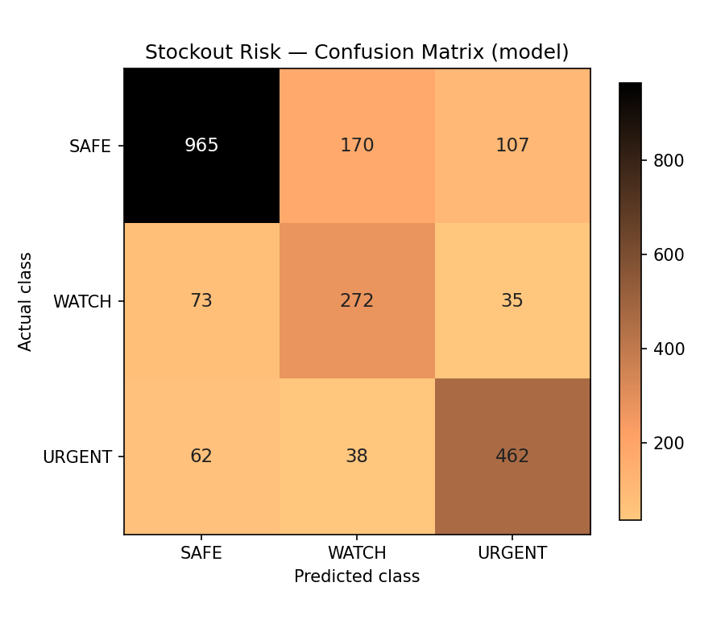
Figure 4.6: Stockout Risk — Confusion Matrix (Static Rule Baseline)
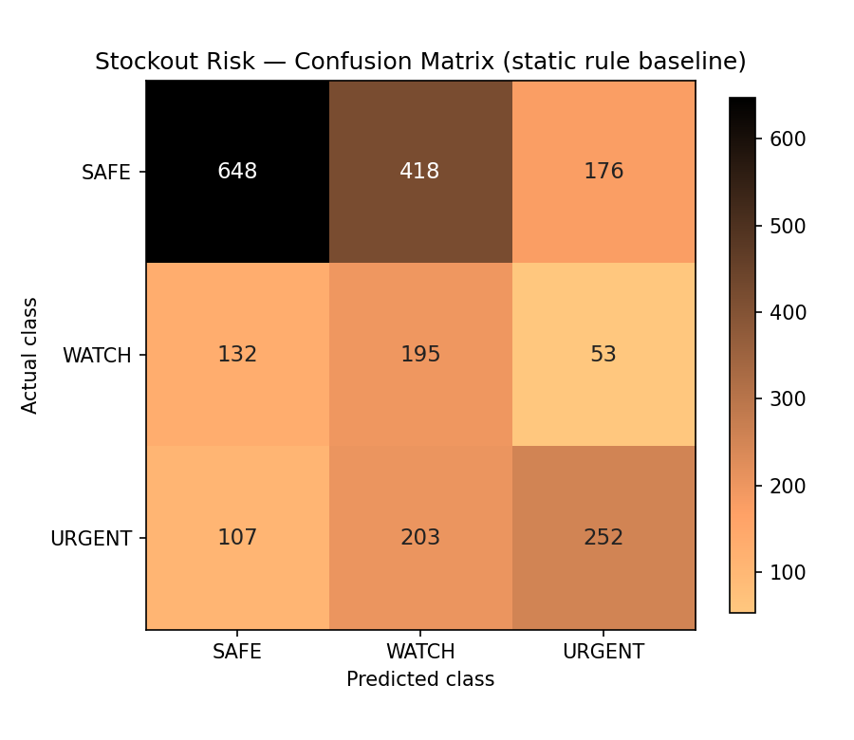
4.4.5 Stockout Risk Classifier — Feature Importance
Figure 4.7: Stockout Risk — Feature Importance
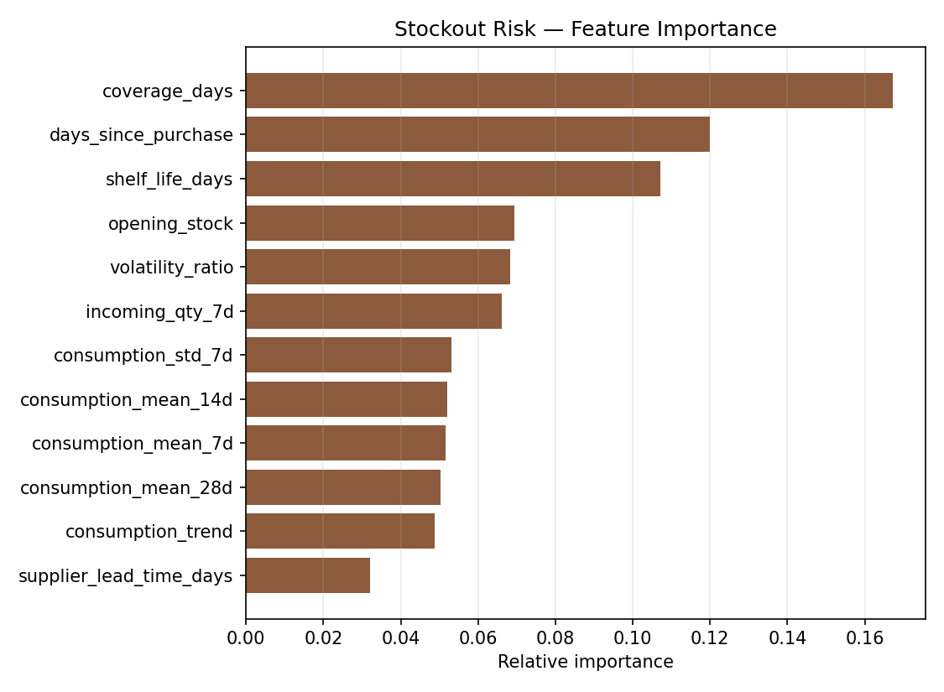
Rank | Feature | Importance
1 | coverage_days | 0.1672
2 | days_since_purchase | 0.1200
3 | shelf_life_days | 0.1072
4 | opening_stock | 0.0695
5 | volatility_ratio | 0.0684
6 | incoming_qty_7d | 0.0661

This distribution is the empirical justification for treating stockout prediction as a learned classification task rather than as arithmetic on days of cover, as argued in Section 2.2.3.
coverage_days — the entire content of the static rule — is the single most important feature, which is unsurprising. But it accounts for only 16.7% of the model's decision-making. The remaining 83.3% comes from information the static rule cannot express: how long it has been since the last delivery, how perishable the item is, how variable its consumption has been, and how much stock is already in transit.
volatility_ratio ranking fifth is the clearest single piece of evidence. Two ingredients with identical days of cover are not equally risky if one has stable consumption and the other does not. The static rule is structurally incapable of representing this. The model learned it from observed outcomes.
4.4.6 Model versus Static Rule — Operational Comparison
Table 4.9: Model versus Static Rule — Operational Comparison
Metric | Random Forest Classifier | Static Coverage Rule | Improvement
Accuracy | 77.79% | 50.14% | +27.65 pp
Macro F1-score | 0.7497 | 0.4727 | +0.2770
URGENT-class recall | 82.21% | 44.84% | +37.37 pp

The final row is the operationally decisive result. URGENT recall measures the proportion of ingredients that genuinely were about to run out within three days and were correctly flagged.
The static rule that CafeOS ships today catches fewer than half of them. The model catches over four in five. In practical terms, for every ten genuine imminent stockouts, the current system warns about four and the model warns about eight.
This is the single most important finding of the project, and it holds despite the model failing two of its accuracy-based acceptance criteria. It is also the reason macro F1 rather than accuracy was used for model selection.
4.4.7 Analysis of the Failed Criteria
Two acceptance criteria were not met. Both concern the risk classifier.
MAT-04 — accuracy 77.79% against a required 80%. MAT-05 — macro F1 0.7497 against a required 0.75.
MAT-05 failed by 0.0003, which is within any reasonable margin of noise. It is nonetheless recorded as a failure, because the threshold was declared before the test window was scored and adjusting it afterwards would invalidate the exercise.
MAT-04 requires genuine explanation. The confusion matrix and the per-class table locate the problem precisely: the WATCH class, whose precision is 0.5667 against 0.8773 for SAFE and 0.7649 for URGENT. Nearly half of the ingredients predicted WATCH were in fact something else.
The cause is that WATCH is intrinsically ambiguous. It denotes "will run out in four to seven days" — a narrow band bordered on both sides. An ingredient with five days of cover and slightly faster consumption than expected becomes URGENT; with slightly slower consumption, or an earlier delivery, it becomes SAFE. The class boundaries are artefacts of a continuous underlying quantity (days until stockout) that has been discretised, and the features available on the snapshot day do not determine which side of a boundary a marginal case will fall.
Three observations qualify this failure.
First, the errors are adjacent rather than catastrophic. The model confuses WATCH with its neighbours, not SAFE with URGENT. Mistaking "order this week" for "order in three days" costs the cafe an early delivery; mistaking "fine" for "about to run out" costs a stockout.
Second, URGENT recall — the metric that determines whether the cafe actually runs out of something — passed at 0.8221 against a required 0.75.
Third, the model substantially outperforms the system it replaces on every measure (Table 4.9), even while failing its own absolute thresholds. The thresholds were set ambitiously. They were not met. The system is nonetheless materially better than what CafeOS had before.
A more appropriate formulation for future work would treat days-until-stockout as a regression target and let the user choose the alert threshold, avoiding the artificial discretisation that creates the ambiguous middle class.
4.4.8 Threats to Validity
Synthetic data. All results derive from simulated data. The models are being asked to recover structure that a program deliberately inserted. Real cafe demand contains effects the simulator omits entirely — weather, local events, road closures, competitor promotions, staff changes, and social media activity. Real-world accuracy will be lower, likely substantially so. No claim to the contrary is made anywhere in this report.
Single simulated cafe. All data comes from one simulated establishment with one menu and one demand profile. Generalisation across cafes is untested.
Fixed constants. Shelf lives and supplier lead times were set as constants rather than learned from data. In practice both vary.
No cost-based evaluation. Models were evaluated with statistical metrics. The economically correct evaluation would weigh the margin lost to a stockout against the cost of spoilage, and optimise expected profit rather than accuracy. This was not attempted.
Simulator and model share assumptions. The festival calendar used by the simulator is the same one used at inference. The model is therefore not tested on its ability to discover festival effects, only to exploit a signal it was given. This inflates the apparent value of the festival_effect feature relative to what would be achievable with a genuinely unknown calendar.

CHAPTER 5: CONCLUSION AND FUTURE WORK
5.1 Conclusion
This project set out to extend CafeOS, an existing cafe management platform, with a predictive inventory capability, replacing a reactive stock alert with a forward-looking purchase recommendation.
All three objectives were met.
A demand forecasting model was developed and deployed. The Random Forest Regressor achieved an R² of 0.8955 and a Mean Absolute Error of 8.13 units on a chronologically held-out test window, improving on a strong seasonal-naive baseline by 16.4%. Feature importance analysis confirmed that cafe demand is dominated by weekly periodicity, with the Nepali festival calendar providing the decisive additional signal on the minority of days when the weekly pattern breaks.
A stockout risk classification model was developed and deployed. The Random Forest Classifier achieved 77.79% accuracy and a macro F1 of 0.7497. Formulating stockout prediction as a learned classification task over observed historical stockout events — rather than as arithmetic on days of cover — was validated empirically: days of cover accounts for only 16.7% of the model's decision-making, with time since last delivery, shelf life, and consumption volatility supplying the remainder.
Both models were integrated into the working application. A FastAPI prediction service, a deterministic rule layer implementing eight purchasing guardrails, an authenticated Next.js route, and a React panel on the existing inventory screen together deliver a ranked purchase list stating what to buy, how much, at what cost, and by when.
The central result is operational rather than statistical. The static coverage rule that CafeOS previously used catches 44.84% of genuinely imminent stockouts. The model catches 82.21%. For every ten ingredients about to run out, the old system warned about four; the new system warns about eight.
Two of nine acceptance criteria were not met, both concerning classifier accuracy. These are reported as failures rather than adjusted away, and Section 4.4.7 traces their cause to the intrinsic ambiguity of the middle WATCH class — a consequence of discretising a continuous quantity, and a design flaw in the target formulation rather than a deficiency of the model.
Acceptance testing also found a genuine defect in the safety guardrails: pack-size rounding allowed a perishable order to exceed its shelf-life cap by 0.01 days. The rule ordering was corrected. That a breach this small was caught at all is an argument for expressing safety constraints as executable tests rather than as prose.
The most significant limitation of this work is stated plainly and repeatedly: all training and evaluation data is synthetic. The live database held approximately seventeen genuine orders, and no supervised model can be trained on that. Every figure in Chapter 4 measures the recovery of simulated structure. None of them is evidence of real-world accuracy.
5.2 Future Work
Validation on real trading data. This is the necessary next step and the precondition for every other item below. CafeOS should be operated at a working cafe until six to twelve months of genuine order history exists, and the models retrained and re-evaluated on it. Until this is done, the accuracy figures in this report describe a simulation.
Reformulate the risk target as regression. Predicting days-until-stockout as a continuous value, and allowing the manager to set the alert threshold, would eliminate the ambiguous WATCH class identified in Section 4.4.7 and give the user control over their own sensitivity-versus-noise trade-off.
Cost-based objective. Replace statistical accuracy with expected profit as the optimisation target, weighing lost margin from a stockout against the cost of spoilage. This is the newsvendor formulation described in Section 2.2.4 and is the economically correct objective.
Prediction intervals. Random Forests can supply quantile estimates. Presenting "between 140 and 175 units" rather than a single number would let the manager order against a service level rather than against a point estimate.
Learn supplier behaviour. Lead times and delivery reliability are currently constants. A cafe that records delivery dates could learn per-supplier lead time distributions, which directly improve the order-by date calculation.
External signals. Weather forecasts are freely available for Kathmandu and are known to affect footfall. Local event calendars and school or college holiday schedules would likely improve accuracy further.
Automated retraining. Models are currently retrained by running a script. A scheduled job that retrains monthly, evaluates against held-out recent data, and promotes the new model only if it improves would keep the system current without intervention.
Waste tracking. The simulator models spoilage, but the live CafeOS database records no waste events. Adding waste capture would both improve the models and give the cafe visibility of a cost that is currently invisible in its accounts.
Multi-cafe learning. With several cafes on the platform, a shared model with per-cafe features would allow a new cafe to receive useful predictions from its first week, borrowing strength from established establishments.

REFERENCES
[1] L. Breiman, "Random Forests," Machine Learning, vol. 45, no. 1, pp. 5–32, 2001.
[2] L. Breiman, J. Friedman, R. Olshen, and C. Stone, Classification and Regression Trees. Belmont, CA: Wadsworth International Group, 1984.
[3] J. H. Friedman, "Greedy Function Approximation: A Gradient Boosting Machine," Annals of Statistics, vol. 29, no. 5, pp. 1189–1232, 2001.
[4] F. Pedregosa et al., "Scikit-learn: Machine Learning in Python," Journal of Machine Learning Research, vol. 12, pp. 2825–2830, 2011.
[5] S. Makridakis, E. Spiliotis, and V. Assimakopoulos, "The M5 Accuracy Competition: Results, Findings and Conclusions," International Journal of Forecasting, vol. 38, no. 4, pp. 1346–1364, 2022.
[6] R. J. Hyndman and G. Athanasopoulos, Forecasting: Principles and Practice, 3rd ed. Melbourne, Australia: OTexts, 2021. [Online]. Available: https://otexts.com/fpp3/
[7] E. A. Silver, D. F. Pyke, and D. J. Thomas, Inventory and Production Management in Supply Chains, 4th ed. Boca Raton, FL: CRC Press, 2016.
[8] S. Nahmias, "Perishable Inventory Theory: A Review," Operations Research, vol. 30, no. 4, pp. 680–708, 1982.
[9] M. Khouja, "The Single-Period (News-Vendor) Problem: Literature Review and Suggestions for Future Research," Omega, vol. 27, no. 5, pp. 537–553, 1999.
[10] A. A. Tsay, "Managing Retail Channel Overstock: Markdown Money and Return Policies," Journal of Retailing, vol. 77, no. 4, pp. 457–492, 2001.
[11] "Petpooja — Restaurant Management System," Petpooja, 2026. [Online]. Available: https://petpooja.com/. [Accessed 30 July 2026].
[12] "Square for Restaurants," Block, Inc., 2026. [Online]. Available: https://squareup.com/us/en/point-of-sale/restaurants. [Accessed 30 July 2026].
[13] "MarketMan — Restaurant Inventory Management Software," MarketMan, 2026. [Online]. Available: https://www.marketman.com/. [Accessed 30 July 2026].
[14] "Supabase Documentation," Supabase Inc., 2026. [Online]. Available: https://supabase.com/docs. [Accessed 30 July 2026].
[15] "FastAPI Documentation," S. Ramírez, 2026. [Online]. Available: https://fastapi.tiangolo.com/. [Accessed 30 July 2026].
[16] "Next.js Documentation," Vercel Inc., 2026. [Online]. Available: https://nextjs.org/docs. [Accessed 30 July 2026].
[17] "Unified Modeling Language (UML)," Object Management Group, 2017. [Online]. Available: https://www.omg.org/spec/UML/. [Accessed 30 July 2026].

APPENDICES
Appendix A: Project File Structure
cafeos/
├── ml-service/ # The contribution of this project
│ ├── generate_dataset.py # Dataset simulator (Section 3.4)
│ ├── train_models.py # Training, selection, evaluation
│ ├── test_acceptance.py # Acceptance test suite (Section 4.3)
│ ├── requirements.txt # Pinned dependencies
│ ├── start.bat # One-click service launcher
│ ├── app/
│ │ └── main.py # FastAPI service + rule layer
│ ├── data/ # Generated datasets
│ │ ├── sales_history.csv # 11,466 rows
│ │ ├── ingredient_history.csv # 14,448 rows
│ │ ├── menu_items.csv
│ │ ├── ingredients.csv
│ │ └── recipes.csv
│ ├── models/ # Serialised model bundles
│ │ ├── demand_forecaster.joblib
│ │ └── stockout_risk.joblib
│ └── reports/
│ ├── metrics.json # All figures quoted in Chapter 4
│ ├── acceptance_tests.csv
│ └── figures/ # Figures 4.1 – 4.7
│
├── src/
│ ├── app/
│ │ ├── api/ml/reorder-plan/route.ts # Authenticated bridge + fallback
│ │ └── cafe/inventory/page.tsx # Modified to mount the panel
│ └── components/cafe/
│ └── SmartReorderPanel.tsx # User interface
│
└── docs/project-report/
└── CafeOS_Project_Report.md # This document

Appendix B: Reproducing the Results
cd ml-service

# 1. Environment
python -m venv .venv
.venv\Scripts\python.exe -m pip install -r requirements.txt

# 2. Generate the dataset (fixed seed — reproducible)
.venv\Scripts\python.exe generate_dataset.py

# 3. Train both models and produce all figures
.venv\Scripts\python.exe train_models.py

# 4. Run the acceptance test suite
.venv\Scripts\python.exe test_acceptance.py

# 5. Start the prediction service
.venv\Scripts\python.exe -m uvicorn app.main:app --port 8000

All randomness is seeded (numpy.random.default_rng(20260731) in the simulator, random_state=42 in every model), so the figures in this report reproduce exactly.
Appendix C: Sample API Interaction
Request — POST /predict/stockout
{
"target_date": "2026-08-01",
"ingredients": [
{
"ingredient": "Milk",
"unit": "L",
"opening_stock": 18.0,
"shelf_life_days": 4,
"supplier_lead_time_days": 1,
"pack_price_rs": 95,
"days_since_purchase": 2,
"incoming_qty_7d": 0,
"recent_consumption": [42, 40, 44, 47, 52, 56, 38, 41, 40, 45, 46, 53,
58, 39, 42, 41, 44, 48, 51, 55, 39, 41, 40, 44,
46, 53, 57, 40]
}
]
}

Response
{
"target_date": "2026-08-01",
"model": "Random Forest Classifier",
"predictions": [
{
"ingredient": "Milk",
"risk_class": "URGENT",
"confidence": 0.644,
"probabilities": { "SAFE": 0.1183, "WATCH": 0.2376, "URGENT": 0.644 },
"coverage_days": 0.39
}
]
}

Appendix D: Acceptance Test Output
====================================================================================
CafeOS - MODEL ACCEPTANCE TEST RESULTS
====================================================================================
Test ID Acceptance Criterion Required Actual Status
MAT-01 Demand forecast R-squared >= 0.85 0.8955 Pass
MAT-02 Demand forecast MAE <= 12 units 8.13 units Pass
MAT-03 Improvement over lag-7 baseline >= 10% 16.4% Pass
MAT-04 Risk classifier accuracy >= 80% 77.79% Fail
MAT-05 Risk classifier macro F1 >= 0.75 0.7497 Fail
MAT-06 URGENT-class recall (safety-critical) >= 0.75 0.8221 Pass
MAT-07 Beats the static coverage rule on macro F1 > baseline 0.7497 vs 0.4727 Pass
MAT-08 Perishable order never exceeds shelf life <= 3 days of supply 2.98 days Pass
MAT-09 Chronological split - no future in training train < test ok Pass
------------------------------------------------------------------------------------
Passed: 7 Failed: 2 Acceptance pass rate: 77.78%
====================================================================================

