**Project Report**

**Object Detection**

Object detection is like having superpowers for computers. It's a special ability that allows a computer to "see" and recognize different things in pictures or videos, just like how we humans can recognize objects around us.

Imagine you have a magical camera that can show you what's happening around you, but it doesn't just show you the whole picture; it can also highlight and tell you what objects are in that picture. For example, it can say, "Hey, there's a person standing over there," or "Look, a car is moving in that direction!".

Object detection in computers works similarly. We use special algorithms and a powerful brain called a neural network to train the computer to recognize objects. We show it lots and lots of pictures with different things in them, like cars, dogs, and people, and we tell the computer what each object is in those pictures. After training, when we give the computer a new picture or video, it uses what it learned to find and identify objects all by itself. It can draw boxes around them and tell us what each object is. So, just like our magical camera, the computer can point out and describe objects in the pictures or videos it "sees."

This superpower of object detection has many useful applications, like helping self-driving cars understand the road, assisting doctors in medical imaging, enhancing security systems, and much more. It's a fantastic technology that makes computers even more helpful and intelligent!

**Demo**

**Using Live Web Cam :**

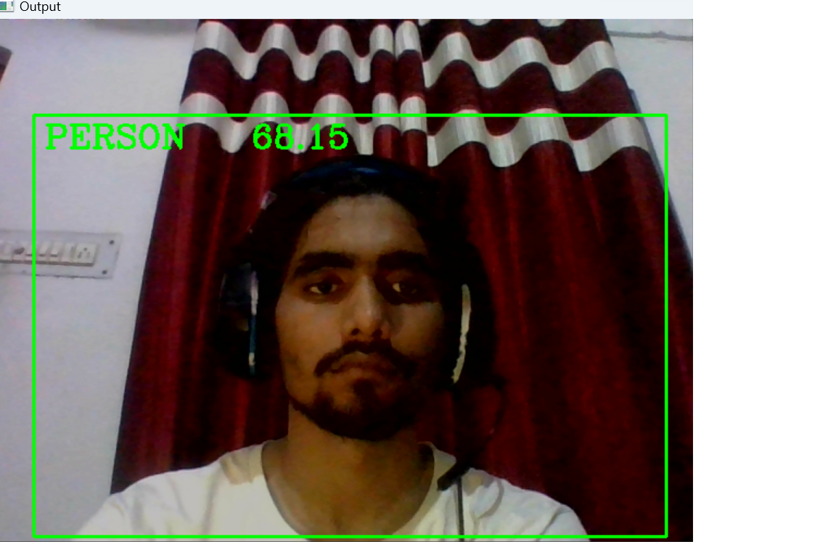

In above it is predicting the person ,then in below code it is predicting the cup

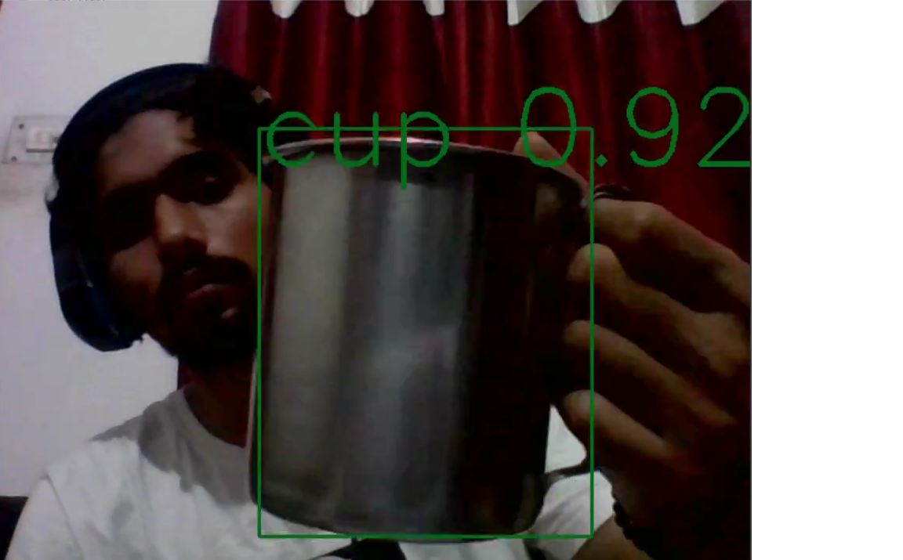

In this ,I have used a Live web cam where it can be seen as it is predicting cup.

**Using a Video:**

**In** this I have submitted the video and taken it as input :

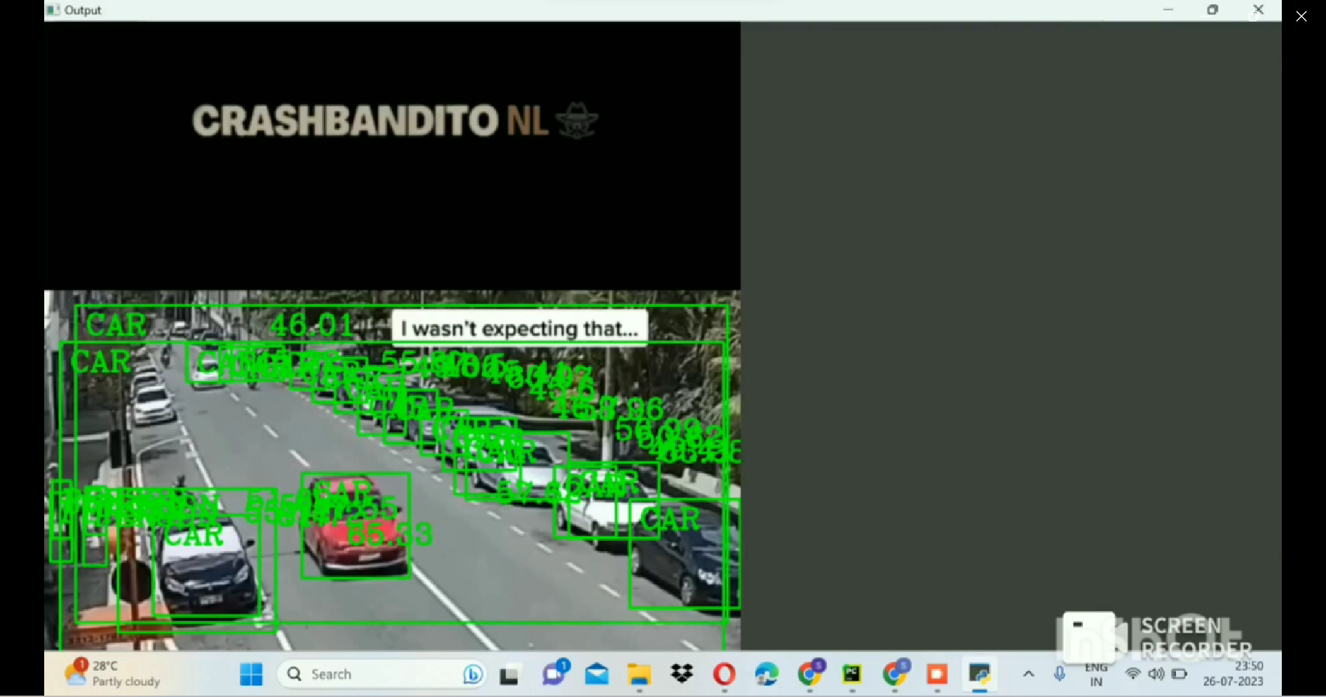

In the above scenario I have Taken a Video and passed it in my model and here we can see it is predicting the multiple object simultaneously

Demo Video Link : <https://drive.google.com/file/d/1jDfuEqWPpg5qP4WvdMtx1qrMVSnPQ9u5/view?usp=sharing>