Azure End-to-End Data Engineering Project Documentation

1. Overall Solution Architecture
This architecture illustrates an end-to-end Azure Data Engineering solution. Azure Data Factory ingests data from HTTP-based data sources into Azure Data Lake Storage Gen2. Azure Databricks performs transformation operations on the raw data and stores the transformed datasets into curated layers. Azure Synapse Analytics serves the transformed data for business intelligence and reporting using Power BI dashboards.
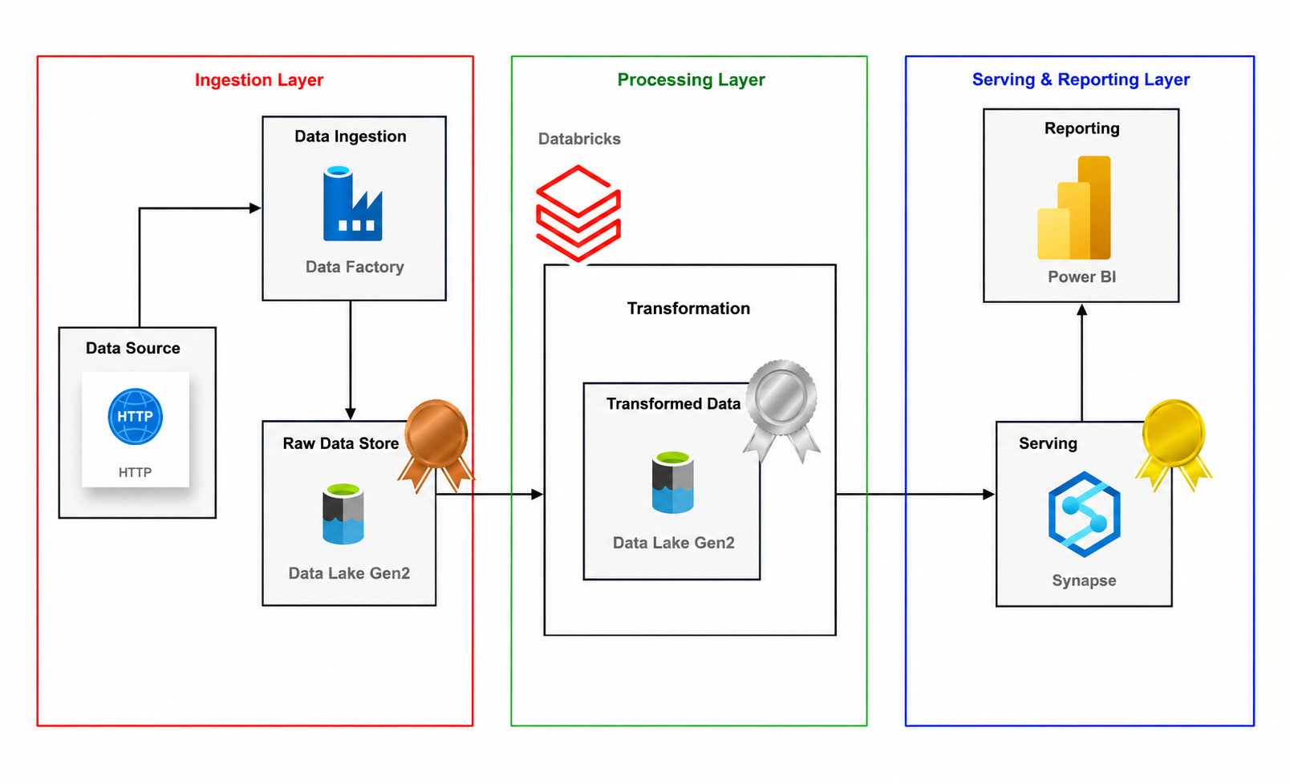

2. Azure Data Factory Pipeline Flow
The Azure Data Factory pipeline dynamically retrieves metadata using a Lookup activity. The output is passed into a ForEach activity that iterates through multiple datasets and executes dynamic copy operations for scalable data ingestion workflows.
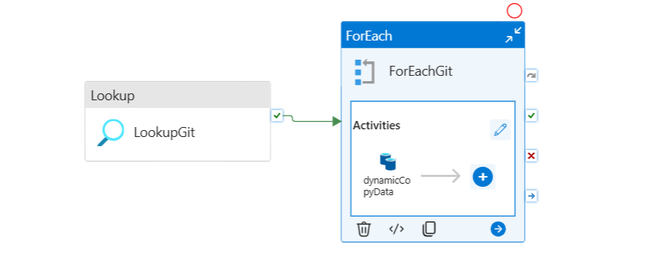

3. Dynamic Copy Data Activity
The Copy Data activity inside the ForEach loop performs automated ingestion from source systems into Azure Data Lake Storage Gen2. This activity enables reusable and scalable ETL workflows within the Azure Data Factory pipeline.
