**1->pwd :**

The pwd command (print working directory) writes the full pathname of the current working directory .

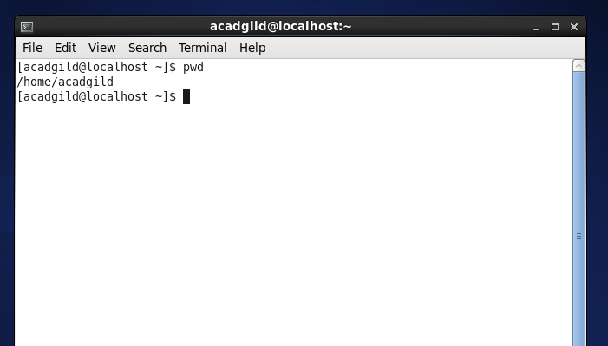

**2->vi**

The default editor that comes with the UNIX/Linux operating system is called vi (visual editor).The vi editor is a full screen editor and has two modes of operation:

Command mode commands which cause action to be taken on the file, and

Insert mode in which entered text is inserted into the file.

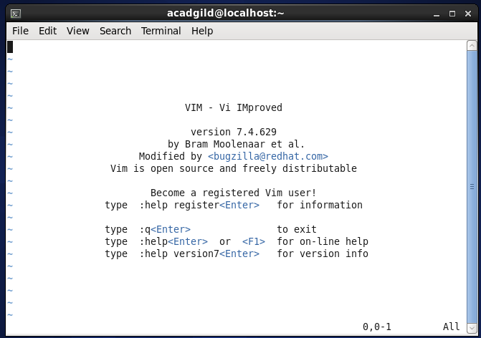

**3->Touch**

The touch command is the easiest way to create new, empty files. It is also used to change the timestamps on existing files and directories.

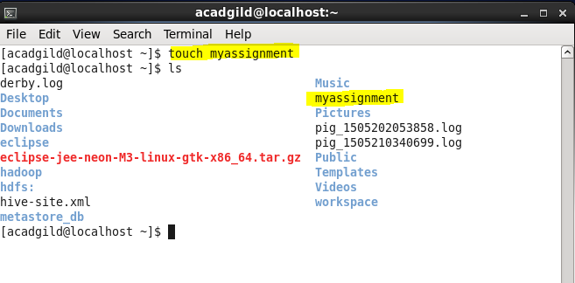

**4->mkdir**

mkdir command in UNIX allows users to create directories or folders as they are referred to in some operating systems.

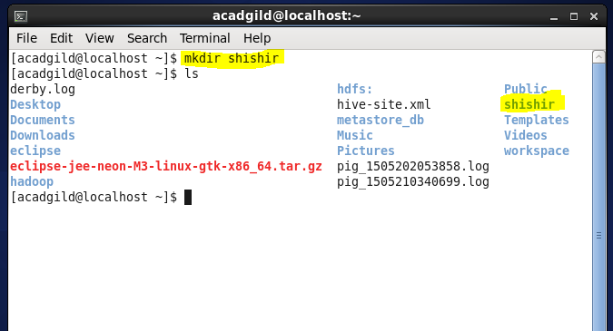

**5->rm**

 rm (short for remove) is a basic UNIX command used to remove objects such as files, directories, device nodes, symbolic links, and so on from the filesystem.

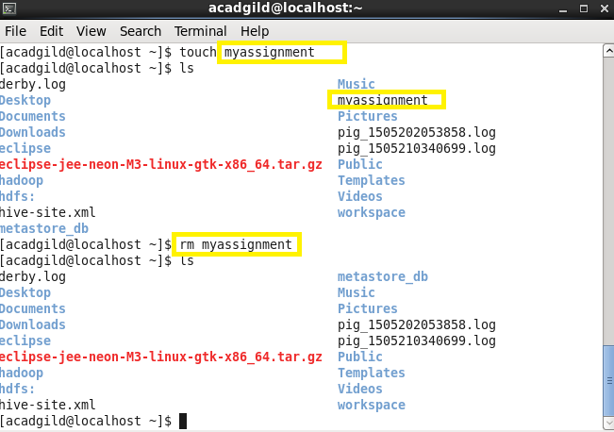

**6->ls**

 ls is a command to list files in Unix/Linux operating systems.

**7->echo**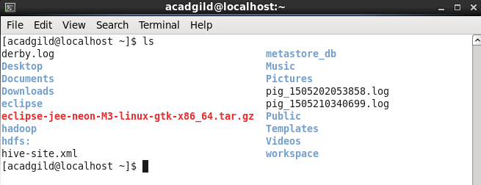

 echo is a command Unix/Linux operating systems that outputs the strings it is being passed as arguments. It is a command typically used in shell scripts and batch files to output status text to the screen or a file.

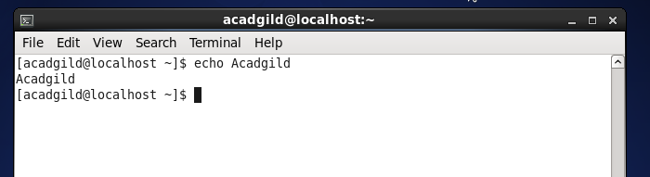

**8->cat**

 cat command allows us to create single or multiple files, view contain of file, concatenate files and redirect output in terminal or files.

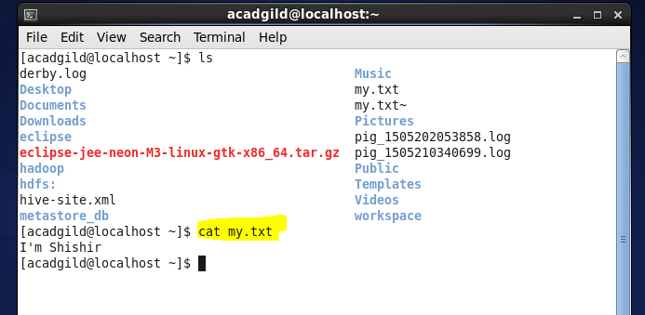

**9->Who**

The standard Unix/Linux command who displays a list of users who are currently logged into the computer.

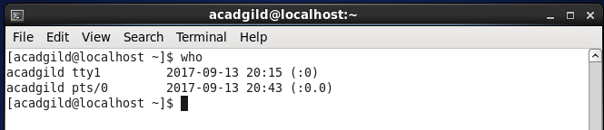

**10->cd**

The cd command, also known as chdir (change directory), is a command-line OS shell command used to change the current working directory in operating systems such as Unix, (where if a bare path is given, cd is implied), Windows, and Linux.

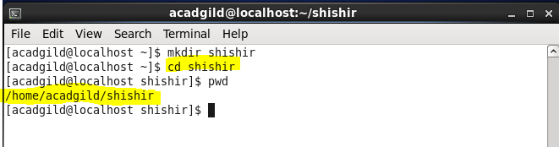  
**11->date**

date print or set the system date and time .

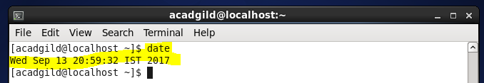

**12->cal**

cal is a standard program on Unix/Linux systems that prints an ASCII calendar of the given month or year.

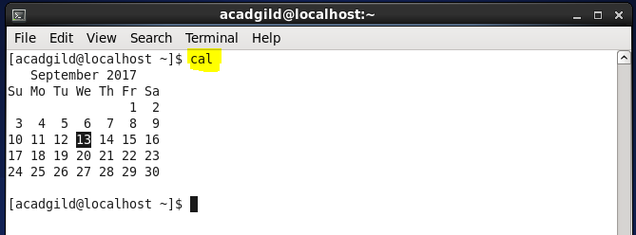

**13->mv**

mv is a Unix command that moves one or more files or directories from one place to another.

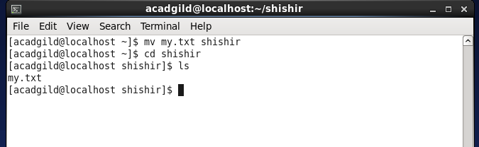

**14->cp**

cp is a UNIX command for copying files and directories. The command has three principal modes of operation, expressed by the types of arguments presented to the program for copying a file to another file, one or more files to a directory, or for copying entire directories to another directory.

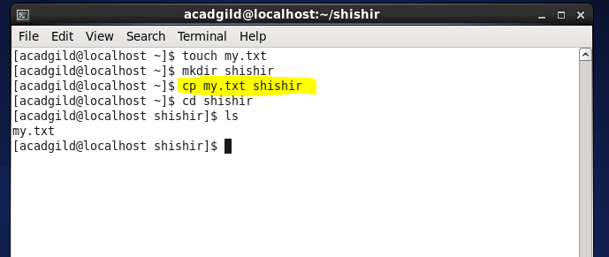

**15->which**

which is a Unix command used to identify the location of executables.

