**Task 3:**

-Step 1: Creating file max-temp.txt using touch command

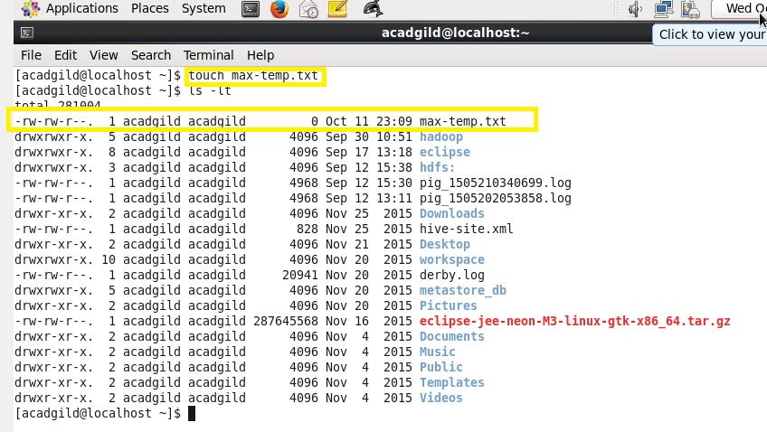  
Step 2: Appending Year and corresponding Temperature using echo command and checking the data using head command inside max-temp.txt

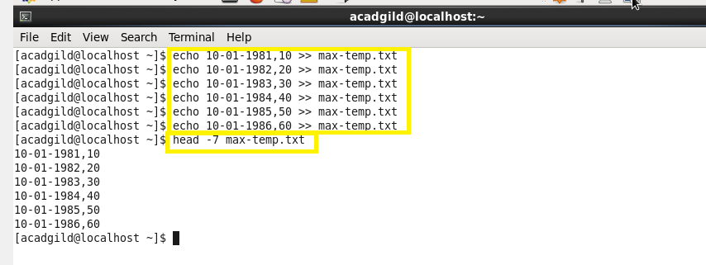

-Step 3: Moving a max.temp.txt inside the /user/acadgild/hadoop using hadoop fs –put command

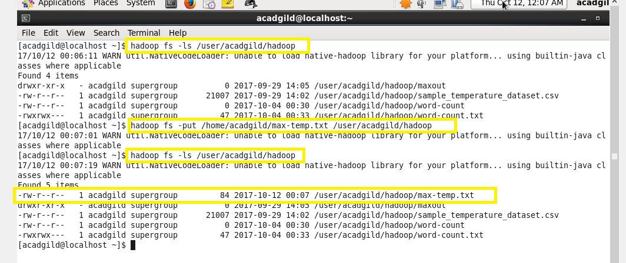

**Task 4:**

-Changing max-temp.txt file permission using hadoop fs –chmod 770 command

