Command

CREATE DATABASE IF NOT EXISTS CUSTOM;

Show databases;

CREATE TABLE temperature_data

(

full_date STRING,

ZIP INT,

tempratue INT

)

ROW FORMAT DELIMITED

FIELDS TERMINATED BY ',';

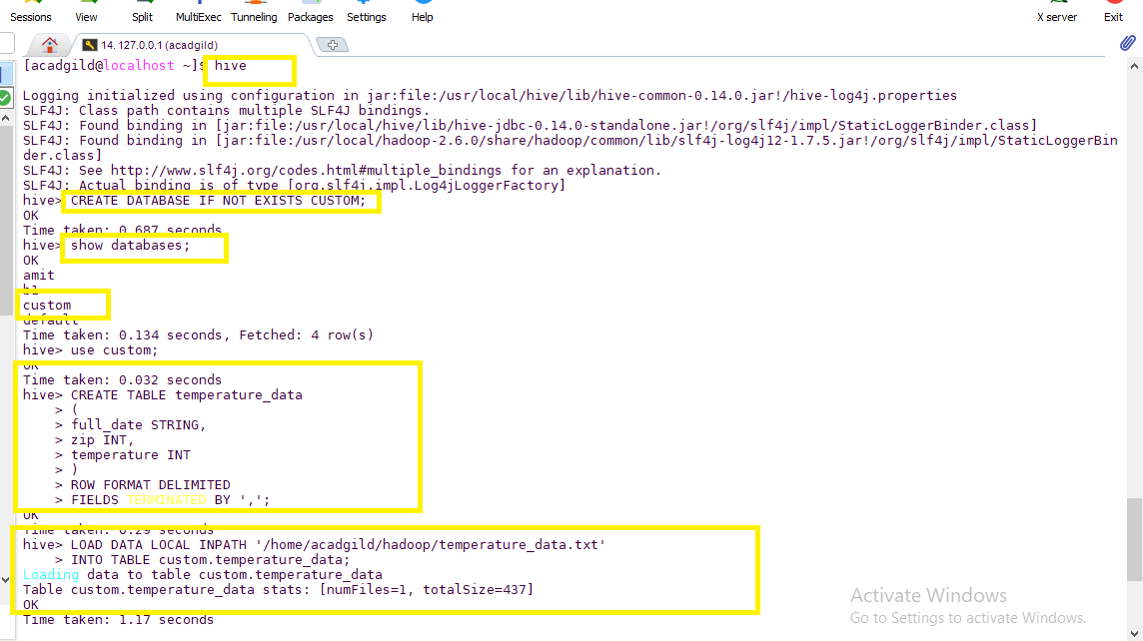

LOAD DATA LOCAL INPATH ‘/home/acadgild/hadoop/temperature_data.txt’

INTO TABLE custom.temperature_data;

Describe custom.temperature_data;

select *from custom.temperature_data limit 10;

