-Created Database name CUSTOM and table temperature_data

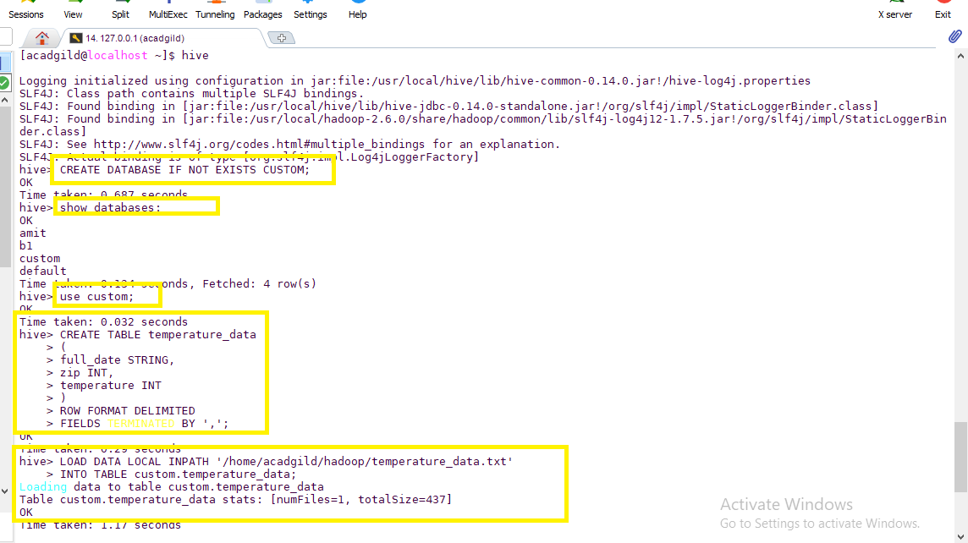

Question a:

Fetch date and temperature from temperature_data where zip code is greater than

300000 and less than 399999.

Command:

SELECT * FROM temperature_table WHERE zip > 300000 and zip < 399999;

Screen-Shot Output:

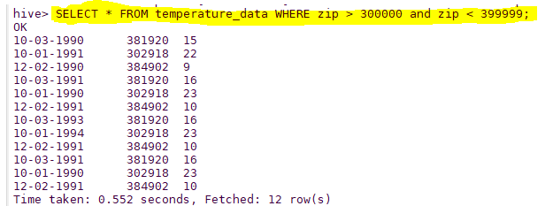

Question b:

SELECT SUBSTR(full_date,7,10), MAX(temperature) From custom.temperature_data GROUP BY SUBSTR(full_date,7,10);

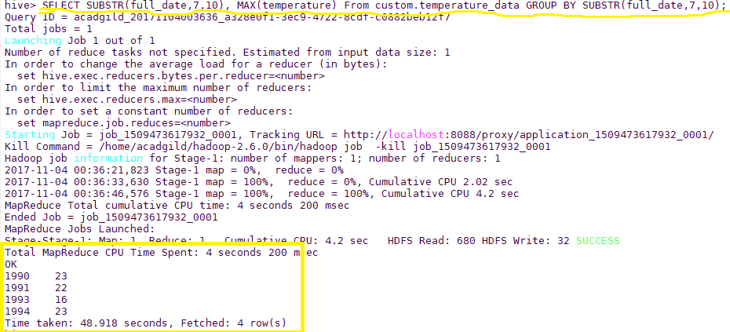

Question c:

Calculate maximum temperature from temperature_data table corresponding to those

years which have at least 2 entries in the table.

Command:

SELECT

year,

MAX(t1.temperature) as temperature

FROM

(select SUBSTRING(full_date,7,4) year, temperature from temperature_data) t1

GROUP BY

year

HAVING

count(t1.year) >= 2; 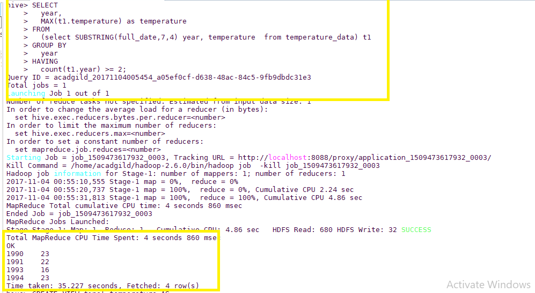

Question d: Create a view on the top of last query, name it temperature_data_vw.

Command:

CREATE VIEW temperature_data_vw AS

SELECT

year,

MAX(t1.temperature) as temperature

FROM

(select SUBSTRING(full_date,7,4) year, temperature from temperature_data) t1

GROUP BY

year

HAVING

count(t1.year) >= 2;

SELECT *FROM temperature_data_vw;

Output Screen-shot

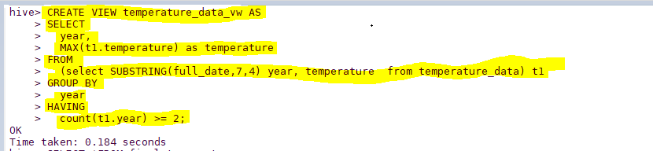

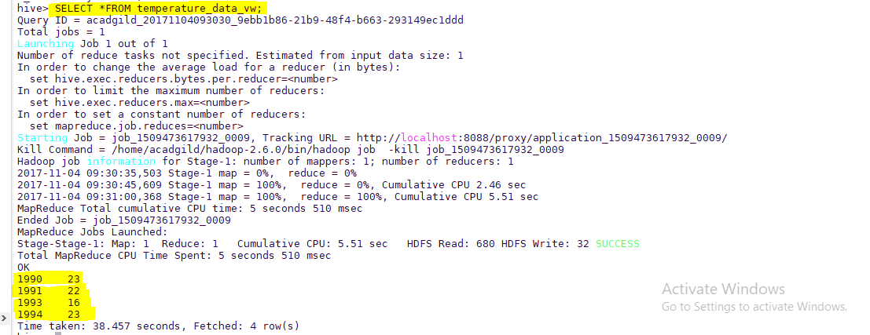

Question e:

Export contents from temperature_data_vw to a file in local file system, such that each

file is '|' delimited.

Command:

INSERT OVERWRITE LOCAL DIRECTORY '/home/acadgild/hadoop/temperature_data_vw' ROW FORMAT DELIMITED FIELDS TERMINATED BY'|' SELECT *FROM temperature_data_vw;

Output Screen-Shot

