1. Write a Hive program to find the number of medals won by each country in swimming.

Ans:

Code:

>CREATE DATABASE IF NOT EXISTS GAME;

>Show databases;

>use game;

>CREATE TABLE olympix

>(

>athelete STRING,

>age INT,

>countryname STRING,

>year INT,

>closingDate STRING,

>sportname STRING,

>GoldMedals INT,

>SilverMedals INT,

>BronzeMedals INT,

>TotalMedals INT

>)

>ROW FORMAT DELIMITED

>FIELDS TERMINATED BY '\t';

>LOAD DATA LOCAL INPATH '/home/acadgild/hadoop/olympix_data.csv' INTO TABLE GAME.olympix;

> select countryname,SUM(TotalMedals) from olympix where sportname = "Swimming" GROUP BY countryname;

Screen-Shot:

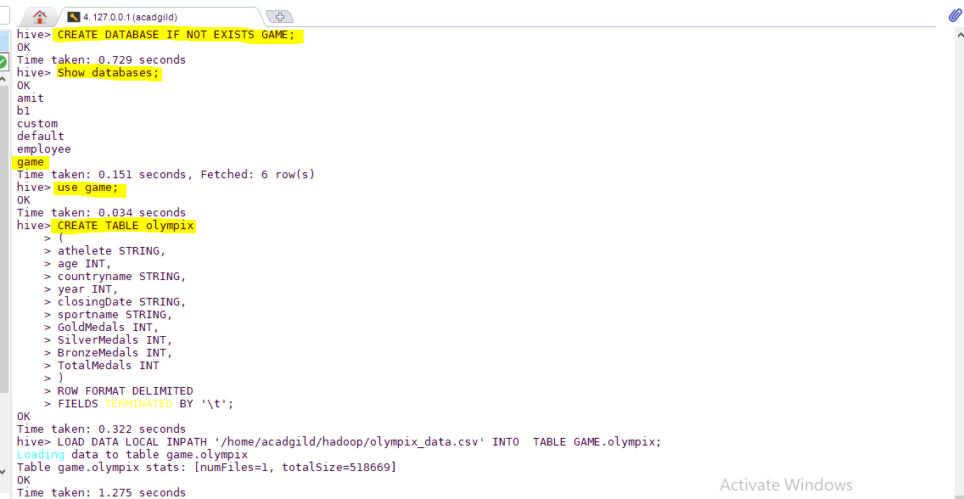

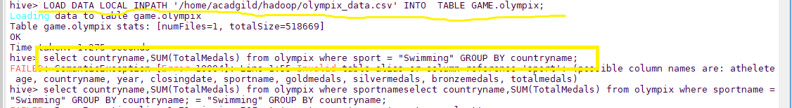

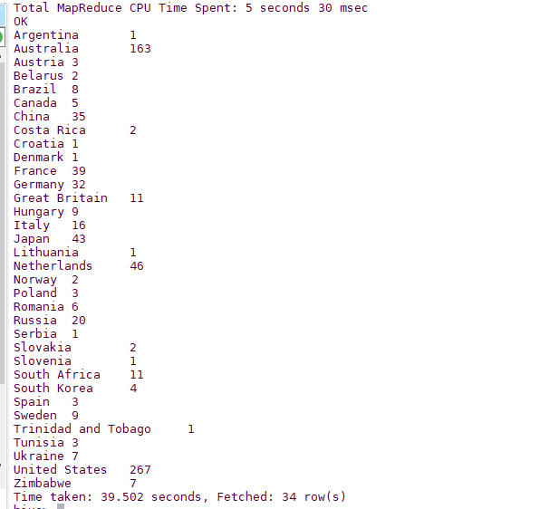

1. Write a Hive program to find the number of medals that India won year wise.

Code

>select year,SUM(TotalMedals) from olympix where country = "India" GROUP BY year;

Screen-Shot

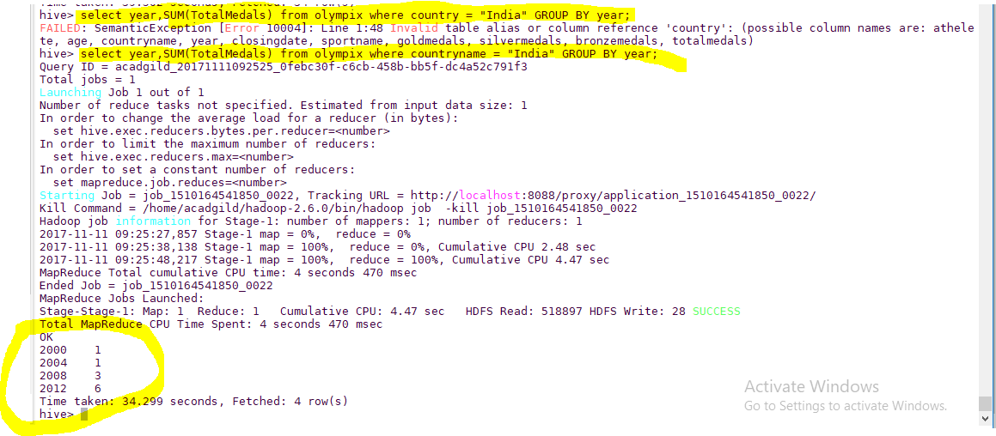

1. Write a Hive Program to find the total number of medals each country won.

Code

> select countryname,SUM(TotalMedals) from olympix GROUP BY countryname;

Screen-shot

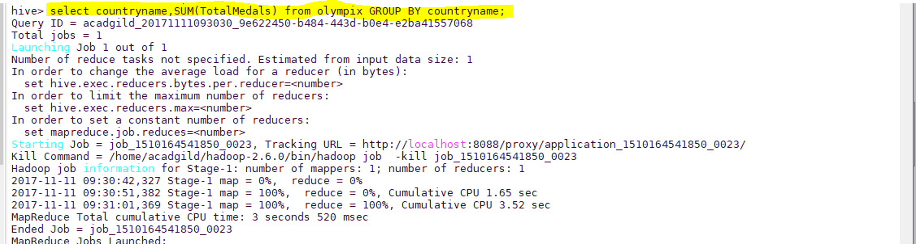

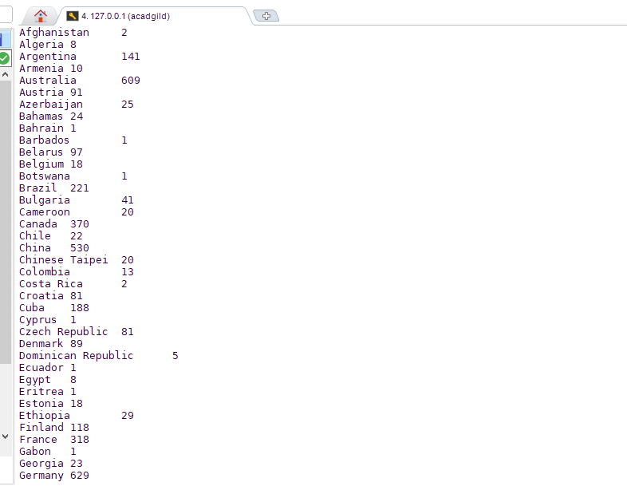

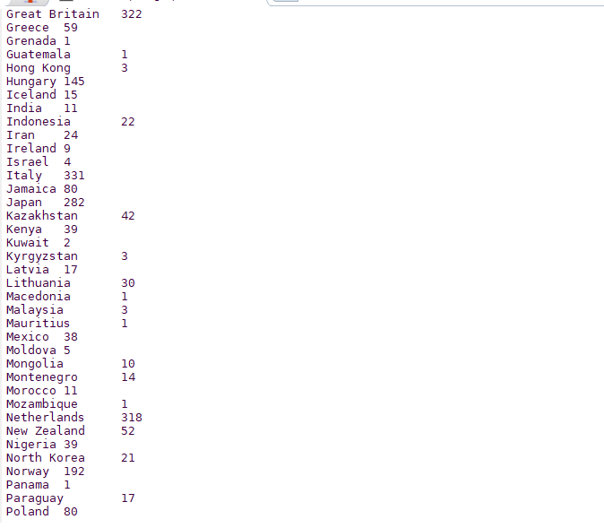



1. Write a Hive program to find the number of gold medals each country won.

Code

> select countryname,SUM(GoldMedals) from olympix GROUP BY countryname;

Screen-Shot

