Below is the query used to get a list of employees who receive a salary less than 100, compared to their immediate employee with higher salary in the same unit-

**with temp as**

**(**

**select emp_id,**

**emp_name,**

**sal,**

**dept,**

**LEAD(sal, 1)**

**OVER(PARTITION BY dept**

**ORDER BY sal) - sal as diff**

**FROM emp**

**)**

**select emp_id,**

**emp_name,**

**dept,**

**sal**

**from temp**

**where diff >100;**

Below is the screenshot for same

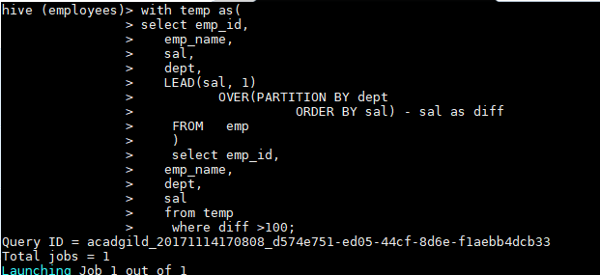

Below screenshot show output of above query-

