Below screenshot shows content of table emp-

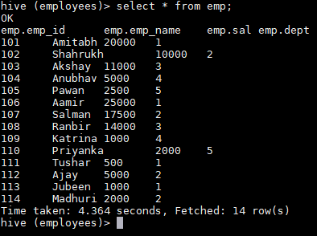

Below query was used to find list of all employees who draw higher salary than the average salary of that department-

**SELECT temp.emp_name, temp.sal, temp.dept, temp.avg_salary**

**FROM**

**( SELECT avg(sal) OVER (PARTITION BY dept) AS avg_salary, emp_id, emp_name, sal, dept FROM emp ) temp**

**WHERE temp.sal > temp.avg_salary;**

Below screenshot shows the query and results for it-

