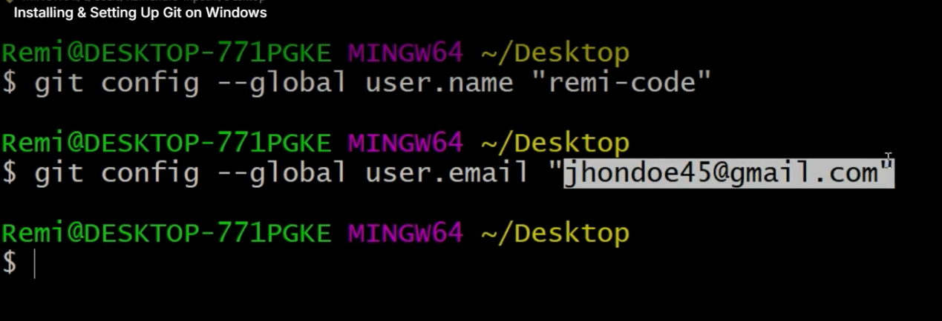

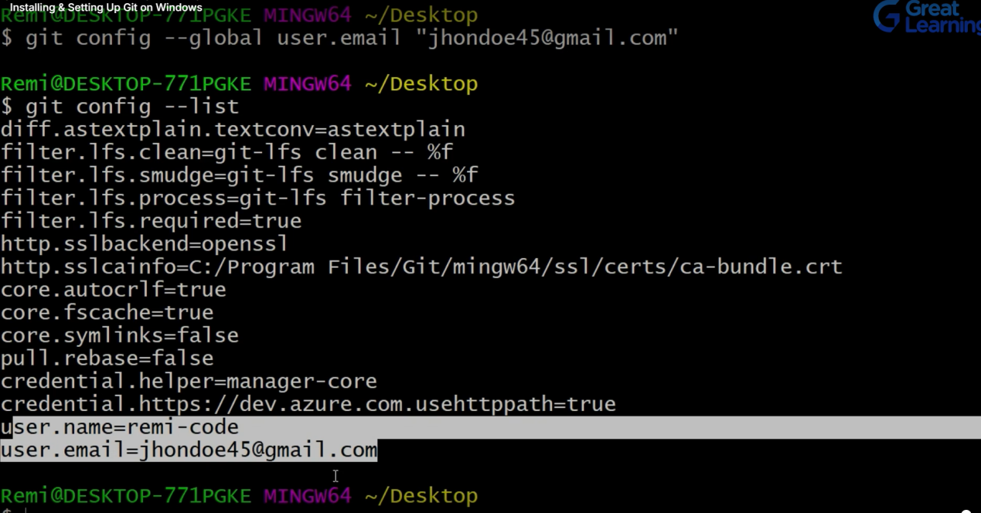

**git config --global user.name “Shishu123”**

**git config --global user.email “[shishupalkumar@gmail.com](mailto:shishupalkumar@gmail.com)”**

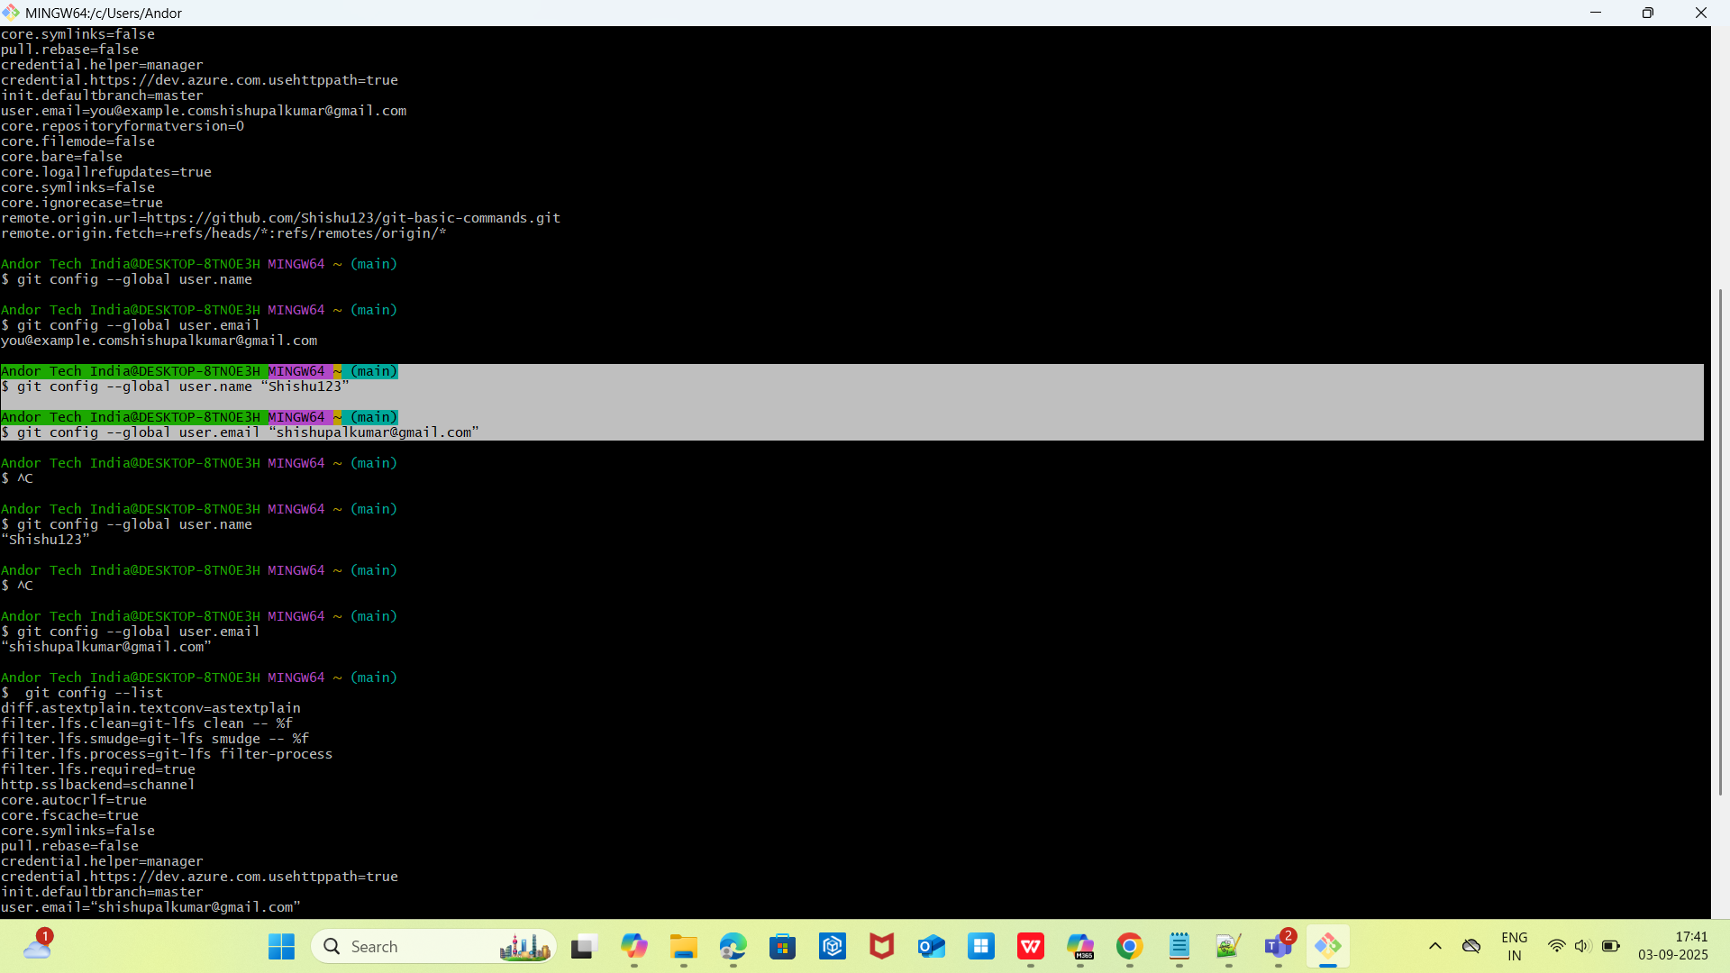

Ubantu Server : Use EC2 or Any Ubantu Server and inside that Install Git

Note: sudo => for Super User Access.

1. sudo apt update

Update all packages:  
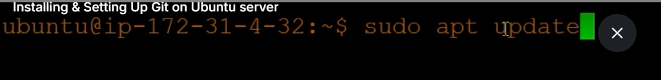

1. Sudo apt install git

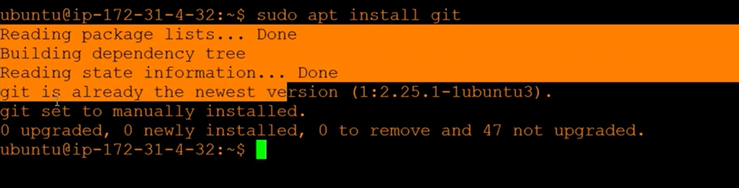

1. Configure git

**sudo git config --global user.name “Shishu123”**

**sudo git config --global user.email “[shishupalkumar@gmail.com](mailto:shishupalkumar@gmail.com)”**

**List config:**

**sudo git config --list**

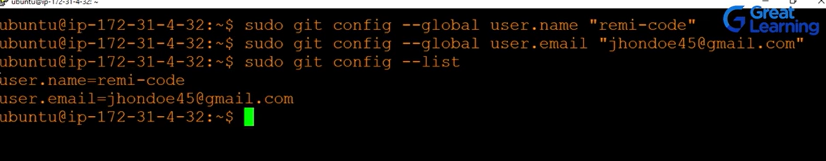

GIT BASIC COMMANDS :

Step1: Create a new Project Directory in Local drive

mkdir project

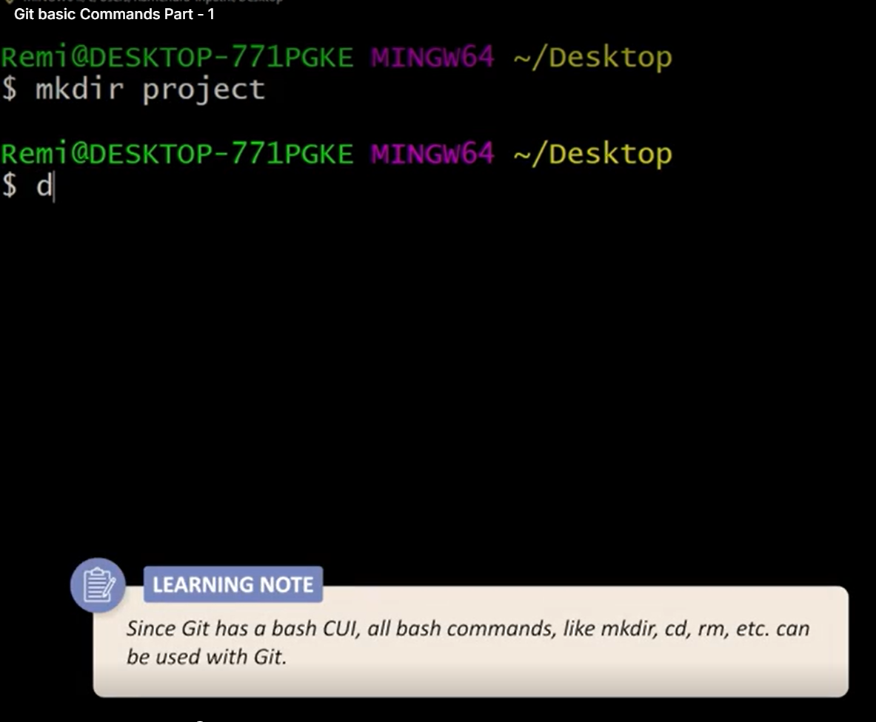

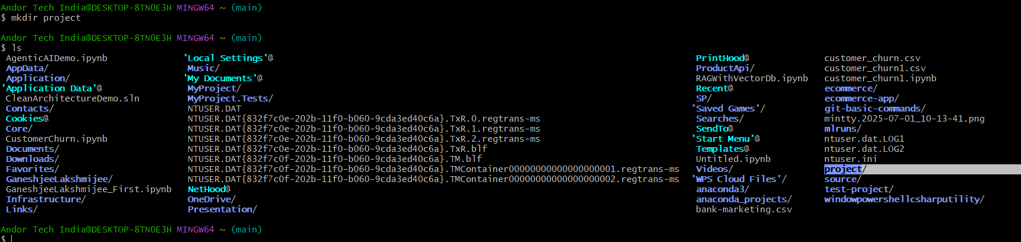

1. Change to working directory / folder

cd project

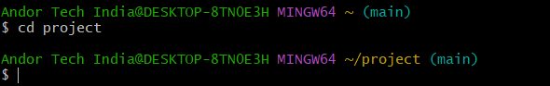

1. Initialize local directory as a repository:

git init

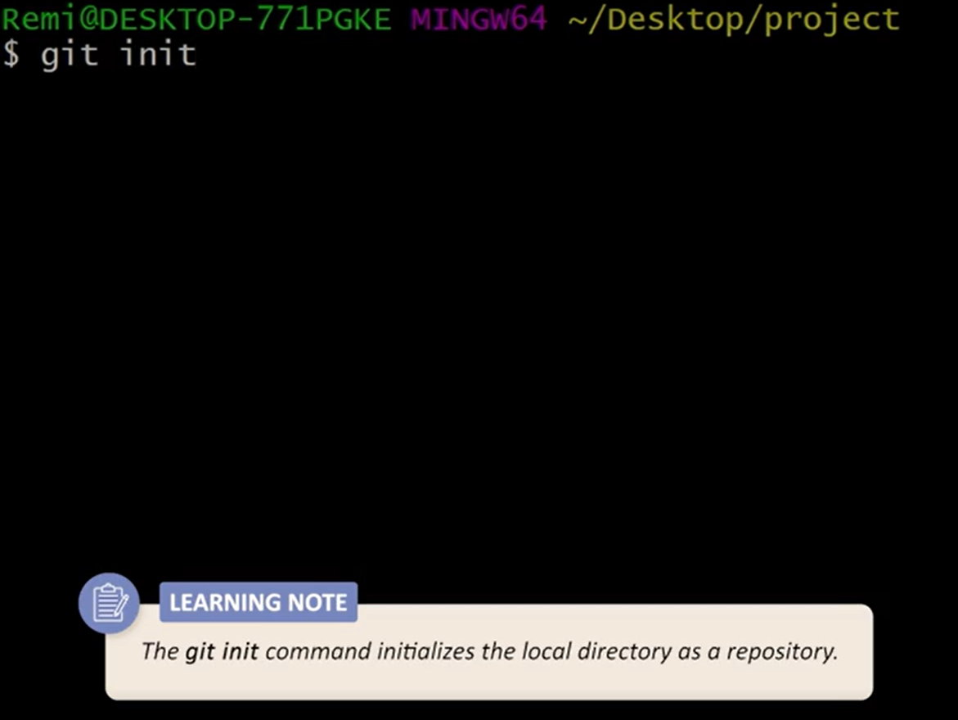

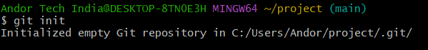

Note : (main) => main / master branch

1. Create a file using nano editor

Eg. Create an Index.html file => a Basic html file

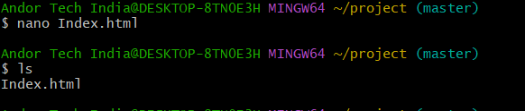

Ctrl+o then Enter

Ctrl+x =>Exit

1. Staging =>Marking of the file and its current version to go into

The commit snapshot:

git add .



This will staged all files in current / working directory/

Note :Check the status of the git

git status

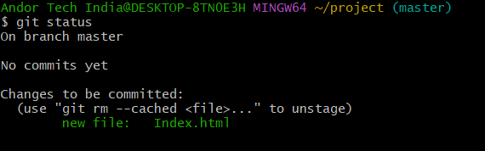

1. Commit changes

git commit -m “Added Index.html file”

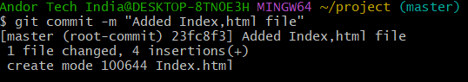

Note: git commit =>commit changes and save only stagged file of previos step.

So for committing stagging of files must be completed.

- chech status:

git status

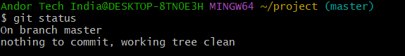

1. Push the code to Git Repository:

This is our git url :https://github.com/Shishu123/git-basic-commands.git

We have already commited code say Index.html to push this url.

We know this but git does not know this what chanes need to push inside the git.

So , we need to run this command:

Andor Tech India@DESKTOP-8TN0E3H MINGW64 ~/project (master)

$ git remote add origin https://github.com/Shishu123/git-basic-commands.git

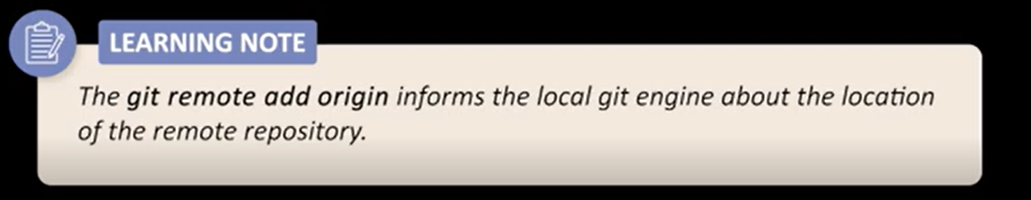

Note : we are adding git url as origin

Now we will push our file to this origin:

Andor Tech India@DESKTOP-8TN0E3H MINGW64 ~/project (master)

$ git push origin master

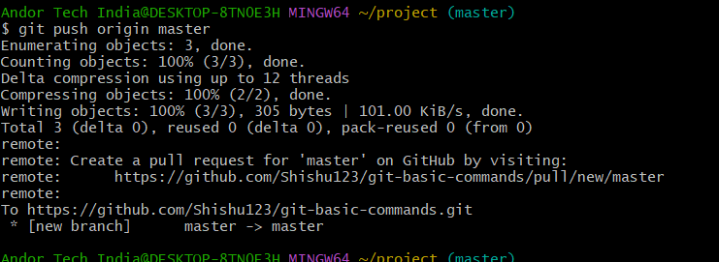

Note: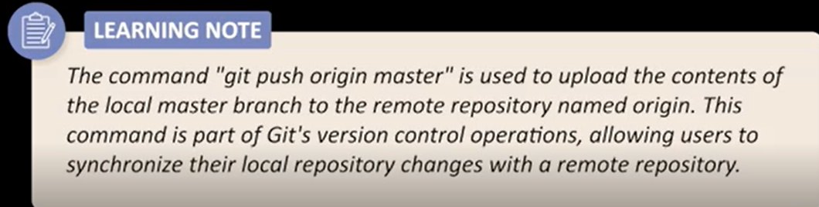

So here local branch master and its commint changes say in Index.html will pushed to the origin.

Origin => url or stands for remote location of the Git.

We can see this Index.html file in git now:

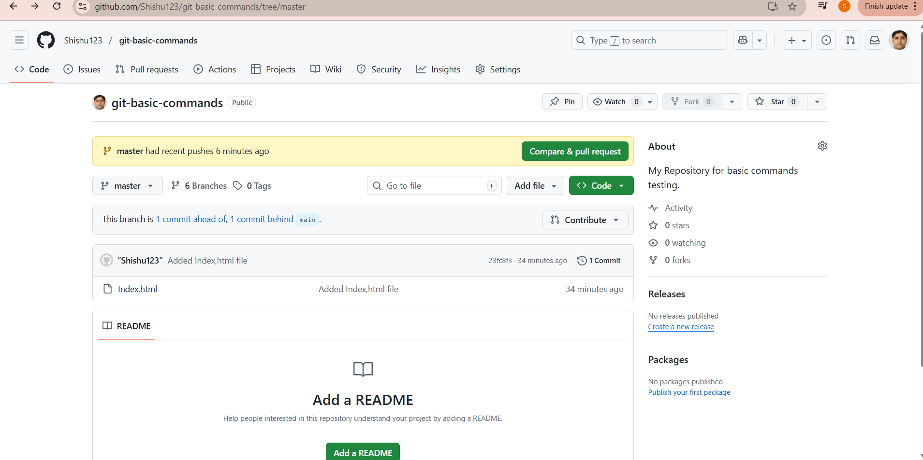

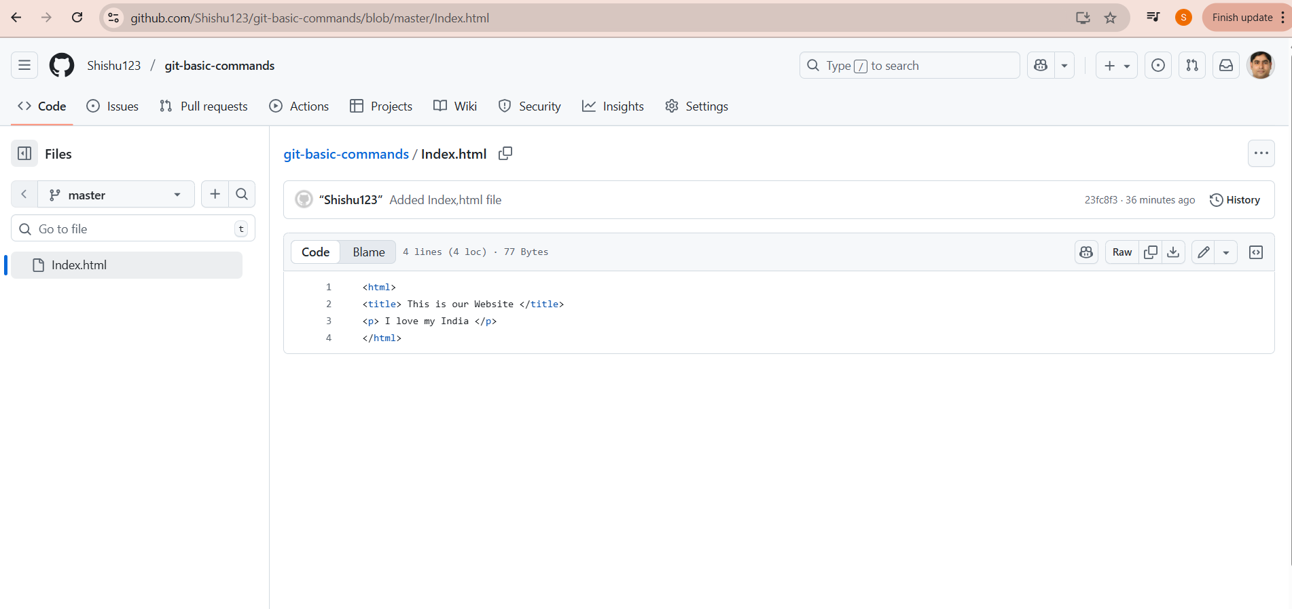

Important Points:

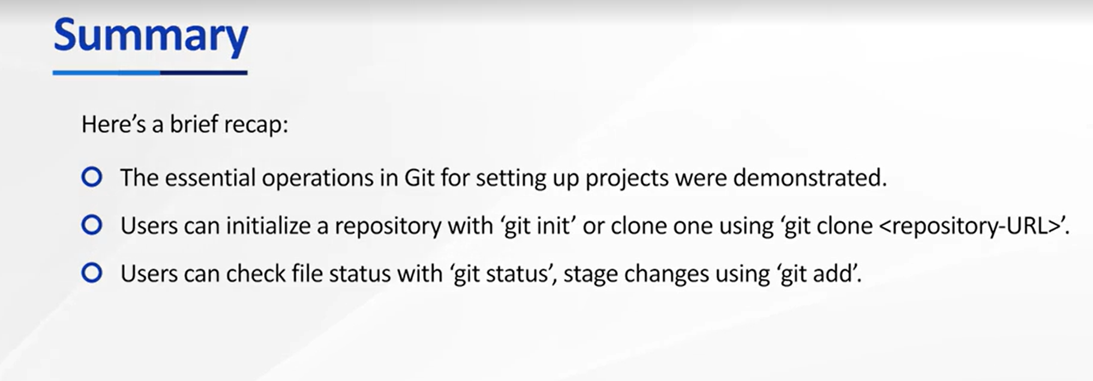

Now we will Change something in Index.html ->Stagged->coomit->Push to origin

Open Index.html file with nano command ->make changes like add h1 tag ->ctrl O for Save ->Enter->Ctrl+X for come out

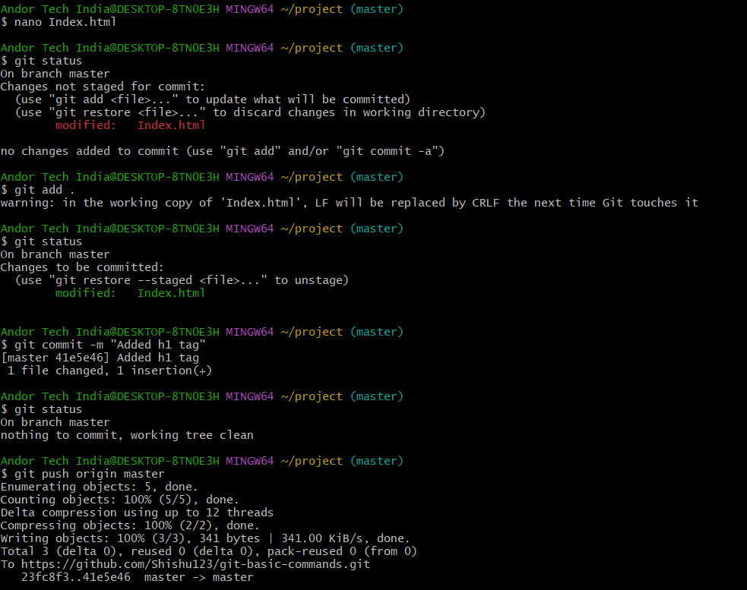

Note : Only 1 time Remote add is required if once done then no need we can directly use

:git push origin master

Example:

Andor Tech India@DESKTOP-8TN0E3H MINGW64 ~/project (master)

$ git push origin master

3rd changes:

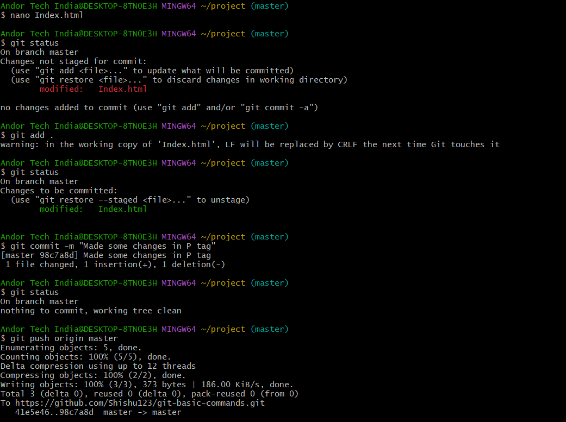

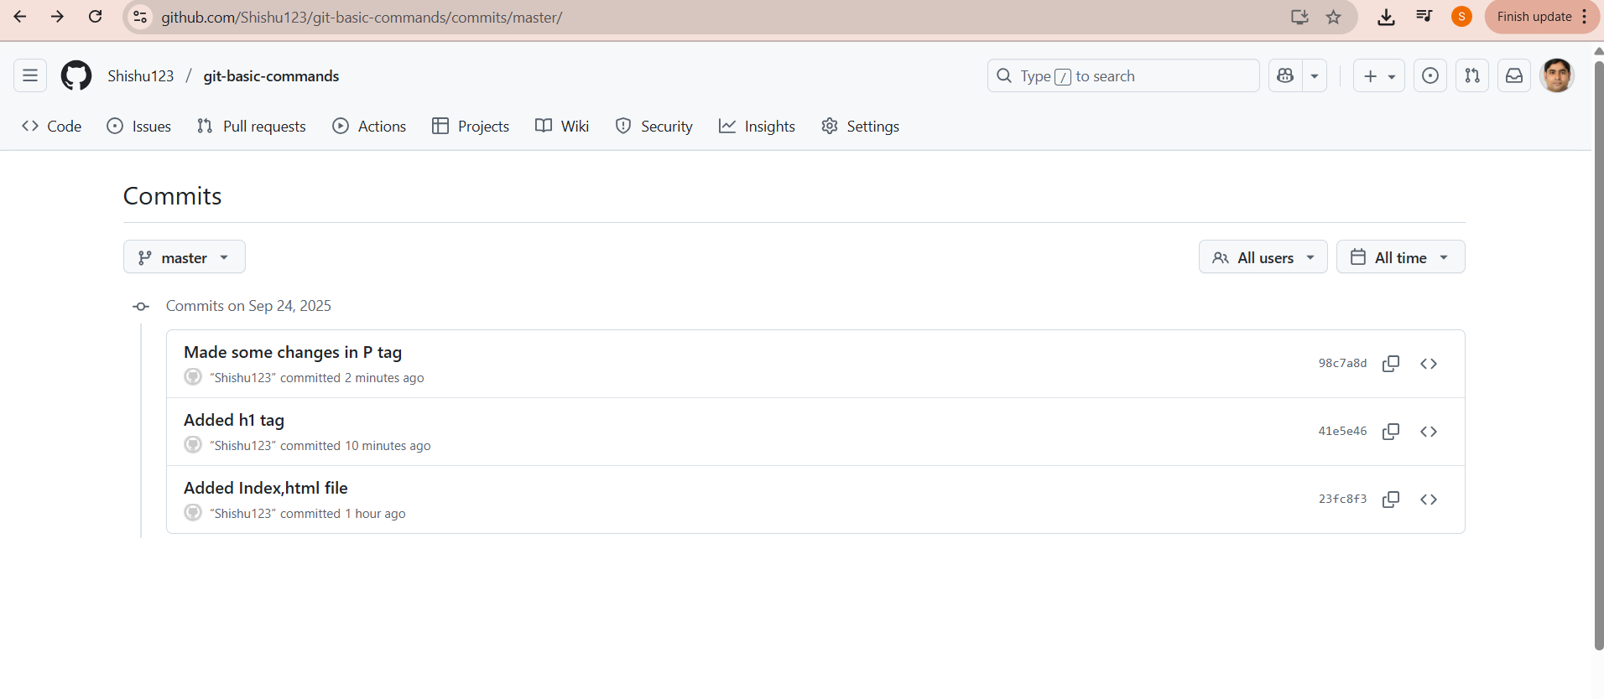

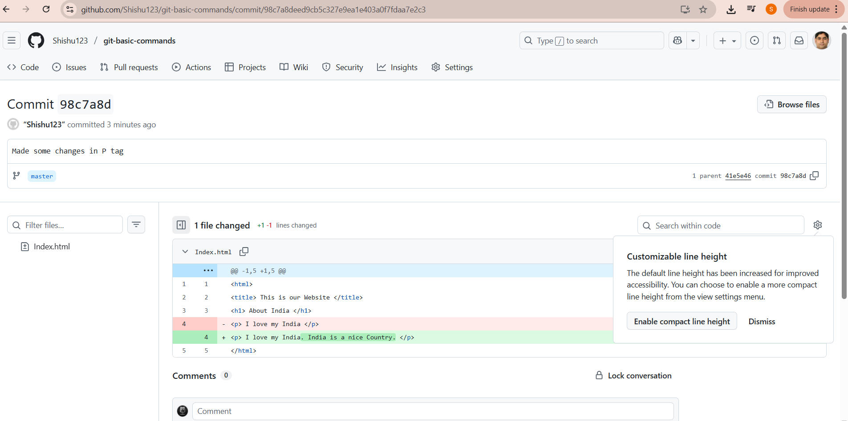

git log =>Tell all local commit commands

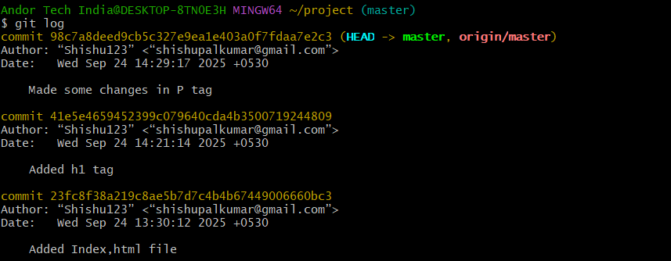

Here 3 commits with 3 commit Ids.

git revert command : It will revert to any git commited version with their commit Id.

