MLops

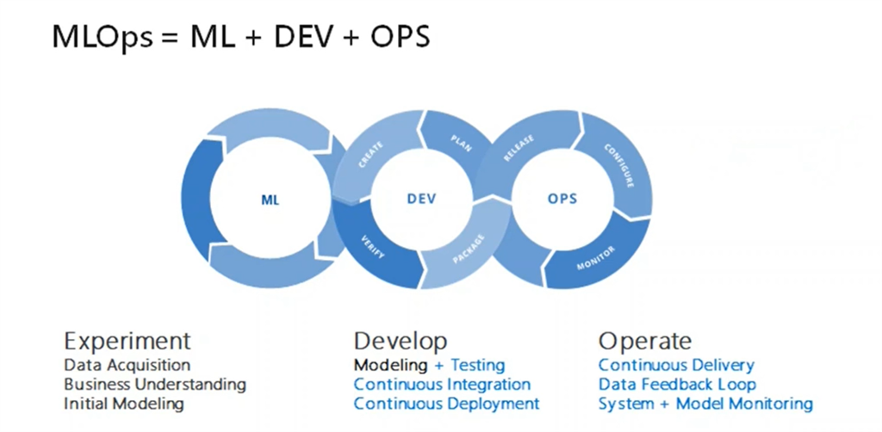

Task Description

1. Create container image that’s has Jenkins installed using dockerfile

2. When we launch this image, it should automatically starts Jenkins service in the container.

3. Create a job chain of job1, job2, job3 and job4 using build pipeline plugin in Jenkins

4. Job1 : Pull the Github repo automatically when some developers push repo to Github.

5. Job2 : By looking at the code or program file, Jenkins should automatically start the respective language interpreter install image container to deploy code ( eg. If code is of PHP, then Jenkins should start the container that has PHP already installed ).

6. Job3 : Test your app if it is working or not.

7. Job4 : if app is not working , then send email to developer with error messages.

8. Create One extra job job5 for monitor : If container where app is running. fails due to any reson then this job should automatically start the container again.

Step 1 -> Here is the Dockerfile to create a image that has Jenkins installed , so that when I launch container it should automatically start Jenkins

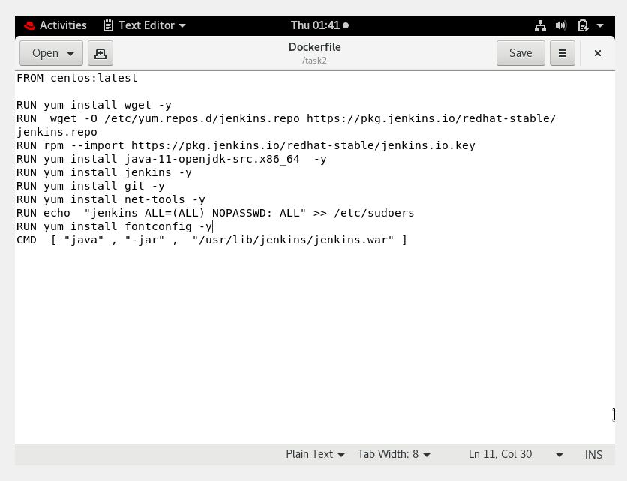

When I launched the container it automatically started the Jenkins

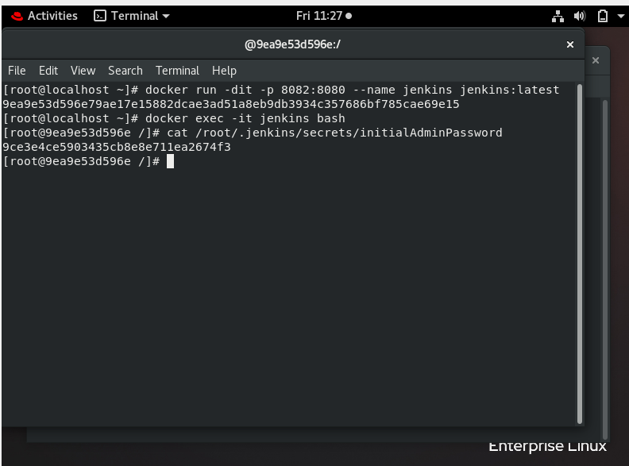

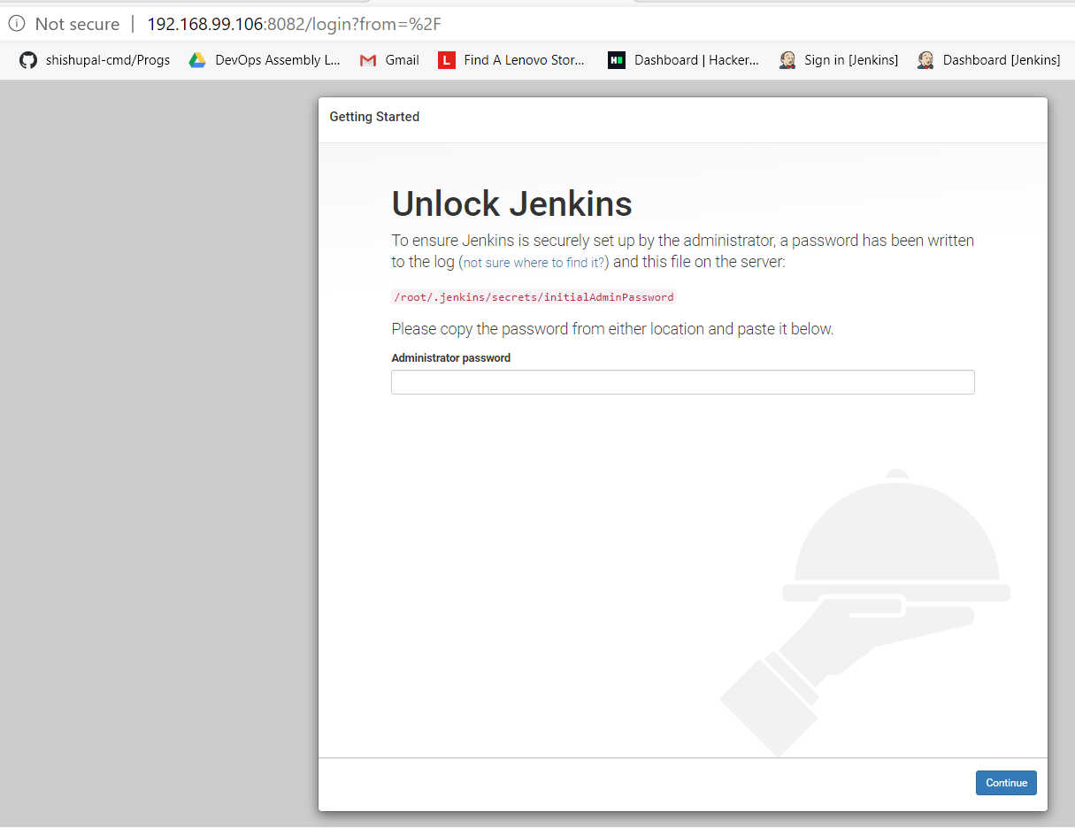

STEP 2 -> Here I have created php and html code in my local git and pushed it to my Github Repository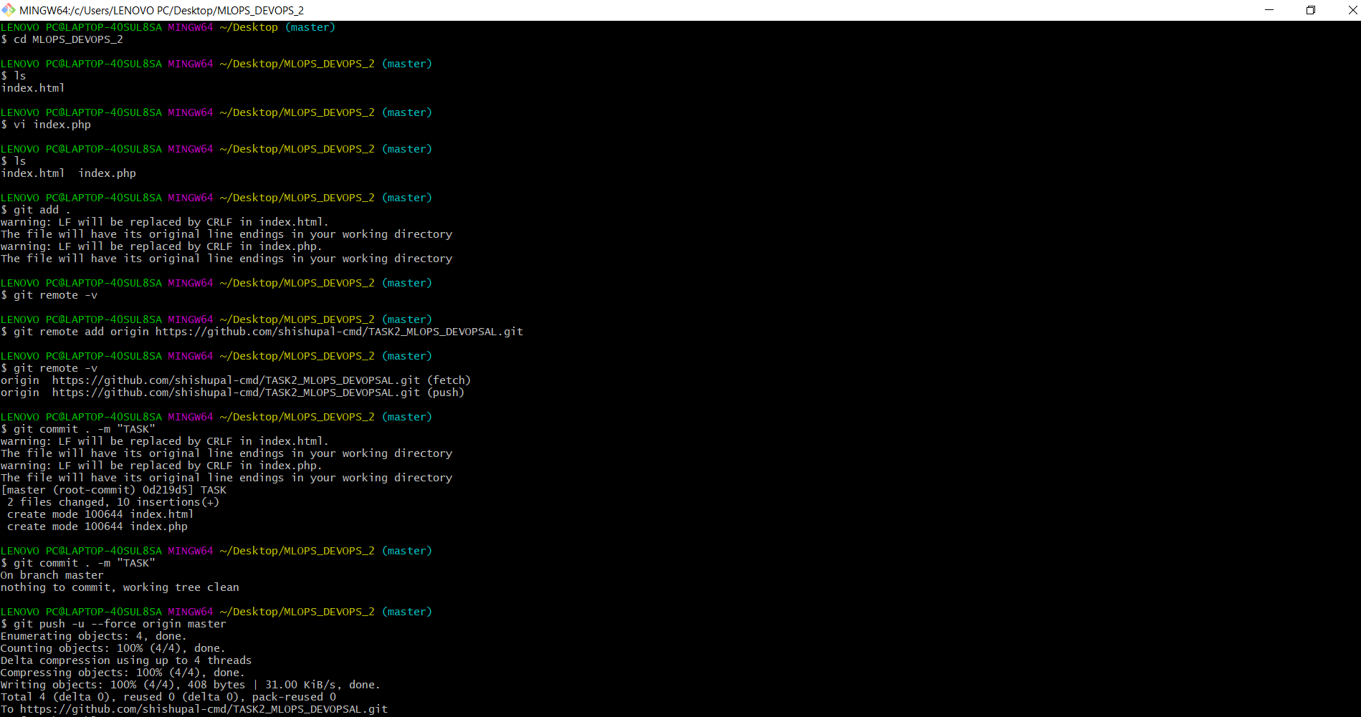

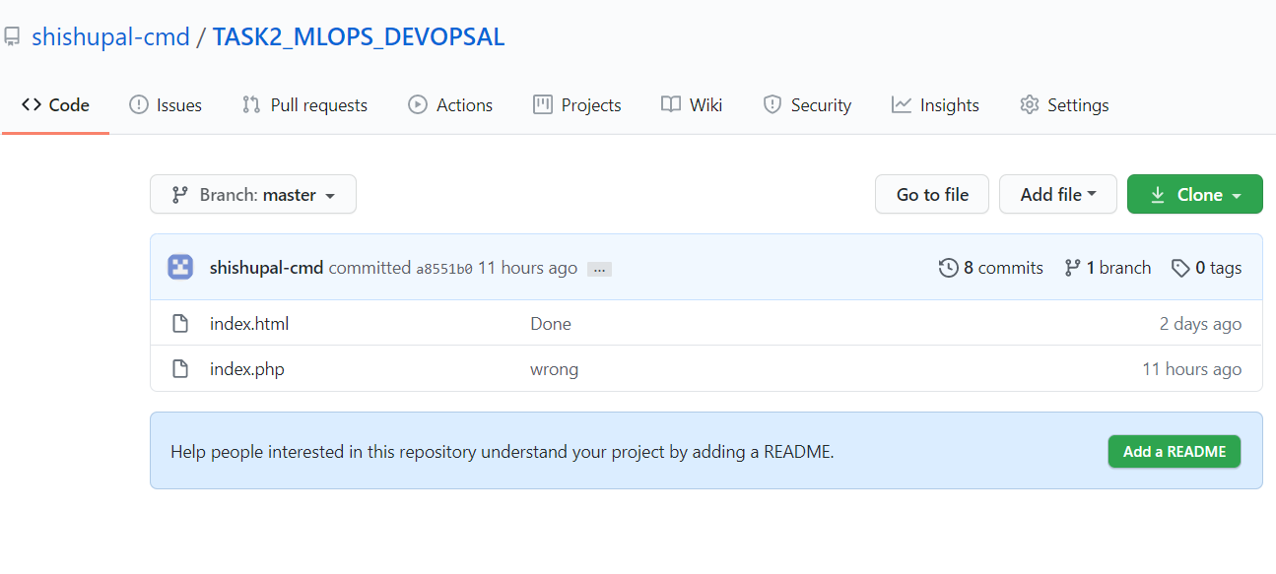

JOB 1 -> This Job will download the code from github and stores in respective language folder

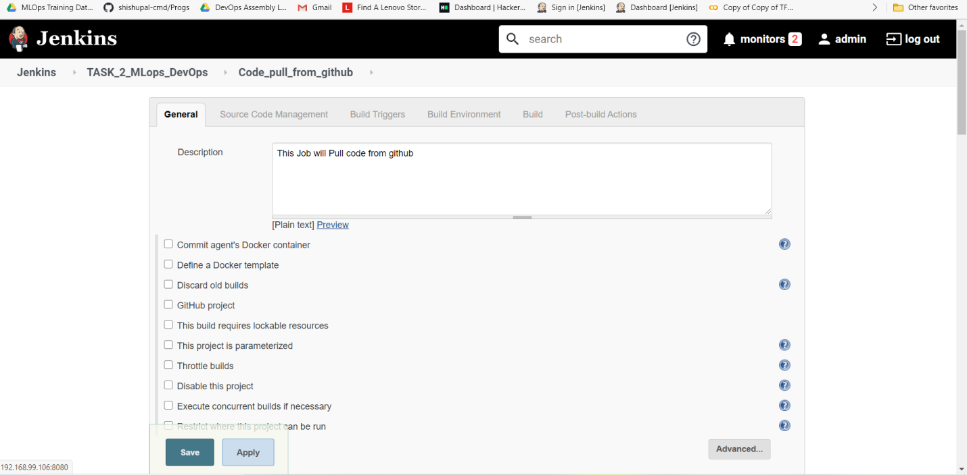

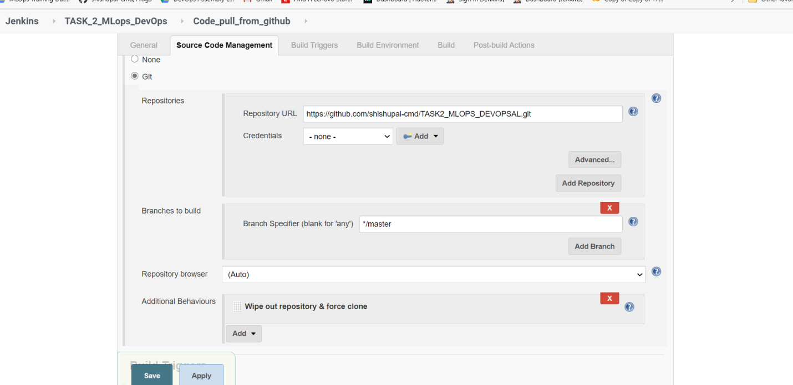

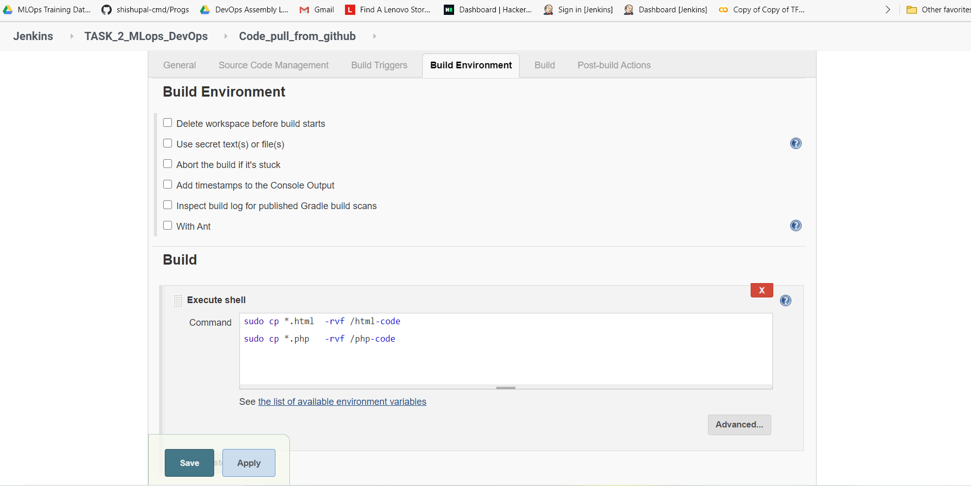

JOB 2 -> This Job will check the code language and run the code in respective container by downloading the image

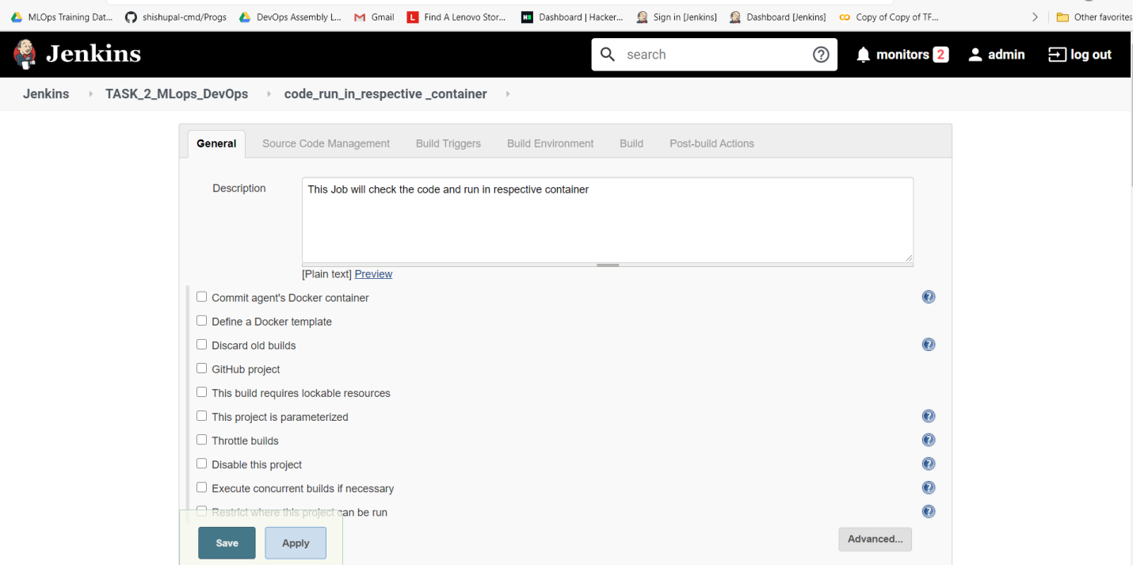

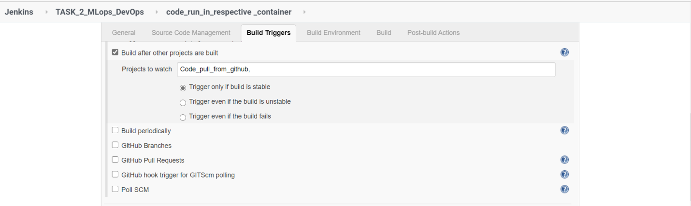

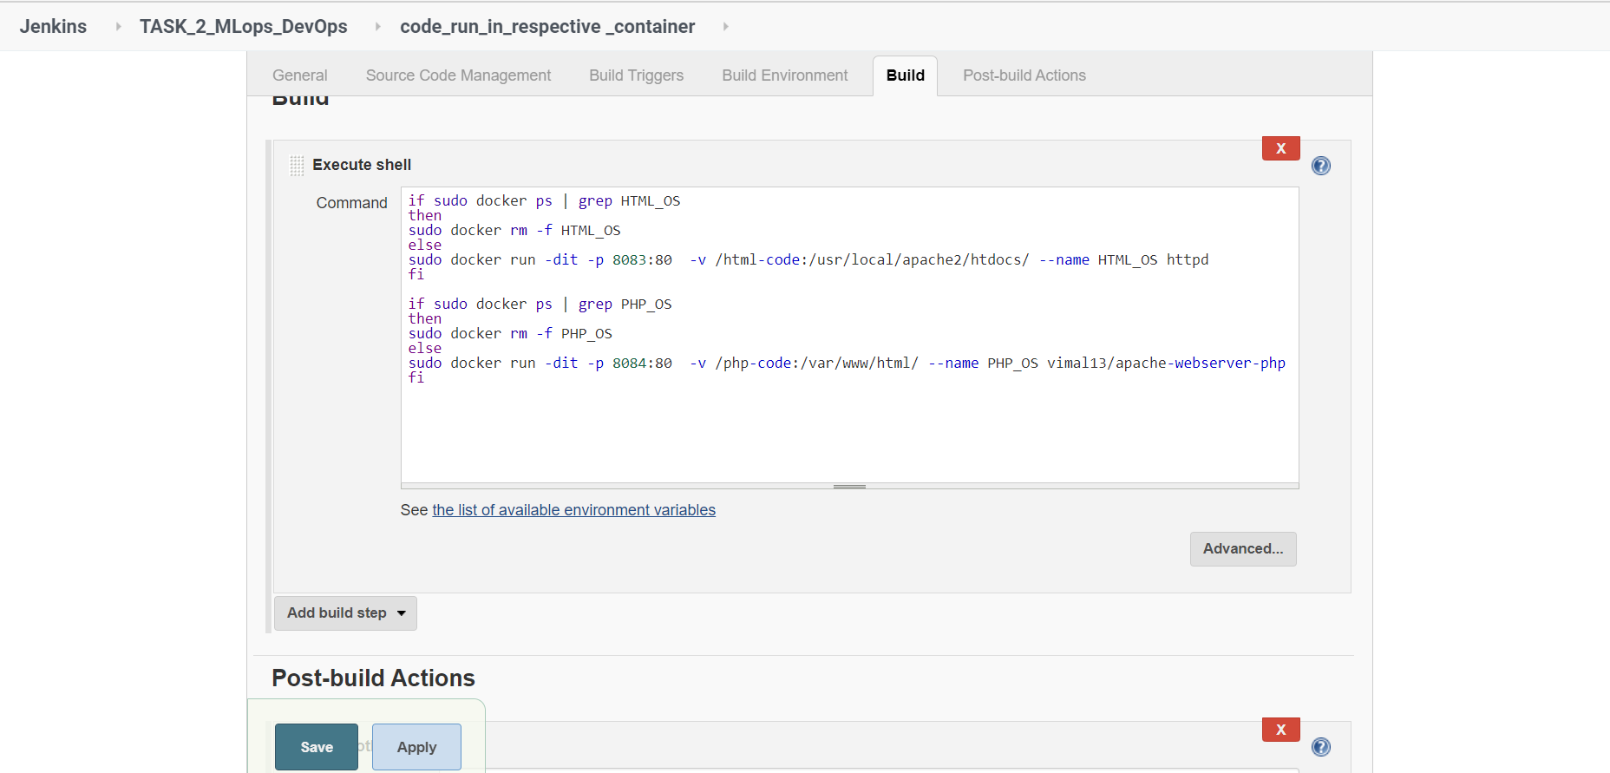

JOB 3 -> This Job is checking whether your application is running well or not . If not then it would display the message and it would fail the build , it woul also trigger the JOB 4

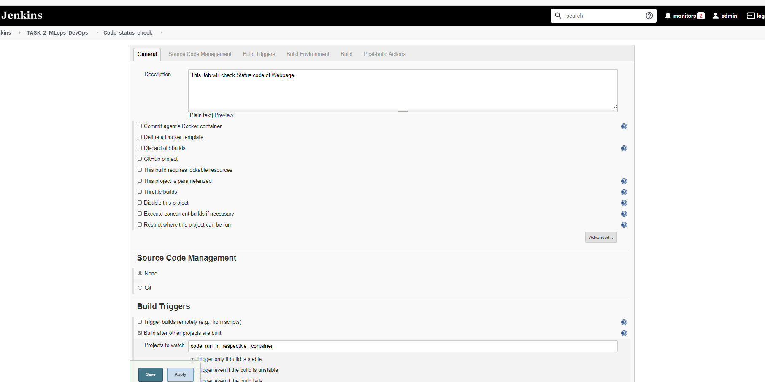

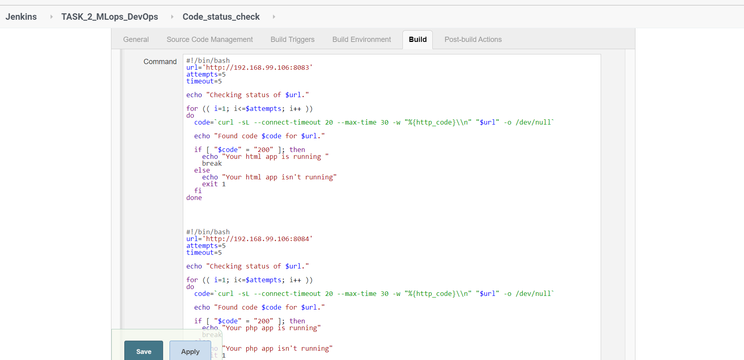

JOB 4 -> This Job will send an email if JOB 3 fails in getting the status code 200 , it would also trigger JOB 5

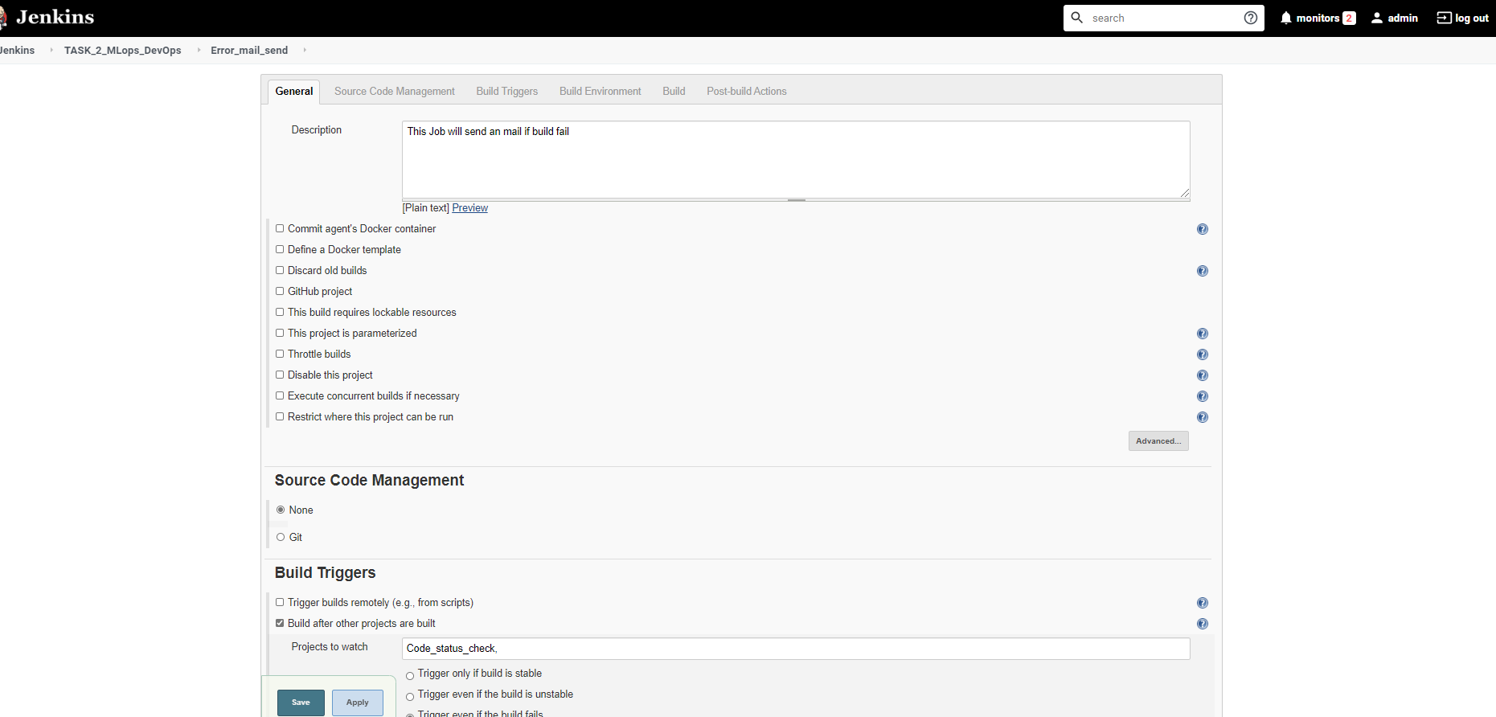

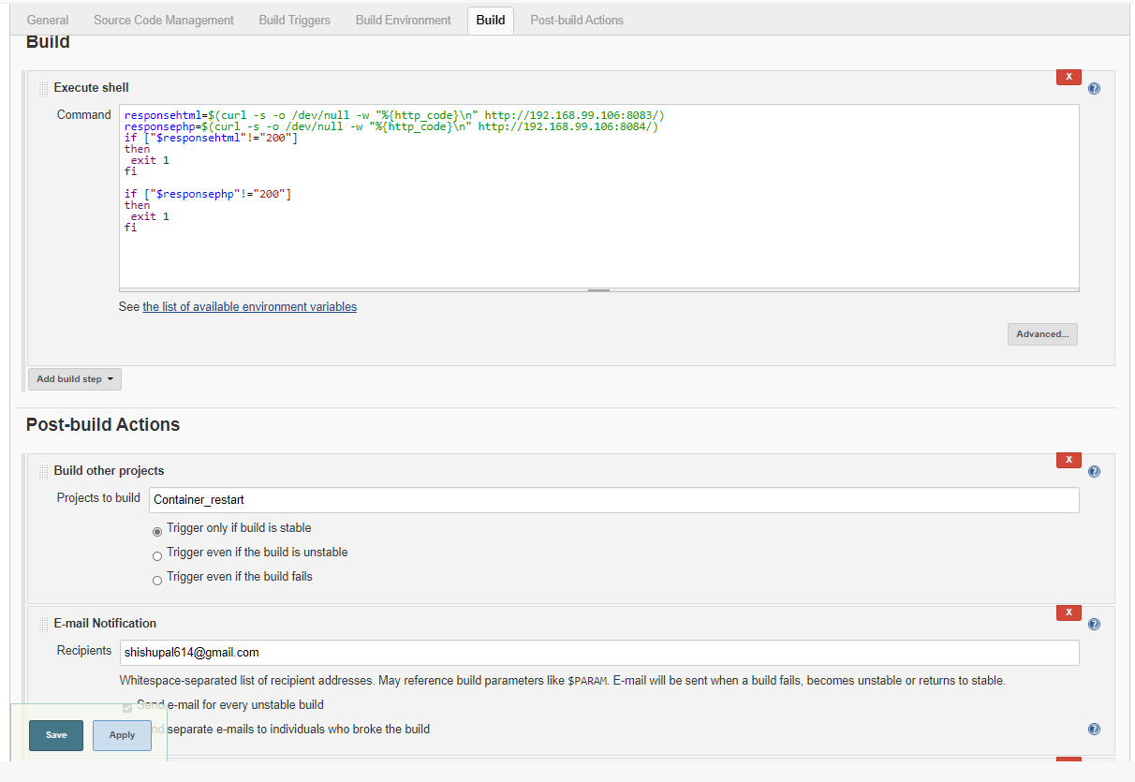

JOB 5 -> This Job will restart the container if container is down

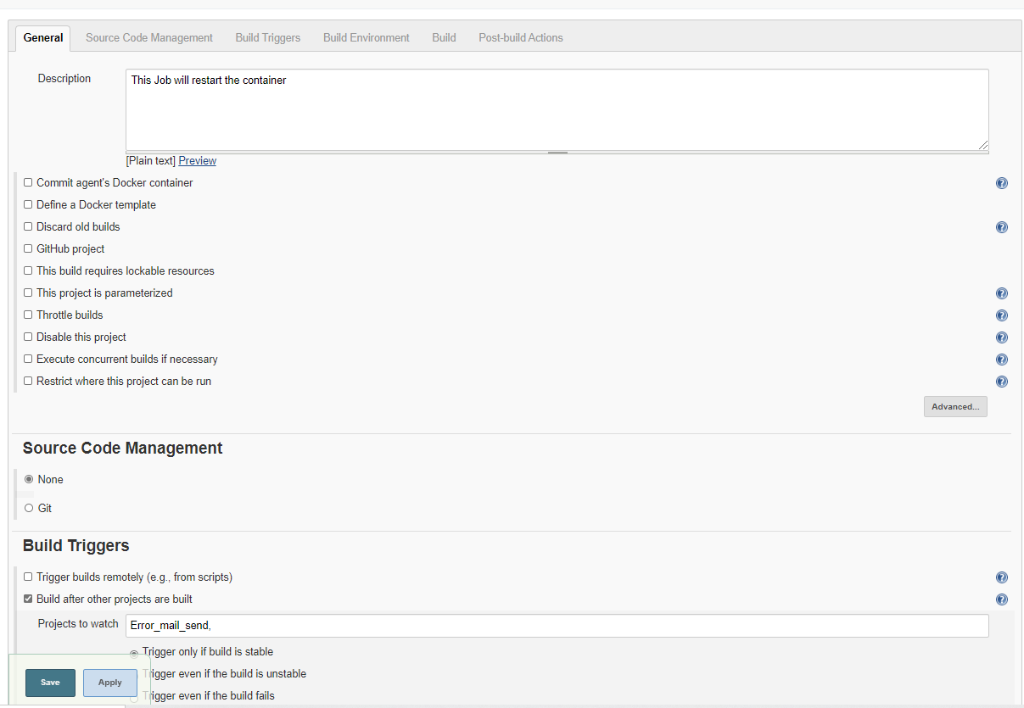

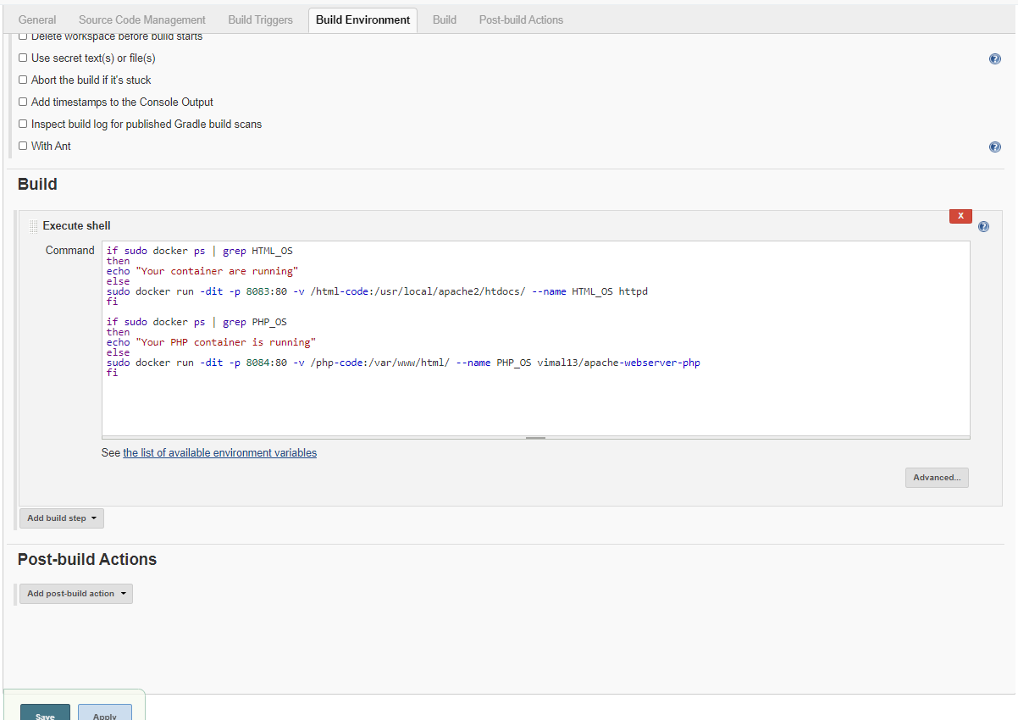

All Job run successfully

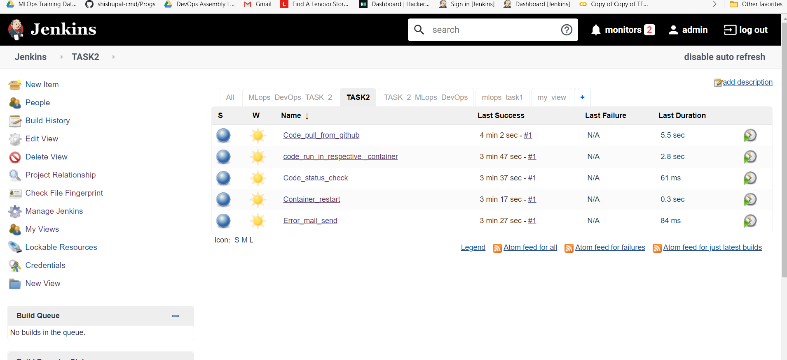

This is the Pipeline to show the order of Jobs

JOB 1 - > JOB 2 -> JOB 3 -> JOB 4 -> JOB 5

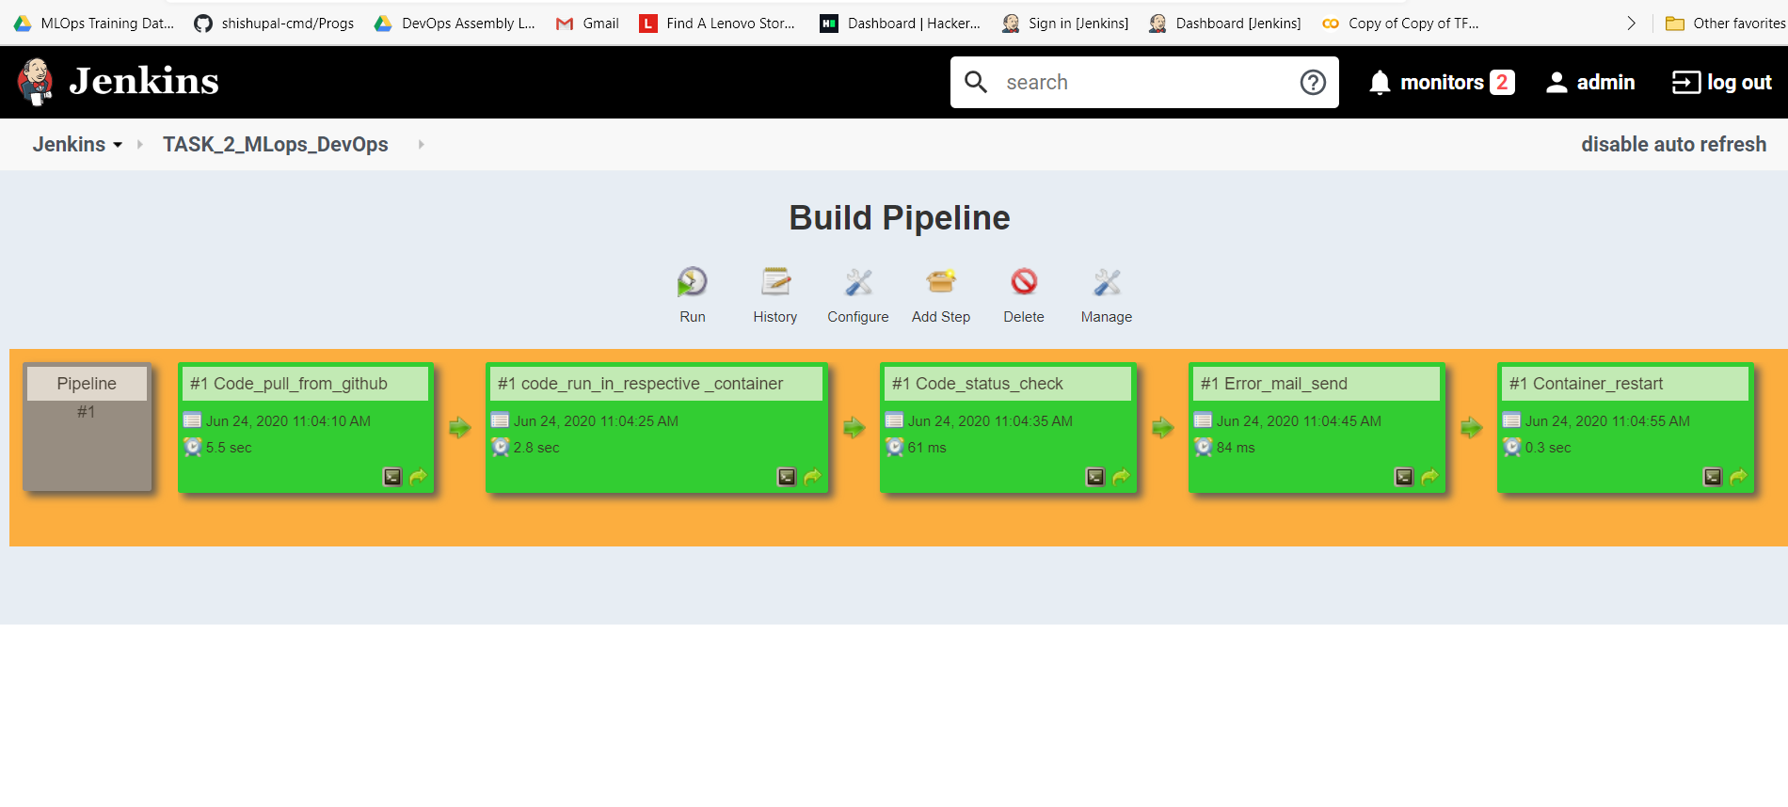

Here I have made some error in PHP code

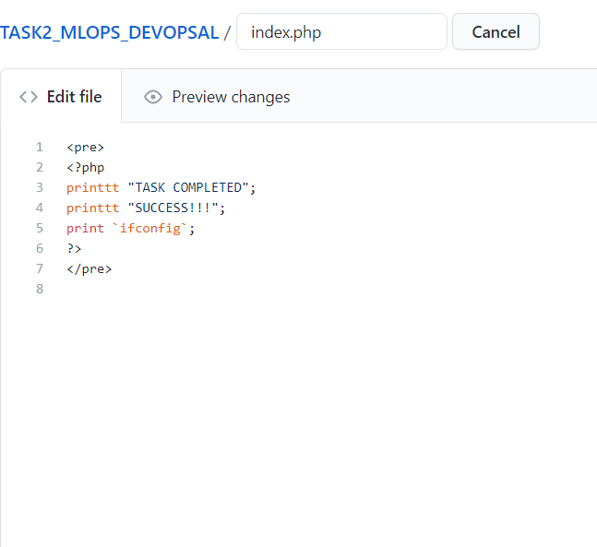

Since the code has error so the JOB 3 and JOB 4 failed and it triggered an email

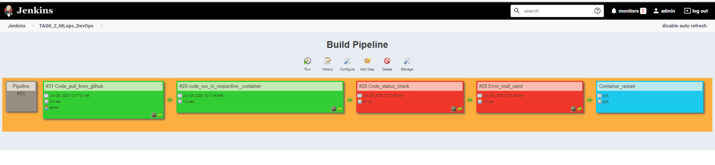

This is the Error Email I have received with Log file

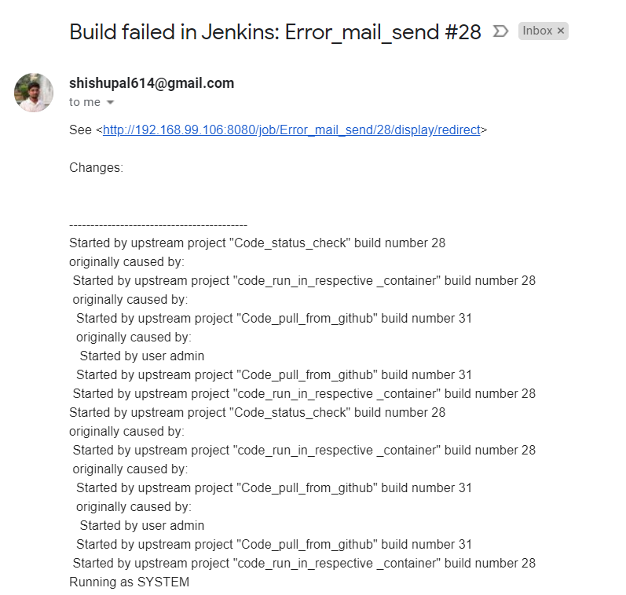

Thank you!!!!