SQL
SQL is a standard language for storing, manipulating and retrieving data in databases.

What is SQL?
- SQL stands for Structured Query Language
- SQL lets you access and manipulate databases
- SQL became a standard of the American National Standards Institute (ANSI) in 1986, and of the International Organization for Standardization (ISO) in 1987
What Can SQL do?
- SQL can execute queries against a database
- SQL can retrieve data from a database
- SQL can insert records in a database
- SQL can update records in a database
- SQL can delete records from a database
- SQL can create new databases
- SQL can create new tables in a database
- SQL can create stored procedures in a database
- SQL can create views in a database
- SQL can set permissions on tables, procedures, and views
- SQL is a Standard - BUT....
- Although SQL is an ANSI/ISO standard, there are different versions of the SQL language.
- However, to be compliant with the ANSI standard, they all support at least the major commands (such as SELECT, UPDATE, DELETE, INSERT, WHERE) in a similar manner.

RDBMS
RDBMS stands for Relational Database Management System.
RDBMS is the basis for SQL, and for all modern database systems such as MS SQL Server, IBM DB2, Oracle, MySQL, and Microsoft Access.
The data in RDBMS is stored in database objects called tables. A table is a collection of related data entries and it consists of columns and rows.

Some of The Most Important SQL Commands
- SELECT - extracts data from a database
- UPDATE - updates data in a database
- DELETE - deletes data from a database
- INSERT INTO - inserts new data into a database
- CREATE DATABASE - creates a new database
- ALTER DATABASE - modifies a database
- CREATE TABLE - creates a new table
- ALTER TABLE - modifies a table
- DROP TABLE - deletes a table
- CREATE INDEX - creates an index (search key)
- DROP INDEX - deletes an index

SQL CREATE DATABASE Statement
The SQL CREATE DATABASE Statement
The CREATE DATABASE statement is used to create a new SQL database.
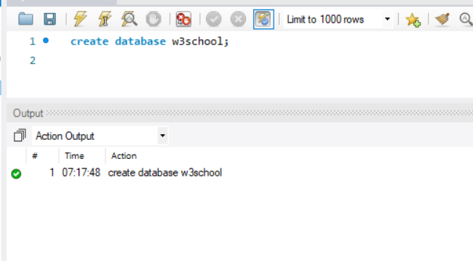

SQL DROP DATABASE Statement
The SQL DROP DATABASE Statement
The DROP DATABASE statement is used to drop an existing SQL database.
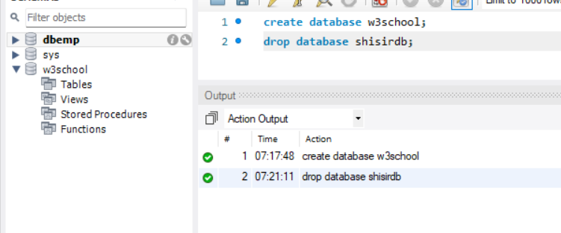
SQL CREATE TABLE Statement
The SQL CREATE TABLE Statement
The CREATE TABLE statement is used to create a new table in a database.
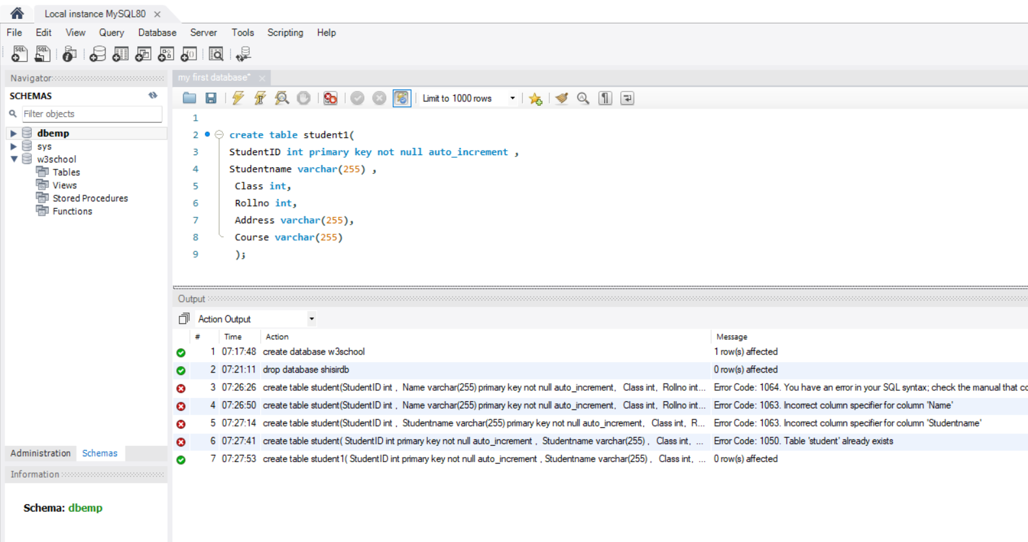

The SQL DROP TABLE Statement
The DROP TABLE statement is used to drop an existing table in a database.
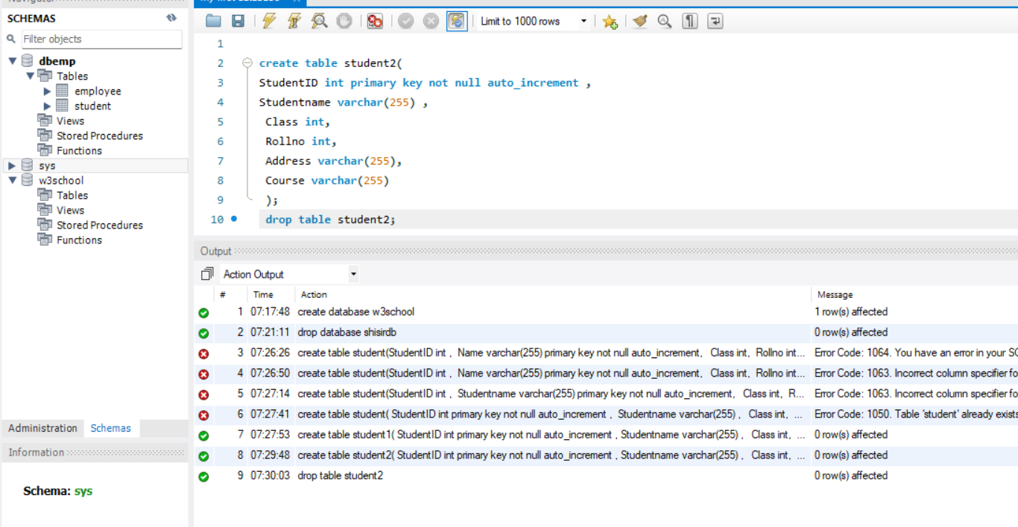

SQL INSERT INTO Statement
The SQL INSERT INTO Statement
The INSERT INTO statement is used to insert new records in a table.
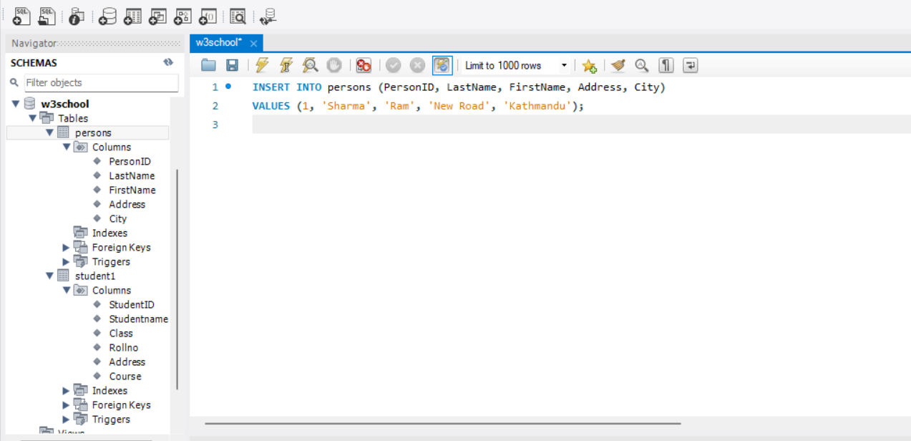

SQL UPDATE Statement
The SQL UPDATE Statement
The UPDATE statement is used to modify the existing records in a table.

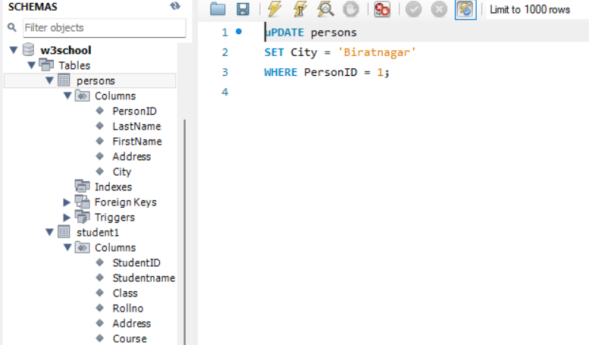
SQL LIKE Operator
The SQL LIKE Operator
The LIKE operator is used in a WHERE clause to search for a specified pattern in a column.
There are two wildcards often used in conjunction with the LIKE operator:
- The percent sign % represents zero, one, or multiple characters
- The underscore sign _ represents one, single character
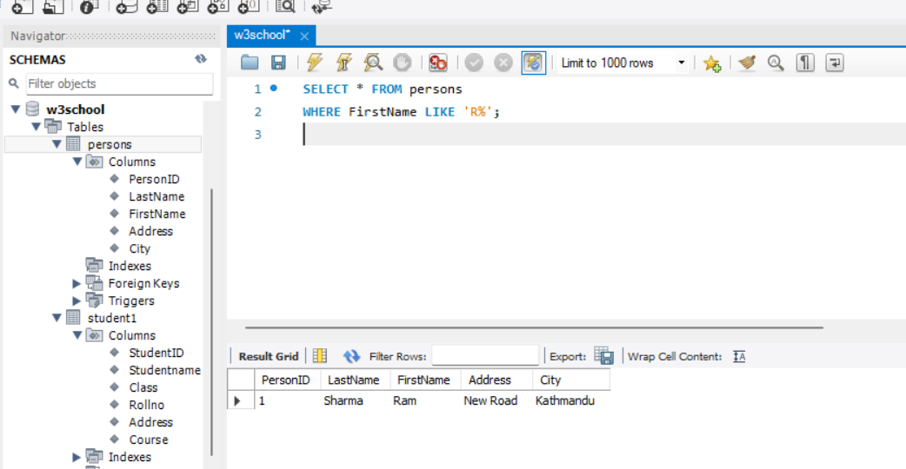

SQL Joins
SQL JOIN
A JOIN clause is used to combine rows from two or more tables, based on a related column between them.
