**Car Rental System**

Project 2- Part 1

**Members**

Rabindra Yadav

Saugat Karki

Shiska Raut

CSE 3330 – Spring 2021

Instructor: Nadra Guizani

**Mini World description**

A rental company allows customers to rent an available vehicle of choice. Each rental leads to creation of a rental entity that keeps track of all information regarding the vehicle rented. The company also keeps track of information relating customer (Name, Phone, CustomerID) and all the vehicles in their inventory (make, model, year, etc.). In order to rent out a vehicle, the company also tracks vehicle availability (StartDate, ReturnDate, etc.The company stores information relating to every vehicle that is rented(RentalID, VehicleID, IDNo, etc..).

**Entities and Relations**

Prior to designing a database for a car rental company, three entities and 3 relations were determined from the stated requirements. The first relation ‘makes’ connects entity ‘CUSTOMERS’ to entity ‘RENTALS’ as customers make rentals from a rental company. The second relation ‘includes’ connected entity ‘RENTALS’ to entity ‘CARS’ as rentals include cars. A third relation ‘availability’ also exists between entity ‘CARS’ and entity ‘RENTALS’ as cars may or may not be available to rent by the company.

**Primary and Foreign Keys**

The primary key for entity ‘CUSTOMERS’ will be a unique ‘IdNo’ generated by the system with auto-increment for each new customer. The primary key for entity ‘CARS’ will be a unique ‘VehicleID’ and the primary key for entity ‘RENTALS’ will be a unique identifier ‘RentalID’. ‘RENTALS’ will also have two foreign keys” ‘IdNo’ referenced from ‘CUSTOMERS’ and ‘VehicleID’ referenced from ‘CARS’. An additional table will be created for relationship ‘AVAILABILITY’ which will have a foreign key ‘VehicleID’ referenced from ‘RENTALS’.

**Additional Attributes**

In order to keep track of whether a rental is currently active or scheduled for the future, an additional attribute ‘activeorscheduled’ was added to ‘RENTALS’. Additionally, to keep track of the period during which a car becomes available, attribute ‘AvailablePeriod’ was added to relation ‘AVAILABILITY’.

**Derived Attributes**

Attribute ‘ReturnDate’ and ‘AmountDue’ in RENTALS was listed as a derived attribute as they can be calculated using other attributes such as ‘StartDate’, ‘NoOfDays’, ‘DailyRate’,’WeeklyRate’,etc. Attribute ‘AvailablePeriod’ was under relation ‘AVAILABILITY’ was also listed as a derived attribute as it can be derived using ‘StartDate’, ‘ReturnDate’ in ‘RENTALS’.

**ER diagram**

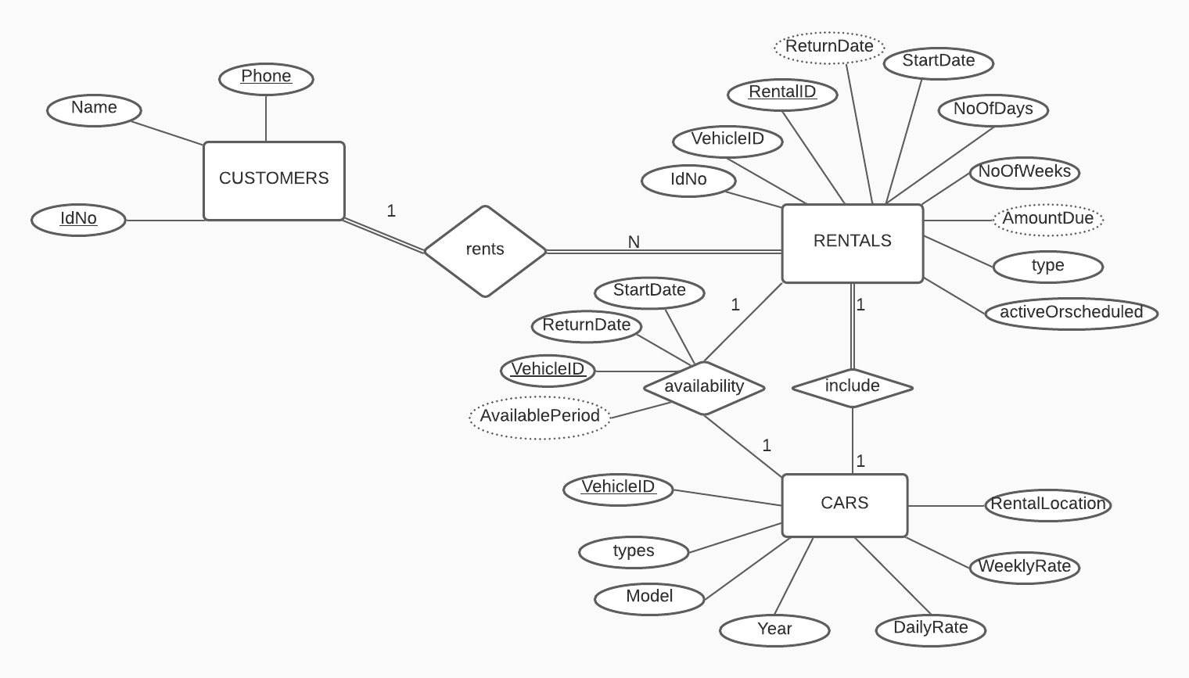

**Relational database schema**

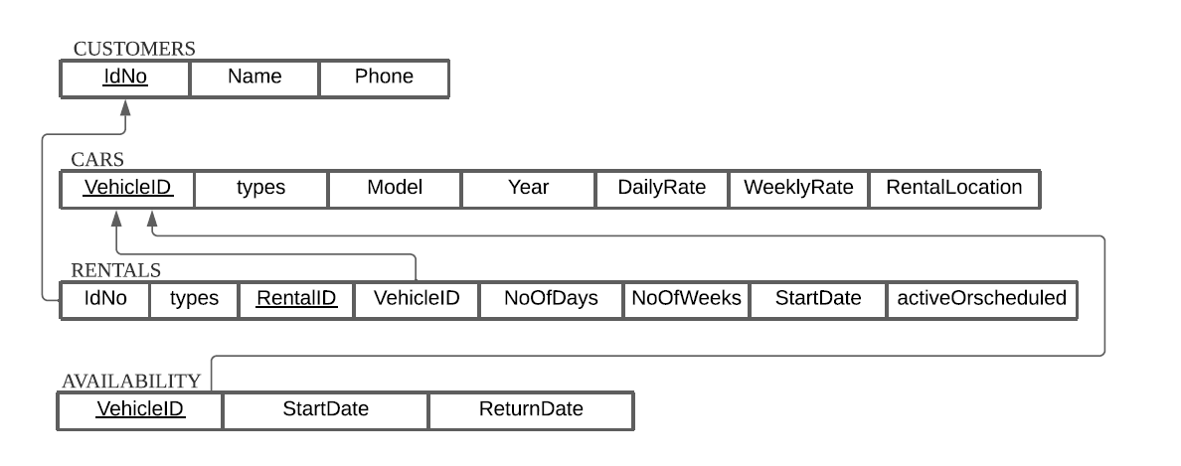

**References**

1. Mapping the er model to relational dbs. (n.d.). Retrieved April 02, 2021, from <http://jcsites.juniata.edu/faculty/rhodes/dbms/ermapping.htm>
2. Er diagram representation. (n.d.). Retrieved April 02, 2021, from https://www.tutorialspoint.com/dbms/er_diagram_representation.htm

HONOR CODE:

*I pledge, on my honor, to uphold UT Arlington's tradition of academic integrity, a tradition that values hard work and honest effort in the pursuit of academic excellence. I promise that I will submit only work that I personally create or that I contribute to group collaborations, and I will appropriately reference any work from other sources. I will follow the highest standards of integrity and uphold the spirit of the Honor Code.*