**CSE 3330: Project 2 - Part 3**

Rabindra Yadav

Saugat Karki

Shiska Raut

HONOR CODE

I pledge, on my honor, to uphold UT Arlington’s tradition of academic integrity, a tradition that values hard work and honest effort in the pursuit of academic excellence.

I promise that I will submit only work that I personally create or that I contribute to group collaborations, and I will appropriately reference any work from other sources. I will follow the highest standards of integrity and uphold the spirit of the Honor Code.

RABINDRA YADAV

HONOR CODE

I pledge, on my honor, to uphold UT Arlington’s tradition of academic integrity, a tradition that values hard work and honest effort in the pursuit of academic excellence.

I promise that I will submit only work that I personally create or that I contribute to group collaborations, and I will appropriately reference any work from other sources. I will follow the highest standards of integrity and uphold the spirit of the Honor Code.

SAUGAT KARKI

HONOR CODE

I pledge, on my honor, to uphold UT Arlington’s tradition of academic integrity, a tradition that values hard work and honest effort in the pursuit of academic excellence.

I promise that I will submit only work that I personally create or that I contribute to group collaborations, and I will appropriately reference any work from other sources. I will follow the highest standards of integrity and uphold the spirit of the Honor Code.

SHISKA RAUT

**TASK 1:**

**Query 1:**

--adding a new column ‘Returned’ to Rental that will have 1 for returned vehicles and 0 if not returned

ALTER TABLE RENTAL

ADD Returned TINYINT NOT NULL DEFAULT

(CASE WHEN RENTAL.ReturnDate IS NOT NULL THEN 1 ELSE 0 END);

‘SELECT * FROM RENTAL’ results:

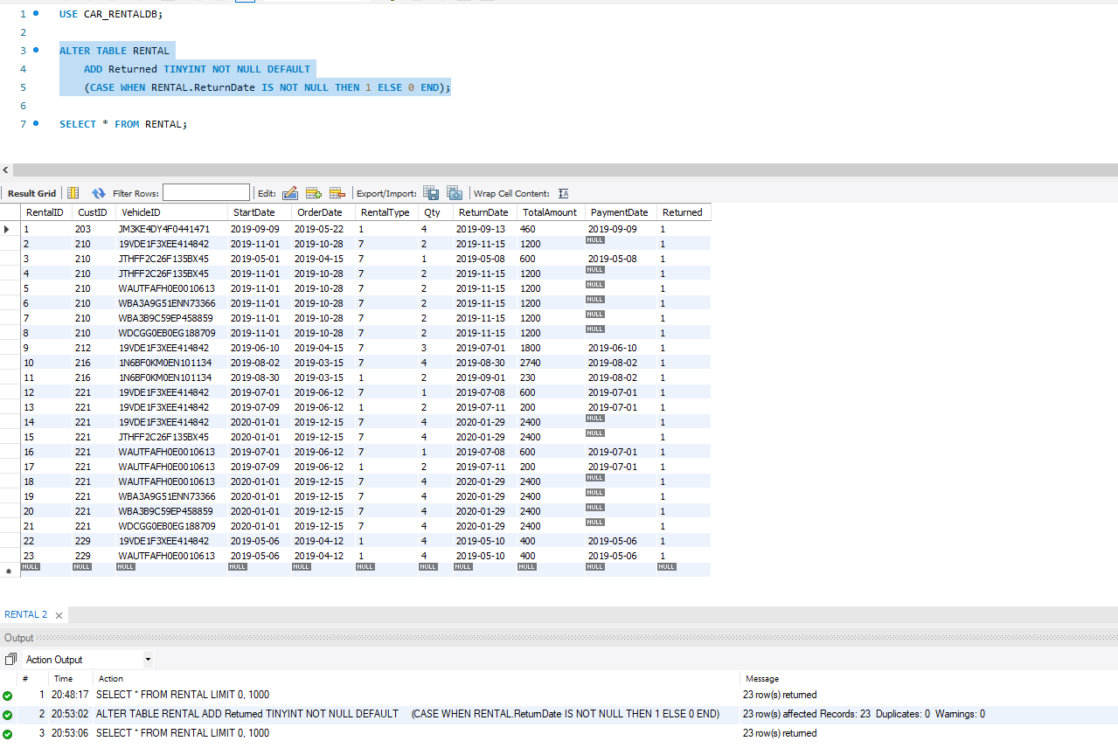

--updating column Rental.Returned to have 1 for vehicles with a payment date and 0 for those with null values for PaymentDate

UPDATE RENTAL

SET RENTAL.Returned = (CASE WHEN RENTAL.PaymentDate IS NOT NULL THEN 1 ELSE 0 END);

‘SELECT * FROM RENTAL’ results:

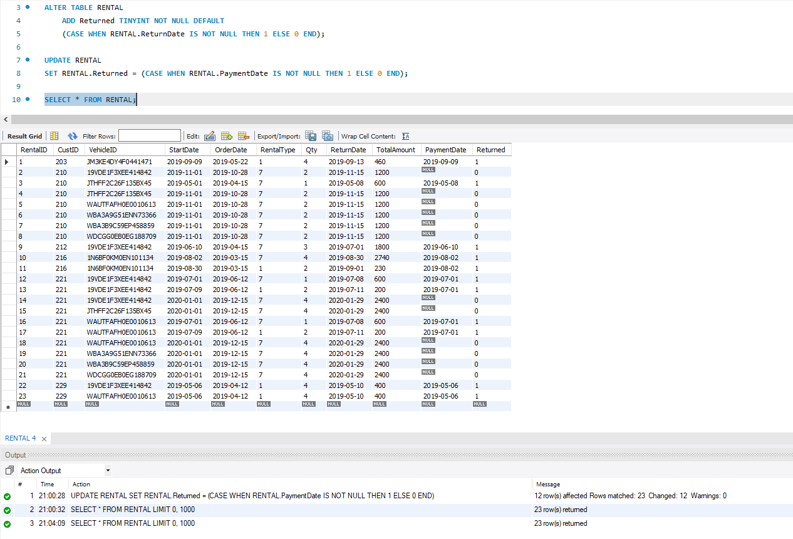

**Query 2:**

CREATE VIEW vRentalInfo

AS SELECT R.OrderDate, R.StartDate, R.ReturnDate, R.VehicleID AS 'VIN',

V.Description AS 'Vehicle', V.Category AS 'Category',

R.CustID AS 'CustomerID', C.Name AS 'CustomerName', R.TotalAmount AS 'OrderAmount',

CASE

WHEN V.Type = 1 THEN 'Compact'

WHEN V.Type = 2 THEN 'Medium'

WHEN V.Type = 3 THEN 'Large'

WHEN V.Type = 4 THEN 'SUV'

WHEN V.Type = 5 THEN 'Truck'

WHEN V.Type = 6 THEN 'VAN'

END AS Type,

CASE

WHEN R.ReturnDate IS NOT NULL THEN DATEDIFF(R.ReturnDate, R.StartDate)

END AS TotalDays,

CASE

WHEN R.PaymentDate IS NOT NULL THEN 0

WHEN R.PaymentDate IS NULL THEN R.TotalAmount

END AS ReturnBalance

FROM RENTAL R

NATURAL JOIN VEHICLE V

NATURAL JOIN CUSTOMER C

ORDER BY R.StartDate ASC;

‘SELECT * FROM vRentalInfo’ result:

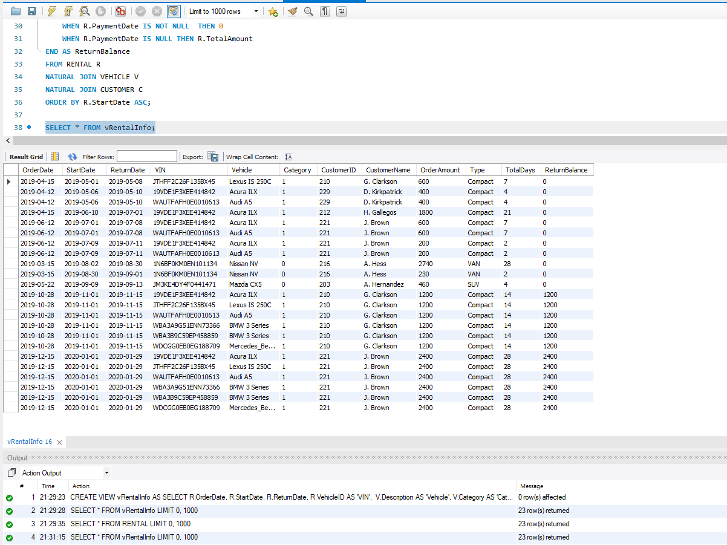

Action Output Response:

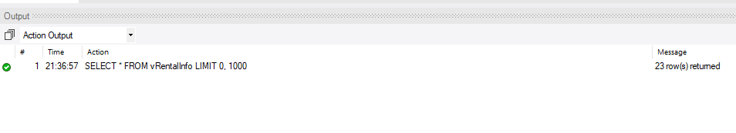

**TASK 2:**

**Query 1:**

custname = name.get()

custphone = phone.get()

c.execute("INSERT INTO CUSTOMER( Name, Phone) VALUES ( '"+custname+"', '"+custphone+"')")

**Query 2:**

vid = vehicleID.get()

desc = description.get()

yr = year.get()

tpe = type.get()

cat = category.get()

c.execute("INSERT INTO VEHICLE(VehicleID, Description, Year, Type,Category) VALUES ('"+vid+"', '"+desc+"', '"+yr+"', '"+tpe+"', '"+cat+"')")

**Query 3:**

-- this query will first create a view with a table which will make finding avaialbility easier

CREATE VIEW AVAILABILITY1

AS SELECT V.VehicleID, R.RentalID, R.StartDate, R.ReturnDate,

CASE

WHEN R.RentalID IS NOT NULL THEN DATEDIFF(R.ReturnDate, R.StartDate)

WHEN R.RentalID IS NULL THEN DATEDIFF('2021-04-16', '2021-04-16') -- zero

END AS Days_Rented

FROM VEHICLE V

LEFT JOIN RENTAL R

ON V.VehicleID = R.VehicleID;

-- query will run to show a list of vehicles available during the entered period of specific category and type

-- this query uses start date '2019-06-01' and end date '2019-06-20' Type 1 and Category 0

SELECT V1.VehicleID, V1.Description,

CASE

WHEN V1.Category = 1 THEN 'Luxury'

WHEN V1.Category = 0 THEN 'Basic'

END AS Category,

CASE

WHEN V1.Type = 1 THEN 'Compact'

WHEN V1.Type = 2 THEN 'Medium'

WHEN V1.Type = 3 THEN 'Large'

WHEN V1.Type = 4 THEN 'SUV'

WHEN V1.Type = 5 THEN 'Truck'

WHEN V1.Type = 6 THEN 'VAN'

END AS Type

FROM VEHICLE V1

WHERE V1.VehicleID IN

(SELECT DISTINCT V.VehicleID AS VIN

FROM VEHICLE V

LEFT JOIN AVAILABILITY1 A

ON V.VehicleID = A.VehicleID

WHERE V.VehicleID IN (SELECT DISTINCT A1.VehicleID

FROM AVAILABILITY1 A1

WHERE ((A1.StartDate < '2019-06-01' AND A1.ReturnDate < '2019-06-01') -- avaiable bc already returned before 1

OR (A1.StartDate > '2019-06-20' AND A1.ReturnDate > '2019-06-20')) -- avaiable bc will only ne rented after 20

AND A1.VehicleID NOT IN (SELECT DISTINCT A3.VehicleID

FROM AVAILABILITY1 A2, AVAILABILITY1 A3

WHERE A2.VehicleID = A3.VehicleID

AND ((A3.ReturnDate > '2019-06-00' AND A3.ReturnDate < '2019-06-21') OR (A3.StartDate > '2019-06-00' AND A3.StartDate < '2019-06-21')))) -- rented during forbidden period

OR (A.RentalID IS NULL) AND V.Type = 1 AND V.Category = 0

GROUP BY V.VehicleID)

AND V1.Type = 1 AND V1.Category = 0;

**Query 4:**

SELECT R.TotalAmount, R.RentalID

FROM RENTAL R

NATURAL JOIN VEHICLE V

NATURAL JOIN CUSTOMER C

WHERE C.Name = 'G. Clarkson' AND R.ReturnDate = '2019-11-15'

AND V.Description = 'Acura ILX';

UPDATE RENTAL R

SET R.Returned = 1, R.PaymentDate = current_date()

WHERE R.ReturnDate = '2019-11-15'

AND R.CustID IN (SELECT C.CustID

FROM CUSTOMER C

WHERE C.Name = 'G. Clarkson')

AND R.VehicleID IN (SELECT V.VehicleID

FROM VEHICLE V

WHERE V.Description = 'Acura ILX');

**Query 5-a:**

-- this query will execute if the user searchers by CustomerID '210' CustomerName 'G. Clarkson' or part of a customer's name as 'arks'

SELECT V1.CustomerID, V1.CustomerName,

CASE

WHEN V1.RentalBalance IS NOT NULL THEN CONCAT('$',FORMAT(V1.RentalBalance,2))

WHEN V1.RentalBalance IS NULL THEN CONCAT('$',FORMAT(0,2))

END AS AmountDue

FROM vRentalInfo V1

WHERE V1.CustomerID = '210' OR

V1.CustomerName = 'G. Clarkson' OR

V1.CustomerName LIKE '%arks%';

-- this query will execute if the user dones not enter any fields

SELECT V1.CustomerID, V1.CustomerName,

CASE

WHEN V1.RentalBalance IS NOT NULL THEN CONCAT('$',FORMAT(V1.RentalBalance,2))

WHEN V1.RentalBalance IS NULL THEN CONCAT('$',FORMAT(0,2))

END AS AmountDue

FROM vRentalInfo V1

ORDER BY V1.RentalBalance DESC;

**Query 5-b:**

-- this query will execute if the user searchers by VehicleID '219VDE1F3XEE414842' V.Description 'Acura ILX', or part of a description as 'ILX'

SELECT DISTINCT V.VehicleID AS VIN, V.Description,

CASE

WHEN R.TotalAmount IS NOT NULL THEN CONCAT('$', FORMAT(R.TotalAmount/DATEDIFF(R.ReturnDate, R.StartDate),2))

WHEN R.TotalAmount IS NULL THEN 'Non-Applicable'

END AS AvgerageDailyPrice

FROM VEHICLE V

LEFT OUTER JOIN RENTAL R

ON V.VehicleID = R.VehicleID

WHERE V.VehicleID = '219VDE1F3XEE414842' OR

V.Description = 'Acura ILX' OR

V.Description LIKE '%ILX%'

ORDER BY (R.TotalAmount/DATEDIFF(R.ReturnDate, R.StartDate)) ASC;

-- this query will execute if the user searchers without providing any filters

SELECT DISTINCT V.VehicleID AS VIN, V.Description,

CASE

WHEN R.TotalAmount IS NOT NULL THEN CONCAT('$', FORMAT(R.TotalAmount/DATEDIFF(R.ReturnDate, R.StartDate),2))

WHEN R.TotalAmount IS NULL THEN 'Non-Applicable'

END AS AvgerageDailyPrice

FROM VEHICLE V

LEFT OUTER JOIN RENTAL R

ON V.VehicleID = R.VehicleID

ORDER BY (R.TotalAmount/DATEDIFF(R.ReturnDate, R.StartDate)) ASC;