1.Write a Java program to print 'Hello' on the screen and then print your name on a separate line.

***Flowchart:***

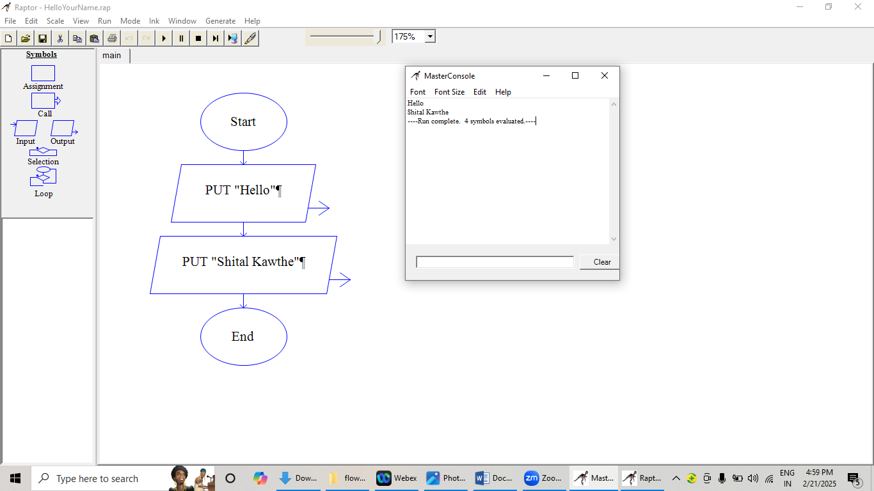

***Code:***

public class HelloName{

public static void main(String args[]){

System.out.println("Hello");

System.out.println("Shital Kawthe");

}

}

***Output:***

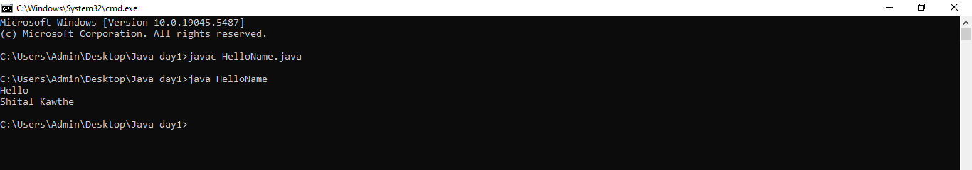

**2.Write a Java program to print the sum of two numbers.**

***Flowchart:***

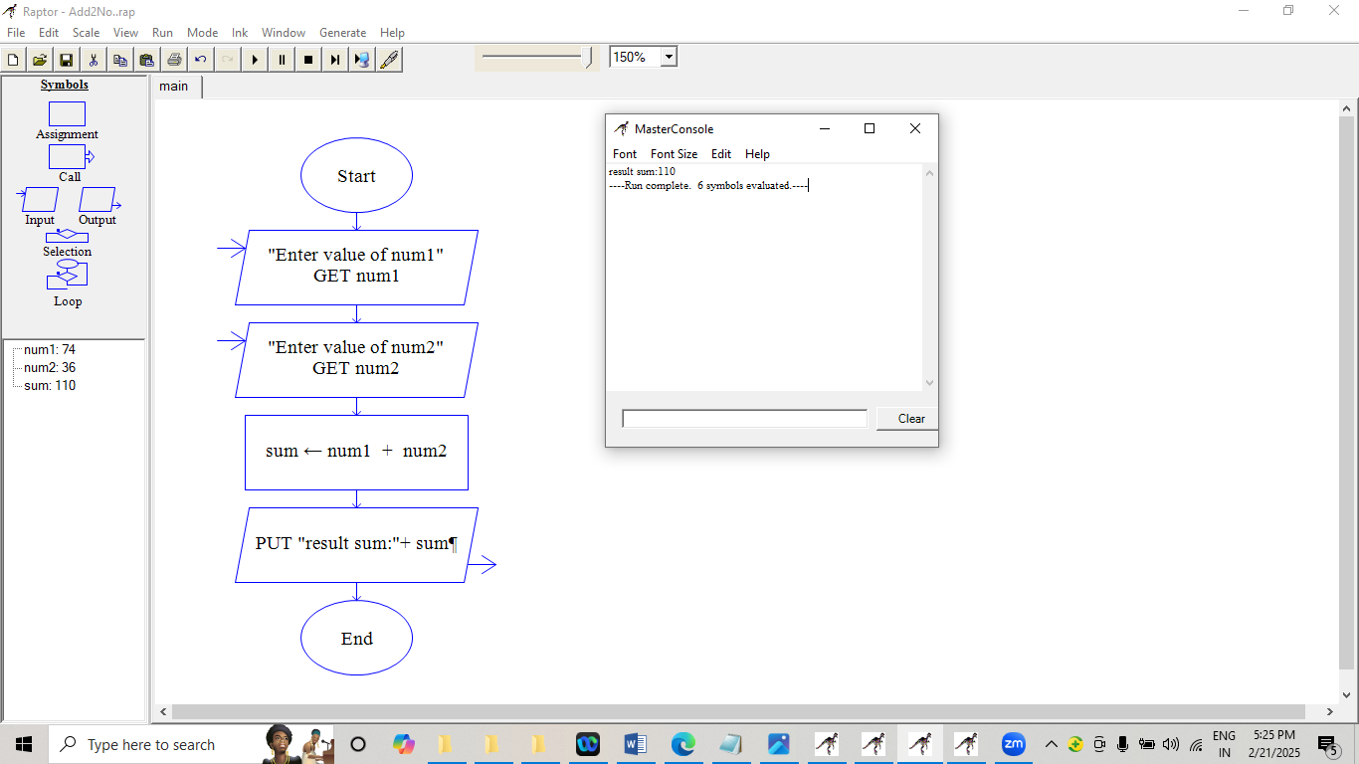

***Code:***

public class AddTwoNumbers{

public static void main(String args[]){

int num1;

int num2;

int sum;

num1 = 74;

num2 = 36;

sum = num1 + num2;

System.out.println("The sum is; " + sum);

}

}

***Output:***

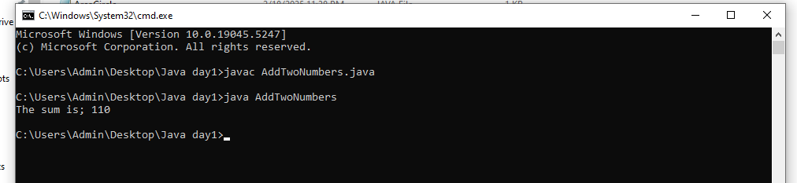

**3.Write a Java program to divide two numbers and print the result on the screen.**

***Flowchart:***

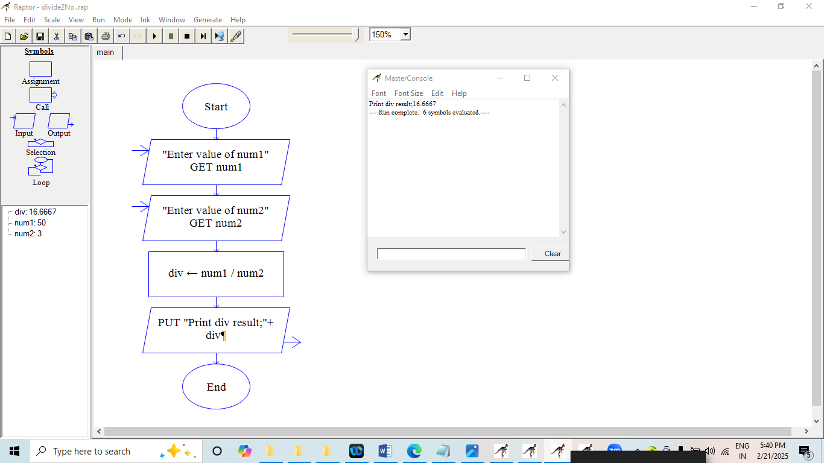

***Code:***

public class DivideTwoNumbers {

public static void main(String[] args) {

int num1 = 50;

int num2 = 3;

int result = num1 / num2;

System.out.println("The result of the division is: " + result);

}

}

***Output:***

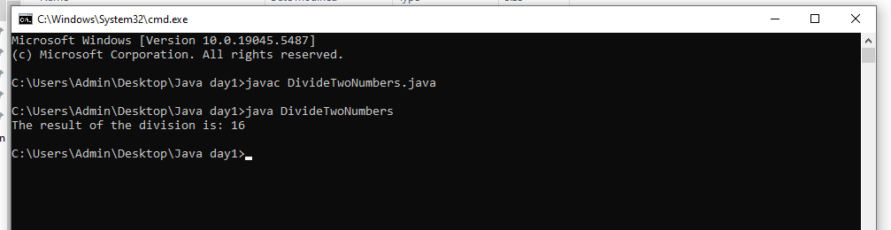

**4.Write a Java program to print the result of the following operations.**

***Code:***

public class ArithmaticOperations {

public static void main(String[] args) {

// Calculate and print the result of : -5 + 8 * 6

System.out.println(-5 + 8 * 6);

// Calculate and print the result of : (55 + 9) % 9

System.out.println((55 + 9) % 9);

// Calculate and print the result of : 20 + -3 * 5 / 8

System.out.println(20 + -3 * 5 / 8);

// Calculate and print the result of : 5 + 15 / 3 * 2 - 8 % 3

System.out.println(5 + 15 / 3 * 2 - 8 % 3);

}

}

***Output:*** 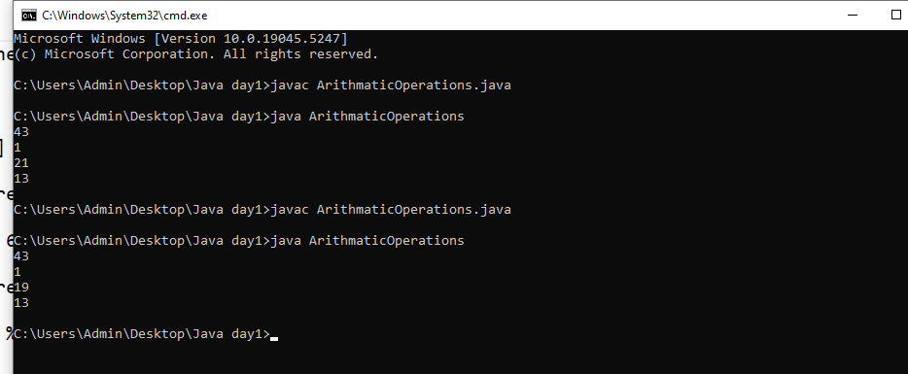

**5.Write a Java program that takes two numbers as input and displays the product of the two numbers.**

***Flowchart:***

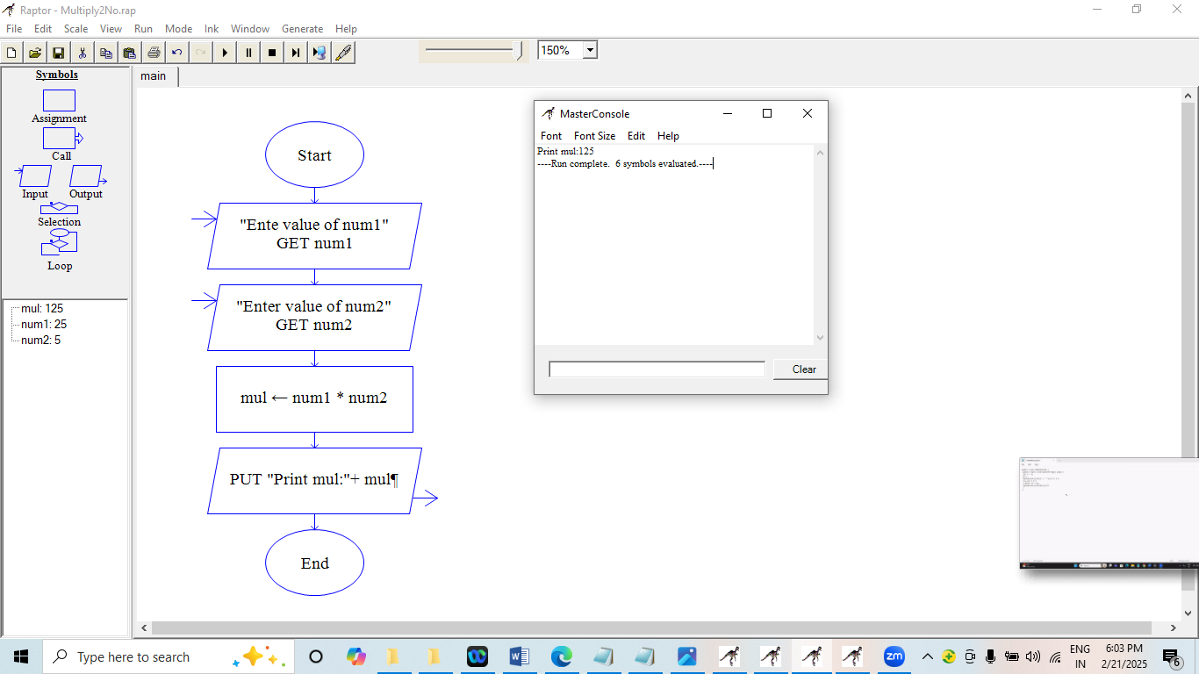

***Code:***

public class Multiply{

public static void main(String[] args){

// Declare and initialize variables x and y

int x = 25;

int y = 5;

int result = x * y;

// Calculate and print the product of x and y

System.out.println("Multiplication: " + result);

}

}

***Output:***

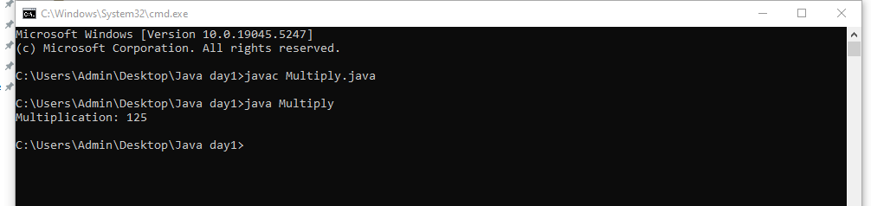

**6.Write a Java program to print the sum, multiplication, subtraction, division, and remainder of two numbers.**

***Code:***

public class BasicOperations {

public static void main(String[] args) {

int num1 = 125;

int num2 = 24;

// Calculate operations

int sum = num1 + num2;

int product = num1 * num2;

int difference = num1 - num2;

double quotient = (double) num1 / num2;

int remainder = num1 % num2;

// Print results

System.out.println("Operations on " + num1 + " and " + num2);

System.out.println("----");

System.out.println("Sum: " + sum);

System.out.println("Product: " + product);

System.out.println("Difference: " + difference);

System.out.println("Quotient: " + quotient);

System.out.println("Remainder: " + remainder);

}

}

***Output:***

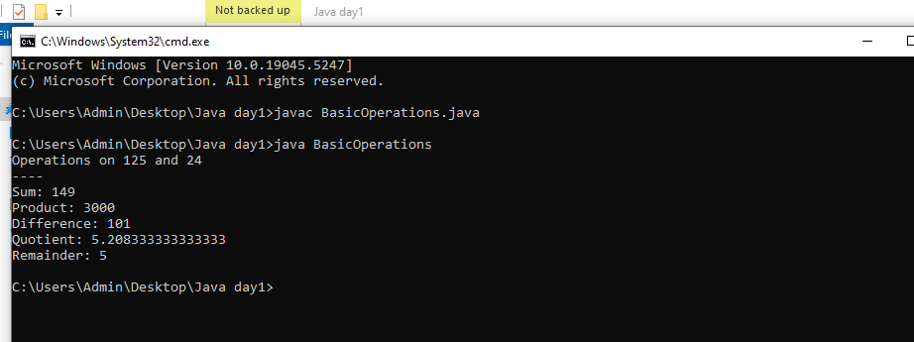

**8.Write a Java program to swap the values of two variables without using a third variable.**

***Flowchart:***

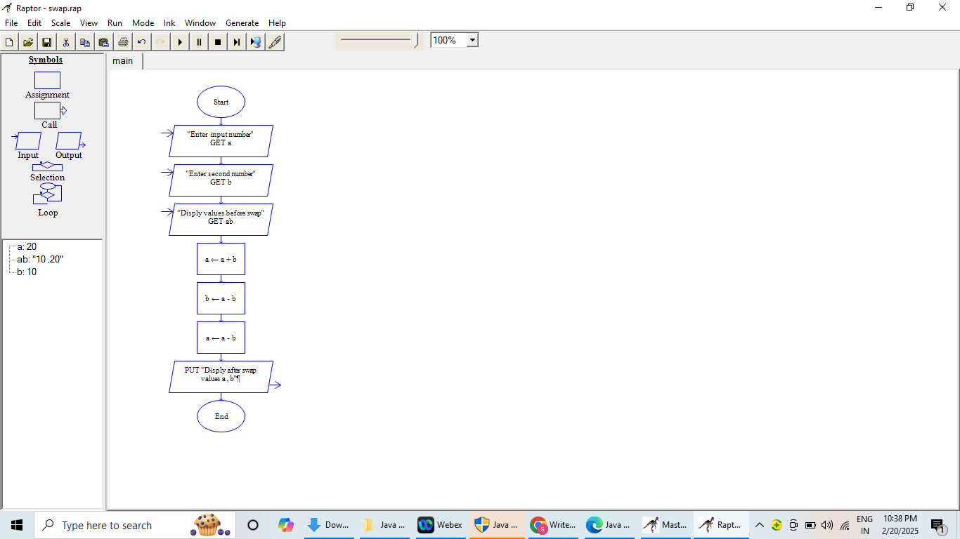

***Code:***

public class Swap {

public static void main(String[] args) {

// Declare variables for the values to be swapped

int a, b, temp;

// Assign values to variables a and b

a = 10;

b = 20;

// Print the values before swapping

System.out.println("Before swapping : a, b = " + a + ", " + b);

// Perform the swap using a temporary variable

temp = a;

a = b;

b = temp;

// Print the values after swapping

System.out.println("After swapping : a, b = " + a + ", " + b);

}

}

***Output:***

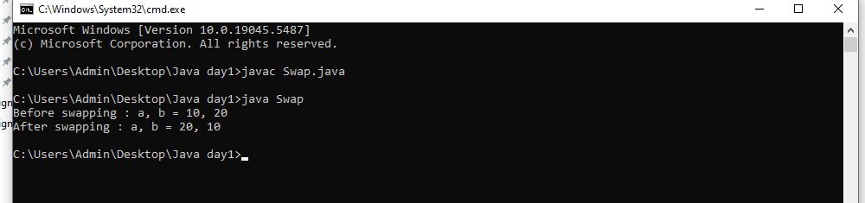

**9. Write a Java program that calculates the area of a circle.**

***Code:***

public class AreaCircle {

public static void main(String[] args){

int radius;

double pi = 3.142, area;

radius = 7;

// calculating the area of the circle

area = pi * radius * radius;

// printing the area of the circle

System.out.println("Area of circle is :" + area);

}

}

***Output:***

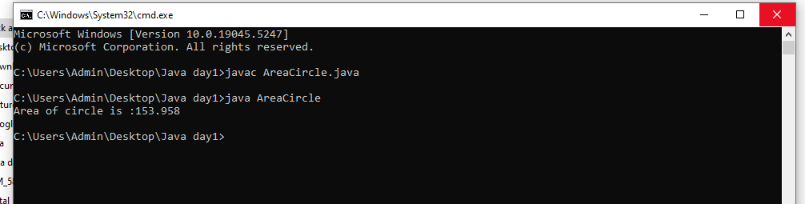

**10. Write a Java program that checks if a number is even or odd.**

***Flowchart:***

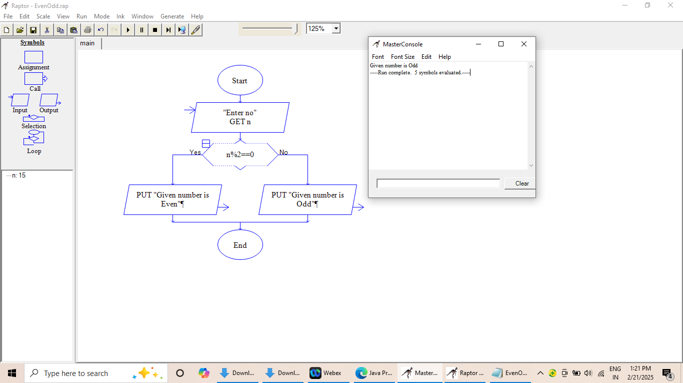

***Code:***

public class EvenOdd {

public static void main(String[] args) {

int num = 15;

//checking whether the number is even or odd

if(num % 2 == 0)

System.out.println(num + " is even.");

else

System.out.println(num + " is odd.");

}

}

***Output:***

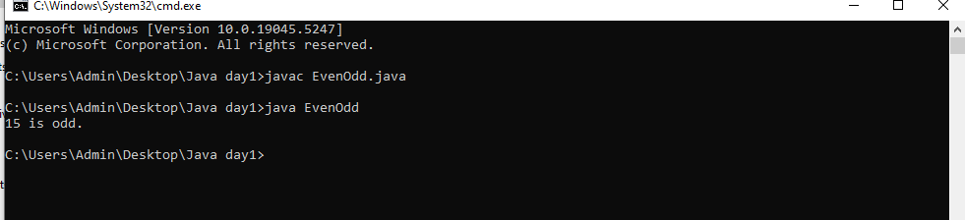

**11. Write a Java program that takes three numbers as input and finds the largest of the three.**

***Flowchart:***

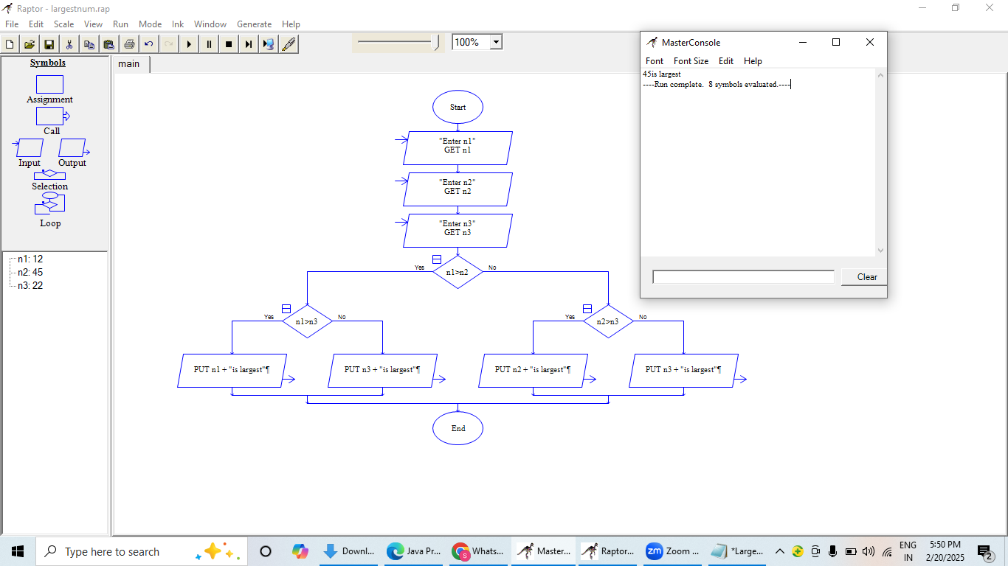

***Code:***

public class LargestNum {

public static void main(String[] args) {

int n1 = 12, n2 = 45, n3 = 22;

if( n1 >= n2 && n1 >= n3)

System.out.println(n1 + " is the largest number.");

else if (n2 >= n1 && n2 >= n3)

System.out.println(n2 + " is the largest number.");

else

System.out.println(n3 + " is the largest number.");

}

}

***Output:***

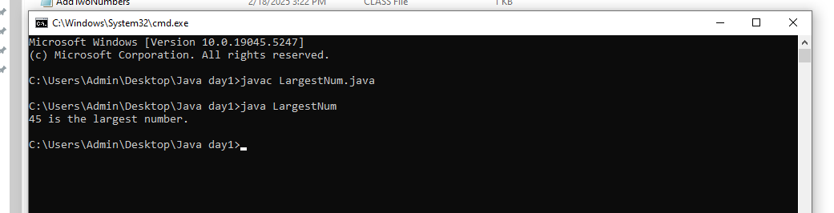

**12.Write a Java program that takes a number as input and prints the reverse of that number.**

***Code:***

public class Reverse {

static int reverseDigits(int n) {

int revNum = 0;

while (n > 0) {

revNum = revNum * 10 + n % 10;

n = n / 10;

}

return revNum;

}

public static void main(String[] args) {

int num = 12345;

System.out.println(reverseDigits(num));

}

}

***Output:***

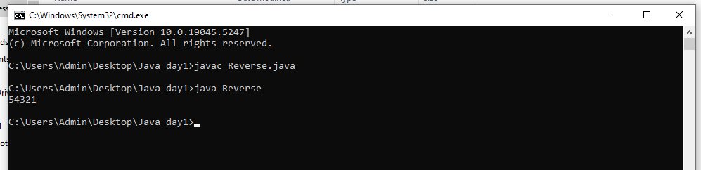

**13.Write a Java program to calculate the average of three numbers.**

***Flowchart:***

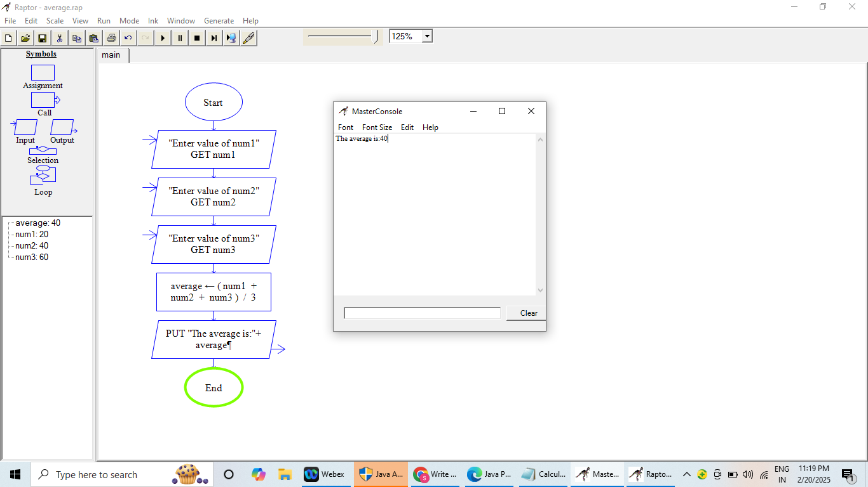

***Code:***

Public class CalculateAverage {

public static void main(String[] args) {

double num1 = 20;

double num2 = 40;

double num3 = 60;

double average = (num1 + num2 + num3) / 3;

System.out.println("The average is: " + average);

}

}

***Output:***

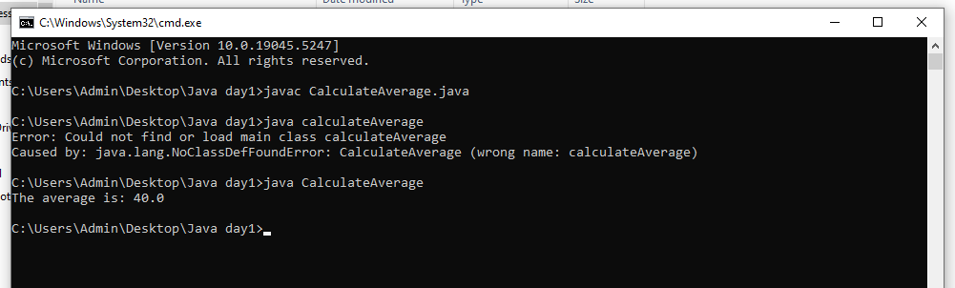

**14.Write a Java program to print the Fibonacci series up to the 10th number.**

***Code:***

public class FibonacciSeries {

public static void main(String[] args) {

int n = 10; // number of terms

int t1 = 0; // first term

int t2 = 1; // second term

System.out.print("Fibonacci Series: ");

for (int i = 1; i <= n; i++) {

System.out.print(t1 + " ");

int sum = t1 + t2;

t1 = t2;

t2 = sum;

}

}

}

***Output:***

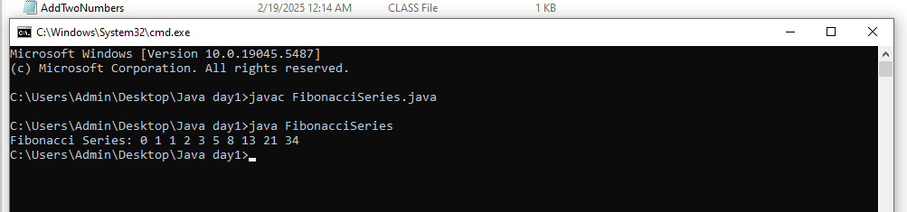

**15.Write a Java program to find the factorial of a number.**

***Flowchart:***

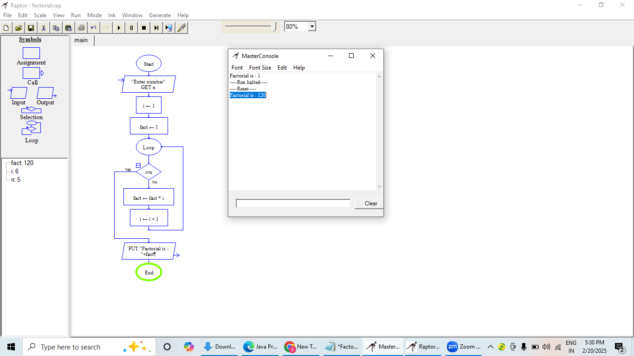

***Code:***

import java.util.*;

public class Factorial{

public static void main(String []args){

//Take input from the user

//Create an instance of the Scanner Class

Scanner sc=new Scanner(System.in);

//Declare and Initialize the variable

System.out.println("Enter the number: ");

int num=sc.nextInt();

int i=1,fact=1;

while(i<=num)

{

fact=fact*i;

i++;

}

System.out.println("Factorial of the number: "+fact);

}

}

***Output:***



**16.Write a Java program to check whether a number is prime or not.**

***Code:***

import java.util.Scanner;

public class PrimeNumber {

public static void main(String[] args) {

Scanner scanner = new Scanner(System.in);

System.out.print("Input number: ");

int num = scanner.nextInt();

scanner.close();

if (isPrime(num)) {

System.out.println(num + " is a prime number.");

}

else {

System.out.println(num + " is not a prime number.");

}

}

public static boolean isPrime(int num) {

if (num <= 1) {

return false;

}

for (int i = 2; i <= num / 2; i++) {

if (num % i == 0) {

return false;

}

}

return true;

}

}

***Output:***

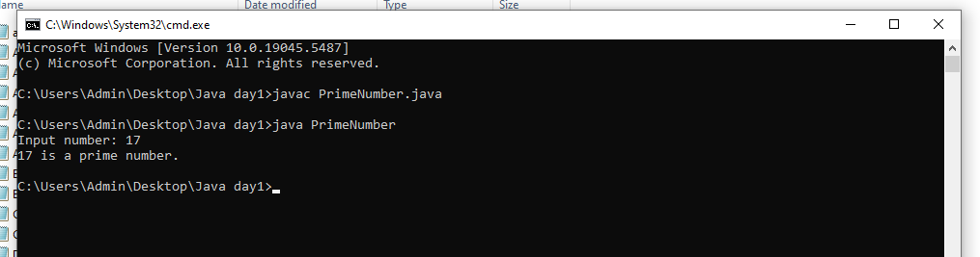

**17.Write a Java program to print the first N natural numbers, where N is provided by the user.**

***Code:***

import java.util.Scanner;

public class NaturalNumbers {

public static void main(String[] args) {

Scanner scanner = new Scanner(System.in);

System.out.print("Input a number: ");

int n = scanner.nextInt();

scanner.close();

System.out.println("First " + n + " natural numbers are:");

for (int i = 1; i <= n; i++) {

System.out.print(i + " ");

}

}

}

***Output:***

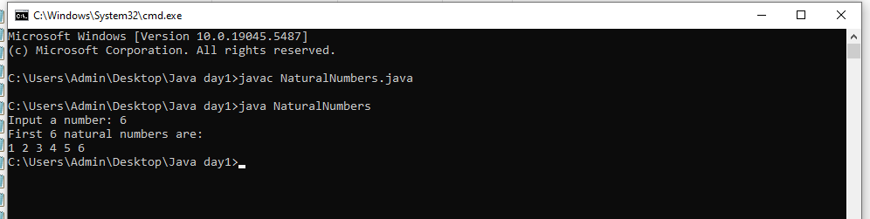

**18.Write a Java program to convert a temperature from Celsius to Fahrenheit.**

***Code:***

class celsiustofahrenheit {

public static void main(String[] args){

// initialising

double celsius = 10.0, fahrenheit = 0.0;

// formula for conversion

fahrenheit = (celsius * 1.8) + 32;

System.out.println( " value of temperature in fahrenheit:"+ fahrenheit);

}

}

***Output:***

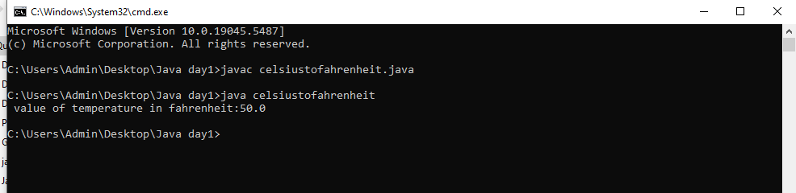

**19.Write a Java program that calculates the power of a number.**

***Code:***

import java.util.Scanner;

public class PowerCalculator {

public static void main(String[] args) {

Scanner scanner = new Scanner(System.in);

System.out.print("Input base number: ");

double base = scanner.nextDouble();

System.out.print("Input exponent number: ");

double exponent = scanner.nextDouble();

scanner.close();

double result = Math.pow(base, exponent);

System.out.println(base + " raised to the power of " + exponent + " is " + result);

}

}

***Output:***

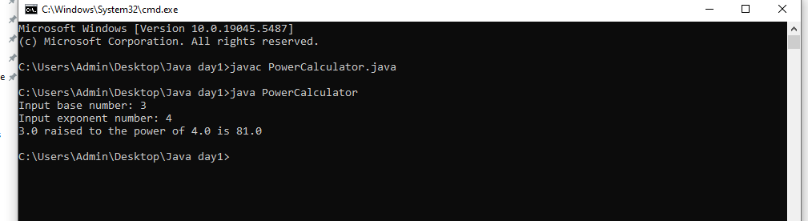

**20.Write a Java program that counts the number of digits in a given number.**

***Code:***

import java.util.Scanner;

public class CountDigits {

public static void main(String[] args) {

Scanner scanner = new Scanner(System.in);

System.out.print("Input number: ");

int num = scanner.nextInt();

scanner.close();

int count = 0;

while (num != 0) {

num /= 10;

count++;

}

System.out.println("Number of digits: " + count);

}

}

***Output:***

