**1. Check Positive Number:**

***Flowchart:***

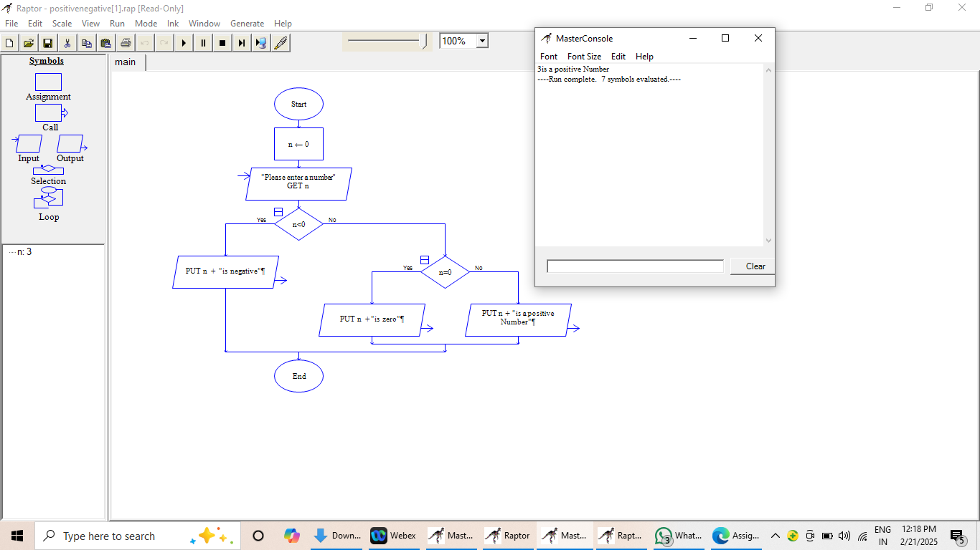

***Code:***

class Positivenumber

public static void main(String[] args){

int n = 1;

if(n < 0){

System.out.println(n + " is negative");

}

else if(n == 0){

System.out.println(n + " is positive");

}

else{

System.out.println(n + " is zero");

}

}

}

***Output:***

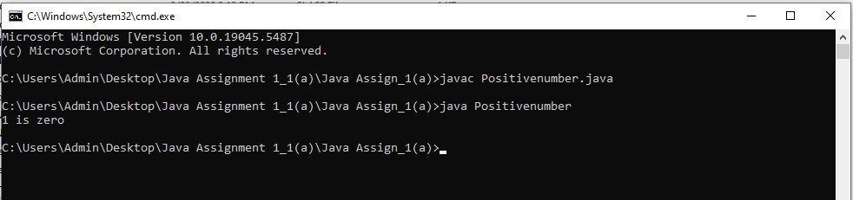

**2. Check Negative Number:**

***Flowchart:***



***Code:***

class Negativenumber{

public static void main(String[] args){

int n = -22;

if(n < 0){

System.out.println(n + " is negative");

}

else if(n == 0){

System.out.println(n + " is positive");

}

else{

System.out.println(n + " is zero");

}

}

}

***Output:***

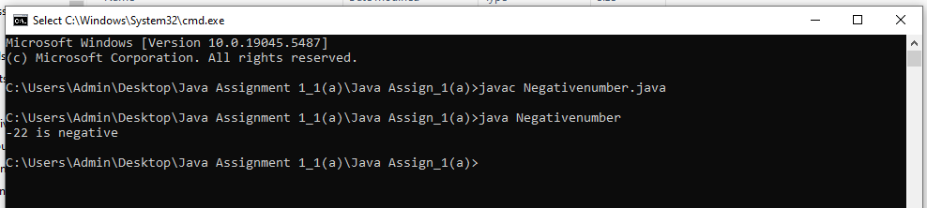

**3. Check Odd or Even Number:**

***Flowchart:***

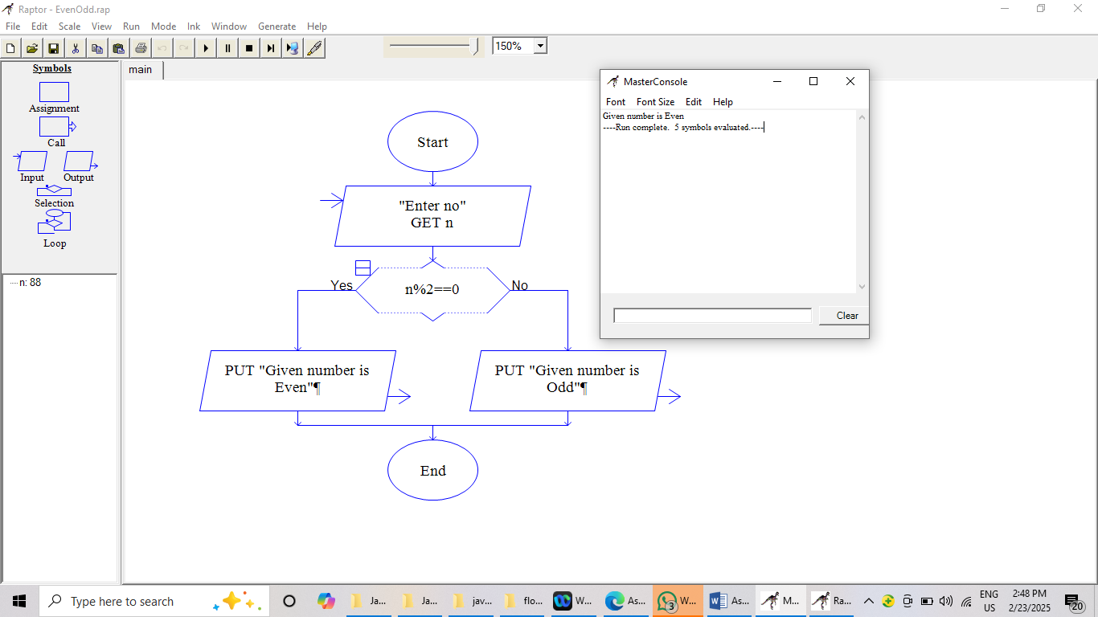

***Code:***

class Evenodd{

public static void main(String [] args){

int num = 88;

if(num % 2 == 0){

System.out.println(num + " is even number");

}

else

{

System.out.println(num + " is odd number");

}

}

}

***Output:***

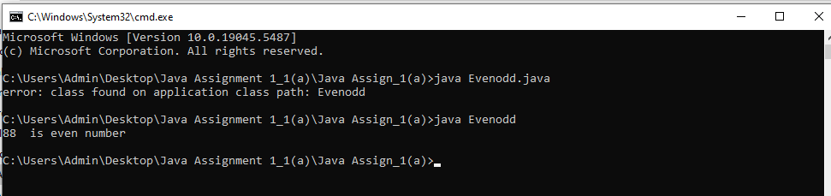

**4. Display Good Morning Message Based on Time:**

***Flowchart:***

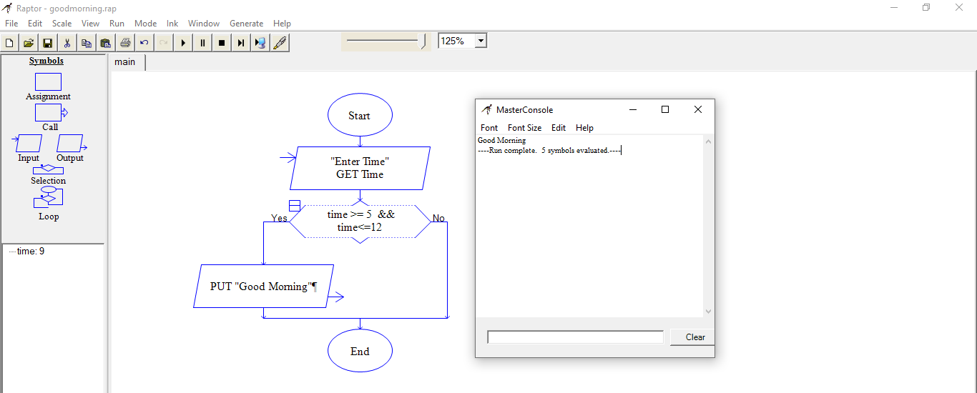

***Code:***

class GoodMorningMessage{

public static void main(String[] args){

int time = 9;

if(time >=5 && time <= 12){

System.out.println("Good Morning");

}

}

}

***Output:***

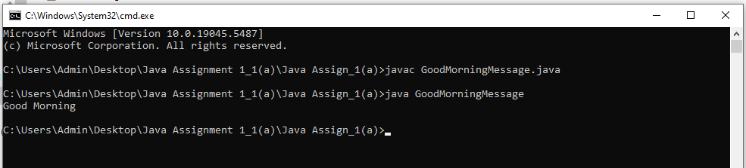

**5. Print Area of a Square:**

***Flowchart:***

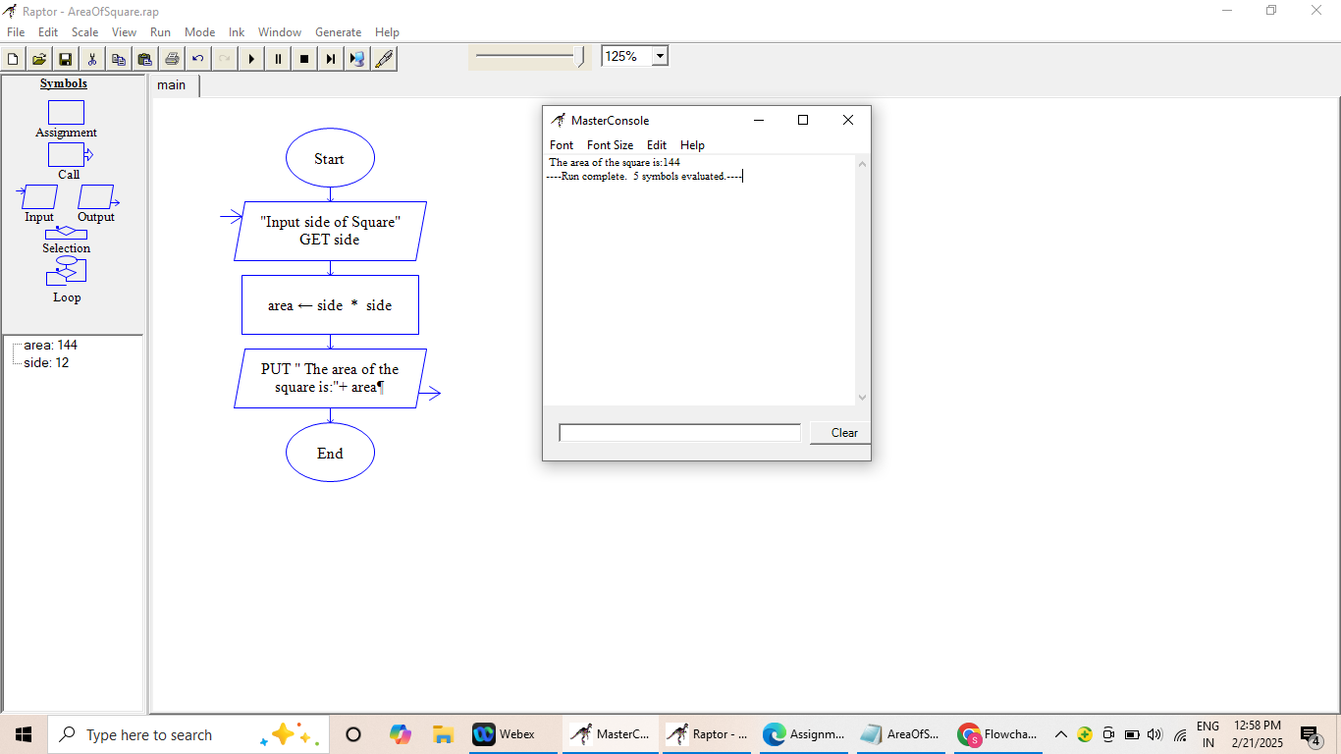

***Code:***

class AreaOfSquare{

public static void main(String[] args){

int side = 12;

double result = side * side;

System.out.println("Area of Square is: "+result);

}

}

***Output:***

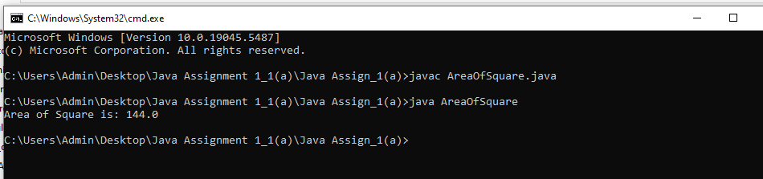

**6. Print Area of a Rectangle:**

***Flowchart:***

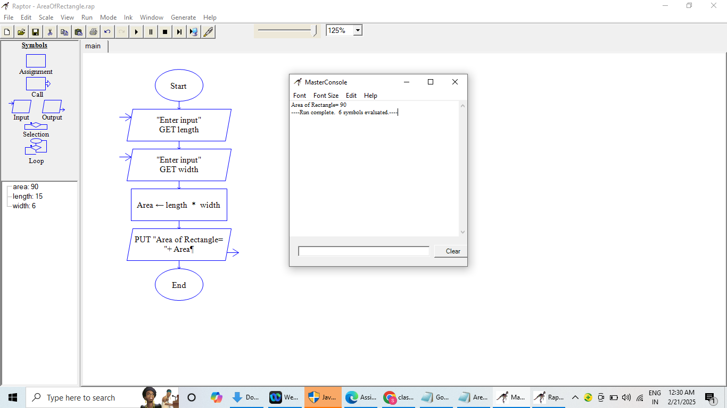

***Code:***

class AreaOfRectangle{

public static void main(String[] args){

int length = 15;

int width = 6;

int area = length * width;

System.out.println("Area of Rectangle is: "+ area);

}

}

***Output:***

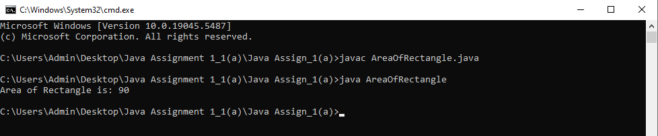

**7. Find the Largest of Three Numbers:**

***Flowchart:***

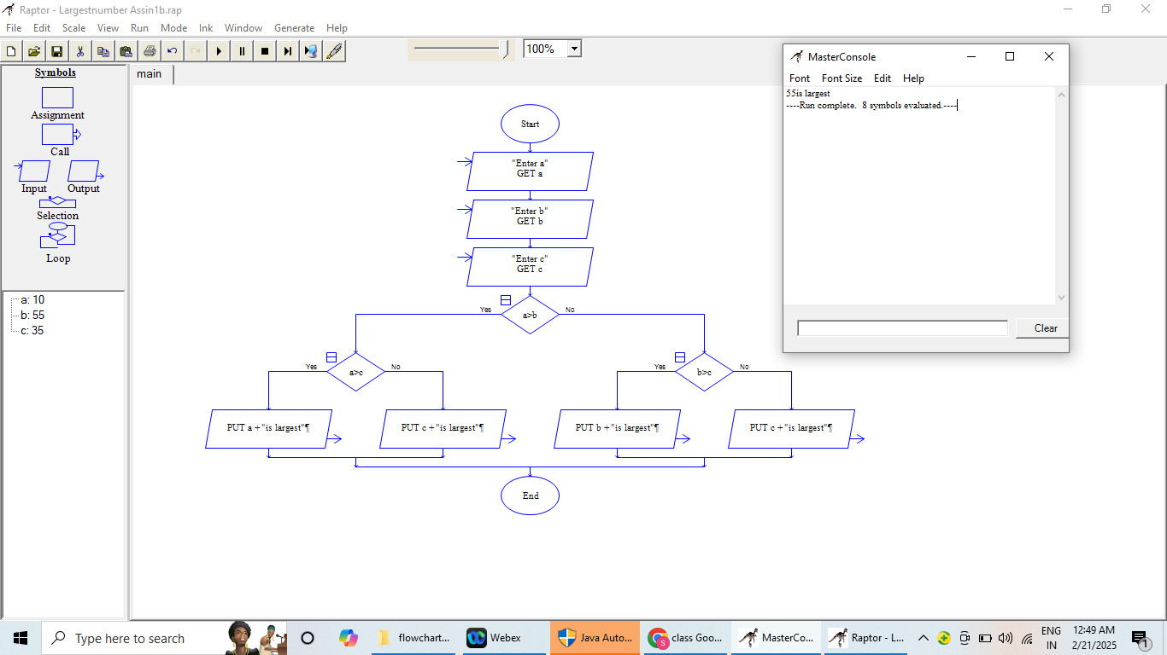

***Code:***

class LargestNumber{

public static void main(String[] args){

int a = 10;

int b = 55;

int c = 35;

if(a>b) //10>55

{

if(a>c) //10>35

{

System.out.println("largest number is:" +a); //this block will not execute because condition not satisfied

}

else{

System.out.println("largest number is:" +c);

}

}

else

{

if(b>c) //55>35

{

System.out.println("largest number is:" +b);

}

else{

System.out.println("largest number is:" +c);

}

}

}

}

***Output:***

