**Section 1: Error-Driven Learning in Java**

1.

public class Main {

public void main(String[] args) {

System.out.println("Hello, World!");

}

}

Error: in Main method is not static in class Main

Corrected code:

public class Main {

public static void main(String[] args) {

System.out.println("Hello, World!");

}

}

2.

public class Main {

static void main(String[] args) {

System.out.println("Hello, World!");

}

}

Error: Main method not found in class Main

corrected code:

public class Main {

public static void main(String[] args) {

System.out.println("Hello, World!");

}

}

3.

public class Main {

public static int main(String[] args) {

System.out.println("Hello, World!");

return 0;

}

}

Error: Main method must return a value of type void in class Main

Corrected code:

public class Main {

public static void main(String[] args) {

System.out.println("Hello, World!");

}

}

4.

public class Main {

public static void main() {

System.out.println("Hello, World!");

}

}

Error:Main method not found in class Main

Corrected code:

public class Main {

public static void main(String[] args) {

System.out.println("Hello, World!");

}

}

5.

public class Main {

public static void main(String[] args) {

System.out.println("Main method with String[] args");

}

public static void main(int[] args) {

System.out.println("Overloaded main method with int[] args");

}

}

Yes,we can have multiple main methods with different types of input parameter.

6.

public class Main {

public static void main(String[] args) {

int x = y + 10;

System.out.println(x);

}

}

we will get error: cannot find symbol, because we have not declare and define variable y.

Coreected code:

public class Main {

public static void main(String[] args) {

int y = 5;

int x = y + 10;

System.out.println(x);

}

}

7.

public class Main {

public static void main(String[] args) {

int x = "Hello";

System.out.println(x);

}

}

we will get error: incompatible types: String cannot be converted to int, we cannnot assign string value to int variable.

Corrected code:

public class Main {

public static void main(String[] args) {

int x = 5;

string str = "Hello";

System.out.println(x);

}

}

8.

public class Main {

public static void main(String[] args) {

System.out.println("Hello, World!"

}

}

Ans : closing bracket and semi colon is missing, its an compiler error. Compilation will get terminate.

Corrected code:

public class Main {

public static void main(String[] args) {

System.out.println("Hello, World!");

}

}

9.

public class Main {

public static void main(String[] args) {

int class = 10;

System.out.println(class);

}

}

Ans : we can't use reserved keywords as a user defined varibale name

Corrected code:

public class Main {

public static void main(String[] args) {

int num= 10;

System.out.println(num);

}

}

10.

public class Main {

public void display() {

System.out.println("No parameters");

}

public void display(int num) {

System.out.println("With parameter: " + num);

}

public static void main(String[] args) {

display();

display(5);

}

}

ans: non-static method display() cannot be referenced from a static context

Corrected code:

public class Main {

public static void display() {

System.out.println("No parameters");

}

public static void display(int num) {

System.out.println("With parameter: " + num);

}

public static void main(String[] args) {

display();

display(5);

}

}

11.

public class Main {

public static void main(String[] args) {

int[] arr = {1, 2, 3};

System.out.println(arr[5]);

}

}

Ans : we will get this ArrayIndexOutOfBoundsException, because we only have array of 3 index but in print we are trying to get the value of index 5.

Corrected code :

public class Main {

public static void main(String[] args) {

int[] arr = {1, 2, 3};

System.out.println(arr[2]);

}

}

12.

public class Main {

public static void main(String[] args) {

while (true) {

System.out.println("Infinite Loop");

}

}

}

Ans : it will go infinte loop because every time in while condition is true so will run infinite time. to avoid this we can write condition to break the loop.

Corrected code :

public class Main {

public static void main(String[] args) {

int i=0;

while (i!=5) {

System.out.println("Infinite Loop");

i++;

}

}

}

13 .

public class Main {

public static void main(String[] args) {

String str = null;

System.out.println(str.length());

}

}

Ans: we will get NullPointerException, it will occur because we have assign str to null and on null object we are trying to get the length of string.

Corrected code:

public class Main {

public static void main(String[] args) {

String str = "abc";

System.out.println(str.length());

}

}

14.

public class Main {

public static void main(String[] args) {

double num = "Hello";

System.out.println(num);

}

}

Ans: error: incompatible types: String cannot be converted to double

Corrected code:

public class Main {

public static void main(String[] args) {

String num = "Hello";

System.out.println(num);

}

}

15.

public class Main {

public static void main(String[] args) {

int num1 = 10;

double num2 = 5.5;

int result = num1 + num2;

System.out.println(result);

}

}

Ans: we will get incompatible types: possible lossy conversion from double to int, we can handle this situation by defining int result to double result.

Corrected out:

public class Main {

public static void main(String[] args) {

int num1 = 10;

double num2 = 5.5;

double result = num1 + num2;

System.out.println(result);

}

}

16.

public class Main {

public static void main(String[] args) {

int num = 10;

double result = num / 4;

System.out.println(result);

}

}

Ans: the result will be 2.0.

17.

public class Main {

public static void main(String[] args) {

int a = 10;

int b = 5;

int result = a ** b;

System.out.println(result);

}

}

Ans: we will get error: illegal start of expression,

Corrected out:

public class Main {

public static void main(String[] args) {

int a = 10;

int b = 5;

int result = a * b;

System.out.println(result);

}

}

18.

public class Main {

public static void main(String[] args) {

int a = 10;

int b = 5;

int result = a + b * 2;

System.out.println(result);

}

}

Ans: we will get 20 as a answer because as per BODMAS rule multiplications precedence is higher than addition.

19.

public class Main {

public static void main(String[] args) {

int a = 10;

int b = 0;

int result = a / b;

System.out.println(result);

}

}

Ans : we will get ArithmeticException because its not possible to divide any number by zero in mathematics.

Corrected out :

public class Main {

public static void main(String[] args) {

int a = 10;

int b = 5;

int result = a / b;

System.out.println(result);

}

}

20.

public class Main {

public static void main(String[] args) {

System.out.println("Hello, World")

}

}

Ans : error: ';' expected

Corrected out :

public class Main {

public static void main(String[] args) {

System.out.println("Hello, World");

}

}

21.

public class Main {

public static void main(String[] args) {

System.out.println("Hello, World!");

// Missing closing brace here

}

Ans : error: reached end of file while parsing

Corrected out :

public class Main {

public static void main(String[] args) {

System.out.println("Hello, World!");

}

}

22.

public class Main {

public static void main(String[] args) {

static void displayMessage() {

System.out.println("Message");

}

}

}

Ans : error: illegal start of expression, we can't declare method inside the method.

Corrected out:

public class Main {

public static void main(String[] args) {

displayMessage();

}

static void displayMessage() {

System.out.println("Message");

}

}

23.

public class Main {

public static void main(String[] args) {

int value = 2;

switch(value) {

case 1:

System.out.println("Value is 1");

case 2:

System.out.println("Value is 2");

break;

case 3:

System.out.println("Value is 3");

default:

System.out.println("Default case");

}

}

}

Ans: we can avoid execution of default by placing break in case 2.

24.

public class MissingBreakCase {

public static void main(String[] args) {

int level = 1;

switch(level) {

case 1:

System.out.println("Level 1");

case 2:

System.out.println("Level 2");

case 3:

System.out.println("Level 3");

default:

System.out.println("Unknown level");

}

}

}

Ans: it will print all the level because break not initialized after each case.

break is used to to terminate switch cases.

25.

public class Switch {

public static void main(String[] args) {

double score = 85.0;

switch(score) {

case 100:

System.out.println("Perfect score!");

break;

case 85:

System.out.println("Great job!");

break;

default:

System.out.println("Keep trying!");

}

}

}

Error: incompatible types: possible lossy conversion from double to int, we can use only int with the case can't use double.

Corrected code:

public class Switch {

public static void main(String[] args) {

int score = 85;

switch(score) {

case 100:

System.out.println("Perfect score!");

break;

case 85:

System.out.println("Great job!");

break;

default:

System.out.println("Keep trying!");

}

}

}

26.

public class Switch {

public static void main(String[] args) {

int number = 5;

switch(number) {

case 5:

System.out.println("Number is 5");

break;

case 5:

System.out.println("This is another case 5");

break;

default:

System.out.println("This is the default case");

}

}

}

Error: duplicate case label, in case statement we can't have the same case condition in single switch case statement.

Corrected code:

public class Switch {

public static void main(String[] args) {

int number = 5;

switch(number) {

case 4:

System.out.println("Number is 5");

break;

case 5:

System.out.println("This is another case 5");

break;

default:

System.out.println("This is the default case");

}

}

}

**Section 2: Java Programming with Conditional Statements.**

**Question 1: Grade Classification**

***Code:***

import java.util.Scanner;

public class GradeClassifier {

public static void main(String[] args) {

Scanner scanner = new Scanner(System.in);

System.out.print("Enter the student's score: ");

int score = scanner.nextInt();

scanner.close();

char grade = classifyGrade(score);

System.out.println("The student's grade is: " + grade);

}

public static char classifyGrade(int score) {

if (score >= 90) {

return 'A';

} else if (score >= 80) {

return 'B';

} else if (score >= 70) {

return 'C';

} else if (score >= 60) {

return 'D';

} else {

return 'F';

}

}

}

Output:

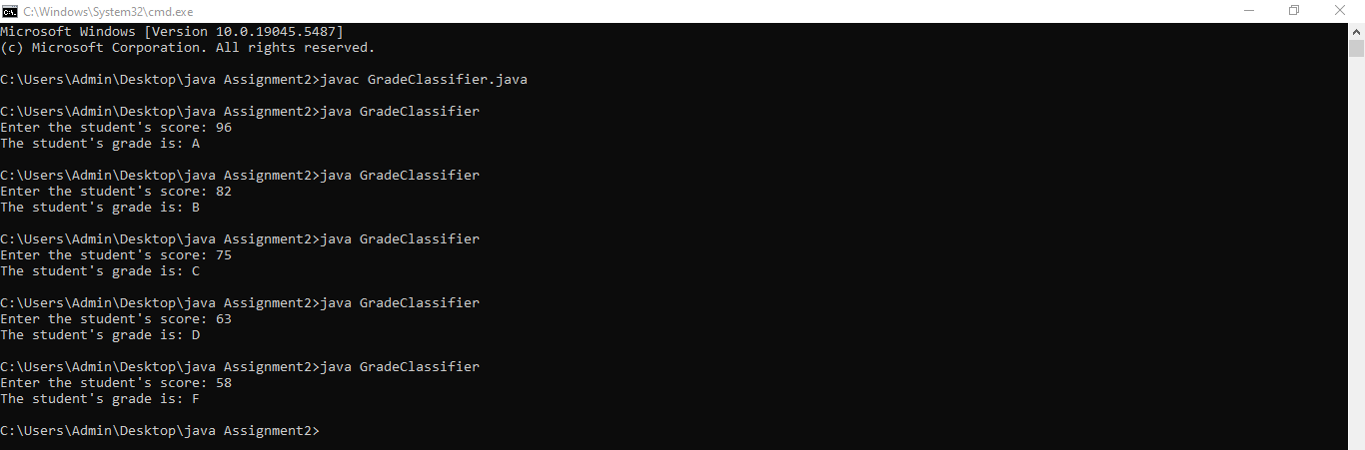

**Question 2: Days of the Week**

***Code:***

import java.util.Scanner;

public class DaysOfWeek {

public static void main(String[] args)

{

Scanner in = new Scanner(System.in);

System.out.print("Input number: ");

int day = in.nextInt();

System.out.println(getDayName(day));

}

// Get the name for the Week

public static String getDayName(int day) {

String dayName = "";

switch (day) {

case 1: dayName = "Monday"; break;

case 2: dayName = "Tuesday"; break;

case 3: dayName = "Wednesday"; break;

case 4: dayName = "Thursday"; break;

case 5: dayName = "Friday"; break;

case 6: dayName = "Saturday"; break;

case 7: dayName = "Sunday"; break;

default:dayName = "Invalid day range";

}

return dayName;

}

}

***Output:***

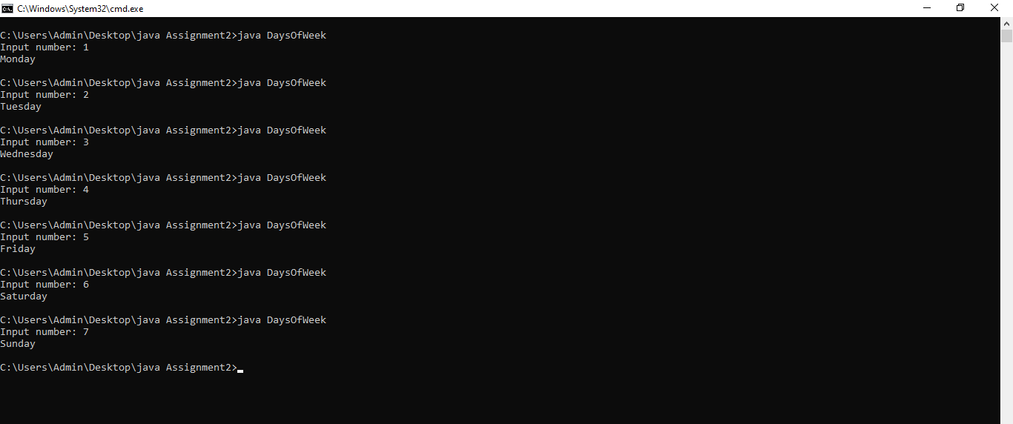

**Question 3: Calculator**

***Code:***

import java.util.Scanner;

public class SimpleCalculator {

public static void main(String[] args) {

Scanner scanner = new Scanner(System.in);

System.out.print("Enter the first number: ");

double num1 = scanner.nextDouble();

System.out.print("Enter the operator (+, -, *, /): ");

char operator = scanner.next().charAt(0);

System.out.print("Enter the second number: ");

double num2 = scanner.nextDouble();

double result = calculateResult(num1, operator, num2);

if (result != Double.MIN_VALUE) {

System.out.println("Result: " + num1 + " " + operator + " " + num2 + " = " + result);

}

scanner.close();

}

public static double calculateResult(double num1, char operator, double num2) {

double result = Double.MIN_VALUE;

switch (operator) {

case '+':

result = num1 + num2;

break;

case '-':

result = num1 - num2;

break;

case '*':

result = num1 * num2;

break;

case '/':

if (num2 != 0) {

result = num1 / num2;

} else {

System.out.println("Error: Division by zero is not allowed.");

}

break;

default:

System.out.println("Error: Invalid operator.");

}

return result;

}

}

***Output:***

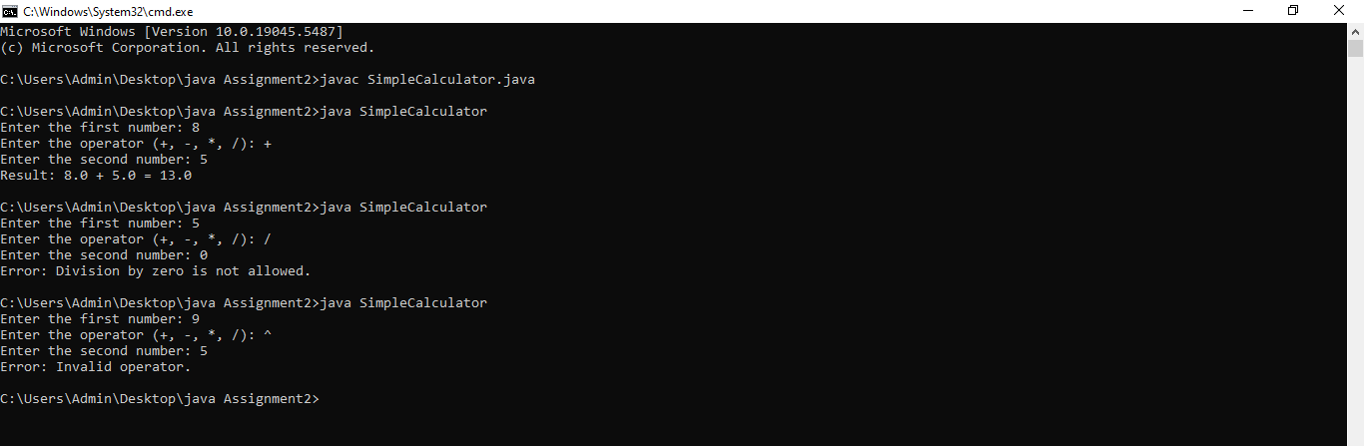

**Question 4: Discount Calculation**

***Code:***

import java.util.Scanner;

public class DiscountCalculation {

public static void main(String[] args) {

Scanner scanner = new Scanner(System.in);

System.out.print("Enter the total purchase amount: Rs.");

double purchaseAmount = scanner.nextDouble();

System.out.print("Do you have a membership card? (yes/no): ");

String membershipStatus = scanner.next();

double discount = calculateDiscount(purchaseAmount, membershipStatus);

double finalAmount = purchaseAmount - (purchaseAmount * discount / 100);

System.out.println("Discount: " + discount + "%");

System.out.println("Final Amount: Rs." + finalAmount);

scanner.close();

}

public static double calculateDiscount(double purchaseAmount, String membershipStatus) {

double discount = 0;

if (purchaseAmount >= 1000) {

discount = 20;

} else if (purchaseAmount >= 500) {

discount = 10;

} else {

discount = 5;

}

if (membershipStatus.equalsIgnoreCase("yes")) {

discount += 5;

}

return discount;

}

}

***Output:***

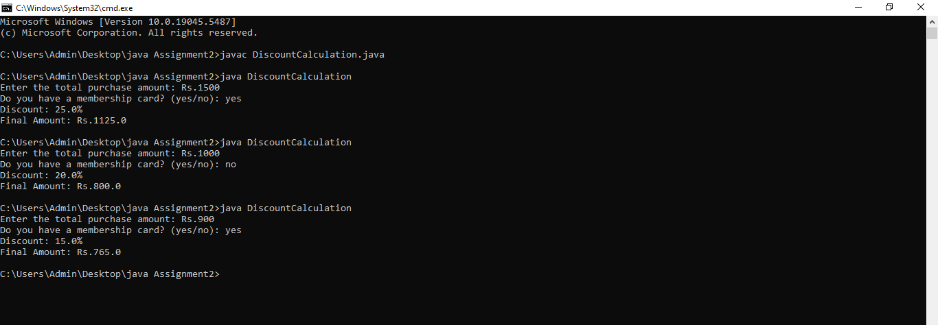

**Question 5: Student Pass/Fail Status with Nested Switch**

***Code:***

import java.util.Scanner;

public class GradesOfStudents {

public static void main(String[] args) {

Scanner scanner = new Scanner(System.in);

System.out.print("Enter the student's name: ");

String studentName = scanner.nextLine();

System.out.print("Enter the grade in Subject 1: ");

int subject1Grade = scanner.nextInt();

System.out.print("Enter the grade in Subject 2: ");

int subject2Grade = scanner.nextInt();

System.out.print("Enter the grade in Subject 3: ");

int subject3Grade = scanner.nextInt();

int failedSubjects = evaluateGrades(subject1Grade, subject2Grade, subject3Grade);

if (failedSubjects == 0) {

System.out.println(studentName + " passes.");

} else {

System.out.println(studentName + " fails in " + failedSubjects + " subjects.");

}

scanner.close();

}

public static int evaluateGrades(int subject1Grade, int subject2Grade, int subject3Grade) {

int failedSubjects = 0;

if (subject1Grade <= 40) {

failedSubjects++;

}

if (subject2Grade <= 40) {

failedSubjects++;

}

if (subject3Grade <= 40) {

failedSubjects++;

}

return failedSubjects;

}

}

***Output:***

