
LA GRANDEE INTERNATIONAL COLLEGE
Simalchaur, Pokhara, Nepal

A Project Proposal
on
PhishGuard
Submitted to
Bachelor of Computer Application (BCA) Program
LA GRANDEE International College

In partial fulfillment of the requirements for the degree of Bachelor of Computer
Application under Pokhara University

Submitted by
Name of the Student | PU Registration Number | Semester
Deven Shrestha | 2023-1-53-0325 | VI
Shital Dhakal | 2023-1-53-0345 | VI

May, 2026

Table of Contents
Table of Contents ii
1. Introduction 1
2. Aim and Scope 2
2.1 Aim 2
2.2 Scope 2
3. Objectives 4
4. Study of Previous Systems 5
5. Current Problem and Proposed Solution 7
5.1 Current Problem 7
5.2 Proposed Solution 7
6. High Level Requirements 9
6.1 Functional Requirements 9
6.2 Non-Functional Requirements 10
6.3 Requirement Prioritization Table 10
7. Design 11
7.1 ER Diagram 11
7.2 Use Case Diagram 11
7.3 DFD 12
7.4 UML Class Diagram 14
8. Detail Budget 15
8.1 Budget Breakdown 15
9. Detail Timeline 16
10. Conclusion 17
References 18

Introduction
Email has become the primary communication channel for modern organizations, with an estimated 347 billion emails sent and received worldwide each day (Statista, 2024). However, this widespread adoption has made email the most exploited attack vector in cybersecurity. According to the Anti-Phishing Working (APWG, 2024), over 4.7 million phishing attacks were recorded in 2023 alone, marking a significant rise in email-based threats targeting organizations across all sectors. Phishing attacks are a form of social engineering where malicious actors impersonate trusted entities such as banks, service providers, or internal departments to deceive recipients into revealing sensitive information, clicking on malicious links, or downloading harmful attachments (Chiew et al., 2018). These attacks often bypass basic spam filters by using sophisticated techniques such as lookalike domains, URL obfuscation, urgency-driven language, and legitimate email authentication through compromised or free email accounts (Nightingale, 2017). To address these challenges, this project proposes Email Phishing Detection and Analysis Platform, an Email Phishing Detection and Spam Classification System. Email Phishing Detection and Analysis Platform is a web-based application built using the Django framework (Python) that provides a centralized platform for submitting, analyzing, classifying, and visualizing email threats. The system automates the email investigation process by parsing email headers, extracting indicators of compromise (IOCs), analyzing URLs and keywords for phishing patterns, classifying emails into threat categories, and calculating risk scores — reducing the analysis time from 15–30 minutes to under 30 seconds per email. The platform also incorporates data analysis using Pandas and data visualization using Matplotlib and Chart.js to provide actionable insights into email threat trends across the organization.

2. Aim and Scope

2.1 Aim
This project aims to design and develop a web-based Email Phishing Detection and Analysis Platform using Django (Python). The system will automate the analysis of suspicious emails, classify them as clean, spam, or phishing, calculate risk scores, and provide data-driven visualisations of email threat trends to support organisational security decisions.

2.2 Scope
- Email Ingestion via Auto-Forwarding and IMAP:
    - The system uses a post-delivery scanning architecture. Employee mailboxes are configured with auto-forwarding rules to send copies of all incoming emails to a central reporting mailbox (e.g., reports@organization.com).
    - The platform connects to the reporting mailbox via IMAP, retrieves all forwarded emails, and processes each through the analysis engine. This ensures every organisational email is scanned without manual employee action.
    - Users, including employees and analysts, can also manually submit suspicious emails for analysis by pasting the raw email content into a web form for ad-hoc investigation.
  - Automated Email Analysis:
- Parse email headers to extract sender information (From, Reply-To, Return-Path), recipient details, subject line, and authentication results (SPF, DKIM, DMARC).
- Extract indicators of compromise (IOCs) from the email body, including IP addresses, URLs, domain names, and email addresses.
- Analyse extracted URLs for suspicious features such as URL shortening, IP-based URLs, misspelled domains, suspicious TLDs, and excessive subdomain depth.
- Detect phishing-indicative keywords and urgency patterns in the email body and subject line using a weighted keyword scoring system.
- Classification and Risk Scoring:
- Classify each analysed email into one of three categories: Clean, Spam, or Phishing.
- For phishing emails, further classify the phishing type into sub-categories: credential harvesting, fake invoice, account suspension, banking fraud, delivery scam, reward scam, malware attachment, or unknown.
- Calculate a risk score from 0 to 100 based on weighted analysis results across multiple detection categories (authentication failures, header anomalies, URL features, keyword indicators, and threat intelligence lookups).
- Assign a verdict: Safe (0–30), Suspicious (31–60), or Malicious (61–100).
- Report Management:
- Store all analysis results as structured reports in the database with full CRUD (Create, Read, Update, Delete) operations.
- Allow analysts to review reports, update verdicts, add investigation notes, and mark false positives.
- Provide search and filtering capabilities across all analysis reports.
- Data Analysis and Visualisation:
- Perform data analysis using Pandas to compute email threat statistics, including phishing category distribution, risk score trends over time, spam-to-ham ratios, and detection accuracy metrics.
- Generate server-side charts using Matplotlib for trend analysis (phishing volume over time, category-wise average risk scores, vulnerability aging).
- Display interactive, browser-based charts using Chart.js on the dashboard (severity distribution pie chart, recent analysis bar chart, risk trendline chart).
- Data Export:
- Export analysis reports, IOC lists, and trend data in CSV format and as PDF for external use and management reporting.

3. Objectives
- Develop a web-based email analysis platform that automatically retrieves and processes emails forwarded from employee mailboxes to a centralized reporting mailbox for analysis.
- Implement an automated email analysis engine that parses headers, extracts indicators of compromise (IOCs) such as URLs, IP addresses, and domains, and detects phishing-related keywords and urgency patterns in the email body.

4. Study of Previous Systems
- Gmail Spam Filter (Google): Built in email filter in gmail included for free in Gmail.
- Key Features:
  - Employs deep learning models trained on billions of emails daily to detect spam and phishing patterns (Kumaran et al., 2017)
  - Checks email authentication protocols (SPF, DKIM, DMARC) and flags authentication failures
  - Integrates with Google Safe Browsing to cross-reference URLs with known malicious sites (Google Cloud, 2023)
  - Scans all attachments for malware and blocks potentially harmful file types
  - Learns from user feedback when emails are reported as phishing or spam to improve detection accuracy
- Limitations:
  - Performs only binary classification, marking emails as Spam or Not Spam, without risk scoring or phishing category classification.
  - Lacks a dashboard or analytics, so users cannot view phishing trends, category distribution, or organizational threat posture.
- KnowBe4 PhishER: Developed by KnowBe4, PhishER is a paid Security Orchestration, Automation, and Response (SOAR) platform designed to streamline an organization's phishing incident response process.
  - Key Features:
    - Employees report suspicious emails using a "Phish Alert Button" or by forwarding to a dedicated mailbox, similar to the proposed system's auto-forwarding architecture (KnowBe4, 2024).
    - Automatically prioritizes emails into three categories: Clean, Spam, or Threat, similar to the proposed system's classification.
- Limitations:
  - Enterprise-only with no free tier, making it inaccessible for small organizations or academic projects
  - Closed-source, so it cannot be customized, extended, or inspected for educational purposes
  - Relies on employees manually reporting emails using the Phish Alert Button rather than auto-scanning all emails

5. Current Problem and Proposed Solution

5.1 Current Problem
- Reliance on Basic Spam Filters:
  - Most organizations depend only on built-in spam filters from providers like Gmail and Outlook. These filters block bulk spam but function as black-box systems (Buber et al., 2017). They make binary decisions without explaining why an email was flagged or missed, do not categorize threats, assign risk scores, or provide analytics on threat trends. Consequently, targeted phishing emails that bypass these filters often go undetected and uninvestigated.
- Manual and Time-Consuming Investigation: Investigation of suspicious emails is entirely manual. An IT administrator must:
  - Open the email and inspect the raw headers to check SPF, DKIM, and DMARC authentication results
  - Copy each URL from the email body and manually verify it against threat intelligence databases
  - Search for the sender's IP address in reputation databases
  - Check the domain registration age and ownership
  - Look for phishing keywords and patterns in the body text
  - Document the findings in a spreadsheet or email thread
- Enterprise Solutions Are Inaccessible: Dedicated email security platforms such as KnowBe4 PhishER address these problems but are designed for large enterprises with dedicated IT budgets. Their licensing costs ($2 to $6 per user per month), complex infrastructure requirements, and vendor lock-in make them inaccessible for small and medium-sized organizations, educational institutions, and startups in Nepal.

5.2 Proposed Solution
To address these problems, we propose the Email Phishing Detection and Analysis Platform, a web-based application built with Django (Python) that offers an accessible, automated solution for email threat analysis and classification. The system uses a post-delivery email scanning architecture. Employee mailboxes are set up with auto-forwarding rules that send copies of all incoming emails to a centralized reporting mailbox. The platform connects to this mailbox via IMAP, retrieves all forwarded emails, and processes each through an automated analysis pipeline. This includes parsing headers, extracting IOCs, analyzing URLs, detecting phishing keywords, classifying the threat category, and calculating a risk score from 0 to 100. Results are stored in the database and displayed on an interactive dashboard.

6. High Level Requirements

6.1 Functional Requirements
FR-01: Account Management and RBAC
- The system shall allow users to register, login, and manage their accounts with role-based access control (Employee, Analyst, Administrator).
FR-02: Automated IMAP Fetching
- The system shall connect to a configured IMAP and automatically fetch forwarded emails for analysis.
FR-03: Manual Email Submission
- The system shall allow any user to manually submit a suspicious email by pasting raw email content (headers and body) into a web form.
FR-04: Header Parsing and Extraction
- The system shall parse email headers and extract sender information (From, Reply-To, Return-Path), authentication results (SPF, DKIM, DMARC), and routing details.
FR-05: Phishing Detection System
- The system shall detect phishing keywords and urgency patterns in the email subject and body using a weighted keyword scoring system.
FR-06: Classification and Categorization
- The system shall classify each email as Clean, Spam, or Phishing, with phishing sub-categories (credential harvesting, fake invoice, account suspension, banking fraud, delivery scam, reward scam, malware attachment).
FR-07: Risk Scoring and Verdict
- The system shall calculate a risk score from 0 to 100 and assign a verdict of Safe, Suspicious, or Malicious.
FR-08: Report Storage and CRUD Operations
- The system shall store all analysis results as reports in the database with full CRUD operations (create, read, update, delete).
FR-09: Interactive Dashboard
- The system shall display an interactive dashboard with summary statistics, severity distribution chart, phishing category chart, and recent analysis results.

6.2 Non-Functional Requirements
NFR-01: Usability and Accessibility
- The web interface shall be intuitive and accessible through any modern web browser.
NFR-02: Interoperability
- The system shall support IMAP connections to any standard email provider.
NFR-03: Deployment and Scalability
- The system shall support deployment optionally via Docker for containerized environments.
NFR-04: Data Portability
- The system shall allow users to export analysis reports in CSV and PDF formats.

6.3 Requirement Prioritization Table
Table 6.3-1- Requirement Prioritization Table
ID | Description | Priority
FR-01 | Account Management and RBAC | High
FR-02 | Automated IMAP Fetching | High
FR-03 | Manual Email Submission | High
FR-04 | Header Parsing and Extraction | High
FR-06 | Phishing Detection System | High
FR-07 | Classification and Categorization | Medium
FR-08 | Risk Scoring and Verdict | Medium
FR-09 | Report Storage and CRUD Operations | High
FR-10 | Interactive Dashboard | Low
NFR-01 | Usability and Accessibility | Medium
NFR-02 | Interoperability | Medium
NFR-03 | Deployment and Scalability | Low
NFR-04 | Data Portability | Medium

7. Design

7.1 ER Diagram
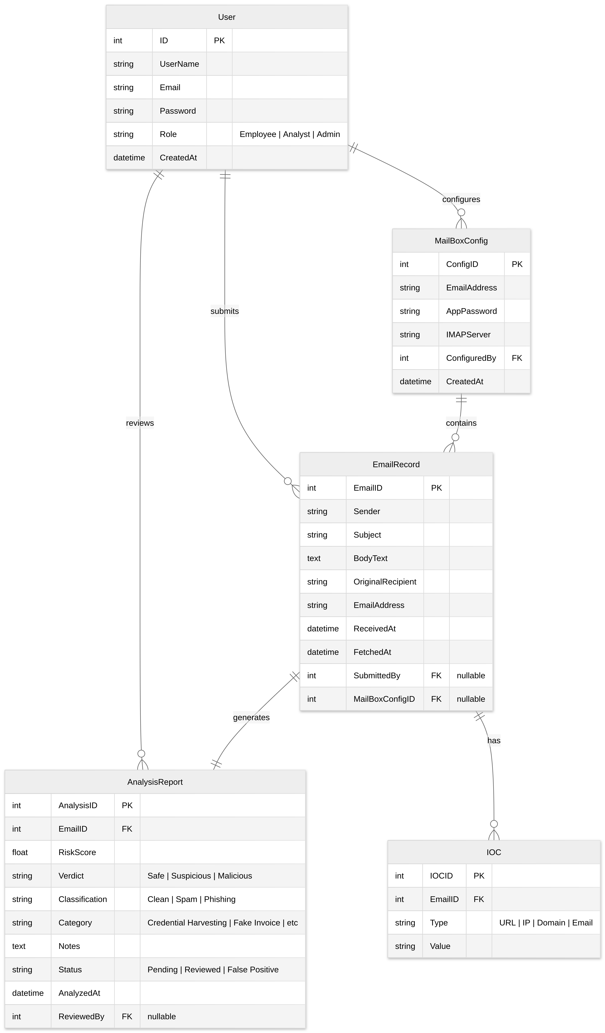

7.2 Use Case Diagram
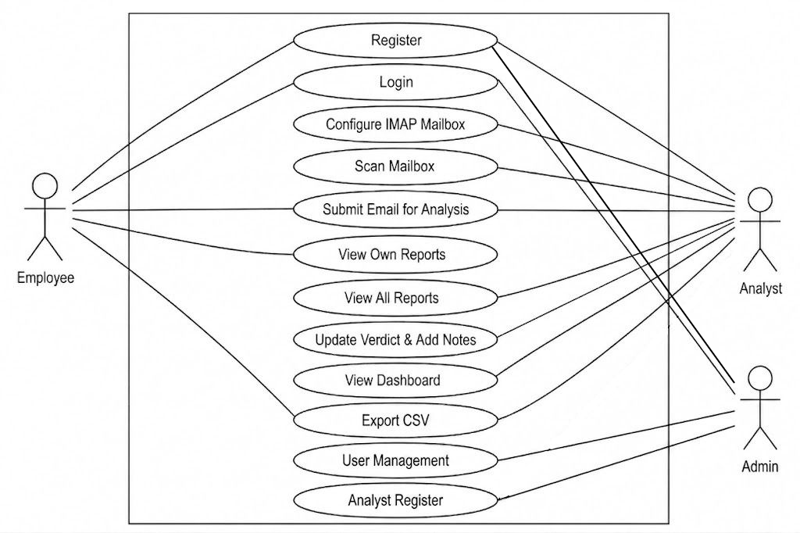
Figure 00-1 - Use Case Diagram

7.3 DFD
- Level 0:
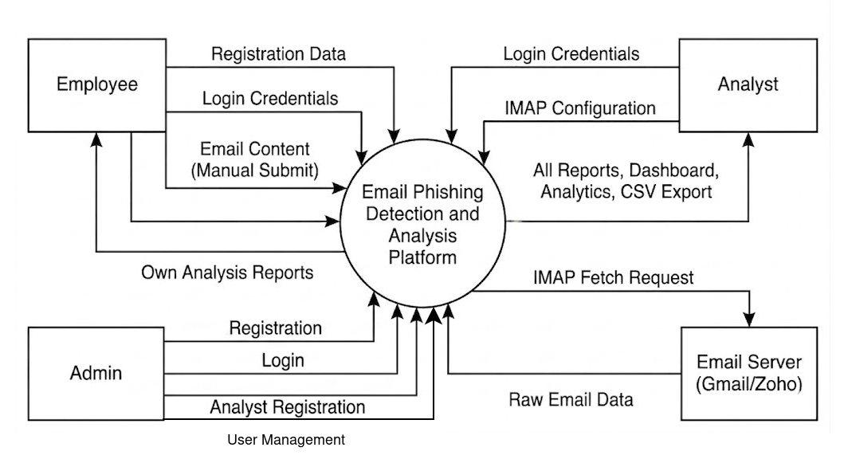
Figure 7.3 1 - DFD Level 0
- Level 1:
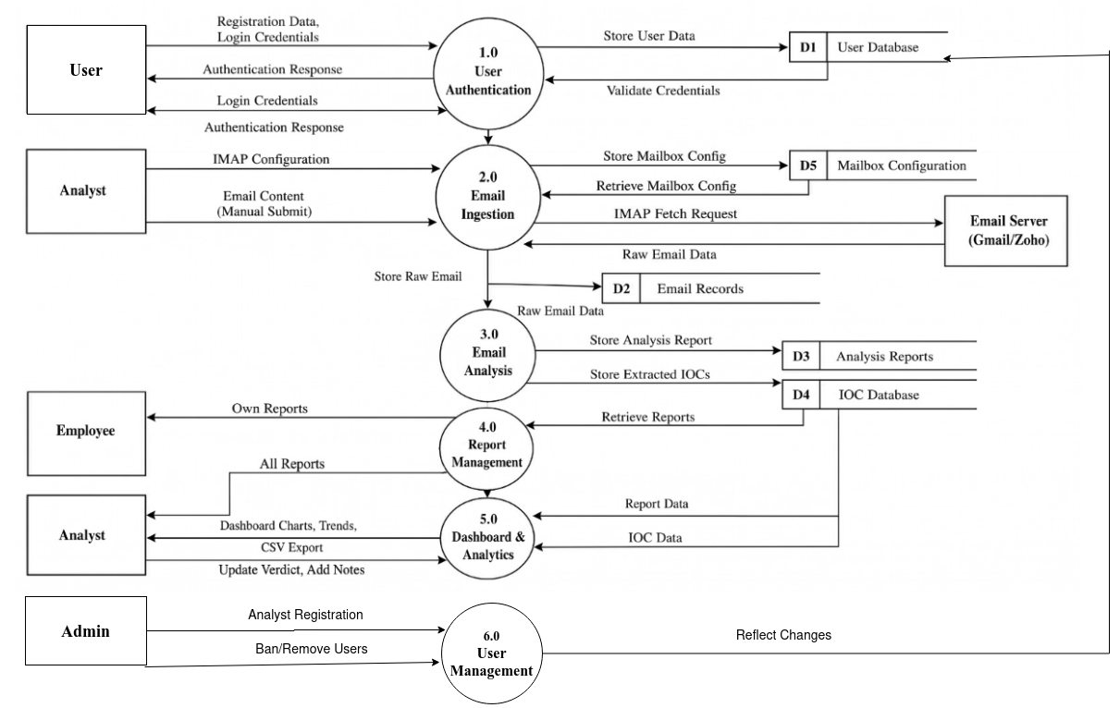
Figure 7.3 2 - DFD Level 1

7.4 UML Class Diagram
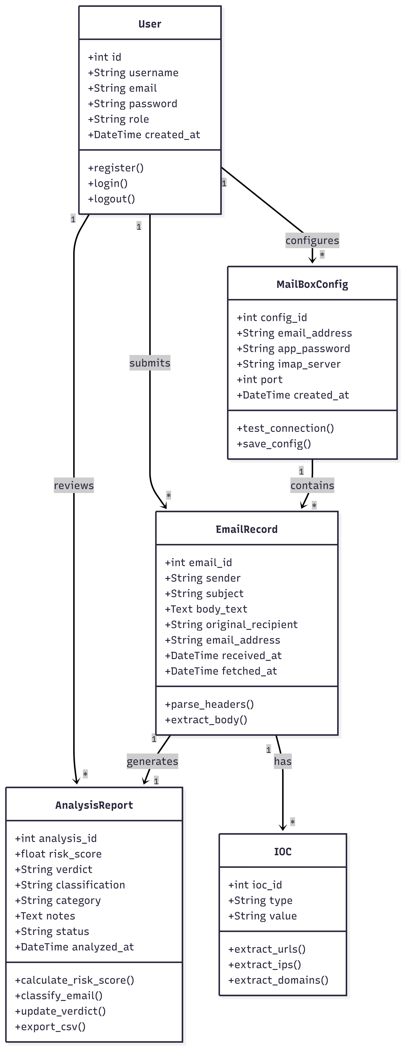
Figure 7.4 1 - UML Class Diagram

8. Detail Budget
Table 8 1 - Detail Budget
Category | Item | Quantity | Cost (NPR) | Total (NPR)
Hosting | DigitalOcean Droplet (Basic) | 12 Months | 1,100 | 13,200
Domain | .com Domain Registration (Namecheap) | 1 | 1,674 | 1,674
Security | SSL Certificate (Let’s Encrypt) | 1 Year | Free | 0
Email | Gmail (Free — IMAP access with App Password) |  | Free | 0
Tools | Development Tools (Python, Django, VS Code, Git) | — | Free | 0
Libraries | Pandas, Matplotlib, Chart.js, imaplib | — | Free | 0
Database | PostgreSQL (on DigitalOcean) | Included | Free | 0
API Fees | Threat Intelligence APIs (VirusTotal, AbuseIPDB) | 12 Months | 500 | 6000
Total |  |  |  | 20,874

8.1 Budget Breakdown
Table 8.1 1 - Budget Breakdown
Category | Amount (NPR) | Percentage
Hosting (DigitalOcean) | 13,200 | 63.23%
.com Domain Registration (Namecheap) | 1,674 | 8.01%
API Fees (Threat Intelligence) | 6,000 | 28.76%
Total | 20,874 | 100%

9. Detail Timeline
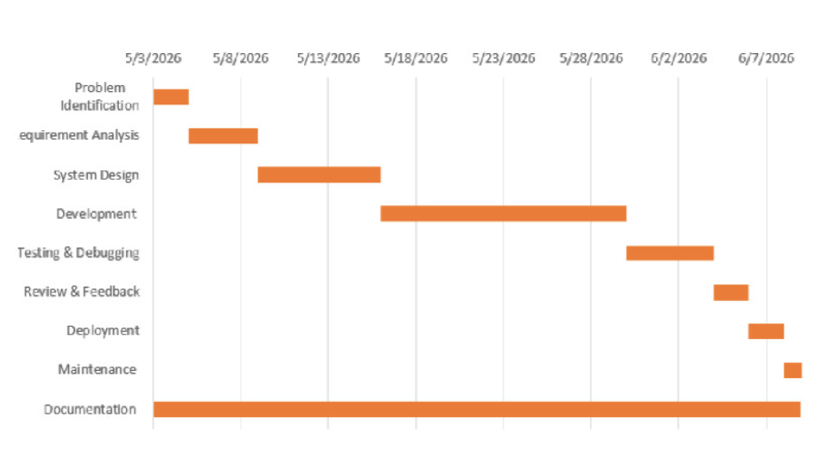
Figure 9. 1 - Detail Timeline

10. Conclusion
Email-based attacks, especially phishing and spam, are among the most common cybersecurity threats to organizations. The proposed Email Phishing Detection and Analysis Platform offers a Django-based web solution that automates the ingestion, analysis, classification, and visualization of email threats through post-delivery scanning via IMAP. The project integrates web development (Django), data analysis (Pandas), data visualization (Matplotlib and Chart.js), database management with CRUD operations, role-based access control, and subscription-based payment integration. Its modular architecture ensures maintainability, extensibility, and scalability for deployment as a multi-tenant SaaS platform.

References
Anti-Phishing Working Group (APWG). (2024). Phishing Activity Trends Report, 4th Quarter 2023. https://www.apwg.org/trendsreport/
Buber, E., Demir, Ö., & Sahingoz, O. K. (2017). Feature selection methods on phishing website detection. 2017 International Conference on Computer Science and Engineering (UBMK), 118-123.
Capterra. (2024). KnowBe4 Pricing, Reviews and Features. https://www.capterra.com/p/171545/KnowBe4/
Chiew, K. L., Tan, C. L., Wong, K., Yong, K. S. H., & Tawie, W. K. (2018). A survey of phishing analysis and detection. IEEE Access, 6, 44293-44317.
Django Software Foundation. (2024). Django Documentation (Version 5.0). https://docs.djangoproject.com/
Google Cloud. (2023). Google Workspace Security: Phishing and Spam Protection. Google Cloud Documentation.
KnowBe4. (2024). PhishER: The Security Orchestration, Automation, and Response Platform. https://www.knowbe4.com/products/phisher
Kumaran, S. S., & Sakhare, P. B. (2017). Email spam detection using machine learning based on string matching. International Journal of Computer Science and Network Security, 17(10), 1-5.
Nightingale, J. (2017). Email authentication: SPF, DKIM, and DMARC. Global Cyber Alliance. https://www.globalcyberalliance.org/
Statista. (2024). Number of sent and received emails per day worldwide from 2017 to 2027. https://www.statista.com/statistics/456500/daily-number-of-emails-worldwide/

