**Table of Contents**

1 Introduction 2

1.1 Purpose 2

1.2 Scope 2

1.3 Definitions, Acronyms, and Abbreviations. 3

1.4 Overview 3

2 The Overall Description 3

2.1 Product Perspective 3

2.1.1Hardware Interfaces 3

2.1.2Software Interfaces 4

2.2 Product Functions 4

2.3 User Characteristics 4

2.4 Apportioning of Requirements. 5

2.5 Assumptions and Dependencies 5

3 Specific Requirements 5

3.1 External Interfaces 6

3.1.1 User Interfaces 6

3.1.2 Software Interfaces 6

3.1.3 Hardware Interfaces 6

3.1.4 Communication Interfaces 6

3.2 Functional Requirements 6

3.3 Non functional Requirements 7

3.3.1 Performance Requirements 7

3.3.2 Logical Database Requirements 7

3.3.3 Design Constraints 8

3.3.4 Standards Compliance 8

3.3.5 Reliability 8

3.3.6 Availability 8

3.3.7 Security 8

3.3.8 Maintainability 8

3.3.9 Portability 8

**4.System Design 9**

4.1.System Architecture 9

4.1.1DFD Level 0 9

4.1.2DFD Level 1 10

4.1.3DFD Level 2 11

4.2.Class Diagram 12

4.3Use Case 13

4.4Sequence Diagram 14

4.5Collabarotion Diagram 15

# Introduction

The Chat Bot Builder (CBB) is an android app which will provide the prescription to the user according to given symptoms. The proper treatment for particular disease is need of hour. Because many cases are in front of us that, due to improper treatment patient lose his/her life, because of improper prediction of disease makes people suffer from difficult situations. The poor quality of health service may also affect the patient life. As we all know very well that health is wealth, so we have to take care of ourselves to be healthy one and live longer.

* 1. **Purpose**

The Software Requirements Specification (SRS) will provide a detailed description of their requirements for the Chat Bot Builder (CBB). This SRS will allow for a complete understanding of what is to be expected of the CBB to be constructed. The clear understanding of the CBB audits functionality will allow for the correct application to be developed for the end user and will be used for the development of the future stages of the project. This SRS will provide the foundation for the project. From this SRS, the CBB can be designed, constructed, and finally tested. The purpose of the CBB is to enhance the capability of health care in an efficient manner. It is an interactive system solve users query regarding medicine.

* 1. **Scope**
* Identify important parameters for maintaining the query and patient health.
* Build the chatbot for interaction between patient and Chat Bot System.
* Identify implementation of machine learning algorithm that will help to provide prescription to the patient.
  1. **Definitions, Acronyms and Abbreviations.**

*Table 1: Acronyms and Abbreviations.*

|  |  |
| --- | --- |
| SRS | Software Requirements Specification |
| CBB | Chat Bot Builder |

* 1. **Overview**

The SRS is organized into two main sections. The first is The Overall Description and the second is the Specific Requirements. The Overall Description will describe the requirements of the CBB from a general high-level perspective. The Specific Requirements section will describe in detail the requirements of the system.

# 2.The Overall Description(Abstract)

Describes the general factors that affect the application and its requirements. This section does not state specific requirements. Instead it provides a background for those requirements, which are defined in section 3, and makes them easier to understand.

## Product Perspective

The CBB is a dependent application. It is totally dependent on Medical Surveillance and prescription.

**2.1.1 Hardware Interfaces (Existing System)**

* **Computer System:**

We are using the system which has following specifications:

Processor: MIN i3, RAM: 8 GB, Hard disk: 1 TB, Graphics card: MIN 2GB

### Software Interfaces (Existing System)

1. **Android:**

Android version is 3.3.1Android is required for design the Chat bots Builder. The overall design of chat we will cover in android as well as the natural language processing.

**2) Database:**

We will use Fire base database to storing the information about symptoms given by him/her and according to symptoms the prescription.

## Product Functions (Informal approach)

**Login**

* Login with username & password
* Allows to register with details as well as their previous reports.

**UI Communication**

* Natural Language Processing on user entered symptoms.
* Provide the appropriate prescription.

**Prescription Model**

After NLP processing the symptoms are matched with the symptoms that are store in database. And gives prescriptions.

## User Characteristics

* Knowledge about handling android app – Medium
* Experience of CBB application – None
* Educational Knowledge (English) - Medium

## Apportioning of Requirements

**Login**

* User can login to the application.
* It will enter his or her queries.

**Chat Bot interface**

* According to entered queries system will answers users’ queries.
* It will provide prescription to the user by considering all the parameters.

**Query processing**

* After entering the queries that the natural language processing is done.
* The stop words are get removed and only essential data is given further for processing.
* And at the end after completion of all the processing steps the prescription is provided to user.

## Assumptions and Dependencies

As Chat Bot Builder(CBB) is an android application it will requires data connection for downloading. And also, for running this application.

**3. Specific Requirements**

This section contains all the application requirements at a level of detail, that when combined with the system DFD, UML, use cases and use case description is sufficient to enable designers to design a system to satisfy those requirements, and testers to test that the system satisfies those requirements

## 3.1 External Interfaces

The Chat Bot Builder will use the android device.

### 3.1.1 User Interfaces

| **Screen Name** | **Description** |
| --- | --- |
| Login | Log into the system. |
| Registration | Registration is not mandatory. |
| UI Communication | It the platform for patient to interact with the system. |

The User Interface Screens are described in table 2.

Table 2: Chat Bots Builder User Interface Screens

### 3.1.1 Software Interfaces

Application developed by android studio and Firebase Database interaction.

### 3.1.3 Hardware Interfaces

This application required only android devices.

### 3.1.4 Communication Interfaces

The Patient should communicate to System with the help of User interface. User will interact with Chat Bot through Internet.

## Functional Requirements

Functional requirement defines the functionality of our project.

1. Patient can register as per their need.
2. Patient should enter queries and then system should have to give response to their queries.
3. Natural language processing should be performed on the patient’s queries.

## 3.3. Non-functional Requirements

Nonfunctional requirements define the needs in terms of performance, logical database requirements, design constraints, standards compliance, reliability, availability, security, maintainability, and portability.

### 3.3.1 Performance Requirements

Performance requirements define correct response times for system functionality.

* The system must be interactive and delays involved must be less.
* The load time for user interface screens shall take no longer time.
* The log in information shall be verified within few minutes.
* Queries shall return result in time.

**3.3.2** **Logical Database Requirements**

The logical database requirements include the attention of the following data elements. This list is a complete list and is designed as a starting point for development.

**Login**

* User validation should be performed.

**Chat Bot interface**

* According to entered queries system will answers users’ queries.
* It will provide prescription to the user by considering all the parameters.

**Query processing**

* After entering the queries that the natural language processing is done.
* The stop words are get removed and only essential data is given further for processing.
* And at the end after completion of all the processing steps the prescription is provided to user.

### 3.3.3 Design Constraints

The CBB shall be running in an android device. The system shall be developed using android and an Access to the fire base database.

### 3.3.4 Standards Compliance

There shall be consistency in variable names within the system. The graphical user interface shall have a consistent look and feel.

### 3.3.5 Reliability

Specify the factors required to establish the required reliability of the system at time of service.

### 3.3.6 Availability

The system shall be available 24 hours.

### 3.3.7 Security

User will be able to log in to CBB. User will be able to interact with the system only for its health-related issues.

### 3.3.8 Maintainability

The CBB is being developed in android. Android is a mobile operating system. It is based on modified version of open source software. Android's default user interface is mainly based on direct manipulation, using touch inputs that loosely correspond to real-world actions, tapping and manipulate on-screen objects along with a virtual keyboard.

### 3.3.9 Portability

The CBB is android application that uses Internet facility.

1. **System Design:**

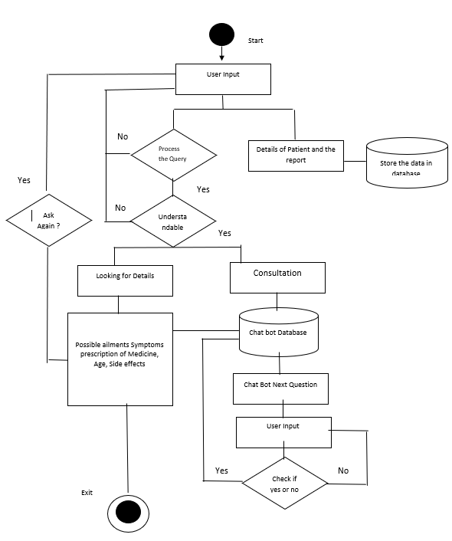

**Fig: System Architecture**

When patient enter their report with their quires then chat bot should process the query. If the query is processed successful then it is going to understandable phase otherwise go to user input phase. In understandable phase if the query is understandable then it goes to the consultation phase and Looking for details phase otherwise query goes to the user input phase. In consultation phase it will check for the symptoms and prescription in chat bot database. Then the chat bot asks new next question to patient to understand patient disease then patient should enter the answer. if patient can’t give the response to chat bot then chat bot can ask question again to patient otherwise chat bot check the answer of patient in chat bot database. After looking for details phase chat bot give the good possible suggestion ailments, symptoms, prescription of medicine, age, side effects.

* + 1. **DFD Level 0:**

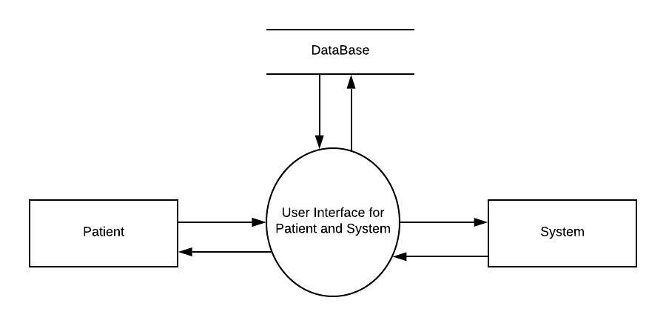

**Fig: DFD Level 0**

* + 1. **DFD Level 1:**

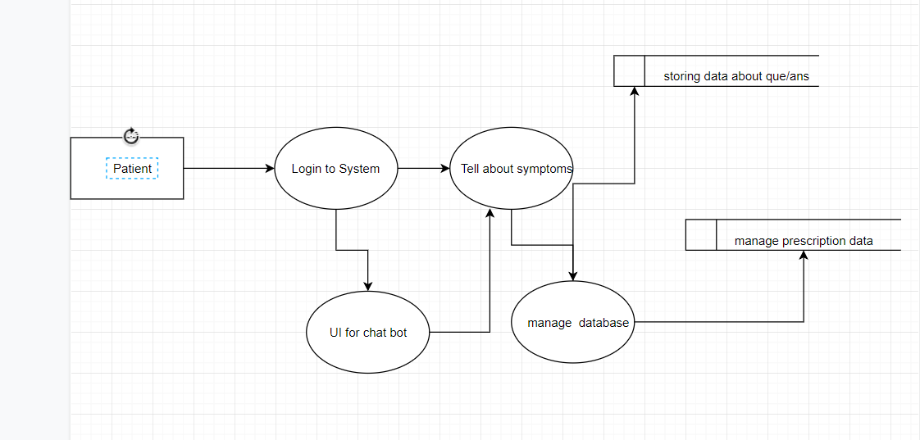

**Fig: DFD Level 1**

* + 1. **DFD Level 2:**

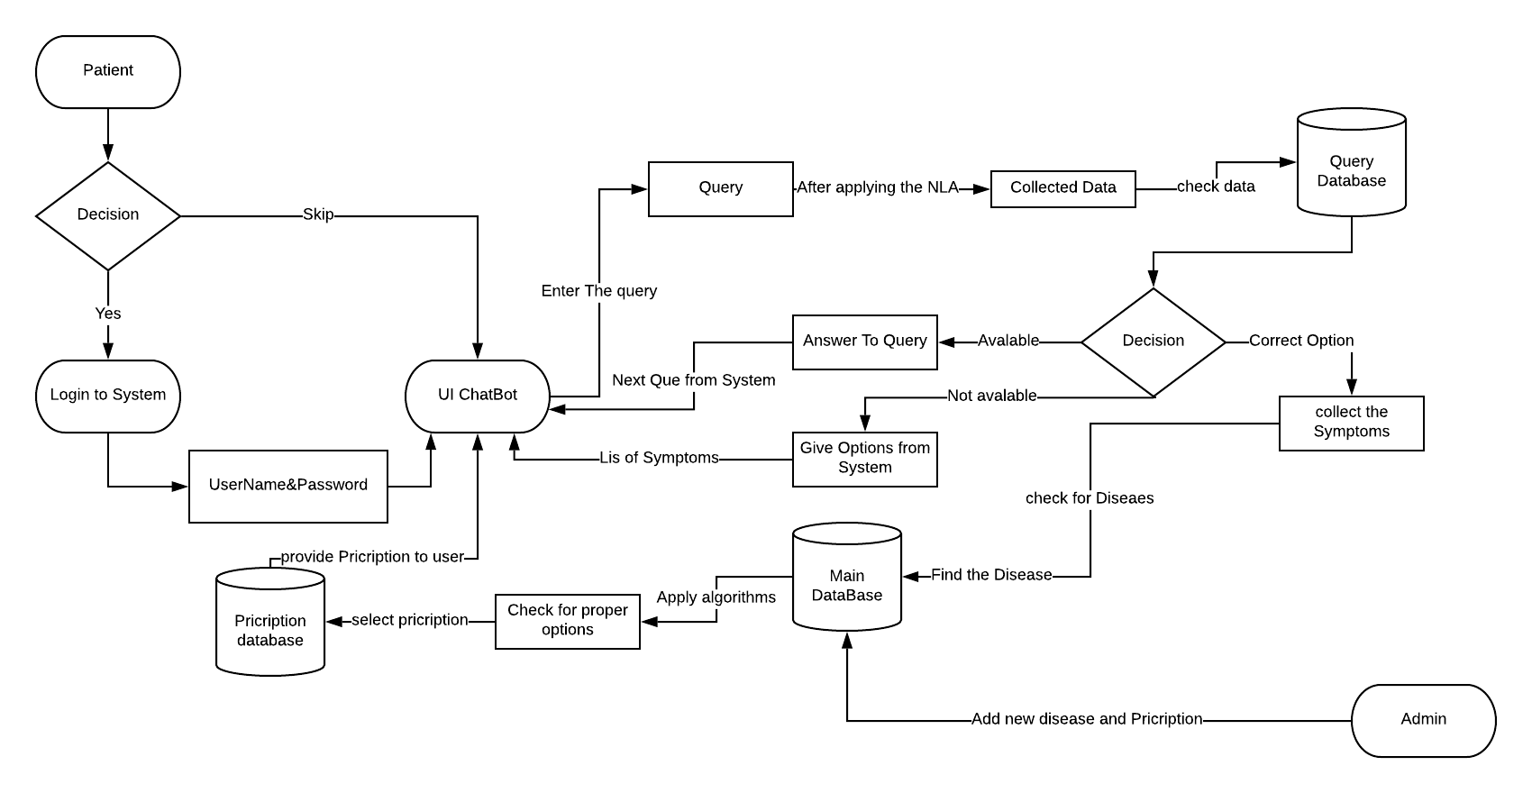

**Fig: DFD Level 2**

* 1. **Class Diagram:**

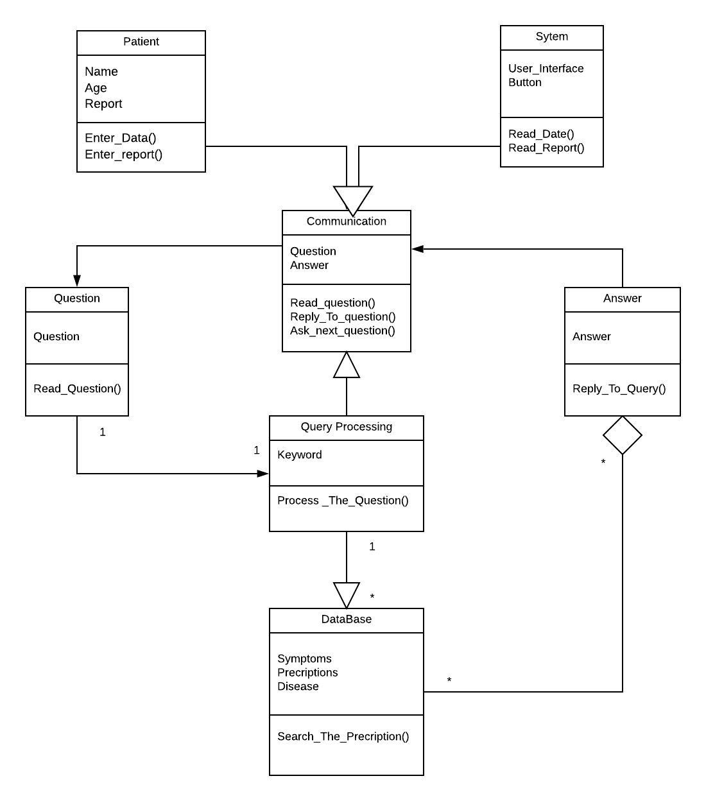

**Fig: Class Diagram**

**4.3 Use Case:**

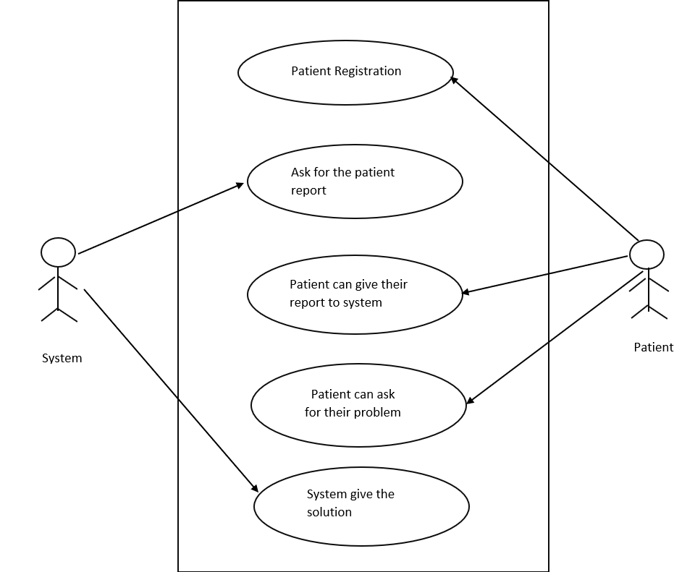

**Fig: Use Case Diagram**

**4.4 Sequence Diagram:**

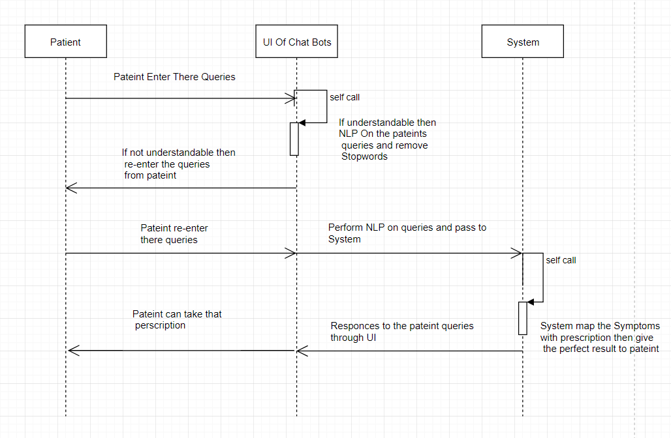

**Fig: Sequence Diagram**

**4.5 Collaboration diagram:**

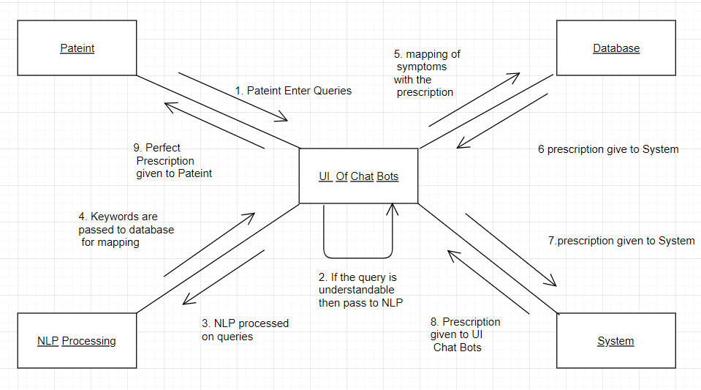

**Fig: Collaboration Diagram**