AI STUDY COMPANION
Edtech Proof of Concept
Notes to questions, assessment insights and handwriting OCR
MyClassBoard | 24 September 2026
1. Overview
This POC proves that one AI-powered tool can turn a student's or teacher's own notes into practice questions, measure understanding through assessments, and point each learner to the exact topics they need to revisit. It has three modules: Notes-to-Questions, Assessment & Insights, and Handwriting OCR. The goal is a working, demo-ready prototype in 4 to 6 weeks that shows value to schools, coaching institutes and edtech buyers before any larger build.
2. Problem and objectives
Teachers spend hours writing question papers by hand, students revise without knowing which topics are weak, and handwritten notes stay locked on paper where nothing can search, reuse or analyse them. Assessment results are usually a single score, which says how a student did but not what to fix.
The POC has four objectives:
- Generate relevant, syllabus-aligned questions from uploaded notes in under a minute, with 2-3 alternative versions on demand.
- Convert assessment results into a visual report that names weak topics and suggests what to study next.
- Digitise handwritten notes so they can flow straight into question generation.
- Show that the three modules work together as one loop: notes, questions, assessment, insight, revision.
3. Module 1: Notes upload to question generation
A user uploads subject notes and receives a ready set of probable exam questions, with up to three regenerable versions.
How it works
- The user uploads notes as PDF, DOCX, TXT or an image, and picks subject, class level and difficulty.
- The system extracts the text, splits it into topics and concepts, and builds a topic map.
- An LLM generates probable questions per topic, with the answer key and a short rationale.
- The user can hit Regenerate to get Version 2 or Version 3 (up to 3 versions per upload), each with a different emphasis.
- The user can edit, accept or discard questions, then export the set as a printable paper or send it to Module 2 as an assessment.
Question types
Type | Example use
MCQ | Quick concept checks
Short answer | Definitions, one-line explanations
Long answer | Reasoning, derivations, essays
Fill in the blanks | Vocabulary, formulas
True / False | Misconception checks

Version logic. Version 1 is a balanced mix across all topics. Version 2 leans on application and reasoning questions. Version 3 leans on recall plus previously missed topics. Every question is tagged with its topic and difficulty so Module 2 can analyse results by topic.
4. Module 2: Assessment, pictorial report and suggestions
The user attempts an assessment, and the system turns the result into a visual report that routes them to the topics that need work.
How it works
- The user takes a test built from Module 1 questions, or the teacher uploads marks per question.
- MCQ, true/false and fill-in answers are auto-scored. Short and long answers are scored by an LLM against the answer key and rubric, with the teacher able to override.
- Each score is rolled up by topic, difficulty and question type.
- The report is generated and a recommendation engine ranks topics from weakest to strongest.
Pictorial report contents
Visual | What it shows
Topic-wise bar chart | Score per topic, weakest highlighted
Radar chart | Overall subject strength at a glance
Difficulty split | Performance on easy, medium and hard questions
Progress trend | Score across repeated attempts
Priority list | Top 3 topics to work on, in order

Suggestions routed to topics. For every weak topic the report links back to the relevant section of the user's own notes, offers a short revision summary, and can generate a fresh practice set on that topic only (a return to Module 1). Topics scoring below a set threshold, for example 60%, are flagged as needing work; the threshold is configurable by the teacher.
5. Module 3: Handwriting OCR
Teachers and students photograph or scan handwritten notes and get clean, editable digital text that plugs into the other two modules.
How it works
- The user uploads photos or scans of handwritten pages (JPG, PNG or PDF), or captures them from a phone camera.
- Pre-processing straightens, crops, denoises and sharpens the image.
- A handwriting-capable OCR or vision-language model reads the page and outputs text, keeping headings, bullets and basic structure.
- A review screen shows the original image beside the extracted text, with low-confidence words highlighted for quick correction.
- The corrected text is saved as a digital note and can be sent straight to Module 1 to generate questions.
POC boundaries. The POC targets English handwriting on ruled or plain paper, with printed-style diagrams kept as images rather than interpreted. Accuracy on messy handwriting is measured during the POC and reported honestly; the review screen is what keeps the output usable when the model is unsure. Regional-language and mathematical-formula recognition are left for a later phase.
6. End-to-end flow and architecture
The three modules form one learning loop: handwritten or typed notes go in, questions and assessments come out, and the results feed back into what the learner studies next.
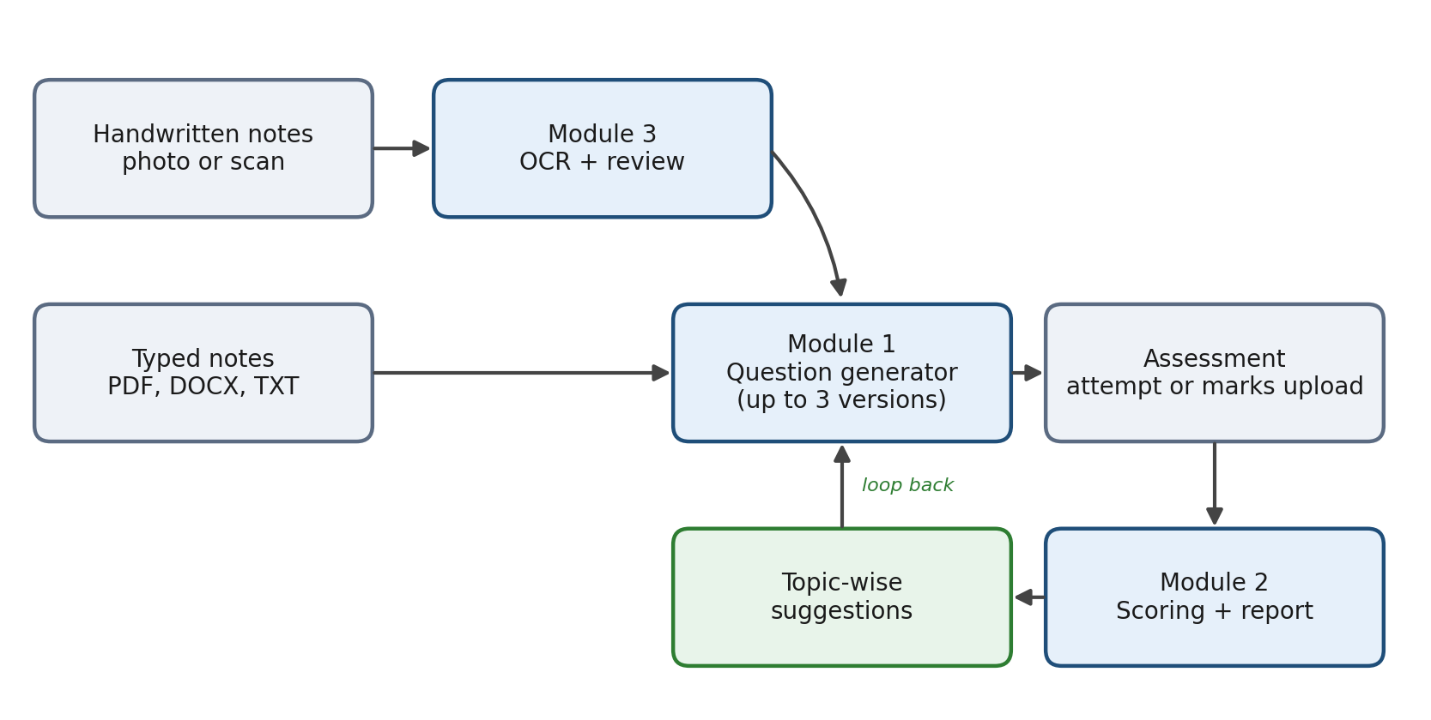
Figure 1: Both note types converge on the question generator; weak-topic suggestions loop back.
Reading it left to right: both note types converge on the question generator, its output becomes an assessment, and the report's weak-topic suggestions loop back to generate targeted practice.
At system level the POC has four layers: a web front end for uploads and reports, an API layer that orchestrates each module, an AI layer (OCR model, LLM for questions and scoring), and a small database that stores users, notes, topics, questions, attempts and scores.
7. Suggested tech stack and scope
The stack below is a suggestion chosen for speed of build; each piece can be swapped to match your team's preferences.
Layer | Suggested option
Front end | React or Next.js with a charting library for reports
Back end | Python (FastAPI) or Node.js
LLM for questions and scoring | Claude or another hosted LLM through an API
Handwriting OCR | A vision-language model, or a cloud OCR service (for example Google Vision, Azure Document Intelligence or AWS Textract)
Document parsing | PDF and DOCX text extractors
Database | PostgreSQL, with file storage for uploads
Hosting | Any cloud VM or container service

In scope: the three modules above, single-subject demos, simple login for teacher and student roles, exportable question papers and reports.
Out of scope for the POC: regional languages, formula and diagram recognition, full LMS integration, large-scale multi-school administration, mobile apps, and proctored exams.
8. Timeline, success metrics and risks
A lean team can deliver the POC in about 6 weeks.
Week | Milestone
1 | Finalise scope, sample notes and question formats; set up project skeleton
2-3 | Build Module 1: upload, topic extraction, question generation, regenerate flow
4 | Build Module 2: assessment, scoring and pictorial report
5 | Build Module 3: OCR, review screen and hand-off to Module 1
6 | Integration, testing with real teacher notes, demo and feedback
Success metrics
- At least 80% of generated questions rated relevant and usable by teachers in a sample review.
- Question set generated in under 60 seconds for a 10-page note.
- OCR word accuracy of 90% or better on neat handwriting, with results reported for messy samples.
- Weak topics in the report match a teacher's own judgement in at least 4 of 5 test cases.
Key risks and mitigations
Risk | Mitigation
Questions drift from the notes or contain errors | Ground the LLM only on uploaded text; teacher review step before use
Poor handwriting lowers OCR accuracy | Image pre-processing, confidence highlighting and manual correction
Subjective answers scored unfairly | Rubric-based scoring with teacher override
Student data privacy | Consent, encrypted storage and no use of student data for model training

Next steps: confirm scope and target users, share 5 to 10 sample notes (typed and handwritten), agree the success metrics, and approve the 6-week plan.

