**Assignment**

**Background**

The most common use of Angular Frontends is using CRUD APIs to save and view data. Create an Angular application to view a list of records, add records, and edit records.

**Assignment**

Create an Angular application that has the following areas. You may use any CSS like bootstrap, angular material, or library to make the pages look nice.

**Form Component:**

Form to create a add new Person

The form should have fields for first name, email, country, and phone number (**Reactive forms with username and email mandatory and phone number with maximum length 10 validations)**

**Once you submit the form store the data in local storage and using the decorators display it on ListView Component**

**Please find the below template for reference**

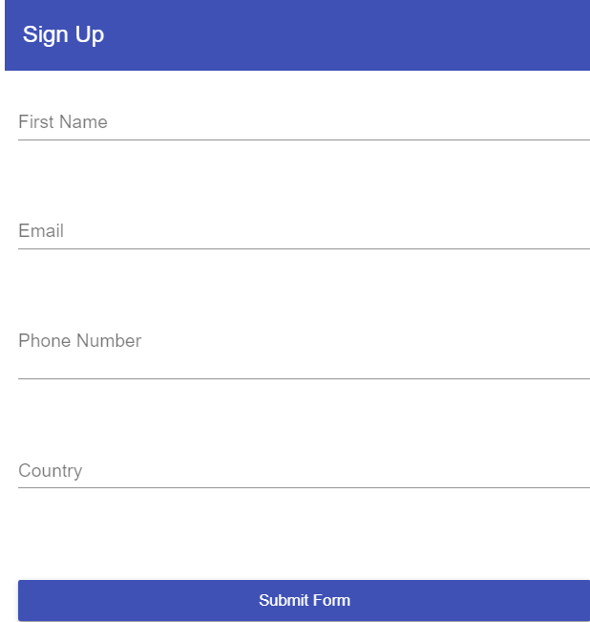

**List Component**:

List of Persons:

1. Show the list in a "table" format rather than a simple list. (ListView should be a component with input parameters). On this page show the id , name, email, dob, and country of the person which is added using the form.

2. Clicking on the edit action of any row should open the form to edit the respective details.

3. Clicking on the delete action of any row should delete the respective details.

**Please refer to the below image for reference.**

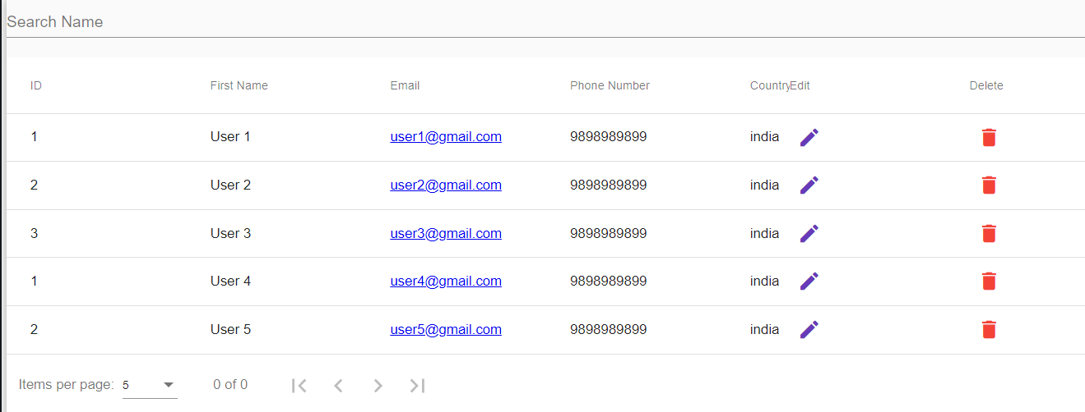

**Deliverable**

Create a repository in your GitHub account if it is accessible and commit the code into that repository. Send us the link to the repository.

**Assessment Criteria:**

The code quality of the Angular Code.

The code quality of the HTML and CSS if any.

Use local storage to save and display the data.

Look and feel of the form and list pages.