# EASYCHESS DEVELOPER MANUAL

## About

Easy Chess is a single player desktop game on a 4 by 4 board against a trained bot. The board is initially empty, and the player has four pieces, a bishop, rook, knight and a pawn.

The aim of the game is to be the first to align the pieces in vertical, horizontal or diagonal row. Once at least three pieces are placed per player, they may move a piece to capture a piece or place the remaining piece. Capture pieces are returned to their player and may be replayed on any open square.

/*

We can discuss about this

*The game (may) has different modes*

* *Easy*
* *Medium*
* *Difficult*

*It can also be played on a 4 by 4 or 6 by 6 board*

*/

The application keeps track of the players names and the amount of time used to win a particular level.

## Getting started

#### Set up

To have the application up and running, you need python installed (recommended version 3.x) . The latest version can be found here [Download Python | Python.org](https://www.python.org/downloads/). Proceed to install the NumPy library, if not installed. The library can easily be installed using the command *pip install NumPy.*

You also need a database installed locally preferably mysql.

Download (or clone the application for you to be able to contribute to the development of the application) and proceed to run it.

In the config.ini file under the config’s folder, set up the database name and password.

#### The application’s structure

##### App directory

The app directory contains the core code of the application. Almost all the classes of the application are found in this directory.

The app has mainly two folders

* Controllers – this contains classes pertaining the backed
* Views – contains all the classes pertaining the frontend

##### Config directory

Contains all the application’s configuration files.

##### Database directory

Contains database helper classes required to run set up and perform data related queries and storage. It also provides quick helper functions to retrieve data.

##### Log directory

Contains all the logs pertaining the application. A great place to check in case the app crashes.

##### Public directory

Contains the main.py file which is the entry point for the application.

## The Application Architecture

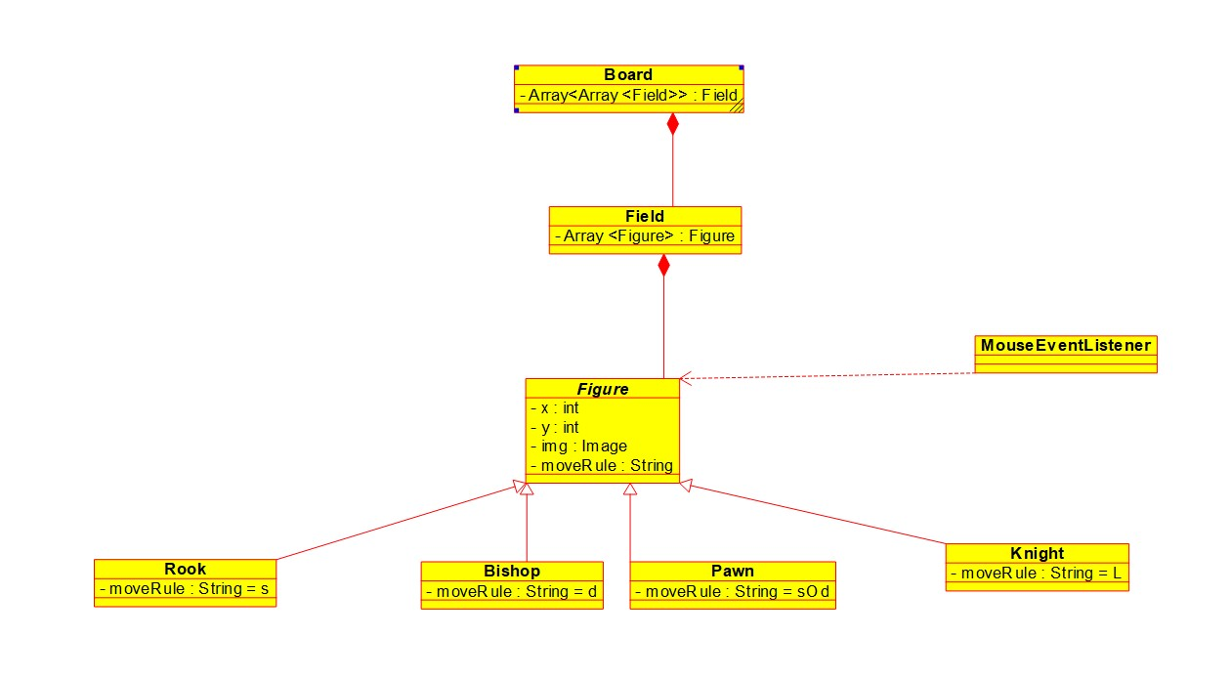

### The User Interface (*front end­*­)

The user interface is developed using python library Tkinter.

Basically, we need one main screen. A panel to enter the player’s name appears first. Once the name is entered a four-by-four chess board is displayed containing four pieces (the bishop, knight, pawn and rook) each side. The panel also has a timer and displays the player’s name on the sidebar menu. A button to quit the game is available on the menu or to restart. (It may also be possible to select the difficulty level.

### The backend

The chatbot, developed using minimax theory …

### The database

The application stores the players’ names, the time used to complete a given game and whether the player won or lost against our inbuilt chatbot. (It may also store the difficulty level of the game).

The database model is made up:

##### The player

Player has a

* unique id – generated by the database system
* time – amount of time used to finish a given game
* won – a Boolean True or False whether the player won the game or not
* created_at – generated by the database system